✅ 1. Log-likelihood under Fréchet
Recall Fréchet:
$$f(x)=Aα(Ax)^{-(1+α)}e^{-(Ax)^{-α}},$$
$$F(x)=e^{-(Ax)^{-α}}$$Use:
$$log⁡f(x)=log⁡(Aα)-(1+α)log⁡(Ax)-(Ax)^{-α} \\ log⁡F(x)=-(Ax)^{-α}$$

🔹 Take logs of your likelihood
$$l(γ;A,α)=\left(\sum_{n=1}^{N_{T}}{l_{n}}\right)log⁡γ+\sum_{n=1}^{N_{T}}{log⁡f(}x_{l_{n}})+\sum_{n=1}^{N_{T}}{(}γ^{l_{n}}-1)log⁡F(x_{l_{n}}) \\ +\sum_{n=1}^{N_{T}-1}{\frac{γ^{l_{n}+1}-γ^{l_{n+1}}}{1-γ}}log⁡F(x_{l_{n}})+1_{l_{N_{T}}<T}\frac{γ^{l_{N_{T}}+1}-γ^{T+1}}{1-γ}log⁡F(x_{l_{N_{T}}})$$

✅ Final log-likelihood
$$\boxed{\begin{matrix}l & =\left( ∑ l_{n}\right)log⁡γ+N_{T}log⁡(Aα)-(1+α)∑log⁡(Ax_{l_{n}}) \\ & -∑(Ax_{l_{n}})^{-α} \\ & -∑(γ^{l_{n}}-1)(Ax_{l_{n}})^{-α} \\ & -\sum_{n=1}^{N_{T}-1}{\frac{γ^{l_{n}+1}-γ^{l_{n+1}}}{1-γ}}(Ax_{l_{n}})^{-α} \\ & -1_{l_{N_{T}}<T}\frac{γ^{l_{N_{T}}+1}-γ^{T+1}}{1-γ}(Ax_{l_{N_{T}}})^{-α}\end{matrix}}$$
OR:
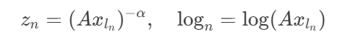
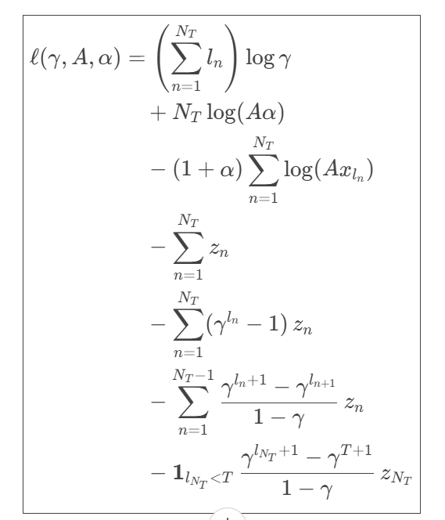
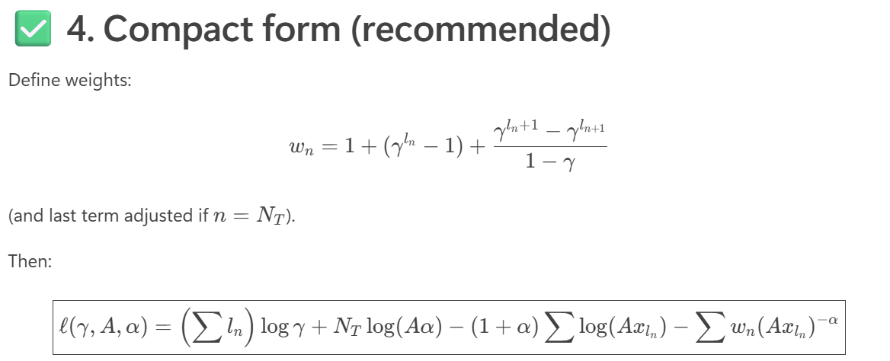

✅ 2. First-order derivatives
Define:
$$z_{n}=(Ax_{l_{n}})^{-α},{log⁡}_{n}=log⁡(Ax_{l_{n}})$$
