Part 1: Technical Indicators
3 different technical indicators were used in this strategy: SMA, Bollinger Bands and Stochastic Oscillator.

Indicator 1: Simple Moving Average (SMA)
Simply put, SMA is the average price of the adjusted stock price for a given window of time. As such, the following expression is used to calculate it, where A is the price of an asset at time n, and n is the number of total periods.
SMA = (A₁ + A₂ + … + A_{n}) / n
It is widely believed that SMA often serve as support or resistance levels. This means that when the price of the stock moves lower towards the SMA from a higher price, it is often met by a growing number of buyers, which acts as a support to stop the stock from further going down in price. Vice-versa, if the price of the stock moves higher towards the SMA form a lower price, it is often met by a growing number of sellers, which makes the price “resistant” from going up. 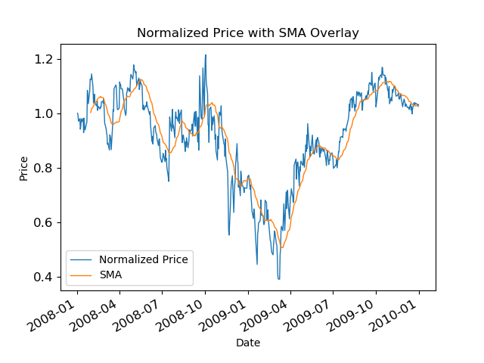

Indicator 2: Bollinger Bands:
Bollinger Bands consist of 2 lines above and below the SMA. The upper line (shown in green) represents the price which is 2 standard deviations above the SMA (shown in orange). The lower line (shown in red) represents the prices which is 2 standard deviations below the SMA (shown in orange). Therefore, the upper and lower Bollinger bands are calculated using this expression, where “n” is the number of days in the given window of timeframe and “std” is the standard deviations during the “n” number of days in the given window.
Upper Band = SMA_{n} + 2*std_{n}
Lower Band = SMA_{n} - 2*std_{n}

Given that the probability that the price is two standard deviations away from the SMA is significantly low, reaching the bands are often seen as a trade signal. When the price of the stock crosses the upper band from below and crosses back from above, it is a sell signal. Similarly, when the price of the stock crosses the lower band from above and crosses back from below, it is a buy signal.

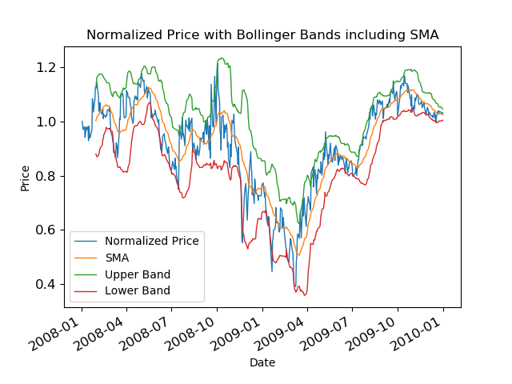

Indicator 3: Stochastic Oscillator:
Stochastic Oscillator is a momentum driven indicator which compares the price of a security to a range of its prices over a window of time. It is calculated using this expression, where P is the most recent price, L is the lowest price traded of the “n” number of previous trading sessions, H is the highest price for the same number of sessions:
K = (C – L_{n}) / (H_{n} – L_{n}) * 100
The Stochastic oscillator is used to identify overbought and oversold signals. As shown in the chart below, it is thought that stochastic readings (shown in blue) below 20 indicate that a stock has been oversold, and thus a buy signal. It is thought that stochastic readings above 80 indicate that a stock has been overbought, and thus a sell signal.
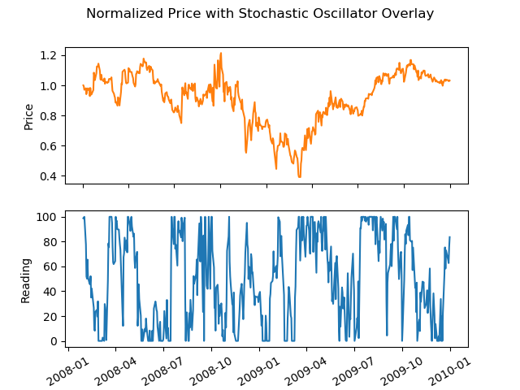

Part 2: Theoretically Optimal Strategy
In the theoretically optimal strategy, my assumptions were as follows:
- I have access to future prices of the stock.
- I am constrained by the portfolio size which had to be 0, 1000 shares long or 1000 shares short.
- My orders were also limited due to the set portfolio size.
- Commission: $0, Impact: 0.00.
To implement this strategy, I traversed through each day of the trading day and peek in the future one day ahead. For each day, depending on the price of the stock the next day and the net holdings, I used the following logic:
- If my net holdings were 0 (which would occur only on the first trading day), if the price of the stock one day in the future was higher, I would buy 1000 shares. If the stock one day in the future was lower, I would short 1000 shares.
- If my net holdings were -1000 shares, meaning I had shorted it the previous day, if the price of the stock one day in the future was higher, I would buy 2000 shares. If the stock one day in the future was lower, I would not make any orders since I was under the constraint of - 1000 shares.
- If my net holdings were 1000 shares, meaning I had bought it the previous day, if the price of the stock one day in the future was lower, I would buy 2000 shares. If the stock one day in the future was higher, I would not make any orders since I was under the constraint of 1000 shares.
As shown below, the theoretically optimal strategy performed fantastically since it could peek into the future. The benchmark showed negative cumulative return over the course of the timeframe. Below are the statistics of stock JPM with the date range between 1/1/2010 and 12/31/2011.
 | Theoretically Optimal Strategy | Benchmark
Sharpe Ratio | 13.323 | 0.160
Cumulative Return | 5.7861 | 0.0123
Average Daily Return | 0.0038 | 0.0002
Standard Deviation | 0.0045 | 0.0170
Final Portfolio Value | $ 678,610.00 | $ 101,230.00

The figure below titled “Theoretically Optimal Portfolio vs Benchmark (Normalized)” shows the performance of the two portfolios over the course of the timeframe. The prices have been normalized so that they can be more easily compared. As expected, the figure depicts that the theoretically optimal portfolio performed much better than the benchmark portfolio, consistently.
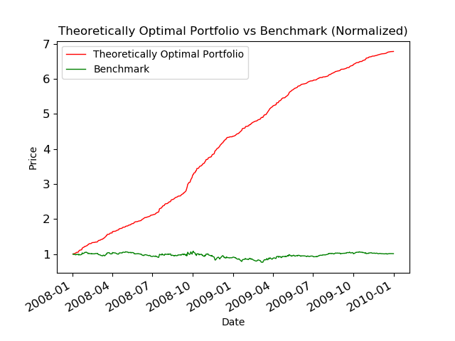

Part 3: Manual Rule-Based Trader Strategy
In the manual rule-based trader strategy, my assumptions were as follows:
- I am constrained by the portfolio size which had to be 0, 1000 shares long or 1000 shares short.
- My orders were also limited due to the set portfolio size.
- Commission: $9.95, Impact: 0.005.
To implement this strategy, I created a set of logic involving SMA, Bollinger Bands and Stochastic Oscillator indicators which was used to determine a long or short signal. Like the theoretically optimal strategy, I traversed through each day of the trading day. However, because we cannot peek into the future using this strategy, we compared the given day with the day(s) before (as opposed to after) to calculate the values for the indicators.
First, I used the Bollinger Band indicator
- If the price the day before was higher than the upper band and the price the day of was lower than the upper band, it was considered a sell signal. If my net holdings were 0, I would short 1000 shares. If my net holdings were 1000 shares, I would short 2000 shares.
- If the price the day before was lower than the lower band and the price the day of was higher than the lower band, it was considered a buy signal. If my net holdings were 0, I would take a long position on 1000 shares. If my net holdings were -1000 shares, I would take a long position on 2000 shares.
Second, I used the SMA indicator:
- If the price the day before was higher than the SMA and the price the day of was lower than 99% value of SMA, it was considered a sell signal. If my net holdings were 0, I would short 1000 shares. If my net holdings were 1000 shares, I would short 2000 shares.
- If the price the day before was lower than the SMA and the price the day of was lower than 101% value of SMA, it was considered a buy signal. If my net holdings were 0, I would take a long position on 1000 shares. If my net holdings were -1000 shares, I would take a long position on 2000 shares.
Lastly, I used the Stochastic indicator:
- If the stochastic reading was higher than 85, it was considered a sell signal. If my net holdings were 0, I would short 1000 shares. If my net holdings were 1000 shares, I would short 2000 shares.
- If the stochastic reading was lower than 15, it was considered a buy signal. If my net holdings were 0, I would take a long position on 1000 shares. If my net holdings were -1000 shares, I would take a long position on 2000 shares.

As shown below in the graph titled “Manual Strategy vs Benchmark (Normalized)”, the manual rule-based trader strategy performed much better than the benchmark. The benchmark showed 1.23% cumulative return over the course of the timeframe, whereas the manual rule-based trader strategy showed 11.40% cumulative return. Below are the statistics of stock JPM with the date range between 1/1/2008 and 12/31/2009.
I believe this is an effective strategy due to the multiple checks it goes through to find any opportunities which meet the criteria of a buy-signal. The 68-95-99.7 rule in statistics states that in a normal distribution, 68% of the population fall under 1 standard deviation from the mean, 95% fall under 2 standard deviations and 99.7% fall under 3 standard deviations. Although market data may not always fall under normal distributions, according to professor Balch, it does more so than not. Given this assumption, I believe that the Bollinger Band is a great indicator signaling a general regression to the mean.
In addition to the statistics, I believe that there is a psychological factor to the market. And as such, I believe the support/resistance of the SMA often is a psychological factor which if crossed with enough momentum, could signal a breakthrough in the direction it was headed.
Lastly, statistics and psychology aside, the stochastic indicator signals that the stock is likely oversold or overbought. If an asset is oversold, there are not enough sellers. And according to professor Balch, this would mean that there is a higher demand than supply of the asset, meaning the price is likely to go up.
With the three indicators which reflect different factors of the assets. I believe this is a very balanced strategy to decide whether the trader should take a long or short stance on the asset or should not take any action.
 | Manual Rule-Based Strategy | Benchmark
Sharpe Ratio | 0.3666 | 0.160
Cumulative Return | 0.1140 | 0.0123
Average Daily Return | 0.0003 | 0.0002
Standard Deviation | 0.0137 | 0.0170
Final Portfolio Value | $ 111,146.35 | $ 101,230.00

