1. Quick sort – not stable

Let’s say quick sort is stable. The easiest way to prove it’s woring is finding a non-stable example.

List = {31, 17, 11, 31, 18} The red one is first 31 and the blue one is second 31.

Pass1: 11, 17, 31, 31, 18

11, 17, 18, 31, 31

Pass2: 11, 17, 18, 31, 31

You can see the first one (red one) is after the second one(blue one)

2. merge sort – stable

Red : first same number

Blue : second same number

8 elements :

* When red and blue are in the same half but not in quarter.

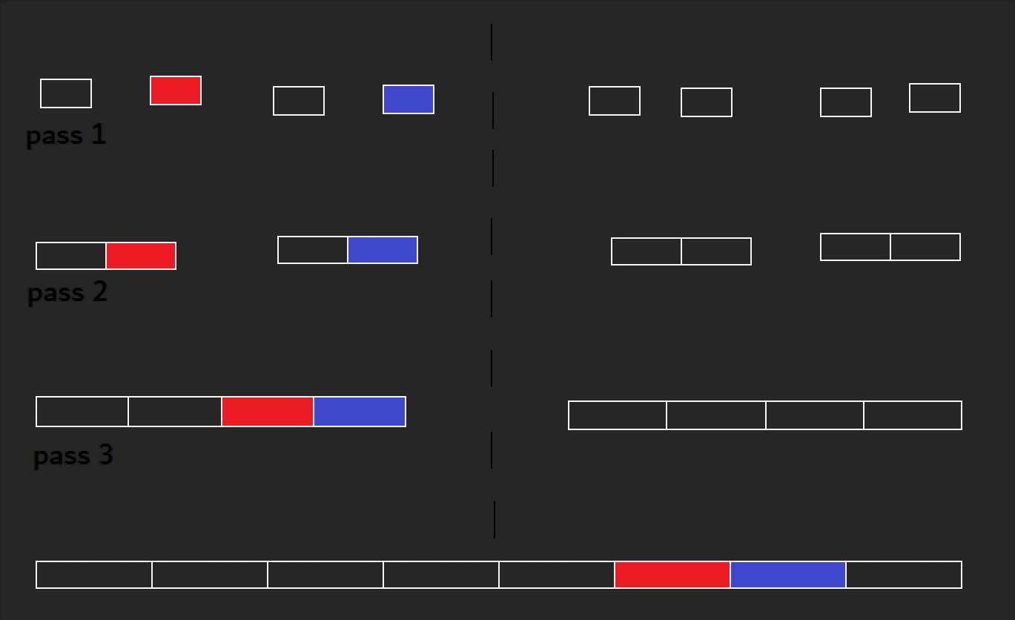

* When red and blue are in different half.

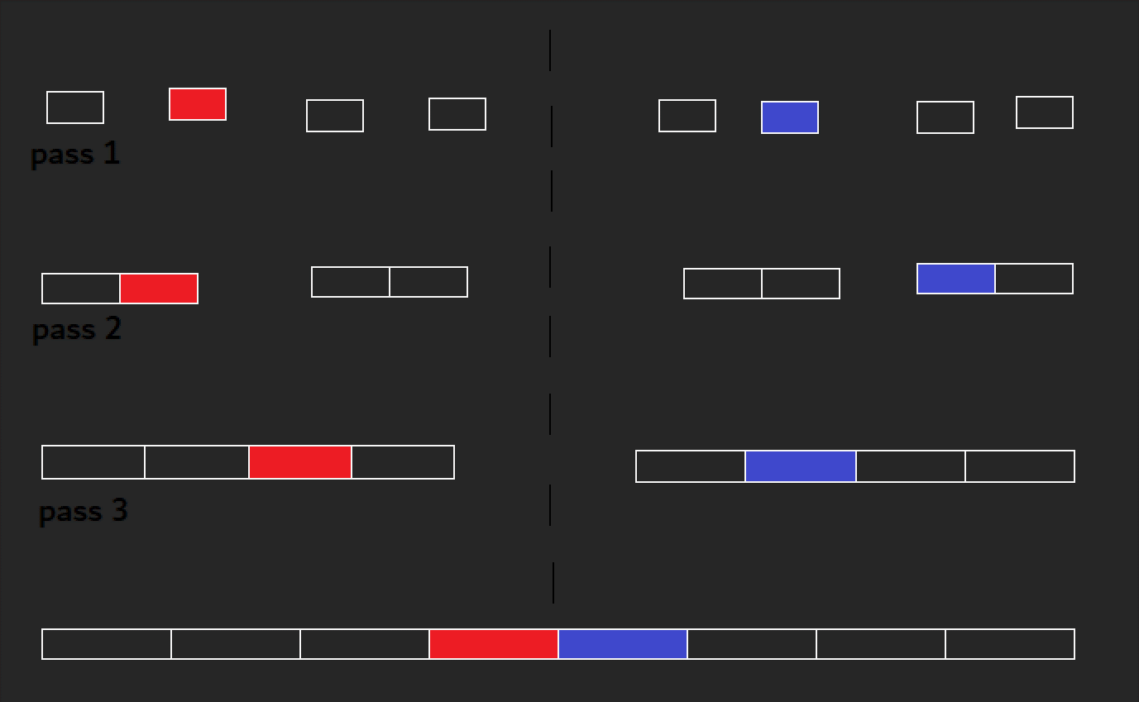

* when red and blue are in same half and quarter

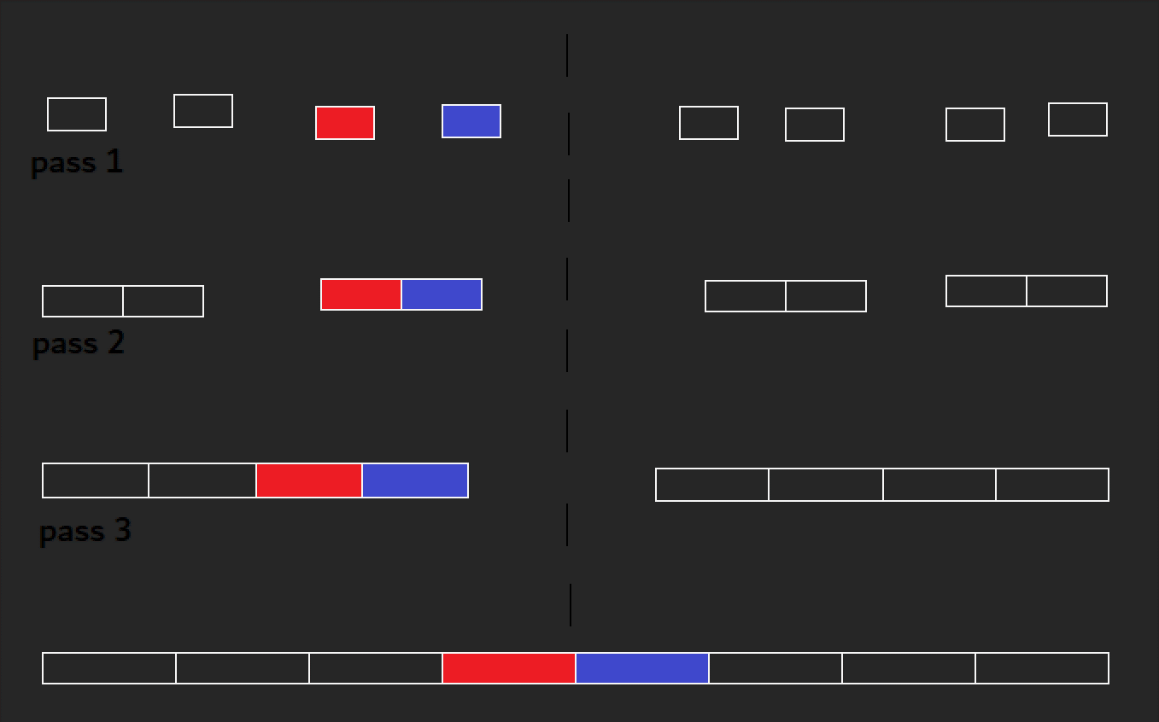

7 elements :

* when red and blue are in different half and blue is in extra one.

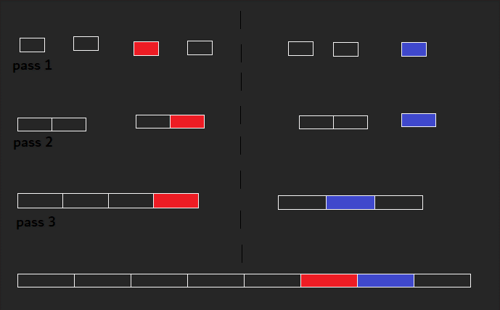

* when red and blue are in different half and both of them are in normal one.

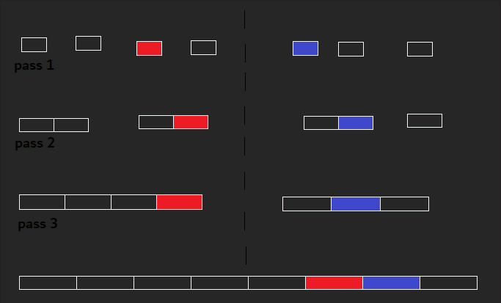

6 elements :

* when red and blue are in different half and red is in extra one.

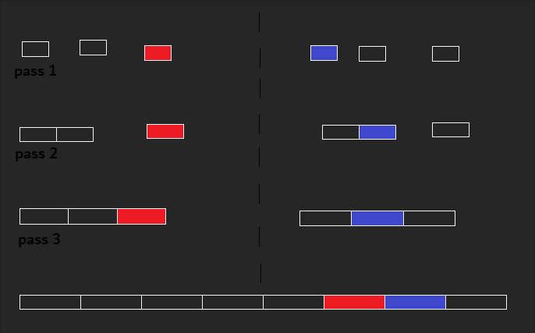

* when red and blue are in different half and both of them are in extra ones.

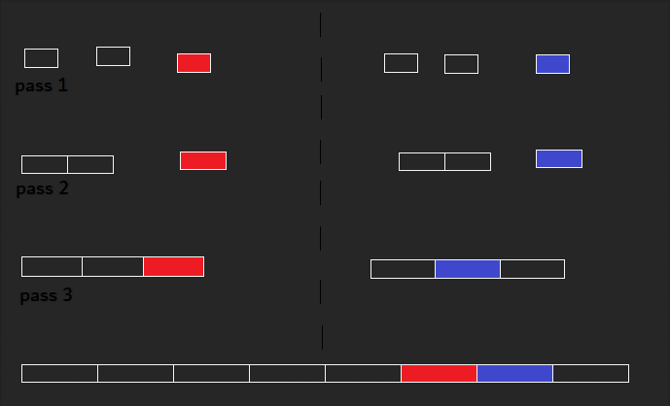

* when red and blue are in different half and they’re all in normal ones.

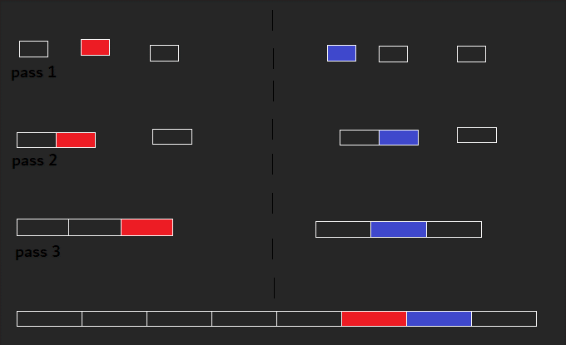

* when red and blue are in different half and blue is in extra one.

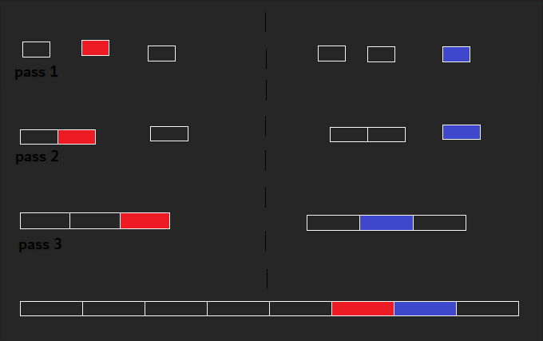

- when red and blue are in the same half but blue is in extra one.

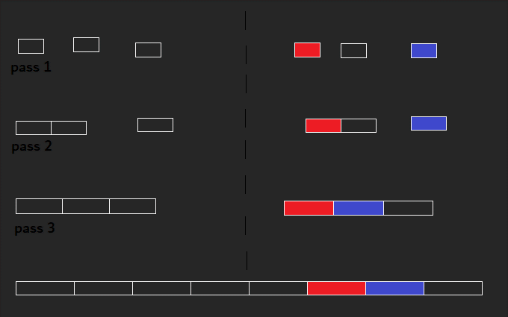

This shows approximately what happens with 2 same values.

Blue(second same value) always comes after red(first same value) when they’re getting merged.

I’ll show you by following pictures.

1. Red and blue are in different bar.



2. Red and blue are in the same bar.

-

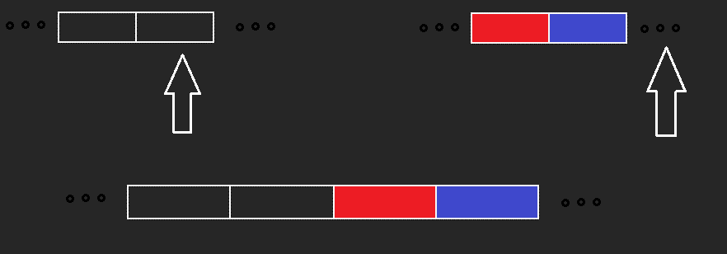

You can see the second same value always comes after the first same value.

3. Least Significant Digit (LSD) Radix Sort – stable

List = {11, 81, 80, 23, 25, 55, 71, 2, 900, 999}

1st pass : (80, 900), (81, 71, 11), (2), (23), (25, 55), (999)

2nd pass : (02, 900), (11), (25, 23), (55), (71), (81, 80), (999)

3rd pass : 2 11 25 23 55 71 81 80 900 999

Let’s say LSD radix sort is not stable so we can shuffle them. You can see the result isn’t in ascending order. Considering the same value as same results the previous pass useless. So it makes the result wrong.

4. Most Significant Digit (MSD) Radix Sort – not stable

List = {11, 81, 80, 23, 25, 55, 71, 2, 900, 999}

Pass 1 : (002 081 025 011 023 055 080 071) , (999 900)

Pass 2 : (002) , (011) , (023 025) , (055) , (071) , (081 080) , (900) , (999)

Pass 3 : (2) , (11) , (23) , (25) , (55), (71), (80) , (81) , (900) , (999)

As you can see, whether you mix the same digit(unstable sorting) in the passes doesn’t make any difference on the result

5. Selection sort – not stable

Let’s say selection sort is stable and find any example that violates this.

List = {6, 4, 6, 7, 1}

Pass 1 : 6, 4, 6, 1, 7

Pass 2 : 1, 4, 6, 6, 7

As you can see, the first 6 comes after second 6.

So selection sort is not stable.