# Probability and Statistics Spring 2022 Instructor: Joon Yoo (joon.yoo@gachon.ac.kr)

**Homework 1 - Problem**

**Due date: Monday March 21, 23:59, Cyber campus**

1. [Pre-lecture] **Sampling and sources of bias.** In 1936 US presidential election, the Literary Digest magazine polled 10 million people and got response from 2.4 million people. The poll showed Landon (Republican) will win over Roosevelt (Democrat) by 57% vs. 43%. However, the Roosevelt won the actual election by 62% vs. 38%. What source of sampling bias happened? Explain your answer.

Convenience sample. Convenience sample is one of the sources of sampling bias that happen when individuals who are easily accessible are more likely to be included in the sample. The magazine had surveyed its own readers, registered automobile owners and registered telephone users for 1936 US presidential election. These groups had incomes well above national average of the day. This was the great depression era, which resulted in lists of voters far more likely to support Republicans, than a truly typical voter of the time. The sample was not representative of the American population at the time. So it didn’t yield an accurate prediction. This convenience sampling caused bias.

1. **Descriptive Statistics.** A chemical engineer desiring to study the evaporation rate of water from brine evaporation beds obtained data on the number of inches of evaporation in each of 55 July days spread over 4 years. The data are given in the following stem and leaf plot, which shows that the smallest data value was .02 inches, and the largest .56 inches.

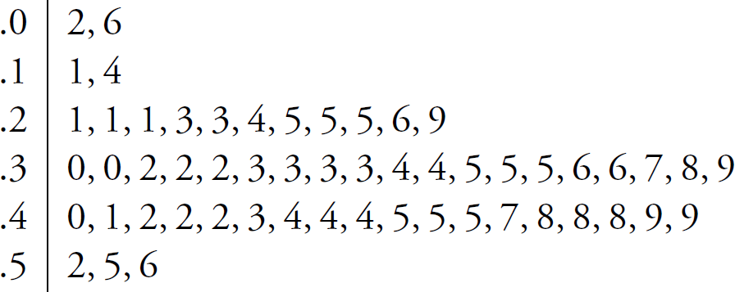

Find the

1. sample mean;

0.34763 ≈ 0.35

1. sample median;

0.35

1. sample standard deviation of these data.

|  |  |  |  |  |
| --- | --- | --- | --- | --- |
| s2 = | |  | | --- | | Σ(xi - x̄)2 | |  | | N - 1 | |

= {(0.02-0.34763)1/2 + …. + (0.56-0.34763)1/2}/(55-1) ≈ 0.74719/54 ≈ 0.01383

S = $√0.01383$ ≈ 0.1176

1. What percentage of data values are within 1 standard deviation of the mean?

34.54%

1. **Permutation.** Four married couples have bought 8 seats in the same row for a concert. In how many different ways can they be seated
2. with no restrictions?

There can be 8 cases on the first seat, 7 cases for second seat, 6 cases for third seat … 1 case for the last seat.

8! = 40320

1. if each couple is to sit together?

There are 4 couples. Let’s say first and second seat is group seats A, third and fourth is group seats B, fifth and sixth is group seats C and seventh and eighth is group seats D. There is 4 cases for group seats A, 3 cases for group seats B, 2 cases for group seats C and 1 case for group seats D. It’s 4! = 24.

And the woman can sits on either left side or right side of the group seat. This happens in 4 couples.

These events happen at the same time. So,

4!*2!*2!*2!*2! = 24 * 16 = 384

1. if all the men sit together to the right of all the women?

Left side is for women and right side is for men. Let’s see the left side first. There is 4 cases on the first seat of the left side, 3 cases for the second seat of the left side, 2 cases for the third seat of the left side and 1 case for the fourth seat of the left side.

This is 4! = 24.

Let’s see the right side. There is 4 cases on the first seat of the right side, 3 cases for the second seat, 2 cases for the third seat and 1 case for the fourth seat of the right side.

This is 4! = 24.

These two events happen at the same time. So 4! * 4! = 576

1. **Probability.** In a poker hand consisting of 5 cards, find the probability of holding
2. 3 aces;

The number of ways of being dealt 3 aces is 4 * 1128= 4,512 (since 4 aces is not allowed. And only none-ace cards can be selected.)

The total number of 5-card poker hands, all of which are equally likely, is 2,598,960

4,512/2,598,960 ≈ 0.001736

So, It’s 0.1736%

1. 4 hearts and 1 club.

The number of ways of being dealt 4 hearts is 715 and 1 club is 13. So the number of ways of being dealt 4 hearts and 1 club is 9,295. The total number of 5-card poker hands, all of which are equally likely, is 2,598,960 (following picture)

Therefore, the probability of getting 4 hearts and 1 club is 0.358%

1. **Probability.** It is common in many industrial areas to use a filling machine to fill boxes full of product. This occurs in the food industry as well as other areas in which the product is used in the home, for example, detergent. These machines are not perfect, and indeed they may A, fill to specification, B, underfill, and C, overfill. Generally, the practice of underfilling is that which one hopes to avoid. Let P(B) = 0.001 while P(A) = 0.990.
2. Give P(C).

P(A) + P(B) + P(C) = 1 since events A, B and C are mutually exclusive and cover the entire space.

P (C) = 1 – 0.990 – 0.001 = 0.009

1. What is the probability that the machine does not underfill?

1 – P(B’) = 1-0.001 = 0.999

1. What is the probability that the machine either overfills or underfills?

P(B) + P(C) = 0.001 + 0.009 = 0.01

Since they’re disjoint

————————–————————–————————–————————–———

**- Homework guidelines:** (read carefully!)

1. Please write the answer and the solution process in detail.
2. Write in English.
3. Cheating is not accepted. (Do not copy any answer from the Internet, other students. All copied homework will result in ZERO points.)
4. Write down your answers in a single WORD file OR you may handwrite your answers and scan/copy&paste onto the word file.
5. The word file name MUST be “ - - .docx”.



1. You will get severely degraded if you do not follow the above five guidelines!!!