Relation schema is table definition so it defines the meta data elements which represents a particular domain. Relation is used to refer to a table and to describe the relationships. For example, people(PhoneNumber, name) is a relation schema and

|  |  |
| --- | --- |
| PhoneNumber | Name |
| 123-456-222 | John |
| 456-78-9123 | Joe Brown |

Is a relation based on that schema

2.11 (10 pt)

Consider the advisor relation shown in the schema diagram in Figure 2.9, with s\_id as the primary key

of advisor. Suppose a student can have more than one advisor. Then, would s id still be a primary key of

the advisor relation? If not, what should the primary key of advisor be?

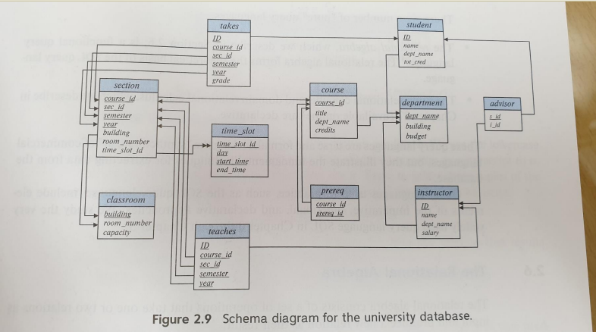

if a student can have more than one advisor, s\_id can’t be the primary key of the advisor relation anymore since it’s not unique anymore. the primary key must be changed into something unique. So, the primary key of the advisor table should be changed into the mixture of i\_id and s\_id.

2.12 (20pt)

Consider the bank database of Figure 2.18. Assume that branch names and customer names uniquely

identify branches and customers, but loans and accounts can be associated with more than one

customer.

1. What are the appropriate primary keys?
2. Branch table – branch\_name
3. Customer table - ID
4. Loan table – loan\_number
5. Borrower table - ID
6. Account table – account\_number
7. Depositor table - ID

b. Given your choice of primary keys, identify appropriate foreign keys.

branch name as a foreign key for the table branch, loan and account.

loan\_number can be a foreign key to connect the table loan and borrower.

account\_number can be a foreign key to connect the table account and depositor.

ID can be a foreign key to connect the table customer, borrower and depositor.

2.13 (30pt)

Construct a schema diagram for the bank database of Figure 2.18.

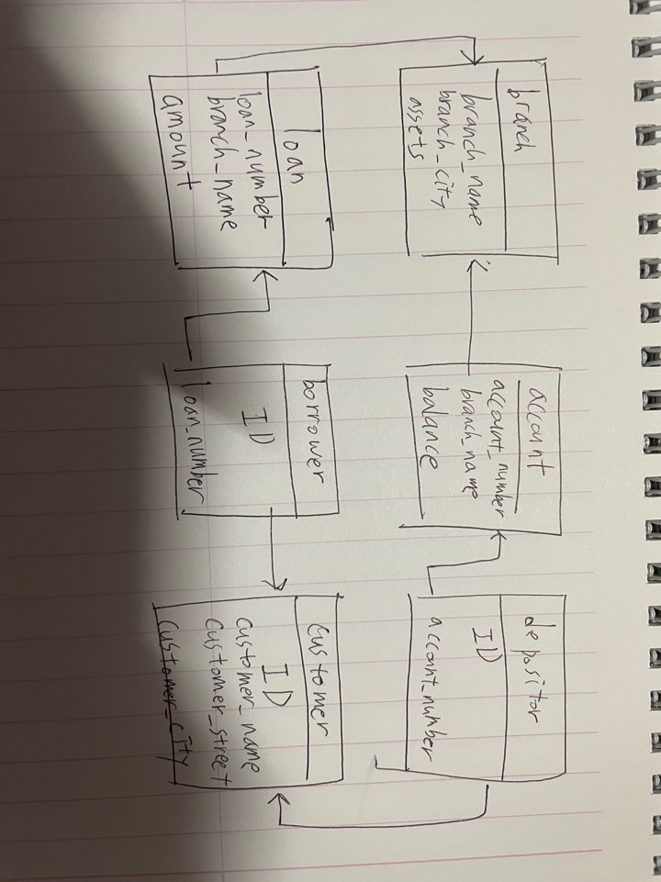

2.15 (30pt)

Consider the bank database of Figure 2.18. Give an expression in the relational algebra for each of the following queries:

1. Find each loan number with a loan amount greater than $10000.

∏(loanNumber)(δ(amount>10000)(loan))

1. Find the ID of each depositor who has an account with a balance greater than $6000.

∏(depositor.ID)(**δ**(depositor.account\_number = account.account\_number and account.balance>6000))

c. Find the ID of each depositor who has an account with a balance greater than $6000 at the “Uptown” branch.

∏(depositor.ID)(δ(depositor.account\_number = account.account\_number and account.balance>6000 and account.branch\_name = “Uptown”)(depositor⋈account))

2.18 (50pt)

Write the following queries in relational algebra, using the university schema.

1. Find the ID and name of each instructor in the Physics department.

∏ID, name(σ dept\_name = “Physics”(instructor))

1. Find the ID and name of each instructor in a department located in the building “Watson”.

∏ID, name(σbuilding=”Watson”( instructor ⋈ department))

c. Find the ID and name of each student who has taken at least one course in the “Comp. Sci.”

department.

∏ID, name( student ⋈ takes ⋈ ∏ course\_ID(σdept\_name = “Comp. Sci.”(department )))

d.Find the ID and name of each student who has taken at least one course section in the year 2018.

∏ID, name(student ⋈ takes ⋈ ∏ course\_ID(σyear=2018(section)))

e.Find the ID and name of each student who has not taken any course section in the year 2018.

∏ID, name(student) - ∏ID, name(student⋈ takes⋈ ∏course\_ID(σ year=2018 (section)))

6.10
Write the following queries in relational algebra, using the university
schema.
a. Find the names of all students who ha

ay Find names of all students who have taken
at least one comp. Sci.course.
The query is :
TT
( Student A Takes
TT
course_id

9 for each de part ment, find the maximum salary
of instructors in that department. You may
assume that every department has