Homework #1 (100 points)

Survey 1 - ( 40 points – each 20 points)

# Survey HTTP methods (POST/GET/PUT/DELETE) by including their concepts and usages

POST : web page often includes form input. If post is being used, then input is uploaded to server in entity body. For example, You put Birthday / name / your phone number / your email address for signing up.

PUT : you can upload file in entity body to path specified in URL field with put method. For example, client can provide a file for the server

DELETE : you can delete file specified in the URL field with DELETE method. For example, client can delete certain file in the server.

GET : you ask request for an object or a file to the server. For example, you can use get method if you want a specified object.

1. Survey HTTP response codes by including their concepts and usages

Information responses

* 100 continue : This response means that the server received the initial part of the request and the client should continue with the request or just ignore the response when the request is finished.
* 101 switching protocols :
* 102 processing : This response means that the request has been accepted already but the server didn’t finish it yet so no response is being made yet.
* 103 Early hints : This response is used to allow the user agent to load objects first when the server is making a response.

Successful responses

* 200 OK : request succeeded and requested object later in this msg.

This OK response code is a response status code that you get what you requested successfully

* 201 Created : This response literally means the request was successfully made and created one or multiple new resources.
* 202 Accepted : This response means the request got accepted for processing. But the processing isn’t finished yet.
* 203 Non-authoritative information : This means the request was successfully made but the meta-information that has been received is different from what we have on the origin server.
* 204 no content : This response means the server successfully made the request but there is not appropriate contents for the request.
* 205 reset content : This response means that the user should reset the contents that sent this request.
* 206 partial content : This response is being sent by the client when requesting only a part of the resource happens.

Redirection messages

* 301 Moved Permanently : requested object moved, new location specified later in this msg.

This 301 response is a response status code that what you requested is moved so they show you the new location sometimes.

* 302 found : This request happens when the URI of the request was changed temporarily.
* 304 not modified : This response happens when letting the client know that the response wasn’t modified yet which means the client can use the present or cached response.
* 305 user proxy : This response makes the client connect to a proxy and repeat the same request in there.

Client error responses

* 400 : Bad Request : request msg not understood by server.

This 400 response is a response status code that happens when client sends wrong message or client’s messages is broken so that server can’t understand.

* 404 : Not found : request document not found on this server.

This 404 response is a response status code that happens when what you requested is not found in the server and also can’t find the new location.

* 405 method not allowed : This response means that the method can’t be used even though the server knows the request method.
* 414 URI Too long : This response happens when the server refuses to service the request because the request-target is longer than what the server want to understand.
* 415 unsupported media type : This response happens when the server rejected the request because the media format of the requested data is not being supported.
* 423 locked : This response happens when the resource that has to be accessed is locked. So it can’t be accessed.

Server error responses

* 502 bad gateway : The server got an invalid response when it’s working as a gateway to deal with the response.
* 503 service unavailable : This response means the server can’t handle the request because it’s not ready yet. This usually happen when the server is down for maintenance or is overloaded.
* 505 : HTTP Version not supported : This 505 response is a response that happens when HTTP version is not correct.
* 507 insufficient storage : This response happens when request can’t be completed because the server can’t store the representation that is needed to successfully conduct the request.
* 508 loop detected : This response happens when the server found an infinite loop when it’s processing the request.

Problem 1 - (20 points)

# Suppose users share a 2 Mbps link. Also suppose each user transmits continuously at 1Mbps when transmitting, but each user transmits only 20 percent of time.

* 1. When circuit switching is used, how many users can be supported? (5 points)

2 simultaneous users can be supported since half of the link bandwidth is used by one user.

* 1. Find the probability that a given user is transmitting (5 points)

0.2

* 1. Suppose now there are three users. Find the probability that at any given time, all t here users are transmitting simultaneously. Find the fraction of time during which the queue grows. (10 points)

Probability that at any given time, all three users are transmitting simultaneously when there are 3 users is 0.008.

The fraction of time during which the queue grows is 0.008

Problem 2 - Read Chapter 2.2.3 (page 131-136) in textbook & solve the problem ( 25 points – each 5 points)

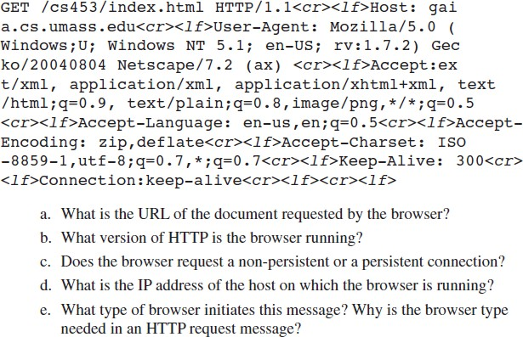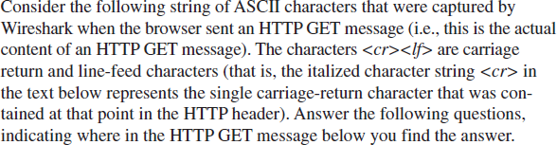

1. <http://gaia.cs.umass.edu/cs453/index.html>
2. HTTP version 1.1
3. Persistent connection
4. The IP address of the host on which the browser is running is not contained in the HTTP message.
5. Mozilla/5.0

Problem 3 - Read Chapter 2.2.3 (page 131-136) in textbook & solve the problem ( 15 points – each 5 points)



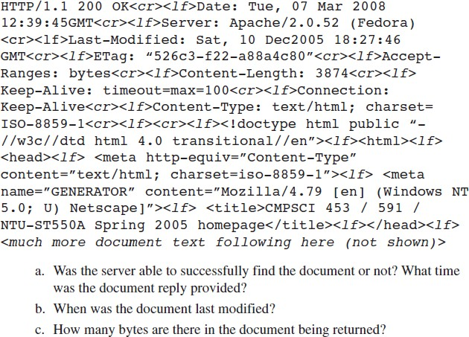

1. The server found the document successfully. The document reply provided at Tuesday March 7th 2008 12:39:45 GMT.
2. The document was last modified on Saturday, December 10th 2005 18:27:46 GMT.
3. 3874 bytes are there in the document being returned.