Document No.
MIM-TR-EPS-002
Document Author
Name
Responsible Engineer
Name
Date
2019.12.12

EPS Specifications
Description of MIMAN EPS General Specifications

Revision History
Date | Version | Author | Description
2019.12.12 | 1.0 | 전승권 | 초안 작성
2022.03.07 | - | 전승권 | 내용 수정
2022.03.08 | 2.0 | 유성엽 | 그림 추가

List of Abbreviations and Acronyms
Contents | Description
SOC | State of Charge
DOD | Depth of Discharge
PCM | Power Conditioning Module
PDM | Power Distribution Module
PCDU | Power Conditioning and Distribution Unit
MPPT | Maximum Power Point Tracker
BCR | Battery Charge Regulator
SEPIC | Single Ended Primary Inductor Converter
LTAN | Local Time Ascending Node

- Contents
1 MIMAN EPS H/W Configuration 5
1.1 Solar Cell 5
1.1.1 H/W Electrical Specification 5
1.2 PCDU 6
1.2.1 H/W Features 6
1.2.1.1 PCM 6
1.2.1.2 PDM 7
1.2.1.3 BCR 7
1.3 Battery 7
1.3.1 H/W Electrical Specification 7
1.4 MIMAN EPS Interface 7
2 MIMAN Power consumption 7
2.1 MIMAN H/W Power consumption 7
2.2 H/W Voltage BUS 7
2.3 PCM & PDM Load 7
3 MIMAN EPS Power generation 8
3.1 Solar panel configuration 8
3.1.1 Solar panel Electrical Specification 8
4 Reference 8
5 Appendix 8

MIMAN EPS H/W Configuration
MIMAN EPS는 Solar Cell, PCDU 그리고 배터리로 구성된다.

Solar Cell
MIMAN EPS에서는 AZURE SPACE사의 “TJ Solar Cell 3G30C - Advanced”를 사용한다.
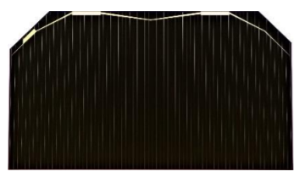
그림 1. TJ Solar Cell 3G30C - Advanced

H/W Electrical specification
[Electrical Data] | BOL | 2,5E14 | 5E14 |  | 1E15
Average Open Circuit V_{oc} [mV] | 2700 | 2616 | 2564 |  | 2522
Average Short Circuit I_{sc} [mA] | 457.0 | 455.5 | 451.6 |  | 440.9
Voltage at max. Power V_{mp} [mV] | 2411 | 2345 | 2290 |  | 2246
Current at max. Power I_{mp} [mA] | 442.8 | 442.1 | 439.8 |  | 427.5
Average Efficiency ŋ_{bare}  (1367 W/m²) [%] | 29.5 | 28.6 | 27.8 |  | 26.5
Average Efficiency ŋ_{bare}  (1353 W/m²) [%] | 29.8 | 28.9 | 28.1 |  | 26.8
 |  |  | @fluence 1MeV [e/cm²]
표 1. 전기적 특성 - 3G30C – Advanced

[Acceptance Values]
Voltage V_{op} [mV] |  |  |  | 2350
Min. average current I_{op} avg @ V_{op} [mA] |  |  |  | 444
Min. individual current I_{op} min @ V_{op} [mA] |  |  |  | 417
표 2. 허용 수치 - 3G30C – Advanced

PCDU
MIMAN EPS에서는 ISIS 사의 “Compact EPS version 2 - CEPSv2”를 사용한다
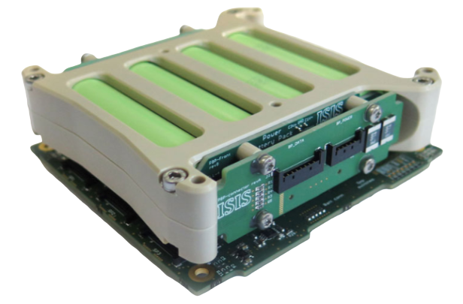
그림 2. ISIS CEPSv2

H/W Characteristics
- Maximum power point tracking (MPPT) 기능
- H/W 과전압, 과전류 방지 기능 탑재
- 방사선 내구성 향상을 위한 FRAM 기반 MCU
- I²C 통신 사용
- 추가 보드 장착을 통한 전기적 연결 확장 가능
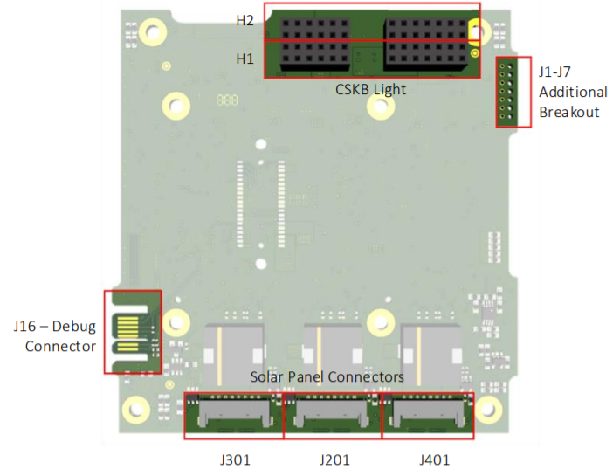
그림 3. ISIS CEPS PCDU Top Connector Pinout

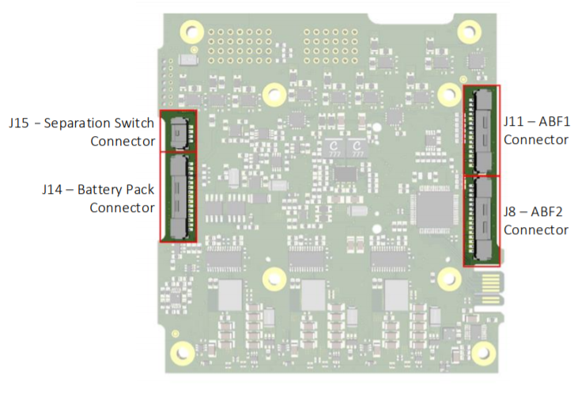
그림 4. ISIS CEPS PCDU Bottom Connector Pinout

PCM
- 총 4개의 전압 영역을 제공한다: 3.3 V @ 4 A, 5 V @ 4 A, 12 V(user selectable) @ 4A, Vbat (12.8 – 16 V) @ 4A (VD0: Vbat/ VD1: 3.3 V/ VD2: 5 V/ VD3: 기본 5 V(최대 12 V 조정 가능)/ VD4: 기본 3.3 V(최대 12 V 조정 가능)
- Mother Board – VD0 & VD1 & VD2, Daughter Board – VD0 & VD3 & VD4
- BCR
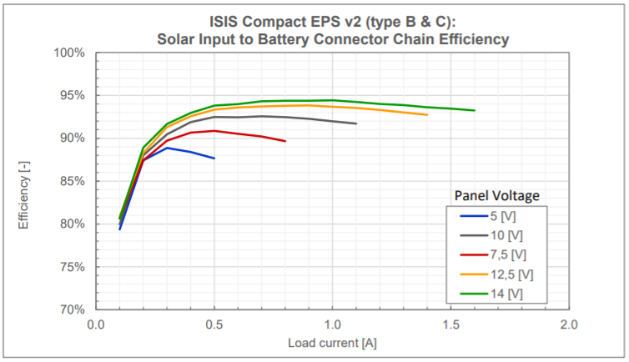
그림 5. Chain efficiency – 태양 전지판-배터리 Chain Efficiency – type B & C

PDM
- 개별 출력 제어 스위치 제공_모든 출력 채널에 대해 제어 스위치를 제공
(총 16의 출력 채널과 그에 따른 제어 스위치 제공)

H/W Electrical specification
Electrical Characteristics
Static (Idle) consumption IU mainboard |  |  |  |  | 90 | mW
Power output IU mainboard (type A, B and C) | VD0 | Number of output channels | Type A and B |  | 1 | -
 |  |  | Type C |  | 1+2
 |  | Output voltage | Type A and B |  | 6.5 – 8.0 | V
 |  |  | Type C |  | 12.8 – 16.0
 | VD1 | Number of output channels |  |  | 4 | -
 |  | Output voltage |  |  | 5 | V
 |  | Output max. current per channel |  |  | 2 | A
 |  | Output max. current total |  |  | 4 | A
 | VD2 | Number of output channels |  |  | 4 | -
 |  | Output voltage |  |  | 3.3 | V
 |  | Output max. current per channel |  |  | 2 | A
 |  | Output max. current total |  |  | 4 | A
Power output  Daughterboard  (type C only) | VD3 | Number of output channels |  |  | 4 | -
 |  | Output voltage |  |  | Custom  (12 V max)  Default: 5V | V
 |  | Output max. current per channel |  |  | 2 | A
 |  | Output max. current total |  |  | 4 | A
 | VD4 | Number of output channels |  |  | 1 | -
 |  | Output voltage |  |  | Custom  (12 V max)  Default: 3.3 V | V
 |  | Output max. current per channel |  |  | 2 | A
 |  | Output max. current total |  |  | 2 | A
Solar panel input | Number of MPPTs inputs |  |  | Type A and B | 3 | -
 |  |  |  | Type C | 3+2
 | Maximum input voltage |  |  | Type A and B | 8.0 | V
 |  |  |  | Type C | 16.
 | Minimum input voltage to start MPPT |  |  |  | 3.5 | V
 | Minimum input voltage if another channel’s voltage is sufficient to start MPPTs |  |  |  | 2.0 | V
 | Maximum input current per channel |  |  |  | 2 | A
표 4. Electrical Characteristics: iEPS Electrical Power System – CEPS

H/W Block Diagram
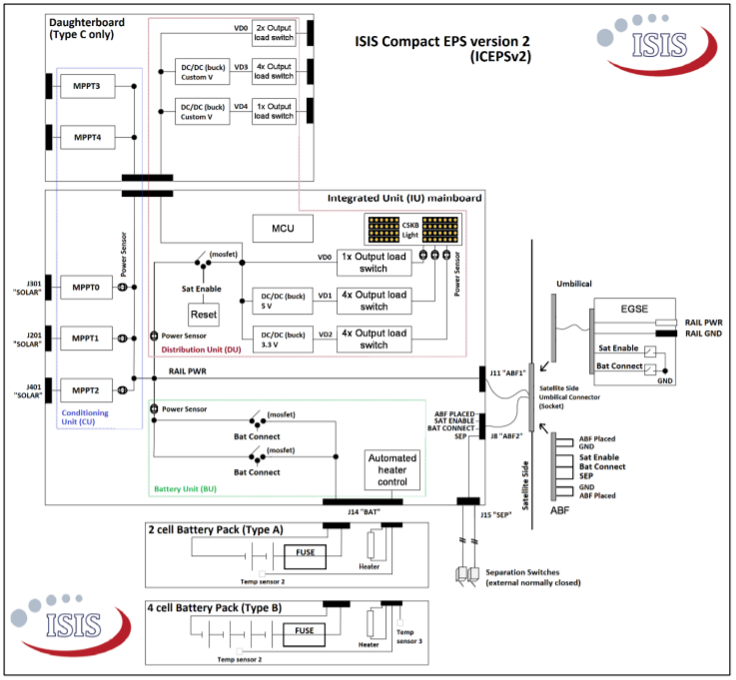
그림 6. Block Diagram: CEPS – ISIS

Battery
MIMAN EPS는 ISIS에서 제조된 배터리(CEPS에서 배터리)를 사용한다.
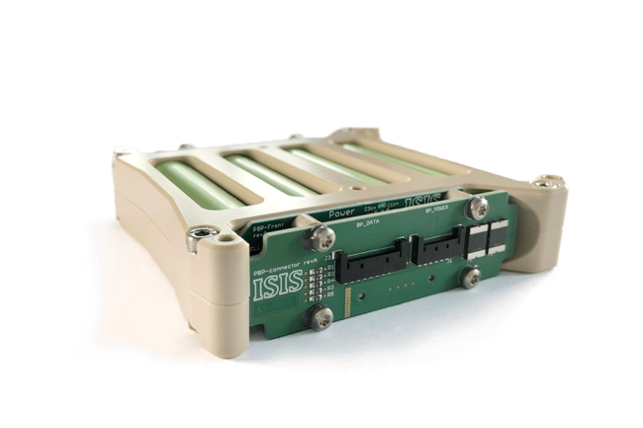
그림 9. 4-Cell Battery Pack (ISIS)

H/W Feature
- 4 직렬 배터리 팩
- 45Wh 용량 (각 베터리 셀 용량: 3.2Ah)
- 히터 제공

H/W Electrical Specification
Configurations | Number of cells | 3200 mAh cell (Nominal)
4S | 4 | 45 Wh  12.8 - 16 V  3.2 Ah
표 5. CEPS 배터리 구성

Battery | Cell | Min., Nom., Max. Voltage (absolute maximum) |  | 2.5, 3.6, 4.2 | V
 |  | Nominal Capacity |  | 3.2 | Ah
 | Pack | Configuration | Type A | 2 in series | -
 |  |  | Type B and C | 4 in series
 |  | Operating Voltage  (hardware limits) | Type A | 5.5 – 8.0 | V
 |  |  | Type B and C | 10.9 – 16.0
 |  | Operating Voltage  (software limits) | Type A | 6.5 – 8.0 | V
 |  |  | Type B and C | 12.8 – 16.0
 |  | Max Input Current |  | 1.5 | A
 |  | Max Output Current |  | 4 | A
 |  | Maximum heater power | Type A | 1.2 | W
 |  |  | Type B and C | 2.5
표 6. ISIS – CEPS 4-cell Battery pack

MIMAN EPS Interface
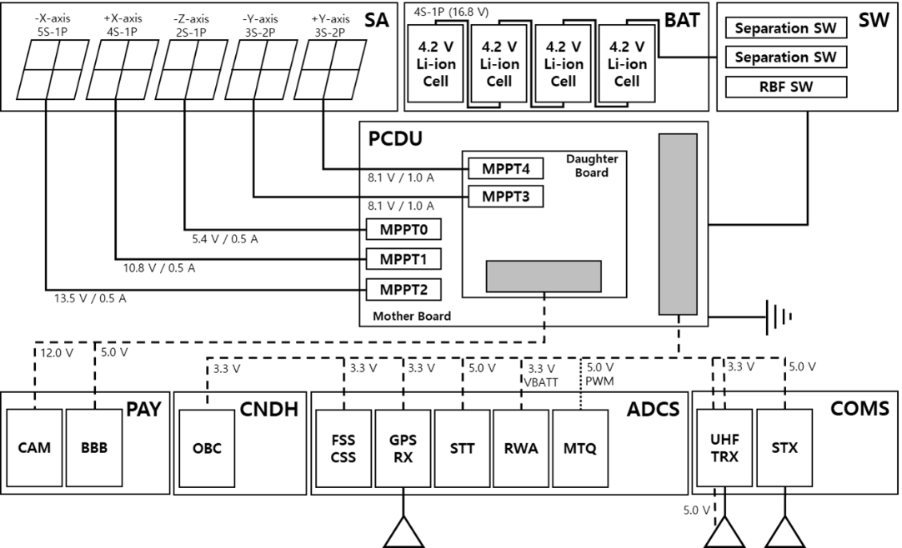
그림 10. MIMAN EPS Electrical Interface

MIMAN Power consumption

MIMAN H/W Power consumption
각 서브시스템 하드웨어 별 소비 전력
Subsystem | Component | Operation  Description | Operation Power(W)
PAYLOAD | Multi spectral imager | Imaging | 5.1
GNC | GPS RX | L1 Typ. | 0.9
 | GPS Ant. | 15 mA Max.  (10 mA Typ.) | 0.0495
ADCS | ADCS Board / IFB | + MMT, IMU | 0.806
 | Fine Sun sensor | Max. | 0.0759
 | Coarse Sun Sensor | - | 0.75
 | Analog to Digital Conv. | - | 0.002475
 | MTQ X 3EA | 0.13~0.24 Am2 | 1.5
 | Reaction Wheel Assembly (RWA) X 3EA | Max. 6000 rpm  (16V + 3.3V) | 7.125
 |  | 2000 rpm  (16V + 3.3V) | 0.615
 |  | zero rpm  (3.3V) | 0.15
 | Star Tracker | Nominal. | 1
TT&C | UHF TRX | RX | 0.396
 |  | TX | 2.805
 | UHF Ant. | Idle (I2C) | 0.01
 |  | Deployment | 5.6
 | S-band TX. | TX active (max) | 5
 |  | Off | 0.61
Deployment | Solar Array | Solar panel | 2
CNDH | OBC/IFB | Gigabit Ethernet  [OBC] | 1
 |  | Max. | 0.8
EPS | PCDU | 3V3 / 5V / 12V / Vbat BUS (Idle) | 0.09
 | Battery | I2C | 0
 |  | Heater | 2.5

표 7. MIMAN H/W Power consumption

H/W Voltage BUS
Subsystem | Component | Product | Operation Voltage(V)
PAYLOAD | Multi spectral imager | B3420 | 12
GNC | GPS RX | OEM719 | 3.3
 | GPS Ant. | TW1421 | 3.3
ADCS | ADCS Board / IFB | STM32H753xI | 3.3
 | Fine Sun sensor | nanoSSOC-D60 | 3.3
 | Coarse Sun Sensor | SFH 2430 | 3.3
 | Analog to Digital Conv. | AEC-Q100 | 3.3
 | MTQ X 3EA | 2 X Rod S, 1 X Air | 5
 | Reaction Wheel Assembly (RWA) X 3EA | Cubewheel M | 5 & 16
 | Star Tracker | KU Leuven Star Tracker | 5
TT&C | UHF TRX | NanoCom AX100 | 3.3
 | UHF Ant. | UHF ANTENNA III | 5
 | S-band TX. | PULSAR-STX | 5
Deployment | Solar Array | Pogo-pin | 16
CNDH | OBC/IFB | STM32H753xI | 3.3
EPS | PCDU | iEPS Type A
 | Battery | ISIS  12.8Ah(45Wh)
표 8. MIMAN H/W Voltage BUS

PCM Load
Voltage BUS | BUS limit | LEOP (Initialization) | LEOP (ANT Deployment) | LEOP (Detumbling) | Commissioning
12.8~16V Bus[W] | 108 | 0.00 | 0.00 | 0.00 | 8.10
8 V-6 V Bus [W] | 19.56 | 0.69 | 6.91 | 2.36 | 1.80
5 V Bus [W] | 13.16 | 6.43 | 6.43 | 6.43 | 7.98
3.3 V Bus [W] | 11.5 | 0.00 | 0.00 | 0.00 | 5.67
Normal | Normal (SA Deployment) | Communication | Mission | Safe Hold | Detumbling
8.10 | 8.10 | 8.10 | 8.10 | 8.10 | 0.00
2.36 | 2.36 | 2.36 | 3.47 | 2.36 | 2.36
7.98 | 10.21 | 7.98 | 9.09 | 6.93 | 6.43
0.00 | 0.00 | 0.00 | 5.67 | 0.00 | 0.00
표 9. MIMAN PCM Load for each Mode

MIMAN EPS Power generation

Solar panel configuration & Connection
Panel configuration | Panel | Solar Cell Configuration (Series)
Series | Deployable Solar Panel 1(-Y-) | 6
Series | Deployable Solar Panel 2(+Y) | 6
Series | Body mounted Solar Panel (-Z) | 2
Series | Body mounted Solar Panel (+X) | 4
Series | Body mounted Solar Panel (-X) | 5
표 10. Solar panel configuration
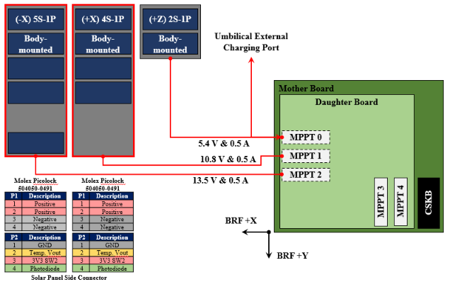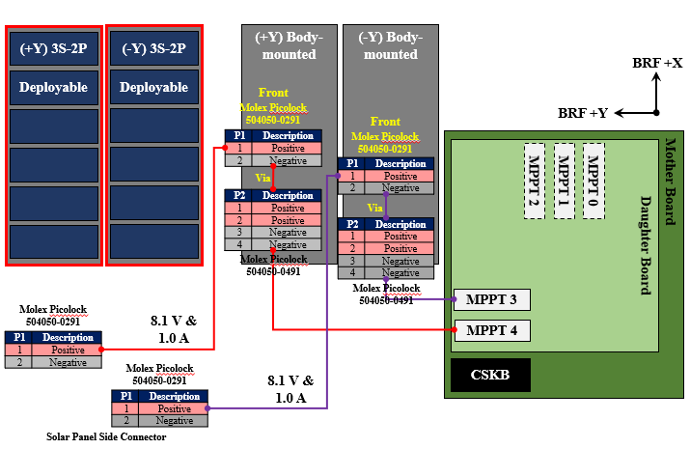
그림 11. MIMAN EPS Solar panel Connection

3.1.1 Solar panel Electrical Specification
Panel | Solar Cell Configuration | Electrical Specification  (max. EOL)
Deployable Solar Panel 1(-Y) | 3S2P | 6.74V @ 0.972A
Deployable Solar Panel 2(+Y) | 3S2P | 6.74V @ 0.972A
Body mounted Solar Panel (-Z) | 2S | 4.49V @ 0.486A
Body mounted Solar Panel (-X) | 5S | 8.98V @ 0.486A
Body mounted Solar Panel (+X) | 4S | 11.23V @ 0.486A
표 11. Solar panel Electrical Specification

Power Generation

3.2.1 Sun-Pointing
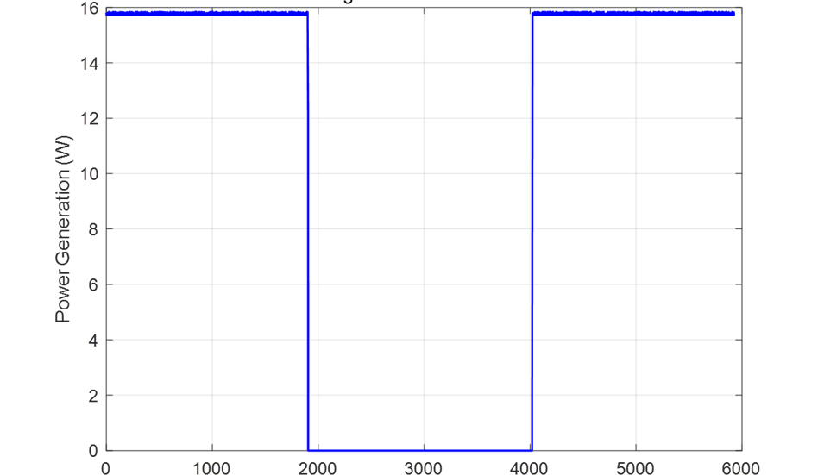
그림 12. Power Generation Sun-pointing
평균 전력: 11.82W
Communication(Day), Charge, Normal 모드에서 적용된다.

3.2.2 Nadir Pointing
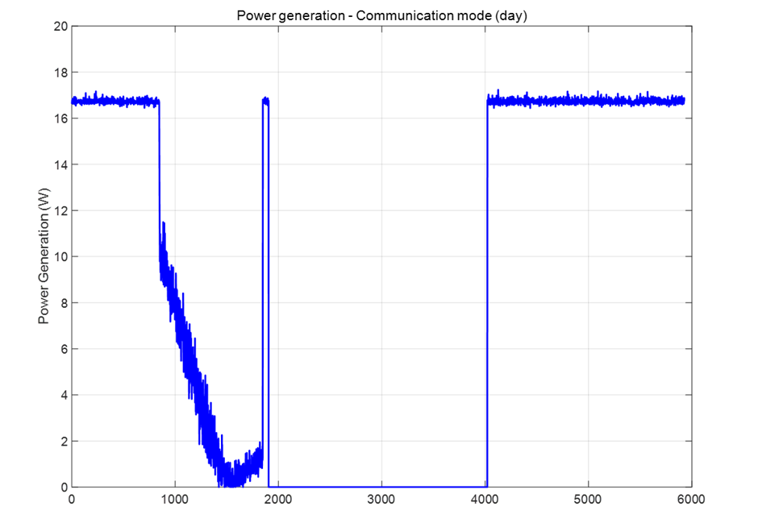
그림 13. Power Generation at Communication mode
평균 생산 전력: 5.5711 W
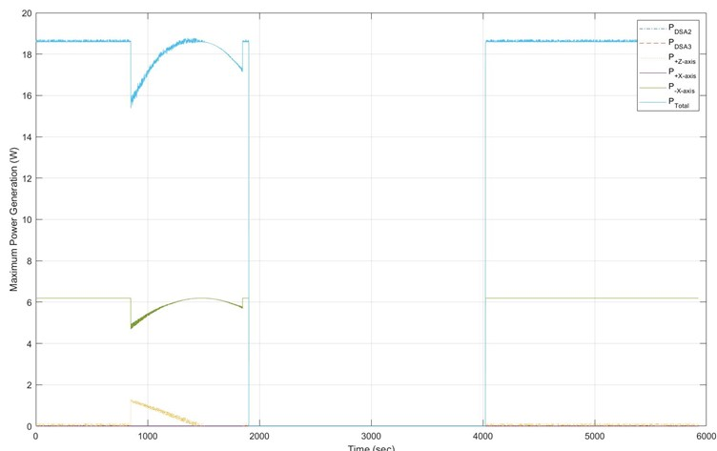
그림 14. Power Generation at Mission mode
평균 생산 전력: - W

Reference
http://www.azurspace.com/images/006050-01-00_DB_3G30C-Advanced.pdf
https://www.cubesatshop.com/wp-content/uploads/2019/06/ISIS-EPS-Brochure-web.pdf
ISIS Compact EPS version 2-Hardware ICD
https://www.batteryspace.com/prod-specs/NCR18650B.pdf

Appendix

