Document No.
MIM-TR-EPS-003
Document Author
Seong-Yeop Yu
Responsible Engineer
Geuk-Nam Kim
Date
2019.12.05

EPS Power Analysis
Electrical power budget & load analysis

Revision History
Date | Version | Author | Description
2019.12.05 | 1.0 | 유성엽 | 초안 작성
2019.06.30 | 1.1 | 유성엽 | 초안 작성
2022.03.09 | 1.2 | 유성엽 | 내용 수정

List of Abbreviations and Acronyms
Contents | Description
EPS | Electrical Power System
SOC | State of Charge
DOD | Depth of Discharge
EoC | End of Charge
PCM | Power Conditioning Module
PDM | Power Distribution Module
PCDU | Power Conditioning and Distribution Unit
MPPT | Maximum Power Point Tracker
BCR | Battery Charge Regulator
SEPIC | Single Ended Primary Inductor Converter
LTAN | Local Time Ascending Node
LAPSS | Laser Pulsed Solar Simulator
Voc | Open Circuit Voltage
Isc | Short Circuit Current
Pmp | Maximum Power
OBC | On Board Computer
COM | Communication
ETB | Electrical Test Bed
Contents
1. Introduction 3
1.1. Electrical Power Budget 4
1.2. Electrical Load analysis 4
2. Methodology 4
2.1. Component’s Specifications 4
2.2. MIMAN subsystem component usage by operating modes 5
2.3. MIMAN power consumption & limit analysis 5
2.3.1. Power Consumption Calculation 5
2.3.2. Limit analysis Calculation 5
3. Result 6
3.1. Power budget table 6
3.2. ELA 6
4. Conclusion 6
5. Reference 6
6. Appendix 6
6.1. MIMAN EPS Component Electrical Power Description 6
6.2. MIMAN System operation 6

Introduction
It is the Electrical Power Budget and Electrical Load analysis about MIMAN EPS.

Electrical Power Budget
MIMAN EPS power budget is consist of electrical component’s operating power, pcm eff, operating voltage, percentage about 1 period of each operating modes.

Electrical Load analysis
Using Power budget’s components, calculate each EPS voltage BUS limit & average power consumption (12.8~16V Unregulated, 5V regulated, 3.3V regulated 12V regulated buses). ELA shows the peak power load of each bus.

Methodology

Component’s Specifications
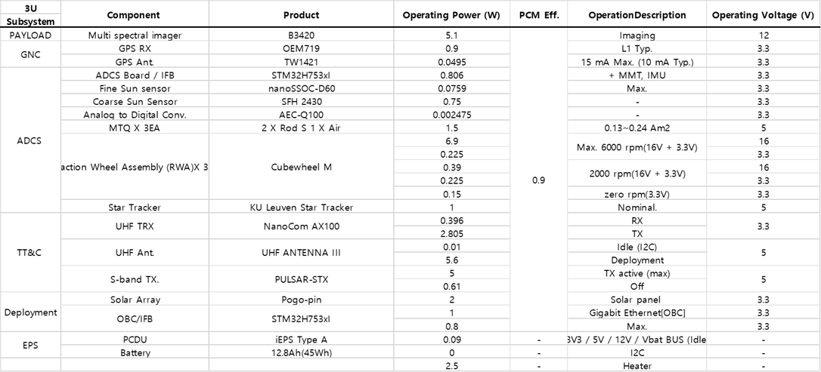
For Electrical Power Budget and Electrical Load analysis, we must know the component’s electrical specification.
Table 1. Specification about Electrical Components
Also, PCM efficiency(~0.9) using in power budget & ELA.
We use average voltage, voltage Input types, operating descriptions to calculate power budget & ELA.

MIMAN subsystem component usage by operating modes
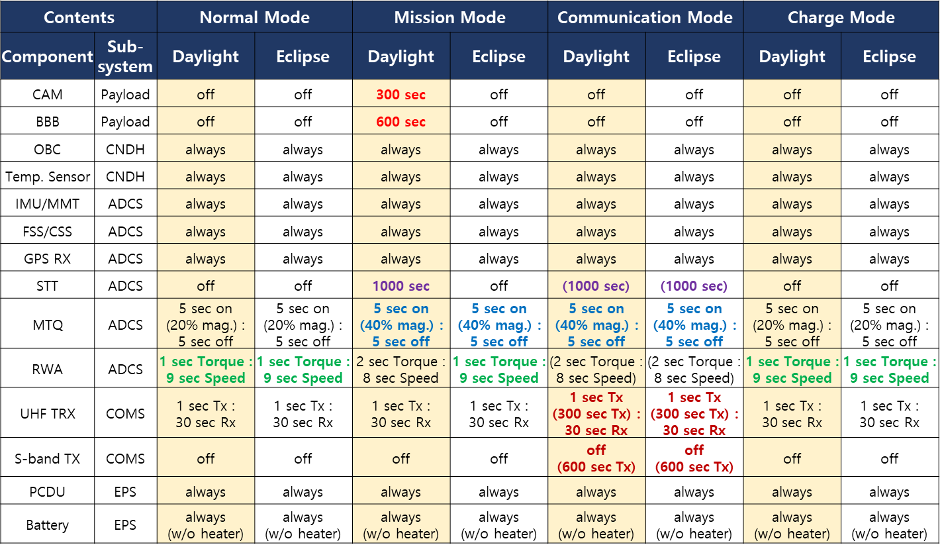
MIMAN has various operating modes and each mode uses different components in operating. To calculate power budget & ELA, we must know component usage of each modes. From scenario description and mission timeline, we can fill in the duty rate about components.
Table 2. Operating time percentage about electrical components of each modes

MIMAN power consumption & limit analysis
From operating time and components specifications, we can calculate the Power consumption & peak power of each buses.

Power Consumption Calculation
Total average Power Sum(W) is summation of [$P_{component}×T_{component}÷{PCM}_{eff}$] except EPS and EPS’s [$P_{component}×T_{component}$].
Total average Power Sum with 20% margin is multiply 1.2 at Total average power sum.
Generated Power avg is from EPS power generation, refer the MIM-TR-EPS-004

Limit analysis Calculation
Each EPS bus limits are defined by EPS PCDU. (3.3V regulated bus : 13.16W, 5V regulated bus : 19.56W, 12V regulated bus : 11.5W , unregulated bus : 108W)
From components usage at each mode, limit analysis is comparing the peak power of each bus and bus limits. Bus’s peak power is summation of components’ operating power which using corresponding bus. Before summation, if component uses pcm, we must divide operating power by pcm efficiency (~0.9).
Peak power is summation of each buses peak power.

Result

Power budget table

3.1.1 Normal Mode
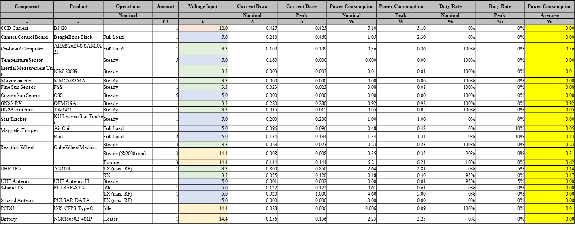

3.1.2 Mission mode
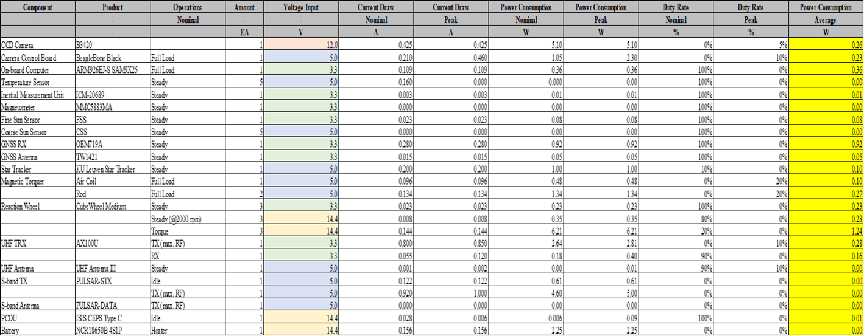

3.1.1 Communication Mode
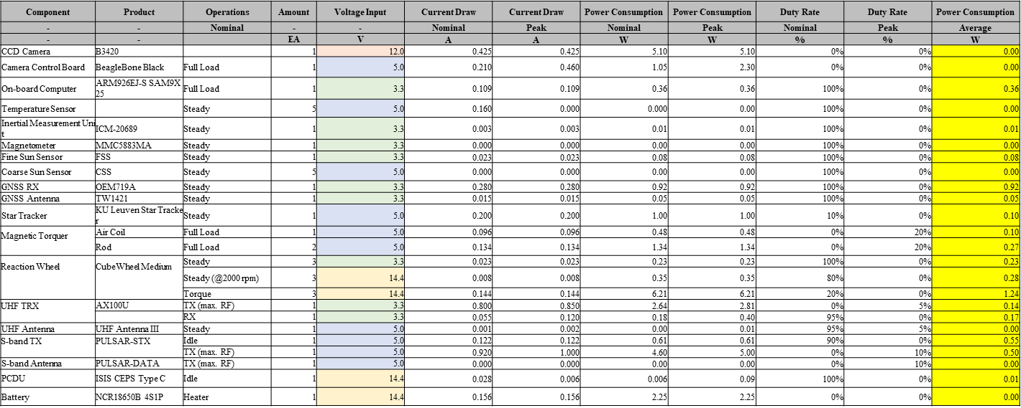

3.1.1 Charge Mode
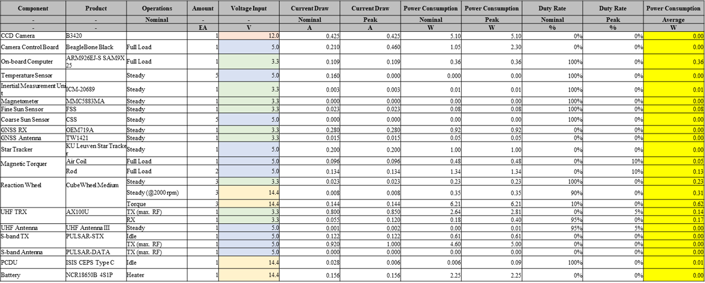

ELA
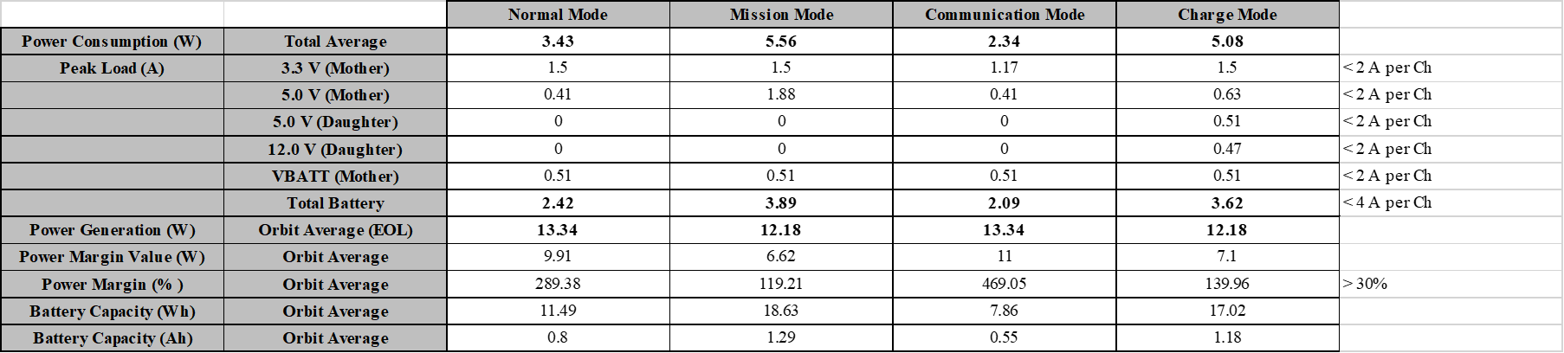Table 4. Bus Limits & peak Load about each mode

Reference

Appendix

