Document No.
MIM-TR-EPS-008
Document Author
Seung-Gwon Jeon
Responsible Engineer
Seung-Gwon Jeon
Date
2019.12.12

EPS Component Test I
MIMAN EPS COTS Components Test and Result: Battery, PCDU

Revision History
Date | Version | Author | Description
2019.12.12 | 1.0 | 전승권 | 초안 작성
2022.03.08 | 1.1 | 전승권 | 내용 수정

List of Abbreviations and Acronyms
Contents | Description
SOC | State of Charge
DOD | Depth of Discharge
PCM | Power Conditioning Module
PDM | Power Distribution Module
PCDU | Power Conditioning and Distribution Unit
MPPT | Maximum Power Point Tracker
BCR | Battery Charge Regulator
EOF | Electro-Osmotic Flow
IU | Integrated Unit
DB | Daughter Board

- Contents

Contents 4
Checkout before Test 5
Checkout after Test 5
Battery Test 6
1. Battery Individual Cell Test 6
2. Battery Pack assembly Test 8
PCDU Test 10
1. IU test 10
2. IU DB test 12
APPENDIX A. 14
APPENDIX B. 16
APPENDIX C. 17

Checkout before Test
- At least two or more people perform test together
- Clean up the surroundings before perform test
- Preparation hard copy of test manual and procedure

Checkout after Test
- Power Off (in order of VCC, DC, GND) -> Visual Check -> Disconnect Data Cable / Electrical Wire
- Arrangement Surroundings: Test Object, equipment, heater, by-products
  - Stop the experiment immediately if it does not work in accordance with the experimental procedures and resume the experiment after discussion with the subsystem / system engineer

* This technical report is about battery and PCDU component test conducted by the manufacturer, ISIS

Battery Test

Battery Individual Cell Test
Test Purpose
- Checking cell capacitance
Test Target
- Battery cell: LIO-10450, LIO-10451, LIO-10452, LIO-10453
Test result

LIO-10450 | LIO-10451
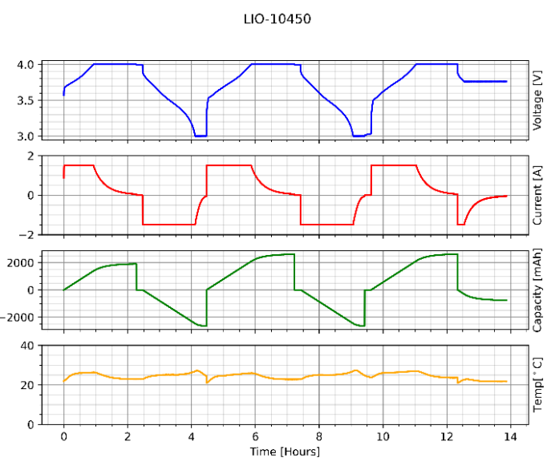 | 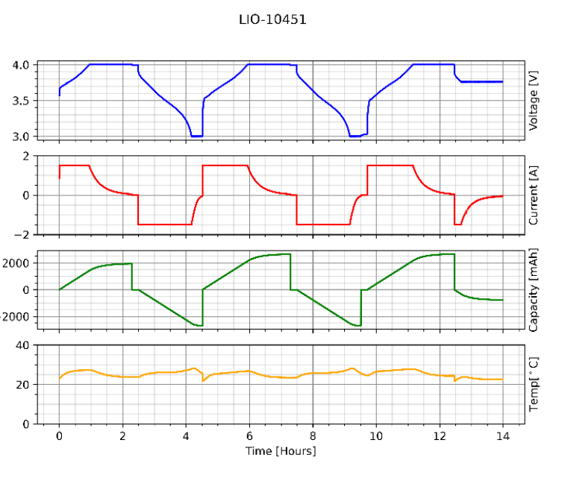
LIO-10452 | LIO-10453
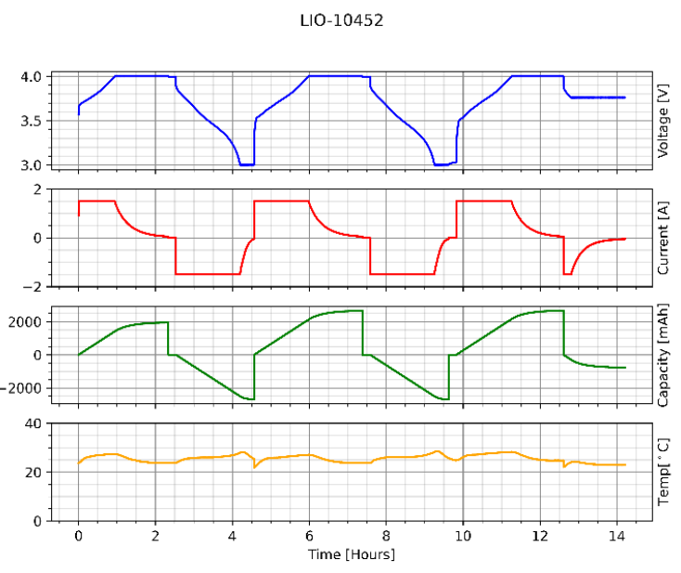 | 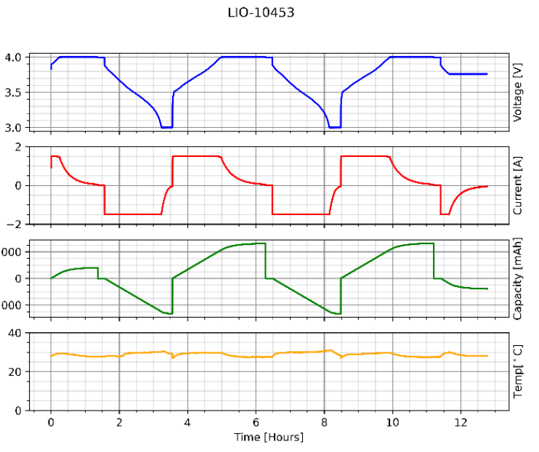
< Charge-discharge cycle test for individual cell >

Description | Expected result | Lio cell number | Result | Unit
Measured cell  capacitance | >2518 mAh | LIO-10450 | 2638 | mAh
 |  | LIO-10451 | 2678 | mAh
 |  | LIO-10452 | 2678 | mAh
 |  | LIO-10453 | 2645 | mAh
< Individual cell capacitance test result >

Battery Pack assembly Test
Test Purpose
- Checking of Battery’s Characteristics in discharge – charge cycle
Test Target
- Power battery pack, Individual cell
Test Result
Description | Expected result |  | Initial Results | Final Results | Unit
Visual inspection-
Mechanical quality: Correct  PCB integrity with no bent  pins, no broken components  or loose wiring, good quality  soldering, no burn marks,  residues and major scratches. | All OK |  | All OK | All OK | -
Battery pack weight | 248±10 g |  | - | 252 | g
Battery pack
Measured cell capacitance | Cycle 1 | >2518 mAh | 2660 | 2652 | mAh
 | Cycle 2 | >2518 mAh | 2654 | 2649 | mAh
 | Cycle 3 | >2518 mAh | 2589 | 2649 | mAh
 | Cycle 4 | >2518 mAh | 2589 | 2649 | mAh
Total pack voltage (EOF charge) 30% SOC | 14.7 ± 0.15V |  | Polarity: OK | 14.63 | V
Resistance of the battery pack heater | 120Ω ± 10Ω |  | 121.5 | 121.5 | Ω
Temperature sensor resistance. | 80kΩ ~ 120kΩ | Temp 1 | 110.6 | 96.8 | kΩ
 |  | Temp 2 | 110.5 | 99.0 | kΩ
Individual cell voltage | Cell 1 | 3.65±0.15V | Polarity: OK | 3.658 | V
 | Cell 2 | 3.65±0.15V | Polarity: OK | 3.659 | V
 | Cell 3 | 3.65±0.15V | Polarity: OK | 3.660 | V
 | Cell 4 | 3.65±0.15V | Polarity: OK | 3.659 | V
< Battery pack assembly test result >

Charge-discharge cycle initial results | Charge-discharge cycle final results
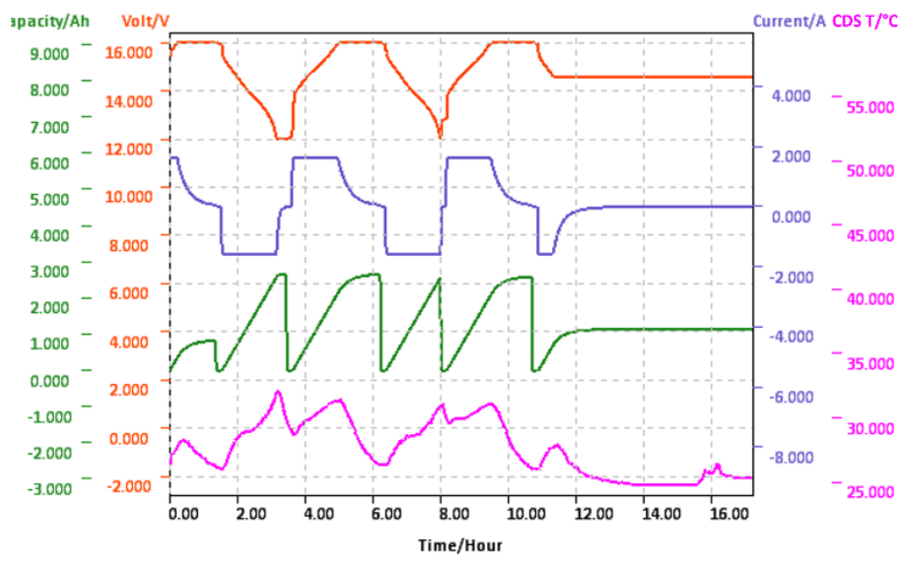 | 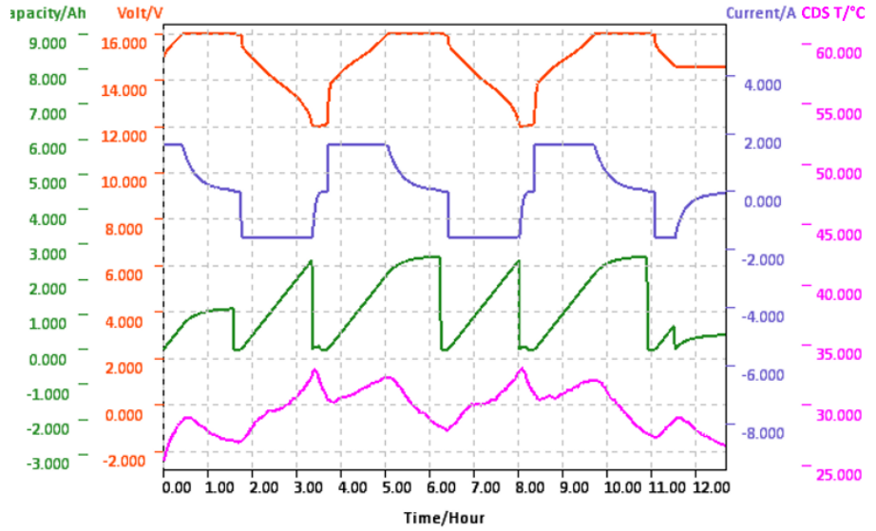
< Charge-discharge cycle test result >

Thermal Cycle
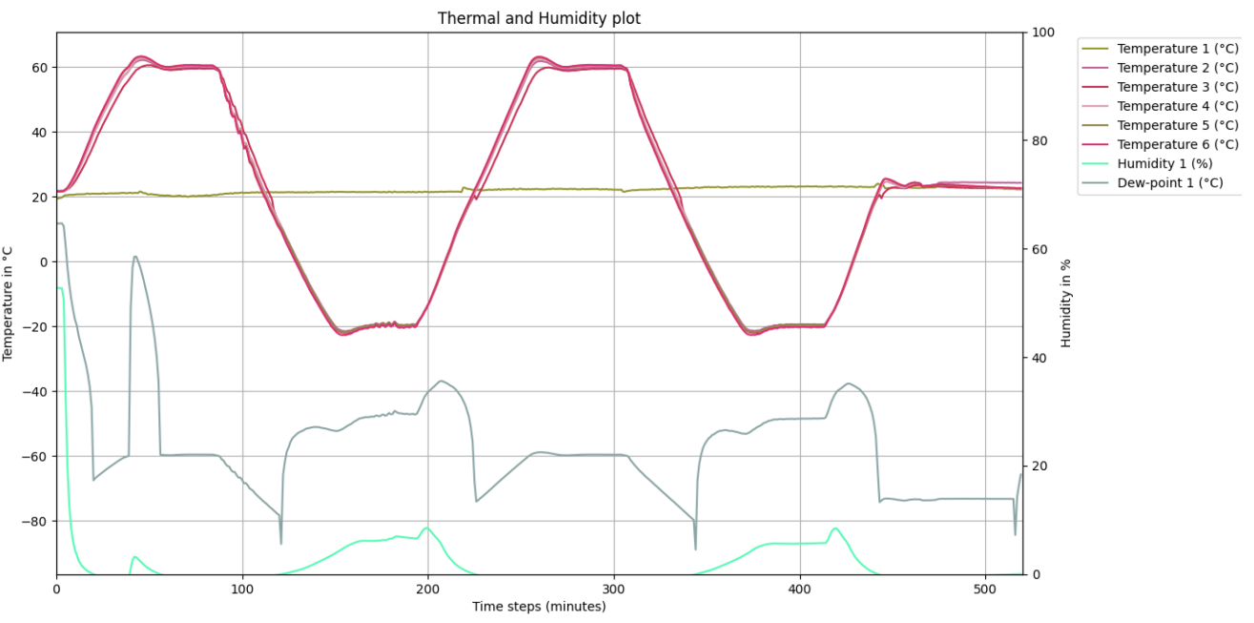
< Thermal cycle test result >

PCDU Test

IU test
Test Purpose
- Checking EPS board’s channel voltage
- Checking EPS board’s functional operation
Test Target
- PCDU(IU)
Test Result
Description | Expected result | Initial Results | Final Results
Visual inspection
Mechanical quality: Correct PCB integrity with no bent pins, no broken components or loose wiring, good quality soldering, no burn marks, residues and major scratches | All OK | All OK | All OK
Initial test
No shorts measured | R > 5kΩ | R > 5kΩ | R > 5kΩ
Function of battery and satellite enable
Battery enable | OK | OK | OK
Satellite enable | OK | OK | OK
Voltage of output channels
OBC00 - VBAT_perm | $U_{BAT_OBC 00 }$= 16.0±0.1 V | 15.983 V | 15.983 V
OBC01 - 5V_perm | $U_{5V_OBC 01 }$= 5.0±0.1 V | 5.023 V | 5.027 V
OBC05 - 3V3_perm | $U_{3V3_OBC 05 }$= 3.3±0.1 V | 3.331 V | 3.33V V
OBC02 - 5V_sw1 | $U_{5V_OBC 02 }$= 5.0±0.1 V | 5.023 V | 5.026 V
OBC03 - 5V_sw2 | $U_{5V_OBC 03 }$= 5.0±0.1 V | 5.032 V | 5.027 V
OBC04 - 5V_sw3 | $U_{5V_OBC 04 }$= 5.0±0.1 V | 5.032 V | 5.026 V
OBC06 - 3V3_sw1 | $U_{3V3_OBC 06 }$= 3.3±0.1 V | 3.332 V | 3.330 V
OBC07 - 3V3_sw2 | $U_{3V3_OBC 07 }$= 3.3±0.1 V | 3.333 V | 3.333 V
OBC08 - 3V3_sw3 | $U_{3V3_OBC 08 }$= 3.3±0.1 V | 3.330 V | 3.332 V
Overcurrent protection output channels
Overcurrent Protection - Channel 0: OBC00 - VBAT_perm | $U_{VBAT_perm }$= 15.3±0.3 V | 15.0 V | 15.0 V
 | $I_{OVERCURRENT }$= 3.0±0.1 A | 3.0 A | 3.0 A
Overcurrent Protection - Channel 1: OBC01 - 5V_perm | $U_{5V_perm}$= 4.7±0.3 V | 4.8 V | 4.8 V
 | $I_{OVERCURRENT }$= 2.9±0.1 A | 2.9 A | 2.9 A
Overcurrent Protection - Channel 5: OBC05 - 3V3_perm | $U_{3V_perm}$= 3.0±0.3 V | 3.1 V | 3.1 V
 | $I_{OVERCURRENT }$= 2.9±0.1 A | 2.9 A | 2.9 A
Overcurrent Protection - Channel 2: OBC01 - 5V_sw1 | $U_{5V_SW1}$= 4.7±0.3 V | 4.7 V | 4.8 V
 | $I_{OVERCURRENT }$= 2.9±0.1 A | 2.9 A | 2.9 A
Overcurrent Protection - Channel 3: OBC02 - 5V_sw2 | $U_{5V_SW2}$= 4.7±0.3 V | 4.7 V | 4.8 V
 | $I_{OVERCURRENT }$= 2.9±0.1 A | 2.9 A | 2.9 A
Overcurrent Protection - Channel 4: OBC03 - 5V_sw3 | $U_{5V_SW3}$= 4.7±0.3 V | 4.7 V | 4.8 V
 | $I_{OVERCURRENT }$= 2.9±0.1 A | 2.9 A | 2.9 A
Overcurrent Protection - Channel 6: OBC06 – 3V3_sw1 | $U_{3V3_SW1}$= 4.7±0.3 V | 3.1 V | 3.1 V
 | $I_{OVERCURRENT }$= 2.9±0.1 A | 2.9 A | 2.9 A
Overcurrent Protection - Channel 7: OBC07 – 3V3_sw2 | $U_{3V3_SW2}$= 4.7±0.3 V | 3.1 V | 3.1 V
 | $I_{OVERCURRENT }$= 2.9±0.1 A | 2.9 A | 2.9 A
Overcurrent Protection - Channel 8: OBC08 – 3V3_sw3 | $U_{3V3_SW3}$= 4.7±0.3 V | 3.1 V | 3.1 V
 | $I_{OVERCURRENT }$= 2.9±0.1 A | 2.9 A | 2.9 A
System overcurrent protection
System Overcurrent Protection | $I_{SYS.OVERCURR }$= 4.0±0.1 A | 4.042 A | 4.057 A
Heater control
Heaters Activation Range | $T_{HEATER.ON }$= 2±1 °C | 2°C | 2°C
 | $T_{HEATER.OFF }$= 6±1 °C | 6°C | 6°C
Current Consumption Heaters | $I_{HEATERS }$= 255±10 Ma | 257 mA | 250 mA
MPPT
MPPT channel 0 | OK | OK | OK
MPPT channel 1 | OK | OK | OK
MPPT channel 2 | OK | OK | OK
Undervoltage Protection
Voltage above undervoltage protection | $U_{SYSTEM}$= 11.7±0.1 V | 11.8 V | 11.8 V
Voltage below undervoltage protection | $U_{SYSTEM}$= 10.3±0.1 V | 10.3 V | 10.3 V
< IU system test result >

IU DB test
Test Purpose
- Checking EPS daughter board’s channel voltage
- Checking EPS daughter board’s functional operation
Test Target
- PCDU(IU-DB)
Test Result
Description | Expected result | Initial Results | Final Results
Visual inspection
Mechanical quality: Correct PCB integrity with no bent pins, no broken components or loose wiring, good quality soldering, no burn marks, residues and major scratches | All OK | All OK | All OK
Initial test
No shorts measured | R > 5kΩ | R > 5kΩ | R > 5kΩ
Function of battery and satellite enable
Battery enable | OK | OK | OK
Satellite enable | OK | OK | OK
Voltage of output channels
VD0_SW[1] | $U_{BAT_OBC 09 }$= 16.0±0.1 V | 16.0 V | 16.0 V
VD0_SW[2] | $U_{16V_OBC 10 }$= 16.0±0.1 V | 16.0 V | 16.0 V
VD0_SW[3] | $U_{16V_OBC 11 }$= 16.0±0.1 V | 16.0 V | 16.0 V
VD3_SW[0] | $U_{5V_OBC 02 }$= 5.0±0.1 V | 5.0 V | 5.0 V
VD3_SW[1] | $U_{5V_OBC 03 }$= 5.0±0.1 V | 5.0 V | 5.0 V
VD4_SW[0] | $U_{5V_OBC 04 }$= 12.0±0.1 V | 12.0 V | 12.0 V
VD4_SW[1] | $U_{3V3_OBC 06 }$= 12.0±0.1 V | 12.0 V | 12.0 V
VD5_SW[0] | $U_{28V2_OBC 16 }$= 28.2±0.1 V | 28.2 V | 28.2 V
Overcurrent protection output channels
Overcurrent Protection - Channel 9: VD0_SW[1] | $U_{VD0_SW[1] }$= 15.3±0.3 V | 15.1 V | 15.1 V
 | $I_{OVERCURRENT }$= 3.15±0.15 A | 3.2 A | 3.2 A
Overcurrent Protection - Channel 10: VD0_SW[2] | $U_{VD0_SW[2]}$= 15.3±0.4 V | 15.1 V | 15.0 V
 | $I_{OVERCURRENT }$= 3.15±0.15 A | 3.2 A | 3.2 A
Overcurrent Protection - Channel 11: VD0_SW[3] | $U_{VD0_SW[3]}$= 15.3±0.4 V | 15.0 V | 15.0 V
 | $I_{OVERCURRENT }$= 3.15±0.15 A | 3.3 A | 3.3 A
Overcurrent Protection - Channel 12: VD3_SW[0] | $U_{VD3_SW[0]}$= 4.7±0.3 V | 4.7 V | 4.9 V
 | $I_{OVERCURRENT }$= 3.15±0.15 A | 3.2 A | 3.2 A
Overcurrent Protection - Channel 13: VD3_SW[1] | $U_{VD3_SW[1]}$= 4.7±0.3 V | 4.7 V | 4.8 V
 | $I_{OVERCURRENT }$= 3.15±0.15 A | 3.2 A | 3.2 A
Overcurrent Protection - Channel 14: VD4_SW[0] | $U_{VD4_SW[0]}$= 12.0±0.3 V | 11.7 V | 12.0 V
 | $I_{OVERCURRENT }$= 3.15±0.15 A | 3.2 A | 3.2 A
Overcurrent Protection - Channel 15: VD4_SW[1] | $U_{VD4_SW[1]}$= 12.0±0.3 V | 11.7 V | 11.9 V
 | $I_{OVERCURRENT }$= 3.15±0.15 A | 3.2 A | 3.2 A
Overcurrent Protection - Channel 16: VD5_SW[0] | $U_{VD5_SW[0]}$= 28.0±0.3 V | 28.1 V | 28.3 V
 | $I_{OVERCURRENT }$= 1.5±0.1 A | 1.5 A | 1.5 A
MPPT
MPPT channel 3 | OK | OK | OK
MPPT channel 4 | OK | OK | OK
< IU-DB system test result >

APPENDIX A.
- [PCDU (IU) & Battery Pack Connection]
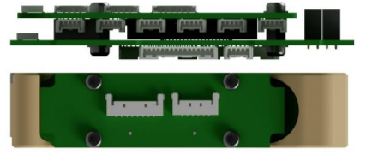
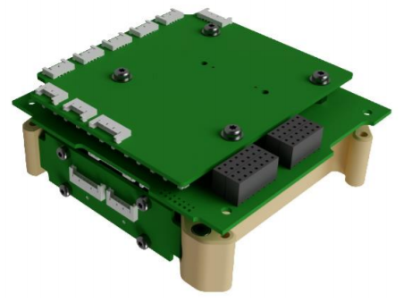

< Type C (Motherboard + Daughterboard)+ Battery Pack(4 cell) >

- [PCDU (IU) & Battery Pack Flight model]
Battery pack top view | Battery pack bottom view
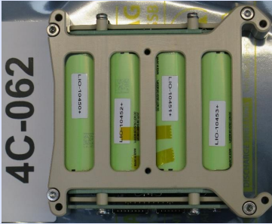 | 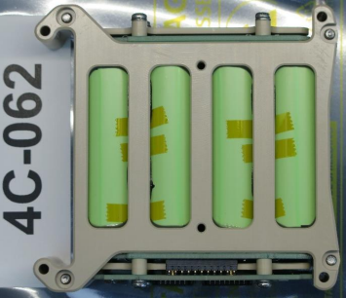
Battery pack front view | Battery pack back view
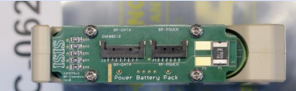 | 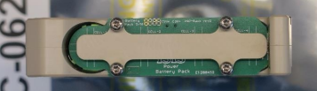
< Battery Pack(4 cell) Flight Model >

PCDU Top View | PCDU Bottom View
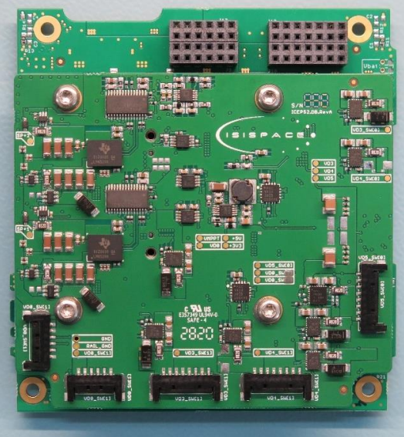 | 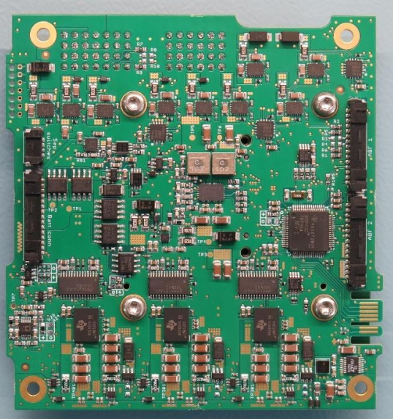

APPENDIX B.
- [ISIS Compact EPS block diagram]

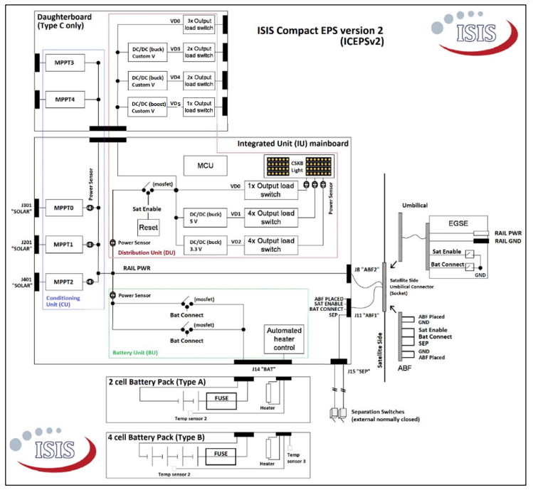< ISIS Compact EPS version 2 block diagram >

APPENDIX C.
- [Test result graph]

< Charge-discharge cycle initial results >

< Charge-discharge cycle final results >


< Charge-discharge cycle test for individual cell ; LIO-10450>

< Charge-discharge cycle test for individual cell; LIO-10451>

< Charge-discharge cycle test for individual cell; LIO-10452>

< Charge-discharge cycle test for individual cell; LIO-10453>

