Astrodynamics I: Final Exam
June 4, 2018 11:05AM-12:45PM (100 minutes)
Closed Books/Notes
Use the following constants and formulae without proof if necessary:
- Radius of Earth R_{E}  6.37810³km  2.09 10⁷ ft
- Gravity Parameter of Earth _{E}  3.98610⁵km³ / sec²  1.407 10¹⁶ ft³ / sec²  e  1 v2  r r (r v)v      , e  1 2EEh2 2

- (10) Integral of Motion

Show that the specific energy is constant for a given orbit of the 2-body problem.

- (30) Kepler’s Equation
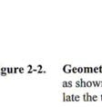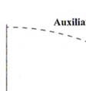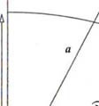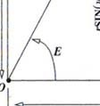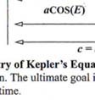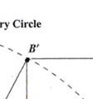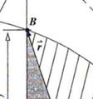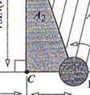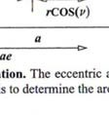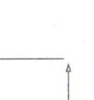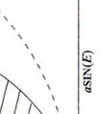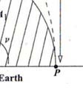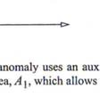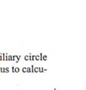
  - (20) Using the notations in Figure 2-2 and Kepler’s Second and Third Laws, derive geometrically Kepler’s equation in basic form:
a³ t T

❍ E  esin E
Hint: You may use the following relations without proof.
BC B C ' 1 e²
 PCB PCB ' 1 e²

  - (10) Introduce the notion of mean anomaly M  E esinE and mean motion n / a³ to rewrite Kepler’s equation in general form which accounts for (1) multiple revolutions and (2) the initial time NOT necessarily located at periapsis.

- (20) Consider a local-vertical-local-horizontal xyz-frame attached to a circular reference orbit whose constant orbital frequency is given by ω . Let the position of deputy spacecraft with respect to the circular reference orbit (or the chief spacecraft in the figure) be given by       r   R r (R  x i)  yj  zk

Earth
(
Cross
−
❒
R
Chief
❒
k
(
)
T
rack
❒
i
❒
j

❒
r
)
(
Radial
A
long
Trac
−

Deput
)
k

  - (5) Determine the velocity and acceleration vector of the deputy spacecraft in terms of
, , -component.
  - (5) Use the two-body equations of motion
r 3 r
r
to derive the equations of motion in terms of , , -component. Here is the gravitational
parameter of the Earth and 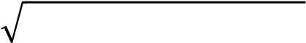 is the distance of the deputy spacecraft from the Earth center.
  - (10) Scale (Non-dimensionalize or Normalize) the equations of motion in (b) by using the canonical units, i.e., by using the reference length R and the reference time 1/ .

- (15) Coordinate Transformations
  - (3) Write down the rotation (coordinate transformation) matrix R_{x}(),R_{y}() and R_{z}( ) about x, y and z-axis, respectively, for an arbitrary angle .
  - (12) Determine the following coordinate transformation matrices in terms of R_{x}( ) ,R_{y}( ) and R_{z}( ) . It is NOT necessary to expand the products of matrices.
i. (4) From Geocentric Equatorial Coordinate System (IJK) to Topocentric Horizontal
Coordinate System (SEZ) ii. (4) From Perifocal Coordinate System (PQW) to Geocentric Equatorial Coordinate
System (IJK) iii. (4) From Geocentric Equatorial Coordinate System (IJK) to Satellite Coordinate System (NTW)

- (15) State the definition of the following terminologies succinctly and precisely:
  - (5) Geocentric Latitude, Geodetic Latitude & Astronomical Latitude
  - (5) Equation of Time & Equation of Equinoxes
  - (5) Julian Date

