(1)
[PART II. ATTITUDE]
<Rigid Body>
◎ Rigid Body $O⊂R^{3}$
$For ∀ p, q ∈O$
$$\left|\left|p\left(t\right)-q\left(t\right)\right|\right|=\left|\left|p\left(0\right)-q\left(0\right)\right|\right| for ∀ t≥0$$

◎ Rigid Motion is a continuous motion such that
$$\left|\left|p\left(t\right)-q\left(t\right)\right|\right|=\left|\left|p\left(0\right)-q\left(0\right)\right|\right| for ∀ t≥0$$

◎ A mapping $g: R^{3}→ R^{3}$ is a Rigid Body Transformation if
i) Length is preserved
$$\left|\left|p-q\right|\right|=\left|\left|g\left(p\right)-g\left(q\right)\right|\right| for ∀ p, q∈R^{3}$$
ii) Cross products are preserved
$$p ×q=g\left(p\right)×g\left(q\right) for ∀ p, q∈R^{3}$$
i) Inner products are preserved
$$p^{T}q=g^{T}(p)g(q) for ∀ p, q∈R^{3}$$

Ref) Arnold, v. I.: Mathematical Methods of Classical Mechanics

(2)
<Attitude Representations>

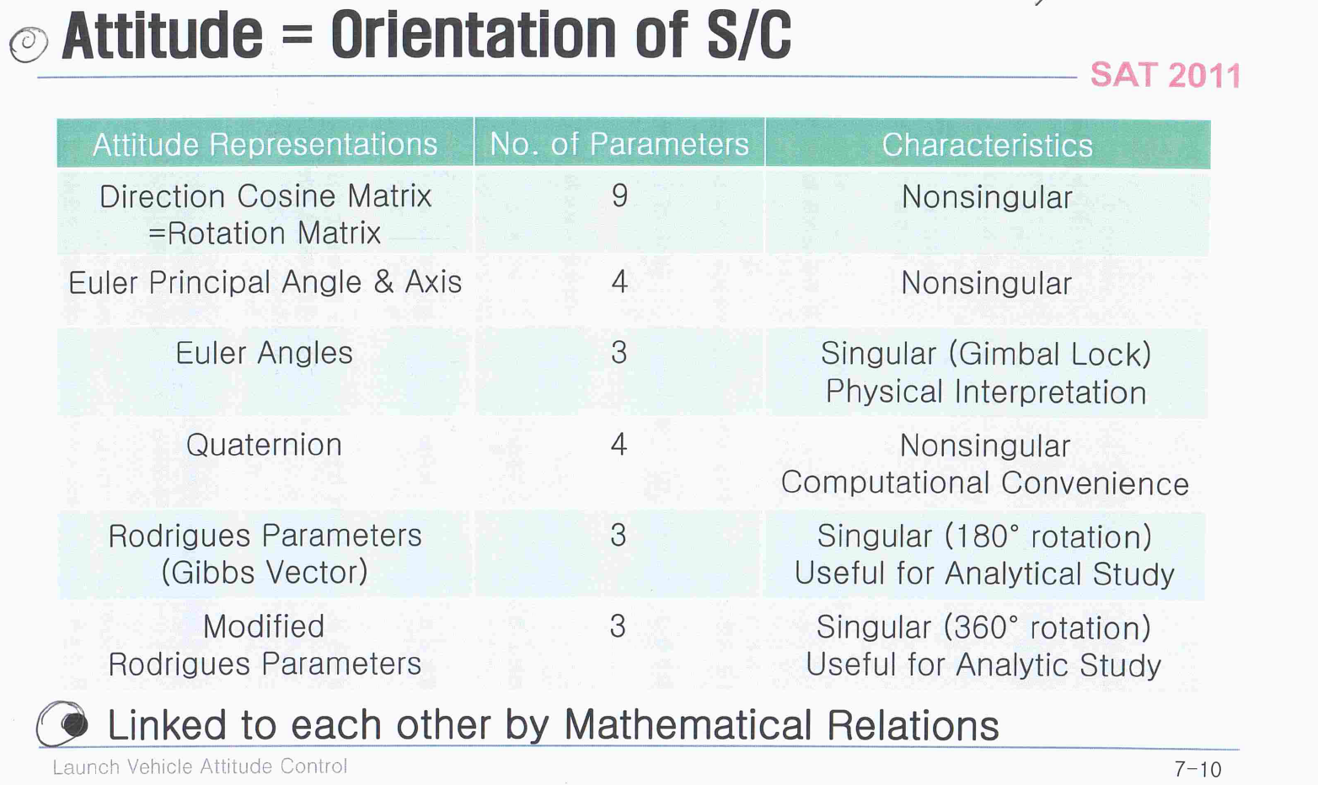

(3)
◎ Rotation Matrix = Direction Cosine Matrix
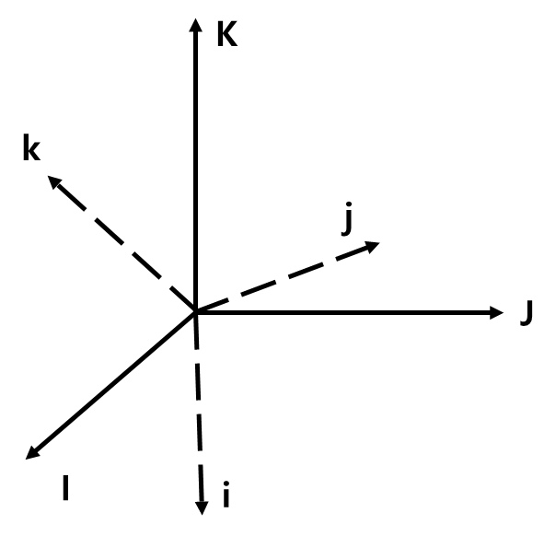
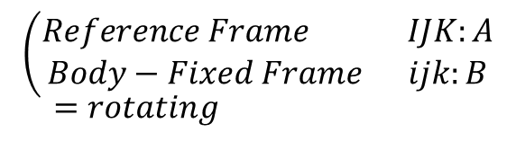
i) Projection of rotating unit vectors of Frame B onto the fixed unit vectors of Frame A
= Specification of the coordinates of rotating unit vectors of Frame B in terms of the fixed Frame A
$\left\{\begin{aligned}i=\left(i∙I\right)I+\left(i∙J\right)J+\left(i∙K\right)K \\ j=\left(j∙I\right)I+\left(j∙J\right)J+\left(j∙K\right)K \\ k=\left(k∙I\right)I+\left(k∙J\right)J+\left(k∙K\right)K\end{aligned}\right.$
$R≜\left[\begin{matrix}i∙I & i∙J & i∙K \\ j∙I & j∙J & j∙K \\ k∙I & k∙J & k∙K\end{matrix}\right] ⇐Rotation Matrix$ $010$

(4)
ii) Properties of Rotation Matrix
① $R=[r_{1} r_{2} r_{3}]$
$r_{i}^{T}r_{j}=δ_{ij} ⇐$ columns & rows are othonormal to each other
② $RR^{T}=R^{T}R=I_{3×3}$
$R^{-1}=R^{T}$
③ $\det{R}=±1 \left\{\begin{aligned}+1 for RHS coordinates \\ -1 for LHS coordinates\end{aligned}\right.$
④ Set of all rotation matrices has a group structure and is often denoted by SO(3)
special orthogonality

iii) $R\sim \left(\begin{matrix}Rotation \\ Attitude of Rigid Body \\ Transformation Matrix\end{matrix}\right.$

iv) Consider a given vector
$\vec{X}=XI+YJ+ZK$ $=xi+yj+zk$ $⇐$ $010$
$⟹\left[\begin{matrix}x \\ y \\ z\end{matrix}\right]=R\left[\begin{matrix}X \\ Y \\ Z\end{matrix}\right] ⟺ \left[\begin{matrix}X \\ Y \\ Z\end{matrix}\right]=R^{T}\left[\begin{matrix}x \\ y \\ z\end{matrix}\right]$

(5)
v) Three Coordinate Frames (A, B, C)
$\left(\begin{matrix}R_{C/B}=rotation matrix of Frame C w.r.t. Frame B \\ R_{B/A}=rotation matrix of Frame B w.r.t. Frame A \\ R_{C/A}=rotation matrix of Frame C w.r.t. Frame A\end{matrix}\right.$
$R_{C/A}=R_{C/B}R_{B/A}$

◎ Euler Principal Angle & Axis
i) Euler’s Principal Rotation Theorem
A rigid body can be brough from an arbitrary initial orientation to an arbitrary orientation by a single rotation through a principal angle ($ϕ$) and a principal axis ($\vec{a}$)
$\vec{a}$ is unity by convention

ii)
$\left[\begin{matrix}Axis/Angle variables \left(\vec{a}, ϕ\right) \\ Exponential coordinates \vec{a}ϕ (\left|\left|\vec{a}\right|\right|=1)\end{matrix}\right.$
$(=Rotation vector)$

iii) Relation to Rotation Matrix
$Let S\left(\vec{a}\right)≜\hat{\vec{a}}=\vec{a}^=\left[\begin{matrix}0 & -a_{3} & a_{2} \\ a_{3} & 0 & -a_{1} \\ -a_{2} & a_{1} & 0\end{matrix}\right]$
$Then, S\left(\vec{a}\right)=-{\left[S\left(\vec{a}\right)\right]}^{T}; Skew-Symmetric$
$\left\{\vec{a}×\vec{b}\right\}=S(\vec{a})\vec{b}$

(6)
① $\left(\vec{a}, ϕ\right) ⇒ R$
$R=e^{S\left(\vec{a}\right)ϕ}=I+S\left(\vec{a}\right)ϕ+\frac{1}{2!}{\left[S\left(\vec{a}\right)ϕ\right]}^{2}+…$
$\left(\begin{matrix}Fact: S{\left(\vec{a}\right)}^{2}=aa^{T}-{\left|\left|\vec{a}\right|\right|}^{2}I=aa^{T}-I \\ S{\left(\vec{a}\right)}^{3}=-{\left|\left|\vec{a}\right|\right|}^{2}S\left(\vec{a}\right)=-S\left(\vec{a}\right) \\ S{\left(\vec{a}\right)}^{4}=-S{\left(\vec{a}\right)}^{2} \end{matrix}\right.$
$R=I+S\left(\vec{a}\right)\left[ϕ-\frac{1}{3!}ϕ^{3}+…\right]+S{\left(\vec{a}\right)}^{2}\left[\frac{1}{2!}ϕ^{2}-\frac{1}{4!}ϕ^{4}+\frac{1}{6!}ϕ^{6}-…\right]$ $=I+S\left(\vec{a}\right)sinϕ+S{\left(\vec{a}\right)}^{2}(1-cosϕ)$
$⟹R=e^{S\left(\vec{a}\right)ϕ}=cosϕI+aa^{T}\left(1-cosϕ\right)+S\left(\vec{a}\right)sinϕ$ (Rodrigues’ Formula)

② $R ⇒ \left(\vec{a}, ϕ\right)$
$ϕ=\cos_{(0, π)}^{-1}\left[\frac{trace\left(R\right)-1}{2}\right]$
$a=\frac{1}{2sinϕ}\left[\begin{matrix}r_{32}-r_{23} \\ r_{13}-r_{31} \\ r_{21}-r_{12}\end{matrix}\right] if ϕ≠0$

(7)
◎ Euler Angles
i) 3 sequential rotations about 3 axes
① 12 combinations
② Gimbal Lock singularity $\left(θ=±\frac{π}{2}\right)$
③ Roll rotation
$R_{x}\left(ϕ\right)=\left[\begin{matrix}1 & 0 & 0 \\ 0 & cosϕ & sinϕ \\ 0 & -sinϕ & cosϕ\end{matrix}\right]$
④ Pitch rotation
$R_{y}\left(θ\right)=\left[\begin{matrix}cosθ & 0 & -sinθ \\ 0 & 1 & 0 \\ sinθ & 0 & cosθ\end{matrix}\right]$
⑤ Yaw rotation
$R_{z}\left(ψ\right)=\left[\begin{matrix}cosψ & sinψ & 0 \\ -sinψ & cosψ & 0 \\ 0 & 0 & 1\end{matrix}\right]$

ii) Relation to rotation matrix (3-2-1 rotation)
① $R=R_{x}\left(ϕ\right)R_{y}\left(θ\right)R_{z}(ψ)$
② $R^{-1}=R_{z}^{-1}\left(ψ\right)R_{y}^{-1}\left(θ\right)R_{x}^{-1}\left(ϕ\right)=R_{z}^{T}\left(ψ\right)R_{y}^{T}\left(θ\right)R_{x}^{T}\left(ϕ\right)$ $=R_{z}\left(-ψ\right)R_{y}\left(-θ\right)R_{x}(-ϕ)$

(8)
ii) Consider for example, 3-2-1 rotation
① One of the most common rotation sequences
② Start from the inertial (=reference) frame, rotate sequentially about the intermediate axis
$\left[\begin{matrix}x \\ y \\ z\end{matrix}\right]=\left[\begin{matrix}1 & 0 & 0 \\ 0 & cosϕ & sinϕ \\ 0 & -sinϕ & cosϕ\end{matrix}\right]\left[\begin{matrix}cosθ & 0 & -sinθ \\ 0 & 1 & 0 \\ sinθ & 0 & cosθ\end{matrix}\right]\left[\begin{matrix}cosψ & sinψ & 0 \\ -sinψ & cosψ & 0 \\ 0 & 0 & 1\end{matrix}\right]\left[\begin{matrix}X \\ Y \\ Z\end{matrix}\right]$ $=R\left(ϕ, θ, ψ\right)\left[\begin{matrix}X \\ Y \\ Z\end{matrix}\right]$ $=R_{x}\left(ϕ\right)R_{y}\left(θ\right)R_{z}(ψ)\left[\begin{matrix}X \\ Y \\ Z\end{matrix}\right]$

(9)
◎ Quaternions (= Euler Parameters)
i) 4 scalar quantities $\left(q_{1}, q_{2}, q_{3}, q_{4}\right)$ combined to represent rotations
ii) No singularity & computational convenience
iii) Definition by relation to Euler Principal Angle & Axis $\left(\vec{a}, ϕ\right)$
①
$\left\{\begin{matrix}\begin{matrix}q_{1}=a_{1}\sin{\frac{ϕ}{2}} \\ q_{2}=a_{2}\sin{\frac{ϕ}{2}}\end{matrix} \\ \begin{matrix}q_{3}=a_{3}\sin{\frac{ϕ}{2}} \\ q_{4}=\cos{\frac{ϕ}{2}} \end{matrix}\end{matrix}\right. ⇒ \sum_{τ=1}^{4}{q_{τ}^{2}}=1$
iv) $\left(q_{1}, q_{2}, q_{3}, q_{4}\right)⇒\left(\vec{a}, ϕ\right)$
$ϕ=2\cos^{-1}\left(q_{4}\right)$
$a=\left\{\begin{matrix}\frac{1}{\sin{\frac{ϕ}{2}}}\left[\begin{matrix}q_{1} \\ q_{2} \\ q_{3}\end{matrix}\right], if ϕ≠0 \\ 0 , if ϕ=0\end{matrix}\right.$

(10)
iv) $\left(q_{1}, q_{2}, q_{3}, q_{4}\right)⇒ R$
$R=\left(q_{4}^{2}-q^{T}q\right)I+2qq^{T}+2q_{4}S(q)$
$q≜\left[\begin{matrix}q_{1} \\ q_{2} \\ q_{3}\end{matrix}\right]$

◎ Rodrigues Parameters = Gibbs Vector
i) Definition by relation to $\left(\vec{a}, ϕ\right)$ and to $\left(q_{1}, q_{2}, q_{3}, q_{4}\right)$
$\vec{g}=\vec{a}\tan{\frac{ϕ}{2}}=\frac{\vec{q}}{q_{4}}$
ii) Useful for analytical study
iii) Undefined for 180° rotations
Undesirable for global attitude representation

◎ Modified Rodrigues Parameters
i) Definition by relation to $\left(\vec{a}, ϕ\right)$ and to $\left(q_{1}, q_{2}, q_{3}, q_{4}\right)$
$\vec{p}=\vec{a}\tan{\frac{ϕ}{4}}= \frac{\vec{q}}{1+q_{4}}$
ii) Useful for analytical study
Undefined for 360° rotations

(11)
<Attitude Kinematics>
◎ Kinematics of Rotating Frame (itself)
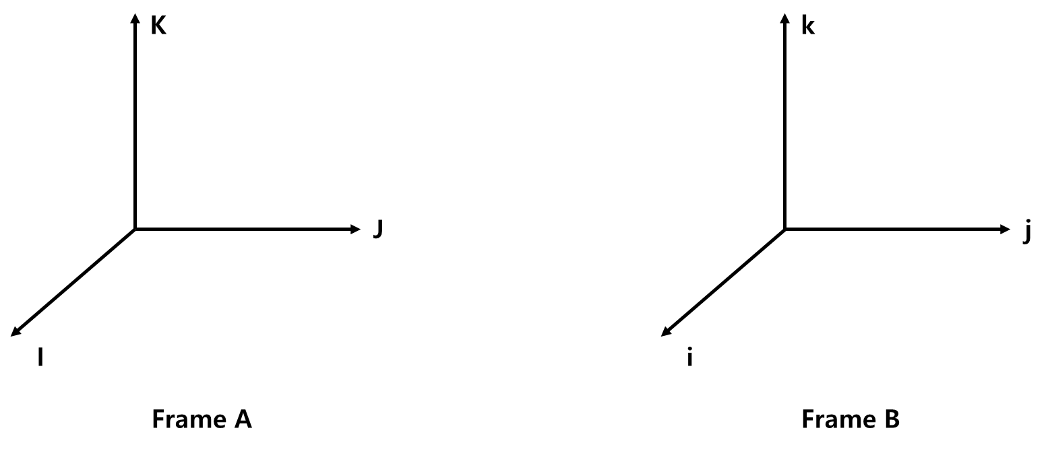
∙ $\vec{w}={\vec{w}}_{B/A}=w_{x}i+w_{y}j+w_{z}k=angular velocity of Frame B w.r.t. Frame A$
∙ Time derivatives of the unit vectors (i, j, k) w.r.t. Frame A
$\left(\begin{matrix}\frac{di}{dt}=\vec{w}×i ⇔ S\left(\vec{w}\right)\left[\begin{matrix}1 \\ 0 \\ 0\end{matrix}\right]=\left\{\frac{di}{dt}\right\} \\ \frac{dj}{dt}=\vec{w}×j ⇔ S\left(\vec{w}\right)\left[\begin{matrix}0 \\ 1 \\ 0\end{matrix}\right]=\left\{\frac{dj}{dt}\right\} \\ \frac{dk}{dt}=\vec{w}×k ⇔ S\left(\vec{w}\right)\left[\begin{matrix}0 \\ 0 \\ 1\end{matrix}\right]=\left\{\frac{dk}{dt}\right\}\end{matrix}\right.$
Perpendicular to the plane generated by $\vec{w}={\vec{w}}_{B/A}$ and the unit vector (i, j, k) respective
cf. $\left[\begin{matrix}\frac{di}{dt} \\ \frac{dj}{dt} \\ \frac{dk}{dt}\end{matrix}\right] ≠S\left(\vec{w}\right)\left[\begin{matrix}i \\ j \\ k\end{matrix}\right],$
└> $=\vec{w}×\left[\begin{matrix}i \\ j \\ k\end{matrix}\right] ⇔ S\left(\vec{w}\right)\left[\begin{matrix}\left\{i\right\} \\ \left\{j\right\} \\ \left\{k\right\}\end{matrix}\right]=S\left(\vec{w}\right)\left[\begin{matrix}[1 0 0] \\ [0 1 0] \\ [0 0 1]\end{matrix}\right]$

(12)
◎ Kinematics in the Rotating Frame
∙ $\vec{r}=r_{1}i+r_{2}j+r_{3}k$
${\left(\frac{d\vec{r}}{dt}\right)}_{A}=\left(\dot{r_{1}}i+\dot{r_{2}}j+\dot{r_{3}}k\right)+\left(r_{1}\dot{\dot{i}}+r_{2}\dot{\dot{j}}+r_{3}\dot{k}\right)={\left(\frac{d\vec{r}}{dt}\right)}_{B}+\left[r_{1}\left(\vec{w}×i\right)+r_{2}\left(\vec{w}×j\right)+r_{3}\left(\vec{w}×k\right)\right]$ $={\left(\frac{d\vec{r}}{dt}\right)}_{B}+\left[\left(\vec{w}×r_{1}i\right)+\left(\vec{w}×r_{2}j\right)+\left(\vec{w}×r_{3}k\right)\right]$ $={\left(\frac{d\vec{r}}{dt}\right)}_{B}+\vec{w}×(r_{1}i+r_{2}j+r_{3}k)$
$⇒{\left(\frac{d\vec{r}}{dt}\right)}_{A}={\left(\frac{d\vec{r}}{dt}\right)}_{B}+\vec{w}×\vec{r}$ ②

∙ $\vec{R}={\vec{R}}_{0}+\vec{r}$
${\left(\frac{d\vec{R}}{dt}\right)}_{A}={\left(\frac{d{\vec{R}}_{0}}{dt}\right)}_{A}+{\left(\frac{d\vec{r}}{dt}\right)}_{A}={\left(\frac{d{\vec{R}}_{0}}{dt}\right)}_{A}+{\left(\frac{d\vec{r}}{dt}\right)}_{B}+\vec{w}×\vec{r}$ ③
${\left(\frac{d^{2}\vec{R}}{dt^{2}}\right)}_{A}={\left(\frac{d^{2}{\vec{R}}_{0}}{dt^{2}}\right)}_{A}+{\left(\frac{d^{2}\vec{r}}{dt^{2}}\right)}_{B}+\dot{\vec{w}}×\vec{r}+2\vec{w}×{\left(\frac{d\vec{r}}{dt}\right)}_{B}+\vec{w}×(\vec{w}×\vec{r})$ ④
Tangential Coriolis Centripetal

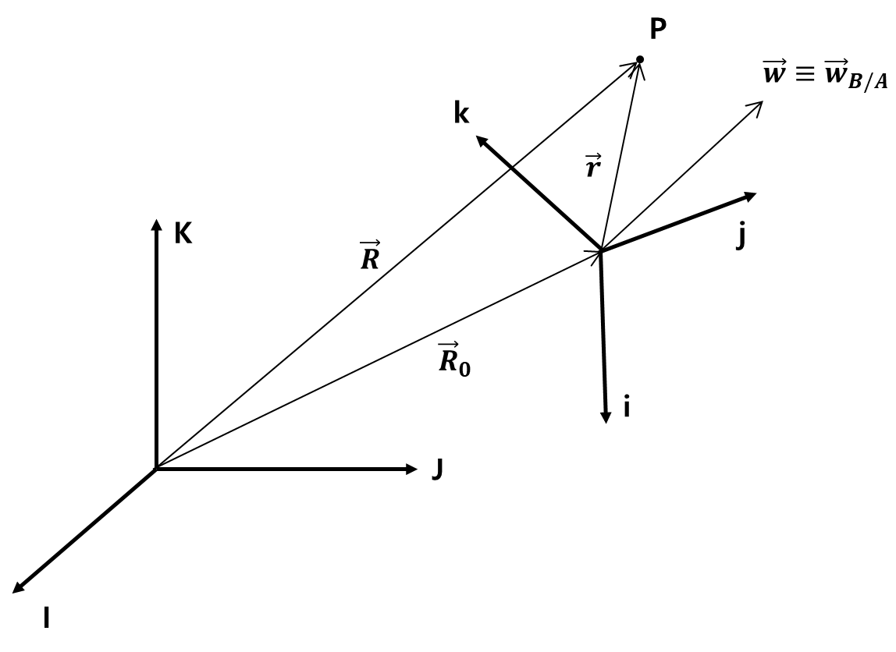

(13)
◎ Attitude Kinematics 1: Rotation (= Direction Cosine) Matrix
∙ $\vec{w}={\vec{w}}_{B/A}^{B}=\left[\begin{matrix}w_{x} \\ w_{y} \\ w_{z}\end{matrix}\right] ⇒ S\left(\vec{w}\right)=\left[\begin{matrix}0 & -w_{z} & w_{y} \\ w_{z} & 0 & -w_{x} \\ -w_{y} & w_{x} & 0\end{matrix}\right]$
∙ $\left[\begin{matrix}i \\ j \\ k\end{matrix}\right]=R\left[\begin{matrix}I \\ J \\ K\end{matrix}\right] ⇒ \frac{d}{dt}\left[\begin{matrix}i \\ j \\ k\end{matrix}\right]=\dot{R}\left[\begin{matrix}I \\ J \\ K\end{matrix}\right]$ ④ (direct differentiation)
$\frac{d}{dt}\left[\begin{matrix}i \\ j \\ k\end{matrix}\right]=\vec{w}×\left[\begin{matrix}i \\ j \\ k\end{matrix}\right]=\vec{w}×R\left[\begin{matrix}I \\ J \\ K\end{matrix}\right]=S(\vec{w})R\left[\begin{matrix}I \\ J \\ K\end{matrix}\right]$ ⑤
(attitude kinematics)
$⇒$ ④ = ⑤
$\dot{R}=S(\vec{w})R$ ⑥
∙ No singularity

◎ Attitude Kinematics 2: Euler Principal Angle & Axis $(\vec{a}, ϕ)$
$\dot{ϕ}=a^{T}w$
$\dot{a}=\frac{1}{2}S\left(\vec{w}\right)a+\frac{1}{2}\cot\left(\frac{ϕ}{2}\right)[w-{(w}^{T}a)a]$
∙ Singularity at $ϕ=0, ±π$

For an arbitrary fixed vector X in the inertial frame
$\left\{x\left(t\right)\right\}=R\left(t\right)\left\{X\right\} ⇒ \left\{\dot{x}\left(t\right)\right\}=\dot{R}\left(t\right)\left\{X\right\}$ ④
$\left\{\dot{x}\left(t\right)\right\}=S\left(\vec{w}\right)\left\{X\left(t\right)\right\}=S\left(\vec{w}\right)R\left(t\right)\{X\}$ ⑤
$⇒$④ = ⑤, $\dot{R}=S(\vec{w})R$
(14)
◎ Attitude Kinematics 3: Euler Angles
i) Consider 3-2-1 rotation
$\left(\begin{matrix}R_{z}\left(ψ\right):A →A' \\ R_{y}\left(θ\right): A^{'} →A'' \\ R_{x}\left(ϕ\right):A^{''}→B\end{matrix}\right. ⇒ \left(\begin{matrix}{\vec{w}}_{A^{'}/A}=\dot{ψ}K= \dot{ψ}k' \\ {\vec{w}}_{A^{''}/A^{'}}=\dot{θ}j^{'}=\dot{θ}j'' \\ {\vec{w}}_{B/A^{''}}=\dot{ϕ}i^{''}=\dot{ϕ}i\end{matrix}\right.$
${\vec{w}}_{B/A}={\vec{w}}_{B/A''}+{\vec{w}}_{A^{''}/A'}+{\vec{w}}_{A^{'}/A}$ $= \dot{ϕ}i+\dot{θ}j^{''}+\dot{ψ}k'$
$\left[\begin{matrix}w_{x} \\ w_{y} \\ w_{z}\end{matrix}\right]=\left[\begin{matrix}\dot{ϕ} \\ 0 \\ 0\end{matrix}\right]+R_{x}\left(ϕ\right)\left[\begin{matrix}0 \\ \dot{θ} \\ 0\end{matrix}\right]+R_{x}\left(ϕ\right)R_{y}\left(θ\right)\left[\begin{matrix}0 \\ 0 \\ \dot{ψ}\end{matrix}\right]$
$⟹\left[\begin{matrix}w_{x} \\ w_{y} \\ w_{z}\end{matrix}\right]=\left[\begin{matrix}1 & 0 & -\sin{θ} \\ 0 & \cos{ϕ} & \sin{ϕ}\cos{θ} \\ 0 & -\sin{ϕ} & \cos{ϕ}\cos{θ}\end{matrix}\right]\left[\begin{matrix}\dot{ϕ} \\ \dot{θ} \\ \dot{ψ }\end{matrix}\right]$
$⟹\left[\begin{matrix}\dot{ϕ} \\ \dot{θ} \\ \dot{ψ }\end{matrix}\right]=\frac{1}{\cos{θ}}\left[\begin{matrix}\cos{θ} & \sin{ϕ}\sin{θ} & \cos{ϕ}\sin{θ} \\ 0 & \cos{ϕ}\cos{θ} & -\sin{ϕ}\cos{θ} \\ 0 & \sin{ϕ} & \cos{ϕ}\end{matrix}\right]\left[\begin{matrix}w_{x} \\ w_{y} \\ w_{z}\end{matrix}\right]$

ii) Singularity at $θ=±\frac{π}{2}$

(15)
◎ Attitude Kinematics 4: Quaternion
i) Start from the kinematics of Rotation Matrix
$\dot{R}=S\left(\vec{w}\right)R$

ii) Introduce Rotation Matrix $⇔$ Quaternion relation
$\left(\begin{matrix}R=\left(q_{4}^{2}-q^{T}q\right)I+2qq^{T}+2q_{4}S(q) \\ q≜{\left[q_{1} q_{2} q_{3}\right]}^{T} \end{matrix}\right.$
result in
$w_{x}=2(\dot{q_{1}}q_{4}+\dot{q_{2}}q_{3}-\dot{q_{3}}q_{2}-\dot{q_{4}}q_{1})$ ①
$w_{y}=2(\dot{q_{2}}q_{4}+\dot{q_{3}}q_{1}-\dot{q_{1}}q_{3}-\dot{q_{4}}q_{2})$ ②
$w_{z}=2(\dot{q_{3}}q_{4}+\dot{q_{1}}q_{2}-\dot{q_{2}}q_{1}-\dot{q_{4}}q_{3})$ ③

iii) Differentiate the identity
$q_{1}^{2}+q_{2}^{2}+q_{3}^{2}+q_{4}^{2}=1$
$⇒2\left({\dot{q}}_{1}q_{1}+{\dot{q}}_{2}q_{2}+{\dot{q}}_{3}q_{3}+{\dot{q}}_{4}q_{4}\right)=0$ ④

iv) Group 4 scalar diff. equations ①~④
$\left[\begin{matrix}\begin{matrix}w_{x} \\ w_{y}\end{matrix} \\ \begin{matrix}w_{z} \\ 0\end{matrix}\end{matrix}\right]=2\left[\begin{matrix}\begin{matrix}q_{4} & q_{3} \\ -q_{3} & q_{4}\end{matrix} & \begin{matrix}-q_{2} & -q_{1} \\ q_{1} & -q_{2}\end{matrix} \\ \begin{matrix}q_{2} & -q_{1} \\ q_{1} & q_{2}\end{matrix} & \begin{matrix}q_{4} & -q_{3} \\ q_{3} & q_{4}\end{matrix}\end{matrix}\right]\left[\begin{matrix}\begin{matrix}\dot{q_{1}} \\ \dot{q_{2}}\end{matrix} \\ \begin{matrix}\dot{q_{3}} \\ \dot{q_{4}}\end{matrix}\end{matrix}\right]$

(16)
$⇔\left[\begin{matrix}\begin{matrix}\dot{q_{1}} \\ \dot{q_{2}}\end{matrix} \\ \begin{matrix}\dot{q_{3}} \\ \dot{q_{4}}\end{matrix}\end{matrix}\right]=\frac{1}{2}\left[\begin{matrix}\begin{matrix}q_{4} & -q_{3} \\ q_{3} & q_{4}\end{matrix} & \begin{matrix}q_{2} & q_{1} \\ -q_{1} & q_{2}\end{matrix} \\ \begin{matrix}{-q}_{2} & q_{1} \\ {-q}_{1} & -q_{2}\end{matrix} & \begin{matrix}q_{4} & -q_{3} \\ {-q}_{3} & q_{4}\end{matrix}\end{matrix}\right]\left[\begin{matrix}\begin{matrix}w_{x} \\ w_{y}\end{matrix} \\ \begin{matrix}w_{z} \\ 0\end{matrix}\end{matrix}\right]$
$⇔\left[\begin{matrix}\begin{matrix}\dot{q_{1}} \\ \dot{q_{2}}\end{matrix} \\ \begin{matrix}\dot{q_{3}} \\ \dot{q_{4}}\end{matrix}\end{matrix}\right]=\frac{1}{2}\left[\begin{matrix}\begin{matrix}0 & w_{z} \\ -w_{z} & 0\end{matrix} & \begin{matrix}-w_{y} & w_{x} \\ w_{x} & w_{y}\end{matrix} \\ \begin{matrix}w_{y} & -w_{x} \\ -w_{x} & -w_{y}\end{matrix} & \begin{matrix}0 & w_{z} \\ -w_{z} & 0\end{matrix}\end{matrix}\right]\left[\begin{matrix}\begin{matrix}q_{1} \\ q_{2}\end{matrix} \\ \begin{matrix}q_{3} \\ q_{4}\end{matrix}\end{matrix}\right]$
$⟺\left[\begin{matrix}\dot{q_{1}} \\ \dot{q_{2}} \\ \dot{q_{3}}\end{matrix}\right]=\frac{1}{2}S\left(\vec{w}\right)\left[\begin{matrix}q_{1} \\ q_{2} \\ q_{3}\end{matrix}\right]+\frac{1}{2}q_{4}\left[\begin{matrix}w_{x} \\ w_{y} \\ w_{z}\end{matrix}\right]$
$\dot{q_{4}}=-\frac{1}{2}{\vec{w}}^{T}\dot{q}$

