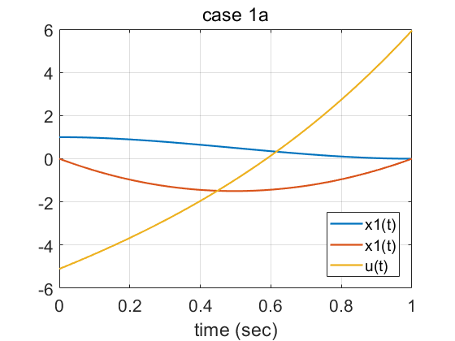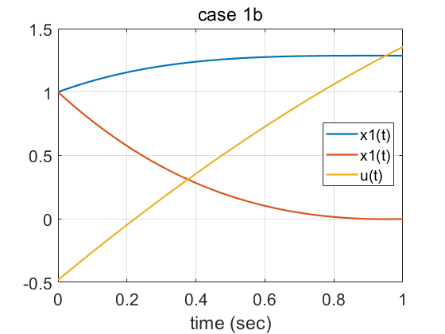

Appendix – code
% 2019-10-21
%case 1a
A = [ 0 1 0 0;
-1 -1 0 -1;
-1 0 0 1;
0 -1 -1 1];

exA=expm(A);

% exA =
%
% 0.5858 0.6524 0.1663 -0.4972
% -0.8187 0.4306 0.4972 -0.9833
% -0.4845 -0.8282 0.2533 1.8131
% 1.1607 -0.8171 -1.6468 2.3973

temp1=exA(1:2,1:2);

temp2=exA(1:2,3:4);

lambda0=-inv(temp2)*temp1*[1;0];

for i=1:101
result(:,i)=expm(A*(i-1)/100)*[1;0;lambda0];
end
t=0:0.01:1;
figure()
plot(t,result(1,:),'linewidth',1.6);% x1
hold on;
plot(t,result(2,:),'linewidth',1.6);% x2
plot(t,-result(4,:),'linewidth',1.6);% u
legend({'x1(t)','x1(t)','u(t)'})
xlabel('time (sec)');
title('case 1a')
grid on;
set(gca,'fontsize',16);

% case 1b
x0=[1;1];
a=exA(2:3,1:2)

b=exA(2:3,3:4)

lambda0b=-inv(b)*a*[1;1];

for i=1:101
resultb(:,i)=expm(A*(i-1)/100)*[1;1;lambda0b];
end
t=0:0.01:1;
figure()
plot(t,resultb(1,:),'linewidth',1.6);% x1
hold on;
plot(t,resultb(2,:),'linewidth',1.6);% x2
plot(t,-resultb(4,:),'linewidth',1.6);% u
legend({'x1(t)','x1(t)','u(t)'})
xlabel('time (sec)');
title('case 1b')
grid on;
set(gca,'fontsize',16);

