EECS 3311 Software Design — Course Project
Stage 1: Project Design Report
Semester Study and Deadline Management Agent
Junhyeok Park
216576324
https://github.com/jj990405/EECS3311
October 9, 2026

Table of Contents

1. Project Overview

1.1 Problem and Motivation
University students take several courses at the same time, and each course comes with its own syllabus, lecture slides, assignments, quizzes, and exams. Deadlines are spread across separate documents, so students often notice too late that several major deadlines fall in the same week. The volume of lecture material also makes review difficult, and students rarely have a clear picture of which topics they are weak in.
Keeping track of this by hand is tedious. Calendar tools require every deadline to be entered manually and do not know which lecture material is relevant to an assessment. General-purpose LLM chat tools can answer questions, but they do not manage a semester: they do not keep track of deadlines, do not know the student's own course materials, and do not remember the student's progress.

1.2 Target Users
University students who struggle with time management and workload management, particularly students taking several courses at once who find it difficult to keep up with deadlines and plan their study.

1.3 Agent Description
The system is a semester-level study and deadline management agent. Its main capabilities are:
- Workspace. The student organizes each semester as a tree: Semester → Course → four fixed categories (Syllabus, Lecture Materials, Assignment Specifications, Other) → files. Files of any format are stored and can be opened in the computer's default program. Each course has a color and a difficulty level.
- Semester calendar from documents. From each uploaded syllabus, the agent extracts assessment deadlines. After the student approves them, they appear in a monthly calendar in which each course has its own color.
- Priority recommendation. For the current week, the system recommends which deadline to work on first: the earlier deadline first and, on the same date, the course with the higher difficulty first. The student decides the actual workload.
- Reference files. On request, the agent tells the student which uploaded lecture files to study for a given deadline.
- Study support. The agent answers questions using only the uploaded materials, summarizes materials, generates and grades quizzes, and identifies weak topics. Explanations are simpler and more detailed for courses marked as difficult.
- Ongoing management. Deadline notifications, progress tracking, a weekly briefing, schedule changes in natural language, a study timer with weekly records, and a history of interactions.
Human approval principle: every AI-generated result that changes the student's data (extracted deadlines, lecture-week assignments, schedule changes, and AI essay scores) is shown to the student and applied only after the student approves it. The agent proposes; the student decides.

1.4 Why an AI Agent
These tasks cannot be handled by a single prompt and response. The system must:
- interpret unstructured documents (syllabi, slides, assignment specifications) whose formats differ between courses;
- decide which tool a request needs (deadline extraction, file search, schedule change, quiz generation);
- execute multi-step tasks, for example extracting deadlines, validating them against the source text, and asking for approval;
- remember information across sessions, such as quiz results, approved changes, and previous conversations;
- recognize when the materials do not contain an answer and say so instead of producing unsupported information.

1.5 AI Model
The system uses a DeepSeek model. All model access goes through the LLMClient interface, implemented by DeepSeekClient, so the rest of the system does not depend on a specific model.

1.6 How the AI Interacts with the System
The LLM never reads or changes the system's data directly. AgentController receives every request from the GUI or the CLI and coordinates the work.
Deterministic components extract text from files (DocumentReaderFactory and its readers), search materials (MaterialSearcher), validate LLM output (DeadlineValidator, FileNameValidator), order deadlines (PriorityRecommender), track progress, grade multiple-choice questions, and store data (DataStore).
PromptBuilder builds the prompt for each task, LLMClient sends it to DeepSeek, and ResponseParser converts the response into objects. Planner interprets natural-language schedule requests. When an agent workflow needs a tool (validating deadlines, checking file names, searching materials), AgentController invokes it through ToolManager.execute(), which runs the registered Tool and returns a ToolResult.
LLM results that would change data are wrapped as Command objects inside a Proposal. They are executed by CommandInvoker only after the student approves them.
Both interfaces call the same AgentController:
Interface | Scope
GUI (Swing) | All features: workspace tree, course pages, monthly calendar, approval dialogs, timer, quizzes, chat.
CLI | The agent's core semester-management functions in text form: creating semesters and courses and uploading files by path, syllabus deadline extraction with item-by-item y/n approval, timeline of deadlines (this week, this month, or one course, with filter, search, and sort), reference file names for a deadline, natural-language schedule changes with y/n approval, marking deadlines as completed, weekly briefing, timer records, and deadline notifications on start.

Scope of the CLI: the CLI gives access to the agent's major functionality for semester management, which is the main purpose of the system. A student can complete the whole core workflow in the terminal: create a semester and courses, upload a syllabus and materials, let the agent extract deadlines and approve them item by item, view deadlines in priority order, ask which files to study, change the schedule in natural language, mark progress, and read the weekly briefing. Study-support functions whose output is long text or requires interactive answering (question answering, summaries, quizzes, weak-topic analysis) and the study timer are provided in the GUI.

1.7 Overall Architecture
The architecture follows the Viewer / Controller / Business Logic / Model separation presented in the SOLID lecture.
Layer | Components | Responsibility
Viewer | MainWindow and its panels (Swing GUI); CommandLineInterface | Receive user input and display results
Controller | AgentController (Facade) | Single entry point for both interfaces; coordinates requests and user approval
Business Logic | Planner, ToolManager, MemoryManager, PromptBuilder, ResponseParser, LLMClient, CommandInvoker, deterministic tools, StudyTimer, DataStore | Agent reasoning, tool execution, LLM access, approved changes, storage
Model | Semester, Course, CategoryFolder, MaterialFile, Deadline, Quiz, QuizResult, Summary, TimerSession, InteractionRecord and related data | Application data
External | DeepSeek API; local data files | Language model service; persistent storage on the user's computer

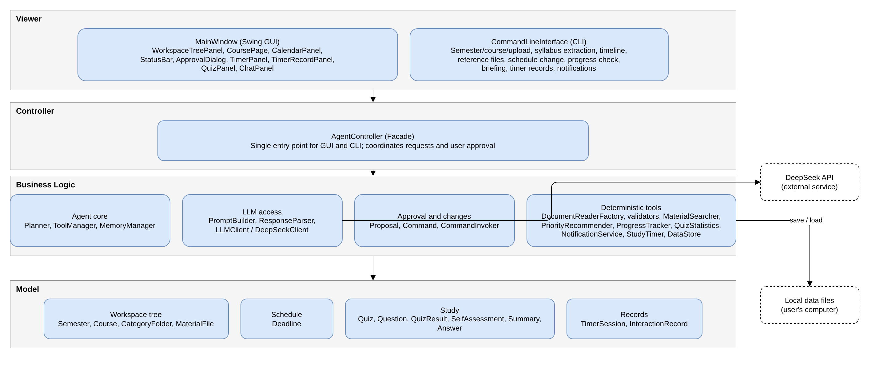
Figure 1: Layered architecture

2. Feature Specifications
The system provides 15 features. Type indicates whether a feature is deterministic, AI-based, or hybrid.
ID | Feature | Type
F01 | Semester, Course, and Material Management | Hybrid
F02 | Syllabus Deadline Extraction | Hybrid
F03 | Schedule View (Calendar and Timeline) | Deterministic
F04 | Priority Recommendation | Deterministic
F05 | Study Timer and Weekly Records | Deterministic
F06 | Reference Files for a Deadline | Hybrid
F07 | Deadline Notifications | Deterministic
F08 | Natural-Language Schedule Modification | Hybrid
F09 | Progress Tracking | Deterministic
F10 | Weekly Briefing | Hybrid
F11 | Question Answering on Course Materials | Hybrid
F12 | Material Summarization | AI
F13 | Quiz Generation and Grading | Hybrid
F14 | Weak Topic Analysis | Hybrid
F15 | Interaction History | Deterministic

F01 — Semester, Course, and Material Management
Description | The student builds a workspace tree: Semester → Course → four fixed categories (Syllabus, Lecture Materials, Assignment Specifications, Other) → files. Several semesters can be kept. Each course has a color and a difficulty level (High, Medium, Low). Files of any format are stored and can be opened in the computer's default program; text is extracted from PDF, PPTX, DOCX, and TXT files. For lecture materials, the agent proposes the lecture week by comparing the material with the syllabus weekly topics. Clicking a course opens its course page (course calendar and deadlines, material list, reference files, and study tools).
User Interaction | In the workspace tree the student creates a semester (name, start date, end date) and a course (name, color, difficulty), selects a category, and uploads one or more files. Proposed lecture weeks are reviewed in the approval dialog. Double-clicking a file opens the original; clicking a course opens the course page. CLI: commands create a semester and a course and upload files by path; proposed lecture weeks are approved item by item (y/n).
Input | Semester name, start date, end date; course name, color, difficulty; category; one or more files.
Output | Updated workspace tree; stored files with extracted text; approved week assignments; course page.
AI Involvement | Hybrid. Storage and text extraction are deterministic. Week matching is done by the LLM. The student confirms the result.
Expected Workflow | 1. The student creates a semester and a course.  2. The student selects a category and uploads files.  3. Each file is stored and its text is extracted.  4. For lecture materials, the LLM proposes a week for each file.  5. The student reviews and approves the proposed weeks.  6. The tree is updated and saved.
Error / Alternative Cases | • Text cannot be extracted (e.g., a scanned file): the file is still stored and can be opened, but it is marked as excluded from AI features.  • Week match is uncertain: the student assigns the week.  • No syllabus has been uploaded yet: the student assigns the week.  • The same file is uploaded again: the student is asked whether to replace it.

F02 — Syllabus Deadline Extraction
Description | When a syllabus or schedule document is uploaded to a course's Syllabus category, the agent identifies assessment items (assignments, quizzes, exams) with their due dates, weights, and covered topics. Each item is validated against the original text and the semester period before it is shown. Only items approved by the student are added to the calendar.
User Interaction | After uploading the syllabus, the student reviews the extracted items in the approval dialog, where each item can be edited, deleted, or approved. CLI: an extract command prints the candidates as a numbered list with their warnings, and the student approves or rejects each item (y/n).
Input | Syllabus file; the course; the semester start and end dates (entered when the semester was created).
Output | Approved deadlines added to the calendar; undated items listed as undated; validation warnings.
AI Involvement | Hybrid. Text extraction and validation are deterministic. Identifying assessment items in unstructured text is done by the LLM. The student makes the final decision.
Expected Workflow | 1. The student uploads the syllabus.  2. The system extracts the text.  3. The LLM returns candidate deadlines.  4. The system validates each candidate: the date must be well-formed, appear in the original text, and fall within the semester. Relative dates such as "Week 5" are converted using the semester start date.  5. Candidates are shown with their validation results.  6. The student edits and approves items.  7. Approved items are saved and shown in the calendar.
Error / Alternative Cases | • Text cannot be extracted: the student enters deadlines manually.  • LLM output is malformed: the system retries, then reports the failure.  • A date does not appear in the original text: the item is flagged; it is added only if the student confirms it.  • Duplicate deadline: the student is asked whether to merge it.  • LLM service unavailable: manual entry.  • No deadline is found: the student is told to enter deadlines manually.  • Date outside the semester: the item is flagged with a warning.  • No date or "TBD": the item is saved as undated and a status bar message is shown, e.g. "EECS3311 – syllabus: there are assignments with no specific date mentioned".

F03 — Schedule View (Calendar and Timeline)
Description | The GUI shows a monthly calendar. The current week is expanded and lists its deadlines; other weeks show one colored dot per deadline, using the course color. The calendar can show the whole semester or one course. Undated deadlines are listed in a status bar at the bottom. Deadlines can be edited or deleted directly. The CLI shows the same deadlines as a timeline grouped by date.
User Interaction | Clicking another week expands it. Clicking a deadline shows its details (title, date, weight, scope). Deadlines can be edited or deleted. Clicking a status bar message opens the related course. CLI: a timeline command prints deadlines for this week, this month, or one course, grouped by date with time, title, type, and course; filtering, search by type or name, and sorting by date are supported.
Input | Period (month, week, or CLI range), course filter, CLI search keyword; edits to a deadline.
Output | Calendar view or printed timeline; updated deadline after an edit or deletion.
AI Involvement | Deterministic.
Expected Workflow | 1. The student opens the calendar (or runs the timeline command).  2. The system loads deadlines for the selected period and filter.  3. The current week is listed in recommended order (F04); other weeks show colored dots.  4. The student may expand a week, open details, edit, or delete a deadline.  5. Edits are validated and saved, and all views are refreshed.
Error / Alternative Cases | • No deadlines: the student is told to upload a syllabus.  • A course has no deadlines: the course is listed in the status bar.  • Invalid edit, e.g. a date outside the semester: the change is rejected.  • Too many items on one day: a summary is shown.  • CLI search has no result: "No results" is printed.

F04 — Priority Recommendation
Description | Each course has a difficulty level (High, Medium, Low) chosen when the course is created. The system recommends the order in which to work on deadlines: the earlier deadline first and, if two deadlines are on the same date, the one from the more difficult course first. The system does not estimate or distribute workload; the student decides the workload by looking at the calendar.
User Interaction | The recommended order is used for the current-week list in the calendar and in the weekly briefing. CLI: the timeline can be sorted by recommended order.
Input | Deadlines in the selected period; course difficulty levels.
Output | Ordered list of deadlines.
AI Involvement | Deterministic. The order only changes how deadlines are displayed; no data is changed, so no approval is needed.
Expected Workflow | 1. A view requests the deadlines of a period.  2. The system sorts them by due date and then by course difficulty.  3. The ordered list is displayed.
Error / Alternative Cases | • Undated deadlines cannot be ordered: they remain listed in the status bar.

F05 — Study Timer and Weekly Records
Description | The student starts a 15-, 30-, or 60-minute study timer. An alarm sounds when the time is up, and the session is recorded. A records screen shows study time per day and the weekly total. The timer is not linked to a course or a deadline.
User Interaction | Timer panel with three buttons (15 min, 30 min, 1 hour) and a stop button; a records screen with a week selector. CLI: timer records can be viewed; the timer itself runs only in the GUI.
Input | Timer length (15, 30, or 60 minutes); week to view.
Output | Alarm; recorded session; daily times and weekly total.
AI Involvement | Deterministic.
Expected Workflow | 1. The student selects a timer length.  2. The timer counts down and the panel is updated.  3. When the time is up, an alarm sounds.  4. The session is saved.  5. The student opens the records screen to see the week.
Error / Alternative Cases | • The timer is stopped early: only the time actually studied is recorded.  • No records for the selected week: "No records" is shown.  • Constraint: the timer does not run while the application is closed.

F06 — Reference Files for a Deadline
Description | When the student asks, the agent tells which uploaded lecture files to study for a given deadline. It compares the syllabus weekly topics and exam scope, and the assignment specification if one was uploaded, with the lecture materials. Only files that actually exist in the course are shown. Nothing is saved.
User Interaction | On the course page, the student selects a deadline and requests reference files; the files are listed and can be opened from the tree. CLI: the student asks for a deadline's reference files and the file names are printed.
Input | The selected deadline; the course's syllabus, assignment specifications, and lecture materials.
Output | List of existing lecture files (GUI) or their file names (CLI).
AI Involvement | Hybrid. Finding relevant materials is done by the LLM; checking that each returned file exists is deterministic.
Expected Workflow | 1. The student selects a deadline and asks for reference files.  2. The system builds a prompt from the deadline, syllabus topics, assignment specification, and material text.  3. The LLM returns file names.  4. The system keeps only names that match uploaded files.  5. The files are shown.
Error / Alternative Cases | • No lecture materials, or none with text: the student is informed.  • No assignment specification: only the syllabus is used.  • No relevant file found: the student is informed.

F07 — Deadline Notifications
Description | The student sets when to be notified before each deadline. While the GUI is running, a notification and a status bar message are shown at that time. When the CLI starts, upcoming deadlines are printed.
User Interaction | The notification time is set in the deadline details; notifications appear in a window and in the status bar. CLI: printed on start.
Input | Notification time per deadline; current time.
Output | Notifications.
AI Involvement | Deterministic.
Expected Workflow | 1. The system checks deadlines against their notification times.  2. Due notifications are shown in the GUI or printed in the CLI.
Error / Alternative Cases | • The notification time passed while the application was closed: the notification is shown on the next start.  • Undated deadlines are not notified; they are listed in the status bar.

F08 — Natural-Language Schedule Modification
Description | The student describes a change in plain language, for example "the EECS3311 assignment deadline moved to October 20". The agent interprets the request, shows the change before and after, and applies it only after approval.
User Interaction | Chat panel; the proposed change is shown in the approval dialog. CLI: the request is typed as a command and approved with y/n.
Input | Natural-language request.
Output | Proposed change; updated schedule after approval.
AI Involvement | Hybrid. Interpretation is done by the LLM; the change is executed by deterministic code after the student approves it.
Expected Workflow | 1. The student types the request.  2. The LLM interprets it into an intent.  3. The system builds the corresponding change (before and after).  4. The student approves or rejects it.  5. An approved change is applied and saved.
Error / Alternative Cases | • Ambiguous request: the agent asks the student to clarify.  • The item does not exist: the student is informed.  • Date outside the semester: the change is rejected.  • The student rejects the change: nothing is changed.

F09 — Progress Tracking
Description | The student marks deadlines as completed. The system shows each course's progress (completed out of total deadlines) and detects past deadlines that are not completed.
User Interaction | A completion check in the calendar; progress on the course page. CLI: a command marks a deadline as completed.
Input | Deadline to mark as completed.
Output | Updated completion status; course progress; overdue warnings.
AI Involvement | Deterministic. Marking a deadline is the student's own action, so no approval step is needed.
Expected Workflow | 1. The student marks a deadline as completed.  2. The status is saved.  3. Course progress is recalculated and displayed.
Error / Alternative Cases | • A past deadline is not completed: it is shown in the status bar.

F10 — Weekly Briefing
Description | At the first start of each week, or on request, the agent produces a short summary of the week: deadlines in recommended order and topics to review.
User Interaction | A briefing window in the main window. CLI: a briefing command prints the briefing.
Input | This week's deadlines; quiz statistics.
Output | Briefing text.
AI Involvement | Hybrid. Data collection is deterministic; the summary text is written by the LLM.
Expected Workflow | 1. The system collects this week's deadlines and orders them (F04).  2. It collects weak topics from quiz statistics.  3. The LLM writes the briefing.  4. The briefing is shown.
Error / Alternative Cases | • LLM service unavailable: only the collected list is shown.

F11 — Question Answering on Course Materials
Description | The student asks a question about a course. The system searches the course materials for relevant passages, and the LLM answers using only those passages, citing the source file and page or slide number. The explanation style depends on the course difficulty.
User Interaction | Chat panel on the course page; the source file can be opened from the answer.
Input | Question; course.
Output | Answer with verified sources.
AI Involvement | Hybrid. Searching and source verification are deterministic; the answer is generated by the LLM.
Expected Workflow | 1. The student asks a question.  2. Relevant passages are retrieved from the course materials.  3. A prompt is built with the passages and the difficulty-based explanation style.  4. The LLM answers with sources.  5. Sources are checked against the uploaded files.  6. The answer is shown and recorded.
Error / Alternative Cases | • No supporting content in the materials: the agent answers that the information is not in the materials.  • Only files without text are available: the student is informed.  • LLM service unavailable: the student is informed.

F12 — Material Summarization
Description | The student selects a file and the agent summarizes it, using the explanation style that matches the course difficulty. The summary is saved and can be reopened.
User Interaction | A summarize action on the course page.
Input | Selected file.
Output | Saved summary.
AI Involvement | AI-based.
Expected Workflow | 1. The student selects a file.  2. A prompt is built from the file text and the explanation style.  3. The LLM produces the summary.  4. The summary is saved and shown.
Error / Alternative Cases | • The file has no text: the student is informed.  • Long material: it is summarized in parts.

F13 — Quiz Generation and Grading
Description | The student chooses a scope (lectures or weeks), the number of questions, a difficulty, and the question types (multiple-choice and essay). The LLM generates the quiz. Multiple-choice answers are graded by code; essay answers are graded by the LLM with an explanation. Explanations follow the course difficulty. AI essay scores are proposals: the student accepts or corrects them before they are saved. Results are stored for weak-topic analysis.
User Interaction | Quiz panel for settings, answering, and results; essay scores are reviewed in the approval dialog.
Input | Scope, number of questions, difficulty, question types; the student's answers.
Output | Quiz; graded result with explanations.
AI Involvement | Hybrid. Generation and essay grading are done by the LLM; multiple-choice grading is deterministic.
Expected Workflow | 1. The student sets the quiz options.  2. The LLM generates the questions.  3. The student answers.  4. Each answer is graded by the matching grading strategy.  5. Multiple-choice scores are saved; essay scores are shown for the student to accept or correct.  6. Approved scores are saved and the result is recorded.
Error / Alternative Cases | • A malformed question is generated: it is regenerated.  • The selected scope has no text: the student is informed.

F14 — Weak Topic Analysis
Description | The system computes accuracy per topic from quiz results, and the student can enter a self-assessment per topic. The LLM combines both, explains the weak topics, and recommends lectures to review. The explanation style depends on the course difficulty.
User Interaction | Self-assessment input and weak-topic view on the course page.
Input | Quiz results; self-assessments.
Output | Weak topics with explanation and lectures to review.
AI Involvement | Hybrid. Statistics are deterministic; interpretation is done by the LLM.
Expected Workflow | 1. The student enters a self-assessment (optional).  2. The system computes accuracy per topic.  3. The LLM interprets the data.  4. The analysis is shown.
Error / Alternative Cases | • Not enough quiz data: the student is advised to take a quiz.

F15 — Interaction History
Description | The system records conversations, quiz results, and approved or rejected changes. Recent records are used as context for later answers. The student can view and delete records.
User Interaction | A history window from the main window.
Input | Interactions (recorded automatically); record to delete.
Output | History list.
AI Involvement | Deterministic.
Expected Workflow | 1. Interactions are recorded as they happen.  2. The student opens the history.  3. The student may delete a record.
Error / Alternative Cases | • Saving fails: the student is informed.

3. UML Class Diagram
The class diagram uses the implementation perspective: each class corresponds to a Java class to be implemented in Stage 2. Visibility follows UML notation (+ public, - private); interfaces and abstract classes are shown in italics with their stereotype. Methods inherited from an interface are not repeated in the implementing class.
For readability the class diagram is presented in four parts (Figures 2a–2d). Each relationship is drawn once, in the part that contains its source class; a class that belongs to another part is shown as a grey dashed box. The complete diagram on a single canvas is provided in the repository as Figure2_ClassDiagram_Full.drawio. Sections 3.1–3.11 list every class, attribute, method, and relationship.

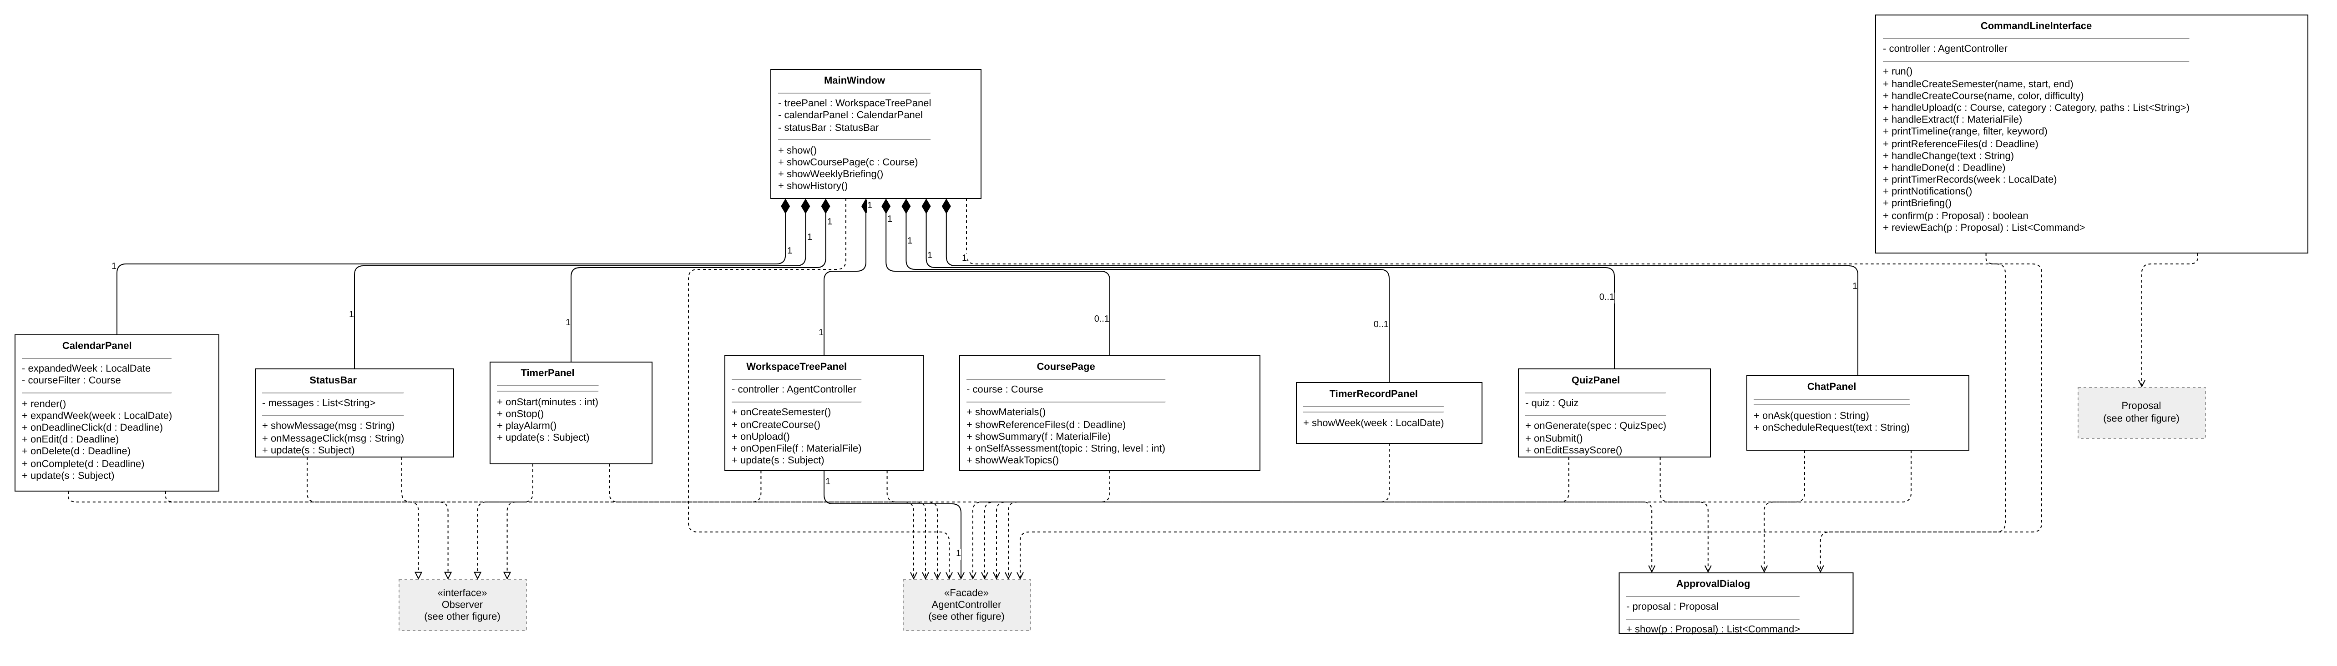
Figure 2a: Class diagram (a) — Viewer (boundary) classes

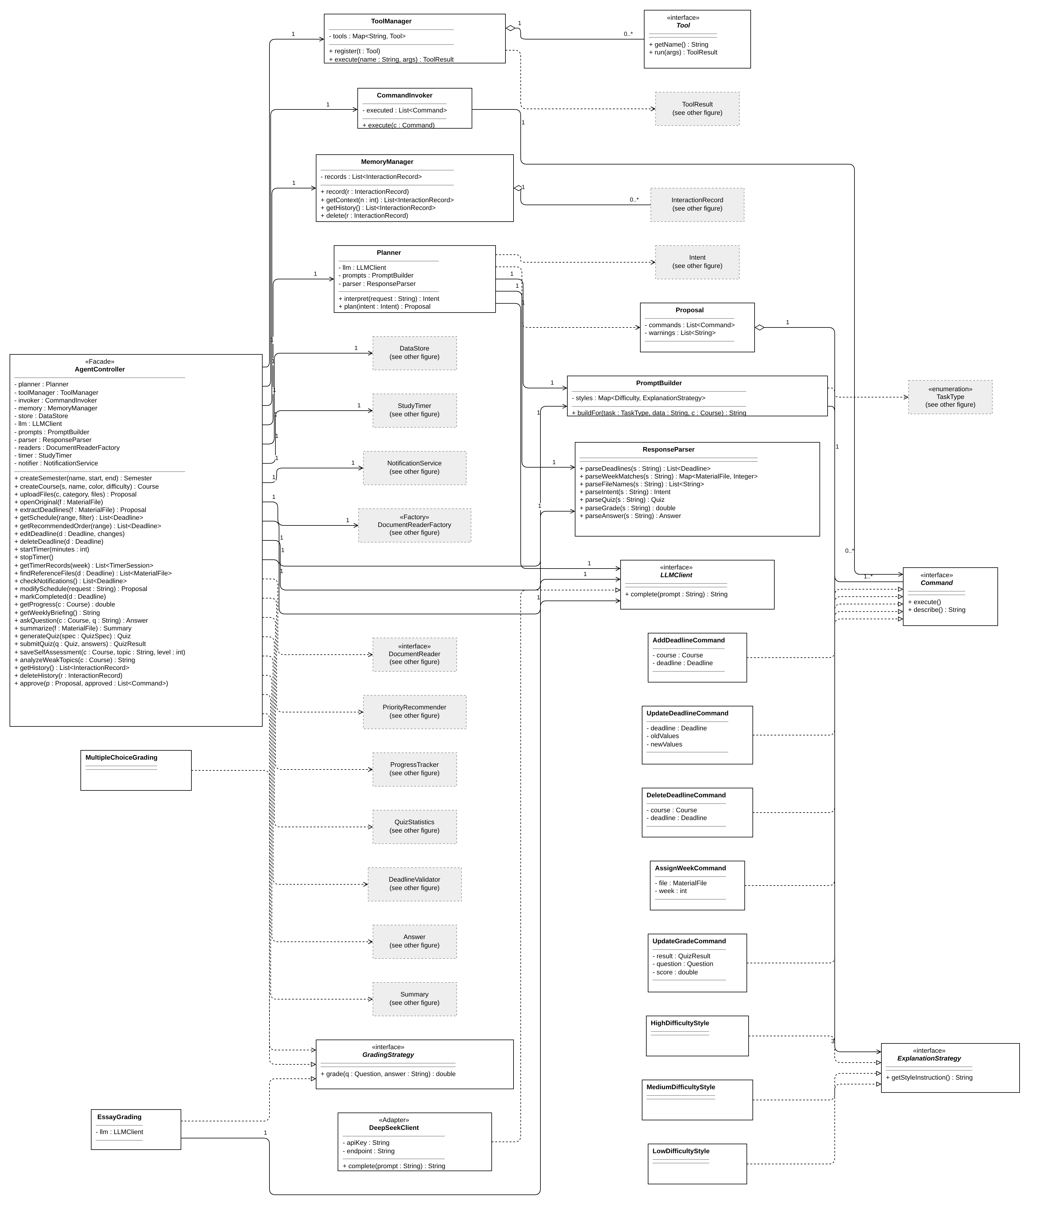
Figure 2b: Class diagram (b) — Controller, agent core, LLM access, approval (Command), Strategy

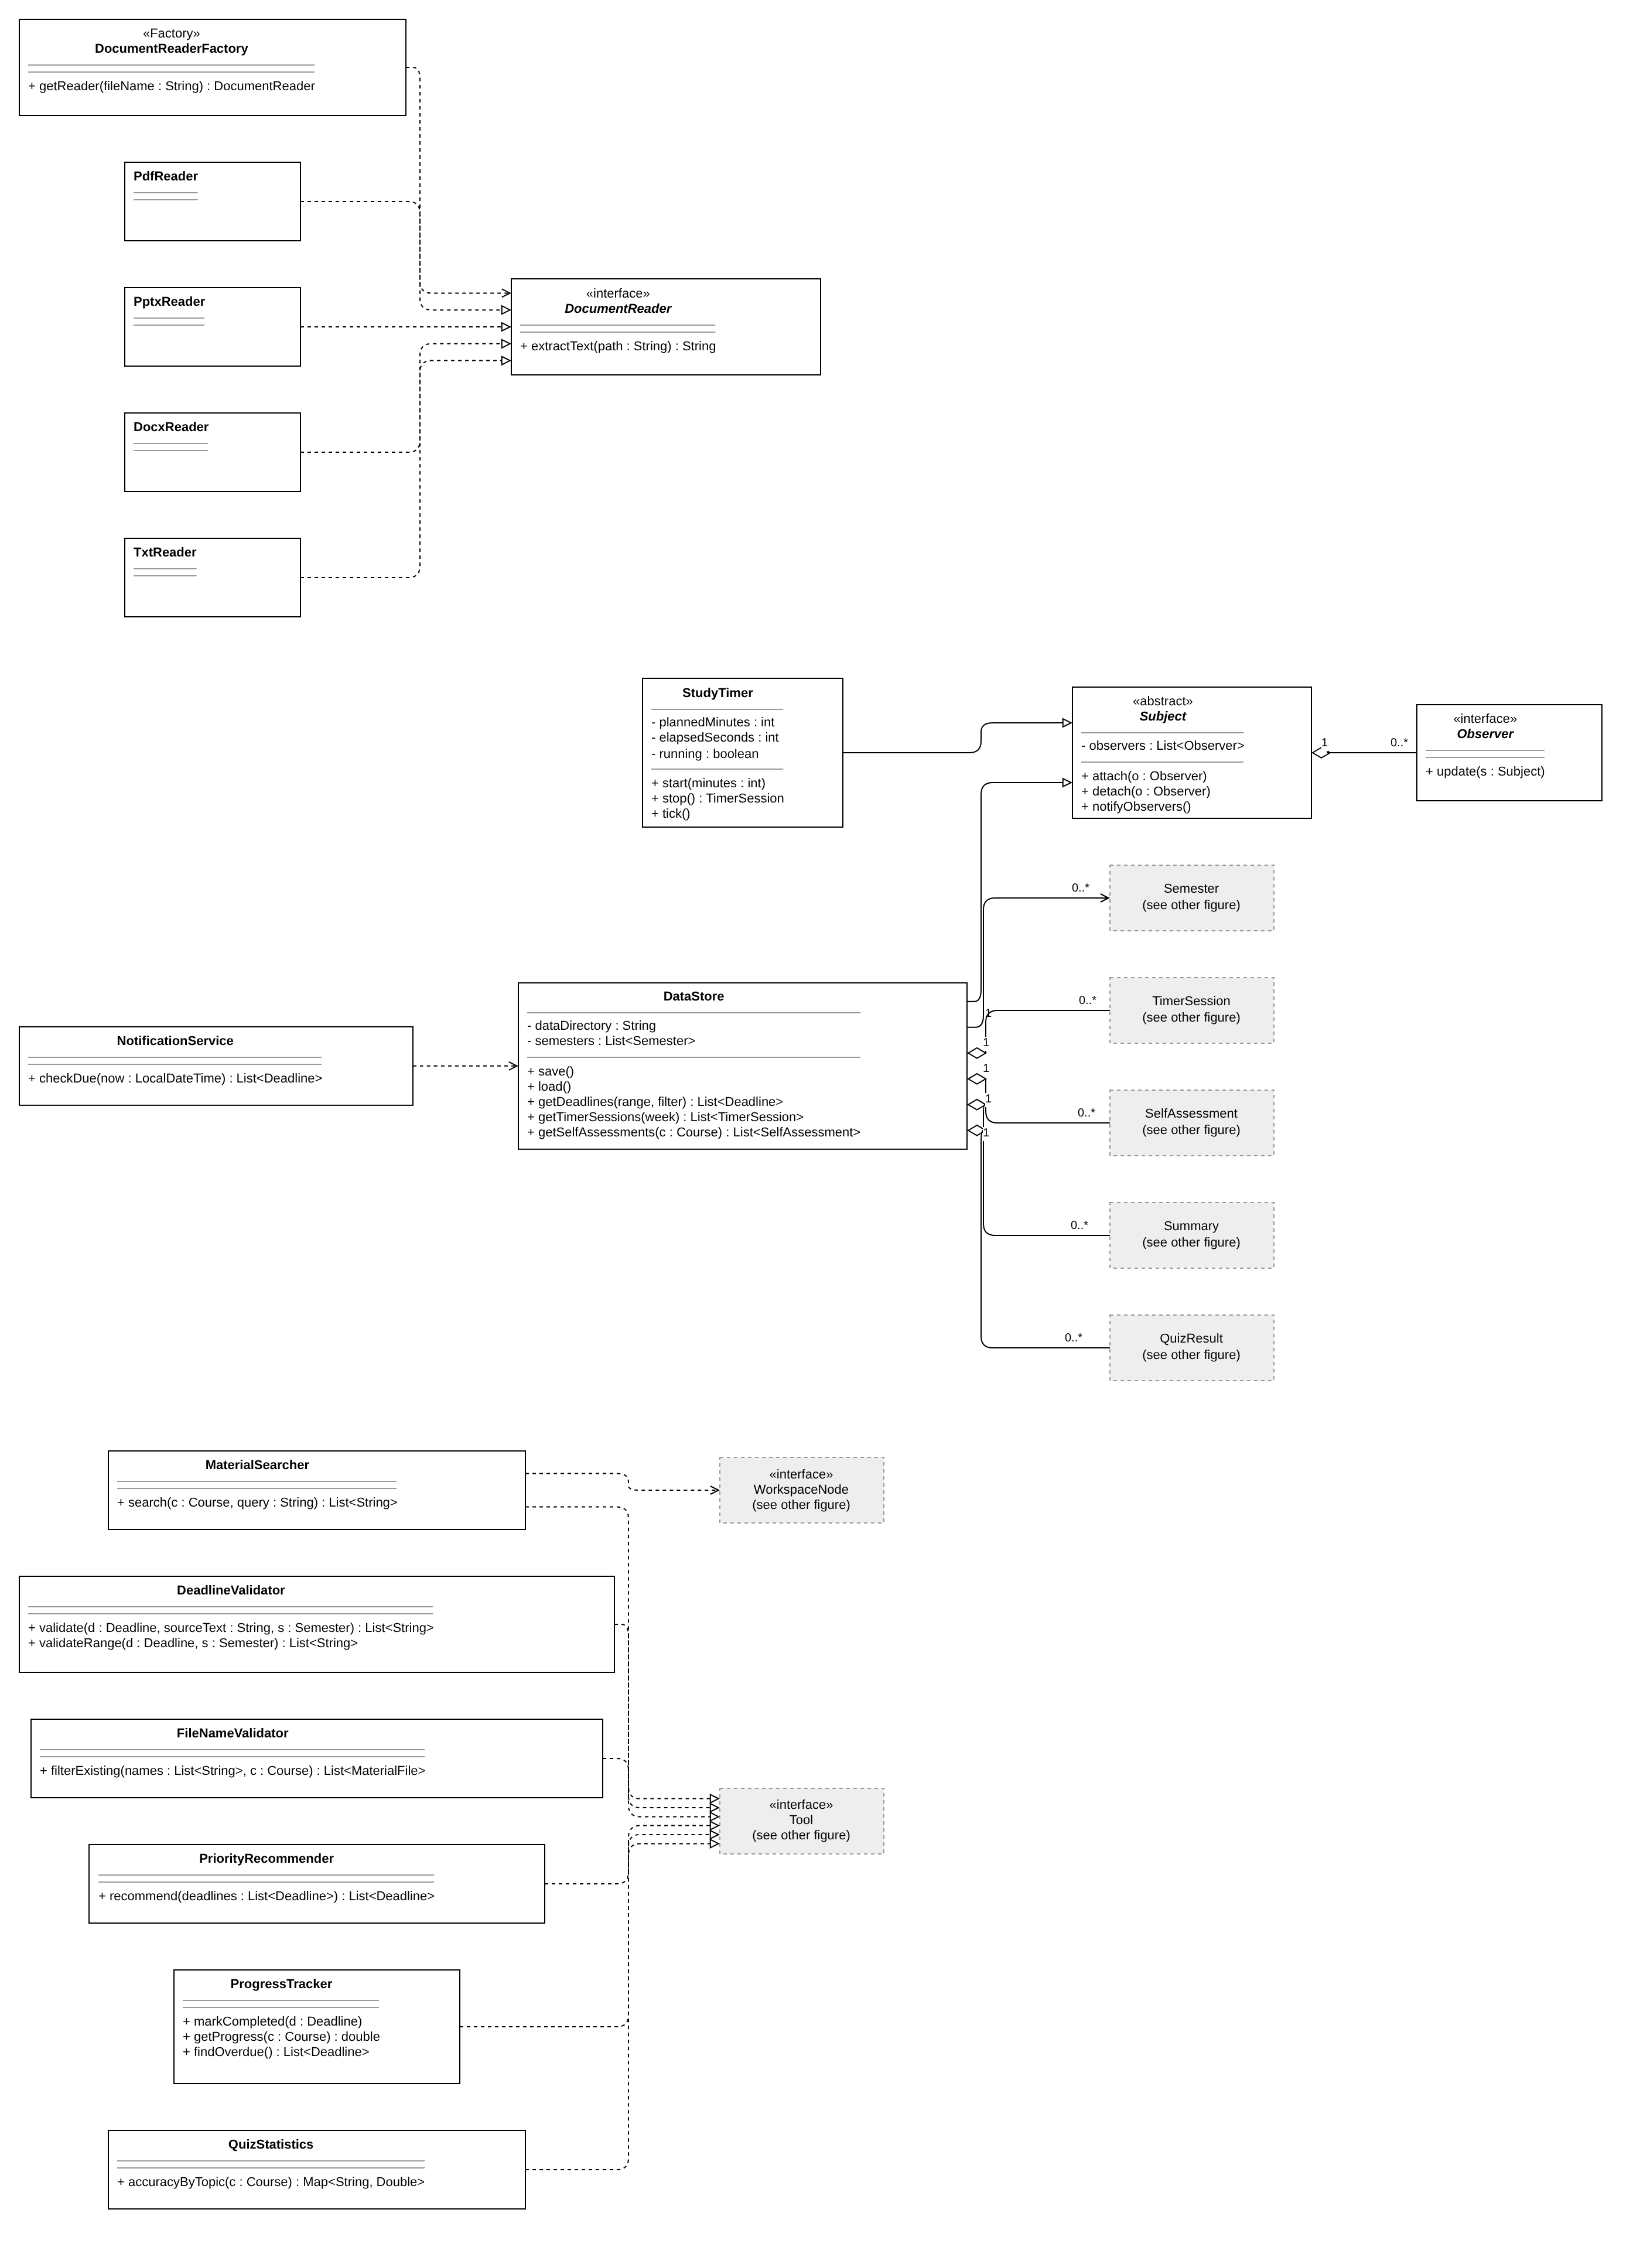
Figure 2c: Class diagram (c) — Deterministic tools, text extraction (Factory), Observer

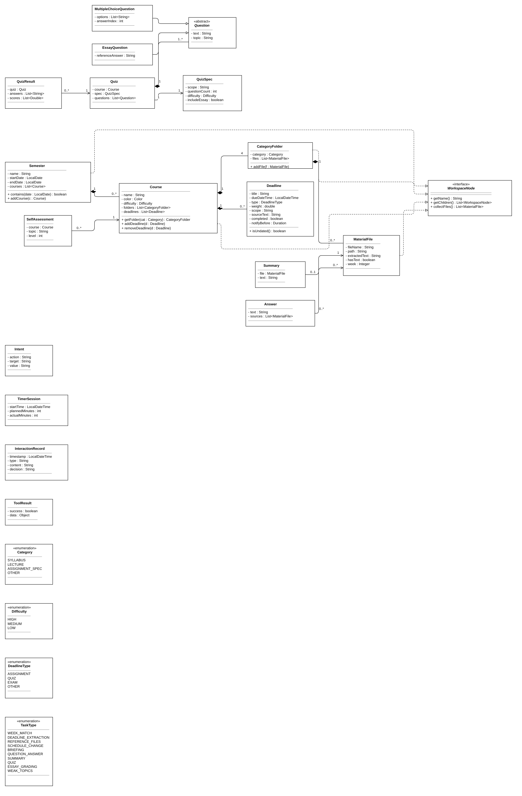
Figure 2d: Class diagram (d) — Model

3.1 Viewer (Boundary) Classes
Class | Attributes | Methods
MainWindow | - treePanel : WorkspaceTreePanel  - calendarPanel : CalendarPanel  - statusBar : StatusBar | + show()  + showCoursePage(c : Course)  + showWeeklyBriefing()  + showHistory()
WorkspaceTreePanel | - controller : AgentController | + onCreateSemester()  + onCreateCourse()  + onUpload()  + onOpenFile(f : MaterialFile)  + update(s : Subject)
CoursePage | - course : Course | + showMaterials()  + showReferenceFiles(d : Deadline)  + showSummary(f : MaterialFile)  + onSelfAssessment(topic : String, level : int)  + showWeakTopics()
CalendarPanel | - expandedWeek : LocalDate  - courseFilter : Course | + render()  + expandWeek(week : LocalDate)  + onDeadlineClick(d : Deadline)  + onEdit(d : Deadline)  + onDelete(d : Deadline)  + onComplete(d : Deadline)  + update(s : Subject)
StatusBar | - messages : List<String> | + showMessage(msg : String)  + onMessageClick(msg : String)  + update(s : Subject)
ApprovalDialog | - proposal : Proposal | + show(p : Proposal) : List<Command>
TimerPanel | — | + onStart(minutes : int)  + onStop()  + playAlarm()  + update(s : Subject)
TimerRecordPanel | — | + showWeek(week : LocalDate)
QuizPanel | - quiz : Quiz | + onGenerate(spec : QuizSpec)  + onSubmit()  + onEditEssayScore()
ChatPanel | — | + onAsk(question : String)  + onScheduleRequest(text : String)
CommandLineInterface | - controller : AgentController | + run()  + handleCreateSemester(name, start, end)  + handleCreateCourse(name, color, difficulty)  + handleUpload(c : Course, category : Category, paths : List<String>)  + handleExtract(f : MaterialFile)  + printTimeline(range, filter, keyword)  + printReferenceFiles(d : Deadline)  + handleChange(text : String)  + handleDone(d : Deadline)  + printTimerRecords(week : LocalDate)  + printNotifications()  + printBriefing()  + confirm(p : Proposal) : boolean  + reviewEach(p : Proposal) : List<Command>

3.2 Controller
Class | Attributes | Methods
«Facade» AgentController | - planner : Planner  - toolManager : ToolManager  - invoker : CommandInvoker  - memory : MemoryManager  - store : DataStore  - llm : LLMClient  - prompts : PromptBuilder  - parser : ResponseParser  - readers : DocumentReaderFactory  - timer : StudyTimer  - notifier : NotificationService | + createSemester(name, start, end) : Semester  + createCourse(s, name, color, difficulty) : Course  + uploadFiles(c, category, files) : Proposal  + openOriginal(f : MaterialFile)  + extractDeadlines(f : MaterialFile) : Proposal  + getSchedule(range, filter) : List<Deadline>  + getRecommendedOrder(range) : List<Deadline>  + editDeadline(d : Deadline, changes)  + deleteDeadline(d : Deadline)  + startTimer(minutes : int)  + stopTimer()  + getTimerRecords(week) : List<TimerSession>  + findReferenceFiles(d : Deadline) : List<MaterialFile>  + checkNotifications() : List<Deadline>  + modifySchedule(request : String) : Proposal  + markCompleted(d : Deadline)  + getProgress(c : Course) : double  + getWeeklyBriefing() : String  + askQuestion(c : Course, q : String) : Answer  + summarize(f : MaterialFile) : Summary  + generateQuiz(spec : QuizSpec) : Quiz  + submitQuiz(q : Quiz, answers) : QuizResult  + saveSelfAssessment(c : Course, topic : String, level : int)  + analyzeWeakTopics(c : Course) : String  + getHistory() : List<InteractionRecord>  + deleteHistory(r : InteractionRecord)  + approve(p : Proposal, approved : List<Command>)

3.3 Agent Core
Class | Attributes | Methods
Planner | - llm : LLMClient  - prompts : PromptBuilder  - parser : ResponseParser | + interpret(request : String) : Intent  + plan(intent : Intent) : Proposal
ToolManager | - tools : Map<String, Tool> | + register(t : Tool)  + execute(name : String, args) : ToolResult
«interface» Tool | — | + getName() : String  + run(args) : ToolResult
MemoryManager | - records : List<InteractionRecord> | + record(r : InteractionRecord)  + getContext(n : int) : List<InteractionRecord>  + getHistory() : List<InteractionRecord>  + delete(r : InteractionRecord)

3.4 LLM Access
Class | Attributes | Methods
PromptBuilder | - styles : Map<Difficulty, ExplanationStrategy> | + buildFor(task : TaskType, data : String, c : Course) : String
ResponseParser | — | + parseDeadlines(s : String) : List<Deadline>  + parseWeekMatches(s : String) : Map<MaterialFile, Integer>  + parseFileNames(s : String) : List<String>  + parseIntent(s : String) : Intent  + parseQuiz(s : String) : Quiz  + parseGrade(s : String) : double  + parseAnswer(s : String) : Answer
«interface» LLMClient | — | + complete(prompt : String) : String
«Adapter» DeepSeekClient | - apiKey : String  - endpoint : String | + complete(prompt : String) : String

3.5 Approval and Changes
Class | Attributes | Methods
«interface» Command | — | + execute()  + describe() : String
AddDeadlineCommand | - course : Course  - deadline : Deadline | —
UpdateDeadlineCommand | - deadline : Deadline  - oldValues  - newValues | —
DeleteDeadlineCommand | - course : Course  - deadline : Deadline | —
AssignWeekCommand | - file : MaterialFile  - week : int | —
UpdateGradeCommand | - result : QuizResult  - question : Question  - score : double | —
CommandInvoker | - executed : List<Command> | + execute(c : Command)
Proposal | - commands : List<Command>  - warnings : List<String> | —

3.6 Text Extraction
Class | Attributes | Methods
«Factory» DocumentReaderFactory | — | + getReader(fileName : String) : DocumentReader
«interface» DocumentReader | — | + extractText(path : String) : String
PdfReader | — | —
PptxReader | — | —
DocxReader | — | —
TxtReader | — | —

3.7 Strategies
Class | Attributes | Methods
«interface» ExplanationStrategy | — | + getStyleInstruction() : String
HighDifficultyStyle | — | —
MediumDifficultyStyle | — | —
LowDifficultyStyle | — | —
«interface» GradingStrategy | — | + grade(q : Question, answer : String) : double
MultipleChoiceGrading | — | —
EssayGrading | - llm : LLMClient | —

3.8 Observer Classes
Class | Attributes | Methods
«abstract» Subject | - observers : List<Observer> | + attach(o : Observer)  + detach(o : Observer)  + notifyObservers()
«interface» Observer | — | + update(s : Subject)
StudyTimer | - plannedMinutes : int  - elapsedSeconds : int  - running : boolean | + start(minutes : int)  + stop() : TimerSession  + tick()
DataStore | - dataDirectory : String  - semesters : List<Semester> | + save()  + load()  + getDeadlines(range, filter) : List<Deadline>  + getTimerSessions(week) : List<TimerSession>  + getSelfAssessments(c : Course) : List<SelfAssessment>

3.9 Deterministic Tools
Class | Attributes | Methods
DeadlineValidator | — | + validate(d : Deadline, sourceText : String, s : Semester) : List<String>  + validateRange(d : Deadline, s : Semester) : List<String>
FileNameValidator | — | + filterExisting(names : List<String>, c : Course) : List<MaterialFile>
MaterialSearcher | — | + search(c : Course, query : String) : List<String>
PriorityRecommender | — | + recommend(deadlines : List<Deadline>) : List<Deadline>
NotificationService | — | + checkDue(now : LocalDateTime) : List<Deadline>
ProgressTracker | — | + markCompleted(d : Deadline)  + getProgress(c : Course) : double  + findOverdue() : List<Deadline>
QuizStatistics | — | + accuracyByTopic(c : Course) : Map<String, Double>

3.10 Model
Class | Attributes | Methods
«interface» WorkspaceNode | — | + getName() : String  + getChildren() : List<WorkspaceNode>  + collectFiles() : List<MaterialFile>
Semester | - name : String  - startDate : LocalDate  - endDate : LocalDate  - courses : List<Course> | + contains(date : LocalDate) : boolean  + addCourse(c : Course)
Course | - name : String  - color : Color  - difficulty : Difficulty  - folders : List<CategoryFolder>  - deadlines : List<Deadline> | + getFolder(cat : Category) : CategoryFolder  + addDeadline(d : Deadline)  + removeDeadline(d : Deadline)
CategoryFolder | - category : Category  - files : List<MaterialFile> | + addFile(f : MaterialFile)
MaterialFile | - fileName : String  - path : String  - extractedText : String  - hasText : boolean  - week : Integer | —
Deadline | - title : String  - dueDateTime : LocalDateTime  - type : DeadlineType  - weight : double  - scope : String  - sourceText : String  - completed : boolean  - notifyBefore : Duration | + isUndated() : boolean
Intent | - action : String  - target : String  - value : String | —
QuizSpec | - scope : String  - questionCount : int  - difficulty : Difficulty  - includeEssay : boolean | —
Quiz | - course : Course  - spec : QuizSpec  - questions : List<Question> | —
«abstract» Question | - text : String  - topic : String | —
MultipleChoiceQuestion | - options : List<String>  - answerIndex : int | —
EssayQuestion | - referenceAnswer : String | —
QuizResult | - quiz : Quiz  - answers : List<String>  - scores : List<Double> | —
SelfAssessment | - course : Course  - topic : String  - level : int | —
Summary | - file : MaterialFile  - text : String | —
Answer | - text : String  - sources : List<MaterialFile> | —
TimerSession | - startTime : LocalDateTime  - plannedMinutes : int  - actualMinutes : int | —
InteractionRecord | - timestamp : LocalDateTime  - type : String  - content : String  - decision : String | —
ToolResult | - success : boolean  - data : Object | —
«enumeration» Category | SYLLABUS  LECTURE  ASSIGNMENT_SPEC  OTHER | —
«enumeration» Difficulty | HIGH  MEDIUM  LOW | —
«enumeration» DeadlineType | ASSIGNMENT  QUIZ  EXAM  OTHER | —
«enumeration» TaskType | WEEK_MATCH  DEADLINE_EXTRACTION  REFERENCE_FILES  SCHEDULE_CHANGE  BRIEFING  QUESTION_ANSWER  SUMMARY  QUIZ  ESSAY_GRADING  WEAK_TOPICS | —

3.11 Relationships
Multiplicity indicators follow the UML notation from the course: 1 = exactly one, 0..1 = zero or one, 0..* = zero or more, 1..* = one or more, and a number such as 4 = exactly that many. They are written as source : target; for example, Semester 1 : 0..* Course means one semester contains zero or more courses and each course belongs to exactly one semester.
Source | Relationship | Target | Multiplicity (source : target)
Semester | Composition | Course | 1 : 0..*
Course | Composition | CategoryFolder | 1 : 4
CategoryFolder | Composition | MaterialFile | 1 : 0..*
Course | Composition | Deadline | 1 : 0..*
Quiz | Composition | Question | 1 : 1..*
Proposal | Aggregation | Command | 1 : 1..*
ToolManager | Aggregation | Tool | 1 : 0..*
Subject | Aggregation | Observer | 1 : 0..*
DataStore | Association | Semester | 1 : 0..*
CommandInvoker | Association | Command | 1 : 0..*
QuizResult | Association | Quiz | 0..* : 1
Quiz | Association | QuizSpec | 1 : 1
MainWindow | Dependency | AgentController | —
CommandLineInterface | Dependency | AgentController | —
CommandLineInterface | Dependency | Proposal | —
AgentController | Association | Planner | 1 : 1
AgentController | Association | ToolManager | 1 : 1
AgentController | Association | CommandInvoker | 1 : 1
AgentController | Association | MemoryManager | 1 : 1
AgentController | Association | DataStore | 1 : 1
AgentController | Association | StudyTimer | 1 : 1
AgentController | Association | NotificationService | 1 : 1
AgentController | Association | DocumentReaderFactory | 1 : 1
AgentController | Association | LLMClient | 1 : 1
AgentController | Association | PromptBuilder | 1 : 1
AgentController | Association | ResponseParser | 1 : 1
AgentController | Dependency | GradingStrategy | —
Planner | Association | LLMClient | 1 : 1
Planner | Association | PromptBuilder | 1 : 1
Planner | Association | ResponseParser | 1 : 1
PromptBuilder | Association | ExplanationStrategy | 1 : 3
DocumentReaderFactory | Dependency | DocumentReader | —
EssayGrading | Association | LLMClient | 1 : 1
MemoryManager | Aggregation | InteractionRecord | 1 : 0..*
MainWindow | Composition | WorkspaceTreePanel | 1 : 1
MainWindow | Composition | CalendarPanel | 1 : 1
MainWindow | Composition | StatusBar | 1 : 1
MainWindow | Dependency | ApprovalDialog | —
WorkspaceTreePanel | Association | AgentController | 1 : 1
CalendarPanel | Dependency | AgentController | —
CoursePage | Dependency | AgentController | —
ChatPanel | Dependency | AgentController | —
QuizPanel | Dependency | AgentController | —
TimerPanel | Dependency | AgentController | —
TimerRecordPanel | Dependency | AgentController | —
StatusBar | Dependency | AgentController | —
MainWindow | Composition | CoursePage | 1 : 0..1
MainWindow | Composition | TimerPanel | 1 : 1
MainWindow | Composition | TimerRecordPanel | 1 : 0..1
MainWindow | Composition | QuizPanel | 1 : 0..1
MainWindow | Composition | ChatPanel | 1 : 1
WorkspaceTreePanel | Dependency | ApprovalDialog | —
ChatPanel | Dependency | ApprovalDialog | —
QuizPanel | Dependency | ApprovalDialog | —
AgentController | Dependency | DocumentReader | —
AgentController | Dependency | PriorityRecommender | —
AgentController | Dependency | ProgressTracker | —
AgentController | Dependency | QuizStatistics | —
AgentController | Dependency | DeadlineValidator | —
NotificationService | Dependency | DataStore | —
MaterialSearcher | Dependency | WorkspaceNode | —
ToolManager | Dependency | ToolResult | —
Planner | Dependency | Intent | —
Planner | Dependency | Proposal | —
AgentController | Dependency | Answer | —
AgentController | Dependency | Summary | —
Answer | Association | MaterialFile | 0..* : 0..*
Summary | Association | MaterialFile | 0..1 : 1
DataStore | Aggregation | TimerSession | 1 : 0..*
DataStore | Aggregation | SelfAssessment | 1 : 0..*
DataStore | Aggregation | Summary | 1 : 0..*
DataStore | Aggregation | QuizResult | 1 : 0..*
SelfAssessment | Association | Course | 0..* : 1
PromptBuilder | Dependency | TaskType | —
DeepSeekClient | Realization | LLMClient | —
StudyTimer | Generalization | Subject | —
DataStore | Generalization | Subject | —
MultipleChoiceQuestion | Generalization | Question | —
EssayQuestion | Generalization | Question | —
Semester | Realization | WorkspaceNode | —
Course | Realization | WorkspaceNode | —
CategoryFolder | Realization | WorkspaceNode | —
MaterialFile | Realization | WorkspaceNode | —
PdfReader | Realization | DocumentReader | —
PptxReader | Realization | DocumentReader | —
DocxReader | Realization | DocumentReader | —
TxtReader | Realization | DocumentReader | —
HighDifficultyStyle | Realization | ExplanationStrategy | —
MediumDifficultyStyle | Realization | ExplanationStrategy | —
LowDifficultyStyle | Realization | ExplanationStrategy | —
MultipleChoiceGrading | Realization | GradingStrategy | —
EssayGrading | Realization | GradingStrategy | —
AddDeadlineCommand | Realization | Command | —
UpdateDeadlineCommand | Realization | Command | —
DeleteDeadlineCommand | Realization | Command | —
AssignWeekCommand | Realization | Command | —
UpdateGradeCommand | Realization | Command | —
DeadlineValidator | Realization | Tool | —
FileNameValidator | Realization | Tool | —
MaterialSearcher | Realization | Tool | —
PriorityRecommender | Realization | Tool | —
ProgressTracker | Realization | Tool | —
QuizStatistics | Realization | Tool | —
WorkspaceTreePanel | Realization | Observer | —
CalendarPanel | Realization | Observer | —
StatusBar | Realization | Observer | —
TimerPanel | Realization | Observer | —

4. Design Pattern Explanations
Seven design patterns from the course are used. Each one addresses a specific design problem of this system.
Pattern | Course lecture | Main participating classes
Facade | Structural patterns (lecture 7) | AgentController; Planner, ToolManager, CommandInvoker, MemoryManager, DataStore, PromptBuilder, LLMClient, ResponseParser, tools; MainWindow and its panels, CommandLineInterface
Composite | Structural patterns (lecture 7) | WorkspaceNode; Semester, Course, CategoryFolder; MaterialFile; WorkspaceTreePanel, MaterialSearcher
Factory | Creational patterns (lecture 6) | DocumentReaderFactory; DocumentReader; PdfReader, PptxReader, DocxReader, TxtReader; AgentController
Adapter | Structural patterns (lecture 7) | LLMClient; DeepSeekClient; DeepSeek API; AgentController, Planner, EssayGrading
Observer | Behavioral patterns (lecture 8) | Subject; StudyTimer, DataStore; Observer; TimerPanel, CalendarPanel, WorkspaceTreePanel, StatusBar
Command | Behavioral patterns (lecture 8) | Command; AddDeadlineCommand, UpdateDeadlineCommand, DeleteDeadlineCommand, AssignWeekCommand, UpdateGradeCommand; CommandInvoker; Course, Deadline, MaterialFile, QuizResult; AgentController, Planner
Strategy | Behavioral patterns (lecture 8) | ExplanationStrategy; HighDifficultyStyle, MediumDifficultyStyle, LowDifficultyStyle; PromptBuilder; GradingStrategy; MultipleChoiceGrading, EssayGrading; AgentController

4.1 Facade
Design problem. Both the Swing GUI and the CLI must access the same functionality. Without a single entry point, each interface would have to know and coordinate many business classes (Planner, ToolManager, CommandInvoker, DataStore, LLMClient, and others), duplicating the same logic in two places.
Participating classes and roles:
Class | Role
AgentController | Facade: offers one method per user action and delegates to the subsystem
Planner, ToolManager, CommandInvoker, MemoryManager, DataStore, PromptBuilder, LLMClient, ResponseParser, tools | Subsystem classes
MainWindow and its panels, CommandLineInterface | Clients

Why this pattern is appropriate. The Facade pattern makes a single class represent an entire subsystem and decouples the subsystem from its clients. This matches the requirement that two different interfaces provide the same agent functionality.
What would be more difficult without it. Coordination code would be duplicated in the GUI and the CLI, the two could behave differently, and any change inside the subsystem would require changes in both interfaces.

4.2 Composite
Design problem. The workspace is a part-whole hierarchy: a semester contains courses, a course contains category folders, and a folder contains files. Operations such as displaying the tree or collecting all files of a course for searching must work the same way at every level.
Participating classes and roles:
Class | Role
WorkspaceNode | Component: common interface (getName, getChildren, collectFiles)
Semester, Course, CategoryFolder | Composites: contain child nodes
MaterialFile | Leaf
WorkspaceTreePanel, MaterialSearcher | Clients that treat all nodes uniformly

Why this pattern is appropriate. The Composite pattern lets clients treat single objects and compositions identically and naturally leads to recursive processing, as in the lecture's department-budget example.
What would be more difficult without it. Each level would need its own traversal code and type checks, and the tree panel would contain separate logic for semesters, courses, folders, and files.

4.3 Factory
Design problem. Files arrive in different formats (PDF, PPTX, DOCX, TXT) and each needs a different way to extract text. The code that uploads files should not need to know which concrete reader to use.
Participating classes and roles:
Class | Role
DocumentReaderFactory | Factory: returns the reader that matches the file extension
DocumentReader | Product interface (extractText)
PdfReader, PptxReader, DocxReader, TxtReader | Concrete products
AgentController | Client

Why this pattern is appropriate. The Factory pattern returns an instance of one of several classes depending on the data provided, like the lecture's NameFactory, and localizes the knowledge of which class is created.
What would be more difficult without it. Extension checks would be repeated wherever text is extracted, and supporting a new format would require modifying existing callers instead of adding one class (Open-Closed Principle).

4.4 Adapter
Design problem. The DeepSeek API has its own request and response format. The rest of the system should depend only on a simple interface for sending a prompt and receiving text.
Participating classes and roles:
Class | Role
LLMClient | Target interface (complete)
DeepSeekClient | Adapter: translates complete() into DeepSeek API requests
DeepSeek API | Adaptee (external service)
AgentController, Planner, EssayGrading | Clients

Why this pattern is appropriate. The Adapter pattern converts the interface of one class into the interface clients expect. Only the adapter knows both sides, so the clients and the external service are decoupled.
What would be more difficult without it. DeepSeek-specific code would be spread across the system, and changing or replacing the model would require changes in every class that uses the LLM.

4.5 Observer
Design problem. When the study timer ticks, the timer panel must update; when data changes (for example, a deadline is approved), the calendar, workspace tree, and status bar must refresh. The data classes should not depend on specific views.
Participating classes and roles:
Class | Role
Subject | Abstract subject: attach, detach, notifyObservers
StudyTimer, DataStore | Concrete subjects
Observer | Observer interface (update)
TimerPanel, CalendarPanel, WorkspaceTreePanel, StatusBar | Concrete observers

Why this pattern is appropriate. The Observer pattern defines a one-to-many dependency so that all dependents are notified automatically when the subject changes. The lecture's ClockTimer and DigitalClock example corresponds directly to StudyTimer and TimerPanel.
What would be more difficult without it. StudyTimer and DataStore would have to call each panel directly, adding a new view would require modifying them, and the business logic would depend on Swing classes.

4.6 Command
Design problem. Changes proposed by the AI (new deadlines, week assignments, schedule changes, essay score corrections) must not be applied immediately. They must be shown to the student, approved individually, and executed only after approval.
Participating classes and roles:
Class | Role
Command | Command interface (execute, describe)
AddDeadlineCommand, UpdateDeadlineCommand, DeleteDeadlineCommand, AssignWeekCommand, UpdateGradeCommand | Concrete commands
CommandInvoker | Invoker: executes approved commands
Course, Deadline, MaterialFile, QuizResult | Receivers
AgentController, Planner | Clients that create commands inside a Proposal

Why this pattern is appropriate. The Command pattern wraps a request as an object, so it can be stored, passed around, and executed later. This directly supports the human approval principle: a Proposal holds commands until the student decides.
What would be more difficult without it. AI output would either change data directly or each feature would need its own way to hold pending changes, and there would be no single place where approved changes are executed.

4.7 Strategy
Design problem. Two families of interchangeable algorithms exist: the explanation style depends on the course difficulty (High, Medium, Low), and grading depends on the question type (multiple-choice graded by code, essay graded by the LLM).
Participating classes and roles:
Class | Role
ExplanationStrategy; HighDifficultyStyle, MediumDifficultyStyle, LowDifficultyStyle | Strategy interface and concrete strategies for explanation style
PromptBuilder | Context: selects the style from the course difficulty
GradingStrategy; MultipleChoiceGrading, EssayGrading | Strategy interface and concrete strategies for grading
AgentController | Context: selects the grading strategy from the question type

Why this pattern is appropriate. The Strategy pattern defines a family of algorithms behind a common interface so that the client and the algorithms can change independently, even at run time.
What would be more difficult without it. PromptBuilder and the grading code would contain conditional branches for every difficulty level and question type, and adding a new one would require changing existing code.

5. Use-Case Diagram
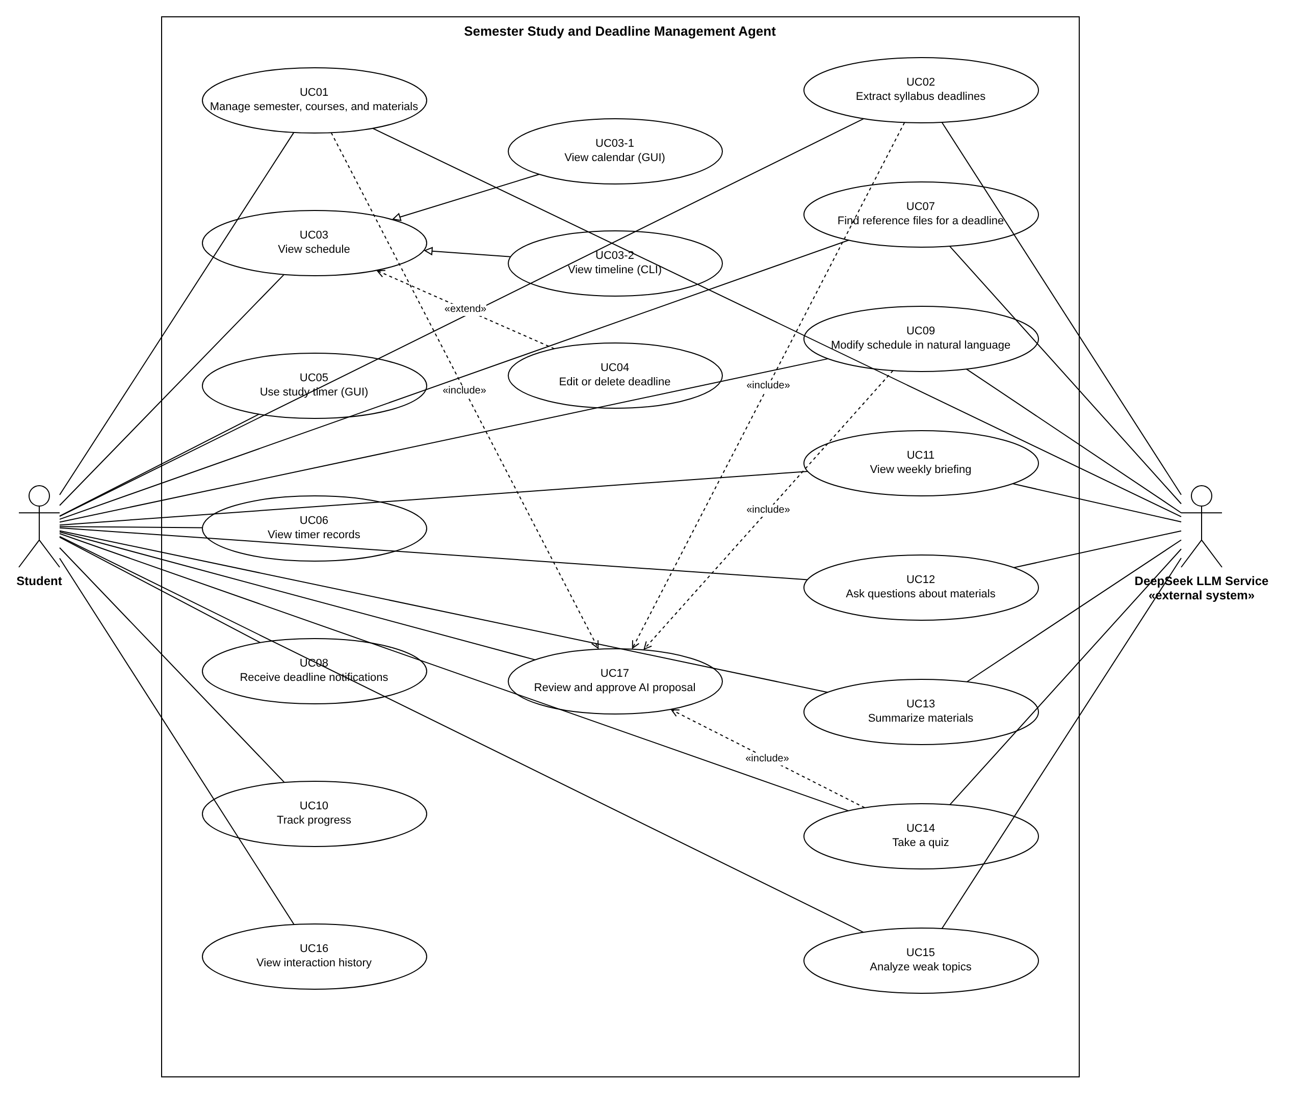
Figure 3: Use-case diagram

5.1 Actors
Actor | Description
Student | Primary actor. Uses the GUI and the CLI.
DeepSeek LLM Service | External system actor. Provides language model responses for week matching, deadline extraction, reference files, schedule interpretation, briefing, question answering, summarization, quizzes, and weak-topic analysis.

5.2 Use Cases
ID | Use case | Related features
UC01 | Manage semester, courses, and materials | F01, F04 (difficulty input)
UC02 | Extract syllabus deadlines | F02
UC03 | View schedule | F03, F04
UC03-1 | View calendar (GUI) | F03, F04
UC03-2 | View timeline (CLI) | F03, F04
UC04 | Edit or delete deadline | F03
UC05 | Use study timer (GUI) | F05
UC06 | View timer records | F05
UC07 | Find reference files for a deadline | F06
UC08 | Receive deadline notifications | F07
UC09 | Modify schedule in natural language | F08
UC10 | Track progress | F09
UC11 | View weekly briefing | F10, F04
UC12 | Ask questions about materials | F11
UC13 | Summarize materials | F12
UC14 | Take a quiz | F13
UC15 | Analyze weak topics | F14
UC16 | View interaction history | F15
UC17 | Review and approve AI proposal | F01, F02, F08, F13

5.3 Relationships
- «include»: UC01, UC02, UC09, and UC14 include UC17 (Review and approve AI proposal), because each of them ends with the same approval behavior (for UC14, whenever the quiz contains essay questions graded by the LLM).
- «extend»: UC04 (Edit or delete deadline) extends UC03 (View schedule); it is optional behavior while viewing the schedule.
- Generalization: UC03-1 (View calendar, GUI) and UC03-2 (View timeline, CLI) are specializations of UC03 (View schedule), because the two interfaces present the schedule differently.

6. Use-Case Descriptions

UC01: Manage semester, courses, and materials
Use Case ID | UC01
Use Case Name | Manage semester, courses, and materials
Actor(s) | Student, DeepSeek LLM Service
Goal | Organize semesters, courses, and course files.
Preconditions | The application is running.
Trigger | The student creates a semester or course, or uploads files (GUI or CLI).
Main Success Scenario | 1. The student creates a semester with a name, start date, and end date.  2. The student creates a course with a name, color, and difficulty.  3. The student selects a category and uploads one or more files.  4. The system stores each file and extracts its text.  5. For lecture materials, the LLM proposes a week for each file using the syllabus weekly topics.  6. Include UC17: the student reviews and approves the proposed weeks (in the CLI, y/n for each item).  7. The workspace tree is updated and saved.  8. The student clicks a course to open its course page, or opens a file in the default program.
Alternative / Exception Flows | • Text cannot be extracted: the file is stored and can be opened, but is excluded from AI features.  • Week match uncertain or no syllabus: the student assigns the week.  • Same file uploaded again: the student is asked whether to replace it.
Postconditions | The tree, files, and week assignments are saved.
Related Feature(s) | F01, F04 (difficulty input)

UC02: Extract syllabus deadlines
Use Case ID | UC02
Use Case Name | Extract syllabus deadlines
Actor(s) | Student, DeepSeek LLM Service
Goal | Add the course's assessment deadlines to the calendar.
Preconditions | The semester (with start and end dates) and the course exist.
Trigger | A file is uploaded to the course's Syllabus category, or the student runs the CLI extract command.
Main Success Scenario | 1. The system extracts the syllabus text.  2. The LLM returns candidate deadlines.  3. The system validates each candidate (format, presence in the source text, semester range) and converts relative dates.  4. The candidates and warnings are shown.  5. Include UC17: the student edits and approves the candidates (in the CLI, the numbered candidates are approved or rejected one by one with y/n).  6. Approved deadlines are saved and appear in the calendar.
Alternative / Exception Flows | • Text cannot be extracted, LLM unavailable, or nothing found: manual entry.  • Malformed LLM output: retry, then report the failure.  • Date not in the source text or outside the semester: flagged.  • Duplicate: the student decides whether to merge.  • No date or TBD: saved as undated; status bar message.
Postconditions | Approved and undated deadlines are saved.
Related Feature(s) | F02

UC03: View schedule
Use Case ID | UC03
Use Case Name | View schedule
Actor(s) | Student
Goal | See deadlines for a period.
Preconditions | A semester exists.
Trigger | The student opens the schedule.
Main Success Scenario | 1. The system loads deadlines for the selected period and course filter.  2. The current week's deadlines are ordered by the priority rule.  3. The schedule is presented by a specialization (UC03-1 or UC03-2).
Alternative / Exception Flows | • No deadlines: the student is told to upload a syllabus.
Postconditions | None (read-only).
Related Feature(s) | F03, F04

UC03-1: View calendar (GUI)
Use Case ID | UC03-1
Use Case Name | View calendar (GUI)
Actor(s) | Student
Goal | See the schedule as a monthly calendar.
Preconditions | As UC03.
Trigger | The student opens the calendar.
Main Success Scenario | 1. The monthly calendar is shown; the current week is expanded as a list in recommended order; other weeks show colored dots.  2. Undated deadlines are listed in the status bar.  3. The student may switch between the whole semester and one course.  4. The student may expand another week, open a deadline's details, or click a status bar message to open the course.
Alternative / Exception Flows | • A course has no deadlines: listed in the status bar.  • Too many items on one day: a summary is shown.
Postconditions | None.
Related Feature(s) | F03, F04

UC03-2: View timeline (CLI)
Use Case ID | UC03-2
Use Case Name | View timeline (CLI)
Actor(s) | Student
Goal | See the schedule as a timeline in the terminal.
Preconditions | As UC03.
Trigger | The student runs the timeline command.
Main Success Scenario | 1. The student selects this week, this month, or one course.  2. Deadlines are printed grouped by date, with time, title, type, and course.  3. The student may filter, search by type or name, and sort by date or by recommended order.
Alternative / Exception Flows | • No search result: "No results" is printed.
Postconditions | None.
Related Feature(s) | F03, F04

UC04: Edit or delete deadline
Use Case ID | UC04
Use Case Name | Edit or delete deadline
Actor(s) | Student
Goal | Correct or remove a deadline.
Preconditions | The deadline exists. Extends UC03.
Trigger | The student chooses edit or delete on a deadline in the calendar.
Main Success Scenario | 1. The student edits the deadline or chooses delete.  2. The system validates the change.  3. The change is applied and saved.  4. All views are refreshed.
Alternative / Exception Flows | • Invalid change, e.g. a date outside the semester: rejected.
Postconditions | The deadline is updated or removed.
Related Feature(s) | F03

UC05: Use study timer (GUI)
Use Case ID | UC05
Use Case Name | Use study timer (GUI)
Actor(s) | Student
Goal | Study for a fixed time and record it.
Preconditions | The GUI is running.
Trigger | The student selects 15, 30, or 60 minutes.
Main Success Scenario | 1. The timer starts and the panel shows the remaining time.  2. When the time is up, an alarm sounds.  3. The session is saved.
Alternative / Exception Flows | • Stopped early: the actual time studied is recorded.  • Constraint: the timer does not run while the application is closed.
Postconditions | A timer session is saved.
Related Feature(s) | F05

UC06: View timer records
Use Case ID | UC06
Use Case Name | View timer records
Actor(s) | Student
Goal | Review study time for a week.
Preconditions | None.
Trigger | The student opens the records screen or runs the CLI records command.
Main Success Scenario | 1. The student selects a week.  2. Study time per day and the weekly total are shown.
Alternative / Exception Flows | • No records: "No records" is shown.
Postconditions | None.
Related Feature(s) | F05

UC07: Find reference files for a deadline
Use Case ID | UC07
Use Case Name | Find reference files for a deadline
Actor(s) | Student, DeepSeek LLM Service
Goal | Know which lecture files to study for a deadline.
Preconditions | The deadline and lecture materials exist.
Trigger | The student asks for the reference files of a deadline (GUI or CLI).
Main Success Scenario | 1. The system builds a prompt from the deadline, syllabus topics, assignment specification, and material text.  2. The LLM returns file names.  3. The system keeps only names that match uploaded files.  4. The GUI lists the files on the course page; the CLI prints the file names.
Alternative / Exception Flows | • No materials or no text: the student is informed.  • No assignment specification: only the syllabus is used.  • Nothing found: the student is informed.
Postconditions | None (nothing is saved).
Related Feature(s) | F06

UC08: Receive deadline notifications
Use Case ID | UC08
Use Case Name | Receive deadline notifications
Actor(s) | Student
Goal | Be reminded of upcoming deadlines.
Preconditions | Deadlines with notification times exist.
Trigger | A notification time is reached, or the CLI starts.
Main Success Scenario | 1. The system finds deadlines whose notification time has been reached.  2. The GUI shows a notification and a status bar message; the CLI prints upcoming deadlines.
Alternative / Exception Flows | • The time passed while the application was closed: shown on the next start.  • Undated deadlines: not notified; listed in the status bar.
Postconditions | None.
Related Feature(s) | F07

UC09: Modify schedule in natural language
Use Case ID | UC09
Use Case Name | Modify schedule in natural language
Actor(s) | Student, DeepSeek LLM Service
Goal | Change the schedule by describing the change.
Preconditions | A semester with deadlines exists.
Trigger | The student types a change request in the chat panel or CLI.
Main Success Scenario | 1. The LLM interprets the request into an intent.  2. The system builds the change and shows it before and after.  3. Include UC17: the student approves (in the CLI, y/n).  4. The change is applied and saved.
Alternative / Exception Flows | • Ambiguous request: the agent asks for clarification.  • Item does not exist: the student is informed.  • Date outside the semester: rejected.  • Rejected by the student: no change.
Postconditions | The approved change is saved.
Related Feature(s) | F08

UC10: Track progress
Use Case ID | UC10
Use Case Name | Track progress
Actor(s) | Student
Goal | Mark work as done and see progress.
Preconditions | Deadlines exist.
Trigger | The student marks a deadline as completed (GUI or CLI).
Main Success Scenario | 1. The deadline is marked as completed and saved.  2. Course progress is recalculated and shown.
Alternative / Exception Flows | • A past deadline is not completed: shown in the status bar.
Postconditions | The completion status is saved.
Related Feature(s) | F09

UC11: View weekly briefing
Use Case ID | UC11
Use Case Name | View weekly briefing
Actor(s) | Student, DeepSeek LLM Service
Goal | Get a summary of the week.
Preconditions | A semester exists.
Trigger | The first start of the week, or the student requests a briefing (GUI or CLI briefing command).
Main Success Scenario | 1. The system collects this week's deadlines in recommended order and the weak topics.  2. The LLM writes the briefing.  3. The briefing is shown in the GUI or printed in the CLI.
Alternative / Exception Flows | • LLM unavailable: only the collected list is shown.
Postconditions | None.
Related Feature(s) | F10, F04

UC12: Ask questions about materials
Use Case ID | UC12
Use Case Name | Ask questions about materials
Actor(s) | Student, DeepSeek LLM Service
Goal | Get an answer based on the course materials.
Preconditions | The course has materials with text.
Trigger | The student asks a question on the course page.
Main Success Scenario | 1. Relevant passages are retrieved.  2. A prompt is built using the difficulty-based explanation style.  3. The LLM answers with sources.  4. Sources are verified against the uploaded files.  5. The answer is shown, recorded, and the source file can be opened.
Alternative / Exception Flows | • No supporting content: the answer is "not found in the materials".  • Only files without text, or LLM unavailable: the student is informed.
Postconditions | The interaction is recorded.
Related Feature(s) | F11

UC13: Summarize materials
Use Case ID | UC13
Use Case Name | Summarize materials
Actor(s) | Student, DeepSeek LLM Service
Goal | Get a summary of a file.
Preconditions | The file has text.
Trigger | The student selects summarize on a file.
Main Success Scenario | 1. A prompt is built from the text and the explanation style.  2. The LLM produces the summary.  3. The summary is saved and shown; it can be reopened later.
Alternative / Exception Flows | • No text: the student is informed.  • Long material: summarized in parts.
Postconditions | The summary is saved.
Related Feature(s) | F12

UC14: Take a quiz
Use Case ID | UC14
Use Case Name | Take a quiz
Actor(s) | Student, DeepSeek LLM Service
Goal | Test understanding of course material.
Preconditions | The selected scope has text.
Trigger | The student sets quiz options and starts a quiz.
Main Success Scenario | 1. The LLM generates the quiz.  2. The student answers.  3. Multiple-choice answers are graded by code and saved; essay answers are graded by the LLM with explanations.  4. Include UC17 (when the quiz has essay questions): the student accepts or corrects the AI essay scores.  5. Approved scores are saved and the result is shown.
Alternative / Exception Flows | • Malformed question: regenerated.  • No text in the scope: the student is informed.
Postconditions | The quiz result is saved.
Related Feature(s) | F13

UC15: Analyze weak topics
Use Case ID | UC15
Use Case Name | Analyze weak topics
Actor(s) | Student, DeepSeek LLM Service
Goal | Know which topics to review.
Preconditions | Quiz results or self-assessments exist.
Trigger | The student opens the weak-topic view or enters a self-assessment.
Main Success Scenario | 1. The student optionally enters a self-assessment per topic.  2. The system computes accuracy per topic.  3. The LLM explains the weak topics and recommends lectures to review.  4. The analysis is shown.
Alternative / Exception Flows | • Not enough data: the student is advised to take a quiz.
Postconditions | Self-assessments are saved.
Related Feature(s) | F14

UC16: View interaction history
Use Case ID | UC16
Use Case Name | View interaction history
Actor(s) | Student
Goal | Review or delete past interactions.
Preconditions | None.
Trigger | The student opens the history.
Main Success Scenario | 1. The history is shown.  2. The student may delete a record.
Alternative / Exception Flows | • Saving fails: the student is informed.
Postconditions | Deleted records are removed.
Related Feature(s) | F15

UC17: Review and approve AI proposal
Use Case ID | UC17
Use Case Name | Review and approve AI proposal
Actor(s) | Student
Goal | Decide which AI-proposed changes are applied.
Preconditions | A proposal exists. Included by UC01, UC02, UC09, UC14.
Trigger | A base use case produces a proposal.
Main Success Scenario | 1. The proposal and validation warnings are shown.  2. The student edits, deletes, or approves each item.  3. Only approved items are executed.  4. The decision is recorded.
Alternative / Exception Flows | • All items rejected: nothing is changed.
Postconditions | Approved changes are applied; the decision is recorded.
Related Feature(s) | F01, F02, F08, F13

7. Sequence Diagrams
The sequence diagrams use the classes and methods defined in the class diagram. Closely related use cases that share the same interaction structure are combined into one diagram. Alternative and error flows are shown as combined fragments (alt, opt, loop) and in a note on each diagram.
Diagram | Title | Use cases
SD01 | Manage semester, courses, and materials (upload and week matching) | UC01, UC17
SD02 | Extract syllabus deadlines | UC02, UC17
SD03 | View schedule, recommended order, edit deadline, track progress | UC03, UC03-1, UC03-2, UC04, UC10
SD04 | Study timer and timer records | UC05, UC06
SD05 | Find reference files for a deadline | UC07
SD06 | Deadline notifications | UC08
SD07 | Modify schedule in natural language | UC09, UC17
SD08 | Weekly briefing | UC11
SD09 | Ask questions about materials and summarize materials | UC12, UC13
SD10 | Take a quiz | UC14, UC17
SD11 | Analyze weak topics | UC15
SD12 | View interaction history | UC16

SD01: Manage semester, courses, and materials (upload and week matching)
Use cases: UC01, UC17
Participants: Student, WorkspaceTreePanel, CommandLineInterface, AgentController, DocumentReaderFactory, DocumentReader, PromptBuilder, LLMClient, ResponseParser, ApprovalDialog, CommandInvoker, DataStore
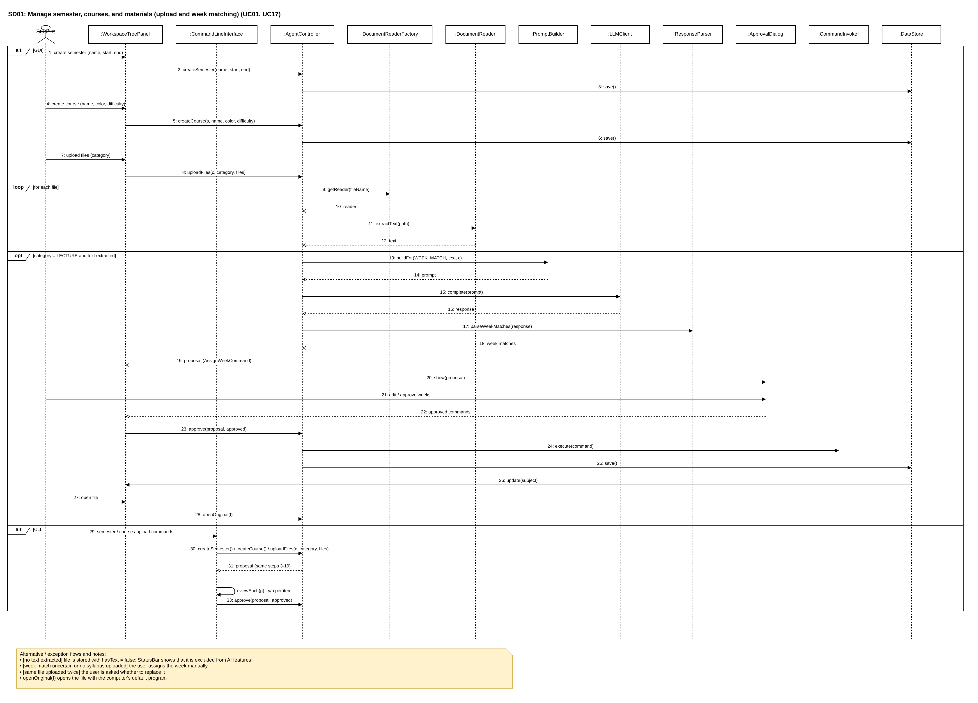
Figure 4: SD01 — Manage semester, courses, and materials (upload and week matching)
Alternative / exception flows and notes:
• [no text extracted] file is stored with hasText = false; StatusBar shows that it is excluded from AI features
• [week match uncertain or no syllabus uploaded] the user assigns the week manually
• [same file uploaded twice] the user is asked whether to replace it
• openOriginal(f) opens the file with the computer's default program

SD02: Extract syllabus deadlines
Use cases: UC02, UC17
Participants: Student, WorkspaceTreePanel, CommandLineInterface, AgentController, DocumentReaderFactory, DocumentReader, PromptBuilder, LLMClient, ResponseParser, ToolManager, DeadlineValidator, ApprovalDialog, CommandInvoker, DataStore, MemoryManager
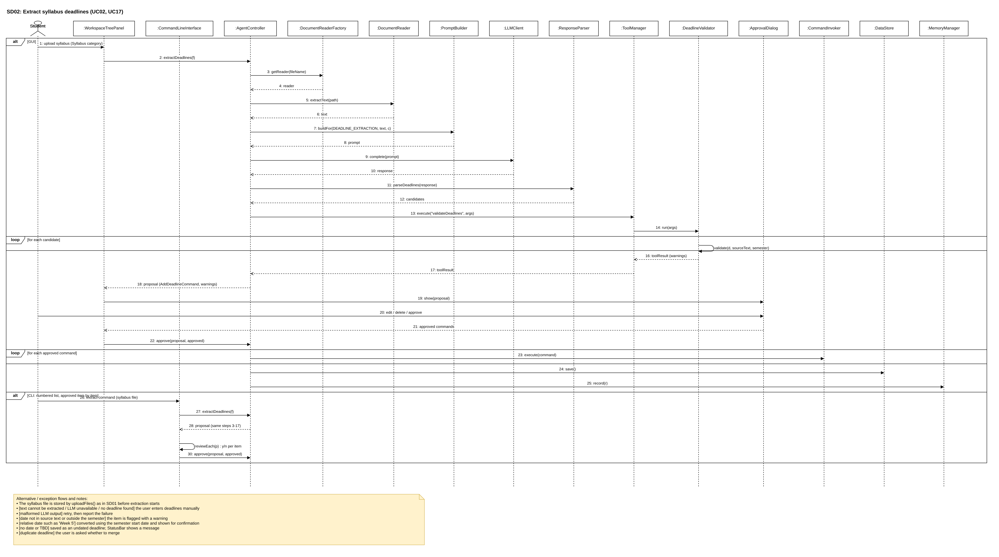
Figure 5: SD02 — Extract syllabus deadlines
Alternative / exception flows and notes:
• The syllabus file is stored by uploadFiles() as in SD01 before extraction starts
• [text cannot be extracted / LLM unavailable / no deadline found] the user enters deadlines manually
• [malformed LLM output] retry, then report the failure
• [date not in source text or outside the semester] the item is flagged with a warning
• [relative date such as 'Week 5'] converted using the semester start date and shown for confirmation
• [no date or TBD] saved as an undated deadline; StatusBar shows a message
• [duplicate deadline] the user is asked whether to merge

SD03: View schedule, recommended order, edit deadline, track progress
Use cases: UC03, UC03-1, UC03-2, UC04, UC10
Participants: Student, CalendarPanel, CommandLineInterface, AgentController, DataStore, PriorityRecommender, DeadlineValidator, CommandInvoker, ProgressTracker
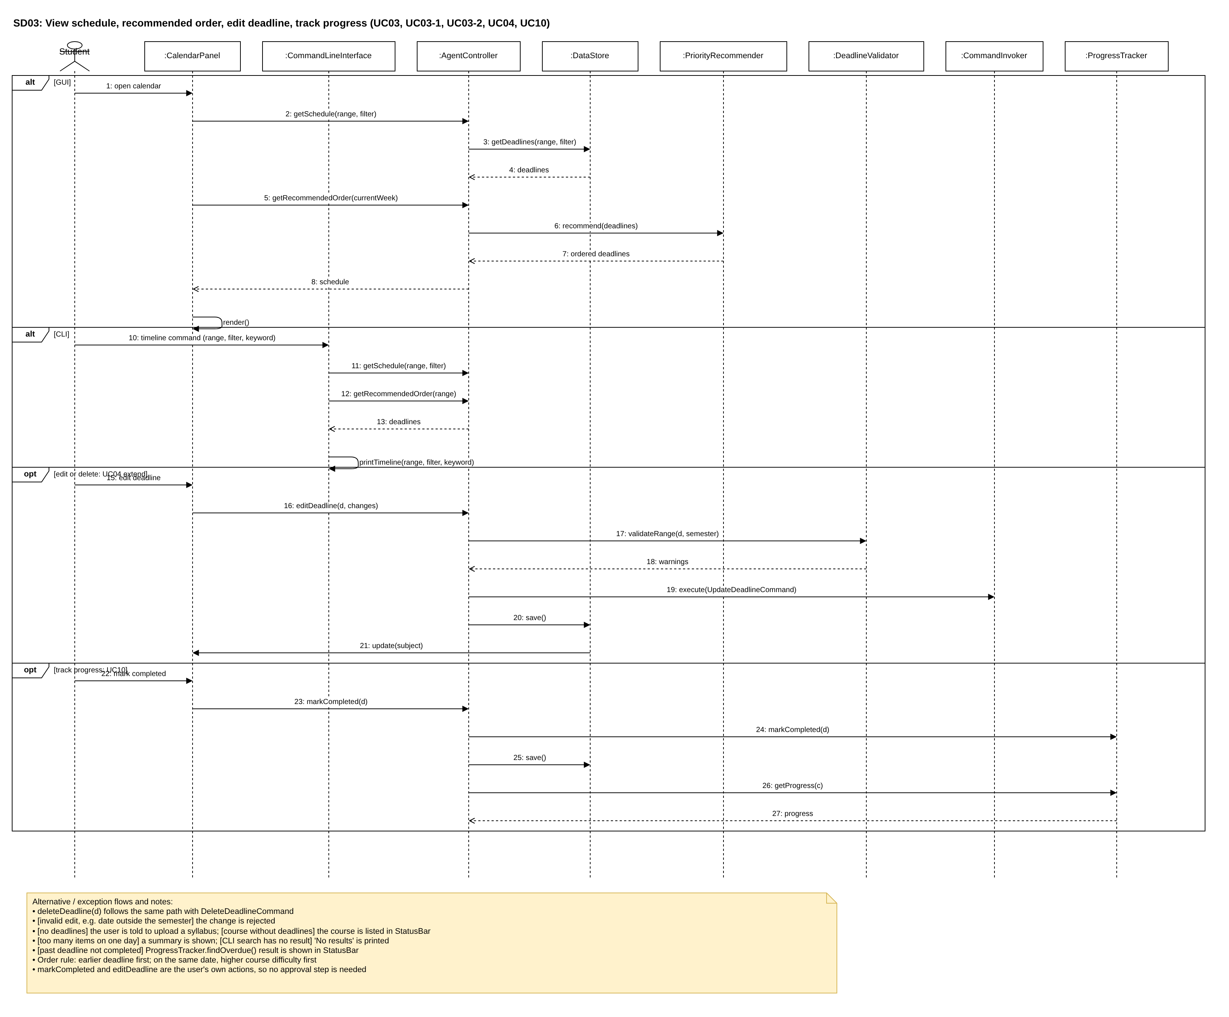
Figure 6: SD03 — View schedule, recommended order, edit deadline, track progress
Alternative / exception flows and notes:
• deleteDeadline(d) follows the same path with DeleteDeadlineCommand
• [invalid edit, e.g. date outside the semester] the change is rejected
• [no deadlines] the user is told to upload a syllabus; [course without deadlines] the course is listed in StatusBar
• [too many items on one day] a summary is shown; [CLI search has no result] 'No results' is printed
• [past deadline not completed] ProgressTracker.findOverdue() result is shown in StatusBar
• Order rule: earlier deadline first; on the same date, higher course difficulty first
• markCompleted and editDeadline are the user's own actions, so no approval step is needed

SD04: Study timer and timer records
Use cases: UC05, UC06
Participants: Student, TimerPanel, TimerRecordPanel, CommandLineInterface, AgentController, StudyTimer, DataStore
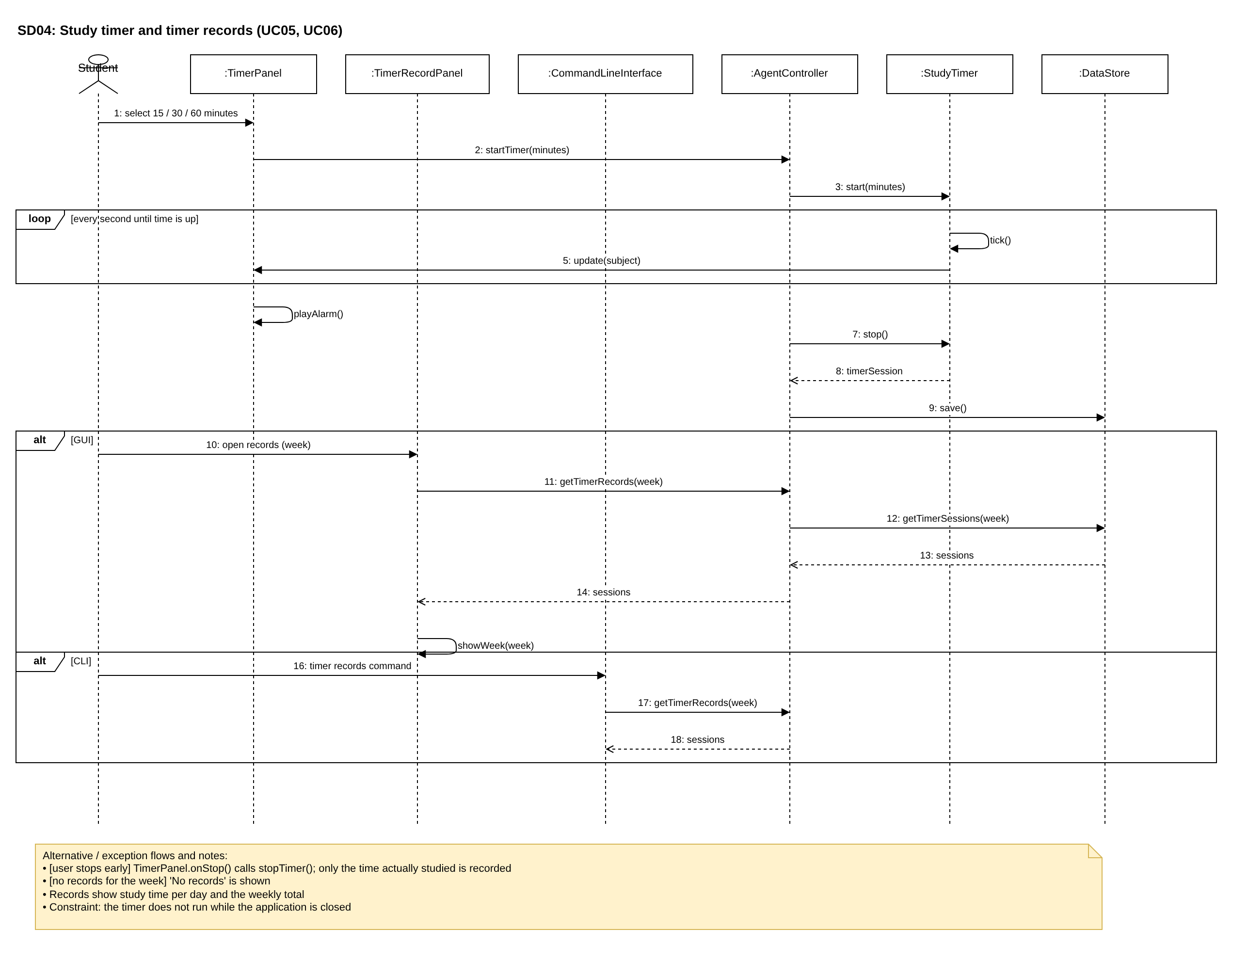
Figure 7: SD04 — Study timer and timer records
Alternative / exception flows and notes:
• [user stops early] TimerPanel.onStop() calls stopTimer(); only the time actually studied is recorded
• [no records for the week] 'No records' is shown
• Records show study time per day and the weekly total
• Constraint: the timer does not run while the application is closed

SD05: Find reference files for a deadline
Use cases: UC07
Participants: Student, CoursePage, CommandLineInterface, AgentController, PromptBuilder, LLMClient, ResponseParser, ToolManager, FileNameValidator
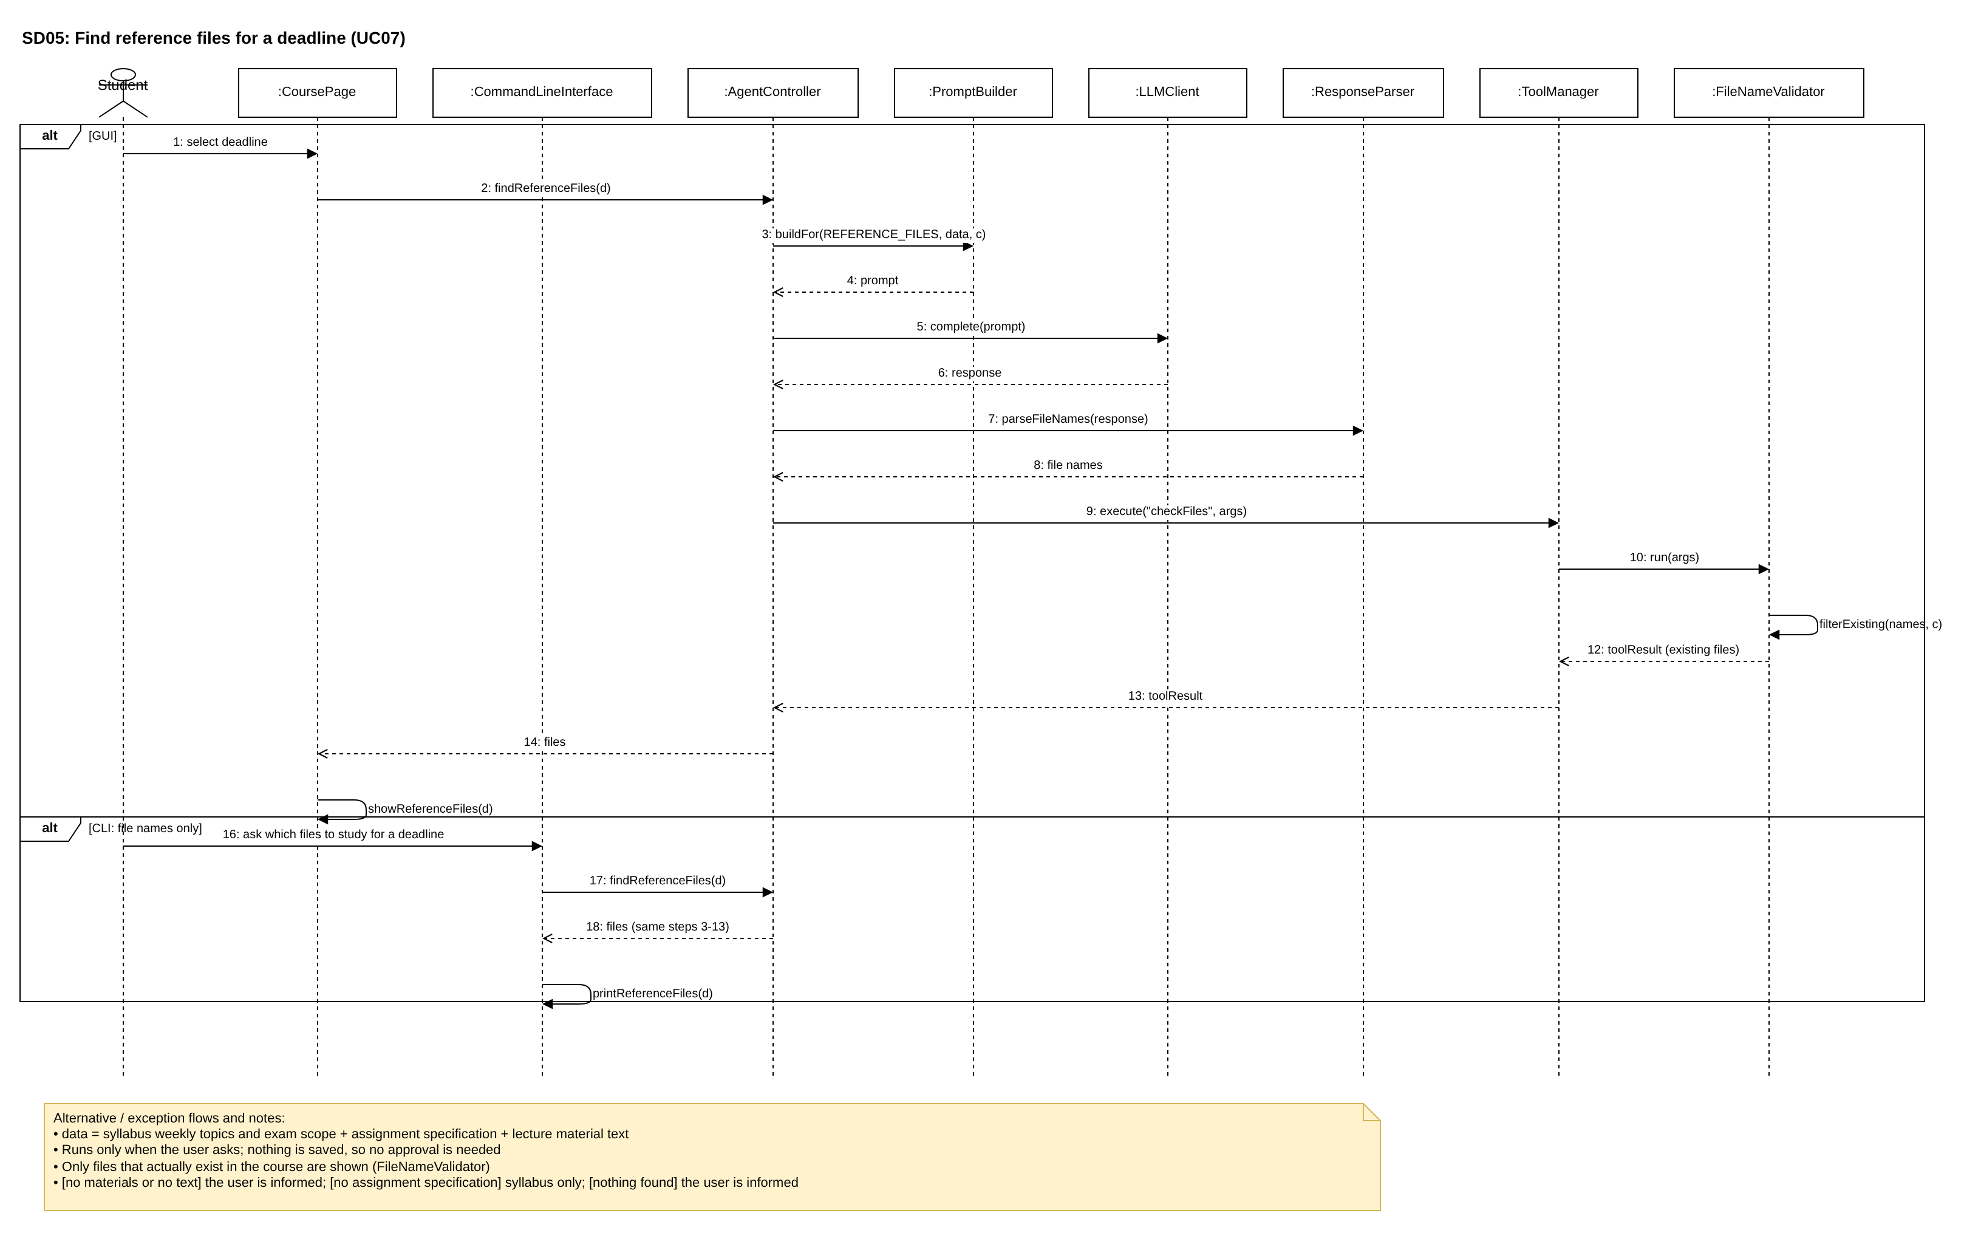
Figure 8: SD05 — Find reference files for a deadline
Alternative / exception flows and notes:
• data = syllabus weekly topics and exam scope + assignment specification + lecture material text
• Runs only when the user asks; nothing is saved, so no approval is needed
• Only files that actually exist in the course are shown (FileNameValidator)
• [no materials or no text] the user is informed; [no assignment specification] syllabus only; [nothing found] the user is informed

SD06: Deadline notifications
Use cases: UC08
Participants: Student, MainWindow, CommandLineInterface, AgentController, NotificationService, DataStore, StatusBar
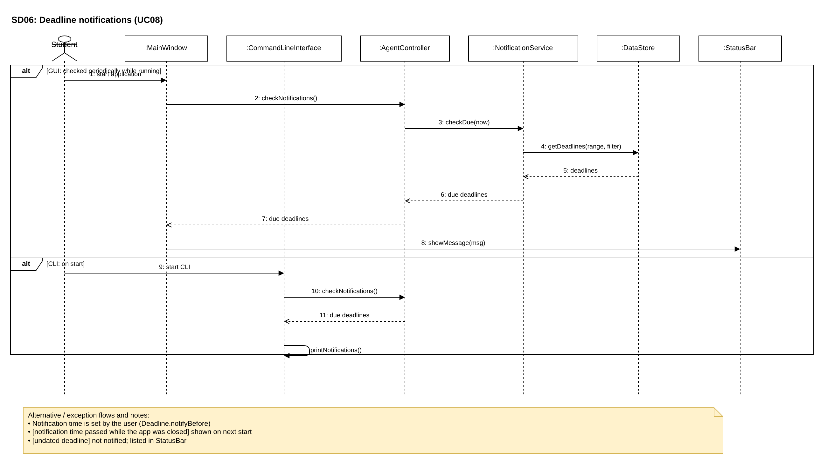
Figure 9: SD06 — Deadline notifications
Alternative / exception flows and notes:
• Notification time is set by the user (Deadline.notifyBefore)
• [notification time passed while the app was closed] shown on next start
• [undated deadline] not notified; listed in StatusBar

SD07: Modify schedule in natural language
Use cases: UC09, UC17
Participants: Student, ChatPanel, CommandLineInterface, AgentController, Planner, PromptBuilder, LLMClient, ResponseParser, ApprovalDialog, CommandInvoker, DataStore, MemoryManager
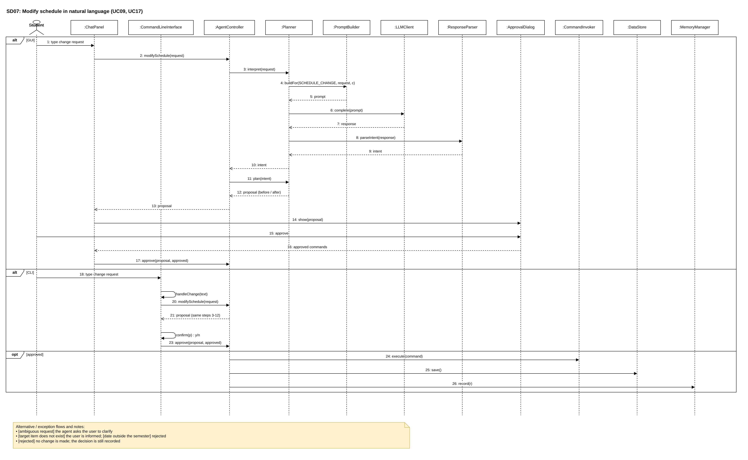
Figure 10: SD07 — Modify schedule in natural language
Alternative / exception flows and notes:
• [ambiguous request] the agent asks the user to clarify
• [target item does not exist] the user is informed; [date outside the semester] rejected
• [rejected] no change is made; the decision is still recorded

SD08: Weekly briefing
Use cases: UC11
Participants: Student, MainWindow, CommandLineInterface, AgentController, DataStore, PriorityRecommender, QuizStatistics, PromptBuilder, LLMClient
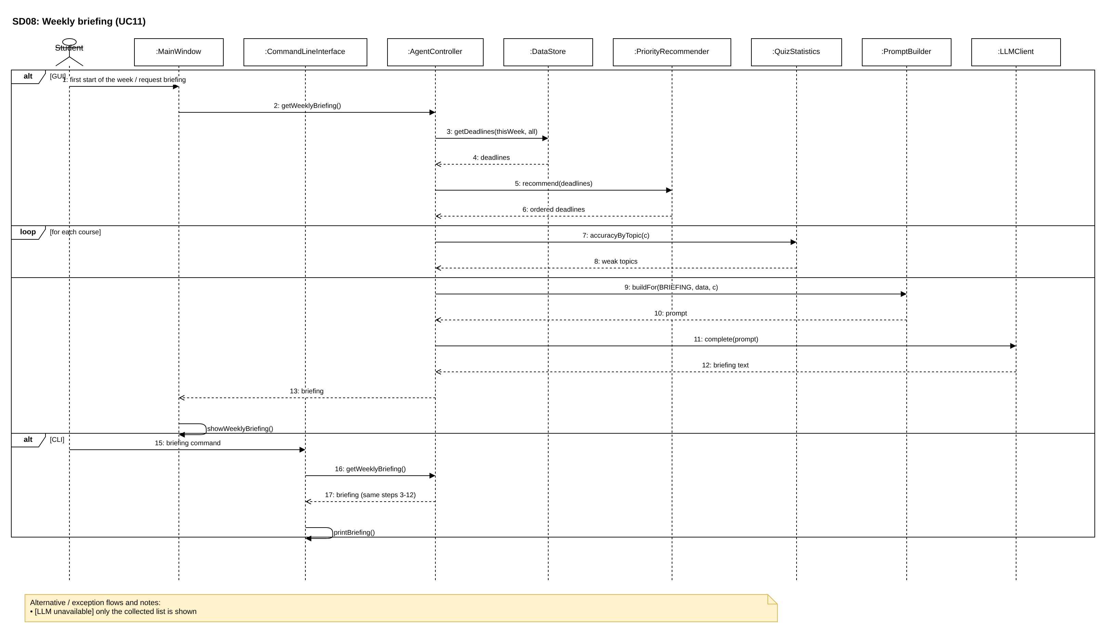
Figure 11: SD08 — Weekly briefing
Alternative / exception flows and notes:
• [LLM unavailable] only the collected list is shown

SD09: Ask questions about materials and summarize materials
Use cases: UC12, UC13
Participants: Student, ChatPanel, CoursePage, AgentController, ToolManager, MaterialSearcher, FileNameValidator, MemoryManager, PromptBuilder, ExplanationStrategy, LLMClient, ResponseParser, DataStore
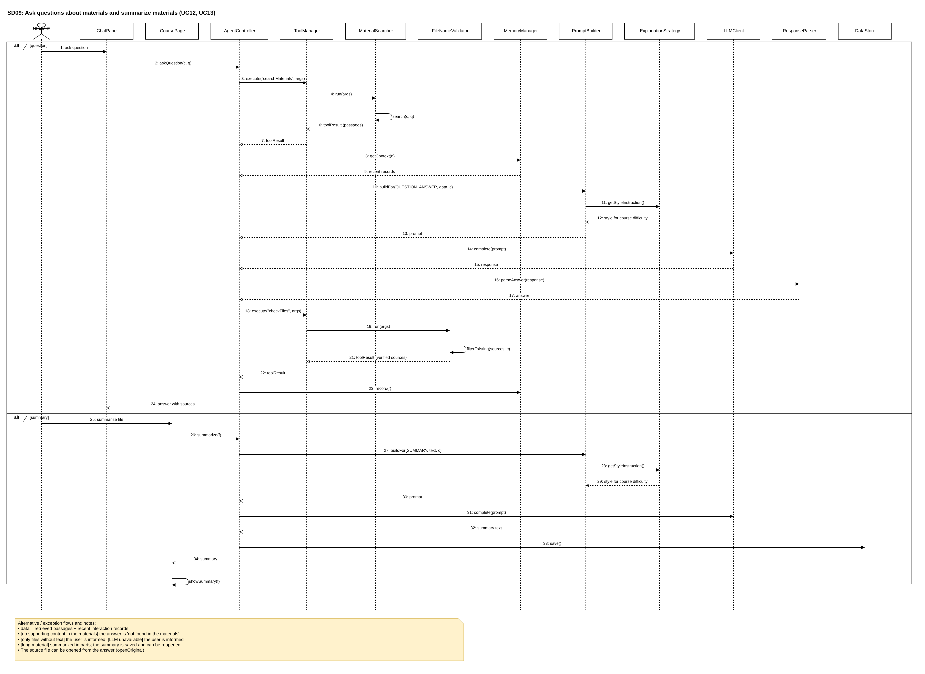
Figure 12: SD09 — Ask questions about materials and summarize materials
Alternative / exception flows and notes:
• data = retrieved passages + recent interaction records
• [no supporting content in the materials] the answer is 'not found in the materials'
• [only files without text] the user is informed; [LLM unavailable] the user is informed
• [long material] summarized in parts; the summary is saved and can be reopened
• The source file can be opened from the answer (openOriginal)

SD10: Take a quiz
Use cases: UC14, UC17
Participants: Student, QuizPanel, AgentController, PromptBuilder, ExplanationStrategy, LLMClient, ResponseParser, GradingStrategy, ApprovalDialog, CommandInvoker, DataStore, MemoryManager
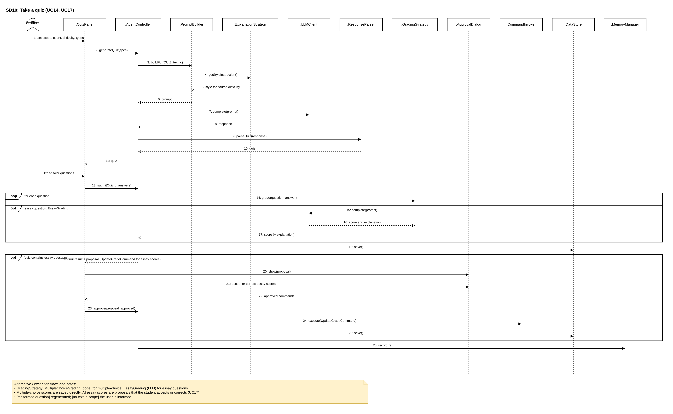
Figure 13: SD10 — Take a quiz
Alternative / exception flows and notes:
• GradingStrategy: MultipleChoiceGrading (code) for multiple-choice; EssayGrading (LLM) for essay questions
• Multiple-choice scores are saved directly; AI essay scores are proposals that the student accepts or corrects (UC17)
• [malformed question] regenerated; [no text in scope] the user is informed

SD11: Analyze weak topics
Use cases: UC15
Participants: Student, CoursePage, AgentController, QuizStatistics, DataStore, PromptBuilder, ExplanationStrategy, LLMClient
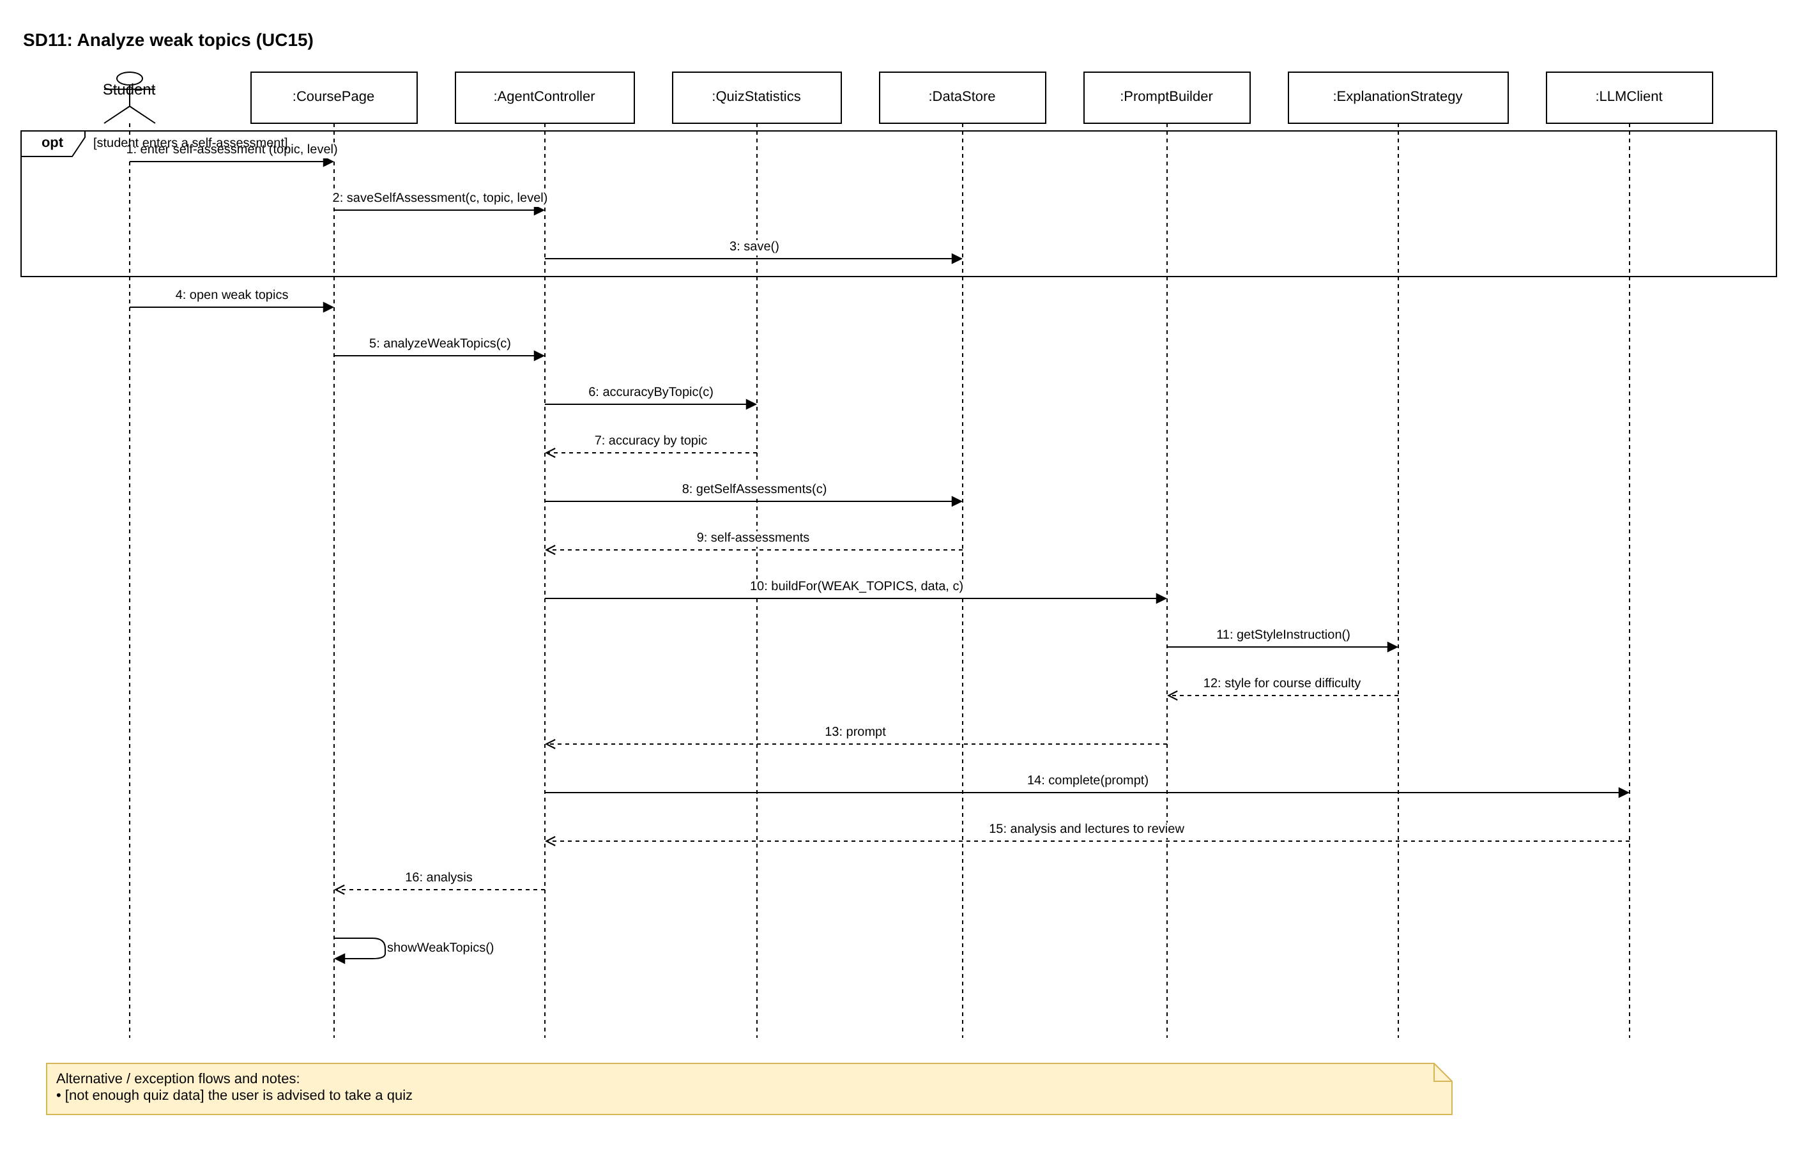
Figure 14: SD11 — Analyze weak topics
Alternative / exception flows and notes:
• [not enough quiz data] the user is advised to take a quiz

SD12: View interaction history
Use cases: UC16
Participants: Student, MainWindow, AgentController, MemoryManager, DataStore
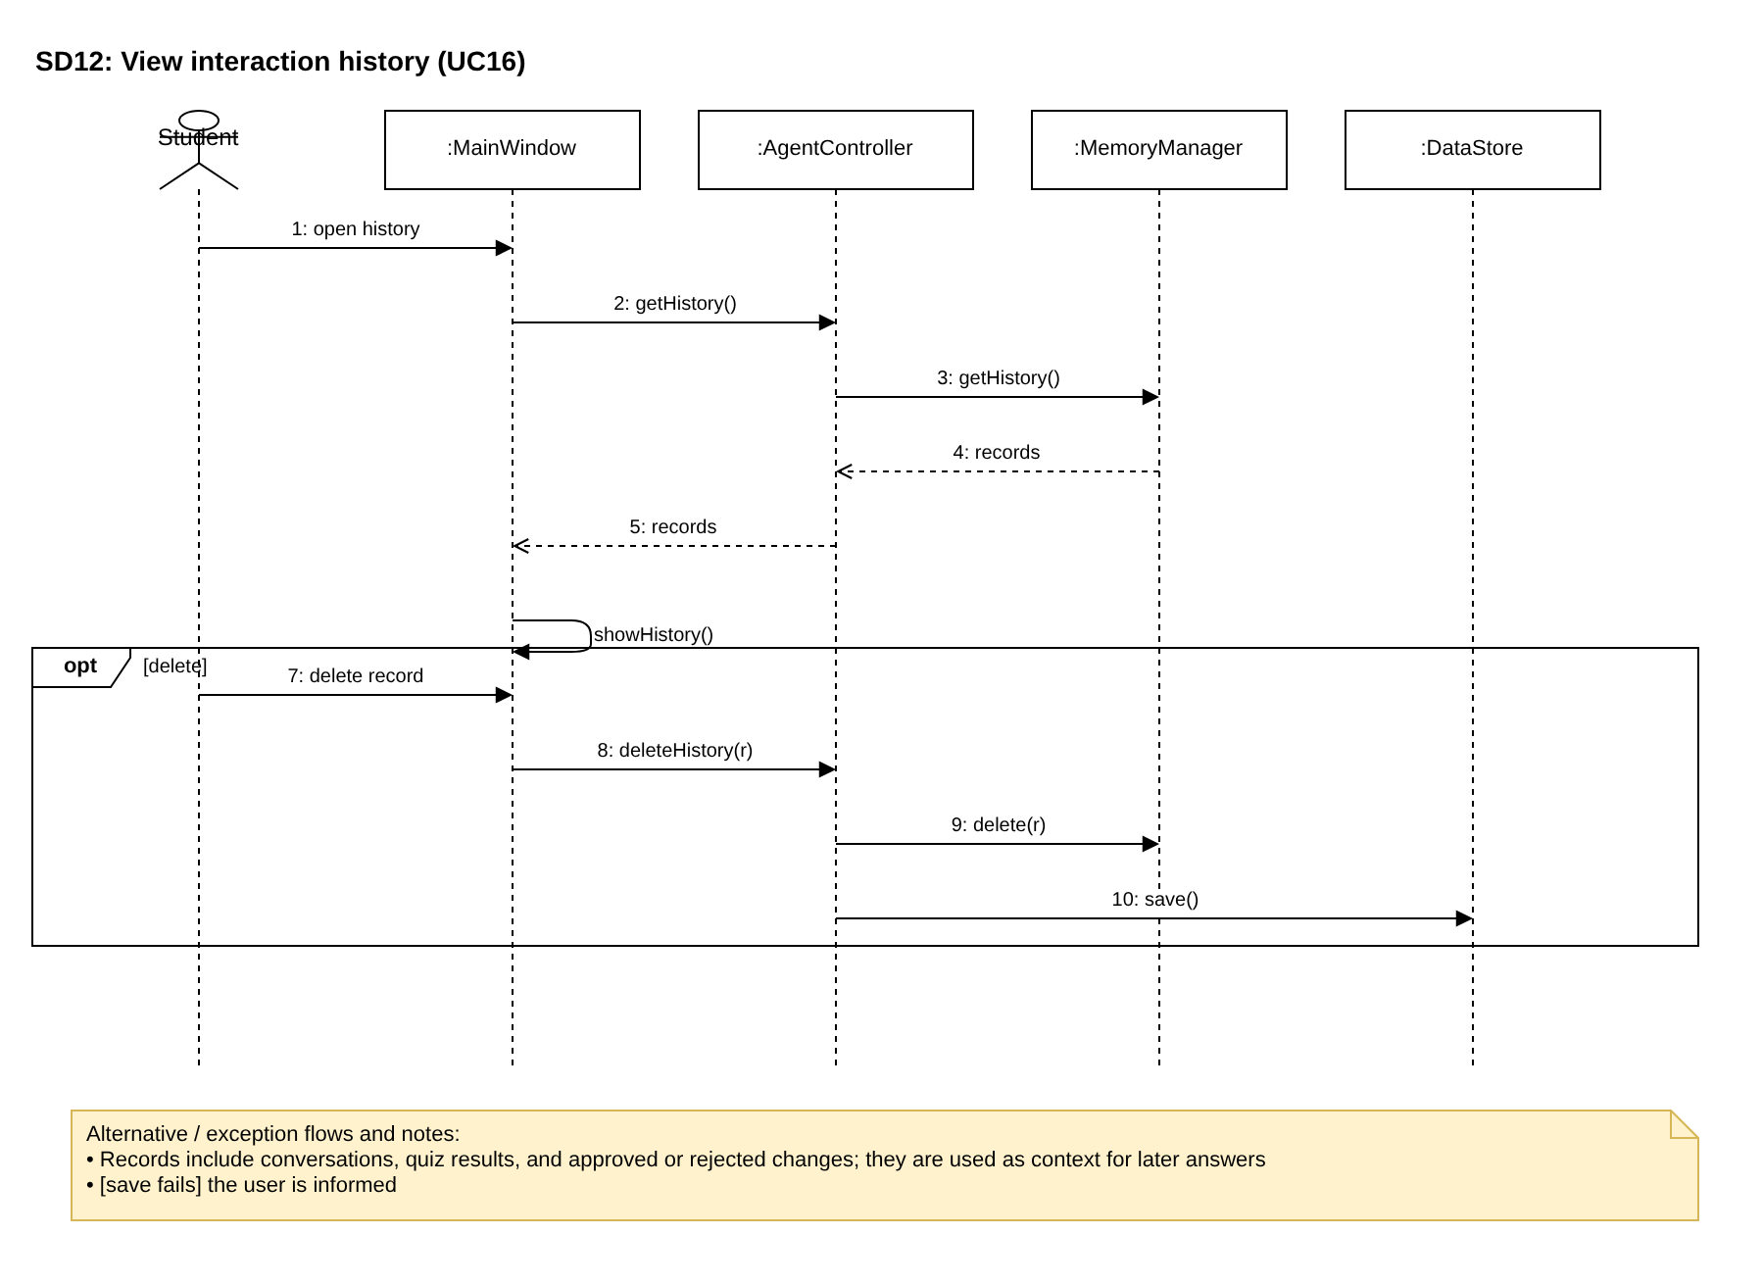
Figure 15: SD12 — View interaction history
Alternative / exception flows and notes:
• Records include conversations, quiz results, and approved or rejected changes; they are used as context for later answers
• [save fails] the user is informed

8. Feature-to-Design Traceability Table
Feature | Description | Type | Use case | Classes | Key methods | Sequence diagram | Design pattern(s)
F01 | Semester, course, and material management | Hybrid | UC01, UC17 | WorkspaceTreePanel, CommandLineInterface, AgentController, Semester, Course, CategoryFolder, MaterialFile, DocumentReaderFactory, DocumentReader, PromptBuilder, LLMClient, ResponseParser, AssignWeekCommand, CommandInvoker, DataStore | createSemester(), createCourse(), uploadFiles(), reviewEach(), getReader(), extractText(), parseWeekMatches(), approve(), execute(), openOriginal() | SD01 | Composite, Factory, Adapter, Command, Observer, Facade
F02 | Syllabus deadline extraction | Hybrid | UC02, UC17 | WorkspaceTreePanel, CommandLineInterface, AgentController, DocumentReaderFactory, DocumentReader, PromptBuilder, LLMClient, ResponseParser, ToolManager, DeadlineValidator, Proposal, AddDeadlineCommand, ApprovalDialog, CommandInvoker, DataStore, MemoryManager | extractDeadlines(), getReader(), extractText(), buildFor(), complete(), parseDeadlines(), execute(), validate(), reviewEach(), approve() | SD02 | Facade, Adapter, Command
F03 | Schedule view and deadline editing | Deterministic | UC03, UC03-1, UC03-2, UC04 | CalendarPanel, CommandLineInterface, AgentController, DataStore, DeadlineValidator, UpdateDeadlineCommand, DeleteDeadlineCommand, CommandInvoker, StatusBar | getSchedule(), getDeadlines(), render(), printTimeline(), editDeadline(), deleteDeadline(), validateRange(), execute() | SD03 | Facade, Observer, Command
F04 | Priority recommendation | Deterministic | UC01, UC03, UC03-1, UC03-2, UC11 | PriorityRecommender, AgentController, Course | getRecommendedOrder(), recommend() | SD03, SD08 | Facade
F05 | Study timer and records | Deterministic | UC05, UC06 | TimerPanel, TimerRecordPanel, CommandLineInterface, AgentController, StudyTimer, TimerSession, DataStore | startTimer(), start(), tick(), update(), stop(), getTimerRecords(), getTimerSessions() | SD04 | Observer, Facade
F06 | Reference files for a deadline | Hybrid | UC07 | CoursePage, CommandLineInterface, AgentController, PromptBuilder, LLMClient, ResponseParser, ToolManager, FileNameValidator | findReferenceFiles(), buildFor(), complete(), parseFileNames(), execute(), filterExisting() | SD05 | Facade, Adapter
F07 | Deadline notifications | Deterministic | UC08 | MainWindow, CommandLineInterface, AgentController, NotificationService, DataStore, StatusBar | checkNotifications(), checkDue(), showMessage(), printNotifications() | SD06 | Facade
F08 | Natural-language schedule modification | Hybrid | UC09, UC17 | ChatPanel, CommandLineInterface, AgentController, Planner, PromptBuilder, LLMClient, ResponseParser, Proposal, Command, CommandInvoker, DataStore, MemoryManager | modifySchedule(), interpret(), parseIntent(), plan(), approve(), execute() | SD07 | Command, Adapter, Facade
F09 | Progress tracking | Deterministic | UC10 | CalendarPanel, CommandLineInterface, AgentController, ProgressTracker, DataStore | markCompleted(), getProgress(), findOverdue() | SD03 | Facade, Observer
F10 | Weekly briefing | Hybrid | UC11 | MainWindow, CommandLineInterface, AgentController, DataStore, PriorityRecommender, QuizStatistics, PromptBuilder, LLMClient | getWeeklyBriefing(), recommend(), accuracyByTopic(), buildFor(), complete(), printBriefing() | SD08 | Facade, Adapter
F11 | Question answering on materials | Hybrid | UC12 | ChatPanel, AgentController, ToolManager, MaterialSearcher, FileNameValidator, MemoryManager, PromptBuilder, ExplanationStrategy, LLMClient, ResponseParser | askQuestion(), execute(), search(), getContext(), buildFor(), getStyleInstruction(), complete(), parseAnswer(), filterExisting(), record() | SD09 | Strategy, Adapter, Facade
F12 | Material summarization | AI | UC13 | CoursePage, AgentController, PromptBuilder, ExplanationStrategy, LLMClient, Summary, DataStore | summarize(), buildFor(), getStyleInstruction(), complete(), save() | SD09 | Strategy, Adapter
F13 | Quiz generation and grading | Hybrid | UC14, UC17 | QuizPanel, AgentController, PromptBuilder, ExplanationStrategy, LLMClient, ResponseParser, Quiz, Question, GradingStrategy, MultipleChoiceGrading, EssayGrading, QuizResult, UpdateGradeCommand, ApprovalDialog, CommandInvoker, DataStore, MemoryManager | generateQuiz(), getStyleInstruction(), parseQuiz(), submitQuiz(), grade(), complete(), approve(), execute() | SD10 | Strategy, Command, Adapter
F14 | Weak topic analysis | Hybrid | UC15 | CoursePage, AgentController, QuizStatistics, SelfAssessment, DataStore, PromptBuilder, ExplanationStrategy, LLMClient | saveSelfAssessment(), analyzeWeakTopics(), accuracyByTopic(), getSelfAssessments(), getStyleInstruction(), complete() | SD11 | Strategy, Adapter
F15 | Interaction history | Deterministic | UC16 | MainWindow, AgentController, MemoryManager, InteractionRecord, DataStore | getHistory(), deleteHistory(), record(), delete() | SD12 | Facade

9. Feature Implementation Explanations

F01 — Semester, Course, and Material Management
Related use case(s): UC01, UC17 Sequence diagram: SD01
Classes involved: WorkspaceTreePanel, CommandLineInterface, AgentController, Semester, Course, CategoryFolder, MaterialFile, DocumentReaderFactory, DocumentReader, PromptBuilder, LLMClient, ResponseParser, AssignWeekCommand, CommandInvoker, DataStore
Important methods: createSemester(), createCourse(), uploadFiles(), reviewEach(), getReader(), extractText(), parseWeekMatches(), approve(), execute(), openOriginal()
Execution: When the student creates a semester or course, WorkspaceTreePanel calls AgentController.createSemester() or createCourse(), and DataStore.save() stores the new node. For an upload, AgentController.uploadFiles() asks DocumentReaderFactory.getReader() for the reader matching each file's extension and calls DocumentReader.extractText(). For lecture materials, PromptBuilder.buildFor(WEEK_MATCH, …) builds a prompt, LLMClient.complete() sends it to DeepSeek, and ResponseParser.parseWeekMatches() returns the proposed weeks, which are wrapped as AssignWeekCommand objects in a Proposal. ApprovalDialog.show() returns the approved commands, AgentController.approve() passes them to CommandInvoker.execute(), and DataStore notifies its observers so the tree refreshes. openOriginal() opens a file in the default program. In the CLI, handleCreateSemester(), handleCreateCourse(), and handleUpload() call the same AgentController methods, and reviewEach() asks y/n for each proposed week before approve() is called.

F02 — Syllabus Deadline Extraction
Related use case(s): UC02, UC17 Sequence diagram: SD02
Classes involved: WorkspaceTreePanel, CommandLineInterface, AgentController, DocumentReaderFactory, DocumentReader, PromptBuilder, LLMClient, ResponseParser, ToolManager, DeadlineValidator, Proposal, AddDeadlineCommand, ApprovalDialog, CommandInvoker, DataStore, MemoryManager
Important methods: extractDeadlines(), getReader(), extractText(), buildFor(), complete(), parseDeadlines(), execute(), validate(), reviewEach(), approve()
Execution: AgentController.extractDeadlines() obtains a reader from DocumentReaderFactory.getReader(), extracts the syllabus text, builds a DEADLINE_EXTRACTION prompt, and calls LLMClient.complete(). ResponseParser.parseDeadlines() converts the response into Deadline candidates, and AgentController calls ToolManager.execute(), which runs DeadlineValidator to check each candidate against the source text and the semester period (validate()). The candidates and warnings are returned as a Proposal of AddDeadlineCommand objects; after approval in ApprovalDialog, or item by item through CommandLineInterface.reviewEach() after handleExtract() in the CLI, CommandInvoker executes them, DataStore saves them, and MemoryManager.record() stores the decision.

F03 — Schedule View (Calendar and Timeline)
Related use case(s): UC03, UC03-1, UC03-2, UC04 Sequence diagram: SD03
Classes involved: CalendarPanel, CommandLineInterface, AgentController, DataStore, DeadlineValidator, UpdateDeadlineCommand, DeleteDeadlineCommand, CommandInvoker, StatusBar
Important methods: getSchedule(), getDeadlines(), render(), printTimeline(), editDeadline(), deleteDeadline(), validateRange(), execute()
Execution: CalendarPanel calls AgentController.getSchedule(), which reads deadlines from DataStore.getDeadlines(), and render() draws the month with the current week expanded. In the CLI, CommandLineInterface calls the same methods and printTimeline() prints them grouped by date. Editing calls editDeadline(); DeadlineValidator.validateRange() checks that the new date is within the semester and CommandInvoker executes an UpdateDeadlineCommand (DeleteDeadlineCommand for deleteDeadline()). DataStore then notifies CalendarPanel and StatusBar.

F04 — Priority Recommendation
Related use case(s): UC01, UC03, UC03-1, UC03-2, UC11 Sequence diagram: SD03, SD08
Classes involved: PriorityRecommender, AgentController, Course
Important methods: getRecommendedOrder(), recommend()
Execution: AgentController.getRecommendedOrder() passes the period's deadlines to PriorityRecommender.recommend(), which sorts them by due date and then by the course's difficulty. CalendarPanel uses the order for the current-week list, CommandLineInterface for the timeline sort option, and getWeeklyBriefing() for the briefing.

F05 — Study Timer and Weekly Records
Related use case(s): UC05, UC06 Sequence diagram: SD04
Classes involved: TimerPanel, TimerRecordPanel, CommandLineInterface, AgentController, StudyTimer, TimerSession, DataStore
Important methods: startTimer(), start(), tick(), update(), stop(), getTimerRecords(), getTimerSessions()
Execution: TimerPanel.onStart() calls AgentController.startTimer(), which calls StudyTimer.start(). Each tick() notifies TimerPanel through update(); when the time is up, TimerPanel.playAlarm() runs and AgentController.stopTimer() obtains a TimerSession from StudyTimer.stop() and saves it. TimerRecordPanel and CommandLineInterface call getTimerRecords(), which reads DataStore.getTimerSessions().

F06 — Reference Files for a Deadline
Related use case(s): UC07 Sequence diagram: SD05
Classes involved: CoursePage, CommandLineInterface, AgentController, PromptBuilder, LLMClient, ResponseParser, ToolManager, FileNameValidator
Important methods: findReferenceFiles(), buildFor(), complete(), parseFileNames(), execute(), filterExisting()
Execution: CoursePage or CommandLineInterface calls AgentController.findReferenceFiles(). PromptBuilder builds a REFERENCE_FILES prompt from the deadline, syllabus topics, assignment specification, and material text; LLMClient.complete() returns file names that ResponseParser.parseFileNames() extracts. ToolManager.execute() runs FileNameValidator, whose filterExisting() keeps only uploaded files. CoursePage.showReferenceFiles() lists them; CommandLineInterface.printReferenceFiles() prints the names.

F07 — Deadline Notifications
Related use case(s): UC08 Sequence diagram: SD06
Classes involved: MainWindow, CommandLineInterface, AgentController, NotificationService, DataStore, StatusBar
Important methods: checkNotifications(), checkDue(), showMessage(), printNotifications()
Execution: MainWindow (periodically) and CommandLineInterface (on start) call AgentController.checkNotifications(), which calls NotificationService.checkDue() with the current time. NotificationService compares each deadline's notifyBefore with its due time. The GUI shows the result through StatusBar.showMessage(); the CLI prints it with printNotifications().

F08 — Natural-Language Schedule Modification
Related use case(s): UC09, UC17 Sequence diagram: SD07
Classes involved: ChatPanel, CommandLineInterface, AgentController, Planner, PromptBuilder, LLMClient, ResponseParser, Proposal, Command, CommandInvoker, DataStore, MemoryManager
Important methods: modifySchedule(), interpret(), parseIntent(), plan(), approve(), execute()
Execution: ChatPanel or CommandLineInterface.handleChange() calls AgentController.modifySchedule(). Planner.interpret() builds a SCHEDULE_CHANGE prompt, calls LLMClient.complete(), and obtains an Intent from ResponseParser.parseIntent(). Planner.plan() turns the intent into Command objects in a Proposal that shows the change before and after. After approval in ApprovalDialog (or confirm() in the CLI), CommandInvoker executes the commands, DataStore saves them, and MemoryManager records the decision.

F09 — Progress Tracking
Related use case(s): UC10 Sequence diagram: SD03
Classes involved: CalendarPanel, CommandLineInterface, AgentController, ProgressTracker, DataStore
Important methods: markCompleted(), getProgress(), findOverdue()
Execution: CalendarPanel.onComplete() or CommandLineInterface.handleDone() calls AgentController.markCompleted(), which calls ProgressTracker.markCompleted() and DataStore.save(). getProgress() returns the course's completed-to-total ratio, and findOverdue() identifies past deadlines that are not completed, which are shown in StatusBar.

F10 — Weekly Briefing
Related use case(s): UC11 Sequence diagram: SD08
Classes involved: MainWindow, CommandLineInterface, AgentController, DataStore, PriorityRecommender, QuizStatistics, PromptBuilder, LLMClient
Important methods: getWeeklyBriefing(), recommend(), accuracyByTopic(), buildFor(), complete(), printBriefing()
Execution: AgentController.getWeeklyBriefing() collects this week's deadlines from DataStore, orders them with PriorityRecommender.recommend(), and collects weak topics with QuizStatistics.accuracyByTopic(). PromptBuilder builds a BRIEFING prompt and LLMClient.complete() returns the text, which MainWindow.showWeeklyBriefing() displays or CommandLineInterface.printBriefing() prints.

F11 — Question Answering on Course Materials
Related use case(s): UC12 Sequence diagram: SD09
Classes involved: ChatPanel, AgentController, ToolManager, MaterialSearcher, FileNameValidator, MemoryManager, PromptBuilder, ExplanationStrategy, LLMClient, ResponseParser
Important methods: askQuestion(), execute(), search(), getContext(), buildFor(), getStyleInstruction(), complete(), parseAnswer(), filterExisting(), record()
Execution: ChatPanel calls AgentController.askQuestion(). ToolManager.execute() runs MaterialSearcher, whose search() retrieves passages from the course's materials (collected through the WorkspaceNode tree), and MemoryManager.getContext() adds recent interaction records. PromptBuilder.buildFor(QUESTION_ANSWER, …) adds the instruction from the ExplanationStrategy that matches the course difficulty. LLMClient.complete() returns the answer, ResponseParser.parseAnswer() creates an Answer, and FileNameValidator (through ToolManager) verifies its sources. MemoryManager.record() stores the interaction.

F12 — Material Summarization
Related use case(s): UC13 Sequence diagram: SD09
Classes involved: CoursePage, AgentController, PromptBuilder, ExplanationStrategy, LLMClient, Summary, DataStore
Important methods: summarize(), buildFor(), getStyleInstruction(), complete(), save()
Execution: CoursePage calls AgentController.summarize(). PromptBuilder builds a SUMMARY prompt with the difficulty-based ExplanationStrategy, LLMClient.complete() returns the summary, and a Summary object is saved by DataStore so CoursePage.showSummary() can display it again later.

F13 — Quiz Generation and Grading
Related use case(s): UC14, UC17 Sequence diagram: SD10
Classes involved: QuizPanel, AgentController, PromptBuilder, ExplanationStrategy, LLMClient, ResponseParser, Quiz, Question, GradingStrategy, MultipleChoiceGrading, EssayGrading, QuizResult, UpdateGradeCommand, ApprovalDialog, CommandInvoker, DataStore, MemoryManager
Important methods: generateQuiz(), getStyleInstruction(), parseQuiz(), submitQuiz(), grade(), complete(), approve(), execute()
Execution: QuizPanel.onGenerate() calls AgentController.generateQuiz() with a QuizSpec. PromptBuilder builds a QUIZ prompt, LLMClient.complete() returns the questions, and ResponseParser.parseQuiz() creates the Quiz. submitQuiz() calls GradingStrategy.grade() for each question: MultipleChoiceGrading for multiple-choice and EssayGrading (which uses LLMClient) for essays. Multiple-choice scores are saved directly. AI essay scores are returned as UpdateGradeCommand objects in a Proposal; after the student accepts or corrects them in ApprovalDialog, CommandInvoker executes them, DataStore saves the QuizResult, and MemoryManager records it.

F14 — Weak Topic Analysis
Related use case(s): UC15 Sequence diagram: SD11
Classes involved: CoursePage, AgentController, QuizStatistics, SelfAssessment, DataStore, PromptBuilder, ExplanationStrategy, LLMClient
Important methods: saveSelfAssessment(), analyzeWeakTopics(), accuracyByTopic(), getSelfAssessments(), getStyleInstruction(), complete()
Execution: CoursePage.onSelfAssessment() calls AgentController.saveSelfAssessment(). analyzeWeakTopics() combines QuizStatistics.accuracyByTopic() with DataStore.getSelfAssessments(), builds a WEAK_TOPICS prompt with the ExplanationStrategy, and LLMClient.complete() returns the explanation and lectures to review, which CoursePage.showWeakTopics() displays.

F15 — Interaction History
Related use case(s): UC16 Sequence diagram: SD12
Classes involved: MainWindow, AgentController, MemoryManager, InteractionRecord, DataStore
Important methods: getHistory(), deleteHistory(), record(), delete()
Execution: MemoryManager.record() is called whenever an interaction, quiz result, or approval decision occurs, and getContext() supplies recent records to later prompts. MainWindow.showHistory() displays the records obtained through AgentController.getHistory(); deleteHistory() calls MemoryManager.delete() and DataStore.save().

