# 读书笔记LCARS: A Location-Content-Aware Recommender System

## 背景描述

Hongzhi Yin, Yizhou Sun, Bin Cui, Zhiting Hu, and Ling Chen. Lcars: a location-content-aware recommender system. In Proceedings of the 19th ACM SIGKDD international conference on Knowledge discovery and data mining, pages 221–229. ACM, 2013

<http://www.cse.ust.hk/~raywong/comp5331/ProjectReferences/KDD13-LocationRecommendation.pdf>

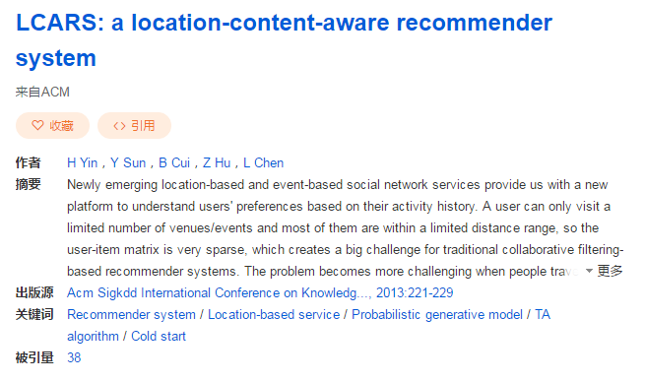

Authors:

Hongzhi Yin Peking University, Beijing, China

Yizhou Sun Northeastern University, Boston, USA

Bin Cui Peking University, Beijing, China

Zhiting Hu Peking University, Beijing, China

Ling Chen University of Technology, Sydney, Sydney, Australia

## Survey对其描述

the opinions from the local experts. Yin et al. 2013 [114] further extend the problem by proposing an LCA-LDA model, a location-content-aware probabilistic generative model to quantify both the local preference and the item content information in the recommendation process.

建立一个LCA-LDA模型去通过位置偏好和内容信息去评价划分。

**摘要ABSTRACT**

关键点：

Probabilistic generativemodel; 概率生成

TA algorithm; 阈值算法

Cold start冷启动

LCARS, a location-content-aware recommender system 基于内容的定位推荐

The offline modeling part, called LCALDA, is designed to learn the interest of each individual user and the local preference of each individual city by capturing item cooccurrence patterns and exploiting item contents.

LCA-LDA

基于内容的定位和离线的捕捉用户模式和兴趣爱好的一个模型部分

**介绍INTRODUCTION**

Newly emerging event-based social network services新兴的基于事件的社会网络服务

location-based social networking services (LBSNs),

文章的目的：解决定位问题，

比如推荐北京的场馆

北京的重要活动如展览演唱会等

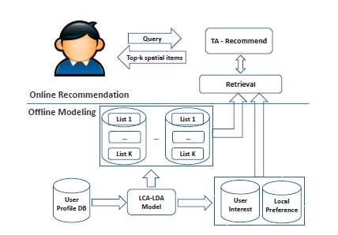

基本逻辑思维线路：

请求需求-》阈值推荐—》检索

用户个人信息-》LCALDA模型-》用户网络和用户偏好-》检索

LCALDA模型-》检索离线的用户的历史数据