《计算机视觉》实验报告

姓名：冯俊佳 学号：23122721

实验10 卷积神经网络
- 任务1
  - 核心代码：
01  02  03  04  05  06  07  08  09  10  11  12  13  14  15  16  17  18  19  20  21  22  23  24  25  26  27  28  29  30  31  32  33  34  35  36  37  38  39  40  41  42  43  44  45  46  47  48  49  50  51  52  53  54  55  56  57  58  59  60  61  62  63  64  65  66  67  68  69  70  71  72  73  74  75  76  77  78  79  80  81  82  83  84  85  86  87  88  89  90  91  92  93  94  95  96  97  98  99 | # 定义转换操作，将图像数据转换为张量，并进行标准化  transform = transforms.Compose([  transforms.ToTensor(),  transforms.Normalize((0.1307,), (0.3081,))])  # 下载并加载训练和测试数据集  train_dataset = datasets.MNIST(root='./data', train=True, download=True, transform=transform)  test_dataset = datasets.MNIST(root='./data', train=False, download=True, transform=transform)  train_loader = DataLoader(train_dataset, batch_size=64, shuffle=True)  test_loader = DataLoader(test_dataset, batch_size=1000, shuffle=False)  # 定义一个简单的卷积神经网络  class Net(nn.Module):  def __init__(self):  super(Net, self).__init__()  self.conv1 = nn.Conv2d(1, 10, kernel_size=5)  self.conv2 = nn.Conv2d(10, 20, kernel_size=5)  self.fc1 = nn.Linear(320, 50)  self.fc2 = nn.Linear(50, 10)  def forward(self, x):  x = F.relu(F.max_pool2d(self.conv1(x), 2))  x = F.relu(F.max_pool2d(self.conv2(x), 2))  x = x.view(-1, 320)  x = F.relu(self.fc1(x))  x = self.fc2(x)  return F.log_softmax(x, dim=1)  # 实例化模型和优化器  model = Net()  optimizer = optim.SGD(model.parameters(), lr=0.01, momentum=0.9)  # 定义训练函数  def train(model, device, train_loader, optimizer, epoch):  model.train()  epoch_loss = 0.0  for batch_idx, (data, target) in enumerate(train_loader):  data, target = data.to(device), target.to(device)  optimizer.zero_grad()  output = model(data)  loss = F.nll_loss(output, target)  loss.backward()  optimizer.step()  epoch_loss += loss.item()  print(f'====> Epoch: {epoch} Average loss: {epoch_loss / len(train_loader):.4f}')  # Evaluate training accuracy after epoch  model.eval()  correct = 0  total = 0  with torch.no_grad():  for data, target in train_loader:  data, target = data.to(device), target.to(device)  output = model(data)  pred = output.argmax(dim=1, keepdim=True)  correct += pred.eq(target.view_as(pred)).sum().item()  total += data.size(0)  train_acc = 100. * correct / total  print(f'Training Accuracy after Epoch {epoch}: {train_acc:.2f}%')  # 定义测试函数  def evaluate(model, device, test_loader):  model.eval()  test_loss = 0  correct = 0  with torch.no_grad():  for data, target in test_loader:  data, target = data.to(device), target.to(device)  output = model(data)  test_loss += F.nll_loss(output, target, reduction='sum').item() # 累计损失  pred = output.argmax(dim=1, keepdim=True) # 获取最大可能的预测值  correct += pred.eq(target.view_as(pred)).sum().item()  test_loss /= len(test_loader.dataset)  print(f'\nTest set: Average loss: {test_loss:.4f}, Accuracy: {correct}/{len(test_loader.dataset)}'  f' ({100. * correct / len(test_loader.dataset):.0f}%)\n')  # 设置设备并运行训练  device = torch.device("cuda" if torch.cuda.is_available() else "cpu")  model.to(device)  for epoch in range(1, 11):  train(model, device, train_loader, optimizer, epoch)  # Evaluate on test set after all epochs  evaluate(model, device, test_loader)  # 保存模型参数到文件（权重）  torch.save(model.state_dict(), "mnist_cnn.pth")  # 保存整个模型结构（推荐用于 Netron 可视化）  torch.save(model, "mnist_cnn_model.pt")
  - 实验结果截图
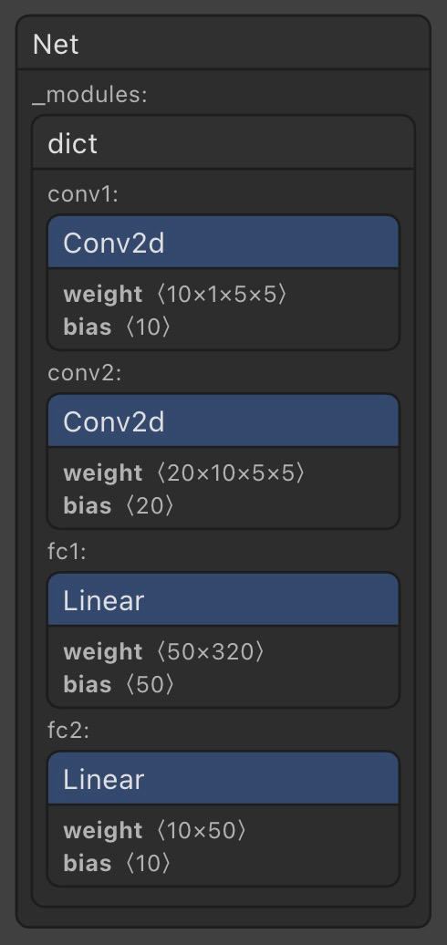
如左图所示，为CNN的网络结构示意图，下表为示意图中的内容注释。
模块名称 | 类型 | 权重维度说明
conv1 | Conv2d | weight: (10×1×5×5)：表示10个5×5卷积核，输入通道为1
conv2 | Conv2d | weight: (20×10×5×5)：20个卷积核，输入通道为10
fc1 | Linear | weight: (50×320)：全连接层，输入展平后大小为320
fc2 | Linear | weight: (10×50)：输出为10类数字（0~9）

下图为训练后的准确度，以及测试一次时候的准确度。
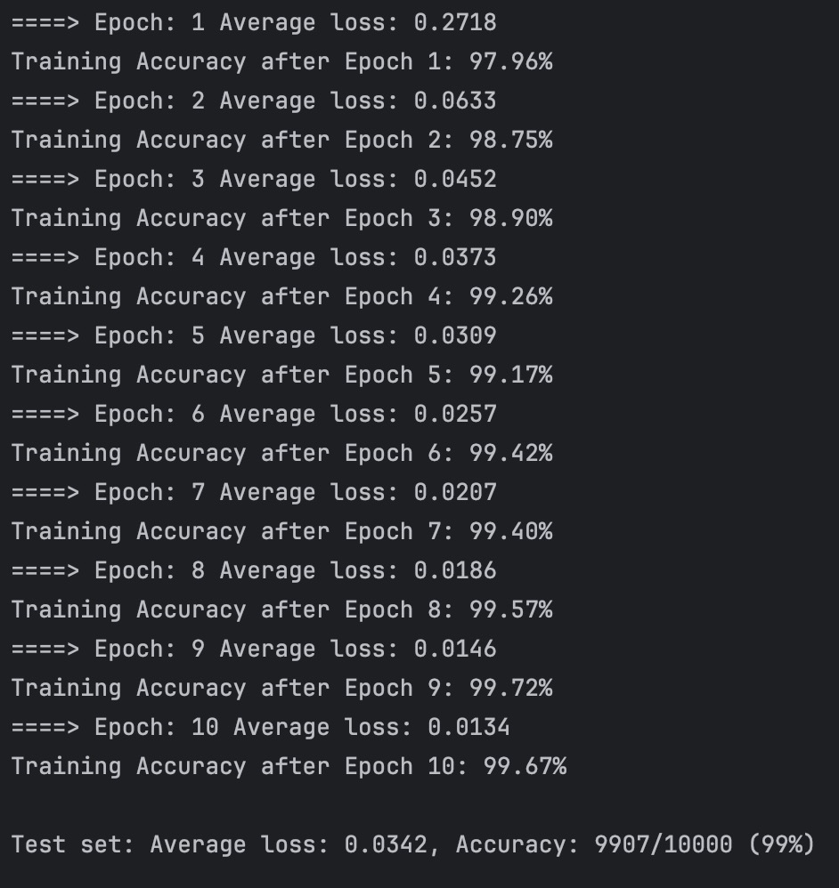
  - 实验小结
本此实验基于PyTorch框架，搭建了一个包含两层卷积和两层全连接层的卷积神经网络（CNN），并在经典的MNIST手写数字识别数据集上进行了训练和测试。经过10个epoch的训练，模型在训练集上的准确率达到了99.67%，在测试集上达到了99.07%的准确率，表现出良好的泛化能力。本实验还通过Netron可视化工具对CNN网络结构进行了可视化处理，进一步加深了我对卷积神经网络各层结构及其参数的理解，为后续更复杂的图像识别任务打下了基础。

