Extjs Task:

The TreeList main view:

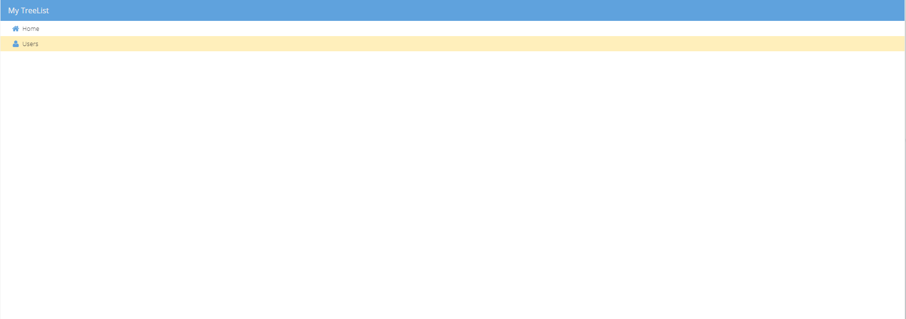

On click on users’ node the windows of list users will be shown:

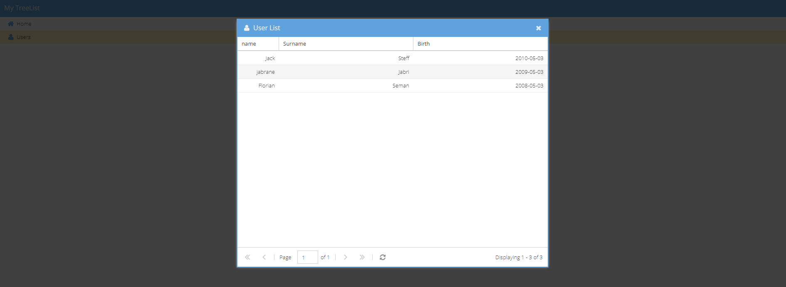

This project contains **two** parts:

Demo project:

* The main view that renders the tree List View with too items.
* The main controller, the controller of main view.
* navigation view(tree list view)

Package:

Package called demoUser this is a remote package that I have created and required into app.json to be used in the demo project.

The package is the grid list view of users.