Evidencia de comandos

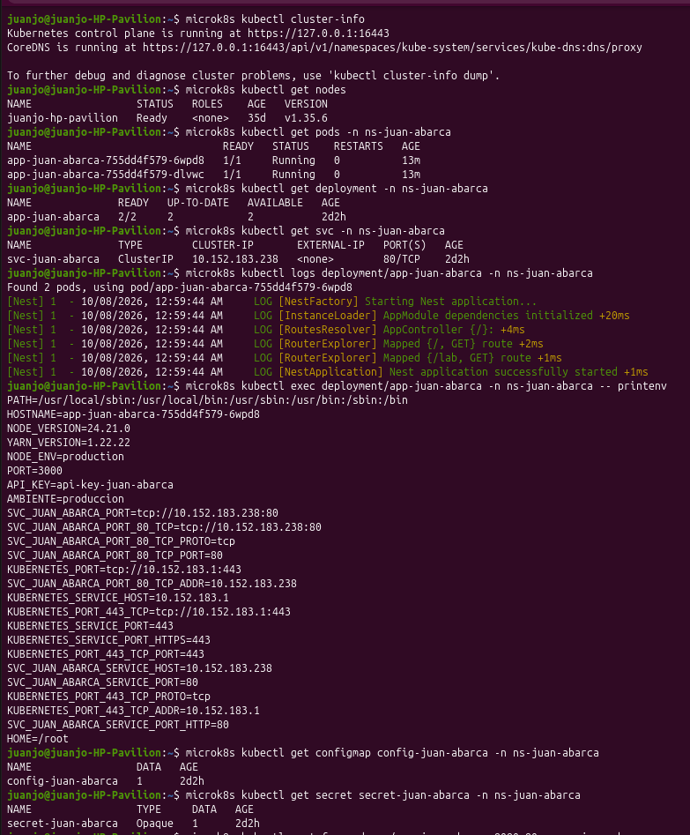
juanjo@juanjo-HP-Pavilion:~$ microk8s kubectl cluster-info
Kubernetes control plane is running at https://127.0.0.1:16443
CoreDNS is running at https://127.0.0.1:16443/api/v1/namespaces/kube-system/services/kube-dns:dns/proxy

To further debug and diagnose cluster problems, use 'kubectl cluster-info dump'.
juanjo@juanjo-HP-Pavilion:~$ microk8s kubectl get nodes
NAME STATUS ROLES AGE VERSION
juanjo-hp-pavilion Ready <none> 35d v1.35.6
juanjo@juanjo-HP-Pavilion:~$ microk8s kubectl get pods -n ns-juan-abarca
NAME READY STATUS RESTARTS AGE
app-juan-abarca-755dd4f579-6wpd8 1/1 Running 0 13m
app-juan-abarca-755dd4f579-dlvwc 1/1 Running 0 13m
juanjo@juanjo-HP-Pavilion:~$ microk8s kubectl get deployment -n ns-juan-abarca
NAME READY UP-TO-DATE AVAILABLE AGE
app-juan-abarca 2/2 2 2 2d2h
juanjo@juanjo-HP-Pavilion:~$ microk8s kubectl get svc -n ns-juan-abarca
NAME TYPE CLUSTER-IP EXTERNAL-IP PORT(S) AGE
svc-juan-abarca ClusterIP 10.152.183.238 <none> 80/TCP 2d2h
juanjo@juanjo-HP-Pavilion:~$ microk8s kubectl logs deployment/app-juan-abarca -n ns-juan-abarca
Found 2 pods, using pod/app-juan-abarca-755dd4f579-6wpd8
[Nest] 1 - 10/08/2026, 12:59:44 AM LOG [NestFactory] Starting Nest application...
[Nest] 1 - 10/08/2026, 12:59:44 AM LOG [InstanceLoader] AppModule dependencies initialized +20ms
[Nest] 1 - 10/08/2026, 12:59:44 AM LOG [RoutesResolver] AppController {/}: +4ms
[Nest] 1 - 10/08/2026, 12:59:44 AM LOG [RouterExplorer] Mapped {/, GET} route +2ms
[Nest] 1 - 10/08/2026, 12:59:44 AM LOG [RouterExplorer] Mapped {/lab, GET} route +1ms
[Nest] 1 - 10/08/2026, 12:59:44 AM LOG [NestApplication] Nest application successfully started +1ms
juanjo@juanjo-HP-Pavilion:~$ microk8s kubectl exec deployment/app-juan-abarca -n ns-juan-abarca -- printenv
PATH=/usr/local/sbin:/usr/local/bin:/usr/sbin:/usr/bin:/sbin:/bin
HOSTNAME=app-juan-abarca-755dd4f579-6wpd8
NODE_VERSION=24.21.0
YARN_VERSION=1.22.22
NODE_ENV=production
PORT=3000
API_KEY=api-key-juan-abarca
AMBIENTE=produccion
SVC_JUAN_ABARCA_PORT=tcp://10.152.183.238:80
SVC_JUAN_ABARCA_PORT_80_TCP=tcp://10.152.183.238:80
SVC_JUAN_ABARCA_PORT_80_TCP_PROTO=tcp
SVC_JUAN_ABARCA_PORT_80_TCP_PORT=80
KUBERNETES_PORT=tcp://10.152.183.1:443
SVC_JUAN_ABARCA_PORT_80_TCP_ADDR=10.152.183.238
KUBERNETES_SERVICE_HOST=10.152.183.1
KUBERNETES_PORT_443_TCP=tcp://10.152.183.1:443
KUBERNETES_SERVICE_PORT=443
KUBERNETES_SERVICE_PORT_HTTPS=443
KUBERNETES_PORT_443_TCP_PORT=443
SVC_JUAN_ABARCA_SERVICE_HOST=10.152.183.238
SVC_JUAN_ABARCA_SERVICE_PORT=80
KUBERNETES_PORT_443_TCP_PROTO=tcp
KUBERNETES_PORT_443_TCP_ADDR=10.152.183.1
SVC_JUAN_ABARCA_SERVICE_PORT_HTTP=80
HOME=/root
juanjo@juanjo-HP-Pavilion:~$ microk8s kubectl get configmap config-juan-abarca -n ns-juan-abarca
NAME DATA AGE
config-juan-abarca 1 2d2h
juanjo@juanjo-HP-Pavilion:~$ microk8s kubectl get secret secret-juan-abarca -n ns-juan-abarca
NAME TYPE DATA AGE
secret-juan-abarca Opaque 1 2d2h
Evidencias CURL

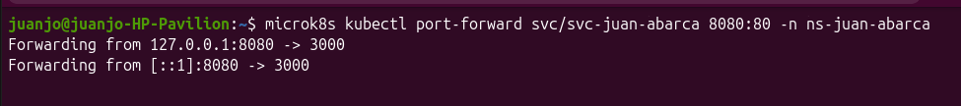
juanjo@juanjo-HP-Pavilion:~$ microk8s kubectl port-forward svc/svc-juan-abarca 8080:80 -n ns-juan-abarca
Forwarding from 127.0.0.1:8080 -> 3000
Forwarding from [::1]:8080 -> 3000

juanjo@juanjo-HP-Pavilion:~$ curl http://localhost:8080/lab
{"AMBIENTE":"produccion","API_KEY":"api-key-juan-abarca"}juanjo@juanjo-HP-Pavilion:~$

Jenkins

