https://github.com/jjacob-t/MAD_Activity14
- Flutterfire configure is needed to connect the Flutter project to the Firebase project. Without it, Flutter would not know which Firebase project to communicate with.
- In the foreground, the screen changes instantly with the cloud message. In the background, a notification will appear in the notification center. When clicked, it will navigate to the app with the changed message text and image, if applicable. An actual pop-up notification will show up sometimes, but I am unsure what causes (or prevents) it to show up in certain circumstances.
- A simple bug faced was assets not being found after they were added. One time was because I switched to jpgs when the code was still using pngs, so that had to be changed to match. I also needed to quit and run flutter pub get a few times. A larger problem that needed to be fixed was when cloud messages wouldn’t ever show system pop-up notifications. This was because FCM deliberately suppresses system tray notifications when the app is in the foreground. To fix this, I had to use the flutter_local_notifications package to manually trigger a popup when a message was received.
- asset was the only key I used, and it was used to change the image displayed. I had to put the name of the file, and the app would find it and display it, assuming it exists with the correct file extension at the end. Other keys that could be used are type for certain kinds of messages, animations for these types of messages, screens that navigate somewhere with the message, duration, priority, and color.
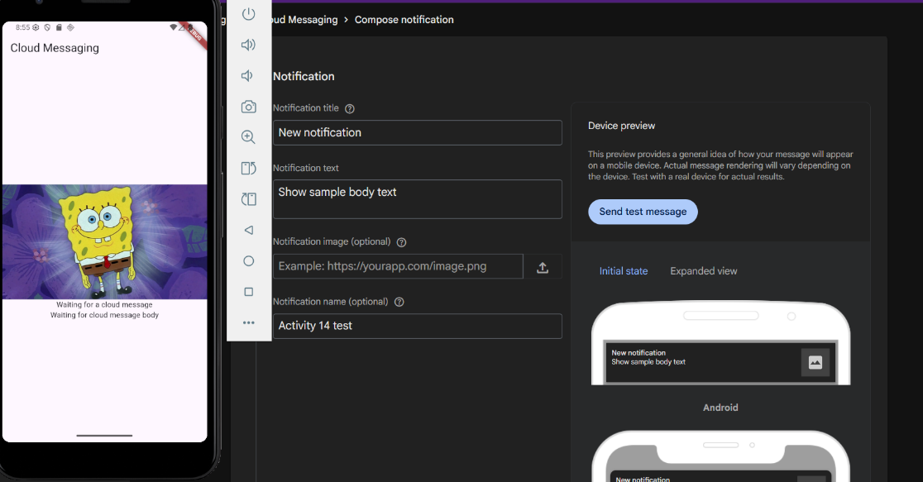
- With more time, I would add and use animations for the messages, such as a celebration for a sale message or warning animation for an alert. I would also investigate why the popups only trigger sometimes and try to either make them appear all the time or only outside of the app.
1Default screen with message to be sent

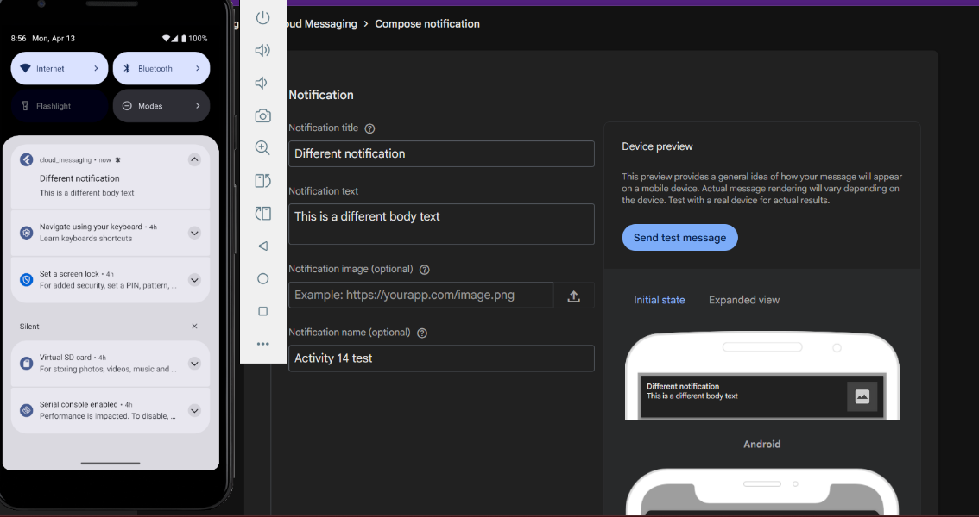
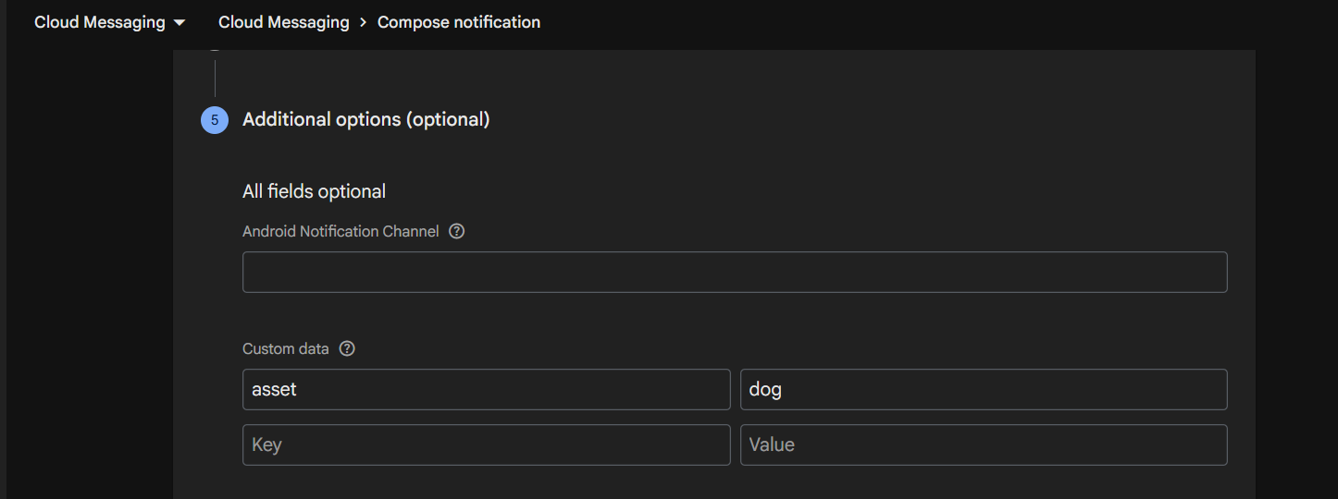
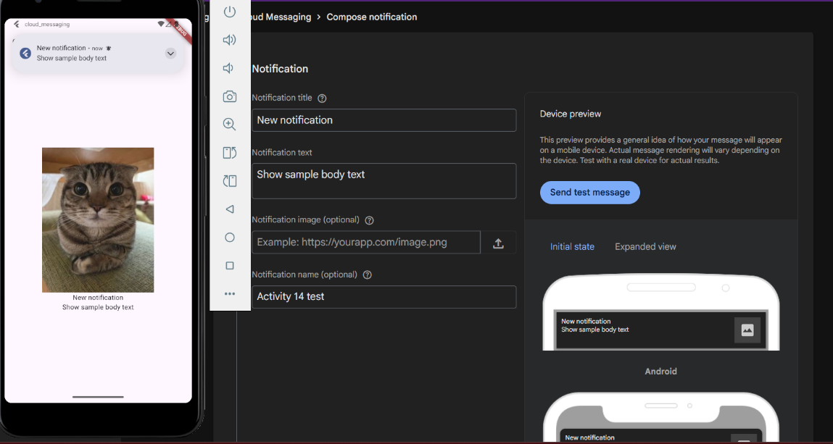
2Message showing up in the notification center while app is in background
3Different asset to be sent
4Message changing app in the foreground and popup notification
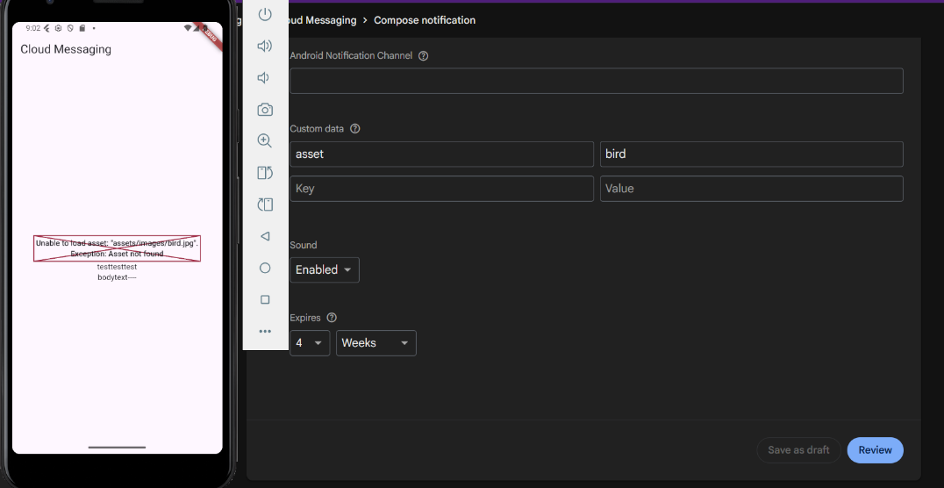
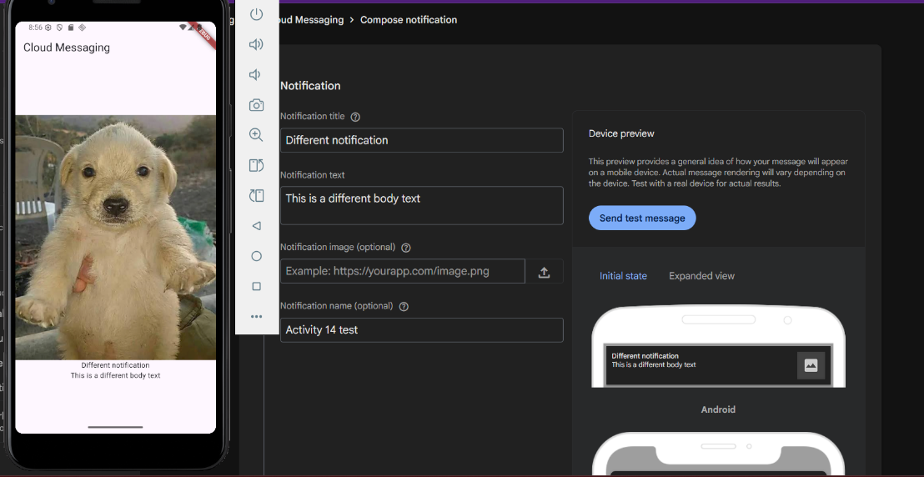
5Sending message with an invalid asset does not crash the app, but shows appropriate error message
6Clicking notification brings user to app with changed message and asset

