econ_assignment4

Jessica Jagdeo

May 28, 2019

1. Model of marginal cost of abatement for each sector

Table 1. Linear Regression Models for Carbon Abatement from Sectors A, B, and C in Country X and Sector D in Country Y.

Dependent variable:

Sector A

Sector B

Sector C

Sector D

(1)

(2)

(3)

(4)

Abatement

0.577***

0.199***

0.784***

0.260***

(0.048)

(0.046)

(0.079)

(0.064)

Constant

-8.644*

9.318**

-11.655

9.688

(4.257)

(4.091)

(6.963)

(5.606)

Observations

16

16

16

16

R2

0.910

0.566

0.875

0.543

Adjusted R2

0.904

0.535

0.866

0.511

Residual Std. Error (df = 14)

8.917

8.569

14.584

11.742

F Statistic (df = 1; 14)

142.288***

18.291***

98.214***

16.661***

Note:

*p<0.1;* ***p<0.05;*** p<0.01

We have determined that linear regression models produce relatively adequate fits for the carbon emissions data from the sectors.

Our linear regression models are:

Sector A: Marginal cost of carbon abatement = 0.5768*(Abatement) - 8.6445 Sector B: Marginal cost of carbon abatement = 0.1987*(Abatement) + 9.3177 Sector C: Marginal cost of carbon abatement = 0.7838*(Abatement) - 11.6550 Sector D: Marginal cost of abatement = 0.2599*(Abatement) + 9.6875

R^2 is the proportion of the variance in cost of abatement that is explained by the tons of carbon abatement. Basd on these models and their associated R^2, tons of carbon abatement significantly predicts marginal cost of abatement.

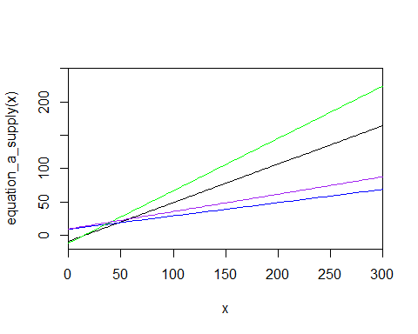

1. Demand Curve

# Find the intersection of the marginal cost curves with current emissions from each sector:  
  
  
# Sector A  
  
# Marginal cost of carbon abatement = 0.5768*(Abatement) - 8.6445  
  
# Current emissions is 180 tons  
  
0.5768*180-8.6445 # Equals $95.18

## [1] 95.1795

# Points: (180, 0) and (0, 95.18)  
  
# Slope: -0.5287778  
  
(95.18-0)/(0-180)

## [1] -0.5287778

# Y-intercept: 95.18  
  
  
  
# Sector B  
  
# Marginal cost of carbon abatement = 0.1987*(Abatement) + 9.3177  
  
# Current emissions are 200 tons  
  
0.1987*200+9.3177 # Equals $49.06

## [1] 49.0577

# Points: (200, 0) and (0, 49.06)  
  
# Slope: -0.2453  
  
(49.06-0)/(0-200)

## [1] -0.2453

# Y-intercept: 49.06  
  
  
  
# Sector C  
  
# Marginal cost of carbon abatement = 0.78388(Abatement) - 11.6550  
  
# Current emissions are 220 tons  
  
0.78388*220-11.6550 # Equals $160.80

## [1] 160.7986

# Points: (220, 0) and (0, 160.80)  
  
# Slope: -0.7309091  
  
(160.80-0)/(0-220)

## [1] -0.7309091

# Y-intercept: 160.80  
  
  
  
# Sector D  
  
# Marginal cost of abatement = 0.2599*(Abatement) + 9.6875  
  
# Current emissions are 300 tons  
  
0.2599*300+9.6875 # Equals $87.66

## [1] 87.6575

# Points: (300, 0) and (0, 87.66)  
  
# Slope: -0.2922  
  
(87.66-0)/(0-300)

## [1] -0.2922

# Y-intercept: 87.66

Demand curves for each sector:

Sector A: y = -0.5287778X + 95.18 Sector B: y = -0.2453X + 49.06 Sector C: y = -0.7309091X + 160.80 Sector D: y = -0.2922X + 87.66

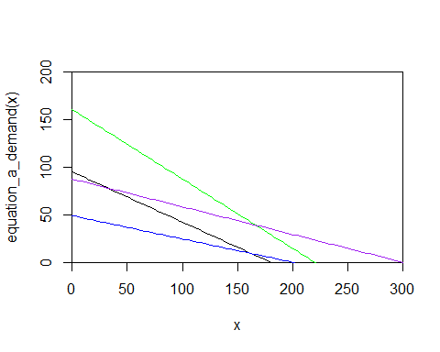

1. Country X Abatement
2. Cap on carbon
3. Tax on Carbon

C. Cap and trade.

No tax revenue in a cap and trade system

1. Again, without any co-benefits, suppose that country Y (which only has one carbon-emitting sector, D) has no obligation to reduce its emissions. Country X asks country Y to enter the country X carbon market. Doing so would require country Y to put a cap on carbon emissions at its current level of emissions (300 tons), but would then allow country Y to sell carbon offsets to sectors A, B, or C. Are there any incentives for country Y to enter country X’s carbon market and to thus place a voluntary cap on its emissions? Are there any incentives for country X to try to attract country Y into its market?

Country X would want Country Y to join the carbon market because the marginal cost of abatement for all four sectors is less than the marginal cost of abatement for Country X (Sectors A, B, and C).

Country Y would want to join the carbon market because it would be able to sell 78 permits to Sectors A and C, therefore making money.

1. Now assume that every ton of carbon emissions creates 1 ton of local air pollution. Local air pollution causes economic damages (health, environmental, etc.), but only in the country in which it is emitted. Assume there are no local air pollution regulations in either country X or country Y.
2. In a carbon cap and trade market that only covers sectors in country X, how much local air pollution would you expect in country X? In country Y?

*In Country X, we expect 300 tons of local air pollution. In Country Y, we expect 300 tons of local air pollution as well.*

1. If country Y enters the carbon market for country X (as in question 4 above), how much local pollution will there be in country X and country Y?

*In Country X, we expect 378 tons of local air pollution. In Country Y, we expect 223 tons of local air pollution.*

1. What advice can you give country X and country Y about the desirability of allowing international trade of carbon emissions credits?

*It is econonmically desirable for Country X and Country Y to engage in carbon trading within this market system. However, it is important to note that in terms of local air pollution, carbon trading may not be desirable because this trading increases air pollution from Country X.*