After starting the application, the main window will appear (see figure 1). Before training a new SVM model, the Positive and Negative training folders should be selected. These folders contain image files that either have or do not have persons in the images. The image files with persons in them are referred to in this document as positive images and thus should reside in the positive training folder. The image files with no persons in them are negative images should reside in the negative training folder.

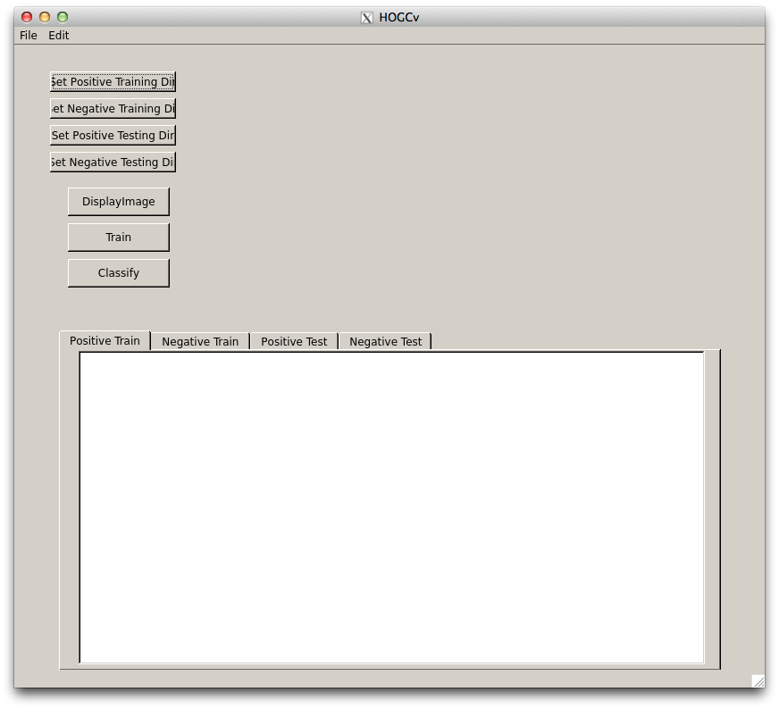

Figure – Main window

To select the positive training folder, press the “Set Positive Training Dir” button and a Find Directory dialog box will appear (see figure 2). Select the folder that contains the file images and press the Choose button. After pressing the Choose button, the Positive Train tab will be populated with the names of files in the selected folder (see figure 3).

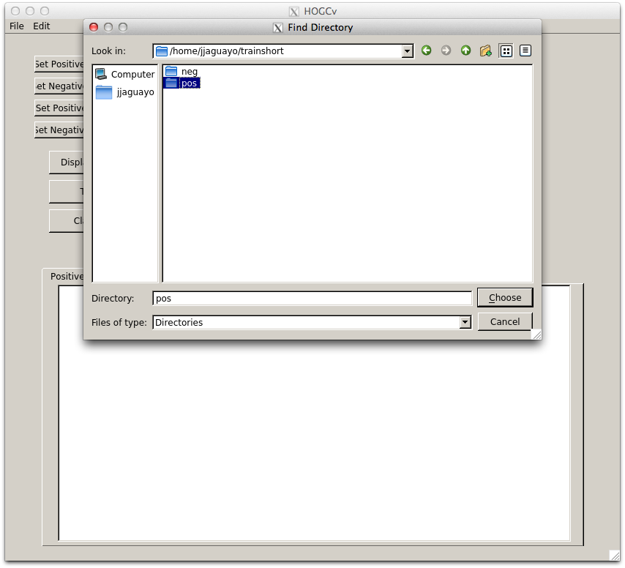

Figure - Choose the positive training directory

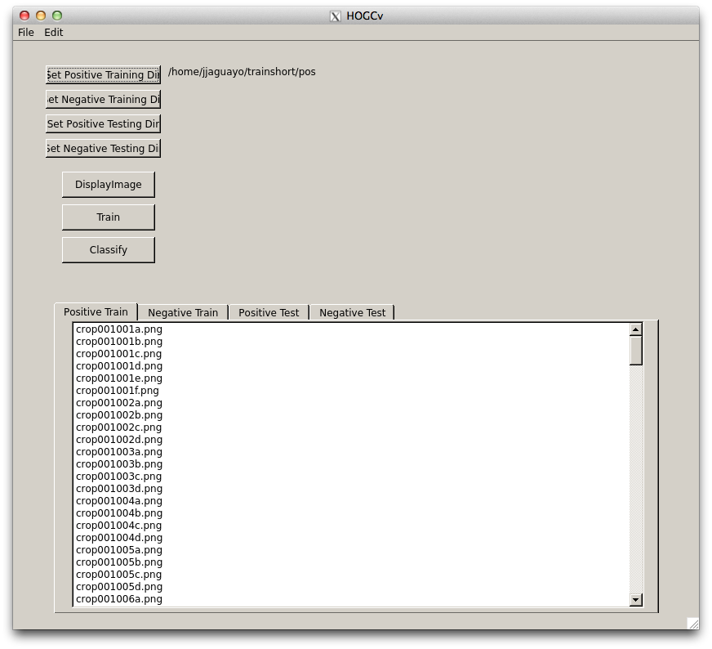

Figure - Populated Positive Train tab

To select the negative training folder, press the “Set Negative Training Dir” button. Again a Find Directory dialog box will appear (see figure 4). Select the directory and press the Choose button and the Negative Train tab will be populated with the image files in the selected directory (see figure 5)

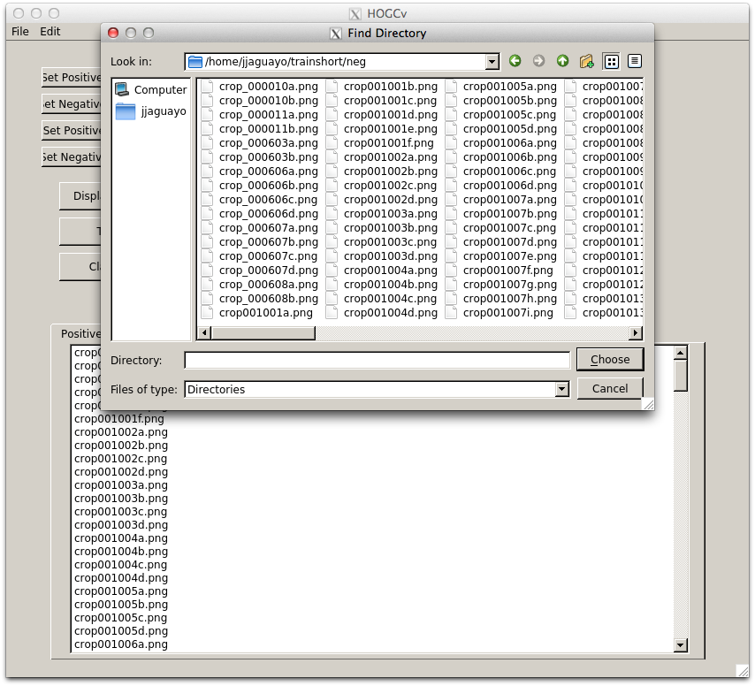

Figure - Choose the negative training directory

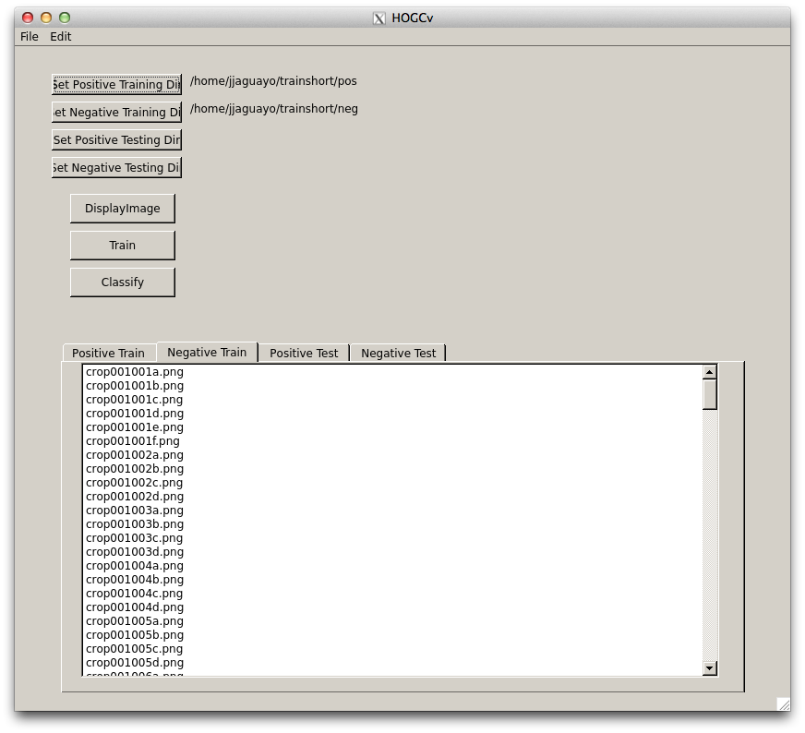

Figure - Populated negative train tab

The positive and negative testing directories can be selected in a similar manner by pressing the “Set Positive Testing Dir” and “Set Negative Testing Dir” buttons.

To train the model, press the “Train” button. When the model is trained, the user will be alerted with a dialog box (see figure 6).

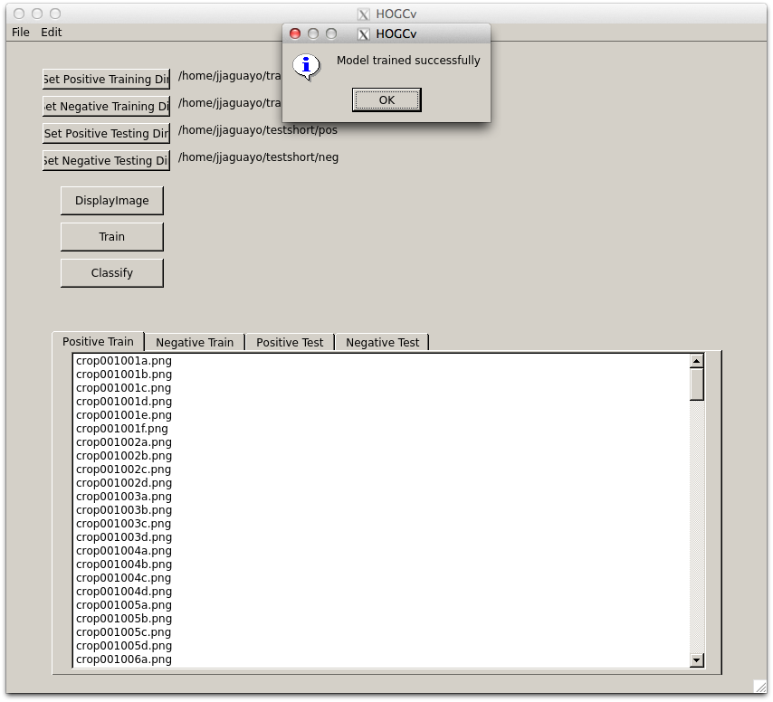

Figure - Dialog box alerting user that the model has been trained.

To classify a set of image files, select the positive or negative test tabs and highlight one or more image file names (see figure 7).

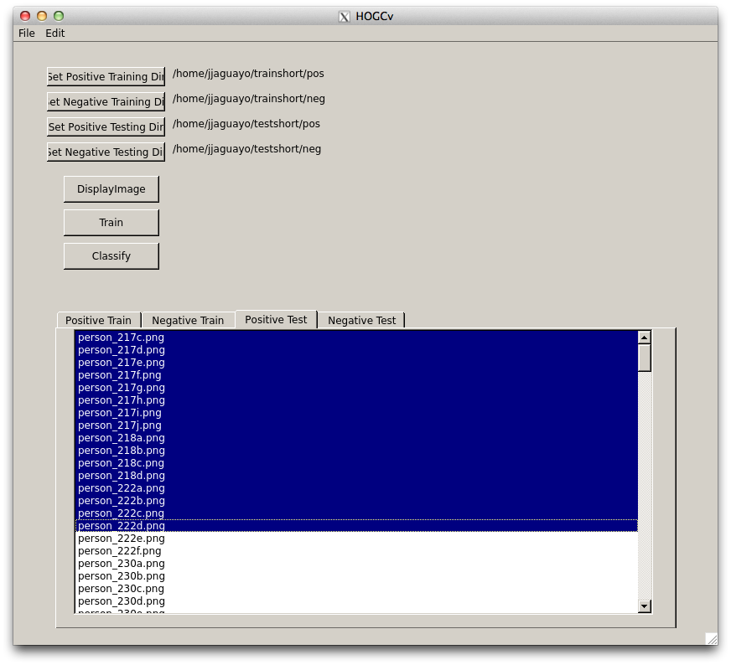

Figure - Set of positive image files that have been selected for classification

Press the “Classify” button. When classification is finished, a dialog box will appear alerting the user of the percentage of selected image files that have been classified correctly (see figure 8 and 9).

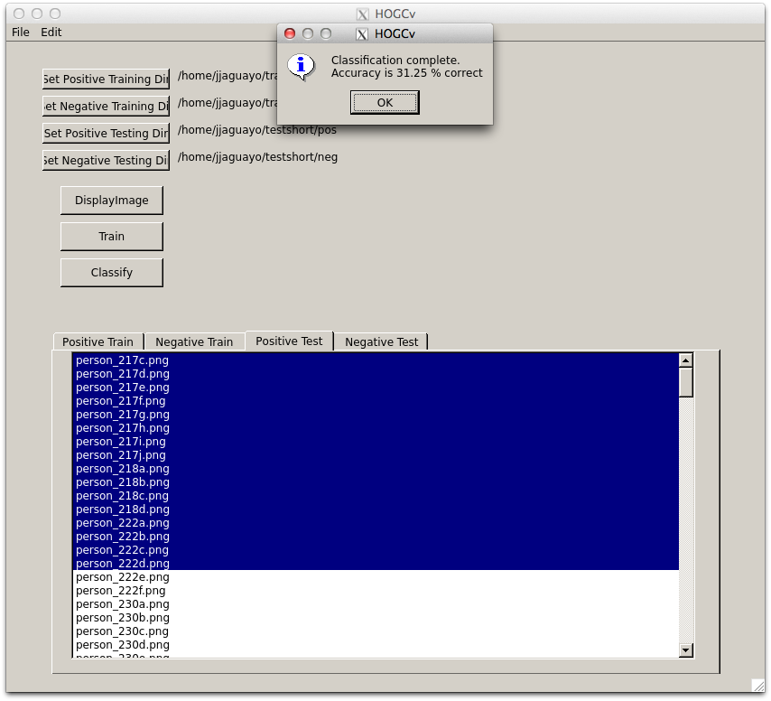

Figure - Dialog box alerting the user of the percentage of selected positive image file classified correctly using the trained SVM model.

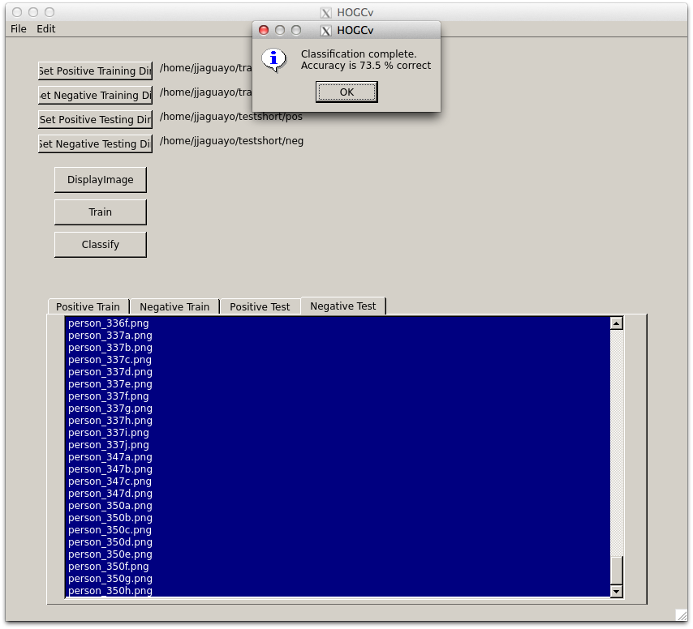

Figure - Dialog box alerting the user of the percentage of selected negative image file classified correctly using the trained SVM model.

To exit the application, press the select the File->Exit menu item.