CEL 51, DCCN, Monsoon 2020

Lab 6: Subnet and Router Configuration

# Topology Diagram



**Addressing Table**

|  |  |  |  |  |
| --- | --- | --- | --- | --- |
| **Device Interface IP Address Subnet Mask Default Gateway** | | | | |
| **R1** | **Fa0/0** |  |  | **N/A** |
| **S0/0/0** |  |  | **N/A** |
| **R2** | **Fa0/0** |  |  | **N/A** |
| **S0/0/0** |  |  | **N/A** |
| **PC1** | **NIC** |  |  |  |
| **PC2** | **NIC** |  |  |  |

**Learning Objectives**

Upon completion of this lab, you will be able to:

* Subnet an address space given requirements.
* Assign appropriate addresses to interfaces and document.
* Configure and activate Serial and FastEthernet interfaces.
* Test and verify configurations.
* Reflect upon and document the network implementation.

# Scenario

In this lab activity, you will design and apply an IP addressing scheme for the topology shown in the Topology Diagram. You will be given one address block that you must subnet to provide a logical addressing scheme for the network. The routers will then be ready for interface address configuration according to your IP addressing scheme.

When the configuration is complete, verify that the network is working properly.

# Task 1: Subnet the Address Space.

## Step 1: Examine the network requirements.

You have been given the 192.168.1.0/24 address space to use in your network design. The network consists of the following segments:

* The network connected to router R1 will require enough IP addresses to support 15 hosts.

1 of 12

* The network connected to router R2 will require enough IP addresses to support 30 hosts.
* The link between router R1 and router R2 will require IP addresses at each end of the link.

## Step 2: Consider the following questions when creating your network design.

How many subnets are needed for this network?

**Ans: 3 subnets** needed for this network, they are:

1. Network connected to R1
2. Link between R1 and R2
3. Network connected to R2

What is the subnet mask for this network in the dotted decimal format?

**Ans:** The binary form of the subnet mask is **11111111.11111111.11111111.11100000**

The subnet mask for this network in dotted decimal format is **255.255.255.224**

What is the subnet mask for the network in slash format?

**Ans:** The binary form of the subnet mask is **11111111.11111111.11111111.11100000**

The total number of ones in the binary form of the subnet mask is 27. So, the subnet mask in slash format is **/27**

How many usable hosts are there per subnet?

**Ans:** Usable hosts = 2h - 2 , where h = number of zeroes in binary form of subnet mask

The binary form of the subnet mask is 11111111.11111111.11111111.11100000, hence **h = 5**. So, Usable hosts = 25 - 2 = 32 - 2 = **30 hosts**

## Step 3: Assign sub-network addresses to the Topology Diagram.

1. Assign subnet 1 to the network attached to R1. Ans: 192.168.1.1/27
2. Assign subnet 2 to the link between R1 and R2. Ans: 192.168.1.33/27
3. Assign subnet 3 to the network attached to R2. Ans: 192.168.1.65/27

# Task 2: Determine Interface Addresses.

## Step 1: Assign appropriate addresses to the device interfaces.

1. Assign the first valid host address in subnet 1 to the LAN interface on R1.

## Ans: R1 - Fa0/0 = 192.168.1.1

1. Assign the last valid host address in subnet 1 to PC1.

## Ans: PC1 - 192.168.1.30

1. Assign the first valid host address in subnet 2 to the WAN interface on R1.

## Ans: R1 - S0/0/0 = 192.168.1.33

1. Assign the last valid host address in subnet 2 to the WAN interface on R2.

## Ans: R2 - S0/0/0 = 192.168.1.62

1. Assign the first valid host address in subnet 3 to the LAN interface of R2.

## Ans: R2 - Fa0/0 = 192.168.1.65

1. Assign the last valid host address in subnet 3 to PC2.

## Ans: PC2 - 192.168.1.94

**Step 2: Document the addresses to be used in the table provided under the Topology Diagram.**

**Addressing Table**

|  |  |  |  |  |
| --- | --- | --- | --- | --- |
| **Device Interface IP Address Subnet Mask Default Gateway** | | | | |
| **R1** | **Fa0/0** | 192.168.1.1 | 255.255.255.224 | **N/A** |
| **S0/0/0** | 192.168.1.33 | 255.255.255.224 | **N/A** |
| **R2** | **Fa0/0** | 192.168.1.65 | 255.255.255.224 | **N/A** |
| **S0/0/0** | 192.168.1.62 | 255.255.255.224 | **N/A** |
| **PC1** | **NIC** | 192.168.1.30 | 255.255.255.224 | 192.168.1.1 |
| **PC2** | **NIC** | 192.168.1.94 | 255.255.255.224 | 192.168.1.65 |

**Task 3: Configure the Serial and FastEthernet Addresses.**

**Step 1: Configure the router interfaces.**

Configure the interfaces on the R1 and R2 routers with the IP addresses from your network design. Please note, to complete the activity in Packet Tracer you will be using the Config Tab. When you have finished, be sure to save the running configuration to the NVRAM of the router.

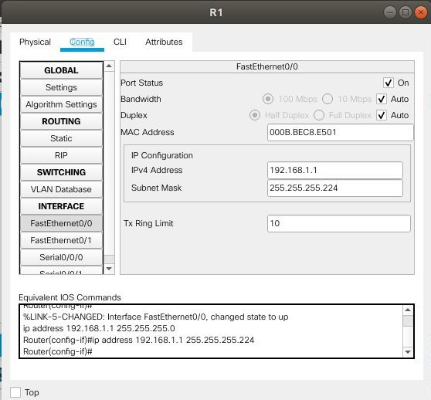

*R1 - Interface FastEthernet 0/0*

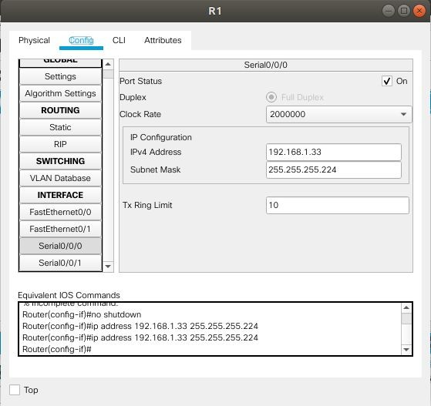

*R1 Interface Serial0/0/0*

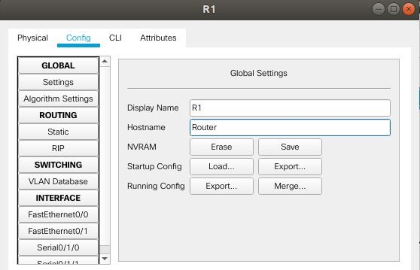

*Saved the running configuration to the NVRAM of the router R1*

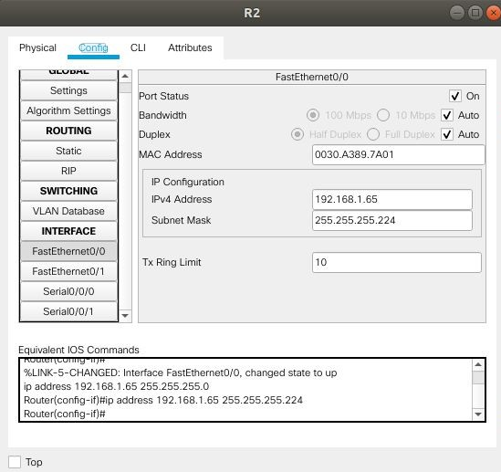

*R2 - Interface FastEthernet 0/0*

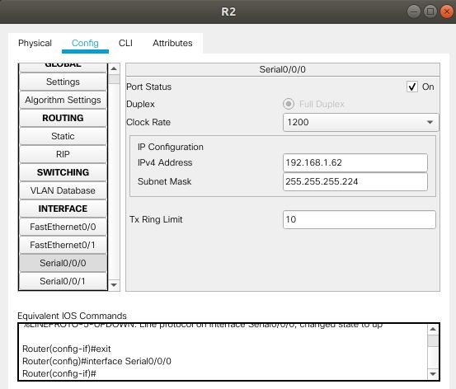

*R2 Interface Serial0/0/0*

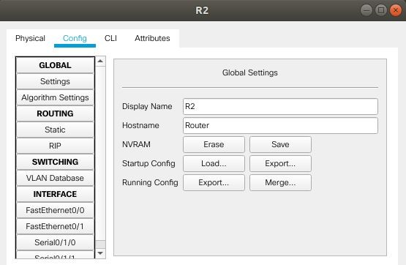

*Saved the running configuration to the NVRAM of the router R1*

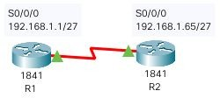

## Step 2: Configure the PC interfaces.

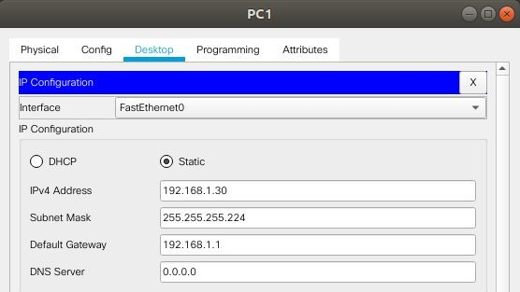Configure the Ethernet interfaces of PC1 and PC2 with the IP addresses and default gateways from your network design.

*PC1 - Ethernet interface*

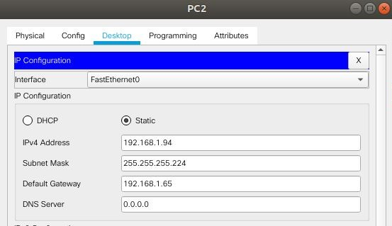

*PC2 - Ethernet interface*

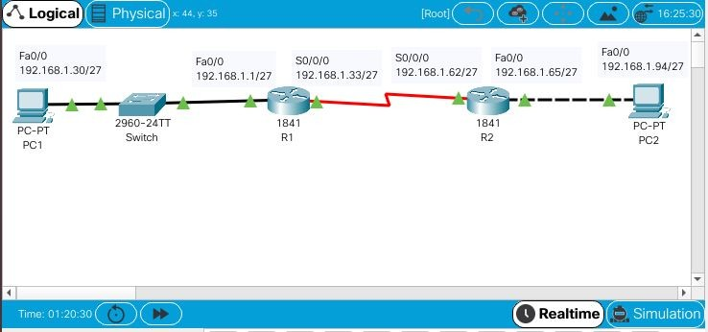

*Final newtork*

# Task 4: Verify the Configurations.

Answer the following questions to verify that the network is operating as expected. From the host attached to R1, is it possible to ping the default gateway?

## Ans: Yes

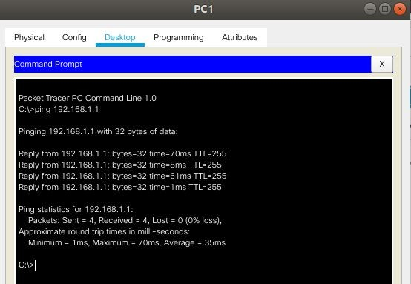

*Ping from PC1 to Fa0/0 R1*

From the host attached to R2, is it possible to ping the default gateway?

## Ans: Yes

*Ping from PC2 to Fa0/0 R2*

From the router R1, is it possible to ping the Serial 0/0/0 interface of R2?

## Ans: Yes

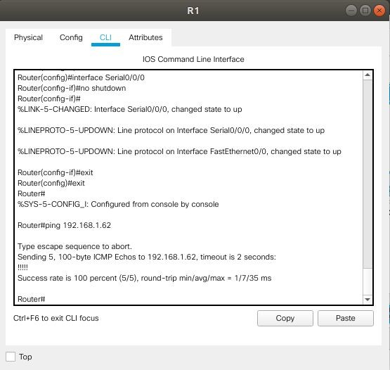

*Ping from R1 to S0/0/0 R2*

From the router R2, is it possible to ping the Serial 0/0/0 interface of R1?

## Ans: Yes

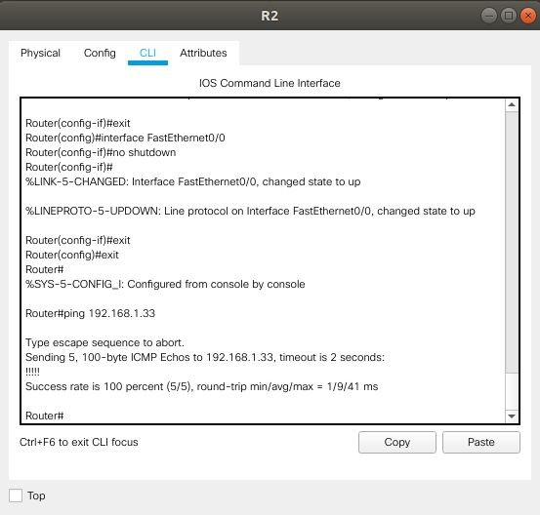

*Ping from R2 to S0/0/0 R1*

The answer to the above questions should be **yes**. If any of the above pings failed, check your physical connections and configurations.

# Task 5: Reflection

Are there any devices on the network that cannot ping each other?

## Ans: The two PCs - PC1 and PC2 cannot ping each other.

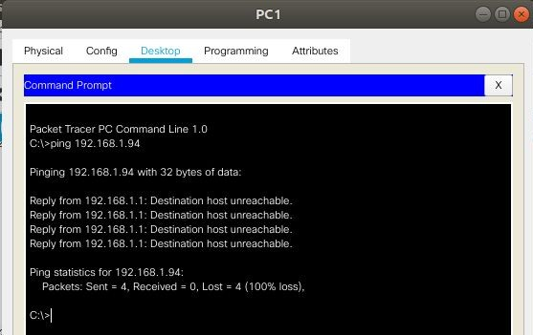

*Ping from PC1 to PC2*

What is missing from the network that is preventing communication between these devices? Ans: We have to configure routing, either static or dynamic in order to establish communication.