Methane

<http://webbook.nist.gov/cgi/cbook.cgi?ID=C74828&Units=SI&Type=IR-SPEC&Index=0#IR-SPEC>

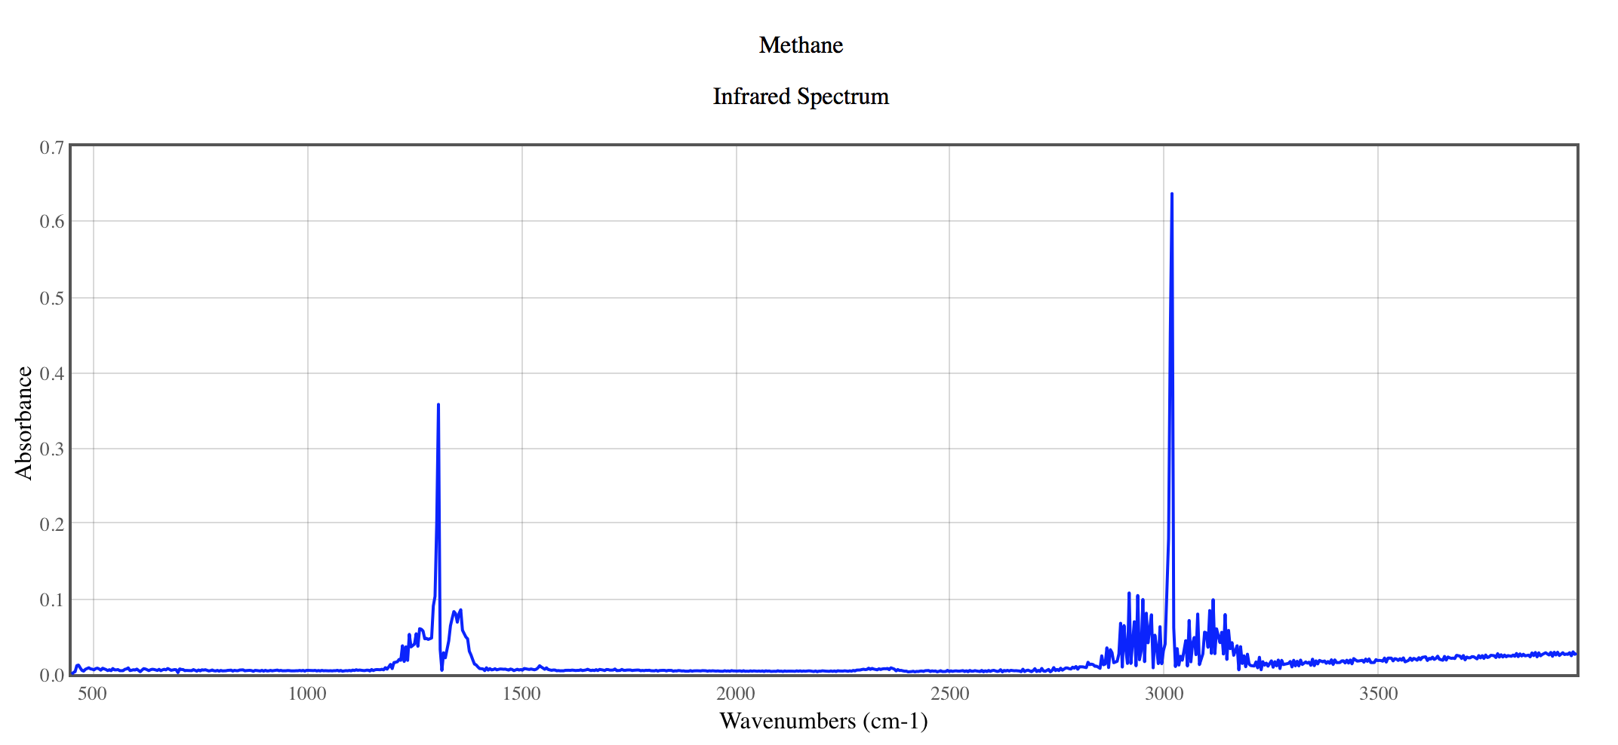





from Autocorrelation function

Methanol

<http://webbook.nist.gov/cgi/cbook.cgi?ID=C67561&Units=SI&Type=IR-SPEC&Index=18#IR-SPEC>

