HistoryLab

Sarah Shields, Department of History

[sshields@email.unc.edu](mailto:sshields@email.unc.edu)

**The Project:**

History professors assign primary sources to students, and expect the students to use these alien documents as evidence in the fashioning of coherent arguments about the past. As I talk with my colleagues about our experiences with student essays, however, it has become clear that students often need assistance in acquiring historians' skills. HistoryLab would be a way to introduce students to the way historians work, in the same way that biology and physics labs introduce students to the techniques used by scientists.

Biology, chemistry and other sciences use laboratories to allow students to participate directly in the work of those disciplines; art and music classes expect students to actively immerse themselves in the kind of work their teachers do; math and economics classes assign problem sets to give their students a taste of their fields. Neither labs nor performances nor problem sets could introduce our students to what historians do.

Historians use primary sources to draw conclusions about the past. Finding a way to have our students reach their own conclusions based on such sources would require them to develop higher level thinking skills. The plethora of contradictory sources would urge them toward critical thinking to decide which of the varied sources is likely to be reliable: how would the author's own position influence her/his creation of the sources, what difference would his/her intended audience make in the presentation, what context might affect the ways in which the author presented the situation? Having compared varied "documents" (which might include letters, government archives, songs, photographs, films, etc.), what conclusions might be drawn? Why would this information lead to those conclusions? What would happen if a different set of documents had been available?

Historians work through these sets of questions during research, and the books and articles that our students read to "explain" history are the results of this work. If students read only the texts written by others, however, they remain unaware of the kinds of ambiguities and challenges with which the historian must contend. More importantly, however, they do not have an opportunity to activate the kinds of higher-level analytical and critical skills necessary to become well-educated citizens.

HistoryLab would provide a digital interface that will ask students questions about authorship, audience, context, and the information contained in a document. HistoryLab will ask them to consider how they would incorporate new information into their conclusions, thereby encouraging critical thinking and reflection. How does new evidence influence previously-drawn conclusions? How do we think about what we know? By the end of the semester, I hope that my students would have constructed a narrative of the Modern Middle East that is self-conscious and self-critical, taking account of the kinds of ambiguities historians always confront and equipped with discipline-specific critical and analytical skills.

**The Frame**

Evernote (see <https://www.evernote.com/>) provides many of the functions that HistoryLab would rely upon. Here is an image from my own collection of notes:

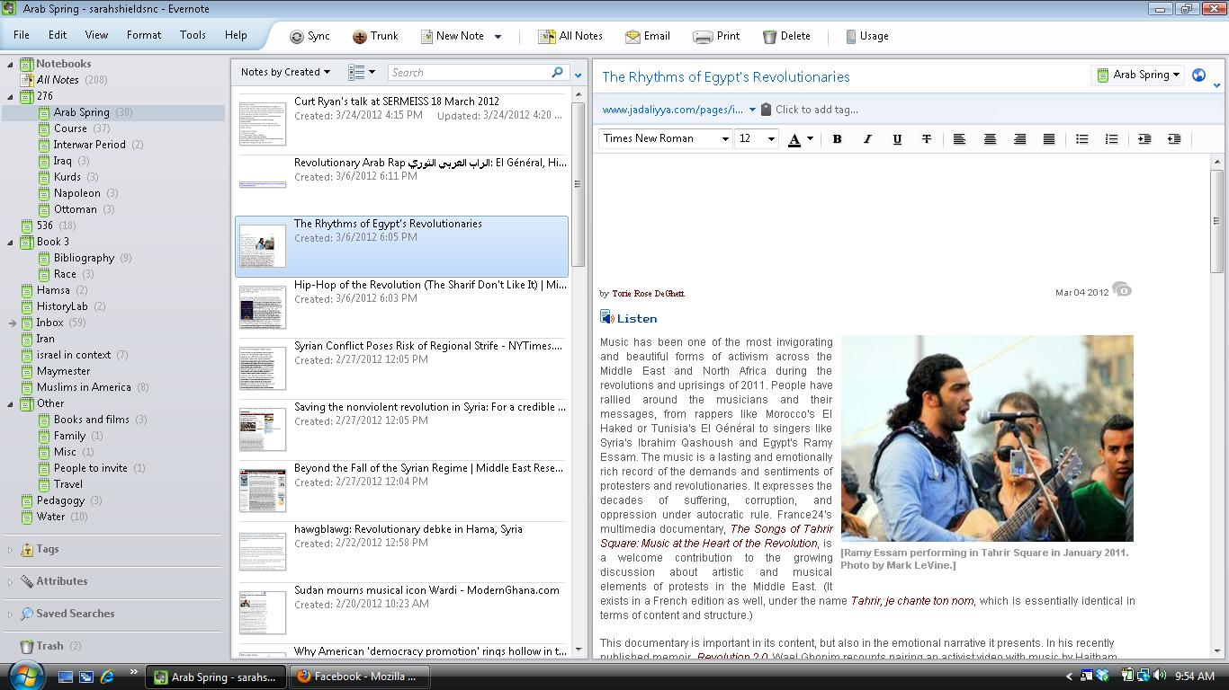

A historical document of some kind (video clip, government announcement, letter from Churchill) or an article would open in the largest window. Ideally the frame would support embedded readers for multiple file formats (e.g. text, PDF, AV files). These articles would be populated by the instructor. The option to hide and unhide documents in the document display for students would allow the instructor to introduce different perspectives sequentially throughout the semester.

A smaller window would ask questions of the document (for some reason I have always imagined this would be to the right of the document). A few questions would be standard for all documents; others would be document-specific. Like Evernote, HistoryLab would archive all of the documents and the students' responses to the questions, making each student's notes searchable. This feature would likely be or function like a wiki.

The folder hierarchy in the third (left-most) column may be used to support student document management or file sharing. It is likely that files created with third party tools (e.g. mind maps and time lines) and exported would need to be uploaded to HistoryLab file space. Folders in this area may be used to host pointers to the files.

The first-level historical functions would be included in this basic level: students would learn to ask and answer questions about the author, audience, agenda, and argument. These could be used to write basic journals and papers asking students to review or explain an article or document. Students might already have some of these skills at some level from high school. These basic functions would allow them to systematize the way they engage with historical sources.

**Other Functions**

* Search: Searching across wiki content and HistoryLab documents would facilitate students’ ability to reference documents throughout the semester. At the very least, the full-text search would need to index student wiki content. The ability to index text from documents, mind maps, and glossary content is unclear at this time.
* Links for context: Historians take this kind of information to another level by analyzing the context in which the event, idea, or issue emerges. This feature would function like an internal glossary. Students could click on a link in a document explaining the event, the person, or the idea mentioned in the source, providing them with the background necessary to understand the context. Initially the instructor would provide content for these links; as the semester progressed, students would be expected to click on the link and provide the context content themselves from their own information, the equivalent of a wiki that could be made available for other students to elaborate. The steps/ability to create links may vary across different text file formats. *Linking to existing sites is ubiquitous, and links would open in new windows; wiki functions are also common, and it might be helpful to use a third column for an ongoing wiki once students begin to create one.*
* Mind-mapping software: It is often difficult to make connections among contexts, events and ideas. Mind-mapping would allow students to draw conclusions by forcing them to discover the relationships among the varied kinds of evidence they had collected. Combining their evidence in a coherent way would lead them to an argument, thus creating an outline for their essay. The HistoryLab interface would link to a local or networked version of third-party mind-mapping software. It is unclear at this time what software would best meet ease-of-use, cost and other criteria. *(I use* [*FreeMind*](http://freemind.sourceforge.net/wiki/index.php/Main_Page) *because it works on my phone, but others might be better.)*
* Graphical additions:
  + Word cloud software might help students see which issues, events, or ideas have been predominant in their notes to remind them of the things they had found important. *(I use* [*wordle*](http://www.wordle.net/) *because it links to Poll Everywhere.)*
  + The ability to create [their own timelines](https://en.wikipedia.org/wiki/Wikipedia:Timeline) would be really helpful for students trying to remember the contexts in which their events have taken place. Like word clouds and mind maps, third party tools for creating timelines would likely be used.
* References: When students write papers, they are usually required to cite their sources as notes, bibliography, or both. UNC takes plagiarism very seriously, and the history profession is very insistent on proper citation of sources. HistoryLab could provide some of the functionality of [zotero](http://www.zotero.org/), a free online tool, that helps scholars keep track of their sources and format them properly as we write. *(Zotero also has note-taking functions that might be helpful for programming.)*
* Sharing: It would be very helpful for students working on projects together to be able to share their work, especially the wikis they create for context and their timelines. *Evernote has this function already, and sharing can be restricted as necessary.*

**Goals and Significance**

The goal of HistoryLab would be to make explicit the process used by historians and other scholars. The skills that need to be acquired in order to effectively present historical analyses are complex:

1. Evaluating the reliability of sources based on the author, intended audience, and agenda
2. Identifying the author's argument
3. Understanding the evidence used to prove that argument
4. Placing the author, events, ideas and arguments into broader historical contexts
5. Marshalling evidence from the sources
6. Making connections across a variety of sources
7. Drawing conclusions based on that evidence
8. Presenting those conclusions as a historical argument with supporting evidence, appropriately cited.

These skills are transferable to many other disciplines, and to many careers outside the university. Nonetheless, we seldom teach them explicitly, relying on students' ability to intuit what is supposed to happen in the "black box" between assigning a reading and producing a paper. HistoryLab seeks to make each of these steps explicit by identifying a series of sources, asking significant questions, and providing a technological framework which would accompany students through the required steps.

**Possible Additional Assignments**

In addition to HistoryLab's chief function of encouraging students to ask disciplinarily appropriate questions of their sources, to critically analyze information, and to draw historically-accurate conclusions based on their evidence, its various functions would be of great use in classroom instruction at many levels.

* Instead of simply assigning a journal response to an article or documents, instructors could request a mind map. This would help students prepare for class discussions.
* Students could be asked to create and compare timelines based on the readings as part of small-group discussions.
* In research-based courses (like my previous version of History 276, my Honors course on the History of Iraq (275H), my FYS History 006, and my Maymester History 277), students could share their findings with group members for joint projects.
* Students could be assigned to find a comparable document, an illustration or cartoon related to the document, or create a video or audio clip related to the document as part of a grade, or share it with other members of small groups.
* Students could create collective or multiple timelines tracing events across many regions or comparing events and ideas.
* Students could be required to populate the document list with one or more documents that bring a different perspective and explain its significance.
* For any given period or issue, students would be asked to create a wordle of all the notes they had taken. We would compare their word clouds in class and talk about the differences in emphasis.