**Bakery Ordering Application Use Cases**

Jenna James

MSSE 674 Service Based Software Development

Regis University

September 3, 2021

**Summary**

***Application Services***

A bakery is in need of an application through which customers can manage cake orders. The orders should be fillable through a user account. Once the customer has logged in, they can generate an order from a prefabricated list of ingredients. These orders can be stored and recalled. Customers have the option to cancel an existing order through the delete operation. Through the customer ordering capabilities, the essential CRUD operations are enacted on the application stores. The Manage Order use case appears as an extension of CRUD in the diagram. Alongside the Manage Order use case are other business-oriented functions associated with account management and access.

***Account Levels And Permissions***

The application will feature two access levels including administrative and customer users. The administrative user will have the ability to manage customer accounts via a series of CRUD operations. These actions are expressed as an expanded view in the use case diagram. The Manage Users use case will include the creation of a user account. All the existing users can be listed, modified and deleted from the administrative level of system access. The same operations will be available as they relate to the administrative accounts. Hence, the Manage Admin (Super User) use case is an extension of the Manage Users use case. Under the administrative level of system access, additional elevated accounts can be created. So, there are elevated permissions associated with the administrative level of access. They can create both users and other admins. By contrast, a customer account will be limited to the CRUD operations as they apply to a single account. Customer users can register and login to an account. They will have the ability to manage their user credentials. They can delete their account as well.

It is important to note a difference in the read operations as they apply to the Manage Users and Manage Account use cases. The former is able to perform the read operation by listing all the existing users in the system. Again, this is an elevated function attributed to the administrative, or super, user. Meanwhile, the customer user enacts the read operation by logging into their account. This is true for the Manage Account use case. Notice that the including relationship has been articulated as Login User (read). The other including relationships will remain consistent with those displayed under the Manage Users use case. Therefore, the Manage Account use case is an extension of the Manage Users use case.

**Use Case Diagram**

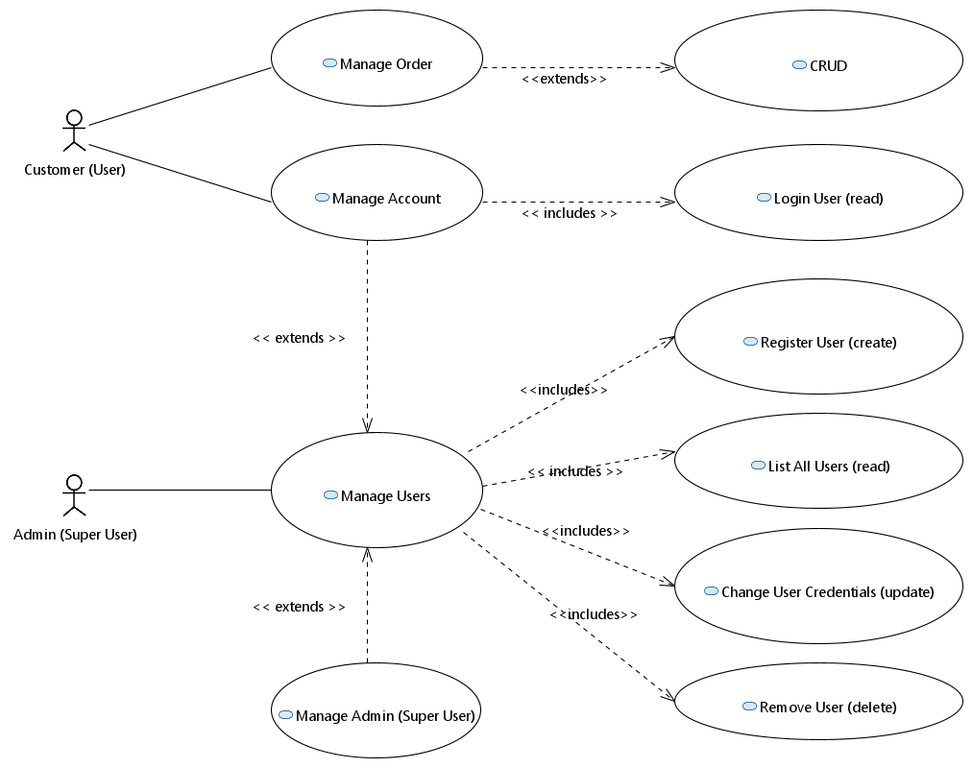

**Prioritized Use Cases**

1. Manage Account
2. Manage Users
3. Manage Order
4. Manage Amin (Super User)

**Use Case Write Up**

***Manage Account (Fully Dressed)***

**Primary Actor.** A customer logs into an account with their credentials. They can view and update their account information.

**Stakeholders and Interests.** The bakery is hosting a web application that will allow them to sell cakes online. Customers should be able to create cake orders from a prefabricated set of ingredients. These orders can be written to the system and recalled.

**Preconditions.** A user should be able to register an account.

**Success Guarantee.** If a user can register for an account and login thereafter, the successful creation of a user has been achieved.

**Main Success Scenario.** The user is able to register an account and successfully login.

**Extensions.** Authentication may be enacted. The user credentials are invalid upon an attempt to login with a wrong username and/or password.

**Special Requirements.** This will have a simple authentication method native to the system.

**Technology And Data Variation List.** Eclipse IDE, Java SE Development Kit 11, Apache Maven for Eclipse, Apache Tomcat for Eclipse.

**Frequency Occurrence.** This use case is likely to be enacted constantly. It is a primary function of the application. Adequate measures should be taken to sustain this load.

**Open Issues.** The application will begin as a simple exploration of user creation and access.

***Manage Users (Casual)***

The customer user accounts will need to be managed by an elevated account type. Such permissions will be attributed to the Amin (Super User) actor. The Mange Users use case includes the CRUD operations. These actions are fully articulated as inclusions within the use case diagram. The administrative use is capable of creating new users. They can also update and delete these records. Finally, they can view a complete list of all the existing customer records. Their respective login credentials are made available to the admin.

While the customer user type will have the ability to register an account, it is helpful to attribute this functionality to an elevated user. The administrative user should have the ability to review those with access to the application. This will be the primary capability of the administrative level accounts.

***Manage Order (Brief)***

Customer users should have the ability to place a cake order through their associated account. Orders will be composed with an application form. Each cake order is outlined by the predetermined ingredients listed. Hence, custom cakes can be created by selecting from various flavor, icing and topping offerings. Once an order is created, it can be reviewed by the customer. The customer should have the ability to update and delete orders as well.

***Manage Amin (Super User) (Brief)***

There should be a way to create additional administrator accounts through the application interface. This capability will be limited to existing administrative users. The same CRUD operations pertain to the management of these account types.