Abandoned but not Forgotten
Stories of Spacecraft and Equipment Left Outside Earth
Compiled for NASA Space Apps Challenge 2026. This document presents key human-made objects that remain on the Moon, Mars, or in deep space. Each section includes an illustrative image and a summary table of essential facts, launch information, mission purpose, and why the hardware did not return to Earth.

Pioneer 10
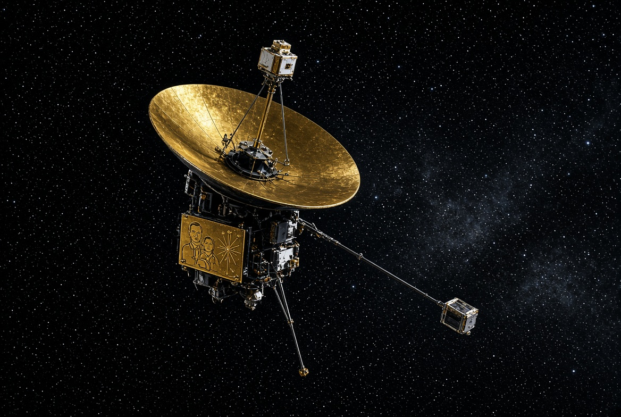
Illustrative image of Pioneer 10 (based on historical design; actual photos available from NASA archives)
Name | Pioneer 10
Agency / Country | NASA / United States
Launch Date | March 2, 1972
Launch Vehicle | Atlas-Centaur
Mission Purpose | First spacecraft to traverse the asteroid belt and fly by Jupiter. Studied the outer solar system, radiation, magnetic fields, and dust.
Key Achievements | First through the asteroid belt (July 15, 1972); first Jupiter flyby (December 3, 1973); carried the famous Pioneer plaque designed with input from Carl Sagan as a message to potential extraterrestrial life.
Why It Did Not Return to Earth | Designed as a one-way probe. After the Jupiter flyby it continued on an escape trajectory out of the solar system. No return capability was built in; the mission was pure exploration of the outer solar system and beyond.
Current Status | Contact lost in January 2003 (last signal). Still traveling toward the star Aldebaran (expected arrival in ~2 million years). Estimated distance ~142 AU from the Sun (as of late 2026).
Important Dates | Launch: 2 Mar 1972 | Asteroid belt: 15 Jul 1972 | Jupiter: 3 Dec 1973 | Last signal: 23 Jan 2003
Additional Notes | Carries a gold-anodized aluminum plaque showing human figures and the location of Earth relative to pulsars. Predecessor to the Voyager Golden Records.

Pioneer 11
Twin of Pioneer 10. First spacecraft to fly by Saturn.
Name | Pioneer 11
Agency / Country | NASA / United States
Launch Date | April 6, 1973
Mission Purpose | Explore the outer solar system; perform first Saturn flyby after using Jupiter gravity assist.
Key Achievements | Closer approach to Jupiter than Pioneer 10; first images of Jupiter’s polar regions; first Saturn flyby (September 1, 1979); discovered Saturn’s F ring and two new moons.
Why It Did Not Return to Earth | One-way deep-space probe on an escape trajectory. After Saturn it continued outward; no propulsion or design for return.
Current Status | Last signal November 1995. Heading toward the center of the Milky Way / constellation Aquila. Estimated ~119 AU from the Sun.
Important Dates | Launch: 6 Apr 1973 | Jupiter flyby: Dec 1974 | Saturn flyby: 1 Sep 1979 | Last signal: Nov 1995

Voyager 1
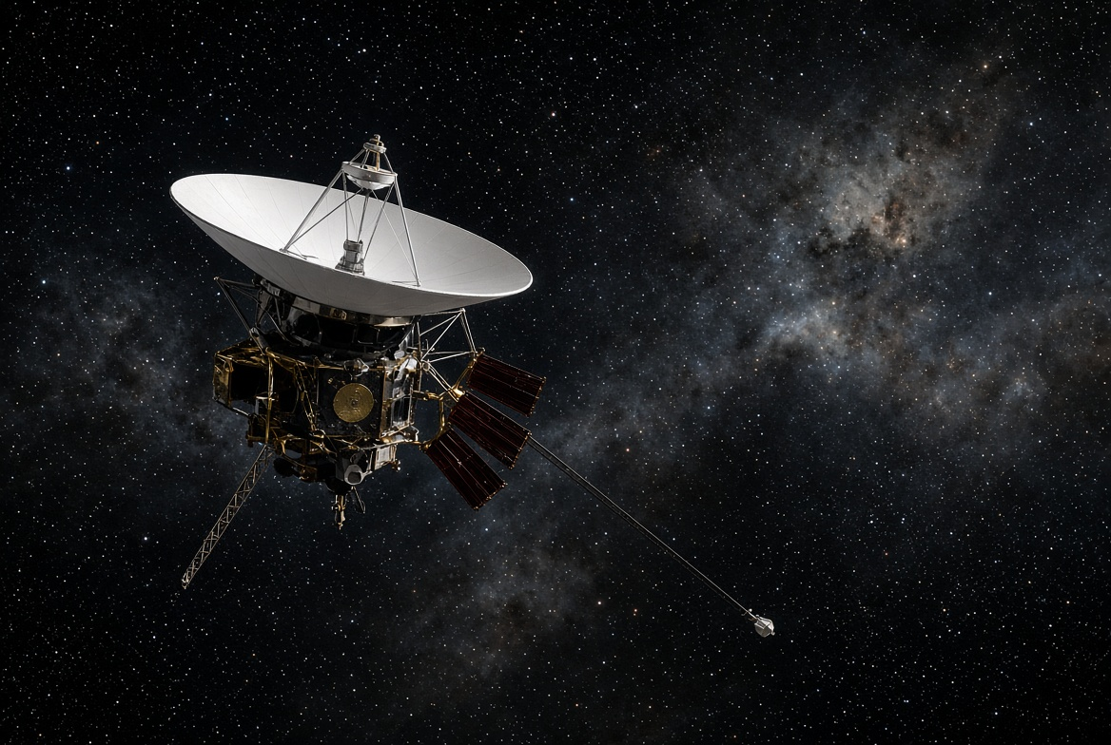
Illustrative image of Voyager 1
Name | Voyager 1
Agency / Country | NASA / United States
Launch Date | September 5, 1977
Mission Purpose | Fly by Jupiter and Saturn (and Titan). Extended to the Voyager Interstellar Mission to study the heliosphere and interstellar space.
Key Achievements | Closest approach to Jupiter (March 5, 1979) and Saturn (November 12, 1980); first spacecraft to enter interstellar space (August 25, 2012); still the farthest human-made object; carries the Golden Record.
Why It Did Not Return to Earth | Designed as a flyby mission with no return trajectory. Gravity assists from the giant planets sent it on a permanent path out of the solar system. Power comes from radioisotope thermoelectric generators (RTGs) that slowly decline.
Current Status (2026) | Still operating with limited instruments (magnetometer and plasma wave subsystem). Will reach one light-day from Earth on November 18, 2026. Distance ~172 AU / ~25.9 billion km.
Important Dates | Launch: 5 Sep 1977 | Jupiter: 5 Mar 1979 | Saturn: 12 Nov 1980 | Interstellar space: 25 Aug 2012 | One light-day: 18 Nov 2026

Curiosity Rover (Mars Science Laboratory)
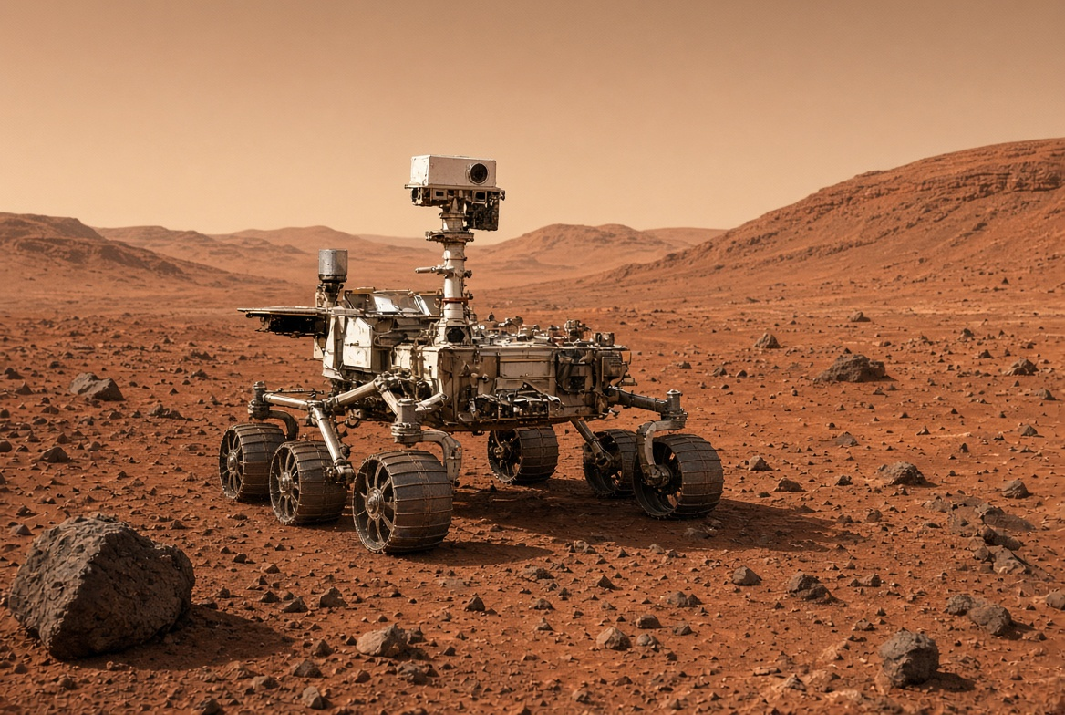
Illustrative image of Curiosity rover
Name | Curiosity (Mars Science Laboratory)
Agency / Country | NASA / United States
Launch Date | November 26, 2011
Landing Date | August 6, 2012
Location | Gale Crater / Mount Sharp, Mars
Mission Purpose | Determine if Mars ever had the environmental conditions to support microbial life. Analyze rocks, soil, and atmosphere.
Why It Is Still on Mars / Did Not Return | Designed as a one-way surface mission. No ascent vehicle or sample-return capability was included. It continues long-term exploration; returning it would require a future dedicated mission.
Current Status (2026) | Still active after more than 5,000 sols. Has driven ~38 km and climbed over 1 km in elevation. Continues to find organic molecules and evidence of ancient habitable environments.
Key Achievements | Confirmed past habitable environments; discovered organic compounds; detailed study of Mount Sharp’s rock layers.

Ingenuity Mars Helicopter
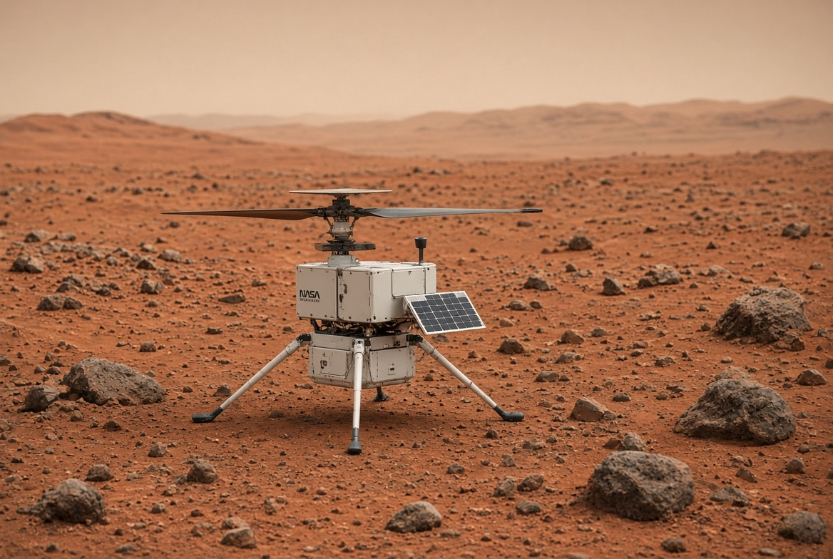
Illustrative image of Ingenuity
Name | Ingenuity
Agency / Country | NASA / United States
Launch Date | July 30, 2020 (with Perseverance)
Deployment / First Flight | Landed with Perseverance February 18, 2021; first flight April 19, 2021
Mission Purpose | Technology demonstration: first powered, controlled flight on another planet. Later served as a scout for the Perseverance rover.
Why It Is Left on Mars | Technology demo completed. After 72 flights a rotor blade was damaged on the final flight (January 18, 2024). Mission ended January 25, 2024. No recovery capability.
Current Status | Permanently grounded at Valinor Hills in Jezero Crater. Still able to collect limited data until contact is lost as Perseverance moves away.
Key Achievements | 72 flights; 17 km flown; altitudes up to 24 m; proved aerial mobility is possible on Mars; paved the way for future flying explorers.

Major Equipment Left on the Moon
Humans have left more than 187,000 kg of material on the lunar surface. Most of it is from Apollo missions (descent stages of Lunar Modules, Lunar Rovers, scientific packages) and earlier robotic landers (Surveyor, Luna). These were left behind to reduce mass for the return journey or because they completed their one-way missions.
Notable Examples | Apollo 11–17 Lunar Module descent stages; Apollo 15–17 Lunar Roving Vehicles; Surveyor landers; Luna 2 (first impact, 1959); Lunokhod rovers
Why Left Behind | Apollo: Descent stages served as launch platforms for the ascent stages that returned astronauts and samples to orbit. Tools, experiments, and rovers were too heavy or unnecessary for return. Robotic missions were designed as one-way.
Still Operational | Retroreflectors from Apollo 11, 14, 15 and Soviet Lunokhods continue to be used for laser ranging experiments that measure the Earth-Moon distance with high precision.
Key Reference | Wikipedia: List of artificial objects on the Moon; NASA Lunar Reconnaissance Orbiter images of landing sites
Sources
Data compiled from NASA Science, The Planetary Society, NSSDCA, Wikipedia lists of artificial objects, and official mission pages. Images are illustrative reconstructions for this document; official NASA photographs are available on the agency’s image libraries.
Prepared for the NASA Space Apps Challenge 2026 challenge: “Abandoned but not Forgotten: Storytelling about NASA’s Discarded Equipment on the Moon and Mars.”

