Abandoned but not Forgotten
Additional Equipment Left on Mars and the Moon
Part 2 of the compilation for NASA Space Apps Challenge 2026. Additional historic hardware that remains on Mars and the Moon.

Opportunity Rover (Mars Exploration Rover)
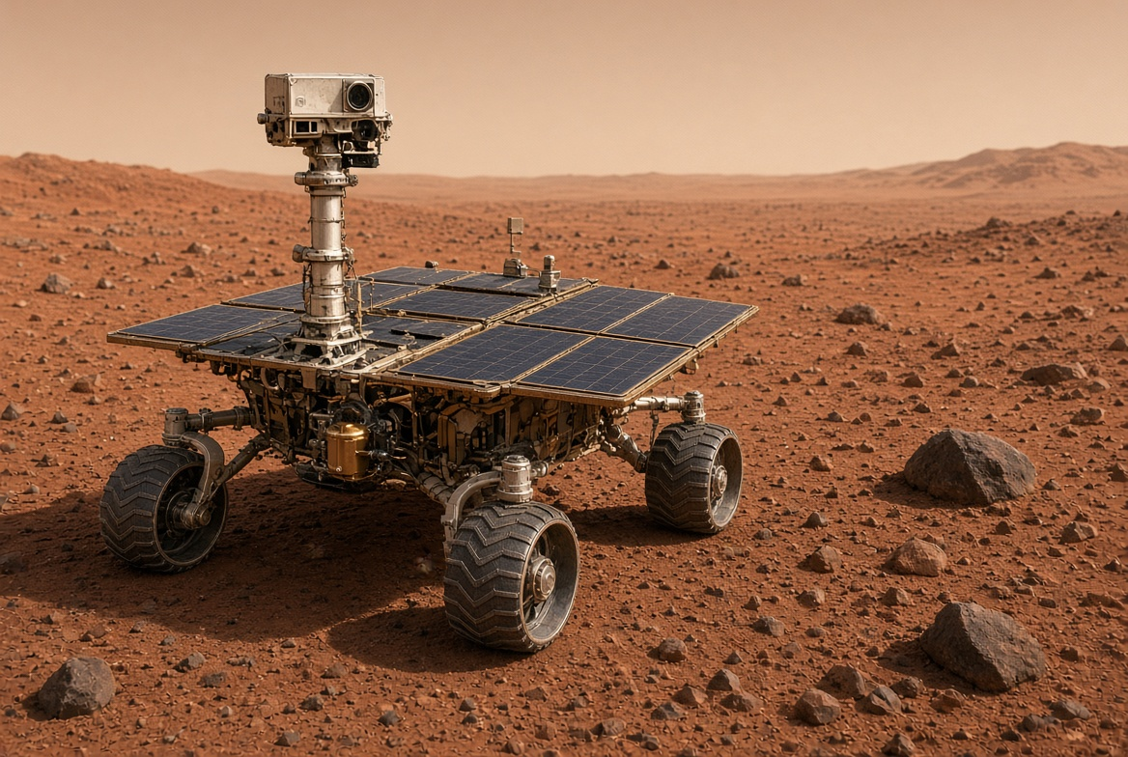
Illustrative image of Opportunity
Name | Opportunity (MER-B)
Agency / Country | NASA / United States
Launch Date | July 7, 2003
Landing Date | January 25, 2004
Location | Meridiani Planum, Mars (final resting place: Perseverance Valley)
Mission Purpose | Search for evidence of past liquid water and study the geology of Mars as a robotic field geologist.
Why It Did Not Return to Earth | Designed as a one-way surface mission. No return capability. It far exceeded its 90-sol design life.
Current Status | Mission ended February 13, 2019. Last contact June 10, 2018 during a global dust storm that covered its solar panels. Still on the surface of Mars.
Key Achievements | Drove 45.16 km (28.06 miles) — marathon distance and previous off-world record; found strong evidence of past water; operated for 15 years.

Spirit Rover (Mars Exploration Rover)
Twin of Opportunity. Explored Gusev Crater and the Columbia Hills.
Name | Spirit (MER-A)
Agency / Country | NASA / United States
Launch Date | June 10, 2003
Landing Date | January 4, 2004
Location | Gusev Crater, Mars (stuck at a site called Troy)
Mission Purpose | Search for evidence of past water and study Martian geology.
Why It Did Not Return to Earth | One-way mission. Became immobilized in soft soil in 2009; continued as a stationary science platform until power failed.
Current Status | Last contact March 22, 2010. Mission officially ended May 25, 2011. Remains on Mars.
Key Achievements | Drove 7.73 km; found evidence of ancient hot springs and water-altered minerals; first robot to summit a hill on another planet.

Apollo 11 Lunar Module Descent Stage (Eagle)
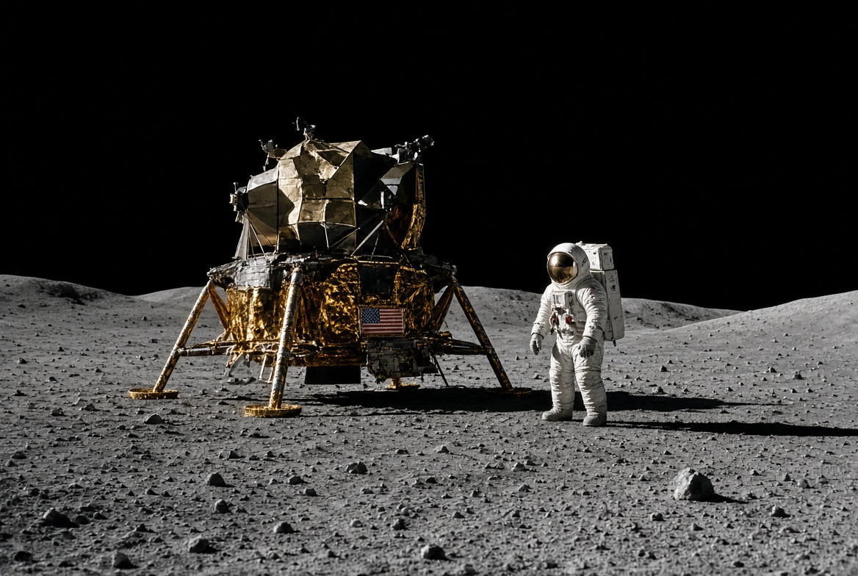
Illustrative image of Apollo 11 Lunar Module descent stage
Name | Apollo 11 Lunar Module Descent Stage (Eagle)
Agency / Country | NASA / United States
Launch Date | July 16, 1969 (Saturn V)
Landing Date | July 20, 1969
Location | Sea of Tranquility, Moon
Mission Purpose | Carry Neil Armstrong and Buzz Aldrin to the lunar surface for the first human Moon landing. Served as a launch platform for the ascent stage.
Why It Was Left on the Moon | The descent stage was designed to stay on the surface. It provided the engine and structure for landing and then acted as the launch pad for the ascent stage that returned the astronauts to lunar orbit. Leaving it behind reduced the mass that needed to be lifted back.
Current Status | Still on the Moon. Visible in high-resolution images from NASA’s Lunar Reconnaissance Orbiter. The lower stage, landing legs, and some equipment remain intact.
Key Notes | First human-made structure left on the Moon after a crewed landing. Part of the larger collection of Apollo hardware (descent stages, rovers, experiments) still on the lunar surface.
Notes
These additional examples continue the theme of equipment left outside Earth. Opportunity and Spirit are classic “abandoned but not forgotten” Mars rovers, while the Apollo 11 descent stage is the most famous piece of hardware left on the Moon.
Sources: NASA mission pages, Planetary Society, Wikipedia, and official mission archives. Images are illustrative reconstructions.

