 | Date: March 2026 | Ref: 60275

Position | Tūranga: Research Associate
Team | Tīma: | Applied Solutions for Plant Protection
Group | Rōpū: | Plant Protection Systems
Portfolio | Aronga: | Bioprotection
Responsible to | Tō kaiwhakahaere: | Science Team Leader
Location | Wāhi: | Lincoln
Key Relationships | Ngā hononga matua: | Line Manager, Project Manager(s), wider science team and science group members.
Tenure | Momo tūranga: | Fixed-term 14 months

Purpose of the Position | Whāinga o te Tūranga
To provide microbiology and basic molecular biology support within the Applied Solutions for Plant Protection team. Key areas of focus are plant pathology and microbial ecology research of vegetable, horticultural and native plants. The Research Associate will also support similar projects on a range of plant hosts, pests and pathogens as required by research leaders. The position requires a combination of skills in 1. Microbiology; 2. Management of plants; 3. Field work; 4. Molecular biology. These skills will be utilised as any new research projects to be supported are undertaken.

Accountabilities | Ngā whakaritenga
- Contribute to laboratory and field research projects under the supervision of scientists
- Design and execution of projects in consultation with supervising scientists
- Data collection and analysis
- Contribute to the preparation of client reports and presentations in consultation with supervising scientists
- Contribute to the preparation of scientific papers in consultation with supervising scientists
- Work within the required laboratory health and safety standards and actively participate in the Health & Safety programme
- Take reasonable care of individual health, safety and wellbeing and that actions or inactions do not harm others
- Follow health, safety and wellbeing instructions, policies and/or procedures and participate in training as required

Our values | Ō mātou Uara
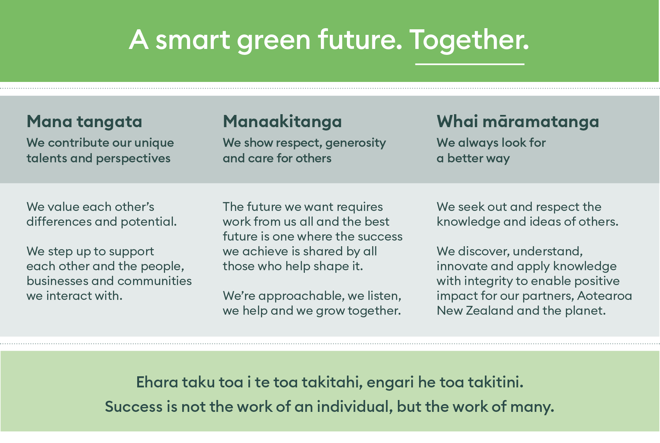

Person Specification | Ngā tino pūkenga me ngā wheako

Professional experience, qualifications and skills:
A degree or diploma in microbiology, plant pathology and relevant practical experience.
- Knowledge and experience of lab-based microbiology techniques including media preparation, microbial isolation and plating. Competency in basic pathology skills including sampling from diseased material, use of microscopes.
- Knowledge and experience in basic molecular biology techniques. Capability in molecular detection techniques such as PCR and qPCR will be important, with at least an introductory knowledge of bioinformatics techniques being highly desirable.
- Flexibility and willingness to work in a team environment with a range of different project leaders on sometimes disparate projects. Willingness and ability to learn on the job will be crucial.
- Self-motivation with the capability to manage time across multiple projects to ensure timely delivery of outcomes.
- Ability to engage in local travel and field experimentation as required, sometimes involving extended hours and overnight stays.
- Careful and accurate laboratory procedures and data recording. An organised and methodical approach to tasks and commitment to effective project management and record keeping.
- Baseline computing skills for recording results and preparing reports e.g. word processing, spreadsheets, graphical.
- Clear verbal and written scientific communication skills.
- Preferably hold a full New Zealand drivers licence.

Measures of Performance | Paearu mahi
Performance will be reviewed in regular informal discussions with the incumbent’s immediate manager and at an annual meeting as part of a Growth, Development and Focus process.
Success in this role will be measured by:
Demonstrated performance against the accountabilities listed above
Completion and reporting of projects, including formal written reports
Proactive engagement with others to encourage and support a culture of well-being and personal safety.

