GUN DREAMS
BY
Kawamura Yasuhisa
based on

BATTLE ANGEL ALITA
by
Yukito Kishiro
Transcription/Translation/English Editing by
Jo Jaquinta
Scans by
DarkStarBeacon

Originally published by Jump J books. Please support the official release.

This work is a fiction. It has no relation whatsoever to real people, organizations, or events.

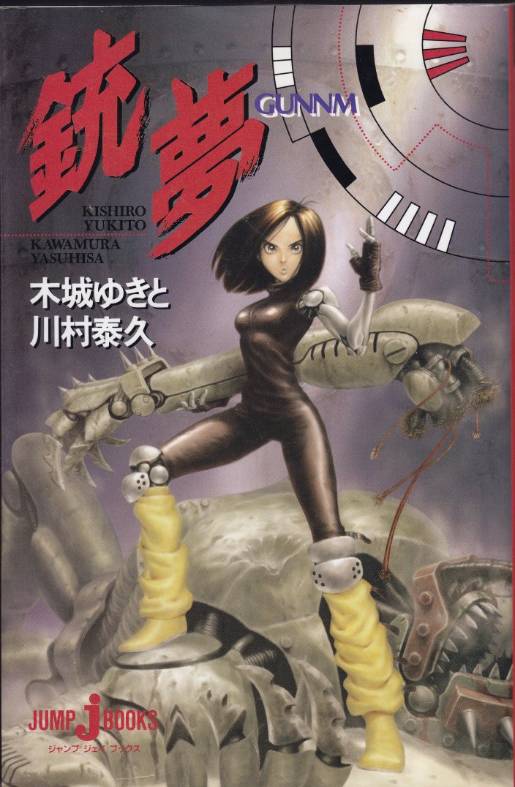
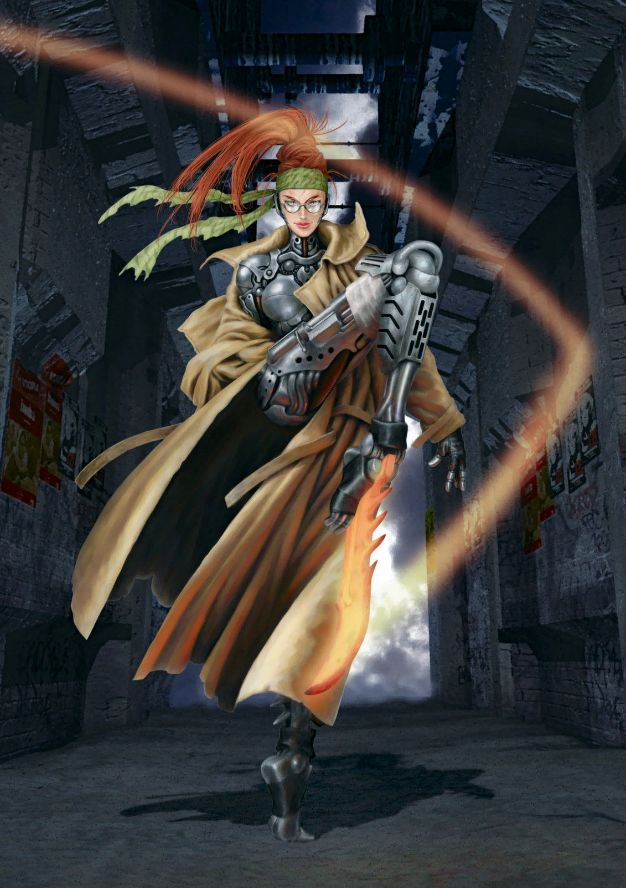
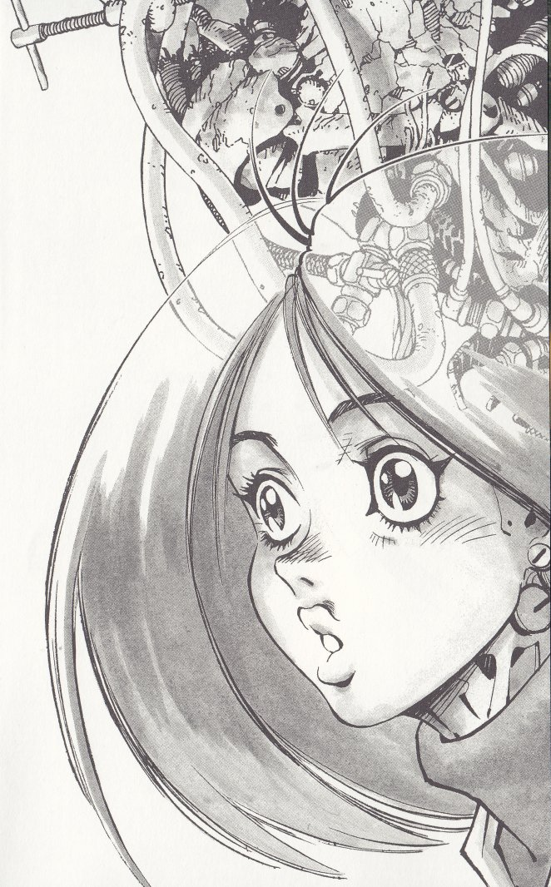
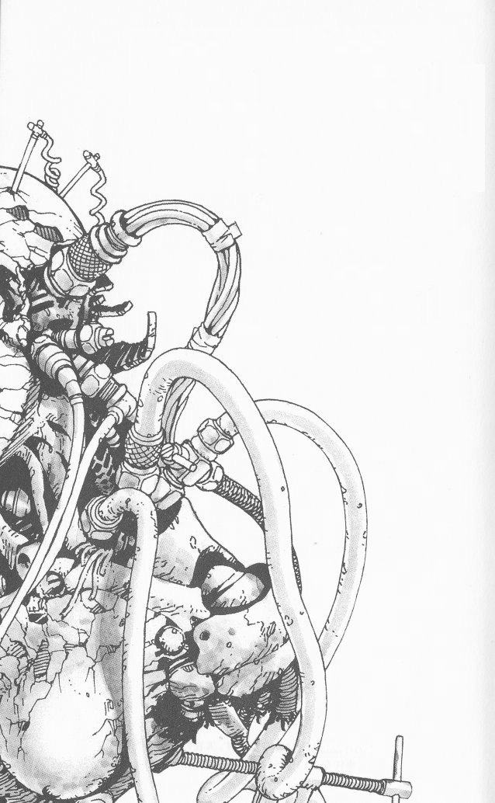

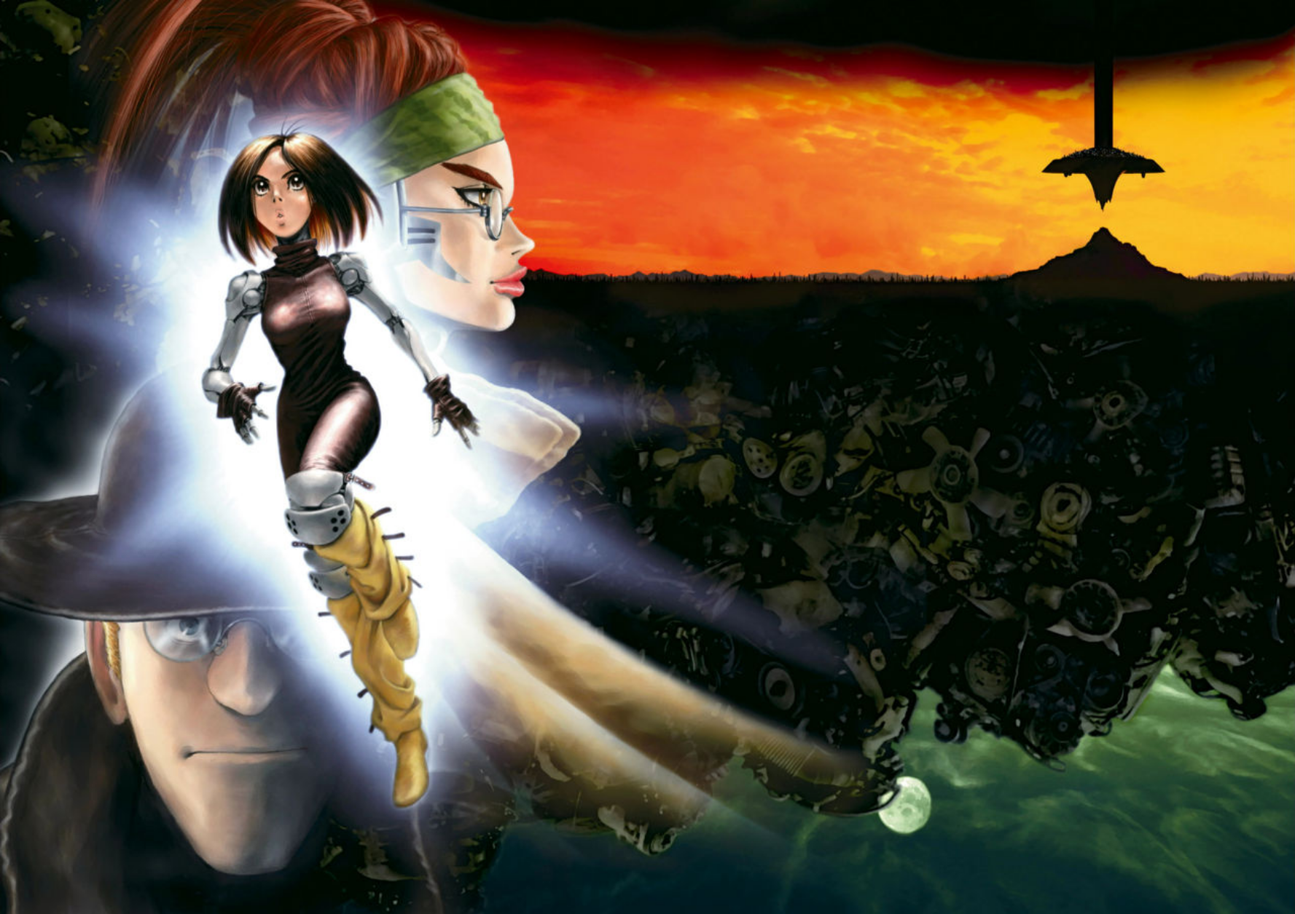
PROFILES
Alita: A cyborg girl who has lost all memories of her past.
Ido: A cybernetic surgeon residing in The Scrapyard, specializing in the repair and maintenance of cyborgs.
Calico: A female cyborg Hunter-Warrior.
Colt: A thug cyborg from The Scrapyard.
Norinco: A homeless old man. A former Hunter-Warrior.

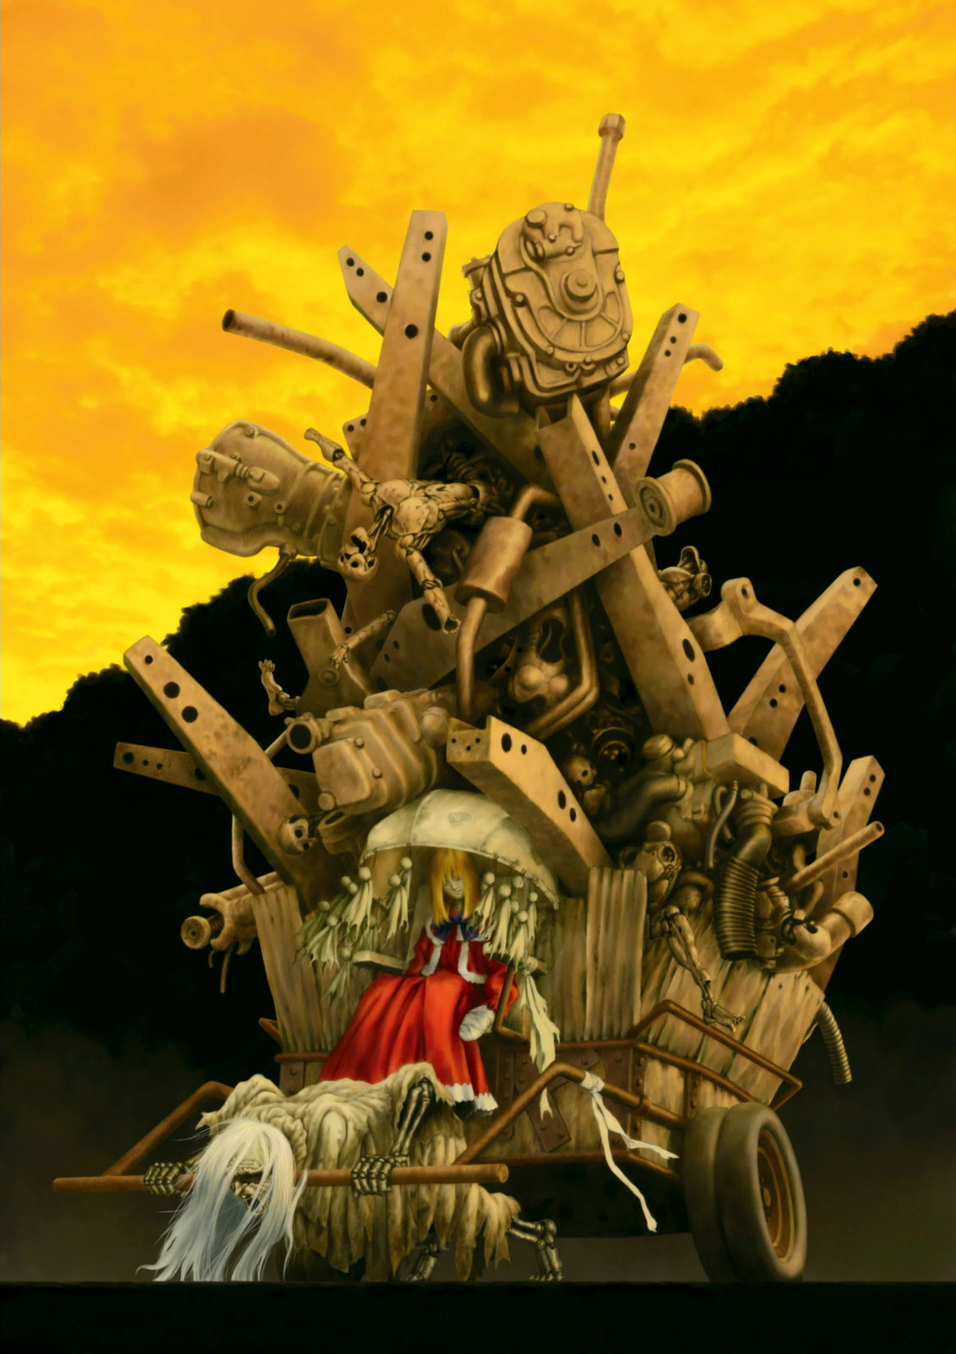

CHAPTER 1
“Aaahh!”
A man was running frantically through the moonlit night. There were no streetlights in the dimly lit alleys. Sparks from torn and hanging cables on the crumbling walls illuminated the darkness with a pale blue light. The man’s wild figure dashed through the flickering light and shadow, appearing and disappearing like frames from an animation. He was a half-cyborg with part of his head and his left arm made of gleaming metal components. In his cyborg arm, he gripped a large, old machete. Its faintly gleaming blade stained with thick, dark blood.
This place was a district far removed from the pleasure quarters of The Scrapyard, where only grimy alleys wound through the narrow gaps between buildings, like capillaries, but devoid of life.
The man ran aimlessly through the narrowing and widening alleys. Whenever a side street split off, he would whip his head around like a starving wild dog, hesitate for a moment, and then dart down one of the alleys, as if on impulse.
"I'll be killed... I'll be melted..." the man muttered, trembling in fear at the hallucinations he saw. To his clouded eyes, the alleys twisted and writhed like obscene, red-black tongues, as if they were alive, pulsating and ready to swallow him whole.
Though crying out in terror at these illusions, he did not stop running. He plunged deeper into the dark maze of alleys, knowing there was no turning back. He was convinced that if he stopped, the walls around him would immediately spew acid and dissolve him completely, leaving no trace. At this point, if you were to squeeze the man's brain, alkaloids would ooze out like juice—he was suffering from withdrawal symptoms and a bad trip caused by plant-based drugs.
Oh no, the sound of footsteps is getting closer. They're coming to melt me!
The man’s desperate escape through countless alleys finally ended at a dead end. He was stopped when the alley abruptly came to a halt at a deep, filthy river of sewage. He trembled as he leaned his back against a wire mesh fence built along the bank of the sewer. The far end of the alley he had just run through was swallowed by darkness, as if cut off by another dimension, making it invisible.
The towering walls on all sides seemed to press down on him, as if ready to crush him. "No! Stop! Stop it!" he screamed with a face contorted in desperation. He clutched the old knife he was holding hard and slashed at his right arm. Once, twice—the skin split open, revealing pink flesh, which was quickly covered by the blood that spurted out.
"Agh! No! Ahh!" The intense pain in his arm made his breathing erratic, his chest rising and falling like a bellows. But as the pain overwhelmed his consciousness, the man’s blurred vision rapidly began to regain clarity. His hallucinations faded and his awareness returned. He let out a twisted, guttural laugh. And then, he stared into the emptiness ahead.
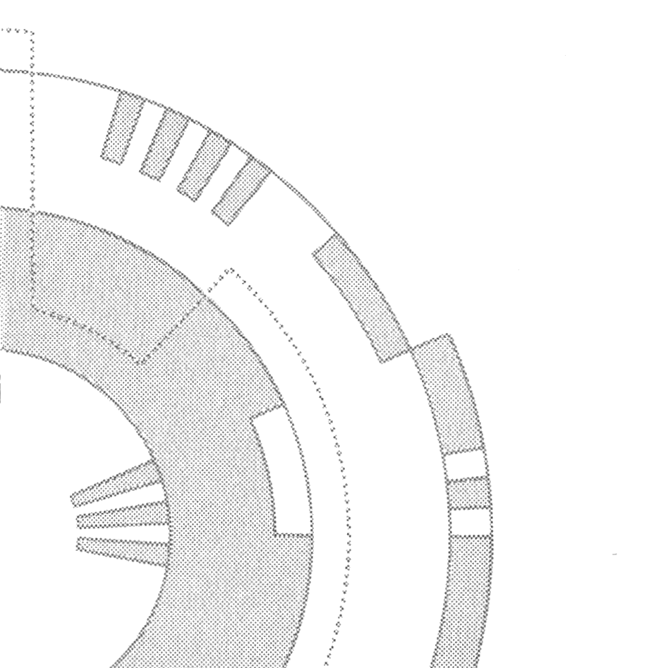
He muttered "Serves you right, serves you right," over and over again. The hallucinations had vanished. However, some of what he had seen chasing him was real, mingling with his hallucinations. This real element did not disappear with the hallucinations when his consciousness cleared. The real element was the existence of his pursuer—the reason he was fleeing while suffering from hallucinations.
"Ah, so you cornered the cheaper end of the bounty market, did you? Hey, do you recognize me, Mr. 90,000 chips?" called out a voice.
The man's vision, which had been blurred and distorted into single and triple outlines until moments ago, had already recovered. As the words sunk in, he strained his bloodshot eyes, looking into the darkness of the alley and saw a shadow seeping out from it.
"You're not a hallucination, are you, you damn Hunter?"
The shadow, as if cut out in human form from the darkness, slowly stepped out from the depths of the alley with hard footsteps striking the pavement. Then, dropping a rolled-up bounty list at his feet, it crushed it with a crunch.
"Don't think you can hunt me so easily." The man wiped his blood-soaked right arm, lowered his stance, and readied his knife. Perhaps because he had survived countless battlefields, his posture was well-practiced and left little room for openings.
At the man's stance, the shadow let out a sigh and whispered in a low voice. "A serial killer who only targets women would fetch a slightly better bounty, but well, a murderer will do for today."
"Haah!"
With a shout, the man sharply kicked off the ground. The leap that seemed impossible for a mere human—more like that of a mountain monkey. As he hurtled through the air he swung his knife straight down onto the shadow's head. His cyborg left arm unleashed immense power, and the accelerated tip of the knife sliced through the air, emitting a sound like a whistle.
It was the one-hit kill technique that had sent many victims and pursuers to their graves.
Just as the man's deadly blade was about to touch the shadow's head, a sharp glint flashed in the shadow's eyes, reflecting the dull light of the knife's blade.
In an instant, a red light raced upward from beneath the shadow. Its brilliance traced an arc from the ground to the sky like a crimson banner before melting into the darkness. Almost simultaneously with the crimson banner of light streaking through the darkness, a high-pitched, clear "ping" echoed, shaking the walls of the dark alley.
"W-what...?" The man felt a sense of unease at the absence of the thrill that should have surged through him when he plunged his blade into the enemy's skull. The resistance of the knife, which should have been felt with the centrifugal force, had vanished somewhere just before touching the shadow's head, leaving him swinging his left arm downward to the ground as if striking nothing but air.
Pulled by the momentum of his swing, the man somersaulted in midair and landed on his back on the pavement, rolling over.
"Ahhh! M-my hand!"
It was when he landed on his back and, due to the pain, reached behind with his left arm that he finally noticed the sense of loss and let out a scream. His left cyborg arm had been severed at the wrist during that brief encounter with the shadow. The remains of the wrist displayed a sharp cut surface, emitting heat and faint wisps of smoke.
The shadow stood before his eyes as if nothing had happened.
"Wh-what the hell is going on?"
After a few seconds, the knife, still gripped left hand finally fell with a thunk beside the man and stuck into the alley's asphalt, vibrating.
The shadow had not avoided the man's knife, which was being swung down at high speed; instead, it had swept a kick across the wrist holding the knife from the side at a speed far exceeding that.
That shadow's kick had been truly a work of art. It was a kicking technique with a supple movement like a waterfowl spreading its wings to take flight to the sky, yet at the same time, it held the destructive power akin to a raptor's talons tearing apart its prey.
As the blade of the knife descended rapidly, the shadow's folded kicking leg extended almost straight upward like a whip. Then, lifting the heel of the supporting foot off the ground, pivoting sharply inward around the base of the big toe, the body turned to almost face forward.
As the kicking leg received the explosive force from the supporting leg that had risen onto tiptoe with the heel's rotation, the lower leg from the folded knee was released, twisting sharply inward. At this moment, the kick's power reached its maximum, impacting the man's left wrist that held the knife, severing it.
The shadow's kick, which surpassed textbook perfection, took less than a fraction of a second to complete. Moreover, astonishingly, the shadow unleashed this supremely powerful kick after confirming that the man was swinging down his knife.
Not only had the shadow's kicking technique reached a godlike level, but its reflexes had as well. Yet, questions remained. No matter how artistic or divine their skills were, could a mere kick not just break but sharply sever the wrist of a steel-made cyborg?
Clearly, the man's mechanical left wrist had indeed been cleanly severed. It seemed there was something beyond just the shadow's advanced kicking techniques at play.
By the time the man vaguely sensed this crucial detail and shuddered, the shadow was already stepping on his back, rendering him immobile.
"D-Damn it!" the man cursed, lying face-down as he struggled to twist his neck and glare at his hated pursuer.
What appeared at the edge of his vision as he painstakingly looked up was a tall, slender figure with silver-framed glasses and a red pineapple-like hairstyle.
"A woman?"
"Heh heh, well, at least my consciousness and chromosomes are," the pursuer said, twisting her red lips, continuing to step on the man.
Indeed, her facial features and silhouette were those of a woman. However, the woman's body, visible beneath her rumpled long coat that only reached above the knees, was entirely artificial, made of steel and ceramics. She was a full-body cyborg, with everything except the skin on her face and her hair fully mechanized.
The cyborg woman leaned over, resting her elbow on the knee of the foot that was stepping on the man, and gave a sarcastic smile at his pathetic state.
"The hunter who blew off my wrist with a kick is a full-body cybernetic maniac chick?" The man desperately twisted his neck and spat out, trying to act tough.
In response to the man's insolent attitude, the woman didn't smile but pressed down harder with the foot on his back. A loud cracking sound, like stepping on a bundle of dry twigs, echoed and the man flailed his limbs like an insect, screaming.
"Yes... yes! I love that sound of bones" cried the woman. Enjoying the sensation of crushed bones, the woman repeatedly stomped on the man's back, licking the corner of her lips—shaped into a cruel smile—with her blood-colored tongue.
As the light in her eyes sparkled behind her glasses, she spoke to the man, whose bravado had completely vanished and who now trembled in mere fear of pain and death. "Never thought I'd have to use a cartridge on someone like you, worth just 90,000 chips. These things are expensive, you know?"
Lifting the hem of her worn-out coat, the woman pointed to the leg she was using to step on the man.
On the shin of that mechanical leg, which had lost any human form, there was a bolt-like handle reminiscent of those seen on firearms and a semi-cylindrical shutter resembling an ejection port.
With a heavy clanking sound, the woman pulled the bolt, causing the shutter to slide open and eject a cylindrical cartridge from inside.
"It's equipped with a blade heated by an electric element built into my shin, like a Bowie knife made of lava. That's what it is."
"This, here's a heated battery cartridge” said the woman, while inserting a cartridge, about 10 centimeters long, into her coat pocket.
"Is that the sound I heard when you did it?"
The secret of the woman's kick was a gimmick where a blade heated up by the battery could slash enemies with its sharpness and impact power. The blade was sufficiently preheated to be deadly, but the cartridge system had a limitation in the number of uses.
The high-speed kick unleashed from her foot released an electric heated blade that cut down the enemy with surgical precision. It was especially effective when it came to close combat, where the kick's reach would increase its threat significantly.
"Well, if I don't finish this soon, it'll interfere with tomorrow's work." She said it casually, her plump red lips curving into a smile. The man, hearing her laughter, shuddered and trembled.
"Pl-please! Help me!" Sweat and tears streamed down the man's face as if his skin were melting. He pleaded with the woman. However, she slowly shook her head in response. A few strands of her thin, reddish hair touched her white forehead and swayed—a sign of refusal.
"If I don't cash in a bounty's head at the Factory, I can't recharge my cartridges. Without the heat, my red-hot legs would just be pop-out knives, wouldn't they?"
While still stepping on the man, the woman turned sideways and slowly stepped her right foot beside the trembling man's neck. The eyes of the man lying face-down widened as if they might pop out, fixated on the cold, dull-colored steel leg of the woman.
"Since it's a special occasion, I'll let you see my red-hot leg up close, okay? Look, it's still hot from the residual heat."
With the sound of modules activating, the steel toes of the woman's foot split open, and from the calf area, a dangerous blade with the sharpness of a spear and the thickness of a knife slowly emerged from the ankle. The blade was slightly charred and blackened, with a thin layer of soot-like substance clinging to the edge. Its center glowed faintly red, radiating heat.
"Eek, stop it!" The man had already lost all composure.
"Is that all you have to say? Come on, since it's your last moment, say something more clever and die with a clear mind, okay?"
Sensing his impending fate, the man flailed desperately, but there was nothing he could do against the strength and weight of the woman stepping on his back. Even though she was designed in a female form, a full-body cyborg possessed considerable power.
As the heat from the blade protruding from the woman's leg scorched his cheek, the man screamed again. "Ahhh, Dad, Mom...!"
As if to silence the man's dying words, the woman casually swung the blade of her foot. With a slicing sound the smell of burning flesh wafted up to her. The man's head separated from his body without ceremony.
As if protesting the sudden separation from its head, the man's body twitched and convulsed two or three times at the woman's feet. Letting out a small sigh, the woman leaned against the wall and searched her coat pocket.
The woman pulled her hand from her pocket and raised it to her mouth.
"Was that it?"
The woman blew a puff of cigarette smoke onto the man’s neck. "You got yourself hooked on that old-fashioned junk, mescaline, tripping out and killing workers in your flashy, drug-fueled stupor. That’s why you ended up being hunted by me, right?"
Mescaline is an alkaloid derived from cacti with hallucinogenic properties. Unlike synthetic drugs such as LSD, which are produced in labs, cocaine and mescaline can be easily and cheaply extracted in large quantities from cultivated plants, provided they’re of decent quality.
Indeed, due to its simplicity, mescaline is a popular drug in the desert surrounding The Scrapyard, where cacti containing it grow abundantly. However, inside The Scrapyard, where much stronger and more addictive synthetic drugs are in fashion, mescaline’s only real use is in cheap mystic cults, where it’s given to believers.
Its effects are simple, short-lived, and require large amounts to be inhaled, making it a primitive and labor-intensive drug. In The Scrapyard, the only people still hooked on this stuff were either from remote villages or factory workers from rural backgrounds, far from the heart of the city.
The man likely joined some mystical religion in The Scrapyard for some reason, and there, he must have inhaled the scent of cacti. After that, he drowned in the familiar taste of his rural hometown and continued using it so much that hallucinations became a part of his daily life. Then, during one of his bad trips, he started committing murders repeatedly until he eventually became a wanted man.
Coming from the countryside to The Scrapyard, getting lost in the chaos, turning to drugs, and spiraling into madness—this too was a common story in The Scrapyard.
Dad... Mom…
The woman, leaning against the wall and staring into the void, suddenly recalled the man’s last words, shouted in desperation. His dying plea for his family.
“What a mess... Man, what a bad aftertaste this job leaves.”
With a sigh, she exhaled a thick cloud of purple smoke from her cigarette and looked up at the sky. Low clouds drifted along with the wind, obscuring the moonlight. The woman spat out the stub of her cigarette and, carrying the man’s severed head in one hand, lazily walked away down the alley.
The gentle night breeze caught her tattered coat, causing its hem to flutter as she disappeared into the shadows.
After the clouds that had hidden the moon drifted away with the wind, what remained in the cold, blue moonlight was the headless body of the man and the knife standing upright like a gravestone in the alley. The woman's name was Calico.

CHAPTER 2
In the middle of The Scrapyard was a desolate landscape of waste mountains, remnants of the previous century, which had piled up over hundreds of years, held together by red rust. The perimeter of the wasteland was made up of mounds of discarded waste in a ring-like formation, creating a high ridge across the surface. In the center was an enormous mountain of garbage, the source from which everything came. At first glance, it seemed like a dead world, but to this world, where everything had decayed and disappeared, it was a precious treasure trove of resources.
Here and there, over the mountains of discarded junk, heavy machines moved. They picked up bucketful of junk after bucketful of junk, moving it from the inner mountain, where it fell from high above, to the outer ring. They worked carefully, as the mountain was precariously balanced, and excavating the base frequently brought landslides. An inattentive digger could get buried and become part of the trash heap, not to see the surface again for hundreds of years.
Autumn had just begun. Bathed in the light of the red setting sun that had melted into the horizon, a girl, half-buried in the desolate heaps of scrap, was now partially exposed on the surface. Recent digging and movement of garbage had unearthed a layer from the mounds that had buried her for a long time.
She had been lying dormant in the deepest part all this time. Her body had entered a state of functional shutdown—a state of death. A long time had passed since the consciousness that once governed the body of the buried girl had slowed to a complete stop. Hundreds of years had passed since she had been buried here. The girl's body was a machine. Even after all this time, there was no dissonance in her lying amidst the sea of scrap, because her body was an artificial creation made of steel and ceramic.
"Aah... Ahhh... Wow!" When Ido Daisuke discovered the girl in the mountain of scrap, he slipped from the ledge in excitement and tumbled down several meters through the pile. There, amidst the scrap, an angel of machines was asleep. The joy of discovering something valuable among junk is something that is always exciting to anyone. With the gleam of a boy in his eyes at this secret discovery, Ido eagerly ran back up the gentle slope and crouched beside the rust-covered girl. Her external appearance seemed to be about fifteen or sixteen years old. Her hair had decayed to a delicate black dust, which he brushed from her soft, egg-shaped face...
Her face. Though her closed eyes weren't particularly long and narrow, they were rather large. Her nose was small but had a straight and defined bridge. Her mouth, also small, had full, plump lips both on the upper and lower parts, leaving a striking impression. She must have been a pretty girl. But it's surprising that her head remained undamaged. Ido let out a faint smile, gently touching the girl's cheek. The synthetic skin had inevitably weathered, and even a light touch caused fine cracks, like worn-out rubber, to appear.
Ido shifted his observation from the girl’s face to her body, searching for any functional discoveries. While she may not have been a high-end model, the girl's body, created with technology from centuries ago, must have been magnificent. It was easy to imagine that traces of advanced cyborg technology—far superior to the current, regressed techniques—would be present throughout her body. As a cyber-physician, Ido’s heart raced with excitement.
However, he couldn’t make any concrete observations. When he dug out more of her body from the scrap, it became apparent that apart from her peaceful, sleep-like expression, the rest of her body was critically damaged. Her arms were missing, as were her legs. Her torso below the chest was severely damaged, and most of her artificial organs and neural conduits were destroyed.
These artificial parts had also weathered, been damaged, or had fallen off. More than half of her artificial spine had been severed, and it was impossible to discern any functionality from it. At this point, there was nothing in this girl’s body that could satisfy Ido’s intellectual curiosity. The remains of this cyborg girl had already become nothing more than old junk. If only I had found her a hundred years earlier. Ido let out a light sigh and scratched his head. Then, standing up, he turned his back on the girl’s remains, ready to say goodbye. She was a cute girl. If the damage had been a little less severe, I could have brought her back and added her to my underground antique collection.
Feeling a twinge of reluctance, Ido began descending the slope. After a few steps, he looked back again. The remains of the girl were still there, lying abandoned atop the heap of scrap, where the tilling of the rusty soil by the diggers had left her, bathed in the orange glow of the setting sun.
Why is it, I wonder... She's truly a strange one. Among the countless cyborg remains, this girl alone seemed strangely vivid.
Although Ido had already confirmed that the girl’s body was nothing more than junk, for some reason, he couldn’t shake the feeling that she wasn’t truly dead. He tried to rid himself of this uncharacteristically illogical thought and reaffirmed what he had already diagnosed with his own eyes.
"The heart and lungs have long since stopped functioning. The liver is missing. The generator is gone, and the emergency battery is half-destroyed and completely useless. There’s nothing left inside this body that’s still working. The only part I haven’t checked is... her brain."
As he muttered this, Ido suddenly had a thought—could her brain still be intact? But almost immediately, he scoffed at himself for such an idea and let out a sigh. It’s been at least a hundred years since this girl ceased to function. There’s no way her brain could still be preserved inside this dilapidated body, not unless it was kept in some kind of preservation unit. It’s just not possible. Not possible, not with today’s technology, but...
“Haha, that’s impossible,” Ido muttered, trying to deny the thought filling his mind, yet he found himself once again crouching beside the girl. Even in the sealed skull of a cyborg, the brain itself is a "living thing." There was no way it could have survived hundreds of years without decaying. Even if somehow it had remained, it would have either decomposed into liquid or turned to dust by now.
“I’m about to do something pointless,” Ido chuckled bitterly to himself as he gently lifted the girl’s body, cradling her lifeless head softly in his hands.
Ido possessed medical knowledge and experience that far surpassed those of an ordinary cybernetic doctor. As a rare comprehensive physician in The Scrapyard, he was capable of diagnosing whether there was any movement of liquid or powder inside her head through careful palpation or percussion. With utmost care, Ido lifted the girl’s head and lightly tapped it from side to side.
It didn’t take long for Ido’s eyes to widen and his cheeks to flush with excitement. “No... this can’t be...”
“Haha... ha, haha! Even something absurd is worth believing in when you have a hunch about it!” Ido shouted to the sky, trembling. The girl’s head felt unexpectedly heavy. Moreover, no matter how much he shook it, the center of gravity within the girl’s head didn’t shift, as if it were like a hard-boiled egg. While he couldn’t understand the exact condition, this meant there was a possibility that the brain inside the girl’s skull had somehow been preserved.
“I’ve never heard of anything like this before. Could a human brain, which has been inactive for hundreds of years, really begin functioning again?” No... wait, back in that city... A memory flashed across Ido’s mind, and he inadvertently glanced upward. It quickly spurred him to make a decision.
“It’s worth a shot!” he said. “I’ll take her to my clinic and attempt a revival operation.”
With renewed resolve, Ido hurried away from the piles of junk. The stars had just begun to twinkle, as he rushed back to his home, where the necessary equipment awaited.

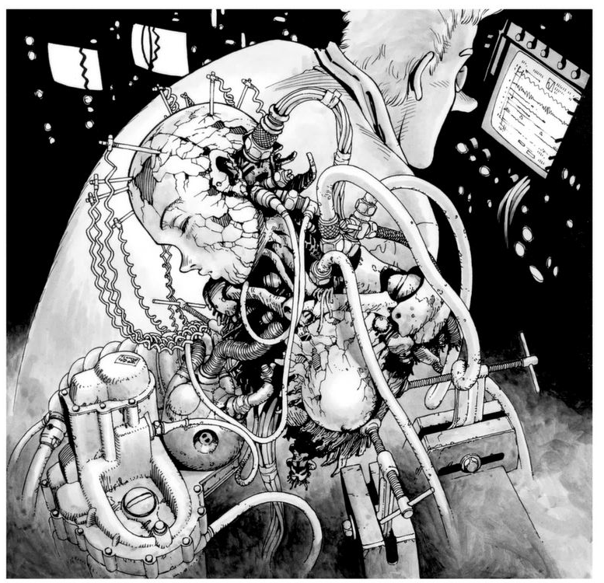
He returned to The Scrapyard, the city of those who live off the scraps of the previous century. Ido Daisuke's cybernetic clinic was in a relatively quiet residential area in the east part of the city, on Tempest Street, inside a mixed-use building. By the time Ido finally arrived in front of his home, the sun had already set, and night had fallen. Still holding the girl’s body, Ido hurried straight to the operating room.
As he walked through the room, which was filled with the mechanical chill of clinical sterility, the machines came to life, almost as if by magic, one after another, lighting up their lamps. The multicolored lights reflected off the dim ceiling’s pipes, creating a complex sheen that resembled the texture of some glistening internal organ.
The half-destroyed girl lay fixed on the operating table, covered in countless cables of various lengths and thicknesses. Surrounded by monitors displaying different waveforms, the girl’s figure, bathed in their glow, resembled a doll imprisoned by mechanical tentacles.
Ido, doing his best to calm his pounding heart, alternated between looking at the scan images of the girl's head and the data, trying to understand what they meant.
As Ido continued to read through the data being displayed one after another, a look of astonishment gradually spread across his face. “I knew it. I can't believe a preservation method like this actually exists,” Ido muttered, trembling at the realization. Could this state be described as "ambient cold sleep"?
What was truly astonishing was that the brain stored within the skull of this decaying girl had been infused with plastic while still alive and preserved in a frozen state. Naturally, the brain's functions had completely stopped since the tissue had been plastinated. However, the fact that it had managed to maintain its structure for hundreds of years, despite the ravages of time and weather, was remarkable.
Who had performed such a unique preservation process on this girl's brain, and for what purpose? It was hard to believe that the girl herself had undergone this procedure on her own. Someone must have treated her for some reason, and then, after completing the procedure, discarded her among the waste in The Scrapyard.
While Ido could only speculate, he felt a certain confidence that he wasn't far from the truth.
“The question now is whether I can successfully thaw her from this state,” Ido muttered to himself. He recalled once reading a clinical report from a file in a certain facility, which described a successful case of reversing plastination and reviving the tissue to its original state. He remembered that the report was part of a vast collection of medical data, and it was about a hundred years old.
"Who would've thought that the special knowledge from back then would come in handy now..." Ido touched the mark on his forehead with his finger. It was a symbol, a circle with the top part cut off in a square shape, an emblem from his homeland, engraved on him long ago.
With a sigh, Ido shook his head and refocused, moving swiftly around the operating room once again. It had been a full day since he brought the girl into the surgery room. He had not taken a single break, completely absorbed in working on her. Naturally, the Cyborgenics clinic had been closed for the day. Dressed in a wrinkled white coat, Ido sat beside the still-sleeping girl.
Aside from occasionally adjusting the equipment, Ido stared intently at the monitor. Several waveforms displayed on the screen reflected in his round glasses, their light tracing smooth, slow arcs. If the thawing process had gone well, she should be waking up soon.
As Ido let out the breath he'd been holding deep in his lungs, the door to the operating room creaked open with a dull sound.
"Hey, Ido! What's got you so worked up this time, huh?" The voice came from a man over fifty, shaking his large belly as he swaggered into the room with a bottle of liquor in hand.
This man, named Gonzu, was one of the few friends Ido had. Gonzu, entirely human except for the iron plate riveted to his head like a manhole cover, filled the room with the pungent smell of alcohol as he entered. Ido wrinkled his nose slightly at the scent but continued typing on the keyboard connected to the monitor without turning around.
“Hey, Gonzu, look at this. It’s amazing, this girl.”
Gonzu let out a belch as he approached the girl fixed to the operating table, his face flushed red. “What? It’s just some old kid's junk, isn’t it? You went and picked up more of this kind of stuff again?” To Gonzu, and most ordinary people, she would indeed appear to be nothing more than junk. Half-destroyed, non-functional cyborgs were a common sight in The Scrapyard, often scattered along the streets. Though they wouldn’t last long before being picked up by dealers, dismantled, and recycled into something useful.
"Calling her junk is harsh. This girl is a proper human being," Ido said, showing the monitor to Gonzu. Gonzu rubbed his thick chin with a finger, blinking his droopy eyelids as he peered at the screen.
"Wait a minute... Are you telling me this old, busted-up heap is still functional?" Gonzu looked at Ido with genuine surprise.
Ido grinned with satisfaction and nodded. "After checking, I found that her brain had been inactive in the scrap heap for about 200 years. But someone took measures to preserve her brain tissue. And I managed to bring her brain back to life."
"Man... You're into some weird stuff, aren't you?" Gonzu muttered.
Gonzu wrinkled his aged, creased face and shrugged. "What are you going to do, waking up a girl from a dream in this bleak world? Isn’t this all a waste of time?" he muttered. As Ido smiled, gazing at the girl, Gonzu tipped back his bottle of cheap liquor, draining the last of it into his stomach. He sighed, the sound mingling with a belch.

It was around 7 PM on the third day after Ido began the resurrection process when the girl finally woke up. Gonzu, who had been napping, woke Ido, and the brainwave monitor indicated that the girl was in REM sleep. Ido, not wanting to miss the moment she awoke, stared intently at her face without even blinking.
Before long, the girl's eyelids slowly lifted, and Ido, his face beaming with joy, gently spoke to her. "Hey, I'm Ido Daisuke. What's your name?"
“Na…me?” The girl, still groggy, cast a sleepy gaze at Ido but made no attempt to answer. She had completely lost her memory during her long period of inactivity. Ido didn’t look particularly concerned, smiling softly and shaking his head.
“That’s okay, you’ll remember in time. Once we fix up your body and you gradually start experiencing the world outside,” he said, pausing for a moment before nodding at the girl, who was still staring at him with that dreamy expression.
“From today, your name will be Alita.”
The girl, drawn in by Ido’s smile, smiled back. Having lost everything, she felt no discomfort or confusion, simply happy to accept the name Ido had given her. The name “Alita” came from a male cat Ido had owned and who had died the previous year.

Five days passed since the girl had woken up and been given the name Alita.
"Is this... me?" Alita widened her large, dark eyes in genuine surprise as Ido held up the mirror he had brought from the sink, showing her reflection. Her straight, fine black hair had been neatly restored, and the damaged facial skin had been replaced with fresh, synthetic skin. When she had been found, Alita's face had been weathered and damaged in several places, but now it had been repaired to look as flawless as a real girl's face, with no trace of scars.
“Thank you, Ido,” Alita said.
Ido scratched his head, embarrassed by her gratitude. "Ah, no, it's nothing... we're not done yet. I still need to finish putting together a proper body for you."
Alita smiled softly at his words and glanced downward. While her head and neck had been fully restored, her torso and limbs were still incomplete. Although Ido had managed to gather internal parts like artificial organs, a synthetic spine, and a generator, he had yet to obtain a female body frame or limbs to complete her exterior.
Even though Alita's internal parts had been restored, she was still fixed in place on the operating bed.
"Can you hold on a little longer, Alita?" Ido said, gently touching her cheek. "I'll find arms and legs that fit you soon, I promise."
His voice was soft, but behind his narrowed eyes, a complex emotion flickered and quickly vanished. Alita didn’t seem to notice this fleeting moment since Ido had turned his face away slightly. It was a brief, subtle pause.

Night fell over The Scrapyard. A silver moon, like frozen cold air solidified in the sky, peeked between the clouds. A man dressed in black walked alone through a dimly lit alley without street lamps. The hard clatter of the case he carried, a metallic trunk, echoed faintly in the darkness. The man in black chose the narrow, unlit streets to walk through, and then suddenly stopped. He had reached a relatively open crossroads.
The moonlight, which had been hidden by clouds until now, began to faintly illuminate the alley, revealing the face of the man dressed in black who had stopped. It was Ido Daisuke. Ido knelt down and quietly opened the trunk, pulling out a disassembled war hammer. The head of the hammer was sharply pointed, and when fully assembled, its handle was about one and a half meters long. This hammer was not a tool for driving stakes; it was a weapon, designed to destroy enemies.
Ido silently gripped the weapon with both hands and pressed himself against the wall, holding his breath. One minute passed... then another... Ido blended into the shadows of the alley, waiting. After a while, footsteps could be heard approaching from the depths of the alley.
"Heh, they're here," Ido muttered, his lips curling into a defiant grin. The only thing bright on him, his white gloves, tightened around the hammer's grip with a faint squeak. The footsteps grew closer and closer as the figures finally approached the crossroads where Ido lay in wait.
Long shadows stretched across the alley, dancing at Ido’s feet as he hid against the wall. The silhouettes appeared to be two women walking together. Ido casually reached into his left pocket. Pulling out a single round chip, he flicked it with a ping sound, sending it rolling down the alley. The chip bounced along like a wheel before tipping over in front of the women as they walked, illuminated by the moonlight.
The moment the two women saw the dark outline of the chip gleaming in the alley, their eyes widened.
“Agh!”
“Haah!”
One of the women let out a simultaneous cry and dashed towards the chip like a monkey, her arm reaching for it. At that exact moment, Ido, having coiled his entire body with focused energy, sprang out into the moonlight, releasing all his pent-up power and ferocity.
"Oooooahhh!"
Ido leaped sideways, putting all his strength into his right foot as it hit the ground. Using it as a pivot, he swung his upper body with full force. There was a mix of sounds — a hard thud and a sickening squish — as the sharp tip of the hammer struck one of the crouching women. The instant the pointed end sank into her skull, pink sparks scattered from the back of her head. She collapsed onto her back with a heavy thud, her head surrounded by a pale pinkish-gray smear of brain matter.
The surviving woman let out a breath of rage, shaken by the gruesome sight of Ido’s lethal strike. Gritting her teeth, she glared at him furiously. Ido quickly raised his hammer and, without hesitation, swung it down from above with crushing force. The hammer hit the ground with a fierce crack, scattering sparks across the road. Ido felt a sharp pain and tingling in his hands from the impact that traveled down the handle.
There lay the woman’s left arm, shattered at the root and lying on the ground. She had narrowly escaped death by sacrificing her arm. While blood gushed from her wound, she leapt back, turned her back to Ido, and ran off into the darkness of the alley like a fleeing rabbit. As her distant screams gradually faded, Ido let out a quiet breath. He glanced around at the street, where several bloodstains bloomed like flowers, with the woman’s body and her severed left arm scattered on the ground.
"One of them got away, huh," Ido muttered coldly, adjusting the brim of his black leather hat.

CHAPTER 3
The underside of the massive ivory-colored pillar that held the floating city of Zalem hung like an elegantly curved bell-shaped slope, reminiscent of a wine glass. However, the beautiful bell’s stem was grotesquely broken, as if gnawed by a beast, and from it, waste spewed down to the earth below, like dirty blood.
Once a day, when the sun reached its zenith, waste was dumped. "Ah, it’s already past noon," Ido muttered as a distant rumble and vibration reached the street where he stood. The waste spewing from Zalem accumulated on the surface, forming a massive slag heap over a thousand meters high at the center of The Scrapyard. When new waste crashed onto the peak of that heap, the impact caused tremors and a distant rumbling sound.
In The Scrapyard, this periodic sound of waste falling from Zalem was used as a kind of time marker. The distant rumble near noon became a signal to break for lunch time. Ido, knowing this custom, used the rumble to remember the time.
"Hey, Alita, come over here," Ido called out. Alita, sitting in a wheelchair, gave him a slightly anxious look. She appeared completely transformed now. Her machine limbs were fully equipped, and her body’s exterior had been repaired with a youthful, feminine silhouette.
It had only been a few days since Ido had obtained the parts for Alita’s legs, and that morning had been spent attaching them.
She had been practicing diligently for this moment. "Okay, I’m coming," Alita said, putting strength into her machine arms. She pressed down on the wheelchair's armrests, lifting her body up.
"That's it, you can do it, Alita!" Ido cheered, his fists clenched in excitement. Alita hesitantly tried to take her first step, and Ido instinctively took a step forward as well. Alita carefully lowered one foot to the ground, as if testing the surface of water, while holding onto the back of the wheelchair. Then, she slowly placed her other foot down.
"I... Ido..." Alita’s face reflected both fear and determination as she hesitantly reached out a hand toward Ido and began walking slowly. Seeing her, Ido broke into a wide smile, unable to contain himself. He stepped toward Alita, whose movements were still slightly awkward, and embraced her tightly.
"Ah, I’m so relieved. It looks like my body still remembers how to walk. Hey, Ido, does this mean I've finally become a proper person?" Alita asked, looking up at Ido's face. Just weeks ago, she had been nothing more than a piece of scrap buried in the junkyard, and now she stood before Ido, smiling with the joy of walking.
"Getting your body back together is just the starting point of your life. You have your whole life ahead of you," Ido said.
"My whole life...? Yeah, you're right," Alita repeated, as if reflecting on Ido’s words. Right now, Alita was alive thanks to Ido. Perhaps she was even living for Ido at this moment. If Ido hadn’t found her, Alita would have never had a life at all. Yet, she wasn’t sure if this was truly her own life.
As she gained control over her body, a vague sense of questioning began to stir within Alita’s heart. Now, she would have to search for what it truly meant to live.

When Alita naturally walked over, balancing a tray with a water jug, Gonzu was just getting up from the living room table.
"Oh, Gonzu, are you leaving already?" Alita asked.
Gonzu, quite drunk and swaying a little, nodded with his wrinkled, flushed face. "Yeah, if I drink any more here, I’ll end up staying over. I'll continue at my apartment."
"I don’t mind if you stay, Gonzu," Ido said, resting his elbow on the table, having lightly shared some drinks with Gonzu. But Gonzu laughed and shook his head.
"Heh, I know well enough that you don't like that sort of thing. Don't worry about it. See you later."
After Alita saw off the drunken Gonzu, she returned to the living room to find Ido stretching out with a big yawn.
"I'm tired today. And with the drink in me... I think I'll head to bed early tonight," Ido said as he stood up from the chair in the living room. Alita tugged at the hem of Ido's jacket and looked up at him with pleading eyes.
"Hey, Ido, are you really going to sleep already? Is the story about the outside world over for today?"
Ever since Alita had gained the ability to move freely, she had been eager to hear various stories from Ido, especially about the outside world. Her curiosity about The Scrapyard was particularly strong, and even the smallest tidbit would make her perk up and listen intently. Since she'd only taken a short walk around the clinic, even the most ordinary stories about the town seemed like grand adventures to her.
"Yeah, sorry, but let's call it a night. I'm really busy right now, but in a couple of days, I'll take you to the lively streets. So, for tonight, try not to stay up too late and get some rest," Ido said as he sluggishly left the living room.
No matter how much Alita puffed her cheeks in dissatisfaction, she had no choice but to return to her room and go to bed.
"Closing my eyes and having another day end... it feels kind of boring," she muttered to herself.
Alita dimmed the lights in her room and slipped under the bed covers, but she couldn’t fall asleep right away. About two hours later, as she was finally on the verge of drifting off after wrestling with her restless mind. Then she heard sounds. They were small, but oddly vivid, and brought her mind back from drifting off to sleep.
What could that be, at this hour? As her mind began to clear, Alita realized the sharp, rhythmic sound she was hearing was the sound of shoes tapping against the floor. She opened her eyes slightly in the dim room, which was illuminated surprisingly well by the moonlight.
Slowly, she sat up in bed and listened carefully. The sound of footsteps passed by her room and descended the stairs. After a short while, she faintly heard the door to the clinic open and close.
Alita slipped out of bed and quietly walked over to the curtained window. Gently lifting the edge of the curtain, she peeked outside. From the dim light, she saw a figure leaving the clinic and heading out into the street.
She saw him. He was dragging a large case beside him. It was a side of Ido that Alita had never seen before. The thought of Ido going into town without her knowing lit a spark of curiosity deep in Alita's heart. As her artificial heart throbbed rhythmically, that spark quickly spread, igniting an uncontrollable flame.
"Where could he be going...?"
Though she felt a bit of fear toward the unknown night streets, it wasn’t enough to stop the growing curiosity inside her. "What could he be doing, keeping it a secret from me?"
With that thought, Alita bolted out of her room and out of the clinic. She dashed into the night, chasing after Ido’s disappearing figure, dressed in black, as he vanished into the shadows of The Scrapyard.

The pleasure district of the eastern part of The Scrapyard, by night, transformed into a dazzling paradise, bathed in garish neon lights that were as bright as heaven and as poisonous as hell.
It was a sleepless city. Sex, violence, drugs, and fraud were all commonplace here, freely rampant without regulation. Homeless people huddled around burning oil drums for warmth, while others sprawled across the street, staring blankly at the monitors as though their souls had been sucked out. The screens displayed cybernetic fighters in intense combat, and excited onlookers started placing bets on the sidewalk.
Nearby, a prostitute who had been laughing suddenly went into a bad trip from a cocktail of drugs, screaming in agony. As she collapsed, foaming at the mouth, a group of men in white coats, looking like doctors, appeared from nowhere, swiftly gathering her up and carrying her off somewhere. A fellow prostitute who had witnessed the whole thing simply shrugged and did nothing.
People in the streets, seeing all this unfold, either laughed or cried at their own whims, without a care in the world, passing by without concern.
"This is too much for me..." Alita felt dizzy from the overwhelming sensory overload of bright colors and stimulation in the pleasure district. She felt as though if she stayed any longer, she might pass out from the sheer intensity.
"Ah, Ido, where are you really going?" Alita clutched her head in frustration as she desperately pushed through the crowd, trying to catch up with Ido. Although Alita’s small frame was almost swallowed by the crowd, Ido’s tall figure made him easy to spot. All Alita had to do was keep her eyes on the high crown of the black, wide brimmed fedora that floated above the crowd.
Unaware that Alita was chasing after him, Ido paused two or three times to check the street before suddenly slipping into a narrow alley.
"Oh no!" Alita pushed her way through the throng, determined to reach the alley Ido had disappeared into. She forcefully nudged aside a few people, trying to cut her way through the crowd.
"Ow! Ouch!" At that very moment, Alita slammed into an unexpected wall, the impact knocking her back and sending her crashing down onto her rear.
"Well, well... seems like Baby’s elbows are pretty sharp!"
As Alita rubbed her nose and looked up, there stood a full-body cyborg with the head of a steel bull. Alita tried to slip past him again, but the bull-headed cyborg intentionally thrust his chest forward.
"Uh... I-I'm sorry." said Alita, apologetically.
"Oh, sorry doesn't cut it, little baby!” sneered the bull-headed cyborg. “You almost made my delicate heart burst from that impact!"
The bull-headed cyborg pressed his steel chest with both arms and spoke in an exaggerated, angry tone, breathing heavily through his nose. Alita, caught off guard, could do nothing but sit there in confusion.
"Hey, baby, what should I do with you now?" The bull-headed cyborg cracked his knuckles menacingly as he stepped closer, causing Alita to slowly scuttled backwards. Her entire body trembled in fear, and she frantically looked around for help. S-someone... anyone...
But none of the bystanders who had witnessed the situation made any move to help her. Some averted their eyes, some walked away disinterestedly, and others even smirked with careless curiosity.
Everyone was just watching Alita’s panicked face. Not a single person came to her aid. I’m all alone… In her cornered state, she felt the weight of that realization settle in, along with a deep sense of despair. Even her only ally, Ido, wasn’t there to help her now.
“I’m gonna smash that scared little face of yours with my hammer blow! That’ll finally fix the pain in my heart!”
The bull-headed cyborg thrust out his literal iron fist, which was about the same size as Alita's head.
“Prepare yourself, baby! Heavenly knock-out punch!”
From his right-side stance, the bull-headed cyborg stepped forward with his right foot, using the momentum to drive his entire right arm and shoulder into a full-powered punch. The surprisingly solid straight punch from the joking bull-headed cyborg was aimed right at Alita’s crouched face.
"Uwaaaaahhh!"
At that moment, Alita screamed in fear and ducked low, bending her body forward to slip under the bull-headed cyborg’s downward punch. As the fist whizzed past, the wind pressure ripped several strands of hair from her head, and Alita rolled forward, jumped up, and dashed through the opening, sliding past under his armpit.
"Fuck!"
The bull-headed cyborg's straight punch missed Alita and instead smashed into a nearby cyborg who was unlucky enough to be passing by.
"Ooooof!"
The unfortunate cyborg was struck in the side and bent over in pain, collapsing like a folding chair. A sickening crack echoed as the cyborg's artificial spine snapped, sending spinal fluid splattering everywhere.
“Shit, that baby got away!”
By the time the bull-headed cyborg turned back with an angry snort, Alita had already disappeared into the crowd.
“Hey, hey, little miss! Wait up! Come over here!”
Alita was still frantically fleeing from the bull-headed cyborg, weaving through the throng of people as she ran for her life.
As Alita darted through the crowd, a soft voice unexpectedly called out to her. She hesitated for a moment before stopping and turning toward the source of the voice. There, she saw a plump woman standing still, waving her hand with a smile. Her face was thickly covered in bright makeup, giving her a charming, raccoon-like appearance.
"Um, are you... an old lady?" Alita asked the woman, but she didn’t answer. Instead, she gently grabbed Alita’s hand and pulled her into a narrow alley. It was the backside of the entertainment district, a filthy, dimly lit alley strewn with garbage.
"For now, you’ll be safe here for a bit. No one will find you," the woman said. "I'm just a lowly prostitute named Zora. What about you, honey?"
"Uh... Alita," she replied.
It seemed Zora had seen everything—how Alita had been hassled by the bull-headed cyborg. That man, known as Colt, was the leader of a gang of thugs in the area, notorious for causing trouble. While he wasn’t officially a wanted man, rumors said he had already killed a few people in the shadows.
"Someone like you wandering around there in the middle of the night is bound to get preyed on," Zora sighed, leaning against the dirty wall. "Honestly, it’s just dangerous."
"I lost sight of Ido... and then that guy, he purposely bumped into me! I didn’t know what was going on and panicked... damn it!" Alita ground her teeth in frustration, her shoulders trembling with anger.
Zora let out a small laugh, surprised by Alita’s unexpected show of strength. "You’re a funny one, Alita. Really funny... Makes me glad I helped you, for real."
But just then, Alita felt a chilling shift in Zora’s soft tone, as if something more dangerous was lurking behind her words.
"Huh?" Alita looked up at Zora, and saw that her eyes, fixed on Alita, had grown cold and half-lidded with a sinister gaze.
"Uh, Zora... what’s wrong?" Alita asked, confused, taking a cautious step backward.
"Hah... oh no..." Alita had no escape. Before she knew it, several women, likely Zora's associates, had emerged from the shadows on both sides of the alley, surrounding her.
"You’re too kind, aren’t you? I didn’t save you for free, you know. It’s time you accept your fate and behave... hey," Zora ordered, nodding her chin.
One of the women pushed Alita against the wall and pressed a knife against her neck.
"What do you plan to do to me?" Alita demanded, but the women ignored her. Instead, they rolled up her sleeves, inspecting her arms and legs.
"Zora, no doubt about it. This girl’s arm... it's from the missing Stella."
"And her legs? They’re from that notorious killer."
The women murmured among themselves, all eyes turning to Zora. Zora let out a low growl, glaring at Alita with an intense expression that bore none of the warmth or playfulness she had shown before.
"Those arms and legs of yours... they're all from our fellow prostitutes who either died or went missing. Alita, where and how did you get those limbs?"
"When you say where, my whole body was fixed by Ido!" Alita replied, to which Zora and the others repeated the name "Ido" in unison. Their voices were filled with deep anger.
"So it was that Ido guy who cut up Stella?"
"And Wanda too."
"Julie was also killed..."
Overwhelmed by the rising bloodlust of the prostitutes, Alita felt a dull numbness creep into her head.
What are these people even saying?
"There's been a serial killer prowling around here lately. Us prostitutes have been hit the hardest, losing many of our sisters to that murderer. We were just about to figure out how to deal with the bastard, and then you show up wearing parts from one of our victims."
Zora said this as she pulled out a knife from her pocket. The blade of the knife emitted a dark metallic sheen, almost reminiscent of reptile skin. Zora licked the blade and then slowly advanced toward Alita.
"So, this Ido guy is a damn serial killer, isn't he, Alita?"
"No, Ido would never—you're wrong! You're all wrong! I don't understand what you're saying!" Alita shook her head violently as she spoke. A chill ran down her spine, and despite gasping for breath, her mind felt oxygen-deprived, as if her artificial lungs were malfunctioning, causing her vision to blur.
"We're going to find that Ido bastard and make him pay. I've already spent a fortune to hire a top-class Hunter for that. Alita, you're just the right offering. We'll tear you apart as a message to him," Zora declared.
The blade in Zora's raised hand caught a faint glimmer of light, reflecting Alita's terror-stricken face like a mirror.
"Time to die, Alita."
"No... no, stop it!" Alita's eyes widened as far as they could go. Zora's lips curled into a cruel smile, and without hesitation, she swung the knife down with full force. The cold, sharp tip of the blade came dangerously close to Alita's forehead. Frozen in fear, Alita couldn't tear her eyes away from the sight. Her mind screamed as the terror of death paralyzed her.
"I don't want to die... not yet!" Her thoughts sparked and blurred into a white-hot flash, and in that moment, something inside Alita snapped with a sharp crack.
"Hi-yah!" Alita's eyes suddenly gleamed with the fierce sharpness of a wild feline, glowing with intense light. As Zora brought down the knife with all her might, Alita reacted with instinctive precision, catching the blade between her fists just before it reached her forehead.
With a loud snap, the knife shattered and scattered into pieces.
"Eeeee!" Zora let out a terrified, shrill cry, shocked by the sudden surge of energy from Alita. She then let out a second, sharp cry as she was caught in the blast of heat that suddenly emanated from Alita. It was as if a small girl had been caught in the gaze of a man-eating tiger suddenly appearing from the shadows. Zora staggered back, her legs giving way, and she collapsed onto the filthy street. The sound of her teeth chattering filled the air, and a foul stench of urine mixed with the smell of the alley as a dark stain slowly spread from where she sat.
"Grrrrrr..." Alita stood still, swaying slightly, as she slowly scanned the faces of Zora's companions. The other prostitutes were already frozen in fear, as though they had been turned into frogs under the gaze of a snake. They dropped their knives, trembling, their legs giving way as they hurriedly pulled Zora along and fled the alley.
Left alone in the dim alley, Alita stood quietly, unmoving. "What... what is this feeling?" Alita whispered, trying to stop the trembling that was spreading throughout her body by hugging herself tightly. It was as if she was being driven by a surge of past memories. Alita had shattered the knife with a swift movement, but now she was left standing in the darkness, shaken by something deep within her.
She had used a technique. The surge of violent impulses and the pride in the skills she possessed arose instantly. Though it felt distant from her current self, there was a deep familiarity with the memory of battle. All of these thoughts filled Alita's mind, overwhelming her to the point where the intensity made her brain feel like it was heating up, ready to boil over. To think that discovering just a fragment of who I once was would feel this intense... Alita was caught between awe and confusion as waves of fear and joy surged through her heart.
Before she could calm her rising emotions, a sharp, blade-like killing intent closed in on her from behind. "That's some impressive skill, young lady," came a chilling voice, as the aura of impending violence crept over Alita like a shroud. Freezing in terror, Alita instinctively threw herself forward, rolling to gain distance before turning to face her attacker.
"You...!" Alita's entire body tingled with an electrifying sensation, as if her skin was bristling from an unseen threat. She narrowed her gaze, locking onto the figure who had just tried to kick her. But the figure, strangely calm, had no trace of killing intent, staring back at Alita with a somewhat vacant expression.
The woman lowered her guard and said, "Oh, my, such a fierce little lady you've turned out to be. Even if I wasn’t serious, dodging that kick is no small feat, huh?" She scratched at her pineapple-shaped red hair with her fingers, twisting her plump red lips into a smirk. Her tall figure, wrapped in a rumpled leather coat, was just like Alita’s—made entirely of steel and ceramic, a machine body.
"Who the hell are you?" Alita asked cautiously, trying to assert dominance over the red-haired woman. Inside, however, she was still reeling from the kick and the brief flash of killing intent the woman had unleashed, her whole body trembling with fear. She clenched her teeth, desperately trying to hide her inner turmoil, not wanting to reveal her anxiety to this intimidating redhead.
Fragments of memories of battles are just starting to wake up deep within me... But I still have no idea how strong those memories truly are. Alita doubted whether the uncertain fighting skills she was only beginning to recall would be of any use against this dangerous woman before her.
The redhead grinned and responded, "Me? I was hired by a certain someone. My job is to track down and kill that serial killer who's been targeting prostitutes."
"But, once the client sinks their teeth into a lead, I can't just stay silent, you know?" The red-haired woman spoke as Alita tensed up, a shudder running through her body that was unmistakably visible to the woman. This skilled fighter is after Ido?
"Even if Ido is a killer, there’s no way I’ll let him be taken down!" Alita screamed as she suddenly dashed toward the red-haired woman, aiming to close the gap.
"Huh? Ido?" The redhead’s eyes widened behind her glasses at Alita’s mention of Ido. That momentary surprise caused her defense to falter for just a fraction of a second, and in that instant, Alita’s spinning attack struck. The red-haired woman couldn’t fully block the force, and she tumbled backward.
"Here I come! Prepare yourself!" Alita, sensing her chance, charged forward as the redhead tried to rise, launching a high kick aimed at her. The force of the kick tore through the air with a sharp whistle, like a high-pitched sound.
A sharp "clink" rang out as sparks briefly flickered in the dim alley.
The one who was sent flying was none other than Alita. Her high-speed kick had been countered by the red-haired woman with an equally powerful kick. Due to Alita's smaller frame and the fact that the red-haired woman had precisely aimed at the less powerful base of Alita’s leg, Alita lost her balance and spiraled into the wall with a crash.
“...Ugh…” Alita’s head slammed hard against the wall, leaving her dazed and disoriented. As her vision blurred, the red-haired woman calmly approached and knelt down, lifting Alita up as she slumped against the wall.
“You said Ido, didn’t you? Could it be… are you Ido's daughter or something?” the red-haired woman asked.
Alita winced through the fog in her mind and weakly shook her head. “No... I was saved by Ido. He’s my savior... He wouldn’t harm anyone.”
The red-haired woman silently observed Alita's face for a while, then let out a deep sigh as she stood up. Alita, seeing this, slowly closed her eyes as her consciousness began to fade. She's terrifyingly strong... this woman...
"Ido... please don't get caught by this woman..." In her fading consciousness, Alita braced herself for the red-haired woman to finish her off.

CHAPTER 4
"Hey... come on, wake up already." A voice that had seemed distant now struck Alita's awareness sharply, pulling her back into reality. When she opened her eyes, the red-haired woman, with an unsettling smile, was peering down at her. Alita had been unconscious for five minutes, and during that time, she had lost all sense of her surroundings.
"Where... am I?" Alita murmured. She found herself lying on what appeared to be the rooftop of a building. The red-haired woman had carried her up here.
The woman stood at the edge of the building, where there were no fences or barriers, gazing down below. "Take a look. It's quite something, don’t you think?"
With a quiet chuckle, the red-haired woman motioned with her chin for Alita to look down from the building. Though slightly annoyed at being ordered around, Alita pouted her own thick lips, not wanting to lose to the woman, and peeked over the edge.
“Ah, that’s... Ido...”
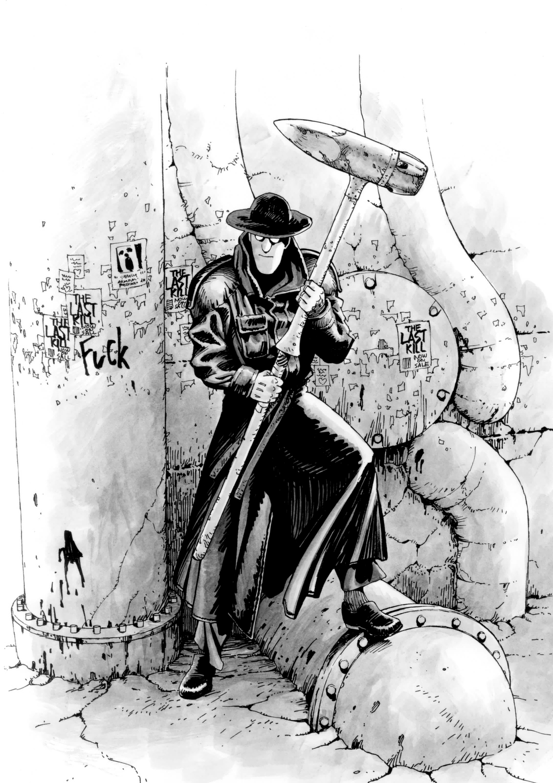
About ten meters below, in a small intersection of alleyways, a black figure was lurking. The figure was unmistakably Ido, dressed in his usual black attire, leaning against the shadow of a building that framed the alley. Next to him was the large case that Alita had seen when he had snuck out earlier.
Ido was holding an abnormally large hammer in his arms. The tip of the hammer was sharply pointed—clearly not meant for driving stakes or anything practical.
“What... what is Ido planning to do?” Alita muttered in a mix of suspicion and concern. Just then, faint footsteps echoed from the darkness of the alley. A silhouette, seemingly of a woman, began to emerge toward the alley where Ido was hiding. Ido, of course, remained still, unnoticed.
Noticing the approaching footsteps, Ido pressed his ear against the wall, his body close to the corner. From the alley just to his left, a woman slowly emerged. As Ido silently raised his hammer, Alita began to grasp what was about to happen, and a shiver of realization ran through her.
"No... you can't, Ido!"
The red-haired woman watching the scene wore a gleeful smile, as if savoring the spectacle before her.
"A-ah..."
Just as Alita reached out and began to shout to stop him, Ido's made his move. As the woman reached the crossroads of the alley, Ido swiftly stepped out from the side, cutting in front of her from behind. The woman, startled by the sudden encounter, froze.
Ido swung his hammer like a pendulum, allowing the force of its momentum to carry him into a spinning motion, just like a shot put.
As the head of Ido’s hammer rose on the arc it was swinging, when the acceleration and centrifugal force were at the highest advantage, he mercilessly swung the hammer's tip into the woman's temple. The sound was eerily similar to crushing an insect underfoot. "Ah... so Ido is the serial killer," Alita muttered, overwhelmed by the brutal reality in front of her, unable to avert her eyes. Below, Ido stood, gazing down at the head of the woman now crushed into the hammer. Her head had been obliterated by the force of the blow, making it impossible to even recognize it as once being human. Ido let out a faint smile, stepping on the flattened remains to pull them free from the hammerhead. Then, he carefully placed the crushed head into a burlap sack he was holding.
"He he... shocked, aren't you?" whispered the red-haired woman who had crouched down beside Alita, speaking softly into her ear. Alita sat there, dazed and frozen. Seeing this, the red-haired woman smiled broadly at first, but as Alita remained unresponsive, she sighed.
"Oh dear... she's completely out of it. Maybe I went a little too far with the fun, huh?"
The red-haired woman shook the dazed Alita and lightly slapped her cheeks. "Come on, snap out of it. That was nothing, you know. It's just a hunter's job," she said. Gradually, the focus returned to Alita's once-vacant eyes.
"Ido isn't a serial killer; he's a hunter who hunts down serial killers," the red-haired woman explained. Alita fully came to her senses and grabbed the woman's collar. "A hunter? What do you mean? He just killed that woman like that!"
The red-haired woman began to explain the existence of Hunter-Warriors in The Scrapyard. In The Scrapyard, aside from crimes that concern the Factory or Zalem, everything is handled by the Factory placing bounties on the heads of criminals to maintain order. The bounty hunters who pursue these marked criminals and eliminate them are called Hunter-Warriors in The Scrapyard.
"So, the woman Ido just killed was..."
"Yeah, she was on the list. One of the insane mutant sisters, Asnas."
"She's the youngest of the sisters. Her crimes include multiple murders and assaults. The bounty on her head is a modest 32,000 chips," the red-haired woman said, handing Alita a printout of the bounty list. Alita let out a long sigh of relief after reading it.
"Feeling better now? Ido, well... he's one of the decent ones. He doesn't take on bodyguard gigs like I do. I mean, he only hunts small fry on the side, probably not out of desperation. Still, he's doing alright," the red-haired woman continued.
Alita now understood the truth—that Ido was working as a Hunter-Warrior to earn money to repair her body. The red-haired woman also explained that the body parts were acquired cheaply from corpse recovery dealers.
"Honestly, you were taking everything Zora and the others said so seriously, I couldn't resist messing with you a little," the woman added with a smirk. Her name was Calico, another Hunter-Warrior like Ido. She mentioned that she had met Ido once or twice before. Calico pulled a crumpled cigarette from her coat pocket and lit it, exhaling purple smoke.
"By the way, girl, you said your name was Alita, right? Where did you learn that technique?"
Alita gave a wry smile at Calico's question and replied, "I don't really know. I was just brought back to life by Ido. I still don't understand much about myself."
The various martial arts techniques that had surged up from deep within her heart were still sinking back into the fog of her memories, hidden in the depths of her mind. It seemed that her memories would only surface in moments of extreme stress, triggered by specific situations.
Calico turned to leave. Before she could, Alita asked suddenly "Do you think we'll meet again sometime?" Calico scratched her head, letting her gaze drift into the night sky, then flicked her cigarette away. Without looking back at Alita, she disappeared into the direction of the entertainment district.

"Will I make it home before Ido gets back...?" Alita ran through the dark alleys at a quick pace. By luck, Ido hadn't returned by the time she got back from the entertainment district. He likely had to stop by the Factory to cash in the bounty, which is why he was later than Alita.
The next day, Alita felt as if everything that had happened the previous night was a dream. So much had happened, and it was such a whirlwind of changes. When Alita let her guard down, it felt as if her soul had been drained, leaving her in a daze. The brief encounter with Calico replayed in her mind.
"What happened, Alita? Your body has dents and scratches all over," Ido said in a concerned tone, tightening the bolts on the maintenance hatch of Alita's body as she lay on the bed.
“There’s no problem with your internal organs, but one of your joints is a little misaligned. Did something happen?”
“Uh, no, nothing... I just tripped a bit. Sorry, it’s nothing serious,” Alita responded, but her mind was clearly elsewhere. At that moment, her thoughts were consumed by the battle with Calico in the entertainment district, replaying like a whirlwind in her head. She longed to experience again the fleeting sense of fulfillment she’d felt in that moment, the strange exhilaration when fragments of her past memories flashed back. Her mind was entirely preoccupied with that.
“Alita, what’s going on? Do you have something on your mind? You’re not keeping secrets, are you?” Ido leaned closer, his expression growing more concerned as he gazed at her. At last, Alita snapped back to herself and forced a smile.
“Oh, no, it’s nothing. I just have a few things on my mind, that’s all. Don’t worry about it.”
“...If you say so. Then, alright.”
Ido sensitively picked up on Alita’s awkward attempt to smooth things over, but he decided to let it rest for now. He didn't want to let his emotions get the best of him. However, the feelings he held back found no outlet and sank deep in his gut like sediment. Alita also sensed some tension between herself and Ido, which pained her, but she convinced herself that there was nothing she could do to stop the overwhelming urge that drove her.
That night, Alita finally resolved to confess her troubled thoughts to Ido. Ido, in surprise, slammed the table and stood up.
“Why... why are you suddenly talking about being a Hunter Warrior? This is nonsense! Alita, how could you ever become a Hunter Warrior?”
Alita, her cheeks slightly flushed, looked at Ido with a mix of determination and vulnerability.
“I’ve started to remember... I remember that I used to know the art of combat. And by putting myself in battle, little by little, I can reclaim those skills as my own.”
Ido shook his head, cutting her off with firm resolve.
"But that's not why I dug you out of The Scrapyard," Ido said, turning his back on Alita, ready to leave the room. "You don't understand how ugly and dirty battle really is."
As Ido walked away, Alita shouted at his retreating figure, "I know, Ido! I know you're a Hunter Warrior! If fighting is so ugly and dirty, why are you doing it?"
Her words struck Ido like the tip of a spear, causing him to flinch. "What? So... you knew, huh? That's how you learned about the Hunter Warriors, Alita... I see."
Even though Alita was rattled by her own words, she gathered her strength and pleaded with Ido in a trembling voice. "I'm sorry... for following you. But I realized how much danger you put yourself in to restore me. I can't let you face such filthy, dangerous things all by yourself, not just for me!"
Ido, still facing away from Alita, muttered as if to himself. "For your sake, I'd gladly sever any criminal's head. I'd bathe in their blood without hesitation. But... I want you to remain my dream."
"Ido..." Alita felt a tightening pain in her chest, as if her heart were being crushed. In this world, no one cared for her as deeply as Ido did.
"I just want to make you into something more beautiful," Ido continued, turning to face her, his voice strained and anguished. But Alita, like a butterfly slipping through his fingers, left the room.
"I'm sorry, Ido... but I can't be your dress-up doll."
Left alone in the room, Ido wept.

Alita wandered aimlessly through the bustling streets of the pleasure district. Having left Ido, she was lost, unsure of what to do or where to go. Should she really pursue becoming a Hunter Warrior?
Alita didn’t even know how to become a Hunter, leaving her feeling lost. She sat down on a pile of old monitors at the edge of the street and let out a deep sigh. “What should I do now…”
At that moment, someone placed a hand on her shoulder with a soft pat.
“…We meet again,” a voice said.
“Zora?”
When Alita looked up, she saw the plump woman, Zora. Scratching her head awkwardly, Zora gave a small bow to Alita.
"Yeah, sorry about yesterday. I had no idea your friend was a Hunter. I found out from Calico—what a big mistake, huh?"
As Alita watched the sheepish Zora scratching her head, the once lost and wandering Alita now saw her shining like a beacon. To Alita, Zora appeared as a goddess of salvation. Without thinking, Alita hugged Zora tightly.
“There, there,” Zora said.
The place where Zora took Alita was behind one of The Scrapyard's top pink cabarets, located near the heart of the eastern district's entertainment hub.
“Does Calico live in a place like this?” Alita asked, to which Zora chuckled softly and explained.
“They call her 'Calico the Vagabond.' That woman doesn’t have a proper home. She works as a bouncer for all kinds of places in the entertainment district, so you could say the entire district is basically her home.”
As they walked down the grimy alley, they reached the back entrance of the cabaret. Alita and Zora entered through the door and made their way down the hallway, arriving at one of the dressing rooms for the strippers.
“Hey, it’s me, Zora!” Zora called out, banging on the door roughly. After a brief pause, there was the sound of the doorknob turning.
“Quit making such a racket. Did you finally catch a lead on the serial killer?”
"Oh my, if it isn't baby Alita. You shouldn't be coming to a place like this, it's not good for a kid's upbringing," Calico said, waving her hand dismissively as if to shoo them away.
"Calico, Alita here says she wants to become a Hunter. She came all this way just to ask you," Zora said, wedging her foot in the door as Calico tried to retreat back into the room. Calico sighed and pulled out a cigarette.
"Ms. Calico, since I woke up, I haven't had anyone to rely on. I really don't know anything—about this town or anything. Even though I want to become a Hunter-Warrior, I just... don’t know where to start," Alita pleaded, her words filled with desperation as Calico exhaled smoke with an exasperated look.
"Come on, Calico. Don't be mean—just tell Alita how to register as a Hunter. You only need to take her to the Factory, it's not that hard," Zora said, siding with Alita.
Reluctantly, Calico scratched her head and released a long sigh, expelling all the air she had held in her lungs. She didn’t meet any of their eyes.
Alita trembled at Calico’s gensture and lowered her head in silence. After a moment, she looked up and spoke to Calico with determination.
“Ido is against me becoming a Hunter, but… this is something I’ve decided for myself. It’s true that if it weren’t for Ido, I wouldn’t be alive right now, but as long as I am alive, I need proof—for myself. I want to do something that helps me find out why I’m alive. I want to become a Hunter-Warrior!”
After she finished speaking, Alita pressed her lips together tightly and lowered her head again, clenching her hands so hard that her shoulders shook slightly.
Calico let out a soft sigh and placed her hand on Alita’s shoulder.
“Lift your head, Alita. You look like a child being scolded, hanging your head like that. Honestly, if you have such a pure desire to live your life, that’s admirable. Fine, I’ll tell you how to register as a Hunter. Okay?”
“Really, Calico…?” Alita asked, her voice filled with hope.
Narrowing her deep, cow-like eyes and smiling, Calico stood up and spoke to Zora. “Zora, listen. From the time I leave the Factory and return to the entertainment district, it’ll take me about an hour round trip. Until I get back, make sure our buddies hiding in these dirty back alleys take a break, okay? Oh, and…”
Calico leaned in and whispered a couple of things into Zora's ear.
“Got it, Calico. If those murderers don’t know you’re not around, they probably won’t cause too much trouble,” Zora said with a shiver, flashing her chubby, fox-like smile as she hugged Alita close.
“Alita, when you become a Hunter, come back here. I’ll introduce you to all my Hunter friends. That way, you won’t be in danger, right? So make sure to come see me again, okay?”
Alita, slightly cringing at Zora’s heavy makeup, hesitated for a moment but then wrapped her arms around Zora’s back. “Thank you for everything, Auntie Zora,” she said softly.
“Haha, Alita, really, you shouldn’t be calling an active, single working girl like me ‘Auntie,’” Zora said with a laugh as she turned and quickly disappeared down the alley. Alita and Calico watched her go, then left the entertainment district and headed toward the Factory. That was the last time anyone ever saw Zora.

The Factory was the ground management system controlled by the aerial city of Zalem, which maintained and governed The Scrapyard. Initially, the Factory was simply a system necessary for running the ground-level factories that produced goods for Zalem. However, as more people gathered in the city, drawn by factory jobs and the scrap recycling business, the city expanded, and with it, the issues and crimes increased. In response, the Factory's role grew and diversified into a governing body that handled these troubles. Today, it serves as the core of judicial, legislative, and administrative functions for the city.
In the dim night, the Factory loomed faintly under scattered lights. Massive steel pipes coiled and intertwined, converging as the structure towered high. Looking up, one could see a thick, ivory-colored pipe extending from the top of the structure, stretching toward the sky.
The massive structure seemed to stretch upward, as if being drawn into the distant disc floating in the night sky. This building formed the base of one of the tubes connecting to the aerial city of Zalem. From the enormous front gate of the Factory, two figures emerged.
"Is it really this easy to become a Hunter Warrior?" Alita puffed out her cheeks, looking unsatisfied as she rubbed her head with both hands. She had been brought to the Factory to register as a Hunter Warrior, but all it took was a laser imprinting an identification code directly onto her brain—there were no other formalities involved.
"Becoming one is easy," Calico replied. "But making a name for yourself? That's the hard part. You get that, right?"
"I don't really understand what it means to 'make money' yet..." Alita said, her tone unsure.
"Out at this hour, huh? Sorry for being such villains," said a voice as Alita and Calico approached the entrance to the pleasure district from a dark street. Suddenly, around ten men appeared, surrounding them from the front and back. Each of the ten men held different weapons, their bodies partially modified with cybernetics. Not a single one looked like an upstanding citizen.
"Hey, what's the meaning of this?" Calico flicked her spent cigarette onto the ground and asked. A large, fully-cyberized man stepped forward from among the group of thugs.
"Remember me, baby?" His steel bull-like face gleamed in the darkness.
"You’re that guy… Colt, right?" Alita said, recognizing him. The bull-headed Colt snorted and nodded arrogantly.
"Of course you couldn’t forget me, baby. Just like I never forgot about you," Colt growled. "Yeah, baby!"
"So, are you a bounty target?" asked Alita cautiously, taking a step forward, locking her gaze on Colt. He chuckled at her stance, answering with a sneer.
"Oh, baby, are you a Hunter? That’s a surprise. I’m no fool, though—I haven't been reckless enough to end up on any wanted list. But if you’re in the mood for a fight..."
Colt suddenly grabbed one of his henchmen nearby.
"Huh? What’s up, Colt?" The man barely finished his sentence before Colt casually snapped his neck, as if cracking an egg. The man's body convulsed, his pants staining with waste, before he went limp.
"Ahh, so that’s my future happy ending?" one of the thugs muttered, trembling.
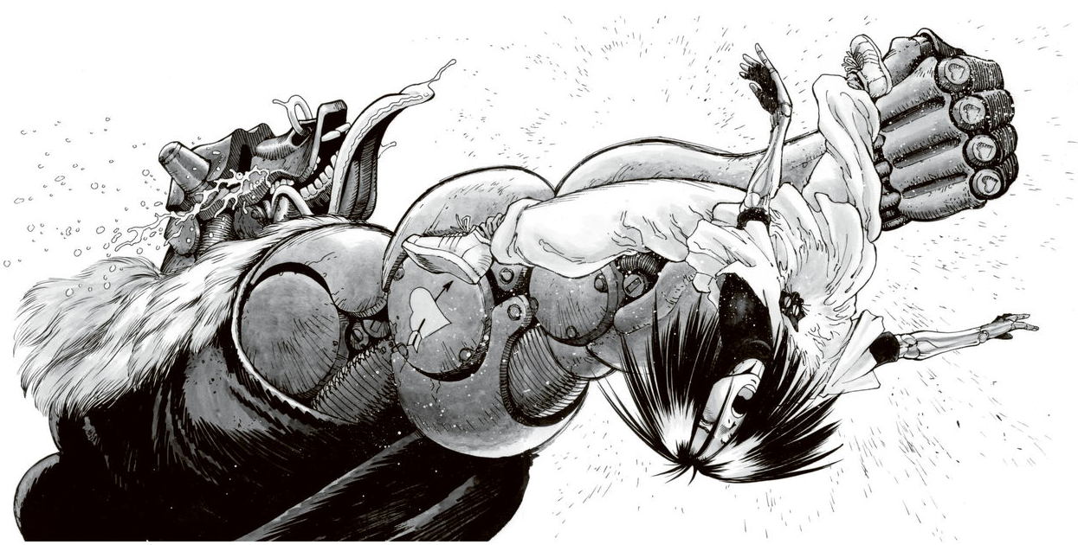
"Haha... killing might be kinda fun, though," another grinned, his expression twisted. Each henchman reacted in their own bizarre way, but Colt continued, undeterred.
Just how terrifying was it? Even though they were ready, not one of them tried to flee. Colt grabbed the hair of the man whose neck he had snapped and killed, supporting it with his left hand. Placing his right hand on the man's lower jaw, he moved the corpse's mouth as if performing ventriloquism, making it chatter as he shouted.
"Oh ha ha ha! Come on, baby! What's the price of murder? How much? How much is it... Tell me my bounty, how much!"
Just as Alita was about to be overwhelmed by Colt's madness and vigor, a scream rose from behind her.
Looking back, one of the men blocking Alita and Calico's escape route had fallen, and there stood a man in black attire who seemed to have emerged from the darkness.
"Ido... why…" Alita involuntarily shouted, but the black-clad Ido stood there exuding a dangerous and dark aura, like a different person. As Alita felt a chill from Ido's demeanor and shivered.
"I didn't want you to see me like this... It’s like another me who enjoys killing", he quietly muttered.
As Alita stared at Ido, Calico's hand gently rested on her shoulder.
"I told them to call him for me, you know? I asked Zora and the others to arrange it."
"Heh heh, if you're going to become a Hunter anyway, you need to get proper guardian consent, right?" With that, Calico began to walk gracefully. There were still about eight of Colt's henchmen blocking the way.
"I'll handle these small fry, okay? It's a huge loss to use this outside of work, but I'll show you as a special treat—my full-power red-hot electromagnetic whip."
Calico suddenly dashed forward as if falling, unleashing a mid-level kick with incredible speed. It wasn't a kick that shot straight upward all at once, but a sweeping kick that cut horizontally.
As her leg extended, a thermal blade that had been stored inside shot out, and with a sizzling sound, she slashed through the bodies of five men at once.
One of the three remaining men swung a thick blade resembling a machete and charged at Calico. Maintaining a cold smile, Calico shifted her stance to the side and sharply thrust her blade-protruding kicking leg like an ice pick. The man wielding the machete became a riddled mess in an instant and fell to the ground.
The remaining two trembled in fear at the power of Calico's kick. When one dropped his weapon and fled, the other followed suit.
"Oh dear, I went through the trouble of heating up my blade. Let me cut you some more, won't you?"
Calico licked her red lips with her tongue and swiftly closed the gap toward the two men fleeing with their backs turned.
"Haaa!"
With a sharp exhale, she slashed one man's neck. The last one she cut straight down from the crown of his head to his groin with a spinning heel kick, flipping her body forward.
Calico had annihilated eight men in almost ten seconds. She smiled with satisfaction, having fully utilized her red-hot legs.
Then, Calico said to Alita "Ha ha ha, baby, are you afraid of me? You're very, very scared, aren't you? That red woman says things like that, but I think it'll be tough to hunt me down alone. The guys that the black fellow and the red woman killed are nothing but numbers, as insignificant as farts. But I’m different, you see.
Listen well, baby! To do what you want and get what you desire, you need to make an effort! And to fulfill your desires, you have to dedicate your soul—a pure soul in a life like mine!"
Pure thrusts with proper hip movement, powerful front kicks, side kicks—all of them seem simple and brute-force, but that's not all there is to them. Regardless of his nature or logic, Colt was a formidable warrior who had honed his own skills, and for Alita, he was an opponent she couldn't afford to underestimate at all.
He was an opponent who should be confronted with strength.
"I'm doing my best too!" Alita murmured as if convincing herself, adjusted her breathing, and focused her mind to recall memories of battle.
"Ka-yah!"
Alita took Colt's charge head-on. Spinning rapidly, she was blown back about ten meters. She managed to control her posture in midair and rolled to absorb the impact upon landing.
"Alita!"
Ido involuntarily shouted and tried to intervene, raising his hammer. Calico stopped him by placing a hand on his shoulder.
"What are you doing?"
"It's okay; she jumped back and took that hit on purpose. Let's watch her carefully for now, okay?"
Calico took a cigarette out of her coat pocket and pressed it against the thermal blade of her red-hot leg. "It's reckless. He's not as easy an opponent as you say. He may seem dim-witted, but his strength is first-class," she said.
As Calico exhaled a slow stream of purple smoke, she watched Alita and Colt's battle intently. "Alita insisted on doing it herself, right? Hunter-Warrior. When you're a Hunter, it's common to fight opponents of this level, you know? So every time that happens, are you always going to step in and help?"
Ido clenched his jaw as he watched the fight, shaking off Calico's hand from his shoulder. "Damn it, I understand that much, but still—"
"Well, you should just trust her, in that girl's strength," Calico replied.
Colt was relentlessly chasing after Alita, using charges and straight thrusts. "Damn it!"
Alita parried and dodged, then retreated. Colt, with a confident smile, tried to corner Alita by showering her with continuous attacks.
“Hey, baby! What's wrong? Isn't running away getting very, very tiring? Even if you keep running, I won't get tired so easily. Baby, you'll never win. Bwa ha ha!'
Alita desperately tried to focus her mind, but the memories of battle deep within her heart wouldn't resurface as she wished. She was desperately hoping to remember something as she kept evading, but it seemed unlikely.
What should I do? What?
There's only one thing left!
At the moment she thought that, Alita stopped moving, adopting a welcoming stance with her arms spread wide open. Then she quietly closed her eyes.
“No! Alita!"
Ido and Calico, who had been watching, stood up and shouted simultaneously. Alita had resolved to take Colt's attack head-on. By exposing herself to his blow and facing death, Alita bet her life on awakening something that should be sleeping within herself.
In that stance, Alita received Colt's straight thrust as if to embrace it; with a resounding 'thud,' she was sent flying head over heels.
"Babyyyyyy!"
At the moment his thrust directly struck Alita, Colt shed tears of joy. Alita was slammed into the ground, rolling over two or three times, and lay sprawled on the cold asphalt of the street.
"A... Alita!"
Ido rushed over, his whole body trembling. The handle of his hammer fell to the ground with a clattering sound.
"Alita, hey?""
Calico dropped the cigarette that had been hanging from the corner of her lips. Alita lay face down, not moving a muscle. Colt swung his bull-like head and let out a victorious roar into the night street.
Alita was dreaming—a silent, soundless scene like a black-and-white film tinted entirely in red, with blurred spots in her vision. Boulders rolled across a desolate land. In that land where sand danced and flew, Alita was standing still.
When she opened her eyes, asphalt was in front of her. Small pebbles embedded themselves into her cheek as she lay there. There was a metallic taste in her mouth. When she moved her tongue slightly, a gritty sensation spread across it—perhaps there were fragments of teeth among it.
Alita had stood up. Neither Ido, Calico, nor Colt saw the moment she rose. She had fallen before their very eyes, and they shouldn't have been able to look away from that scene, yet Alita was standing there.
"Well now, baby, you managed to get up. For a woman like you to appear… I must thank God. When I met you back then and became obsessed with you, I must have already foreseen this moment," Colt said, raising his bull-like head high and sighing.
Then, facing Alita, who stood naturally, he readied his fists.
"Time to finish it!"
With a shout, Colt stepped forward with his right foot and unleashed a full-powered, lethal double-arm strike.
Alita let out a sharp breath, kicked upward from below, and lifted her vertical fist. Without resisting the upward momentum, she placed her hands on the ground as if performing a cartwheel, spinning both legs like a tornado to kick Colt.
With that single blow, Colt's fully extended right arm was shattered from the shoulder and blown several meters away, spinning and rolling on the road.
"Ungh! How does a baby like you have such destructive power!"
While trembling in fear, Colt simultaneously felt his brain numb with intense joy and madness that would have made him ejaculate if he were human.
"This is it, baby! Is this moment the final station of desire in my runaway express train of life?"
Colt shook his head vigorously and charged at Alita while roaring. However, in the next moment, as Alita leaped, Colt lost sight of her.
“Gah! Where are you, my beloved baby! So you're trying to finish me off, huh? Ha ha ha, I see! Earlier, you took my attack. Now it's my turn, right? Okay!”
Colt spread his remaining arm wide and shouted to the sky.
“I'll receive your love!”
In the next instant, Alita spiraled down from the sky in a straight line, embedding the heels of both her feet into the top of Colt's head like a drill. With a resounding thud, Colt's head was crushed. A liquid that was neither oil nor blood splattered around in fine droplets, making it seem as if a mist had formed for a moment.
'Ooooooh!'
Even after blowing off his head, Alita's rotation didn't stop, and she tore through Colt's body all at once. When Alita landed on the ground and made a sharp turn, stamping her feet, Colt's body was sliced from the crown of his head to his groin, turning into a swirling mass of shattered metal pieces centered around Alita..."
The wind died down, leaving the scattered debris rolling on the ground, and the night alley returned to stillness. The sound of Ido gulping air into his lungs echoed on the night breeze.
"That... was that ancient martial arts from Mars?" Calico shuddered briefly, staring intently at Alita.
"My moves... that technique... Ah, I finally remember it now," Alita murmured quietly as she stood up, swaying slightly, and then gently collapsed as if a feather was falling.

CHAPTER 5
At the same time, when Alita and Calico had left the Factory District behind, a woman was walking alone on the dark Tempest Street. It was the middle-aged prostitute, Zora.
"I hope that man Ido truly understands Alita," she muttered.
Zora walked quietly along the deserted nighttime street. She had visited Ido Daisuke's clinic with a message from Calico: That Alita had become a Hunter and was now left in the pleasure district with Calico.
"I have preparations to make. You may return now," Ido said only that to Zora and closed the door. Zora shrugged at Ido's rude and arrogant attitude, but since Calico hadn't asked her to guide him, she decided to return alone to the pleasure district.
Zora passed through Tempest Street and went into an alleyway—a shortcut leading to the pleasure district. She entered a narrow alley about one meter wide that twisted and turned in complex ways. Although there were no streetlights and it was maze-like, if you knew the way, you could reach the front of the pleasure district in about five minutes. Choosing the main roads would take twice as long.
As Zora was jogging through the narrow alley, a sound like something being rubbed together echoed along the grimy walls from somewhere.
"What is this sound?"
Zora furrowed the wrinkles on her skull-like face, forming an uneasy expression as she made her way through the alley.
"Ah!"
She shuddered as if something had stroked her back. That strange friction sound was definitely, little by little, getting closer to Zora.
"Ah... ah... ah... aah..."
The friction sound crept up quietly and steadily, like the tongue of a snake tasting its prey.
Drenched in cold sweat, Zora ran through the narrow, winding alley. She turned right, then left, proceeding straight ahead without glancing at the side paths.
Out of breath, Zora ran through the alley and turned a corner.
"Ah..."
On the other side of the narrow alley, a small, glittering light was flickering.
Zora's eyes smiled with relief.
Just 20 more meters and he could have burst out into the crowded streets of the entertainment district.
I made it...
At that moment, a black mass fell in front of Zora, causing her to stumble as if something had grabbed her attention.
"W-what the... all of a sudden..."
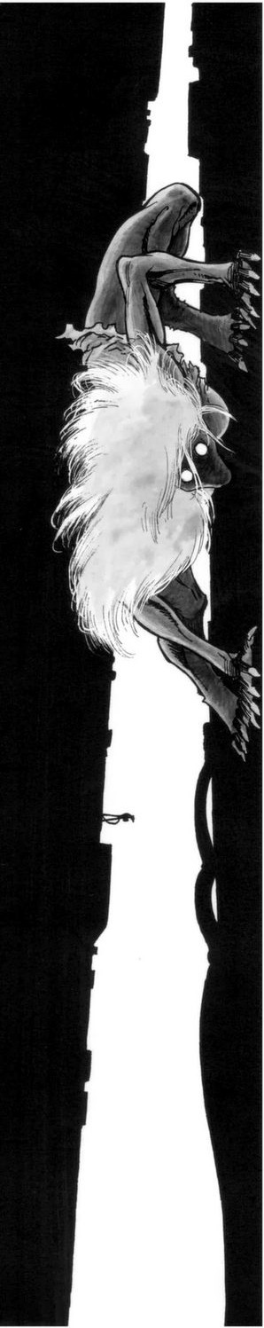
It was a woman's torso. The arms, legs, and head had been cleanly severed. What fell before him was just a body, like a hollow tube.
"Ahhh! Ahhhhhh!!"
When Zora screamed and looked up at the sky, there was a shadow bracing itself with both hands and feet against the walls of the buildings that formed the alley. The shadow's lips twisted, and blood traced down, forming a long string that hung and fell directly onto Zora's forehead.
"Aaghhhaaahhh!!"
Zora's scream echoed fiercely off the narrow alley walls, but it died away before it could reach the street of the entertainment district, twenty meters away.

The quiet returned to the junkyard town at night. Amidst the scattered cyborg corpses lying in the alley, Alita, having fought to exhaustion, collapsed onto the ground as if she were merely sleeping, unconscious.
"You did well, Alita," Ido whispered as he gently picked up the fallen Alita, brushing the disheveled hair from her bruised and dirtied face with a tender hand.
"...Hey, can I ask? This martial art she used—whether it's an ancient Martian fighting style or some kind of mechanized combat technique—what exactly is it?"
Calico lit the cigarette held between her lips. She wanted to know what Ido knew about Panzer Kunst. He didn't answer for a while, stroking Alita's hair, but then suddenly began to speak as if to himself.
"I don't know much about Panzer Kunst. But I've heard that it's a legendary martial art that was destroyed because it was terrifyingly powerful. It's probably called the ancient Martian martial art for that reason."
That fact had faded into oblivion, but in the former space age, humanity had reached Venus, Mars, and Jupiter, and had built unique cultures on each planet. Among them, the Martian Panzer Kunst wielded terrible power in wars through assassinations and guerrilla warfare, and thus was feared as "On Mars, there is Panzer Kunst."
"Heh, I see... Indeed, the principles are quite different from our Earth-style martial arts. Even watching that technique, I can't imagine the battlefield is limited to the ground, you know," Calico said.
Calico walked over to Alita, who was held by Ido, gently placed her hand on the girl's cheek, and smiled as if praising her brave fight. However, that smile gave Ido a chilling sense of unease. Contrary to the mask of her smile, her eyes harbored a golden light filled with the instinctive hostility of a woman's jealousy hidden within.
He had sensed it.
“Calico, you…”
Ido muttered as if groaning, his expression turning grim. Turning his back to Calico to shield Alita, he squeezed out a trembling, suppressed voice.
“...I won't let you meet Alita anymore. After seeing your eyes just now, I'm convinced. If you and Alita are together, you will inevitably end up trying to kill each other someday.”
Calico was at a loss for words for a moment. Then, understanding the feelings Ido had intuitively grasped, she let out a dry chuckle that bubbled up from within. Turning her back to the two of them without looking back, she quietly spoke as she left.
'Indeed. She was a cute girl, but I've just come to dislike her. Ido, make sure you tell her not to come after me, okay?”
Calico's had a fierce temperament and immense pride as a skilled fighter, and was absolutely unwilling to allow someone of comparable stature nearby. If Alita continued to grow like this and came to possess power that could surpass her, eventually the two would have to settle matters by violently comparing their mutual prestige...
They would have to settle it eventually; it was an unavoidable fate for those who live as martial artists.
After Calico melted into the depths of the darkness of the alley, Ido began walking home, carrying Alita. After taking a few steps, he seemed to reconsider and stopped, turning back to the alley with a stern expression. There, a yawning darkness spread like a gaping hole, with not even the slightest trace remaining.
"Calico's hostility is far more dangerous to Alita than Colt's twisted passion. If only I had killed that woman here and now..."
Ido said this as he clenched his fist, but he fully understood that he did not have the ability to carry it out. Holding the defenselessly sleeping Alita, Ido could only mutter curses at his own powerlessness.
However, whether his curses reached the heavens or not, the root of that calamity would be removed before the night was over.

CHAPTER 6
Late that night, the towering lights of the aerial city Zalem above The Scrapyard vanished as soon as they were enveloped by a veil of thick, dark rain clouds that had crept in.
The midnight bustle—a hallmark of the entertainment district in the northern part of town—also quickly disappeared as people hurried back to their shops and homes at the hint of an impending thunderstorm.
When Calico turned a corner in a familiar back alley of the entertainment district, she found not a continuation of the road but a narrow path less than a meter and a half wide, created by the gaps between buildings.
Entering the dim, unlit path, she would arrive at the back door of the Pink Cabaret, where her bed was, in less than a minute without walking much.
As Calico reached the back door and placed her hand on the doorknob, her ears caught a scraping sound echoing from deep within the alley.
What's that?
Calico squinted her eyes, trying to discern the hazy distance, but in this narrow space between buildings where neither streetlights nor neon lights reached, she could see at most ten meters ahead.
Was it just my imagination? No.
The rumble of thunder shook every corner of the alley. At that moment, thunderclouds that had suddenly gathered overhead began pouring heavy rain upon Calico with a deafening sound.
Calico chose not to ignore that unknown presence. Releasing her hand from the doorknob, she focused her sharpened senses into the depths of the alley's darkness, paying no mind to the pounding rain.
Though the sound was drowned out by the rain and the figure was hidden in the darkness, Calico's keen beast-like senses detected the approaching presence. She wasn't certain whether it was dangerous, but a strange unease sounded an alarm in her heart.
Keeping her gaze fixed into the depths of the darkness, Calico lifted the hem of her wet and heavy coat, revealing a steel gun that gave off a dull shine in the rain. As she slowly pulled the bolt lever on the rear part of the machine, with a heavy operating sound, a used battery cartridge was ejected and fell to the ground.
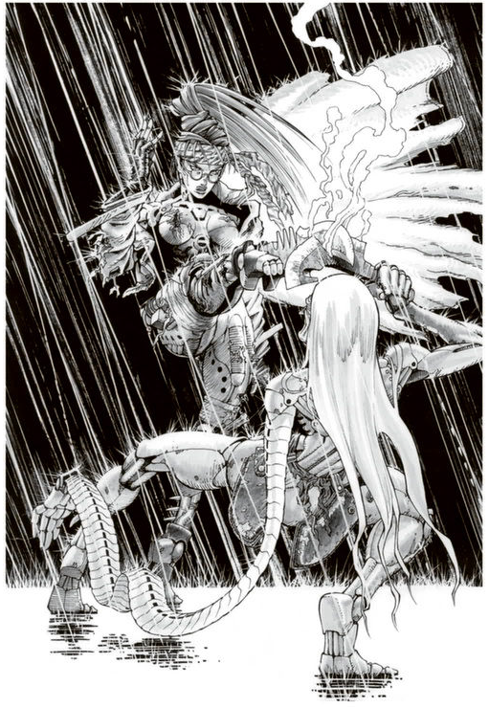
Calico rummaged through the inside pocket of her coat and confirmed it, clicking her tongue softly. In the earlier fight, she had used three cartridges of the red-hot power supply. The "Red Heat Leg" was a gimmick designed to exert destructive power through the high heat generated by an internal electric blade, but its weakness was that the special steel blade cooled down quickly, making it difficult to maintain a high temperature. To use it, pre-heating was necessary, and to expect full power, she would need more battery cartridges. However, with only one cartridge left, she had no choice but to rely on the residual heat from when it was last used in the battle with Colt's gang.
Taking a deep breath and steeling herself, Calico finished loading the last cartridge. As the tension in the air heightened, her soaked body trembled with a fearless laugh. With subtle movements that were almost imperceptible, she lightly shifted her stance by opening her legs just slightly forward and backward. This was all she could do for now.
Just then, another clap of thunder roared, and with it, a thick, blue lightning bolt filled with intense energy cut through the sky.
A bolt of lightning illuminated the scene for a brief moment, casting it in an eerie blue light, and even the bold Calico couldn't help but let out a low groan.
The figure standing there was a woman. She glistened in the torrential rain, her skin slick with the water. But it wasn't her nudity that made her so grotesque. Both of her arms had been brutally severed at the shoulders, leaving streams of blood running down her body and painting the ground in red. A single slash ran from her chest down to her navel, her intestines, stained pink with blood, spilling out like a grotesque sash clinging to her legs. Despite the massive blood loss and unimaginable pain, she was somehow still alive, wheezing with shallow breaths as she staggered forward.
"Zo—Zora..." Calico immediately recognized who the woman was. The disfigured woman, beaten and bloodied in the storm, was undoubtedly Zora—the old prostitute she had known since their early days together.
Zora had likely dragged her ruined body all the way here, desperate to reach Calico. At the sound of her strangled voice, it seemed to trigger the last of her strength, and she collapsed slowly, sliding down into the blood-soaked alleyway, leaning against the wall.
As Calico prepared to move toward the falling Zora, a strange, grinding noise emerged from the darkness behind her, distinct even over the torrential rain. Calico's eyes flared with anger as she glared into the gloom behind Zora. The narrow alley was filled with nothing but darkness, the source of the eerie grinding noise barely noticeable, hiding itself in the shadows.
Calico, crouched and ready for any attack, subtly shifted her stance. She adjusted her weight slightly, moving it from her back foot to the ball of her front foot. By leaning her weight slightly forward, she sacrificed some of her linear movement but gained the ability to initiate her attack much faster. Though her face remained focused, she concealed her rising anxiety beneath a mask of calm readiness.
Shifting her tactics from defensive to offensive, Calico spoke in a low, deliberate voice. "Come out, you murderer of prostitutes. I know you're there, aren't you?" She sent out a wave of killing intent into the darkness, probing for the presence of whoever was hiding there. The density of her killing intent was enough to make most people faint as if struck by lightning or rush at her in a panic. But there was no response from the shadows, not even a hint of a breeze.
The eerie presence lurking in the dimness absorbed Calico's intent like a reed bending to the wind, unaffected and utterly silent. Calico's eyes narrowed as she tried to gauge the strength of this invisible opponent, who was watching her like a phantom. Who is this? she wondered.
After a brief pause, as though it had grown bored of the silence, the figure began to move. From the darkness behind Zora's collapsed form, a steel hand quietly slithered out. Only the long, thin fingers of a cyborg hand emerged from the shadows, reaching out without a sound, casually grabbing hold of Zora's hair.
The figure suddenly lifted Zora nearly three meters into the air, effortlessly hoisting her up. Then, without warning, a blinding surge of killing intent emanated from deep within the shadows, crashing into Calico's senses like a tidal wave. In an instant, a sharp, angular presence launched a vicious attack from an elevated position in the shadows. The pivot foot spun sharply as it struck, rising almost 30 centimeters into the air mid-kick.
The swift, devastating kick sliced through Zora's torso with ease. As her body split apart, Zora let out a strained, final agonized cry, her voice breaking. "Aghh... oh no, how could you do this... so cruel..."
"You… you're no ordinary person, are you?" Calico asked. The figure of the old man, whose grotesque, steel hands had just euthanized Zora, stepped out from the shadows, emitting strange, wheezing breaths. In the pouring rain, Calico watched as this small, elderly, full-body cyborg emerged into her line of sight. Despite his size, his appearance was a horrifying reflection of the madness that drove a serial killer.
His face was hidden beneath wild, tangled white hair, with only his wrinkled, twisted mouth visible in a sneer. Below his unsettling head, his body had been replaced with a genderless, cyborg frame. His left arm, replaced from shoulder to wrist with a horrifying, multi-jointed machine resembling the segmented exoskeleton of a centipede, was capable of extending and contracting.
The only clothing this grotesque old man wore was a scrap of fabric, with large machete-like knives dangling from his waist on either side.
"Shut up… I don't mix personal feelings with my hunts, you hear?" Calico narrowed her eyes, licking her full red lips with a long tongue.
At her words, the old man clicked his tongue in disapproval. He grinned darkly beneath his mess of white hair and slowly spoke again. "What a waste…"
Calico remained silent, trying to gauge the old man's intentions, calming the storm within her. The old man, wheezing and cackling, continued, "Well then, let's see what you’ve got, eh?"
Calico exuded a menacing aura, like a coiled serpent ready to strike, while the fierce rain poured between the narrow gaps of the surrounding buildings. Calico and the old man, who had introduced himself as Norinco, clashed like two writhing serpents, their bodies moving with deadly precision as they splashed through the pooling water beneath them. Thunder cracked as Calico's elegant kicks lit up the scene, revealing Norinco's cunning evasive maneuvers in the flashes of lightning.
Calico shouted mockingly at Norinco as she attacked fiercely. "How long are you going to keep playing around, huh? Weren't you supposed to finish me off?" Calico taunted him. Her voice was filled with deadly intent.
The old man, wheezing and making a hissing friction sound from his mouth, had barely launched half the attacks that Calico had so far. Every now and then, Calico's relentless kicks would land because Norinco couldn't entirely deflect the overwhelming onslaught. From an outside perspective, it appeared that Calico was completely dominating Norinco, who was only defending.
"Come on! Fight back a little, will ya?" she taunted.
However, despite her apparent upper hand, Calico hadn't inflicted any significant damage on Norinco. The old man expertly blocked her attacks, either deflecting them with his hands or adjusting his position just enough to avoid taking serious hits. Sparks would fly every time her kicks grazed his steel arms or torso, but it was all show—there was no real damage being done.
Internally, Calico struggled to remain calm as she fought desperately, her frustration building at the sight of Norinco standing unfazed after every strike. She pushed herself harder, trying to keep her composure but feeling increasingly irritated at her inability to land a decisive blow.
"Hiss... You're strong, girl. But you've got no luck at all. Whether you realize it or not, you're holding back just a bit, afraid of slipping on the wet ground. I can see it in your kicks," Norinco hissed, mocking her further. "Your precious kicks are afraid of a little water, girl."
Calico clicked her tongue in irritation and, shaking her wild, disheveled red hair, she landed a fierce front kick into Norinco's torso. The old man quickly crossed his arms to block the blow, bending his body like a hinge as he deliberately leapt backward. Though he was sent flying several meters, skidding across the wet ground, he managed to stop himself without taking any significant damage.
"Too bad... There's no next time to try again. Hissss... Don't panic now. Even though these dull eyes of mine cant’s see you, I can tell struggling to keep up, huh?" Norinco wheezed mockingly.
"Huh? What are you talking about? You can't see...?" Calico, startled, hesitated in her attacks. It was hard to believe that the old man, who had been evading her relentless strikes so easily, was actually blind.
"Hissss... Go on, take a look. Do you see any eyes on me?" The old man rasped, pushing aside the tangled white hair that covered his face with both hands.
Calico's breath caught in her throat as she stared in shock at the strange sight beneath his hair. In place of eyes, the old man had nothing but small, white dish-like objects where his eyeballs should have been.
"Hisss... Did you catch on yet? These dishes in place of my eyeballs are radar eyes. They visualize ultrasonic waves, allowing me to move easily even in the dark. Though, to be honest, I rely more on intuition and sensing than these gadgets," Norinco said, turning his head as if scanning the surroundings with his radar eyes. He nodded in satisfaction.
"Hisss... Oh dear, the heavy rain's distorting the sound images a bit, but it looks like we've ended up in a nice spot."
At some point, Norinco and Calico had emerged from the narrow alley into an open area.
"This place..." Calico recognized it immediately. In front of them was a wide cul-de-sac, with a chain-link fence at its far end, and beyond that, a deep sewage river flowed.
This was the same place where she had recently hunted down a junkie, who had turned one of his arms into a cybernetic weapon. His corpse still lay there, rotting on the ground, beaten by the rain, as no one had bothered to clean it up.
Norinco, now in the dead-end alley, had shifted his stance completely. Unlike his earlier defensive posture, he took up a strange and focused pose. He spread his legs wide, lowered his body, and turned almost completely sideways. Then, preparing for something unseen, he waited.
Both of Norinco's hands were shaped like beaks, with his fingers curled and trembling slightly as if they were probing for something. "Hisss... well, well... the worthless trash of this forsaken world. Rejoice, for death is a ceremony that happens only once in a lifetime. Let’s make it memorable by disassembling you piece by piece," he taunted.
At that moment, Calico launched herself forward in a rapid charge, aiming to strike. Norinco, still in his low stance, moved sideways like a crab, sliding across the ground with an eerie fluidity. It was as though his movements were like vines wrapping around a tree, expertly catching Calico's incoming kick. Manipulating her momentum, he tried to throw her off balance, taking advantage of the moment to close the distance between them. Once he was close enough, Norinco began landing sharp, slicing blows with precision. Calico, gritting her teeth, fought back desperately, using her elbows and knees to counter his attacks.
"Damn it!" Calico cursed as she struggled against Norinco's mysterious fighting style. Though she was able to fend off severe damage with a desperate defense, she was nearing her limit against the elderly man's refined techniques.
"Hisss... Ah, seems like you're used to attacking from a distance, aren't you? But you've never dealt with someone up close, have you? In close combat, your skills are quite sloppy," Norinco taunted, slithering with confidence.
Damn... not yet. Calico wasn’t just being tossed around aimlessly—she had secretly triggered the red-hot blade function in her leg when they arrived at this spot. Drawing power from the last battery cartridge, the thirty-centimeter electric heat blade hidden in her right leg was now heating up inside the holster, glowing red-hot. Though she hadn’t preheated it and was relying on residual heat, which lowered its reliability, it was still her trump card with enough destructive power to potentially turn the tide.
"Hisss... Oh, you're planning something, aren't you? Hahaha, go ahead, try to kill me if you can," Norinco sneered, clearly sensing the determined aura emanating from Calico despite her pain.
Panting heavily, Norinco hissed out a breath. The old man, now fully on the defensive like a silkworm in a cocoon, relentlessly struck at Calico with a rapid barrage of sharp finger thrusts. Overjoyed with his advantage, Norinco’s attacks grew increasingly reckless.
In that moment, for just a split second, the force of his attacks caused his body to shift slightly off balance, tilting his axis away from Calico at a diagonal.
Sensing this in an instant, Calico reacted with the precision of a spider lunging at its prey. She charged forward, slamming her shoulder into Norinco before he could recover his footing. The quick-moving old man, unable to correct his stance in time, stumbled.
"Sh-shit...!" Norinco gasped, his body thrown off balance.
"Rrrraaaaahhh!" Calico roared as she lunged forward, taking advantage of the opening to close the distance between them.
Calico delivered a decisive kick. If this didn’t end it, she would lose. Throwing her entire body into the attack, her thigh shot upwards like a knee strike, and her lower leg, folded at the knee, unfolded with a sharp downward angle. At the same time, the red-hot thermal blade stored in her calf sprang out like a jackknife, aimed directly at Norinco’s exposed skull.
The speed of the kick, the angle, the timing, and the power—everything about this strike was flawless. It was one of the best executions of Calico's "Red Heat Leg" in her lifetime.
A dull metallic sound rang out once, echoing off the walls. For a moment, only the heavy rain, the thunder, and the sound of the now-turbulent sewage river filled the space.
"...Impossible," Calico muttered, breaking the silence. Then, low and raspy gasps came from Norinco, mixed with the acrid smell of something burning, followed by his eerie, wheezing laughter.
Unbelievably, Calico's most powerful thermal blade strike was stopped just short of Norinco's skull by the large knife hanging at his waist. The blade, now cooled by the rain, had turned black, emitting a faint sizzling sound as water vaporized on contact. On the other hand, Norinco’s thick-bladed knife, which had taken the brunt of the thermal blade, was almost eighty percent melted through, bent into an "L" shape. It was a near-miss for Norinco.
"Hoo, hoo, hoo... You really impress me. I can’t believe you had such a hidden move," Norinco wheezed, laughing. "But in the face of my dissection knife, well... it didn’t amount to much."
His quick reaction to draw the knife and the durability of the special steel blade had been unlucky for Calico. However, what truly sealed her fate was the rain, which had dragged the fight out and cooled her thermal blade, and the fact that she had no additional cartridges for pre-heating, which prevented the blade from reaching its maximum destructive potential.
"Sheesh, I don’t wanna fight someone like you any longer. How about I hang you up now and finish this once and for all?" Norinco sneered as he prepared to make his move.
Calico, having exhausted all her strength after her all-out attack was thwarted, was no match for Norinco, the master of combat. Effortlessly countering Calico’s last attempts to fight back, the old man closed in and struck a precise blow to her jaw, rendering her unconscious. Grabbing her red hair with his multi-jointed left arm, he dragged her helplessly along the alley wall.
"Hee hee... Let's see, a good wall or a bad wall? I can tell from the sound waves... Hmmm... Heh, this one’s good. Sweet sound waves, just the right resonance. My hand blade will pierce nicely here."
Lifting Calico with ease, Norinco hurled her tall frame against the wall. His multi-jointed arm coiled and shot forward like a steel spring, his long, razor-like fingers piercing through her steel body, pinning her to the wall.
"Cyborgs don’t scream in pain when you dismantle them, which is boring... but I'll take my time disassembling you piece by piece," Norinco said with a sadistic grin.
Calico, barely conscious, tried to escape, but her body no longer responded to her commands. It was now merely a lifeless mass of steel.
All Calico could do was glare weakly as Norinco tossed away his broken knife into the river and drew a new one.
Shiiiinggg!
The large knife, sharp as a blade, showed no mercy as it dug into Calico’s defenseless cyborg body. The same tough special steel that had withstood her heated blade was now slowly chipped away with heavy, grinding strikes from Norinco's knife. The blows echoed off the walls as they bit deeper into her body.
With each frenzied strike, Norinco’s knife hacked through Calico’s left arm, severing it below the elbow, while her right leg dangled loosely, nearly torn off. Her once powerful body was reduced to a tattered mess, the outer casing shattered and mangled.
"Hi-yaaah!"
Norinco delivered the final blow, a brutal diagonal slash that cleaved her body apart. The twenty-centimeter-long blade sunk deeply into the steel frame of her torso, tearing through her cyborg body like a rag. Her right side and head, now shredded like worn-out fabric, fell from the wall and rolled across the wet ground, coming to a stop against the sewer grate.
"......."
Calico, regaining a small amount of control over her paralyzed body after the shock of her fall, desperately dragged herself along the ground with her remaining tattered right arm, trying to survive.
"Ssshh, still conscious, are you?" Norinco muttered as he noticed Calico's movement. She had spotted a tear in the metal fence and was pulling her broken body towards it. The old man quickly threw a knife to stop her, but it only managed to pin a part of her torn cyborg frame to the ground. Calico continued to slip away, tumbling into the sewer river and vanishing into the raging current.
"Enh... I'll give you that, your determination is admirable. But surviving that current with a body like yours would truly be a miracle."
The deep sewer river, swollen with rainwater, roared like a wild torrent, surging violently. Covered in his shaggy white hair, the twisted killer Norinco took a final glance before merging into the shadows of the rain-soaked alleyway, his eerie wheezing fading away into the storm.

CHAPTER 7
It was nighttime in The Scrapyard. A mix of humans and cyborgs came and went, set up stalls, peddled goods, ate and drank, scavenged for items, got drunk and passed out, sat down, and even died. Amidst the dazzling neon lights flickering in the night along the main street of the eastern district of The Scrapyard, Alita swam through the crowd with glee. Lately, Ido had been busy with daytime clinic appointments, and Alita would sneak out into the nighttime city without him noticing. On nights when she planned her escapades, she couldn't help but smile with excitement and thrill, making every effort not to be caught by Ido until he disappeared into his bedroom.
It had been three weeks since she first ventured out alone into the night, during the incident where she had her first trial as a Hunter-Warrior, facing off against Colt. The outcome of that fight was something she had learned after waking up on the maintenance bed a day later, when Ido told her what had happened.
Though Alita had fought, she remembered very little about the actual battle or its progress. The only thing that stayed with her was the lingering memory of the technique she used. Every time she ventured into the night alone, she would test her strength on streetlights or other objects in deserted streets.
“Alita, don’t go hunting any bounty heads that you don’t recognize. You’re still an inexperienced Hunter, after all,” Ido had sternly told her. For a while, he had made it clear that he wouldn’t let her take on any Hunter jobs unless he was with her. Even now, Ido wasn’t entirely happy with Alita becoming a Hunter-Warrior. He worried that she might get seriously injured again, or that she would become disillusioned with the city’s crime and moral decay. He feared she might grow violent or pick up bad habits. His deep care for Alita drove his concern. She had become a vital member of his family.
As a result, Ido had recently started sighing every time he saw Alita, though she, seemingly unaware, remained carefree. “I’m much stronger than Ido thinks. He doesn’t trust me enough,” Alita muttered to herself, leaning against a streetlamp that illuminated the night streets. She puffed up her thick lips in slight frustration.
Alita pouted, her lips still pursed in dissatisfaction. She didn't fully understand that Ido's worries were unrelated to her high abilities or trustworthiness. Being naturally straightforward, Alita had a tendency to understand things very simply. While she could grasp the idea that "being strong means there's nothing to worry about," she struggled to comprehend the more nuanced concern that "even if you're strong, that doesn’t stop someone from worrying."
Crouching under the streetlight, Alita watched the flow of people passing by. With only three months' worth of memories, everything still felt new and exciting to her, including simply observing people move through the city. There had even been times when she got so absorbed in watching the never-ending flow of people late into the night that she didn't realize the sky had begun to lighten with dawn.
"Hmm? Who’s that?" she murmured, her attention caught by a group passing nearby. Alita pulled out a crumpled piece of paper from her pocket and glanced between the paper and the people walking by, comparing them. Her eyes lit up, and she stood, eagerly following them into the crowd. The crumpled paper in her hand was a printed bounty list.
Alita had obtained the crumpled bounty list two days earlier when she accessed the interface of a Factory security information management robot, a "Netman", on the street. Ido, tonight I’ll go out on my own again, without telling you, and do a perfectly fine job as a Hunter-Warrior. Soon, you’ll recognize that I can handle everything on my own, she thought to herself.
"Sixty thousand, seventy-six thousand, eighty-one thousand..." Alita mumbled as she repeated the bounty amounts while pushing through the crowd. The three bounties she had spotted were worth 60,000 chips, 76,000 chips, and 81,000 chips, respectively. For Alita, who was still being supported by Ido, these amounts didn't hold much meaning financially. However, using the bounty as a measure of how dangerous the criminals were made it easier for her to remember than just their names.
As Alita followed the trio through the bustling street, pondering when and where she should strike, they suddenly disappeared into one of the small shops that lined the street. "Oh no, I lost them," she muttered, getting swept along by the crowd like a leaf in the wind. After some effort, she finally made her way to the front of the shop. Alita bent over, resting her hands on her knees, taking a deep breath, and then looked up at the shop’s sign.
As Alita lifted her head, she saw the strange name of the bar, "Gamma Ray," written above the entrance. If I go in here, there’s no worry about them escaping, but if a fight breaks out in there... Alita knew that if she entered the bar, her presence would immediately stand out, and it would become difficult to continue tailing the three bounty targets. Worse, she might be forced into a brawl inside the bar, with other customers likely around.
As a beginner Hunter-Warrior, it was ideal to lure her targets into an open space where she could fight without worrying about bystanders. But to do that, she’d need to wait outside patiently for the three to leave the bar. However, that wasn’t a good option for Alita, who needed to be home before dawn.
Ugh... hmm... ah, whatever! After pacing back and forth in front of the bar entrance with her mouth in a frustrated frown, Alita finally shook her head vigorously and grabbed the door handle.
Just as she turned the old knob and pulled to open the door, there was a loud crash, and the door suddenly burst open from the inside with a scream, as if it had exploded.
Several women, terrified, screamed as they rushed out into the street, one after another. One woman had a deep cut across her back and collapsed from blood loss before she could reach the crowded street. Alita, stepped through the entrance of the bar, and quietly closed the door behind her with a soft "click" that somehow sounded louder than the faint melody of the old record playing inside the dimly lit bar.
There wasn't a single intact table or chair in the room—most had been smashed or toppled over, lying in pieces on the floor. Among the wreckage were the lifeless bodies of several unlucky patrons who hadn’t managed to escape in time.
Alita felt her body twitch for a moment as she took in the scene of destruction. Am I trembling? she thought to herself. What am I scared of? Get a grip. She mentally repeated these words, trying to calm her body, which was becoming stiff with tension. Alita took a deep breath, silently, so as not to be noticed.
The three bounty heads who had rampaged through the bar, leaving nothing living behind, were enjoying the aftermath of their violence, completely oblivious to Alita. A man standing against the wall with only his arms and legs cybernetically enhanced, worth a bounty of 60,000 chips, held a bloodstained curved blade in one hand, his unfocused eyes staring blankly into space after taking a hit of synthetic drugs. A second man, worth 76,000 chips, fully cybernetic and clad in a black coat, sat calmly at the counter, pouring himself a glass of bourbon, his demeanor unfitting of the brutal scene around him. The third, a black woman, also fully cybernetic and worth 81,000 chips, was rifling through the bar’s storage, counting the stolen cash she’d found in the safe with obvious glee.
"What a vile thing to do," Alita muttered under her breath.
Then Alita spoke out loud to the three, her voice cutting through the air. "Closing time, you bastards." Alita voice was as steady as she could muster, but the slight tremble at the end of her words made her curse silently to herself.
The man worth 76,000 chips, who was casually drinking whiskey, muttered a response before even turning to face her. "So what? That just means there's no one left to get in our way."
Until now, the three bounty heads had barely reacted to the lone girl in front of them. But Alita’s provocation had changed that. In an instant, they all turned their eyes toward her, their hostile glares and palpable malice suddenly electrifying the air in the dimly lit bar.
Surrounded by their deadly intent, Alita felt a tremor run through her once again.
"Hah! Heh heh, look at this little kitten here, talking tough," sneered the man worth 60,000 chips, leaning against the wall and holding a broad curved blade. His drug-fueled body swayed as he laughed mockingly. "She’s shaking... She’s scared stiff, huh?"
The man approached Alita with an unsteady gait, sneering as he moved closer. Still a bit scared. Do I still not trust myself? Damn it, I’m strong enough. I beat that Colt guy, didn’t I? Alita tried to shake off her hesitation, mentally urging herself on, but Ido's voice echoed in her mind. "Alita, you're still less than half a Hunter..."
"Damn it! Don’t underestimate me! I’m a Hunter!" Alita shouted, sharply exhaling as she forced her fear aside. She darted forward, weaving around broken tables and bodies as she charged at the man worth 60,000 chips, who staggered drunkenly.
"Ha ha ha! A Hunter, you say? This little girl?!" the man slurred, his voice filled with mockery. Though clearly high and unsteady, his anger flared as Alita quickly closed the gap. With a powerful swing of his curved blade, powered by his cyborg arm, he slashed at her.
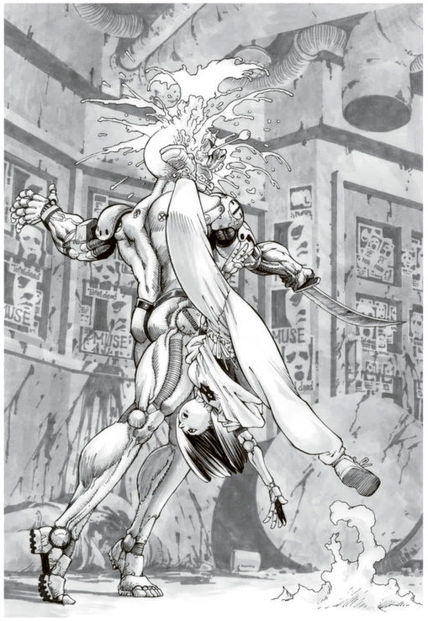
Alita ducked under the sweeping blade, lowering her head to avoid the strike, then planted her right hand on the floor as she kicked her left leg upward. Using her hand as a pivot, Alita twisted her body, executing a cartwheel-like motion. Her heel came up from below, in a sweeping arc, aimed at the man’s temple from his blind spot.
Alita’s reverse roundhouse kick echoed through the room with the sound of bones shattering, sending the head of the 60,000-chip man flying through the air. "Two more to go!" Alita shouted as she spun across the floor, ready for her next target. The man worth 76,000 chips, momentarily stunned by her unexpected combat prowess, stood up from the counter, baring his teeth before spitting on the floor in fury.
"You brat! Damn you!" he snarled, flinging open the front of his black coat. Inside, it was lined with throwing knives, like silver scales. With practiced ease, he grabbed four in each hand, eight in total. "Take this!" he roared, hurling the knives with speed and precision, aiming directly at Alita as she closed the distance.
Sensing the danger, Alita swiftly dodged to the side, causing the knives to miss their mark and pierce the floor instead, riddling it with holes like a honeycomb. Alita rolled to the side and used a fallen round table as cover, stopping her movement to conceal herself behind it.
"My knives have been underestimated, huh? You think a flimsy wooden shield will stop me?!" The man, using the full power of his cyborg arm, hurled his knives with such force that they could easily pierce through two and a half centimeters of steel. With a cruel smile, he launched all eight knives toward the round table where Alita was hiding. The knives flew at incredible speed, striking the table and tearing it apart as if it were tissue paper.
"You little brat, calling yourself a Hunter! You think you can get away with that?!" He spat in anger as he approached the spot where the table had been, intending to stomp on Alita’s remains. But when he got there, all he saw were shattered wooden pieces. No body, not even a trace of a cyborg arm.
"Up here, you idiot!" He looked up in a panic, cold sweat running down his face, only to find Alita hanging from the ceiling pipes. She had jumped to the ceiling at the last moment, avoiding the knives that destroyed the table.
"Damn brat!" the man roared, his face twisting with rage as he began to hurl knives wildly at her, trying to hit his elusive target.
Alita dodged the inaccurately thrown knives with calm precision and swiftly closed the distance. With a sharp jab, she pierced the face of the man with the 76,000 chip bounty, killing him instantly. She shook off the blood from her fist and quietly exhaled. The fear she had felt before the fight had vanished like mist, leaving her in a composed state of mind, as if she were walking through her living room.
"One more left." As Alita turned her gaze toward the counter, a high-pitched scream escaped the last remaining target, the woman with the 81,000 chip bounty. The woman backed away in terror, clutching a pile of chips. Bottles crashed to the floor from the liquor shelf behind her, shattering loudly.
"P-please, spare me!" the woman begged through her tears, desperately placing a pile of chips on the counter. "There are 100,000 chips here. If you let me live, I'll give you another 50,000. Come on, it’s better than turning my head in to the Factory, right? Look, you want these chips, don’t you?"
Alita silently approached the woman, grabbed her collar across the counter, and lifted her up. "The chips don't matter," Alita said softly. The woman, her face filled with disbelief, kicked and struggled helplessly in midair. "P-please, don’t kill me! I don’t want to die yet!" Alita held the pathetic, flailing woman aloft for a moment, then shifted her gaze and carelessly released her. The woman collapsed backward, her face a mess of tears and snot, paralyzed by fear.
"You're not the kind of opponent I’m looking for," Alita said, turning her back on the woman, who sat on the floor in relief, her legs too weak to stand. Without bothering to take the bounty, Alita began to leave the wrecked bar.
"Hmph..." At the very moment Alita turned her back, the woman's expression drastically changed. The once pathetic figure, covered in tears and snot, now radiated fury, her face contorted with rage, emanating a violent, ominous aura that made her seem like a completely different person.
The woman, moving swiftly and silently, leaped over the counter like a big cat, closing in on Alita's back with a smooth, predatory speed. In her hands, she gripped two long needles, each about 30 centimeters, weapons that had claimed countless lives. Her most effective tactic was to feign weakness, exploiting people's sympathy, only to strike them down in a moment of vulnerability. The number of people she had killed this way far exceeded that of her companions. Foolish little girl, she thought, ready to make Alita regret her moment of mercy in hell. Just as the woman moved to plunge a needle into Alita's ear, it happened.
"Hey, you know something? You don’t throw a finishing blow, you drop it." A deep voice boomed close to her ear. The moment she heard it, the woman felt an overwhelming force on her body, and suddenly, she was weightless. Lifted from the floor, her world flipped upside down before she could even comprehend what was happening. A split second later, her head was violently slammed into the ground, and she lost consciousness forever.
After the heavy thud, the bar returned to its eerie silence, with only the melancholic, sepia-toned tune of an old record playing like a lonely ghost. By the time Alita sensed the killing intent behind her and turned around, the woman was already lying on the floor, her head slumped backward.
Just as the woman's head slammed into the floor, the mysterious figure who had thrown her held a graceful bridge position, frozen in place. As the woman's body convulsed in its final moments, the figure smoothly transitioned out of the bridge and stood before Alita. It was a full-body cyborg, with a bulky, square-shaped form. Despite resembling a humanoid, the design gave off a non-human, robotic vibe. Most notably, the figure had strange, distinctive hooks mounted on the back of its hands, seemingly designed to lock onto opponents during throws.
"I watched your moves, kid. Not bad at all. But you need to tighten up—you'll get yourself killed being too soft. If you're a Hunter, you should upgrade to a combat body, even if it's a cheap one." The man, who had suddenly appeared and saved Alita, grinned as he offered his critique. Alita responded with a slightly confused expression.
"Hmm. But, mister, where were you hiding while those guys were causing all that trouble?"
The man laughed heartily. "Ha ha ha, blame it on this secondhand body. My digestive system hasn't been working right lately, so I was off taking care of some business!"
“Even though I’m a full-body cyborg, they still call me ‘Sticky.’” The man pointed with his thumb at a small door in the corner of the shop, then slapped his stomach with his palm, laughing loudly.
According to him, he had just gone to the bathroom when the three bounty heads barged in. Seeing the situation, he had planned to fight them, waiting for the right moment to strike. But while he was watching and waiting, it seemed that Alita had already taken them down.
The man, who called himself Bergman, used to be a fighter in a Western district arena. Though he never became a champion under the official rules, his unique fighting style—focused on throwing techniques—was highly regarded by fans for its power in combat.
“In a race, you have to be the first to finish if you want to win. But back when I was active, all I could think about was tossing the guy in front of me. That’s how I fought,” he said with a chuckle.
“Wow, so there’s stuff like that in this town too?” Alita found Bergman’s stories refreshing and eagerly absorbed each topic he brought up.
“Hey, Bergman, can we meet again? I’d love to hear more stories from you.” Alita hesitantly asked as they were parting ways.
In response, Bergman gave her a wide grin and nodded.
He pulled out a piece of paper and a pen from his pocket and drew a simple map, handing it to her. "I'm running a rental body shop now. If you come by, I've got a few hunter bodies suited for a tough girl like you. Bring along what you earned today and come check it out."
Alita carefully folded the map Bergman gave her and tucked it away before leaving the night streets, which would start to lighten in about an hour.

CHAPTER 8
“Alita, haven’t you been getting up a bit late recently?” Ido called from the clinic, just poking his head out to speak when he saw Alita finally come down from the bedroom on the second floor around noon.
“Yeah, sorry,” Alita replied, still sleepy, as she made her way to the dining room.
“By the way, Alita, I’m thinking of going hunting tonight. Want to come along?”
As Alita quietly ate her late breakfast, which was more like lunch at this point, Ido entered the dining room, rolling his neck and shoulders as he spoke. However, her response was hesitant and unenthusiastic. “Well, um, tonight… I kind of…”
Alita was feeling tired from her activities the previous night, but more than that, she declined Ido’s offer out of a subtle sense of rebellion. After all, she had taken down two bounty heads on her own just the day before.
Ido noticed her attitude and furrowed his brow, looking at her with a somewhat disappointed gaze. “What’s the matter, Alita? You were so interested in hunter work. Don’t tell me you’ve already lost interest?”
Alita shook her head quickly in response and, after finishing her meal, stood up from the table. “Sorry, that’s not it… I just don’t feel up to it tonight. But I promise I’ll go next time.”
With that, Alita hurriedly left the dining room and bolted out of the house. Ido stood frozen for a moment, as if trying to call her back, but after a while, he let out a sigh and slumped slightly, feeling drained.
Ido sat down in a chair, reflecting. “Alita... you were so fixated on being a Hunter, on fighting, so why now?” Could it be that Alita is hiding something from me? As this thought crossed his mind, he felt something dark stir deep within him, causing a faint tremor. It was a black emotion, akin to jealousy. “My Alita...” Ido muttered, lowering his head over the table.
Meanwhile, Alita was walking down the bustling main street in the early afternoon, surrounded by crowds of people. “Wow… it's so lively during the day,” she remarked. The people filling the streets during the day were mostly workers and shoppers, creating a comparatively bright and lively atmosphere. However, that didn’t mean the junkies or collapsed homeless had disappeared, and in some corners of the street, drug deals and shady dealings were happening out in the open, even in broad daylight. The atmosphere, while vibrant, still carried hints of its rough edges.
The Scrapyard may have its changing sides, but it didn’t seem to transform into a completely different town. As Alita left the crowded main street and ventured down a few side alleys, she found herself in a quieter area with sparse shops. According to the map, she only had to walk a bit further to reach Bergman's rental body shop.
"This must be it. Looks like Bergman’s place," Alita said to herself after walking about three minutes, arriving at a shop called "Catch." The building's walls were covered with countless embedded cyborg body parts, all arranged to depict various throwing techniques. The entrance door had "Catch" hastily scrawled in red paint, with no clear sign indicating it was a rental body shop.
“Hm, what is this?” Alita chuckled as she looked up at the building but soon noticed a battered cart placed near the entrance. The cart’s bed was piled high with mysterious parts, machinery, and broken cyborg components. The precarious stack seemed like it could collapse at the slightest touch, adding to the chaotic vibe of the shop.
However, in front of the cart piled with filthy junk, something oddly out of place caught her eye. “Wow, that’s pretty,” Alita said. It was a female cyborg body with a mannequin head perched on top, seated on a makeshift chair at the front of the cart. The doll, dressed in cute, girlish clothes, was kept unnaturally pristine compared to its surroundings.
As Alita examined the odd display on the cart, a pleading voice came from inside Bergman’s shop. “Please, I’m begging you... I’m begging you!” A moment later, the shop door opened, and an elderly blind man, a full-body cyborg with a cloth wrapped around his eyes, was pushed outside by Bergman.
“Come on, please, Mr. Bergman, have mercy on me...” the old man begged.
“You didn’t bring anything worth my time today. I’m not in the market for useless parts. Sorry, try somewhere else,” Bergman replied dismissively.
Bergman shoved the old man, who was clinging to his legs, pushing him onto the street. “What’s going on, Bergman?” Alita asked as she watched the scene unfold.
Bergman, who had a stern look on his face, softened slightly when he saw Alita and explained the situation. "Yeah, well, this homeless guy keeps begging me for some food or chips in exchange for parts, but he’s got nothing worth trading. On top of that, he’s being a real nuisance, so I chased him off."
Bergman crossed his square-shaped arms over his chest and let out a frustrated sigh. Alita responded with a nonchalant “Hmm,” then turned to the dirty old man who had curled up in front of the shop.
“Hey, old man, did you take care of that doll made from the cyborg body? It’s surprisingly clean,” she asked.
The old man, dragging himself towards the cart, responded with a raspy voice mixed with wheezing. “Doll? I don’t know anything about a doll.”
Alita, confused by his answer, furrowed her brows and asked again.
"You don't know? I mean the cyborg body doll sitting in the front seat of this cart. Isn't that yours, old man?"
"Ahh... Br-... Breda, Breda!!" The old man panicked, shaking his white hair wildly as Alita pressed him further. Stumbling around to the front of the cart, he reached out and carefully pulled the doll seated there towards him, holding it tightly in both arms. "Shush shush... Breda, Breda... Oh, I told you, didn’t I? You shouldn’t talk to strangers! It’ll be too late if something happens to you... You’re such a delicate girl..."
Seeing the old man’s frantic behavior, Alita stood there with her mouth slightly open, unable to comprehend the situation. Bergman gently tapped her on the shoulder and shook his head slightly. The old man had already forgotten everything else, his mind entirely consumed by the doll he called Breda.
"Let’s go home, Breda... I know you must be a little hungry, but forgive me, alright?" The old man muttered as he slowly pulled the old cart, disappearing down the street.
"Wait, the body might be impressive, but the head is just a doll, right?" Alita asked, still puzzled.
"Yeah, Alita, that’s just a regular doll. The old man lost his mind a long time ago," Bergman responded, sighing.
"He's completely gone in the head. He used to be a skilled Hunter called Norinco, but now he's lost his eyesight and ended up like that," Bergman said.
Alita responded with a simple "Hmm," quickly losing interest in the old man. Her focus was on checking out the Hunter-grade combat cyborg bodies available in Bergman's shop.
"Hey, Bergman, um... What kind of Hunter bodies do you have?" Alita asked, her eyes sparkling with excitement.
Bergman gave her a wink and a thumbs-up, grinning. "You came back the day after already? Don't worry, kid, my stock is the best in the Eastern District. Whatever your budget, I can get you exactly what you need. Come on in."
"Awesome! I wonder if you have a body like Calico’s? It must be super expensive though," Alita said as the two of them laughed and disappeared into the shop.

CHAPTER 9
A cloudless night. Deep within the vast wastelands on the outskirts of The Scrapyard, there lay a desolate ruin. Once functioning as a waste processing plant, it now served only as the resting place of a homeless old man. Orange flames flickered through a hole in the crumbling wall of the dilapidated structure. The old man, Norinco, who had been seen earlier in the day, sat by the fire, hunched over, clutching his head in despair.
"Breda, in my foolishness...," he groaned, writhing in agony. His hunched silhouette wavered against the wall, illuminated by the flickering flames. "Please, forgive me," he pleaded. Though his eyes had long since gone blind, the last sight they captured remained vividly etched in his mind—an image so clear that, to this day, not a single day had passed without the torment of guilt and regret it evoked.

The old man's eyes still held a glimmer of light, and his black hair resembled a mane.
"Yaaaah! It's... a Hunter!"
The underground room was the hideout of the Spine Robbery Gang. Norinco, after three months of searching the town like a bloodhound, had finally discovered this hideout. Kicking down the door, Norinco, with his wild black hair, leaped upon the bounty heads like an agile predator. Even those armed, or with cyborg bodies, were caught off guard and fell helplessly before his "Mantis Kung Fu." Sliding forward in a low stance, his sharp hand strikes sent the bounty heads sinking into a sea of blood and flesh.
It hadn't even been five minutes since Norinco had invaded the hideout. The dozen or so bounty heads were all cut down, lying cold on the floor, filling the air with the strong stench of blood. Norinco, drenched in the bloodied sea, flashed a fierce smile as he walked away from the corpses, one after another.
"Heh heh, with this many bounties, I should be able to pay off some of my debt and even buy some children's clothes," Norinco thought, eagerly awaiting the birth of his long-desired child. The tender image of parenthood, something he had dreamed of as a young orphan, had always seemed like a fantasy in this harsh reality. Not knowing his own parents had left him with a deep yearning for that connection. His desire to have his own child was especially strong. When he was around ten years old, an accident had left him with a fully cybernetic body, causing him to lose his reproductive organs. Determined to have a child, Norinco spent 50 million chips on a special fertilization procedure for his wife.
The procedure was a cutting-edge method that extracted DNA from brain cells and fused it with the DNA from an egg. The result was not a clone but a pure descendant that carried the genetic legacy of both parents. As Norinco prepared to leave the hellish underground chamber, with the bodies of numerous bounty heads hanging from his waist and hands, a heavy thud echoed behind him. When he turned around, he saw a boy, about ten years old, who had been hiding behind a pillar. The boy had dropped the knife he was holding."
Norinco, still holding severed heads in both hands, slowly walked toward the trembling boy and spoke in a calm tone. "What's wrong? If you don't hurry, I'll hunt you down too."
"D-Damn it... You killed my dad!" The boy, with tears of fear and anger streaming down his face, picked up the too-heavy knife and wobbled as he tried to swing it. But Norinco easily kicked it away and spoke softly, "I'm in a good mood today. I'm not so bored that I'd hunt down a child who isn't even a bounty."
Then, in a harsher, commanding voice, he continued, "Kid, if you don't want to die, get lost!"
The boy shuddered as if shocked by electricity, then ran off as fast as he could.
Did my parents disappear in front of me like that, too? Norinco wondered. Will that boy, like me, carry an insatiable hunger for his lost family for the rest of his life?
Sighing, Norinco shook his head at the thought of feeling pity for the boy. Normally, he would have killed the child without hesitation. But now, he couldn't help feeling sentimental when it came to children.
Norinco stepped out of the basement and felt something cold gently fall on his forehead. "Oh, snow... when did it start?" The pure white crystals born from the darkness softly made a faint sssff sound as they began to accumulate on the dimly lit street. "I'm coming home, darling..." Leaving footprints in the snow, Norinco hurried down the street and disappeared into the night.
His child—had it been born yet?
A rundown apartment tucked away in a back alley, far from the main streets, was Norinco's home. "Has the baby been born, Belchere? Is our child here yet?" Bursting into the room with an armful of bounty heads, Norinco eagerly asked the woman lying on the bed.
"No, not yet, dear. But it will be soon. This little one keeps kicking, eager to meet their father."
Norinco's wife, Belchere, gently stroked her growing belly and let out a soft sigh. He placed the bounty heads he had been holding on the table and cautiously walked over to the bed, softly touching his wife's swollen abdomen.
"Oh, oh... it's moving. The child inside you is the only thing that gives my life meaning. In this city, where dreams and hope are nonexistent, all I've ever wished for is to raise our child. That wish will soon come true. Thank you."
Belchere gently placed her hand over Norinco's steel one on her belly, shaking her head slightly as she spoke.
"I'm the one who should be thanking you, Norinco. You took in someone like me—just another woman leading a miserable life—and have treated me with such care, making me feel special."
Hearing her words, Norinco's expression clouded, and he averted his eyes.
"No... I'm not a man worthy of your gratitude. To be honest, any woman who could bear my child would have sufficed for me. And for that, I'm truly sorry."
Belchere didn’t let her expression darken in the slightest at Norinco's hesitant words. Instead, she gave him a smile as radiant as a flower. Then, she sat up halfway in bed and gently wrapped her arms around his back, pulling him close.
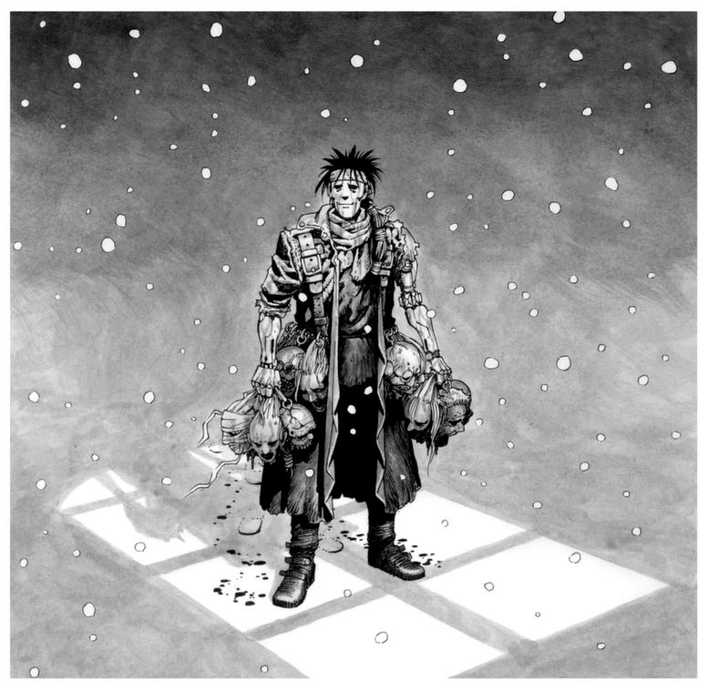
"That’s perfectly fine with me. I never imagined I could find any meaning in life during those days of hardship. But you gave me the precious duty of bringing a child into this world. That alone makes me incredibly happy now. ...Norinco, I’m truly glad to be alive."
Norinco, in turn, wrapped his arms around her back and embraced her. Then, raising his face, he offered her a rare smile and said, "Belchere, I will always take pride in the fact that I am having a child with you."
After that, Norinco slowly stepped away from the bed and grabbed the bounty heads neatly lined up on the table.
"For the sake of our child, who will likely be born tomorrow, I need to turn these bounty heads into chips. I have to hire the doctor and midwives first thing in the morning."
"By the time you return, make sure to wash your face, so you don’t scare the baby," Belchere said with a soft smile. It was only then that Norinco realized his body was still covered in dried blood, giving him a dark, mottled appearance. Shrugging lightly, he left the room.
After walking for about thirty minutes, Norinco arrived at the Factory. He handed over all the bounty heads to Deckman, the interface humans used inside the Factory, and exchanged them for chips.
"One hundred and ten thousand chips, huh... not bad," Norinco muttered to himself as he walked through the snow-covered alley, jingling the chips in his pocket. Even after paying off his debts, he would have forty thousand chips left.
Instead of heading straight home, Norinco decided to make a slight detour. "Might as well celebrate the birth of my child a little early," he thought as he stepped through the door of his usual bar on the main street. By adjusting the alcohol decomposition function, even a cyborg could enjoy a drink.
For about an hour, he quietly drank alone, contemplating names for his unborn child, wondering if it would be a boy or a girl.
Norinco wandered into an alley after leaving the bar, slightly unsteady on his feet from drinking. His apartment was relatively close, about a ten-minute walk, which allowed him to loosen up a bit and have more to drink than usual. As snowflakes fell gently onto his heated face, it felt refreshing, and he walked slowly, gazing up at the night sky.
After about five minutes of walking through the back alleys in a dreamy state, Norinco suddenly caught a whiff of something burning. "What's this smell...?" he muttered suspiciously, wrinkling his brow and sniffing the air. Something was definitely burning nearby.
"Outta the way!"
Just as Norinco was trying to figure out what might be burning, a child suddenly burst from the corner of the alley, running frantically. The child collided with Norinco and fell hard but got back up without so much as a glance in his direction before taking off at full speed again.
The child ran off toward the main street, disappearing from sight.
"What the... What the hell is going on?" Norinco mumbled, his drunken speech slurred, shaking his head in confusion. As he gathered his thoughts, he realized something familiar about the child who had just bumped into him.
"Wait a minute... that kid... Could it be?"
Dammit, you killed my father!
The image of the boy he had spared earlier that night flashed vividly in Norinco's mind. The appearance, the presence, the voice—all matched perfectly with the boy he had encountered just an hour ago. His mind suddenly cleared from the fog of alcohol, and Norinco clenched his teeth, glaring into the dark alley that reeked of burning.
The faint smell from before had now grown stronger, filled with a sharp, acrid stench that stung his nose.
"No... It can't be. No way!"
A terrible premonition welled up inside him, making him feel nauseous. Without hesitation, Norinco started running down the snowy alley, driven by an overwhelming sense of dread.
"My child... my child!" Norinco screamed as he sprinted through the alley, only to be greeted by a scene of utter devastation. His dilapidated apartment was engulfed in raging flames, spewing fire into the night sky.
"Nooooooo!" He let out a feral roar as he ran towards the burning building, ignoring the flames licking at the entrance.
"Hey, that's crazy!"
"It's already too late!" Some of the onlookers shouted at him as they watched the inferno, but by the time they spoke, Norinco had already charged into the fire, disappearing from view.
"I’ll save you, my child!" he cried, ignoring the searing heat that was already beginning to scorch his body. With swift movements, he darted up the crumbling staircase, reaching the third floor where his room was. The hallway on that floor was engulfed in the fiercest flames.
There was no doubt in his mind—the boy he had spared had set this fire, targeting him.
It was clear that a large amount of oil had been used to meticulously set the fire. The flames raged inside like the furnace of a crematorium, consuming the building.
With a wild, animalistic shriek, Norinco hurled himself into the inferno, plunging into the intense heat. He powered up his cyborg body to its maximum and smashed through the wall of the room.
"My child!!!" he screamed, but it was in vain. The room where Belchere had been was already ravaged by the same flames that consumed the hallway. Still burning from the fire clinging to his clothes, Norinco stepped into the room and was met with the horrific sight of his wife's charred corpse.
It was clear that she had tried to protect their unborn child until her final moments. She had collapsed on the floor, curled around her belly. While her back and head had been severely burned, the abdomen where their child lay was untouched, almost as if it were still alive.
"Belchere... I'm so sorry. My child, please forgive me," Norinco wailed. "I made enemies with the wrong people, and now... this."
"If only I hadn't stopped to drink... If I had just gone home, you both wouldn't have had to suffer such a horrible death..."
Norinco, engulfed in flames, consumed by grief, reached up to his own eyes and gouged them out. "This pain, this suffering... it's nothing compared to what you went through!"
Blood poured from the hollow sockets where his eyes had been as he cradled Belchere's charred corpse. Then, holding her tightly, he leapt from the burning building. Falling from a height of about ten meters, he landed with a heavy thud, his feet sinking into the snow-covered alleyway.
Norinco let out a primal scream into the snowy night sky, a cry filled with rage and sorrow. With everything lost to the flames—his unborn child and his beloved wife—he stumbled down the alley, disappearing like a shadow into the snowfall.

More than fifty years passed since that fateful day, as time moved on relentlessly in front of Norinco.
Norinco, his white hair disheveled, was shedding tears from his blind eyes, writhing in agony. "Forgive me. Please, forgive me," he repeated in his heart, clawing at his head as if to silence the flames of the campfire that illuminated him.
"Norinco... Norinco... Lift your head."
At that moment, amidst his groaning, a voice echoed in his mind.
"Norinco, don’t blame yourself too much..."
"Breda... It’s you, Breda, isn't it? Oh, my beloved Breda, my miraculous child... Are you here to comfort this sinful heap of flesh?"
Crying, Norinco crawled towards the doll of the young girl propped up on the chair and clung to her knees. The doll's face, illuminated by the flickering flames, seemed to change expressions as if it were alive.
"You are so kind. Whenever I feel lonely, you always take me to visit my friends..."
"Oh, oh... I'll always take you to visit your friends so you won’t ever be lonely..."
"Are you still not done playing with your friends, Breda?" Norinco asked, lifting his face from the doll's lap. In his blind eyes, it was as if Breda was smiling clearly at him.
"Alright, Breda, I understand. Let's go find some more friends together. And we'll make sure to have plenty of fun with them," Norinco nodded repeatedly, standing up as he stripped off all his clothing. Then, he carefully undressed the doll he called Breda, removing the mannequin head and placing it gently to the side. The old man opened the maintenance hatch of her body, and then his own.
With practiced hands, Norinco began bypassing and connecting their internal systems, gradually sharing functions between himself and the Breda doll. Finally, when he could no longer move his own body, he used the doll's arms to transfer his own head onto Breda's body.
Once the process was complete, Norinco's expression and demeanor had completely transformed into something that resembled an entirely different creature.
"Hush... Breda, I hope that nosy woman doesn’t show up like last time. Well, she's probably at the bottom of the sewer river by now, staring up at the surface."
Covered in white hair entangled around his body, Norinco, now inside Breda’s body, wheezed and strapped a long, deadly knife to his waist before leaving the ruins and heading into the night town. He was out once again to hunt fresh prey to offer Breda tonight.

CHAPTER 10
"You're not going again tonight? Have you already given up being a Hunter?" That afternoon, Ido once again invited Alita to join him in hunting down bounty heads, but, just like the last time, she hesitated and declined to go with him.
"Well, it's not that... it's just... I guess I'm starting to wonder why I always have to go with you, Ido," Alita replied, her full lips pouting slightly as she spoke.
To that, Ido teased her, "That's because your way of fighting isn't exactly top-notch. You keep fighting like you did against Colt every time."
He sighed and crossed his arms. "Look, if you keep this up, you're going to end up in a situation you can't come back from!"
Alita fell silent at those words, biting her lip even harder.
"Well then, what should I do if some sleazy guy attacks me, huh, Ido?"
Ido, unable to contain his frustration at Alita's words, slammed his fist hard against the wall and yelled at her. "You run away."
Alita, offended by that, glared at Ido and responded in a sharp tone. "I don't want to do that. That's just cowardly!"
"And that's exactly why I can't let you be a Hunter on your own! Have you ever thought about how I feel when you come back hurt? Until you fix that impulsiveness of yours, there's no way I can let you be a Hunter!"
Alita was stung by Ido's harsh words, but she retorted, matching his intensity. "Fine, whatever!"
But deep down, Alita knew she wanted Ido to acknowledge that she could be a great Hunter on her own.
"Yeah. I can handle things better than you think, Ido," Alita said firmly before dashing out of the house.
Left behind, Ido trembled, his repressed emotions toward her finally erupting. "Damn it, damn it! She's mine! Mine!" Ido, overcome with rage, starting tearing apart the room in a fit of anger.

After leaving the house, Alita stopped by Bergman's shop to pick up a combat body that had been customized for her. "The design's a bit old-fashioned, but the horsepower is double that of the Cyprian model. The outer shell is made of special self-locking armor, so no ordinary blade can get through. Renting this bad boy for a week costs 30,000 chips—pretty reasonable, eh? What do you think, missy?" Bergman grinned widely as Alita nervously lay down on the operating table, unsure of what was to come.
"Uh, Bergman... are you sure you can really switch my body properly?"
In response to Alita's words, Bergman frowned and pursed his lips before snorting and confidently replying, "You think I can't handle this? I may be a retired ball player, but swapping bodies is a piece of cake for me. Sure, I just picked it up by watching machine engineers, but I've done all the body swaps in this shop myself."
Although Bergman's words initially made Alita feel a little uneasy, he quickly and skillfully completed the body swap. "Wow... you're even faster than Ido," Alita murmured, genuinely impressed as she looked over her new body, which was unpainted and purely metallic in appearance.
"How's it feel? Any problems or discomfort?" Bergman asked. Alita threw a couple of kicks to test it out, and sure enough, the response was leagues beyond her previous civilian model. The neural and mechanical systems were on a completely different level. Previously, she'd sometimes felt a sense of heaviness or awkwardness in her movements, but with this new body, there was almost no weight to hold her back.
"Thanks, Bergman. I love it!" Alita said, her excitement evident.
Alita said this as she put on the jacket and pants that came with her new body and left the shop. "Hey, girl, if you break it, you'll have to buy it or pay for the repairs!" Bergman's loud, hearty laughter echoed after her as she stepped out into the street, now looking sharp and well-equipped.
Alita made her way toward the entertainment district after acquiring the combat body. For some reason, she felt an irresistible urge to see Calico. "Maybe it's because I was told not to meet her..." she said to herself. As always, she blended into the crowd, walking slowly and weaving her way through the gaps between people.
But why doesn’t Ido want me to meet Calico?
When Alita woke up from her two-day coma, the first thing she mentioned was Calico. But Ido reacted sensitively to her casual remark, warning her about it.
"...Calico and Zora were killed by the serial killer?" Alita was shocked by the words she had just heard.
"Yeah, it happened the day Zora brought you to see Calico," came the response. The next morning after the rain, they found Zora dead, her body minced into tiny pieces. As for Calico, she fought the killer by the riverbank along the sewer, but she too was torn apart and killed.
Alita left the Pink Cabaret and walked aimlessly down the street, deeply troubled. She couldn’t believe that Calico had been defeated. It was unimaginable to her that someone as skilled as Calico could lose in a one-on-one fight. To make matters worse, no trace of the culprit was found at the scene, indicating that the assailant had likely walked away without a scratch.
"I’ll never be able to fight Calico again..." Alita murmured as she walked with her head down. Just then, her ears picked up the sound of a man's threatening voice, a woman's shriek, and the faint pleading and cries of an old man, all coming from the edge of the crowded street.
"Please... please forgive me," pleaded the old man.
"Shut up, you filthy old geezer! This ain’t a place for stinking scum like you, got it?" snarled one of the thugs.
"Yeah, finish him off, finish him!" squealed one of the women egging them on.
"He's so annoying! Just kill the old man already!"
Alita, a bit intrigued by the commotion, glanced over. She saw a gang of lowlifes and a few obnoxious women surrounding a homeless old man, mercilessly beating him. It seemed the old man had begged for some change, which led the women to call for the thugs' help. Excited by the attention from the women, the thug, his face flushed with excitement, kept kicking the old man, who repeatedly begged for mercy while the thug laughed cruelly.
"Hey, that's enough. Cut it out," Alita said as she casually stepped into the middle of the beating. She helped the battered old man up. As she got a closer look, she realized it was someone she had met before—the blind old man, Norinco, who had tried to sell scraps to Bergman's shop only to be chased away.
"You're Norinco, right? Are you okay?" Alita asked, concerned, as Norinco's face trembled slightly with recognition. Although Alita found this reaction a bit odd, she checked to ensure that Norinco wasn’t seriously hurt.
"Hey, who the hell are you?! You think just 'cause you’re a bit cute that I’ll let you get away with this?!" The thug, frustrated by Alita interruption of the beating, sneered at her, pulling out a knife from his pocket. Without a word, Alita grabbed the thug's knife and effortlessly bent the blade with a sharp twist. The man let out a terrified yelp before running off, and the women who had been cheering him on scattered like frightened insects into the crowd.
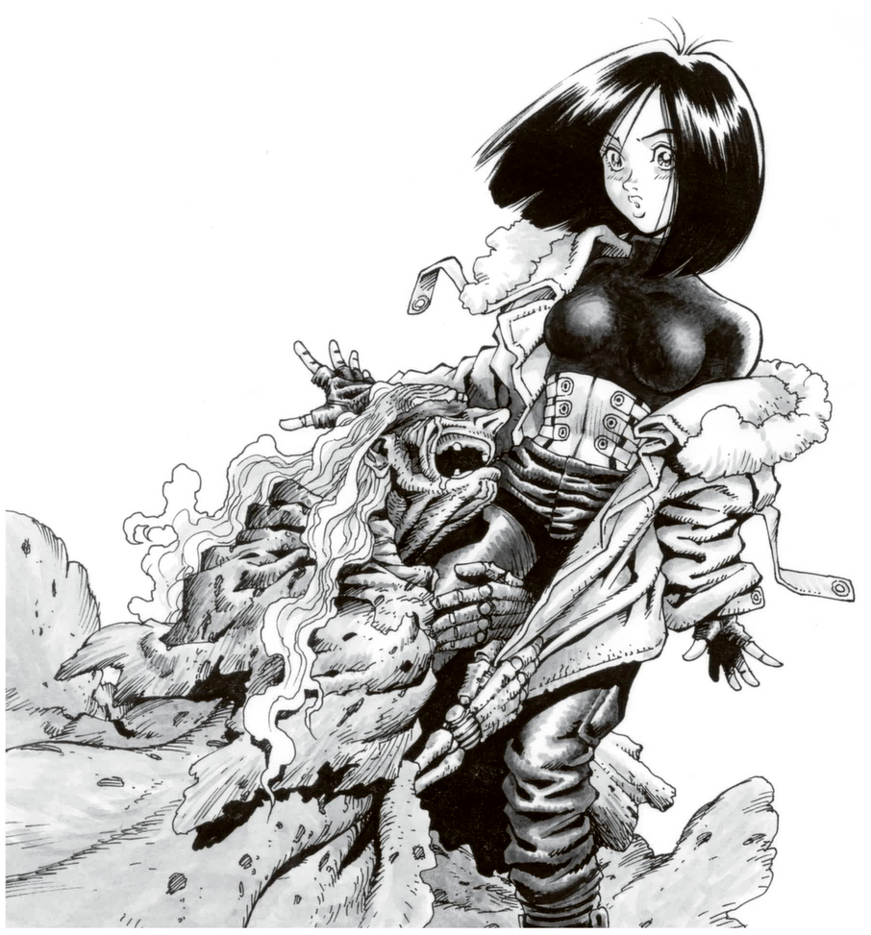
"Serves them right," Alita snorted, ready to leave when she suddenly felt the old man cling to her from behind.
"Oh, Breda! Even during the day, you're here to help me. What a kind child you are!" Norinco muttered.
"Wait, hold on! Norinco, I'm not Breda. I’m Alita!" she said, startled.
Alita shook off Norinco's grip, trying to explain, but the old man, with tears streaming from beneath the cloth covering his eyes, continued to call her "Breda, Breda."
"This is troublesome... Come on, enough already," Alita muttered, though normally she would have reacted more aggressively in a situation like this. However, a thought crossed her mind that made her hesitate. Norinco had once been a renowned Hunter. Perhaps, by pretending to be Breda, she could learn about the old man's legendary past as a Hunter. Her curiosity flickered, and Alita decided to tolerate the discomfort of being mistaken for someone else.
"Alright, I understand. Could you tell me your story, Norinco? Today, you can share it with... Breda," Alita said, sitting beside the Breda doll placed on the cart's seat.
"Sigh... I am a worthless person," Norinco said, addressing Alita as Breda. "I have no reason to keep living."
"Then why are you still alive?" Alita asked Norinco, who was pulling the cart. He gave a crooked smile.
"Oh oh oh... Of course, Breda. I live only to raise you," he replied. Norinco had neither the strength nor the meaning to live for himself anymore. He considered himself nothing more than a lump of flesh. Even so, the only reason he continued to live was for Breda's sake alone.
"I exist only as a body for Breda. It's strange that I even have a consciousness at all. Oh ho ho... After all, I died when I lost my sight," Norinco said, recounting his sorrowful past to Alita. He explained how he had lost his body in an accident and, even then, became a bounty hunter to provide for the expensive fertility treatments necessary to have a child. He eventually arranged for a woman named Belchere to undergo the procedure, and she became pregnant. But near the time of birth, due to his negligence, both the woman and the unborn child were burned alive. Consumed by guilt, Norinco had gouged out his own eyes.
Alita could understand the depth of his pain and regret up until that point, but what followed after became difficult for her to comprehend.
"Breda... Belchere protected you from the inferno when she died," Norinco said.
Alita asked, "So, did Belchere give birth to the child before she burned to death?"
"Oh no no no... If she had given birth in that fire, you would have burned to death too. It’s because she didn’t give birth that you were saved. If you had been partially born, even with one hand out of her womb and burned, I would have become an even more unforgivable lump of flesh than I am now," Norinco explained.
Alita furrowed her brows, deep in thought. She had never heard of a dead woman giving birth to a living child. "Is it really possible for a living baby to be born from a woman who has died in a fire?"
Norinco chuckled, his body shaking as he nodded repeatedly. "Oh ho ho... Under normal circumstances, no. But you were born. In the face of that fact, whether Belchere was alive or dead is such a small detail, isn’t it?"
Alita sighed, glancing at the mannequin-headed doll. Norinco continued to treat Breda as if she had been born from Belchere in those tragic circumstances.
Alita wondered aloud, "Did Breda really ever get born?"
Norinco gave her a strange look, then responded in a mocking tone, "What are you saying, Breda? Look, you're sitting right here, aren't you? It's strange, isn't it, doubting your own birth?"
Alita felt a headache coming on. Breda wasn’t born, she wasn’t alive, and yet Norinco insisted that his daughter Breda had been born. Alita found it increasingly hard to tolerate his insistence. "But, if your mother dies before giving birth, the baby usually dies too, right? So why would I be the exception? That doesn’t make sense."
When Alita said that, Norinco's face turned pale, and he stared at her with his blind, unseeing eyes. The cloth wrapped around his eyes was damp, stained with tears soaking through.
"Oh no no no... Breda, oh, how could this be? You’re trying to deny your own miraculous birth. You seem like a completely different person from your usual gentle and wise self. I swear, I saw it with my own eyes that snowy night. When dead Belchere was bathed in light, you descended from the heavens, smiling down on me," Norinco said.
Alita, frustrated, responded in a firm tone, "But your eyes couldn't see by then, right? That was just a hallucination. Breda died in Belchere's womb."
Alita was determined to make Norinco understand that the idea of Breda's birth was merely an illusion. She hoped that if the old man could grasp the truth, he might free himself from his fractured reality and self-punishing mindset, and perhaps even find a reason to live for himself.
"Even if I couldn’t see, I know what I saw! And if it’s not true, then the proof that you’re alive is also a fantasy... and my only reason for living too... Oh, Breda, you’re my only light, so why are you so stubborn about denying yourself?" Norinco lamented.
At that, Alita grew furious, grabbed the doll, jumped off the rickshaw, and shouted back at him.
"Listen carefully, Norinco. Breda was never born. This is just a doll," Alita said firmly. "You know that deep down, don't you?"
"A doll? Breda, a doll? Oh no no no, what are you saying, Breda?" Norinco asked, confused. Alita handed him the lifeless Breda doll and shook him gently.
"Look, it doesn’t move at all. It doesn’t even have a pulse. This is just a shell, a part of a cyborg—it’s only a doll. And the one talking to you right now is me, Alita. My name is Alita."
Norinco clutched the lifeless form of Breda in his arms, trembling as he tried to reject the painful truth. He began to sweat as he heard the voice of a girl—clearly not Breda—speaking to him from another direction.
"What’s wrong, Breda? Why aren’t you speaking to me today like you usually do? Why are you so limp?" he asked, desperate. "Breda was born... she was born..." Norinco muttered.
"You’ve been lying to yourself all this time because you couldn’t forgive yourself, but that’s not right," Alita said, her voice filled with frustration.
Norinco let out a long, anguished cry, unable to accept the truth.
Norinco, still clutching the Breda doll, suddenly bolted at an unnaturally fast speed, far beyond the limits of his frail, worn-out cyborg legs. "Ah, Norinco!" Alita cried out, stunned by his unexpected reaction, and froze in place for a moment.
"I want him to know the truth. He has to know the truth. Isn’t knowing the truth the path to happiness?" Alita genuinely believed this without doubt. She didn’t understand that for the elderly Norinco, knowing the truth meant despair. Yet, a strange, uncomfortable feeling weighed heavily in her chest.
Alita ran through the alleyways, trying to catch up to Norinco, but he was already out of sight. "Where did he go?" she muttered, searching the streets over and over. She didn’t know what to do if she found him, but all she wanted was to find the wounded old man.
Am I wrong? She didn’t know. Is it better to believe in something that doesn’t exist or to silently overlook someone's delusions?
At least, for herself, it was something she couldn’t accept. That’s why Alita wanted to tell Norinco the truth as well.
"...So, I ended up here, huh." After running through several alleyways, Alita found herself in a desolate wasteland, far from the structures of the city. She had reached the labyrinth of red ruins beyond The Scrapyard. Looking back towards where she came from, she could just make out the silhouette of the floating city of Zalem, tinted red by the setting sun. This was the very edge of the small world known as The Scrapyard.
As Alita walked through the maze of tangled, decaying remnants of the previous century, she thought about the old man, Norinco. Thinking back on it, it seemed that Norinco had subjected himself to abuse rather than merely being forced into it by being homeless. He lived only to love and raise the imaginary daughter, Breda. When that entire illusion was shattered, he fled in despair, screaming.
"Am I... am I wrong?" Alita wondered. The truth isn’t always something that brings happiness. If that’s the case, would her desire to know her true self, the part of her she had lost, only bring her unhappiness?

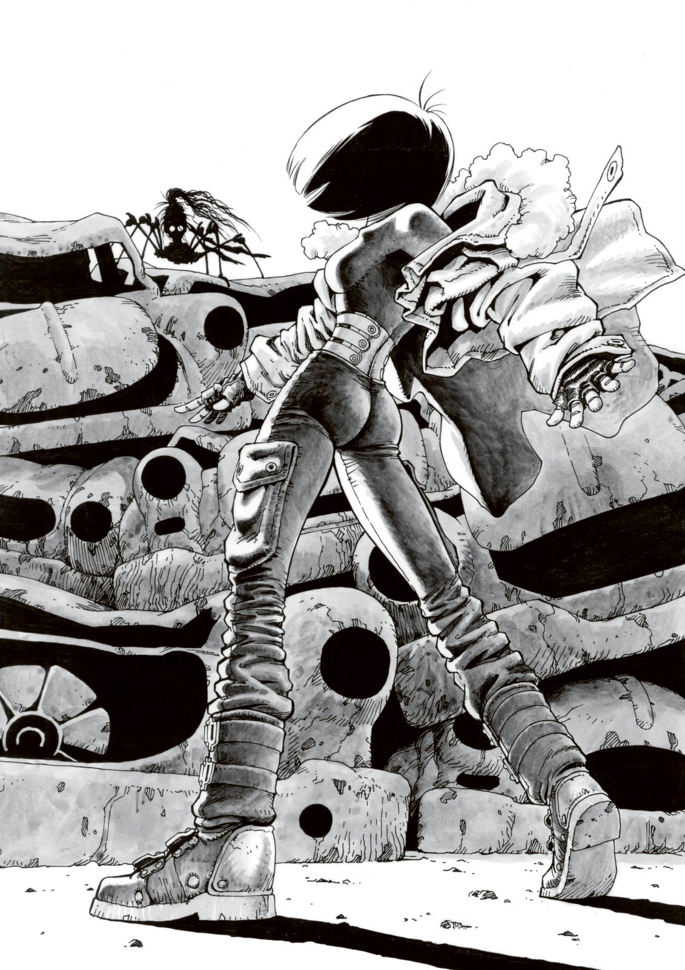
"…Alita, Norinco is hiding ahead, in the shadows of the old factory, you know."
It was at that moment. While Alita was walking through the maze of debris, lost in thought, she suddenly heard a voice from somewhere. It was a voice that she recognized.
"…Could it be… Calico? Calico, is that you? Where are you?"
As Alita looked around, searching, the woman appeared after a few moments.
“Alita, don’t sympathize with the enemy.”
“...Calico, your body…”
The figure that emerged from the shadow of the scrap pile was unmistakably Calico. However, her body no longer resembled her previous form at all. While her head was still that of the original Calico, from the neck down, her body had turned into a strange, inhuman cyborg resembling the shape of a spider.
"Heh heh heh… don’t worry about it, Alita. A cybernetic doctor picked me up when I was on the verge of death."
She pointed a limb towards the old factory. "There's no doubt about it, that one's the serial killer," Calico said, shaking her head slightly while addressing Alita from atop her spider-like body. "Alita, it’s unfortunate, but you’re the only one who can take him down. He’s terrifyingly strong, and unlike me, he has an uncanny ability to counter fighters who rely on complex combination attacks. He can read the combos, close in, and slowly dismantle their opponent’s limbs bit by bit. It’s like watching a mantis systematically tear the wings off its prey, piece by piece."
As Calico scuttled back into the rubble heaps, she left Alita with one final instruction. "If you focus on feints and deceptive moves, you'll have a chance. Please, avenge me and Zora. Take him down, Alita!"
"Calico... I understand," Alita said, pressing her lips together firmly as she dashed through the maze of rubble. Ahead of her, just as Calico had described, loomed the ruins of an old factory, bathed in the fading light.
"This is the place..." Alita muttered as she entered the ruins. The area was vast and open, with parts of the roof collapsed, and steel beams and pillars lay strewn about. The machinery had long since been removed, leaving the space eerily empty.
At her feet, she noticed the headless cyborg body of Norinco and the discarded clothing of the Breda doll. Alita tensed up, adopting a combat stance as she called out in a loud, clear voice that echoed through the dilapidated space.
"Norinco! Where are you hiding? I'll be your opponent—Alita!"
Her voice was soon met with a wheezing, rasping laugh. "Ha ha ha... well now, are you just a little kid, maybe? Ain't it a bit too early for you to be facing me, little one?" The voice was dripping with a sinister confidence . Far different from the elderly Norinco she had encountered during the day.
"Don't mock me!" Alita snapped back, her voice brimming with resolve. "I am a Hunter-Warrior!"
With that, she let out a sharp cry and kicked a nearby partially broken pillar. With just one blow, the pillar, a meter in diameter and reinforced with steel, shattered into pieces.
"Oh, scary, scary. A kid like you is worth dismantling," Norinco taunted as he suddenly pounced from above Alita's head. The old man had been observing her from the steel beams of the ruin's roof.
"Ugh!" Alita narrowly dodged his attack, quickly taking some distance before readying her stance again.
"Did you kill the prostitutes and Zora all for that daughter of yours, Breda, who doesn't even exist?" Alita shouted, her words making Norinco's white hair tremble with anger. The sheer weight of his rising fury made her hesitate for a split second.
"You... I see, you're that same girl who cornered me into despair earlier, aren't you? Alita, was it?" Norinco's body, now inside Breda's, ground his teeth as he glared at Alita with his radar eyes. With a shriek, he closed the distance in an instant, overwhelming Alita.
"Yes, you're right. Breda was never born. Breda was supposed to be the child my wife, Belchere, was going to give birth to," Norinco howled in response.
Norinco closed in on Alita with a strange, serpentine movement, his sharp hand strikes grazing her and steadily wearing away the outer layer of her combat body. He maintained a close distance, never allowing her an opening, like a coiled spring ready to strike.
"Breda wanted to be born. Even in this world where worthless flesh rots away, she would have wanted to come into existence and accomplish something. That's why I send her friends to the afterlife, so Breda won't feel lonely anymore," Norinco said with a mad intensity.
Alita desperately searched for an opening, all while parrying his relentless attacks. But Norinco’s left arm, which extended and contracted at will, combined with his rapid strikes from the right hand, made it nearly impossible for her to counter.
"Ugh, I can't allow you to take the lives of real people just for a phantom!" Alita gritted her teeth as she quickly spun around, attempting to sweep Norinco's legs. But the old man lightly leapt into the air, avoiding her move with ease. Still, she anticipated his reaction.
Alita used the momentum from her leg sweep to roll backward onto her hands, executing a spinning upward kick with outstretched legs as she inverted her body. Norinco, still airborne, couldn't evade her kick completely and tumbled to the ground. However, the damage wasn't critical, and the old man quickly regained his footing. Alita clicked her tongue in frustration at the failed strike.
"Sly little girl, using such a tricky move there. But that won’t work again on the Mantis Norinco," he sneered as he crouched into his peculiar stance once more and slithered toward her.
Alita tried to anticipate his movements, shifting her stance to counter his, but Norinco's approach was like being trapped in a web—no matter how she moved, he closed in. His coiling left arm wrapped around her limbs, constricting her movements. The old man then struck with his right hand, delivering precise blows to her arms and legs.
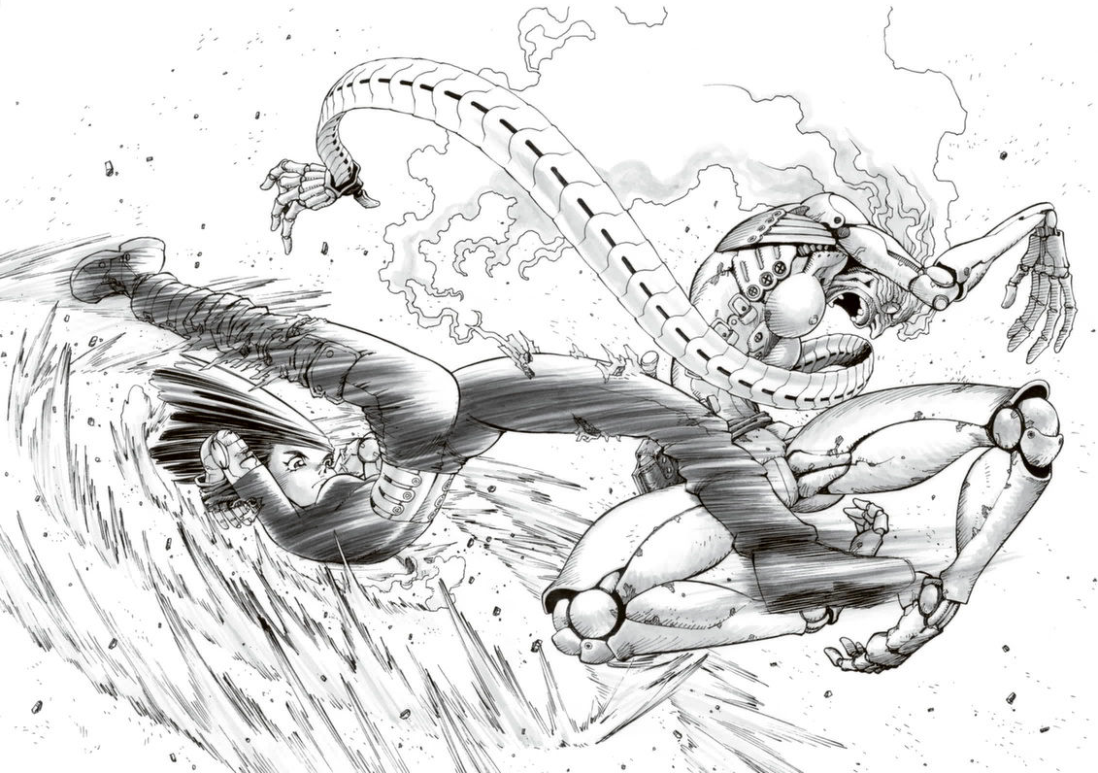
Each attack wasn't particularly strong by itself, but gradually, he peeled away the outer layers of her cybernetic body, exposing the actuators and mechanical components beneath. A chilling sense of dread began to creep over her as she realized the systematic dismantling of her defenses.
"He he he... How does it feel, Alita? Slowly being dismantled from the edges... Cyborgs tend to neglect defending their limbs because they don't feel pain there. My fighting style exploits that by systematically destroying the extremities and rendering them useless," Norinco cackled.
Alita, desperate to fend him off, racked her brain to find a weakness in the old man's brutal tactics. So far, Norinco had only been vulnerable to reckless, sacrificial attacks. Alita recalled the advice from Calico: "If you focus on feints and deceptive moves, you'll have a chance."
Suddenly, clarity struck her. "That's it... That's how I can win," Alita realized.
Though her limbs had been nearly stripped bare by Norinco’s relentless hand strikes, a glimmer of determination returned to her dark eyes. "This is it!" she yelled. Dodging Norinco's next strike, Alita sprinted toward one of the pillars supporting the dilapidated structure. With a powerful hand chop, she shattered the column.
The roof and framework of the ruin, already precariously balanced, began to collapse with a deafening rumble, brought down by Alita's decisive blow.
"Huh...? ughhh!"
After the violent collapse, as the dust settled and the scene revealed itself, the entire area had turned into a mountain of rubble, with not a single pillar left standing.
After a brief pause, something shifted beneath the debris, and Alita slowly stood up, though she had lost her left arm below the elbow, the steel limb having been severed during the fight. "Did I get him...?" Alita muttered, glancing around as she exhaled deeply.
But in the next moment, with a sudden thud, the rubble shifted, and Norinco emerged, seemingly unscathed despite the massive collapse.
"Uuuunh... That gutsy resolve of yours is something else for such a young girl. But it looks like luck is on my side," Norinco sneered.
Alita, sweating from her brow, kept her eyes locked on him, tense. But after a moment, her stern expression softened, and a slight smile crossed her face.
"Hmmm... what's that supposed to mean?" Norinco growled.
"It means I've figured out your weakness," Alita said with a bold smile.
Norinco hesitated for a moment, but quickly grasped the meaning behind her words, his expression hardening.
"Norinco, your fighting style relies heavily on your footwork. It's a style that corners opponents like pieces on a chessboard, assuming every possible move they might make. But to execute that, you need a wide, stable ground to move on, don't you?" Alita stuck her tongue out teasingly as Norinco gritted his teeth.
"My style, on the other hand, relies on throwing myself into attacks. It makes me less dependent on the conditions of the terrain. Probably works as well for a lower gravity, or no gravity! If it comes down to an aerial fight, you stand no chance against me."
"Shut up!" Norinco roared, leaping from the rubble as his left arm stretched out like a whip.
Alita launched herself into the air to meet his attack head-on. As Norinco's sharp hand blade shot toward her, Alita twisted her body mid-air, using a figure-skater-like motion with her arms and lower body to add momentum.
Norinco's hand blade sliced through the air, heading straight for Alita...
At the moment Alita's leg brushed against Norinco’s body, a sharp, clear sound rang out into the red sky. In that brief aerial clash, the two passed each other simultaneously and landed. Alita crouched down, while Norinco stood frozen in place. As Alita wobbled in her stance, her damaged left arm detached from the shoulder and fell to the ground with a thud.
"Uuuugh... huuuugh... you... little... brat," Norinco muttered, before collapsing forward. A closer look revealed that his temple was crushed, with brain matter leaking from his ear. In mid-air, Alita had managed to dodge Norinco's hand blade using her advanced aerial control techniques. By hooking her leg onto his body, she spun around him, positioning herself behind him to strike his temple with her elbow.
The name of that move would later become known as "Angel's Wing Hook", a technique that deeply etched itself into Alita's heart.
Alita approached the fallen Norinco, who lay face down, and gently lifted his body.
"Bre... Breda..." Norinco muttered weakly.
Norinco whispered in a barely audible voice, his trembling hand reaching out to touch Alita’s cheek as she held him. After a brief hesitation, she gently nuzzled her face against his in response.
“Thank you, Father... I’m glad I was born,” Alita said softly. At her words, Norinco gave a faint spasm before he stopped moving entirely. In silence, Alita stood up, leaving the rubble behind as the setting sun cast long shadows. By the time dusk had fully settled, a light rain began to fall as she stood on the street, staring at the soft glow from a familiar window—her home.
The lights on the first floor, where Ido’s clinic was, had long gone out, signaling the end of the day’s consultations. Only the second floor, Ido’s room, remained illuminated. Dragging her battered body, Alita made her way to the streetlamp where she could still see the house. There, she collapsed, sitting beneath the light, knees pulled close to her chest.
“Alita... is that you?”
Hearing the familiar voice, Alita, who had been resting her face against her knees in the misty rain, lifted her head with a start, her heart stirred.
Ido stood there with a worried expression, almost like a dream. As Alita trembled and her lips quivered at the sight of him, her eyes filled with tears, and she clung to him.
Without saying a word, Ido picked up the sobbing Alita and carried her into a warm room, her body soaked.

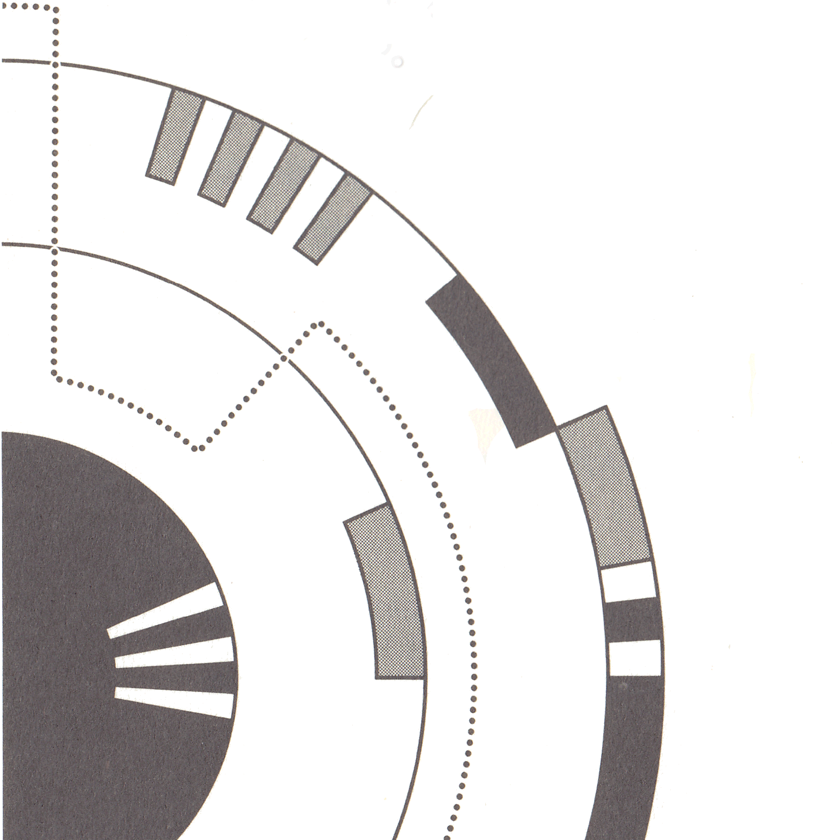
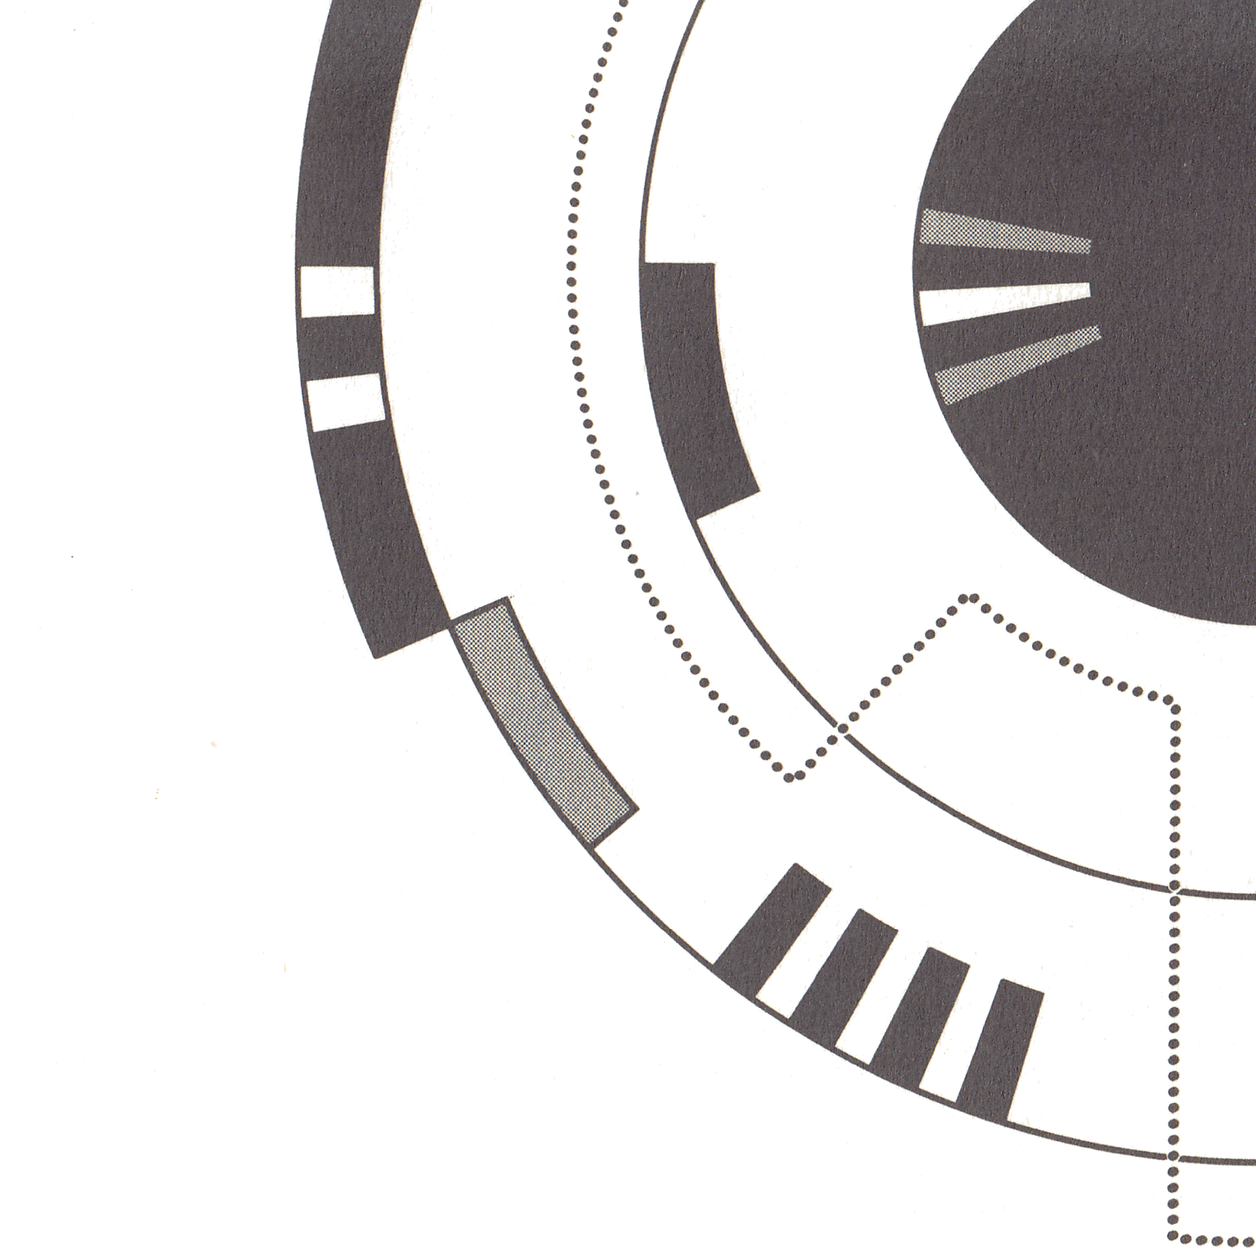

POSTSCRIPT
I am deeply grateful to Mr. Kishiro (though calling him "Mr." feels a bit awkward) and Deputy Editor-in-Chief Hasaka. This novel is a story themed around "reality and unreality" and how the characters grapple with each. The violent Colt, who defines truth as the satisfaction of desires. Norinco, who bears the burden of an unfulfilling past and escapes reality by embracing fiction as truth, alongside a doll in his dual personality. Ido, a good doctor with a hunter's taste for murder, seeking an ideal detached from reality. Each of these characters is confronted with their own reality and unique truths, and nothing is certain. How does Alita face these challenges and reflect on them? I wanted to depict her earnest struggle in this work.
Additionally, the existence of Calico, a disciple of Clive Lee, the rental body shop, and the martial arts scenes featured in the story were added to bring in the fun of "Kawamura Original." I wonder if I succeeded. When I was an assistant, I was told by my teacher, "Go your own way," and was let go. The following year, in his New Year's card, the teacher wrote to me, "Strike out boldly."
I received these encouraging words. Still, when I was asked to write this novel after not having published a single piece of work for so long, it was easy to imagine myself being clumsy and struggling with my own inadequacies. I initially wondered if I should decline the offer out of fear of facing that reality. However, when I considered why the teacher would give me, a "frog in a well," the opportunity to see the vastness of the sky, I realized I couldn't refuse. The teacher not only acknowledged the potential in me, a "frog who doesn’t take risks," but was also concerned that I wasn’t confronting my own abilities. Thinking about this, I knew that, as a "frog," I needed to rise to the occasion and take on this challenge to repay my teacher and for my own sake.
Yukito-san, thank you for always sparring with me using the bamboo sword.
That’s the backstory behind this novel, and now all I can do is hope that as many people as possible will feel, "That was good." I am honored if you have read it.
February, 1997
Yasuhisa Kawamura

POST POSTSCRIPT
It intrigued me, from the moment I discovered it, that there was a version of the Alita story, just out of my reach beyond a language barrier. As an author, I have often though of how I would novelize this manga I love so dearly, and it was exciting to know it had already been done.
I first started making attempts to do so five years ago. The technology was crude, but I felt I was familiar enough with the story and characters that if I could capture the gist of the novel through technology, I could smooth out the resulting roughness with prose. However the beautiful vertical text of the original was challenging for OCR technology, and machine translation was very susceptible to those errors.
But a recent, much improved, wave of tools has come out which is significantly better than before. That, along with some excellent quality scans by DarkStarBeacon was enough for me to finally make good progress.
The translation presented to you here heavily relies on machine assistance, which only allows a glimmer of the original to peak through. My skill is not high enough to match the soul of the original; only to give a dim reflection of the story told. If you enjoy this at all, please do seek out the original. Even if you do not read Japanese, it is a work of beauty that I enjoy paging through for the joy of its presentation.
October, 2024
Jo Jaquinta


