Query 1:

SELECT * FROM PLANET;

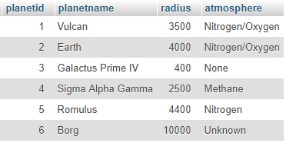

Query 2:

SELECT STARSHIPNAME, CREWSIZE, SHIPCLASS FROM STARSHIP;

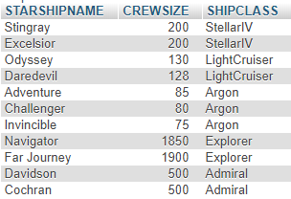
Query 3:

SELECT STARSHIPNAME FROM STARSHIP WHERE STARSHIPID = 501;



Query 4:

SELECT * FROM STARSHIP
WHERE LAUNCHSTARDATE > 21500
ORDER BY SHIPCLASS, STARSHIPNAME;

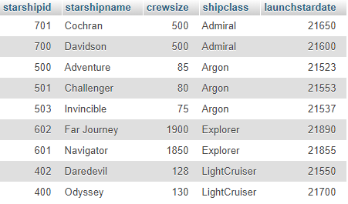

Query 5:

SELECT * FROM STARSHIP
WHERE SHIPCLASS != 'Argon' ORDER BY LAUNCHSTARDATE;

