1. Create a file SampleFile.txt in the local file system with the below contents

Welcome to Hadoop

Learning Hadoop is fun

Hadoop Hadoop Hadoop is the buzz

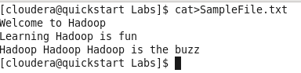

1. Create a dir on HDFS by executing the below command

hadoop fs -mkdir /user/cloudera/MR_demo1

1. Copy the SampleFile.txt to the above path on hdfs

hadoop fs -put SampleFile.txt /user/cloudera/MR_demo1



1. Place the jar file which contains the map and the reduce programs in the current directory in the local file system

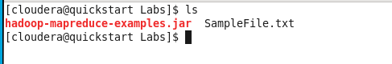

1. For the SampleFile.txt on HDFS execute the jar file

yarn jar hadoop-mapreduce-examples.jar wordcount /user/cloudera/MR_demo1/SampleFile.txt /user/cloudera/MR_demo1/output

here

hadoop-mapreduce-examples.jar contains all the java class files containing the map and the reduce programs

word count the name of the class which we are currently executing

/user/cloudera/MR_demo1/SampleFile.txt – path of the input file on HDFS

/user/cloudera/MR_demo1/output – path of the output directory – this must be a non-existent directory on HDFS. If this directory exists it results in an error

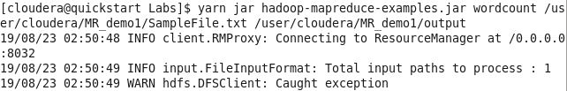

Below are the status messages upon successful execution of the map reduce program

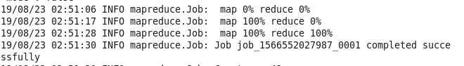

Upon execution of the above command, the result of the map reduce gets saved in the destination path specified

The output directory contains 2 file

1. _SUCCESS – an empty file which serves as a flag indicating that the map reduce program executed successfully
2. part* file – which contains the output of the Mapreduce program



Let’s view the output by the displaying the contents of the part***** file

