Screenshot

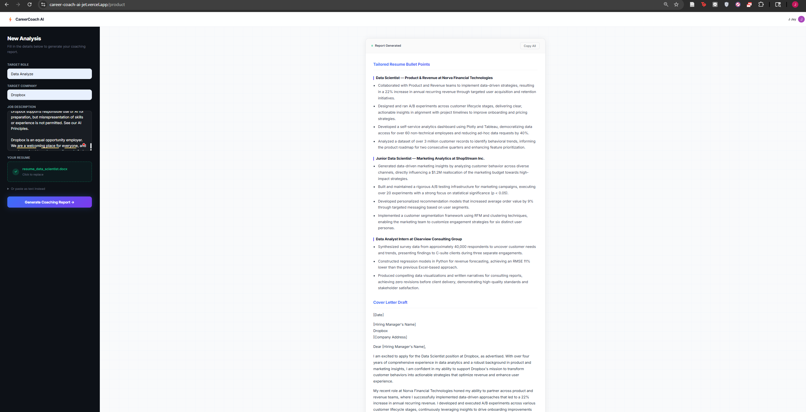
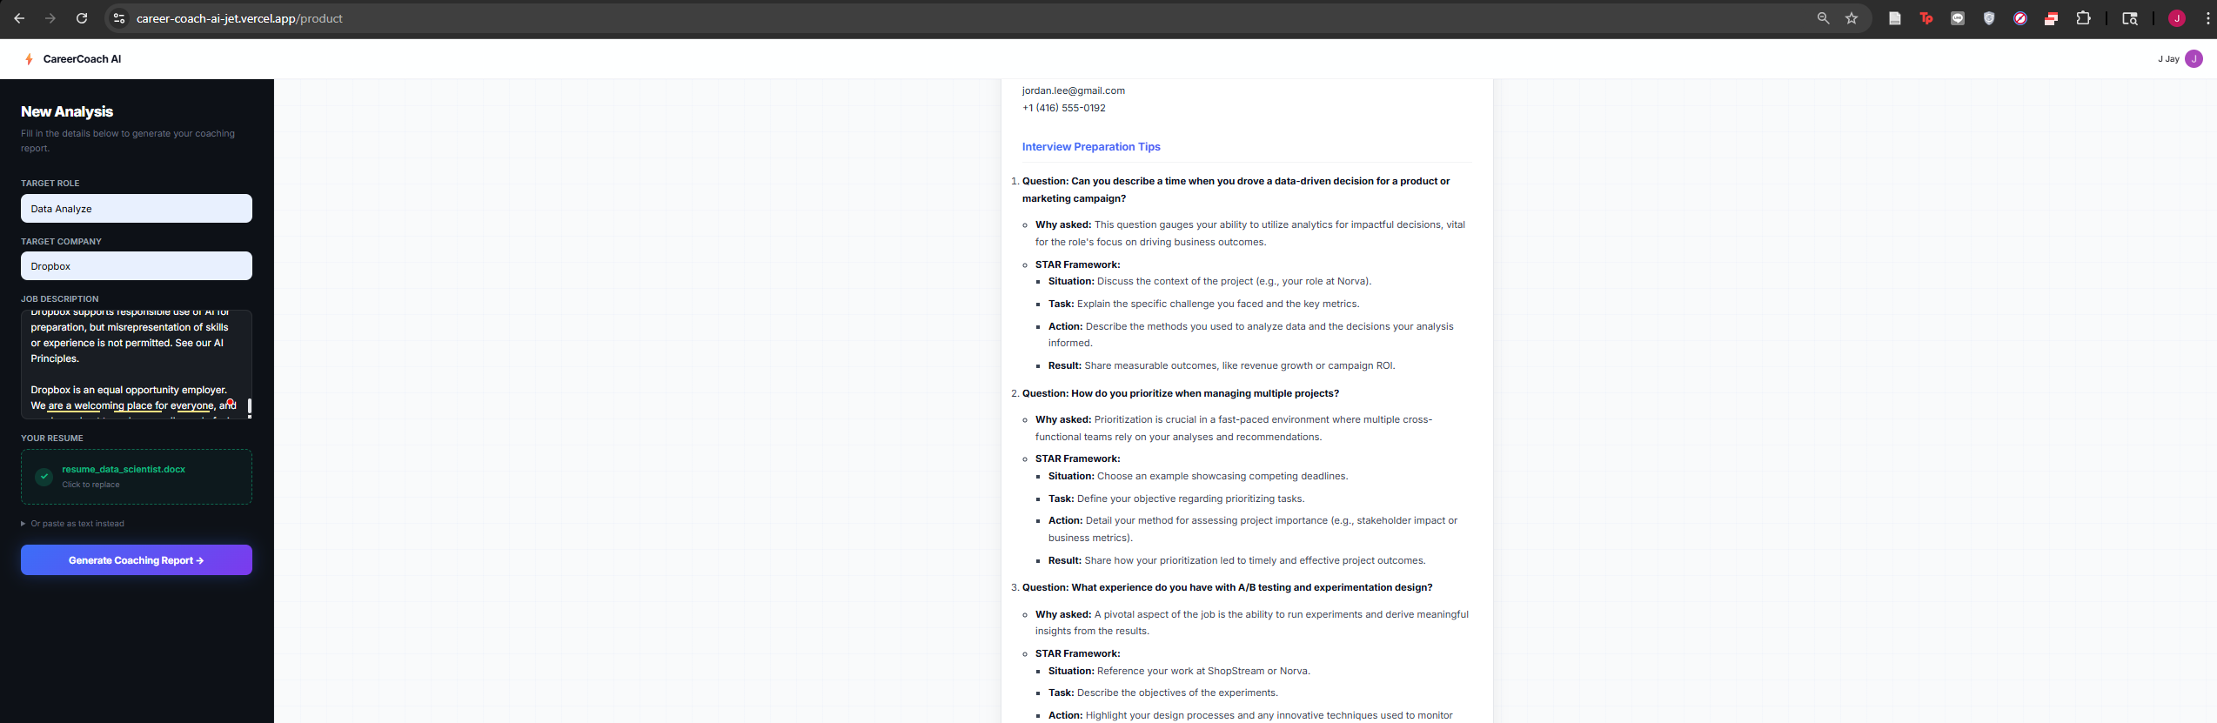
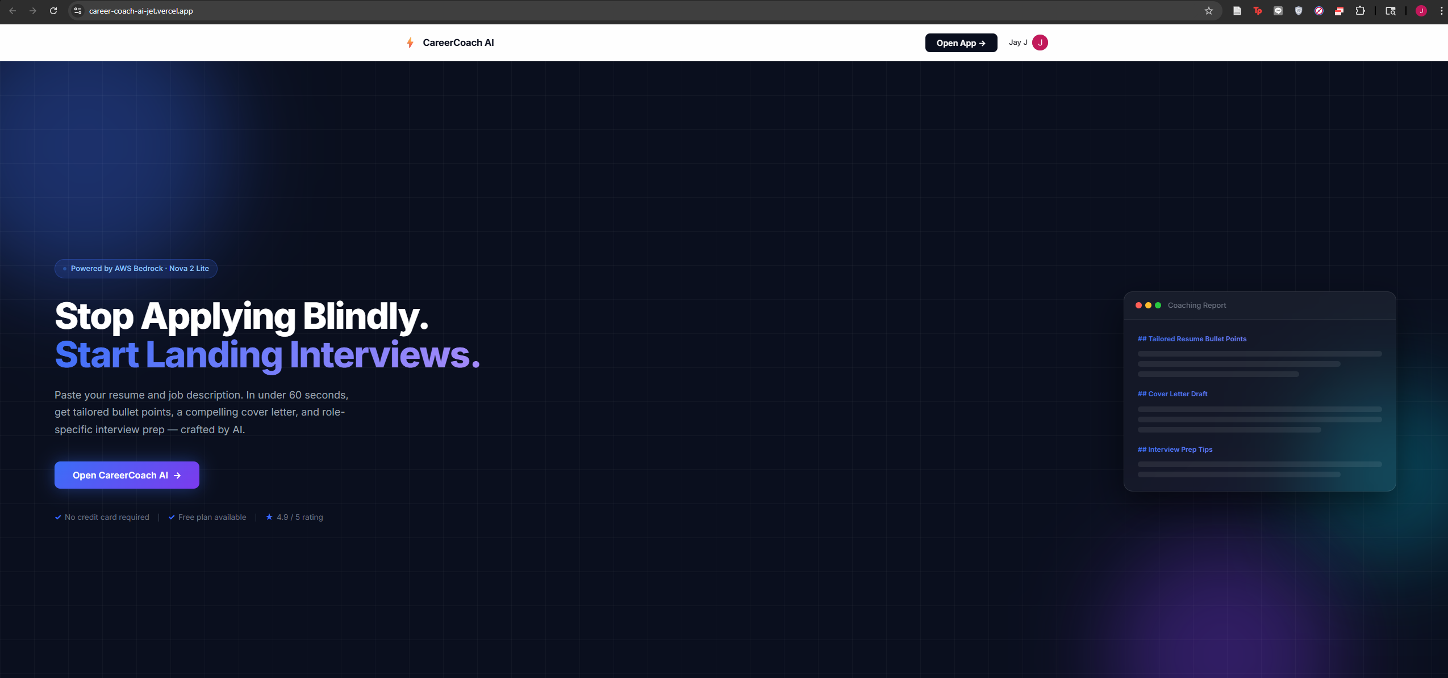
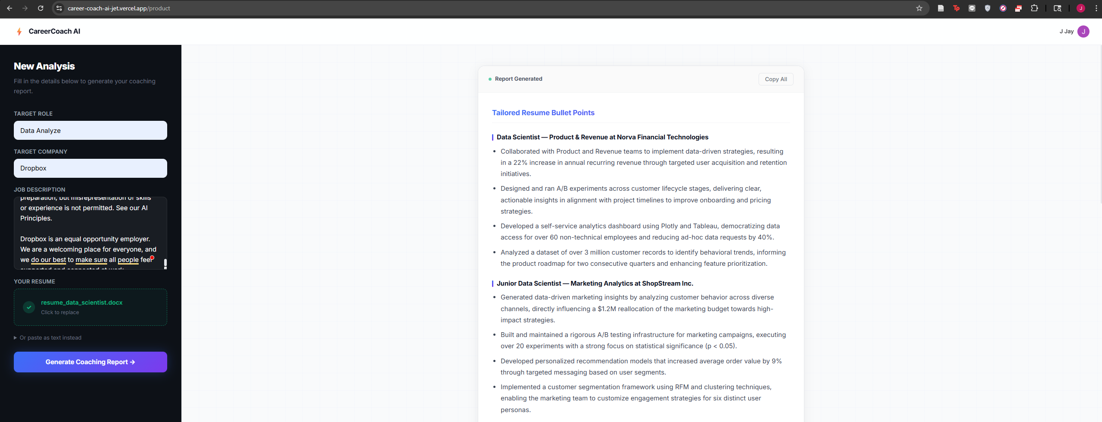
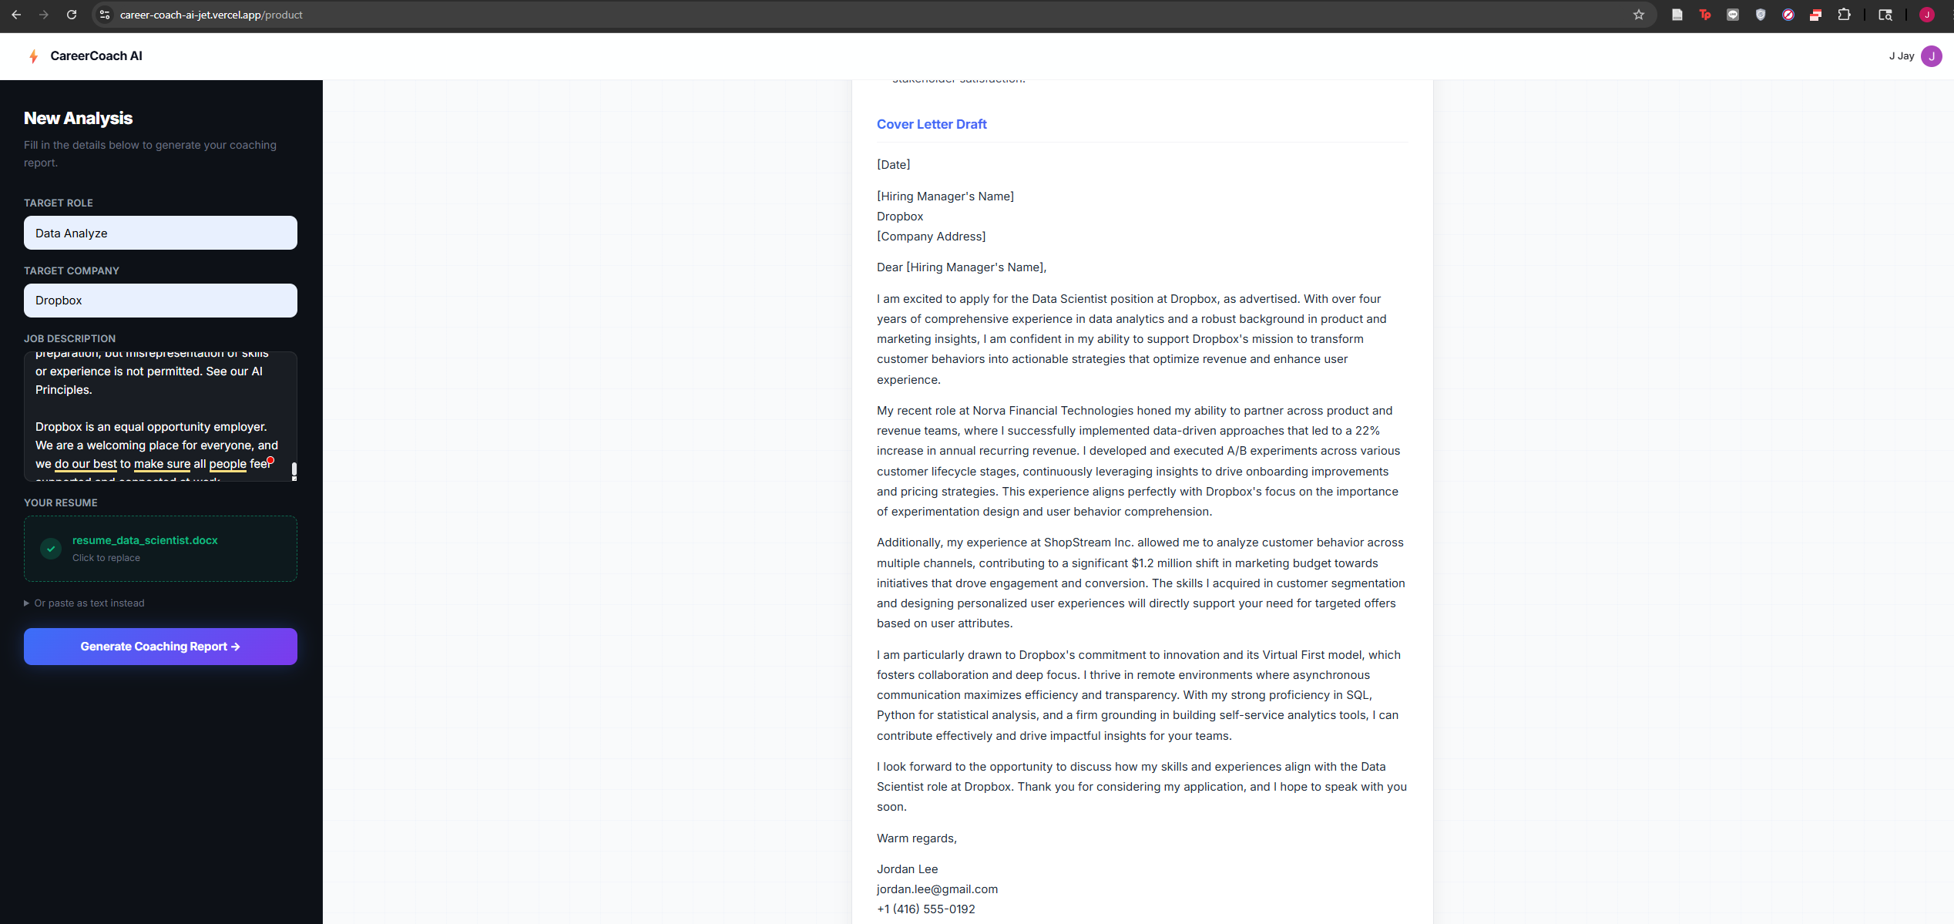
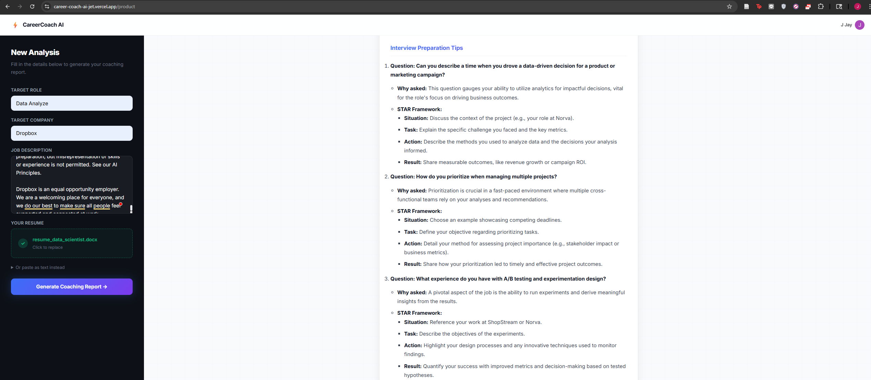

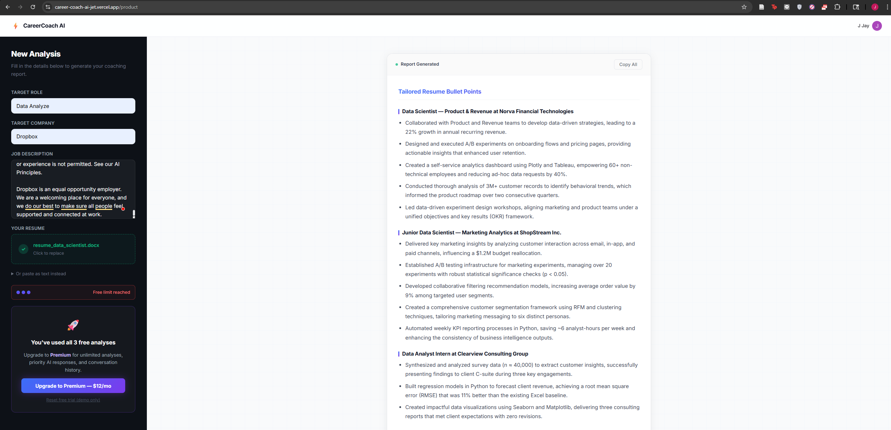

Step-by-Step: Deploy CareerCoach AI

🔷 PHASE 1 — Accounts & Keys Setup (Do this first)
Step 1 — Get your API Keys
OpenAI:
- Go to platform.openai.com → API Keys → Create new key
- Copy it — save as OPENAI_API_KEY
Clerk:
- Go to clerk.com → Create new application → name it CareerCoachAI
- Enable Google sign-in (recommended)
- Go to Configure → API Keys → copy:
  - NEXT_PUBLIC_CLERK_PUBLISHABLE_KEY (starts with pk_test_...)
  - CLERK_SECRET_KEY (starts with sk_test_...)
  - JWKS URL (looks like https://xxxx.clerk.accounts.dev/.well-known/jwks.json)
- Go to Configure → Subscriptions → Create plan:
  - Name: Premium
  - Key: premium_subscription
  - Set a price (e.g., $12/month)

🔷 PHASE 2 — Vercel Deployment (Part 1)
Step 2 — Install tools
npm install -g vercel
Step 3 — Install project dependencies
cd "C:\Users\Admin\Desktop\2ndSem\AI Deployment and MLOps\Applied Activity\final-project"
npm install
Step 4 — Create .env.local for local testing
Create a file called .env.local in the project root:
NEXT_PUBLIC_CLERK_PUBLISHABLE_KEY=pk_test_YOUR_KEY_HERE
CLERK_SECRET_KEY=sk_test_YOUR_KEY_HERE
CLERK_JWKS_URL=https://YOUR-APP.clerk.accounts.dev/.well-known/jwks.json
OPENAI_API_KEY=sk-YOUR_OPENAI_KEY
NEXT_PUBLIC_API_URL=
Step 5 — Update terraform.tfvars with your Clerk JWKS URL
Open infra/terraform.tfvars and replace the clerk_jwks_url line with your actual JWKS URL.
Step 6 — Deploy to Vercel
vercel link
# Follow prompts: create new project, name it career-coach-ai

vercel env add OPENAI_API_KEY
# Paste your OpenAI key → select All Environments → Enter

vercel env add NEXT_PUBLIC_CLERK_PUBLISHABLE_KEY
# Paste your Clerk publishable key → All Environments → Enter

vercel env add CLERK_SECRET_KEY
# Paste your Clerk secret key → All Environments → Enter

vercel env add CLERK_JWKS_URL
# Paste your JWKS URL → All Environments → Enter

vercel --prod
Step 7 — Record your Vercel URL
After deploy completes you'll see something like:
✅ Production: https://career-coach-ai-xxxx.vercel.app
Copy this URL → paste it into FinalProject_AIE1018_StudentName.md where it says Vercel URL: https://___
Step 8 — Test Vercel deployment
- Visit your Vercel URL
- Sign in with Google
- Go to /product — you should see the Pricing Table (you haven't subscribed yet)
- Subscribe to Premium using a test card: 4242 4242 4242 4242, any future date, any CVC
- Submit a test form — you should see streaming AI output
- Take a screenshot of the product page with AI output showing → save it

🔷 PHASE 3 — AWS Setup (Part 2)
Step 9 — Install AWS CLI
Download from aws.amazon.com/cli → install → then:
aws configure
# Enter: Access Key ID, Secret Access Key, Region: us-east-1, Output: json
Step 10 — Package the Lambda ZIP (Windows PowerShell)
cd "C:\Users\Admin\Desktop\2ndSem\AI Deployment and MLOps\Applied Activity\final-project"
.\infra\package.ps1
You should see infra\lambda.zip created (~40-100 MB).
Step 11 — Create the Lambda function in AWS Console
- Go to AWS Console → Lambda → Create function
- Settings:
  - Name: career-coach-ai-api
  - Runtime: Python 3.12
  - Architecture: x86_64
- Click Create function
- Code source → Upload from → .zip file → upload infra/lambda.zip
- Runtime settings → Edit → Handler: lambda_handler.handler → Save
- Configuration → General configuration → Edit → Timeout: 30 sec → Save
- Configuration → Environment variables → Edit → Add:
Key | Value
CLERK_JWKS_URL | your Clerk JWKS URL
CORS_ORIGINS | *
BEDROCK_REGION | us-east-1
BEDROCK_MODEL_ID | global.amazon.nova-2-lite-v1:0
USE_DYNAMODB | false
- Configuration → Permissions → click the role name → Attach policies → attach AmazonBedrockFullAccess
Step 12 — Test Lambda
In Lambda console → Test tab:
- Template: API Gateway AWS Proxy
- Change "rawPath": "/health" and "method": "GET"
- Click Test → Expected: {"status": "healthy", "version": "1.0"}
Step 13 — Create API Gateway
- API Gateway → Create API → HTTP API → Build
- Add integration → Lambda → select career-coach-ai-api
- Routes: add POST /api, GET /health, ANY /{proxy+}
- CORS: Allow-Origin *, Allow-Headers *, Allow-Methods *, Max-Age 300
- Click through → Create
- Copy the Invoke URL (looks like https://abc123.execute-api.us-east-1.amazonaws.com)
Step 14 — Create S3 Bucket for frontend
- S3 → Create bucket
  - Name: career-coach-ai-frontend-YOURACCOUNTID (12-digit account ID)
  - Region: us-east-1
- Permissions tab → Block public access → uncheck all 4 → Save
- Bucket policy → paste:
{
"Version": "2012-10-17",
"Statement": [{
"Sid": "PublicRead",
"Effect": "Allow",
"Principal": "*",
"Action": "s3:GetObject",
"Resource": "arn:aws:s3:::YOUR-BUCKET-NAME/*"
}]
}
- Properties → Static website hosting → Enable → Index: index.html, Error: index.html
Step 15 — Build and upload frontend to S3
Open pages/product.tsx and find the line:
const API_BASE = process.env.NEXT_PUBLIC_API_URL || "";
Make sure your API URL will be injected. Then build:
$env:NEXT_PUBLIC_API_URL="https://YOUR-API-GATEWAY-URL"
$env:NEXT_PUBLIC_CLERK_PUBLISHABLE_KEY="pk_test_YOUR_KEY"
npm run build
aws s3 sync out/ s3://YOUR-BUCKET-NAME/ --delete
Step 16 — Create CloudFront distribution
- CloudFront → Create distribution
- Origin domain: paste S3 website endpoint (from S3 → Properties → Static website hosting, e.g., career-coach-ai-frontend-123.s3-website-us-east-1.amazonaws.com) — without http://
- Origin protocol policy: HTTP only ← critical!
- Viewer protocol policy: Redirect HTTP to HTTPS
- Default root object: index.html
- Price class: Use only North America and Europe
- Click Create distribution → wait ~5-10 minutes for deployment
- Copy the Distribution domain name (e.g., d1abc2def.cloudfront.net)
- Add Custom error responses:
  - 403 → /index.html → 200
  - 404 → /index.html → 200
Step 17 — Update Lambda CORS with CloudFront URL
Go to Lambda → Configuration → Environment variables → Edit:
- Change CORS_ORIGINS from * to https://d1abc2def.cloudfront.net
Step 18 — Test and record URLs
curl https://YOUR-API-GATEWAY-URL/health
# Expected: {"status":"healthy","version":"1.0"}
Visit https://YOUR-CLOUDFRONT-URL — app should load.
Record in your submission doc:
API Gateway URL: https://abc123.execute-api.us-east-1.amazonaws.com
CloudFront URL: https://d1abc2def.cloudfront.net

🔷 PHASE 4 — Terraform (Part 3)
Step 19 — Install Terraform
Download from terraform.io/downloads → add to PATH
Step 20 — Run Terraform
cd "C:\Users\Admin\Desktop\2ndSem\AI Deployment and MLOps\Applied Activity\final-project\infra"

terraform init
terraform workspace new dev
terraform validate # should say: Success!
terraform plan # review — should show ~18 resources
terraform apply # type "yes" → wait 10-15 min
Step 21 — Record all 6 outputs
terraform output
Copy all 6 values into your submission doc.
Step 22 — Update Secrets Manager with CloudFront URL
$SECRET = terraform output -raw secret_name
$CF = terraform output -raw cloudfront_domain
aws secretsmanager update-secret `
--secret-id "$SECRET" `
--secret-string "{""CORS_ORIGINS"": ""https://$CF""}" `
--region us-east-1
Step 23 — Rebuild and sync frontend with Terraform API URL
$API_URL = terraform output -raw api_gateway_url
cd .. # back to project root
$env:NEXT_PUBLIC_API_URL=$API_URL
$env:NEXT_PUBLIC_CLERK_PUBLISHABLE_KEY="pk_test_YOUR_KEY"
npm run build
aws s3 sync out/ s3://$(cd infra; terraform output -raw frontend_bucket)/ --delete
Step 24 — Invalidate CloudFront cache
aws cloudfront create-invalidation --distribution-id YOUR_DIST_ID --paths "/*"

🔷 PHASE 5 — GitHub & CI/CD (Part 4)
Step 25 — Create GitHub repository
- Go to github.com → New repository
- Name: career-coach-ai
- Visibility: Public
- Don't initialise with README
Step 26 — Push code to GitHub
cd "C:\Users\Admin\Desktop\2ndSem\AI Deployment and MLOps\Applied Activity\final-project"
git init -b main
git add .
git commit -m "Initial commit: full-stack AI SaaS with Terraform"
git remote add origin https://github.com/YOUR_USERNAME/career-coach-ai.git
git push -u origin main
⚠️ Verify on GitHub that no .env, lambda.zip, or .tfstate files were committed.
Step 27 — Create OIDC IAM Role in AWS
- IAM → Identity providers → check if token.actions.githubusercontent.com exists
  - If not: Add provider → OpenID Connect → URL: https://token.actions.githubusercontent.com → Audience: sts.amazonaws.com
- IAM → Roles → Create role
  - Trusted entity: Web identity
  - Provider: token.actions.githubusercontent.com
  - Audience: sts.amazonaws.com
  - GitHub org: YOUR_GITHUB_USERNAME
  - Repository: career-coach-ai
- Attach these policies:
  - AWSLambda_FullAccess
  - AmazonS3FullAccess
  - AmazonAPIGatewayAdministrator
  - CloudFrontFullAccess
  - AmazonBedrockFullAccess
  - AmazonDynamoDBFullAccess
  - IAMReadOnlyAccess
- Also add an inline policy for IAM management:
{
"Version": "2012-10-17",
"Statement": [{
"Effect": "Allow",
"Action": [
"iam:CreateRole", "iam:DeleteRole", "iam:AttachRolePolicy",
"iam:DetachRolePolicy", "iam:PutRolePolicy", "iam:DeleteRolePolicy",
"iam:PassRole", "iam:GetRole", "iam:ListRolePolicies",
"iam:ListAttachedRolePolicies", "iam:GetRolePolicy",
"iam:TagRole", "iam:UntagRole"
],
"Resource": "*"
}]
}
- Name the role: github-actions-career-coach-ai
- Copy the Role ARN
Step 28 — Add GitHub Secrets
Go to your GitHub repo → Settings → Secrets and variables → Actions → New repository secret:
Secret Name | Value
AWS_ROLE_ARN | arn:aws:iam::YOUR_ACCOUNT_ID:role/github-actions-career-coach-ai
DEFAULT_AWS_REGION | us-east-1
AWS_ACCOUNT_ID | your 12-digit AWS account ID
NEXT_PUBLIC_CLERK_PUBLISHABLE_KEY | your Clerk publishable key
Step 29 — Trigger the CI/CD pipeline
Make a small visible change:
# Edit pages/index.tsx — change the headline slightly
# Then:
git add .
git commit -m "Update headline — triggering automated CI/CD deployment"
git push
- Go to GitHub → Actions tab
- Watch the workflow run (takes ~10-15 min)
- When complete → take a screenshot of the green checkmark with all steps visible
- Click the "Apply Terraform" step → find the line Apply complete! Resources: X added... → record it

🔷 PHASE 6 — Finalize Submission (Part 5)
Step 30 — Fill in your submission document
Open FinalProject_AIE1018_StudentName.md and:
- not doneReplace [Your Full Name] with your actual name
- not doneReplace all YOUR-* URLs with your real URLs (Vercel, CloudFront, API Gateway)
- not doneReplace all YOUR_USERNAME with your GitHub username
- not doneAdd the two screenshots (product page + GitHub Actions run)
- not doneReplace the 6 Terraform output placeholder values with real values
Step 31 — Rename and submit
FinalProject_AIE1018_StudentName.md
↓ rename to ↓
FinalProject_AIE1018_YourActualName.md
Upload to Moodle submission folder. ✅

