Four cell fast reactor results.

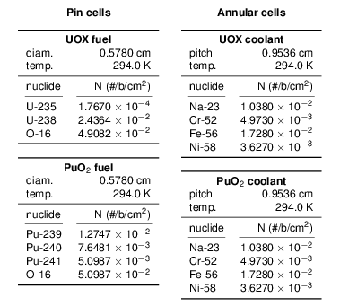

Table 1: Dimensions and composition of a fast reactor fueled with both uranium oxide and plutonium oxide and cooled with sodium. The fuel rod is modeled by smearing steel throughout the sodium. This reactor definition is informed by the MOX reactor in (Palmiotti et al. , 1995 ).

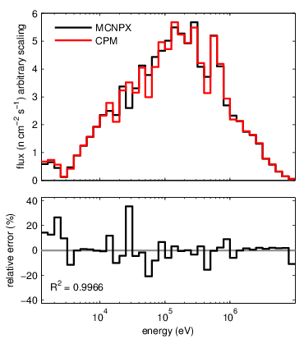

Figure 1: Comparison to MCNPX of spectral flux in the UOX fuel. The top graph compares the fuel flux from our method (“CPM”) to MCNPX results. The bottom graph provides the error between our method and MCNPX. The coefficient of determination between the results is 0.9966.

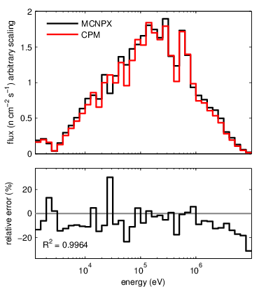

Figure 2: Comparison to MCNPX of spectral flux in the plutonium fuel. The top graph compares the fuel flux from our method (“CPM”) to MCNPX results. The bottom graph provides the error between our method and MCNPX. The coefficient of determination between the results is 0.9966.

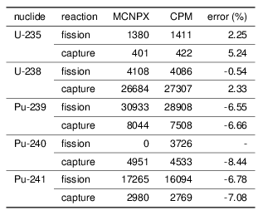

Table 2: Comparison to MCNPX of one-group reaction rates in a sodium fast reactor. The absorption rates for the fuel isotopes are provided. Our method is noted as “CPM”. These reaction rates cover the energy range from 5 eV to 10 MeV. The numbers are normalized to 100,000 total absorptions in the system.

* 1. References

Palmiotti, G., Hill, R., Wade, D., 1995. Physics of Plutonium Recycling. Tech. rep., Nuclear Energy Agency.