**E-ASSET MANAGEMENT**

**BY </CODE-PREDATORS>**

**ER DIAGRAM**

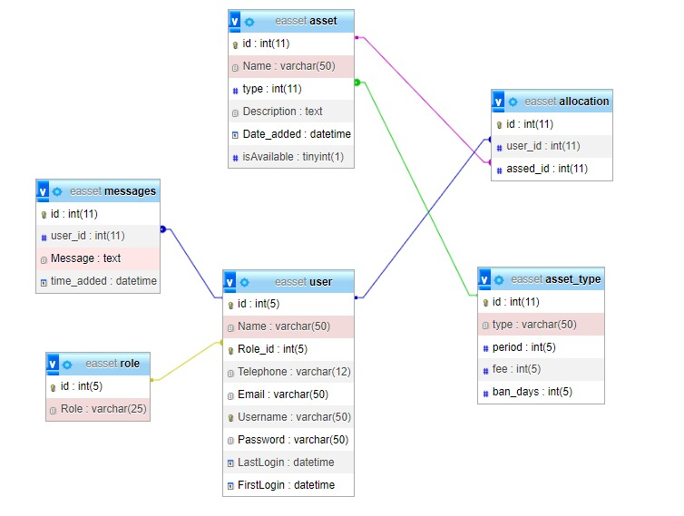

**DATA FLOW DIAGRAM**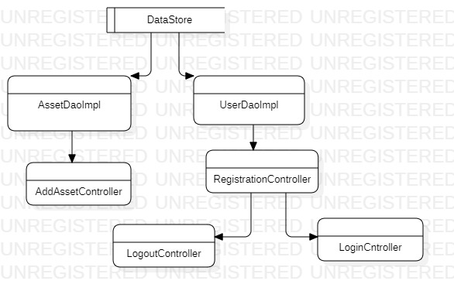

**USER CASE DIAGRAM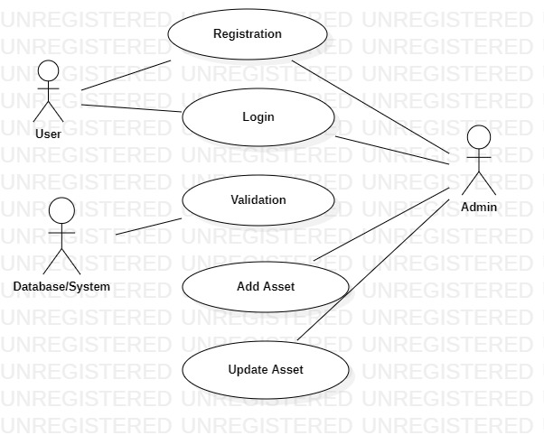CLASS DIAGRAM**