**HW VCS**

|  |  |
| --- | --- |
| Name: |  |

For each of the 13 labs/tutorials on VCS, at the conclusion of each, you will be instructed to make a screen shot of something from the lab/tutorial. You will paste the screen shot in the appropriate place in this document. When you have completed all the tutorials submit this document on BlazeView under *HW-VCS*. This homework will take at least 6-8 hours.

**Tutorial 1**

**Tutorial 2**

**Tutorial 3**

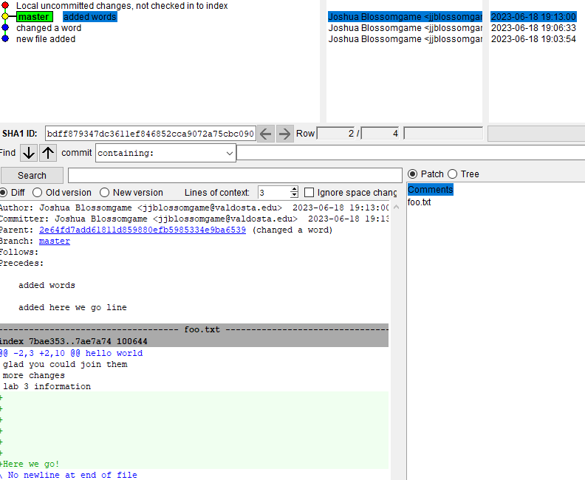 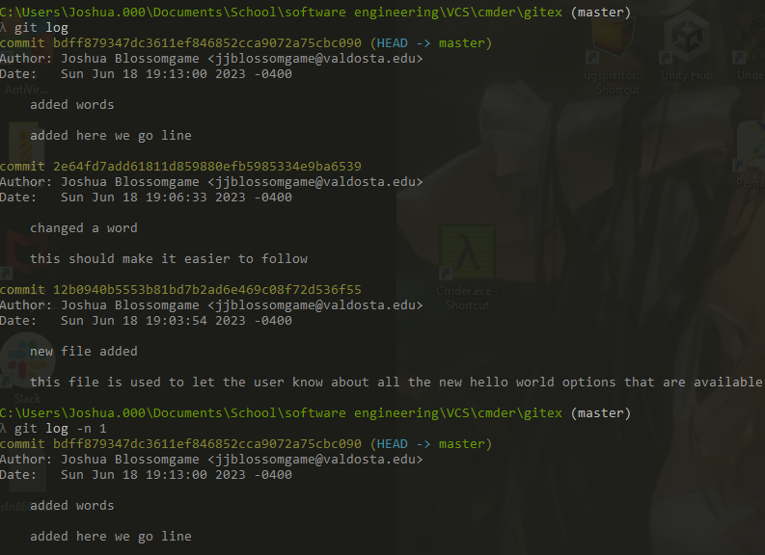

**Tutorial 4**

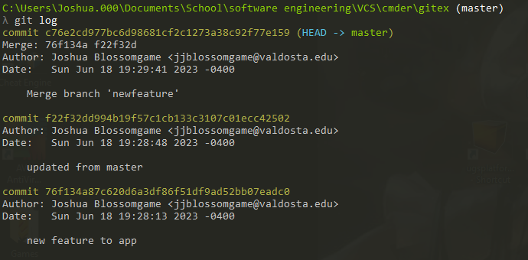

**Tutorial 5**

**Tutorial 6**

**Tutorial 7**

**Tutorial 8**

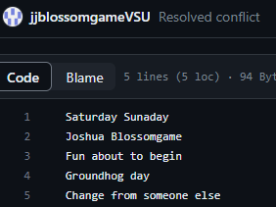

**Tutorial 9**

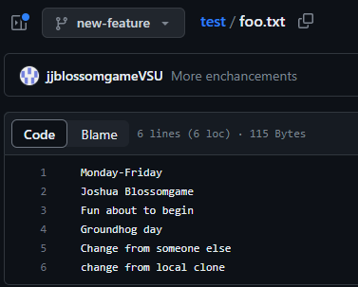

**Tutorial 10**

**Tutorial 11**

**Tutorial 12**

**Tutorial 13**