**Predictions of selection against instability: does subgraph frequency relate to quasi sign-stability in food webs**

Jonathan Borrelli  
Stony Brook University  
Stony Brook NY, 13850

**Abstract**

Food webs structure can be defined by the particular frequencies of three node subgraphs. Of the thirteen possible configurations of three species food webs, some are consistently over and underrepresented in larger (whole community) food webs. This is a robust pattern that spans multiple environments. Any potential explanation must also be able to apply without respect to the particulars of marine, freshwater, or terrestrial environments. I argue that the elimination of unstable subgraphs during the development of the food web can explain the observed pattern. A clear prediction of this hypothesis is that there should be differences in the probability of stability in different subgraphs, and that this probability should be related to their frequency in food webs. Using 50 food webs collected from a variety of databases I determined the frequency of each of the thirteen possible subgraphs with respect to randomized webs. Then by numerical simulation I determined the quasi sign stability (QSS) of each subgraph. My results clearly show the relationship between QSS and over/under-representation of the different subgraphs.(172 words)

**Introduction**

The ecological networks that are observed in nature are those that are able to persist in a dynamically changing environment. Much of the past 40 years of food web ecology has focused on finding those “devious strategies which make for stability in enduring natural systems,” to quote Robert May (2001). Studies such as Thébault and Fontaine (2010) have demonstrated a link between those structures observed in ecological networks (e.g., modularity in food webs and nestedness in mutualistic webs) are also those that emerge from the population dynamics underlying the system. There are many ways to characterize the structure of an ecological network however. Here we discuss the relevance of dynamics to the substructural composition of food webs.

Larger networks are made up of many smaller subnetworks (hereafter subgraphs) that are assembled together. Any large network with *N* nodes can be decomposed into smaller networks of size 1 to *N*-1. There are thirteen possible (connected, directed) configurations of three nodes, five of which require only single direction links and 8 which combine single and bi-directional links. Milo *et al.* (2002) showed that the observed frequency of these three node configurations varies in different types of networks (e.g., food webs, neural networks, electronic networks, etc.). For example, in food webs the tritrophic chain tends to be over-represented compared to random. Those subgraphs which tend to be over-represented are commonly termed *motifs*.

In a study of 16 food webs Stouffer et al.(2007) showed that there were two distinct patterns of the frequency of subgraphs in food webs. Most webs were characterized by over-representation of intra-guild predation and under-representation of apparent and direct competition. The other 6 webs were characterized by the opposite pattern of representation. Overall, however, most webs tended to have the same relative frequencies of the different subgraphs.

In this study I ask whether the commonly observed pattern of subgraph frequency is so results from the loss of subgraphs that are less likely to be stable. To answer this question I will first demonstrate that there exists variation in both frequency and the likelihood of stability across the thirteen different three-node subgraphs. If there is a systemic selection against unstable subgraphs in nature, then we should expect to find a positive correlation between the frequency of a given subgraph and the probability that that subgraph will be stable.

**Methods**

**Data**

*\*NOTE TO SELF: ADD MORE INFO ABOUT EACH OF THE DATASETS*\*

I used 50 food webs collected from a variety of sources. Three food webs were downloaded from the [Dryad Digital Repository](http://datadryad.org/resource/doi:10.5061/dryad.c213h) (Roopnarine and Hertog 2012a, 2012b). Another seven were available from [Ecological Archives](http://esapubs.org/Archive/search.php) (Hechinger et al. 2011, Thieltges et al. 2011, Zander et al. 2011, Mouritsen et al. 2011, Preston et al. 2012). Fourteen webs were provided by Jennifer Dunne of the [PEaCE Lab](http://peacelab.net/) (Baird and Ulanowicz 1989, Warren 1989, Polis 1991, Hall and Raffaelli 1991, Martinez 1991, Christensen and Pauly 1992, Havens 1992, Goldwasser and Roughgarden 1993, Opitz 1996, Waide and Reagan 1996, Yodzis 1998, 2000, Martinez et al. 1999, Christian and Luczkovich 1999, Memmott et al. 2000, Link 2002) that were analyzed in (Dunne et al. 2002, 2004). The remaining 26 food webs were downloaded from the [Interaction Web Database](http://www.nceas.ucsb.edu/interactionweb/html/thomps_towns.html) (Townsend et al. 1998, Jaarsma et al. 1998, Thompson and Townsend 1999, 2000, 2003, 2005, Thompson and Edwards 2001).

**Subgraph Frequency**

The frequency of each subgraph was found using the *triad.census* function from the *igraph*  package (Csárdi and Nepusz 2006) in R *version 3.0* (R Core Team 2014). Counts of each of the thirteen subgraphs were determined for each of the 50 food webs described above. Each frequency was then compared against a null distribution.

To create the null distribution each of the fifty adjacency matrices (each food web) was permuted, maintaining both the number of predators of a species and the number of prey a species has (maintaining row and column sums). 1000 permuted matrices were generated for each food web, and the frequency of each subgraph type was found. Z-scores were computed using the formula:

Where is the frequency of the *ith* subgraphin each empirical food web, is the mean frequency of the *ith* subgraph in the permuted matrices, and σ*l* is the standard deviation. The z-scores were then normalized by dividing by the square root of the sum of the squared z-scores for that food web.

**Subgraph Stability**

Using numerical simulations in R *version 3.0* (R Core Team 2014) I determined the probability of a given subgraph will be stable (quasi sign-stability, QSS), following the method of Borrelli and Ginzburg (in review). Each subgraph was translated into its corresponding sign-structured matrix. Positive elements of the matrix were given a random value drawn from a uniform distribution between 0 and 10, while negative elements were given a value drawn from a uniform between -1 and 0. Because diagonal elements have a large impact on the stability of the matrix, we assigned each diagonal element a random value drawn from a uniform distribution between -1 and 0, thus on average intraspecific effects on population growth rate were approximately the same as the effect of predation. This process was repeated 10,000 times for each subgraph. Quasi sign stability was then calculated as the proportion of randomly sampled matrices whose eigenvalue with the largest real part (Max(Re(λ))) was negative.

**Results**

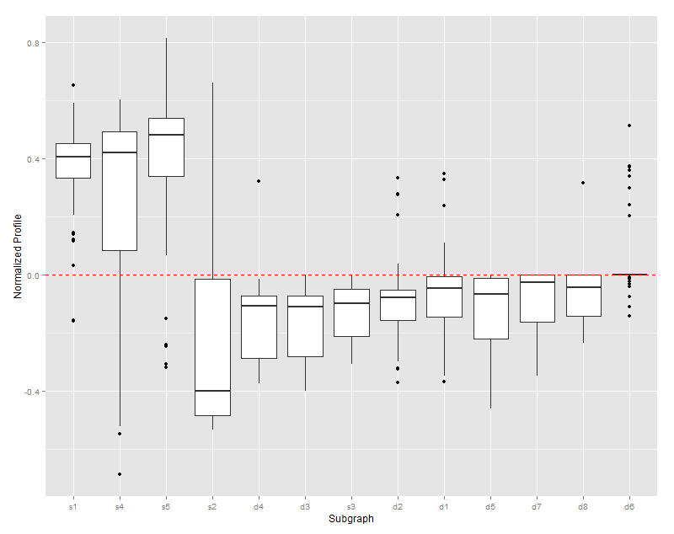The different subgraphs are variable in how frequently they are observed relative to permuted webs. Tritrophic chains, apparent competition, and direct competition all tend to be over-represented in food webs. Intra-guild predation is typically under-represented but is over-represented in some webs. The three-species trophic loop (s3) is under-represented in all webs, as are most subgraphs that include bidirectional links (A eats B, B eats A).

There is also variation in the quasi sign-stability of each subgraph. The three subgraphs that tend to be over-represented are all very likely to be stable. Intra-guild predation is also moderately likely to be stable (approximately 0.5). The remaining subgraphs are all unlikely to be stable, with quasi sign-stability less than 0.2.

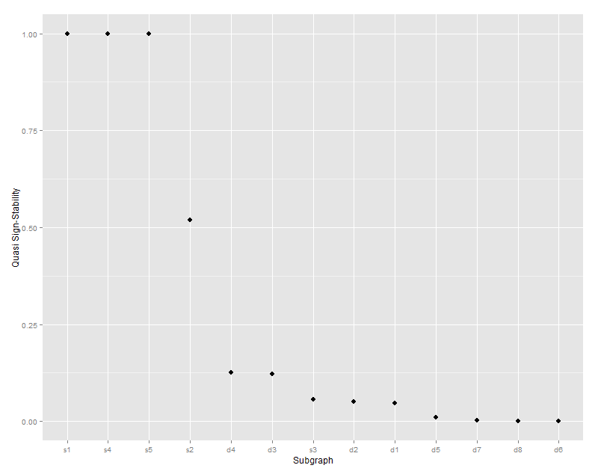

Quasi sign-stability of a given subgraph is positively correlated (0.70; 95% CI: 0.25, 0.90; p-value = 0.007) with the frequency it is observed in empirical networks (relative to random). Subgraphs with a higher quasi sign-stability occur more frequently than expected by random chance, while those with lower quasi sign-stability tend to occur less frequently than expected by chance.

**Discussion**

Two main hypotheses are most frequently compared to explain the observed pattern in the frequencies of different subgraphs. The pattern arises either as (1) a function of the constraints on the development or assembly of the network, or (2) through selection acting on some ecological advantage (Prill et al. 2005, Camacho et al. 2007). Food web models typically do well in reproducing patterns of subgraph frequency, leading Camacho et al. (2007) to argue in favor of the first hypothesis. Yet strong correlation between a measure of stability and absolute frequency of different subgraphs in transcription, neuron, and signaling networks suggested to Prill et al. (2005) that the second hypothesis may have support

**References**

Baird, D., and R. Ulanowicz. 1989. The seasonal dynamics of the Chesapeake Bay ecosystem. Ecological Monographs 59:329–364.

Camacho, J., D. B. Stouffer, and L. A. N. Amaral. 2007. Quantitative analysis of the local structure of food webs. Journal of Theoretical Biology 246:260–268.

Christensen, V., and D. Pauly. 1992. ECOPATH II—a software for balancing steady-state ecosystem models and calculating network characteristics. Ecological modelling 61:169–185.

Christian, R. R., and J. J. Luczkovich. 1999. Organizing and understanding a winter’s seagrass foodweb network through effective trophic levels. Ecological Modelling 117:99–124.

Csárdi, G., and T. Nepusz. 2006. The igraph software package for complex network research. Complex Systems 1695.

Dunne, J. A., R. J. Williams, and N. D. Martinez. 2002. Food-web structure and network theory: The role of connectance and size. Proceedings of the National Academy of Sciences of the United States of America 99:12917–22.

Dunne, J., R. Williams, and N. Martinez. 2004. Network structure and robustness of marine food webs. Marine Ecology Progress Series 273:291–302.

Goldwasser, L., and J. Roughgarden. 1993. Construction and analysis of a large Carribean food web. Ecology 74:1216–1233.

Hall, S., and D. Raffaelli. 1991. Food-web patterns: lessons from a species-rich web. The Journal of Animal Ecology 60:823–841.

Havens, K. 1992. Scale and structure in natural food webs. Science 257:1107–1109.

Hechinger, R. F., K. D. Lafferty, J. P. McLaughlin, B. L. Fredensborg, T. C. Huspeni, J. Lorda, P. K. Sandhu, J. C. Shaw, M. E. Torchin, K. L. Whitney, and A. M. Kuris. 2011. Food webs including parasites, biomass, body sizes, and life stages for three California/Baja California estuaries. Ecology 92:791.

Jaarsma, N. G., S. M. de Boer, C. R. Townsend, R. M. Thompson, and E. D. Edwards. 1998. Characterising food‐webs in two New Zealand streams. New Zealand Journal of Marine and Freshwater Research 32:271–286.

Link, J. 2002. Does food web theory work for marine ecosystems? Marine Ecology Progress Series 230:1–9.

Martinez, N. 1991. Artifacts or Attributes? Effects of Resolution on the Little Rock Lake Food Web. Ecological Monographs 61:367–392.

Martinez, N., B. Hawkins, H. Dawah, and B. Feifarek. 1999. Effects of sampling effort on characterization of food-web structure. Ecology 80:1044–1055.

May, R. M. 2001. Stability and Complexity in Model Ecosystems. Princeton University Press, Princeton, NJ.

Memmott, J., N. D. Martinez, and J. E. Cohen. 2000. Predators, parasitoids and pathogens: species richness, trophic generality and body sizes in a natural food web. Journal of Animal Ecology 69:1–15.

Milo, R., S. Shen-Orr, S. Itzkovitz, N. Kashtan, D. Chklovskii, and U. Alon. 2002. Network motifs: simple building blocks of complex networks. Science 298:824–827.

Mouritsen, K. N., R. Poulin, J. P. McLaughlin, and D. W. Thieltges. 2011. Food web including metazoan parasites for an intertidal ecosystem in New Zealand. Ecology 92:2006–2006.

Opitz, S. 1996. Trophic interactions in Caribbean coral reefs. ICALRM Tech, Makati City, Philippines.

Polis, G. 1991. Complex trophic interactions in deserts : an empirical critique of food-web theory. American Naturalist 138:123–155.

Preston, D. L., S. A. Orlofske, J. P. McLaughlin, and P. T. Johnson. 2012. Food web including infectious agents for a California freshwater pond. Ecology 93:1760.

Prill, R. J., P. A. Iglesias, and A. Levchenko. 2005. Dynamic properties of network motifs contribute to biological network organization. PLoS Biology 3:e343.

R Core Team, R. 2014. R: A Language and Environment for Statistical Computing. R Foundation for Statistical Computing, Vienna, Austria.

Roopnarine, P. D., and R. Hertog. 2012a. Detailed food web networks of three Greater Antillean coral reef systems: the Cayman Islands, Cuba, and Jamaica. Dataset Papers in Ecology 2013:857470.

Roopnarine, P. D., and R. Hertog. 2012b. Data from: Detailed food web networks of three Greater Antillean coral reef systems: the Cayman Islands, Cuba, and Jamaica. Dryad.

Stouffer, D. B., J. Camacho, W. Jiang, and L. A. N. Amaral. 2007. Evidence for the existence of a robust pattern of prey selection in food webs. Proceedings of the Royal Society B 274:1931–1940.

Thébault, E., and C. Fontaine. 2010. Stability of ecological communities and the architecture of mutualistic and trophic networks. Science 329:853–856.

Thieltges, D., K. Reise, and K. Mouritsen. 2011. Food web including metazoan parasites for a tidal basin in Germany and Denmark: Ecological Archives E092-172. Ecology 92.

Thompson, R., and E. Edwards. 2001. Allocation of effort in stream food-web studies: the best compromise? Marine Freshwater Research 52:339–345.

Thompson, R. M., and C. R. Townsend. 2000. Is resolution the solution?: the effect of taxonomic resolution on the calculated properties of three stream food webs. Freshwater Biology 44:413–422.

Thompson, R., and C. Townsend. 1999. The effect of seasonal variation on the community structure and food-web attributes of two streams: implications for food-web science. Oikos 87:75–88.

Thompson, R., and C. Townsend. 2003. Impacts on stream food webs of native and exotic forest: an intercontinental comparison. Ecology 84:145–161.

Thompson, R., and C. Townsend. 2005. Energy availability, spatial heterogeneity and ecosystem size predict food-web structure in streams. Oikos 108:137–148.

Townsend, C. R., R. M. Thompson, A. R. Mcintosh, C. Kilroy, E. Edwards, and M. R. Scarsbrook. 1998. Disturbance, resource supply, and food-web architecture in streams. Ecology Letters 1:200–209.

Waide, R., and W. Reagan. 1996. The food web of a tropical rainforest. University of Chicago. University of Chicago Press, Chicago, Illinois, U.S.A.

Warren, P. 1989. Spatial and temporal variation in the structure of a freshwater food web. Oikos 55:299–311.

Yodzis, P. 1998. Local trophodynamics and the interaction of marine mammals and fisheries in the Benguela ecosystem. Journal of Animal Ecology 67:635–658.

Yodzis, P. 2000. Diffuse Effects in Food Webs. Ecology 81:261–266.

Zander, C. D., N. Josten, K. C. Detloff, R. Poulin, J. P. McLaughlin, and D. W. Thieltges. 2011. Food web including metazoan parasites for a brackish shallow water ecosystem in Germany and Denmark. Ecology 92:2007.