**Interactions, topology, and the impacts of keystone species**

**Introduction**

Keystone species are those that have a disproportional impact on the community relative to their abundance. The textbook case of a keystone species is the sea star *Pisaster* in tidal communities of the Pacific Northwest (Paine 1966, 1969). *Pisaster* feeds on highly competitive mussels, clearing precious real estate in the inter-tidal zone for multiple sedentary species to colonize. Removing *Pisaster* from these communities leads to the competitive exclusion of most of these species, and the domination of the community by a single mussel. Other examples of keystone species include otters, whose predatory interaction with sea urchins helps stabilize the kelp forest (Estes et al. 1998), and the removal of bass in lakes leads to a trophic cascade affecting smaller fish, grazers and algae abundances (Carpenter 1985, Power 1985, Mittelbach 2006).

Most studies involving keystone species are focused on a single interaction type, predator-prey. For example, Paine (1980) highlights that *Pisaster* is effective at reducing competition among mussels because it is a generalist that consumes prey at a range of sizes. Different types of interaction, including competition and mutualism, may mediate the impact that different species have on their community, however. Keystone species’ interactions of different types may be lead to alternative impacts on the community.

Microbial communities offer an exciting avenue for research into the effects of keystone species. Recent efforts have found that species that perform specific functions in gut microbial communities may be keystones (Ze et al. 2013). For example, *Ruminococcus bromii* plays a critical role in the degradation of certain starches and the resulting energy derived from the breakdown of that dietary component supports other microbial species (Ze et al. 2012). With their short generation times, long-term community dynamics may be observed over comparatively short human time scales. Advances in metagenomics have also allowed us to identify microbial taxa and quantify their abundance over time *in vivo*.

In the human gut there is a thriving microbial community with hundreds of coexisting species. Recent advances in metagenomic sequencing have allowed us to catalogue these species and describe the variation in community structure and composition across individuals and within individuals over time. Several factors likely impact the composition of the community. Variation in diet has been shown to influence microbial community composition (Turnbaugh et al. 2009, Wu et al. 2011, Ren et al. 2015). This is likely because different microbes are able to more efficiently use different resources/macronutrients (Turnbaugh et al. 2006, Ze et al. 2013). Additionally, either by hitchhiking on food or other means of transfer, new microbes may invade the community (Gonzalez et al. 2011, Tung et al. 2015). For example, *Eschericha coli* may be introduced to the gut via ingestion of contaminated or undercooked foods. The host environment can also influence which species are able to coexist in the gut community either through an immune response or mediated through some kind of niche-selection (Costello et al. 2012). Finally, the interactions among microbes may both set the boundaries for community composition and drive the response of the community to the other external impacts (Stein et al. 2013, Coyte et al. 2015).

Despite the many ways the gut microbiome may be affected, longitudinal studies have revealed that their composition tends to be stable over long periods of time (Caporaso et al. 2011, David et al. 2014). An understanding of how microbes interact may allow us to understand why the human gut microbiome is able to remain stable. Specifically we may want to know whether the role a species plays in the community can tell us about how important they are for the stability of the system (Berry and Widder 2014). Because it is also likely that the interactions among microbes are universal (Bashan et al. 2016), being able to identify the impact species with different roles have may be generalizable to the larger population.

Microbes can compete with one another directly for limited resources in the gut (both food and space). Alternatively they may interact via the production of metabolites. These compounds can be either beneficial or detrimental to the growth of other microbial populations. Thus, in microbial communities we may expect to see all five major interaction types: competition (-,-), mutualism (+,+), parasitism/predation (+,-), amensalism (-,0), and commensalism (+,0). While prevailing wisdom on microbial communities suggested that their stability and function resulted from mutually beneficial relationships among taxa, recent evidence suggests the opposite. Coyte et al. (2015) found that increasing the number of competitive interactions increased the stability of simulated microbial communities and the opposite for mutualistic interactions.

Recent efforts to infer microbial interaction from time series data have further demonstrated that competition is indeed more common than mutualism (Stein et al. 2013, Marino et al. 2014). Coyte et al. (2015) further demonstrated that their results for simulated microbial communities held true for the empirical result of Stein et al. (2013). Inferring interactions is challenging, however, and limitations in the methods meant that the communities in these studies were reduced from several hundred species to either 11 (Stein et al. 2013) or 17 (Marino et al. 2014). Each study focused on the most abundant taxa throughout the course of the time series and lumped the less abundant taxa into a single category ("Other").

Typically our understanding of keystone species' impacts has come from species removal experiments. In this paper we describe an *in silico* species removal experiment. The impact that removal of each species has on a simulated community was measured using four metrics of stability: persistence, change in equilibrium abundance, variation in abundance, and local stability. Persistence tells us how many secondary extinctions result from species removals. The change in equilibrium abundance and the initial variation of abundances tells us the impact a species’ removal has on other populations. Finally, we measure the local stability of the community following removal. We determined how each of these impacts are mediated by the different ways species interact with one another.

**Methods**

Simulations began by generating a species pool whose interactions were known. Interactions among species were assigned using the Erdos-Renyi model for random networks with 200 nodes and a connectance of 0.2. The distribution for the strength of each interaction was assumed to be equivalent to that found by Stein et al. (2013), from modeled microbial species interactions. Each species was assigned a self-damping term drawn from a beta distributions (a = 1.1, b = 5) scaled between -5 and 0, qualitatively matching the distribution of self-interactions found by Stein et al. (2013). Off-diagonal interaction strengths were drawn from a normal distribution yielding distribution with a mean of -0.07 and standard deviation of 0.354. Growth rates for all species were positive and drawn from a uniform distribution between 0.1 and 1.

Individual communities were created by sampling 50 species and their interactions from the pool. All interactions defined above were assumed to be universal, so individual communities represented subsets of the initial species pool. Dynamics of each community were simulated using the Lotka-Volterra model of species interactions,

where *Ni*is the abundance of species *i*, *ri* is the species specific growth rate, and *aij* is the effect of species *j* on species *i*. The simulation was run for 1000 time steps, which was long enough for most communities to reach equilibrium (constant abundances) or steady-state (stable attractor). Note the difference is that at steady state the abundances of populations may be fluctuating, but they will remain that way unless perturbed (Figure 1).

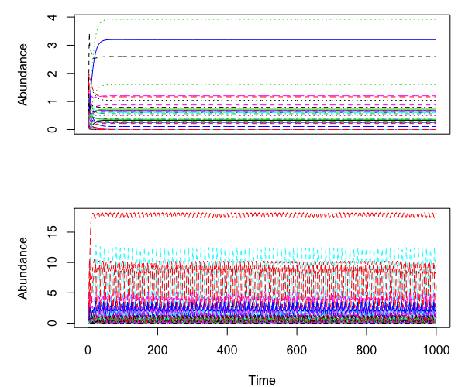

**Figure 1: Representative dynamics of simulated microbial communities.**

In order to identify which species were important to the stability of the community we systematically removed each species (one at a time) and measured the change in the community. The starting point for species removals were the equilibrium/steady-state communities. Following the removal of a species, the resulting community dynamics were simulated for 1000 time steps using the same model and parameters as the initial community. At the end of each simulation, the impact on the community was measured using four metrics: (1) the mean change in abundance, (2) mean coefficient of variation in the first 50 time steps following removal, (3) persistence (the fraction of species with positive abundance), and (4) eigenvalue of the resulting Jacobian matrix with the largest real part (local stability).

The types and strengths of the interactions each species participated in were identified for every community. We counted the frequency of each interaction type that each species participated in. The strengths of those interaction types for each species were computed as the mean of *aij* and *aji.* In addition we identified the structural roles of each species in every community. The structural properties we measured were the betweenness, closeness, eigenvector centrality, page rank, and the number of species within 2 links of the target species (neighborhood size). Betweenness is the number of shortest paths along which the target species lies. Closeness is the number of steps required to access every other species in the interaction network. The eigenvector centrality, and page rank are three methods to compute the importance of species in the network.

A species was considered to be keystone based on its level of community importance (Power et al. 1996) with respect to the four measures of impact on the community following species removal. Community importance is measured as

where *tN* is the quantity of interest in the initial community, *tD* is the quantity of interest following the removal of the species *i*, and *pi* is the relative abundance of species *i*. Keystone species were those whose community importance was in the top 10th percentile for all four metrics. As an example, if the quantity of interest is persistence, then *tN* is the number of species in the initial equilibrium community and *tD* is the number of species remaining at 1000 time steps after the removal of species *i*.The community importance is then the fraction of species remaining divided by the equilibrium relative abundance of species *i*.

To determine what makes a species a keystone in the community, we used a generalized linear model to identify the effect of the measured species properties on keystone status. Keystoneness was modeled as a binomial variable. All combinations of predictor variables were assessed using the *dredge* function of the **MuMIn** R package (Bartoń 2016), and ranked according to AIC . All models with deltaAIC < 2 were averaged together. In addition to defining keystone species as those in the top 10% of community importance for all four metrics (Kfull), we created additional generalized linear models for keystone species defined as the top 10% in each community metric (Kpersist, Kabund, Keigen, Kvar).

**Results**

Equilibrium local communities ranged from 16 to 34 species (median = 25), with connectance between 0.15 and 0.3 (median = 0.215). In each individual metric model there were 454 combinations, out of 4537, of species and community that were identified as being keystone. The Kfull model response variable included 42 instances of a keystone species. The results presented here are for averaged models, where all models with deltaAICc < 2 were included. Parameter estimates and 95% confidence intervals for the individual metric models are presented in Figure 2, and the importance of each parameter (proportion of models in the averaging that included that parameter) is shown in Supplemental Figure 2.

The averaged Kpersist model included all predictor variables except Page Rank (Figure 2). The largest negative effects on keystoneness based on persistence were the strengths of competition and predation. The number of competitive links had a small but significant positive effect in this model but for mutualism both the number and strength of the interactions had a small negative (significant and non-significant respectively) effect on keystoneness. Both closeness centrality and eigenvector centrality had positive effects on keystoneness in Kpersist as well, however these were not significant. This suggests that keystone species identified by persistence are generalist weak competitors.

In the Kabund average model all predictor variables were included except the number of competitive links and the neighborhood size (Figure 2). The strongest positive effects on keystoneness defined as change in abundance were by the topological measures of closeness and Page Rank. Keystoneness was also positively (marginally significant, p < 0.1) related to the strength of mutualistic interactions. The number of mutualistic and predator/parasitic interactions and the strength of competition and predation/parasitism were negatively related to keystoneness. These results indicate that keystone species influencing abundance are those that are specialized mutualists that interact with species who interact with many species.

All predictor variables were included in the averaged Keigen model (Figure 2). The largest effects on keystoneness defined by having a positive effect on the eigenvalue of the Jacobian matrix were competition and predation/parasitism strength (negative), and eigenvalue centrality (positive). We found a weak positive effect of the number of competitive and predation/parasitic links as well. These results suggest that keystone species defined by their effect on local stability are those that compete weakly with many species, or with species that interact with many species.

The Kvar model, where keystone species were defined by the coefficient of variation in species abundances following removal, included all predictor variables (Figure 2). The largest positive effects on keystoneness were closeness centrality and Page Rank. Mutualistic interaction strength had a positive effect on keystoneness but the number of mutualistic interactions had a negative effect. Competitive and predation/parasitic interaction strength had negative effects as well. Thus species that have a large impact on the variation in abundance are those that are specialized mutualists interacting with species that interact with many species.

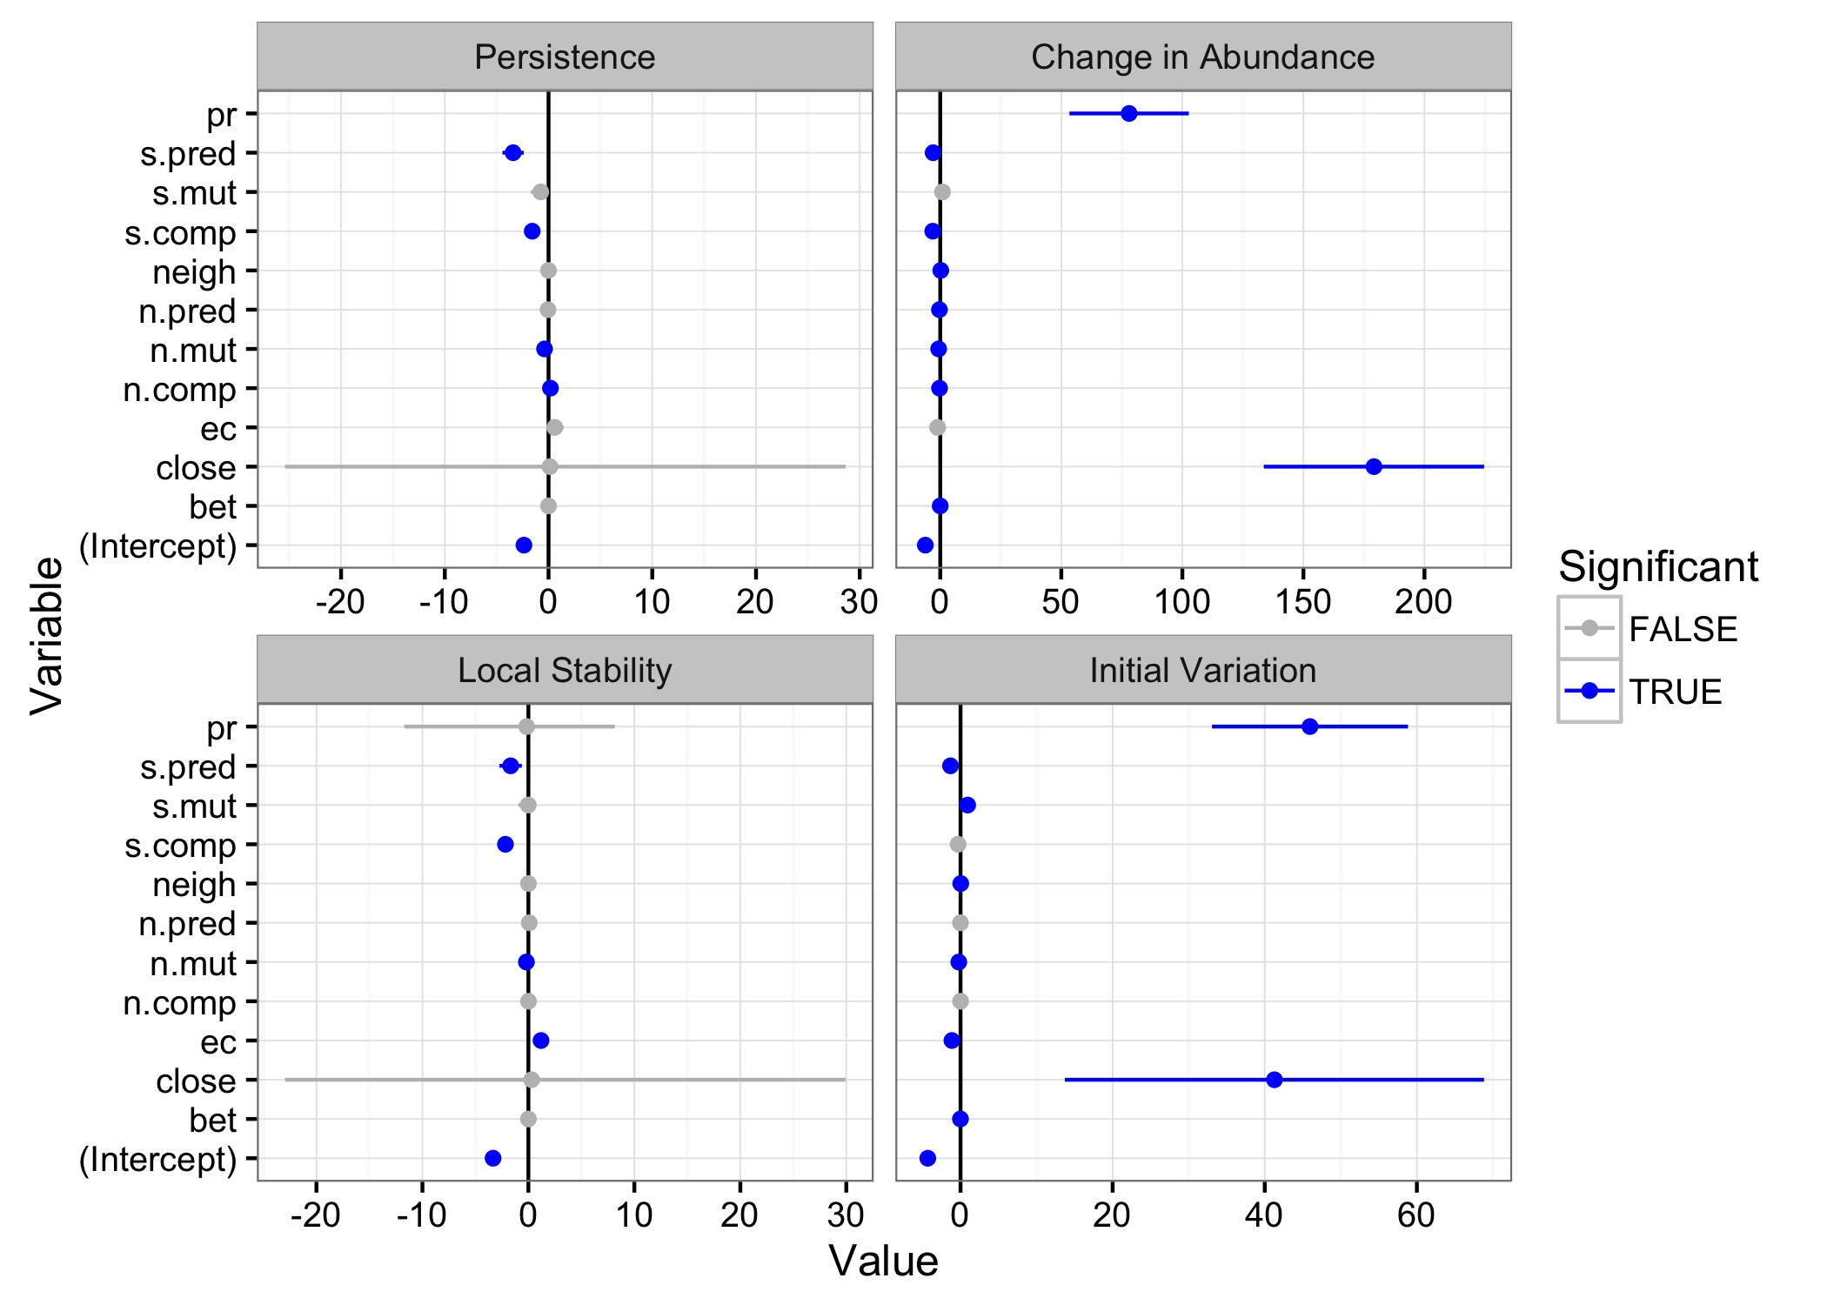

**Figure 2: Model averaged parameters with 95% confidence intervals for the four individual metric based impact models. Models with delta AICc < 2 were included in the averaging. Blue points indicate significantly different from 0. Note changes to the scale of the x-axis. Supplemental Figure 1 shows the smaller scale effects (closer to 0).**

In the Kfull averaged model all predictor variables were included, but the only statistically significant effect was the number of competitive links. The strongest effects on keystoneness were the types and strengths of the target species' interactions. In particular a species was more likely to be identified as keystone if it participated in more competition links and fewer mutualistic links. The effect of the strengths of those interactions, however, is the opposite. Mutualism strength had a positive effect on keystoneness while competition strength had a negative effect. These results indicate that keystone species are those that compete weakly with many species but are also strongly mutualistic with few. The number of predator/parasitic links had a weak positive effect on keystoneness and the strength of those interactions had a large negative effect. Topological predictor variables had relatively small effects on keystoneness. However, eigenvalue centrality and Page Rank (two measures of a species topological importance) had a positive and negative effect on keystoneness respectively.

**Discussion**

A species is more likely to be a keystone, important for the stability of the community, if it is a weak generalist competitor and a specialized strong mutualist. Each of these interaction types is allowing the prospective keystone species to be influencing the community in different ways. When it comes to the persistence and local stability of the community, removing species that have many weak competitive interactions has a large effect. Removing strong specialized mutualists leads to large impacts on equilibrium abundances and variability in the community. By examining the effects of each predictor variable on each individual metric of keystoneness, we are able to parse out why each predictor may be influencing keystoneness in the full model.

Our results corroborate the recent result of Coyte et al. (2015). Coyte and colleagues demonstrated that competition increases the stability of microbial networks, while mutualism decreases it. The number of competitive links a species participated in was positively related to keystoneness in all models, while the number of mutualistic links was negative in all models. Interaction strength, however, is also important to consider when assessing the stability of a community. While Coyte et al. (2015) focused only on the number of interactions, we found that the strength of competition is negatively related to keystoneness when accounting for persistence and local stability, but mutualistic interaction strength can positively influence keystoneness when accounting for impact on abundances. Therefore it may not just be the number of competitive interactions that increase stability, but rather the number of weak competitive interactions.

A recent study by Trosvik et al. (2015) suggested that a candidate keystone taxon in human gut microbial communities is *Actinobacteria*. Based on data from two longitudinal studies (Caporaso et al. 2011, David et al. 2014), Trosvik et al. (2015) modeled the interaction network of the human gut microbial community. They found that *Actinobacteria* in the four individual’s whose microbial communities were sampled tended to have a low relative abundance (around 1.8%). The authors suggest this is a keystone because, in addition to having a low relative abundance, the *Actinobacteria* has a high connectance, suggesting that it is influential in the community. Much like the keystone taxa found in our results, Trosvik et al. (2015) found that *Actinobacteria* tended to participate in more negative interactions than positive, although they did not assess the relative strengths of those interactions. Other taxa with similar relative abundances did not have the same potential influence (connectance).

Alternatively Fisher and Mehta (2014) analyzed the human gut microbial community of the two individuals in the longitudinal data set developed by Caporaso et al. (2011) and found slightly different results. They used a different inference method to determine interactions among taxa (LIMITS; Fisher and Mehta 2014) than Trosvik et al. (2015). Each individual was found to have a different putative keystone taxon, *Bacteroides fragilis* and *Bacteroides stercosis* respectively, based on the number of interactions. Unlike Trosvik et al. (2015) and our study, Fisher and Mehta (2014) found that these keystone taxa participated in more positive interactions than negative.

The position of a species in the network tended to have less of an effect, although it was dependent on the measure used. Metrics like closeness (how many steps it takes to get to every other node) and Page Rank (measure of importance) had strong positive relationships with keystoneness as measured by change in abundance and initial variation. These effects disappeared, however, when keystoneness was defined by all impact metrics or by either persistence or local stability. These results match a recent study investigating the role of interaction network topology on keystoneness (Berry and Widder 2014), and suggest that identifying keystone species based on their connectance (number of interactions) may not be useful.

In most macrobiological studies the species that have been identified as keystone are those that prey upon competitively dominant taxa. Here we have shown that when multiple interaction types and impact is broadly defined, keystone species are those that positively affect taxa that compete weakly with many others. In a study by Berry and Widder (2014) keystone species were also found to have mostly positive direct interactions, but had increased number of negative indirect interactions. In this context, having more weak interactions and fewer strong links can, when defining impact as persistence or local stability, make a species more likely to be a keystone. Species with strong predatory/parasitic links were less likely to be keystone species, despite what we may have expected from other experimentally determined keystones like *Pisaster*.

It is clear that our definition of keystone species depends on how we define "large impact on the community relative to their abundance." Paine (1969) suggested that the impact of a keystone species is on the stability of the community. Power et al. (Power et al. 1996) extended that definition to mean a change in any measurable community trait. Which community trait we pick is therefore going to determine what species are likely to be identified as keystones. We also need to consider what magnitude of impact relative to abundance makes for keystone status. In this paper we called any species whose community importance was in the top 10% a keystone, but that assumption means that some keystone species could potentially have small absolute impacts.

With our quantitative definition, not all simulated communities will have a keystone species, and some may have multiple. Our strictest definition, combining all four impact metrics, only has 42 of the possible 4537 species-community combinations were assigned keystone status so there are at least 139 communities that did not contain a keystone species. For the single impact measures, 454 species-community combinations were considered keystones, so there must have been some communities where multiple species could be considered keystones.

Our study was necessarily limited in its scope. The communities simulated here are much smaller than those that exist in the gut, averaging 25 species while natural gut communities have hundreds. Furthermore, the species in these communities interacted through competition, mutualism, and predation or parasitism. There were no commensal or amensalistic links included.

These results will help us as we move forward with new methods to infer species interactions from time series data. With this new data we will now be able to identify putatively important species. These results can also guide future studies into probiotics. When attempting to introduce new species into the human gut for the purposes of manipulating the microbiome, we need to be able to identify those taxa that will have the largest impact on the community.

**References**

Bartoń, K. 2016. MuMIN: Multi-Model Inference. R package.

Bashan, A., T. E. Gibson, J. Friedman, V. J. Carey, S. T. Weiss, E. L. Hohmann, and Y.-Y. Liu. 2016. Universality of human microbial dynamics. Nature 534:259–62.

Berry, D., and S. Widder. 2014. Deciphering microbial interactions and detecting keystone species with co-occurrence networks. Frontiers in Microbiology 5:1–14.

Caporaso, J. G., C. L. Lauber, E. K. Costello, D. Berg-Lyons, A. Gonzalez, J. Stombaugh, D. Knights, P. Gajer, J. Ravel, N. Fierer, J. I. Gordon, and R. Knight. 2011. Moving pictures of the human microbiome. Genome Biology 12:R50.

Costello, E. K., K. Stagaman, L. Dethlefsen, B. J. M. Bohannan, and D. a Relman. 2012. The application of ecological theory toward an understanding of the human microbiome. Science 336:1255–1262.

Coyte, K. Z., J. Schluter, and K. R. Foster. 2015. The ecology of the microbiome: Networks, competition, and stability. Science 350:663–666.

David, L. A., A. C. Materna, J. Friedman, M. I. Campos-Baptista, M. C. Blackburn, A. Perrotta, S. E. Erdman, and E. J. Alm. 2014. Host lifestyle affects human microbiota on daily timescales. Genome biology 15:R89.

Fisher, C. K., and P. Mehta. 2014. Identifying keystone species in the human gut microbiome from metagenomic timeseries using sparse linear regression. PLoS ONE 9:1–10.

Gonzalez, A., J. C. Clemente, A. Shade, J. L. Metcalf, S. Song, B. Prithiviraj, B. E. Palmer, and R. Knight. 2011. Our microbial selves: what ecology can teach us. EMBO reports 12:775–84.

Marino, S., N. T. Baxter, G. B. Huffnagle, J. F. Petrosino, and P. D. Schloss. 2014. Mathematical modeling of primary succession of murine intestinal microbiota. Proc Natl Acad Sci U S A 111:439–444.

Paine, R. T. 1966. Food web complexity and species diversity. The American Naturalist 100:65–75.

Paine, R. T. 1969. A note on trophic complexity and community stability. The American Naturalist 103:91–93.

Paine, R. T. 1980. Food webs: linkage, interaction strength and community infrastructure. Journal of Animal Ecology 49:666–685.

Power, M. E., D. Tilman, J. A. Estes, B. A. Menge, W. J. Bond, L. S. Mills, G. Daily, J. C. Castilla, J. Lubchenco, and R. T. Paine. 1996. Challenges in the Quest for Keystones. BioScience 46:609–620.

Ren, T., L. E. Grieneisen, S. C. Alberts, E. A. Archie, and M. Wu. 2015. Development, diet and dynamism: Longitudinal and cross-sectional predictors of gut microbial communities in wild baboons. Environmental Microbiology.

Stein, R. R., V. Bucci, N. C. Toussaint, C. G. Buffie, G. Rätsch, E. G. Pamer, C. Sander, and J. B. Xavier. 2013. Ecological Modeling from Time-Series Inference: Insight into Dynamics and Stability of Intestinal Microbiota. PLoS Computational Biology 9:31–36.

Trosvik, P., and E. J. de Muinck. 2015. Ecology of bacteria in the human gastrointestinal tract--identification of keystone and foundation taxa. Microbiome 3:44.

Tung, J., L. B. Barreiro, M. B. Burns, J. C. Grenier, J. Lynch, L. E. Grieneisen, J. Altmann, S. C. Alberts, R. Blekhman, and E. A. Archie. 2015. Social networks predict gut microbiome composition in wild baboons. eLife 2015:1–18.

Turnbaugh, P. J., R. E. Ley, M. a Mahowald, V. Magrini, E. R. Mardis, and J. I. Gordon. 2006. An obesity-associated gut microbiome with increased capacity for energy harvest. Nature 444:1027–31.

Turnbaugh, P. J., V. K. Ridaura, J. J. Faith, F. E. Rey, R. Knight, and J. I. Gordon. 2009. The effect of diet on the human gut microbiome: a metagenomic analysis in humanized gnotobiotic mice. Science translational medicine 1:6ra14.

Wu, G. D., J. Chen, C. Hoffmann, K. Bittinger, Y. Chen, S. A. Keilbaugh, M. Bewtra, D. Knights, W. A. Walters, R. Knight, R. Sinha, E. Gilroy, K. Gupta, R. Baldassano, L. Nessel, and H. Li. 2011. Linking long-term dietary patterns with gut microbial enterotypes. Science 334:105–108.

Ze, X., S. H. Duncan, P. Louis, and H. J. Flint. 2012. Ruminococcus bromii is a keystone species for the degradation of resistant starch in the human colon. The ISME Journal 6:1535–1543.

Ze, X., F. Le Mougen, S. H. Duncan, P. Louis, and H. J. Flint. 2013. Some are more equal than others: the role of “keystone” species in the degradation of recalcitrant substrates. Gut microbes 4:236–240.

**Supplemental**

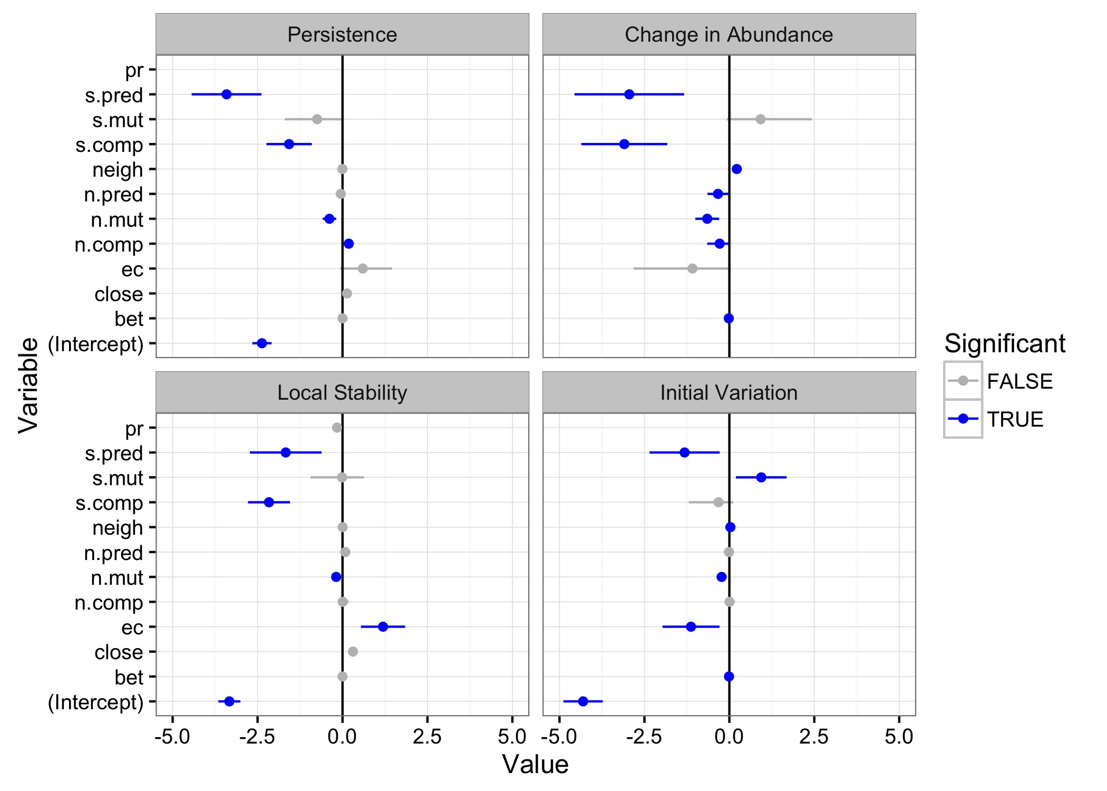

**Supplemental Figure 1: Model averaged parameters with 95% confidence intervals for the four individual metric based impact models zoomed in closer to 0 for more detail than the original figure. Models with delta AICc < 2 were included in the averaging. Blue points indicate significantly different from 0. In the "Change in Abundance" and "Initial Variaiton" panels both PageRank (pr) and Closeness Centrality (close) are present but located outside of the zoomed in range.**

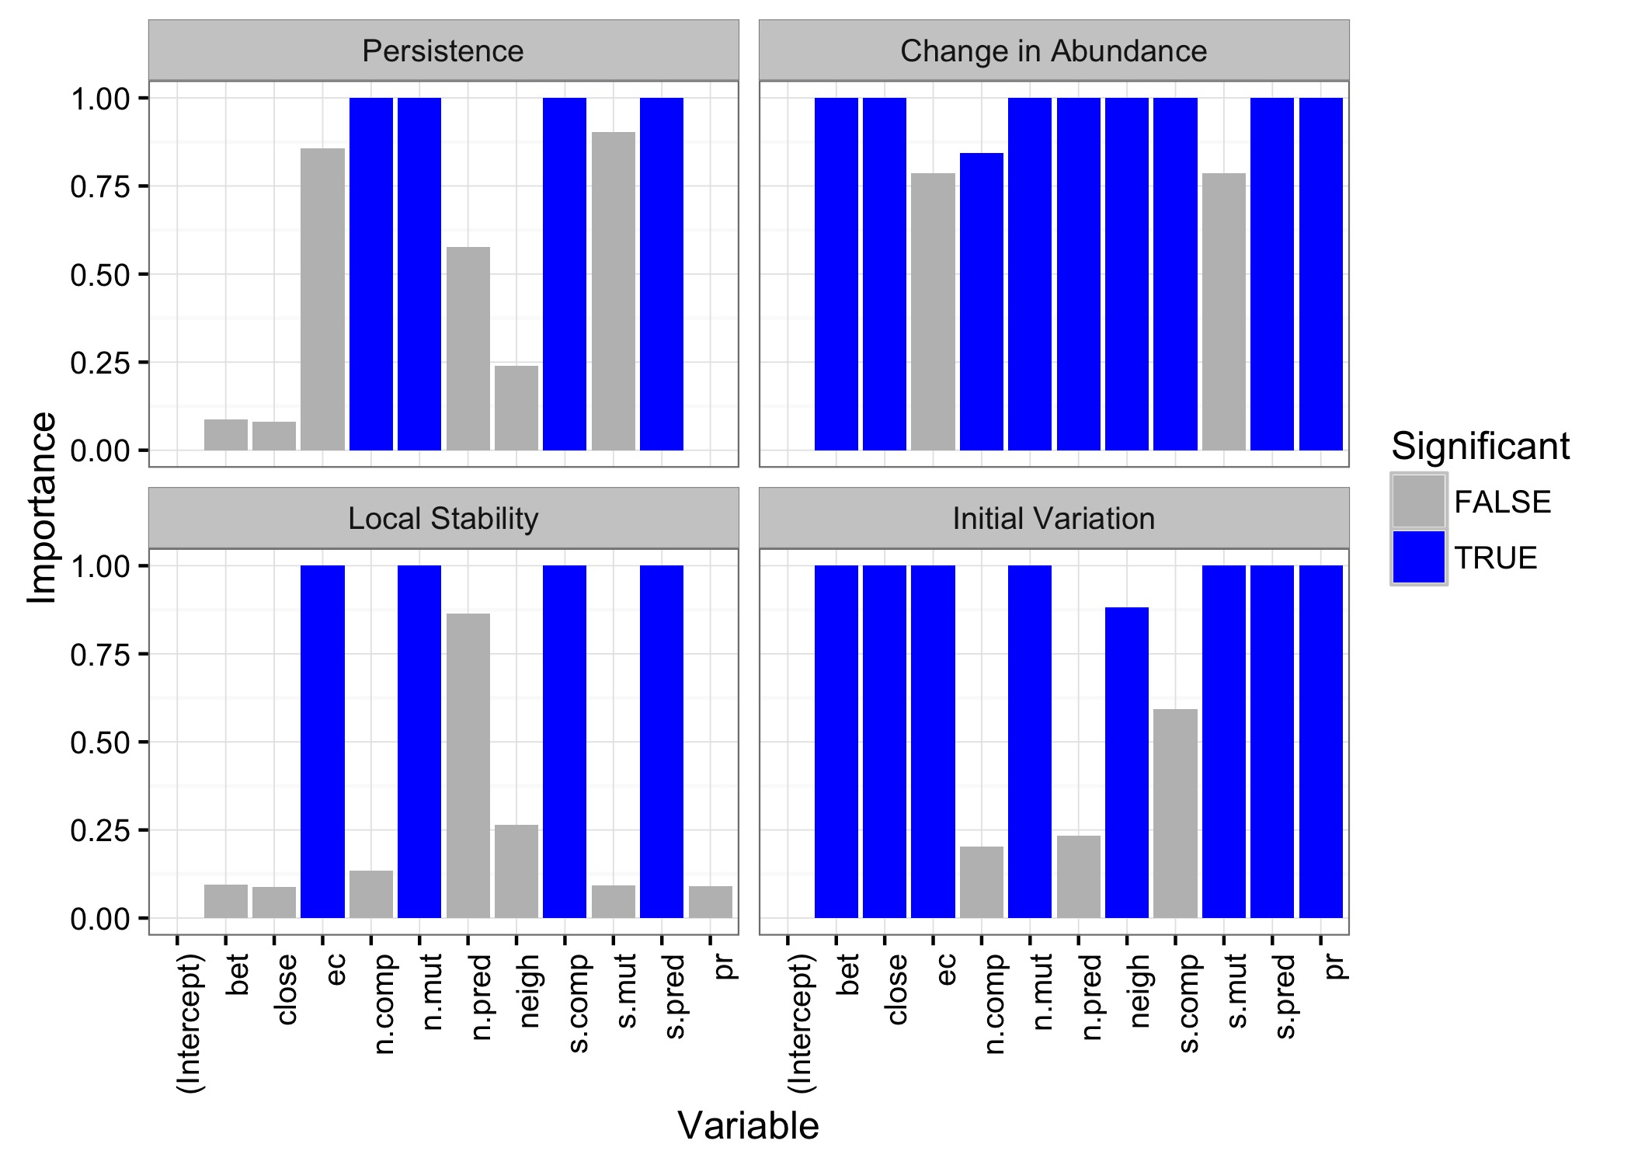

**Supplemental Figure 2: The importance (fraction of models containing that parameter) of each parameter in the averaged model for each of the four cases. All models with delta AICc < 2 were averaged. Blue bars indicate statistical significance of the parameter in the averaged model (p < 0.05).**