Vacancy Chain Length

Individuals in at least two very different (diverse?) species – humans and hermits crabs – obtain some of their most important possessions through the process known as vacancy chain resource distribution. For humans these resources include houses and apartments, jobs, and automobiles, and for hermit crabs the resources are the empty gastropod shells in which they live and carry around as portable shelters. In a vacancy chain an initial unoccupied resource unit coming into a population sets off a chain reaction in which several individuals get new and usually better resource units. For example, in hermit crabs, the shell of a newly killed gastropod is taken by one crab that leaves its old shell behind which is taken by a second crab, and so on. For humans, a newly manufactured car or a newly built house sets off a similar kind of chain reaction. Vacancy chains can also be initiated by an individual leaving an intact resource unit behind such as when a hermit crab dies or a human with a job dies or retires.

Although humans and hermit crabs have little else in common – their evolutionary lines split some 500 million years ago – the fact that vacancy chains occur in both species is not a simple coincidence. White () indicated that the type of resources distributed through vacancy chains in humans all shared the same set of abstract qualities. These qualities include use by only one individual or family at a time, reusability of resource units, and individuals needing or desiring to move periodically to “better” resource units (larger, in better repair, etc.). Chase () showed that gastropod shells as used by hermit crabs shared this same set of abstract properties, and he suggested that vacancy chains would occur in any species that used resources with the same set of abstract qualities.

Here we (1) show that one of the most important features of vacancy chain resource distribution – average vacancy chain length – is roughly equal across different human and hermit crab vacancy chain systems, and we (2) explore why this might be so. The length of a vacancy chain is the number of individuals getting new resource units in a chain starting with the individual getting the initial, vacant unit starting a chain and ending with the individual getting the last unit (see Chase () for an alternative definition of vacancy chain length involving the number of moves that the vacancy initiating a chain makes before it leaves the system). Figure 1 shows the calculation of chain length in several human and hermit crab examples.

Table 1 shows, as far as we can determine, an exhaustive list of all the studies from which average vacancy chain length for a human or hermit crab group can be determined. Only studies that followed chains from their beginning to end are reported in the table; we excluded studies that only reported the length of chains within a particular geographic area or within a particular type of job and did not count the total lengths of chains. Inspection of this table indicates that the average chain length in these very diverse systems ranges from nearly 3.0 to 4.0 individuals getting new resource units.

Is this similarity in average chain length merely coincidence, or does it reflect some deeper similarity, like similar abstract qualities of resource units, in the organization of those systems in humans and hermit crabs showing resource distribution through vacancy chains? In order to answer this question we simulate average vacancy chain length in populations of resource users that could be either humans or hermit crabs. In these simulations we calculate average vacancy chain length as influenced by: total population size of potential resource users, statistical distribution of resource units held by users, density of resource unit holders, distance over which information about a vacant unit is available, and “jump size” – the range of proportional increase in unit size required by users moving to a vacant resource unit.

Some details here on the simulations:

**Methods**

*Static Graph Approach:*

We began our analysis by examining the network structure of potential resource swaps. An arena was set up by placing *N* individuals randomly on a unit square, with their x and y coordinates chosen independently from a uniform distribution between 0 and 1. Each individual was assigned a positive resource value (e.g., shell size in the case of hermit crabs) drawn from independently and randomly from a standard normal distribution (absolute value was used).

A connection between two individuals would require that, in the example of hermit crabs, one individual has a shell that is desirable to another individual. Here we assume that a desirable resource is one that has a greater value than the resource currently held by the individual (e.g., a larger shell size). Two steps were used to define the connections between individuals, where the connections can be thought of as potential resource exchanges.

The first step is based on the idea that an individual has limited information about the world around them. In our simulations this was implemented as a visual threshold. A given individual could only know about resources that were contained within a circle with radius *threshold*, centered on that individual. Thus individuals are only able to know about a set proportion of available resource units.

The second step is based on resource value. Individuals desire a resource with a value that is greater than the one they currently possess. We added the additional constraint that the desired resource must also be below a specified upper limit. For the case of hermit crabs this means that individuals want a larger shell, so that they may continue growth, but there is a trade-off such that if a shell is too large it is sub-optimal; either they will be more easily predated upon or will be unable to forage easily in the larger shell. This upper limit also makes sense in the case of human home-buyers, who frequently have a desired price range. They want a home that is perhaps better than their own, but also one that they are able to afford.

Once these steps are followed the result is a directed network of potential resource exchanges at a given point in time, where the nodes represent the individuals and the links point in the direction of the desirable resources. This network was then analyzed to find the average path length between two nodes. Average path length tells us that if a vacancy chain was started with a random individual, what the expected length of the vacancy chain is.

*Monte Carlo Simulation*

In order to assess how different initial resource values affected the length of the average vacancy chain we used Monte Carlo simulations. The simulations were initialized with a set up the same as the static graph approach, but with no connections included. Individuals with randomly assigned resource values from either a lognormal, uniform, exponential, or normal distribution were placed randomly in the uniform square. Resource values were drawn from distributions with either a small standard deviation (1) or large standard deviation (10).

A new, vacant, resource was then generated by finding the quantiles from the same distributions as the rest of the individuals. The new vacancy was selected from a range of quantiles from the 10th to 100th percentile (by increments of 10). Coordinates for the new vacancy were chosen randomly from the same distribution as the rest of the individuals. Connections representing potential resource swaps were then generated according to the same rules as in the static approach (described above).

To simulate the vacancy chain, we first found all individuals with connections to the vacant resource. From this list a single individual was chosen at random to receive the vacancy. That resource then became vacant, and the process was repeated until there were no more potential swaps. The length of the vacancy chain was recorded as the number of individual resource units involved in the swap.

**Results**

**Figure 1:** Average chain length as it depends on the number of individuals (across the top), difference between  
the min and max swap size (down the right side), and the maximum distance between two individuals that  
can be linked. Note there is a scale change among row y-axes.

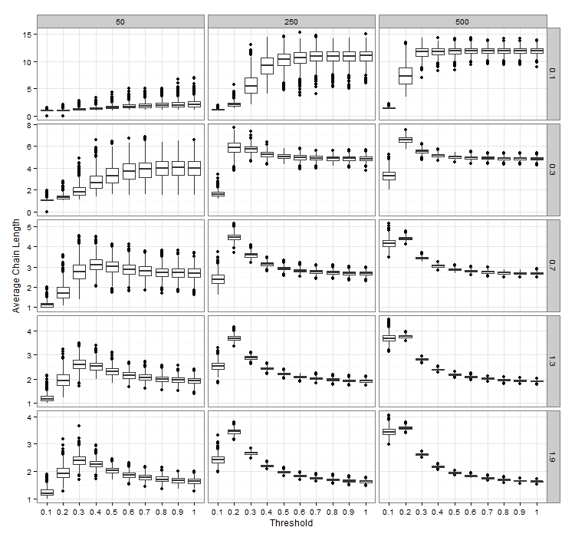

*Static Graph Approach*

Vacancy chain length was greatest when there were a large number of individuals, with moderate to high *threshold*, and a small swap window (upper limit minus the lower limit; **Figure 1**). We find that increasing the swap window size leads to shorter vacancy chains on average. Using small swap windows with alternative lower limits (different than simply >1*individual’s size) does not alter the result. An increasing *threshold* value also leads to shorter average chains, especially when there are more individuals and/or a larger swap window size.

Altering the spatial distribution and the distribution of resource values did not have a strong effect on average chain length (**Figure 2**). The impact of the swap window size was different for normal and lognormal spatial distributions than for uniform. In the former, the shortest chains were found for a smaller number of individuals and a large swap window. In uniformly distributed individuals short chains were found for larger numbers of individuals, but also with a larger swap window. For all simulations a higher *threshold* value typically meant longer chains, except with a large number of uniformly or normally distributed individuals.

Figure 2: Average chain length as it depends on the spatial distribution of individuals (across top) and the  
size distribution of individuals (down the right side)

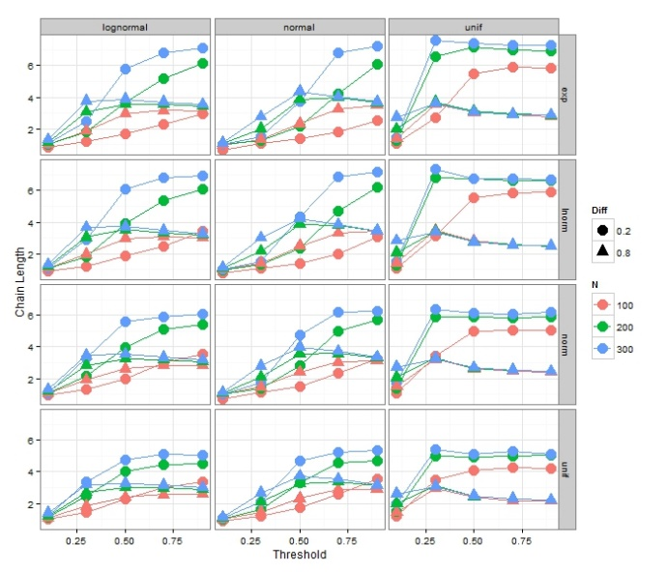

*Monte Carlo Simulations*

Figure 3: The median length of a chain starting with a unit sized based on different quantiles of the existing  
distribution. The left side is the result when there is a small standard deviation in unit size among the  
population, the right is with large standard deviation (1 for small, 10 for large). The simulation was repeated  
with 100, 200, and 300 individuals in the starting population

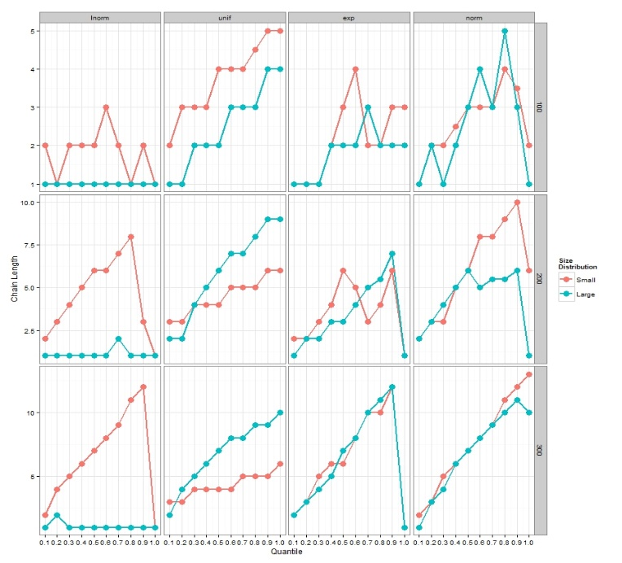

Figures:





