Assingment 2

The goal of this exercise is to build a model to predict the location of a swimming pool in a given image. The first step in this task is to understand the data given and how can it be used to predict where is the swimming pool in a given image. The dataset consist of 14.912 RGB images of size 512x512 that were extracted from Overpy. The second data piece that is relevant to our analysis is the json file that contains the information regarding the location of the image in a given file. This dictionary provides the latitudes and longitudes of the real image and most importantly the pixels of the edges of the polygon where the pool is located in the image. It may not be too obvious, but is necessary to consider that in an image, the x axis goes from left to right and the right axis goes from top to bottom.

Data preprocessing

For the task, we will use a Machine Learning approach by training a Convolutional Neural Network (CNN) given that we consider this an image classification problem where it has to be decided if a given input is or is not a pool. Also, because our images are RGB, a CNN is a good approach to model images and convolute them in order to get a probability for classification. The first issue is what to do with the raw images and the dictionary with the pixels information? At this moment it is not possible to train the network, some data processing has to be done. First, lets understand what is needed for the training of a CNN: it is necessary a set of images with labels 1 and another set of images with a label 0, split the dataset into training, testing and validation set, which will be used to train the network and try new images to validate the accuracy of the model.

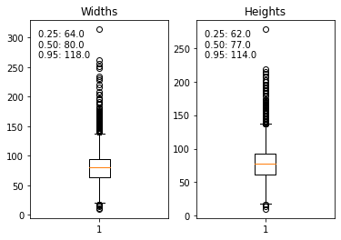
Figure 2.1: Distribution of height and widths of the images

The approach that we are going take is the following: with the dictionary, we are going to crop the pool images to a small image where there is only a pool, and four other images at each side of the pool (top, bottom, left and right) that do not have a pool. This way we create the two datasets with labels 1 and 0 respectively. The first decision that has to be made is the size of the cropped images by taking into account that the original size is 512x512. Figure 2.1 shows the distribution of the maximum heights and widths in the raw dataset., so by taking a look at the graph, we consider a cut point of 100x100. The disadvantage is that the prediction will work only with images where the pool is inside the chosen range, so it will not be possible to accurately detect a big pool. Nevertheless, this approach is a good way to simplify the exercise and we still can get good results. After the computation process of cropping the images, we get around 11.000 images that contain a pool and 44.000 images that do not contain a pool. Figure 2.2 shows a sample of how our new images look. Now we are ready to train a CNN

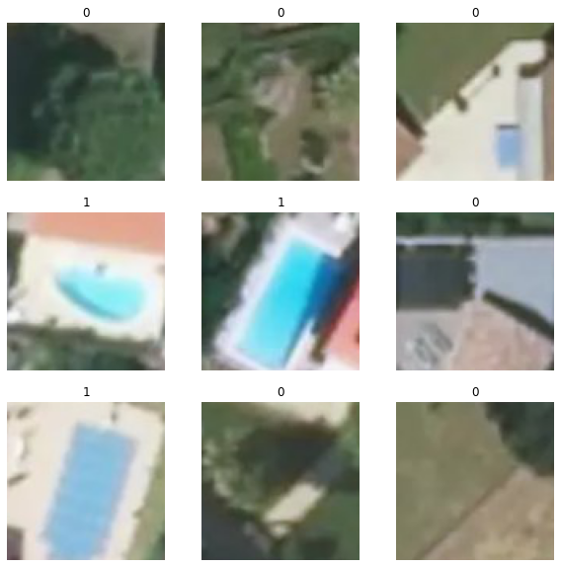
Figure 2.2: Sample of the input images

The model
The next step is to define an architecture of the CNN that will be trained. The way we decided is by researching different types of architectures that have been trained for similar tasks. We keep in mind that that the main purpose of the architecture is to go from a 100x100x3 input to a vector to which we can apply a sigmoid activation function. Between the hidden layers of the network there are data augmentation, rescaling and batch normalization function along with Relu activations, max pooling and convolution steps. At the very end of the networks we get a 4x4x1024 input to which we apply a Dropout to get a 1024 vector that will be used as the input of sigmoid function in order to get a probability if a given image is a pool or not. For the training we will use and Adam optimizer, a binary cross entropy loss function and an accuracy metric to validate the model. We chose tensorflow and keras to train our CNN in 50 epochs.
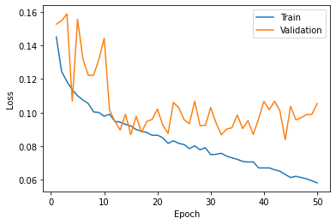 | 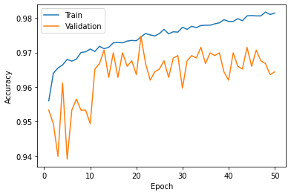
Figure 2.3 Loss and accuracy behavior in the 50 epochs

Figure 2.3 shows the behavior of the loss and accuracy for the train and validate dataset during the 50 epochs. For the test set the movement of the lines is expected: the loss will sequential drop and the accuracy will improve at every epoch. But since the images in the validation set are not used during training, the accuracy may not be improving with more training and the loss may start stop decreasing. Therefore, we pick the model that was trained in the 20th epoch because the accuracy was the highest and the loss is not too far from the minimum loss among the epochs.
In order to detect pools in a 512x512 image, we created a function to loop over the image and taking 100x100 sub images to pass them through the model and the sub image that gets the highest prediction will be consider to be the location of the pool. Figure 2.4 shows the result for 4 random images. It looks like the predictor does well in many cases, and even if the program only detects one pool, it seems that the classifier is doing the job. Nevertheless, there are some cases where the pool is not detected and some other object may get a higher probability to be a pool, like the case in the fourth image.
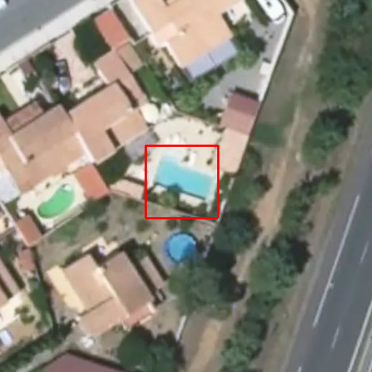 | 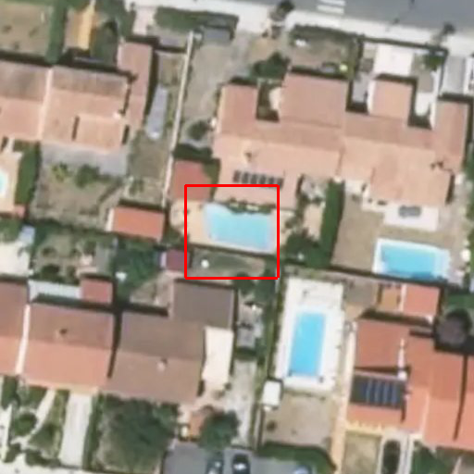
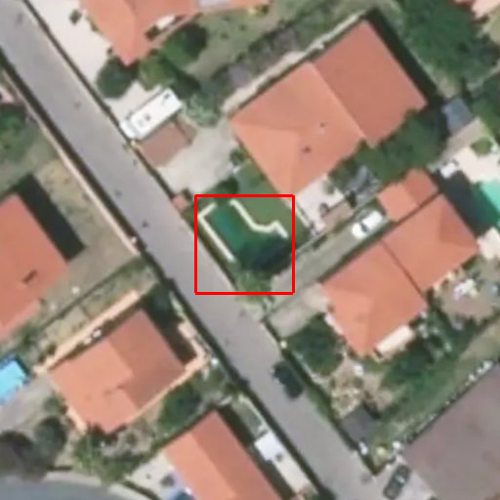 | 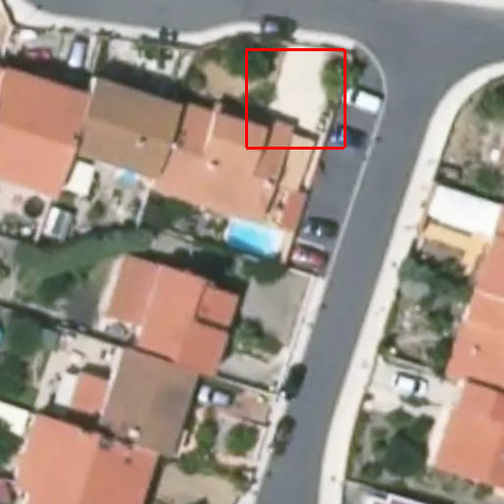
Figure 2.4 Pool detection for new images

