Advance Analytics Project

Assignment 4: GEPHI Assignment

Along with Facebook, Instagram, Twitter and some few others, TikTok may be the newest big social networks platform with over 1 billion users. Like other platforms, it is used to share short videos that can go from 1 second to 10 minutes, of different genres such as comedy, music, dance, etc, and when a video ends, another one will start playing automatically, creating an infinite loop that will end when the user decides to close the app. Even if it was launched in 2016 by Bytedance, it was during the middle of 2019 that its popularity increased substantially not only in China, but also in the rest of the world.
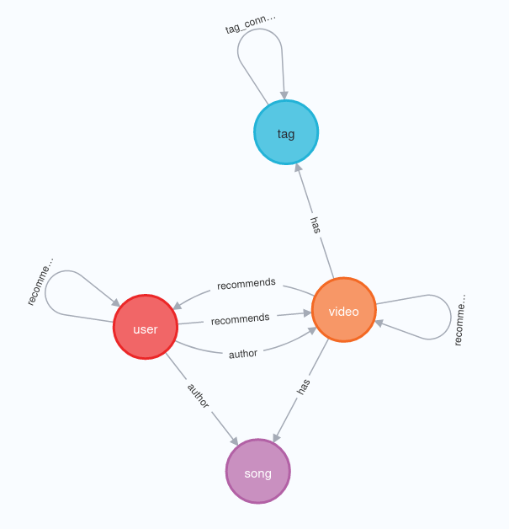
Figure 4.1 Schema for TikTok graph

After Russia decided to invade Ukraine, the war started to be a trending topic in the platform. Similar to other trends, users were uploading different type of clips like journalism, showing how war was affecting their daily lives, creating comedy content, fake news and some others. With the help of an unofficial API and using Selenium scripts, a Graph Database was provided with content regarding the Russia-Ukraine war. With the use of neo4j, we can take a look of how are related the different “objects” in TikTok, which can be users, videos, tags, etc. First, it is important to understand the schema of the database to define a start point and where to from there. Figure 4.1 shows the schema for this data set. As same as in the platform of mobile app, it is possible to see that there are Users, Videos, Songs and hashtags that are connected (e.g, a User authors a Video). The goal of this assignment will be to understand what type of content related to the war has been uploaded in the platform (or at least in the available database).
Node | Count |  | Relation | Count
Video | 137.319 |  | has | 715.903
User | 127.224 |  | author | 189.705
Tag | 77.146 |  | tag_connected | 4.004
Song | 85.586 |  | recommends | 228.389
Table 4.1 Size of the graph

We start our analysis by taking a look at the size of the graph in Table 4.1. From the schema, we can see that Video has has relations with song and hashtag, and the from the table it is clear that there are way more relations than nodes. This indicates that for each of the 77k tags, we can find many videos related to the same tag or tags. The other interesting tag if recommends, which is present relations between different types of nodes, so it is necessary to be specific which type or relation we are looking for, this is because videos that suggest other videos may take us in a different direction than taking a look at the videos of user that were suggested by other users.
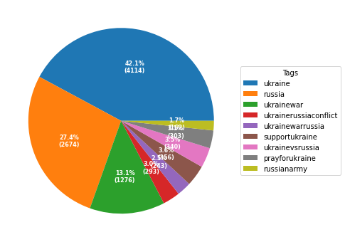
Figure 4.2 Video count for each hashtag

As suggested, our starting point will be the hashtags that were used to create the graph, which also for obvious reasons are the tags present in most of the videos. Figure 4.2 shows the amount of videos in which each tag appears, so this means that if a video has all of this tags, it will be a plus 1 for each tag. The first two items on the list are too broad because it may refer to something out of topic like life style, food, traveling, etc, so our approach will be to start with the tag ukrainewar, so let’s take a look at the videos that contain this hashtag.

