# Diagrams

## Use Case

This use case includes the use cases U1 through to U5.

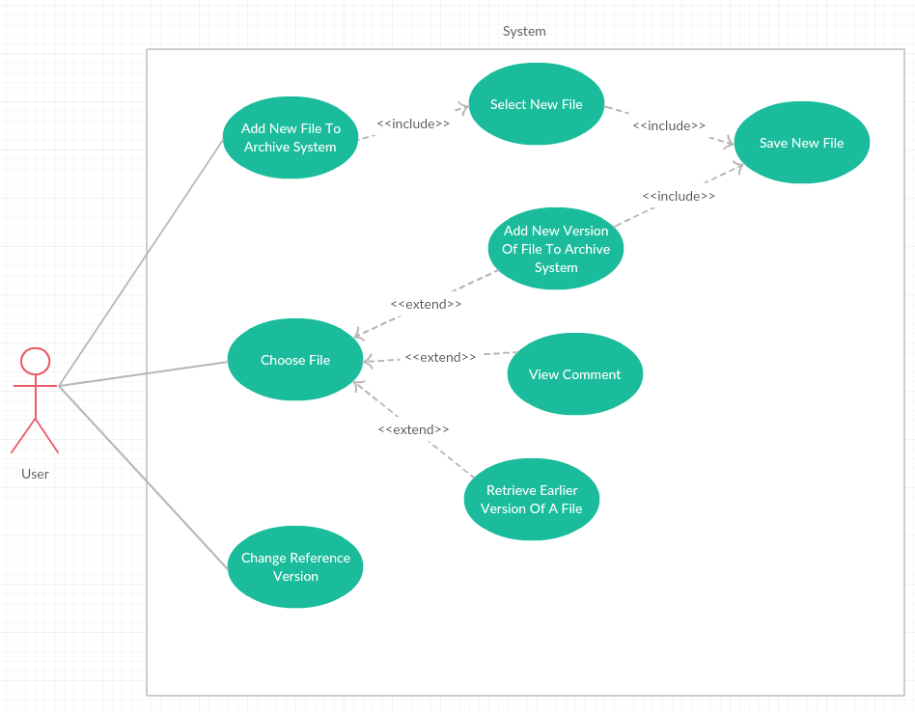

## Sequence Diagrams

## The sequence diagrams will highlight how the system uses its classes to work together.

### Adding the initial file to the FileArchiver System.

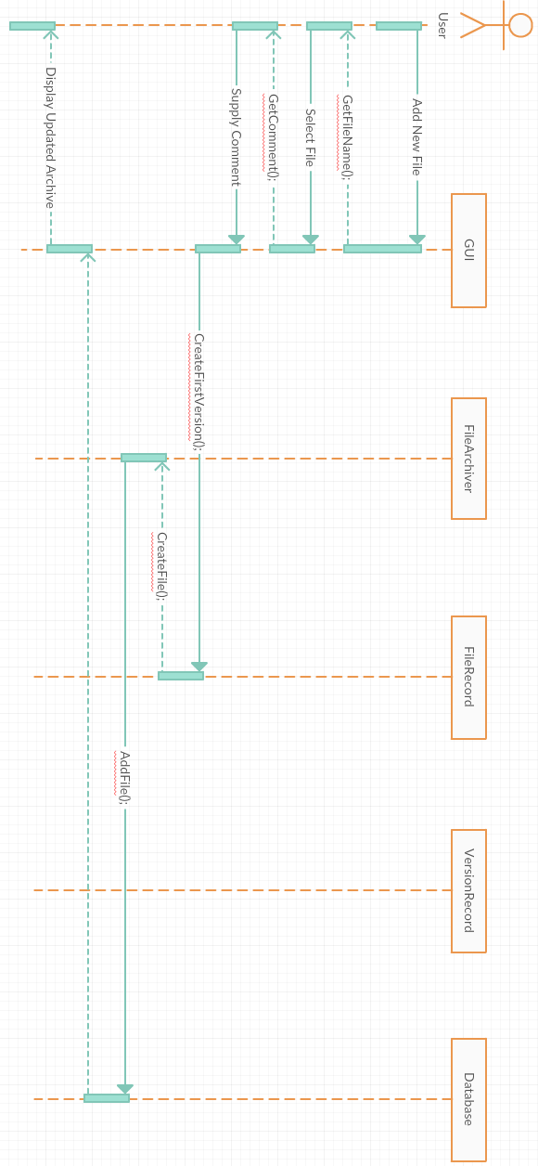

### Updating a current file in the system.

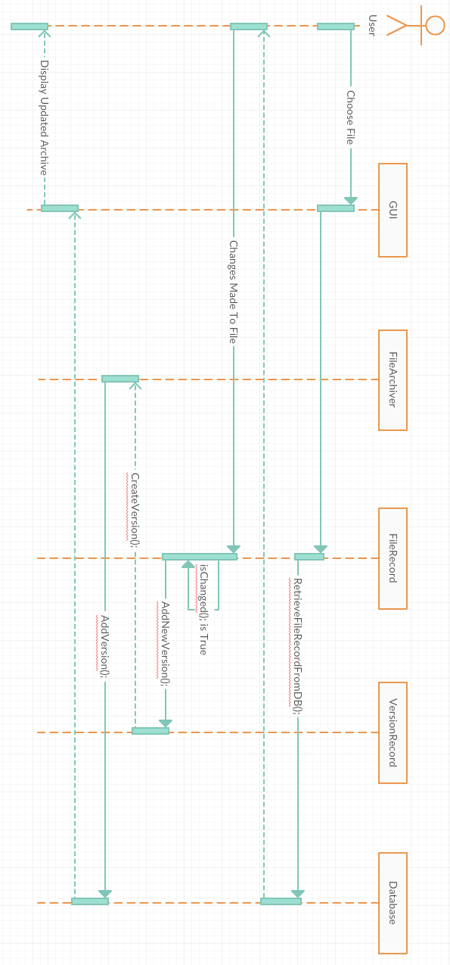

### Retrieving A Current Version and Setting as Reference

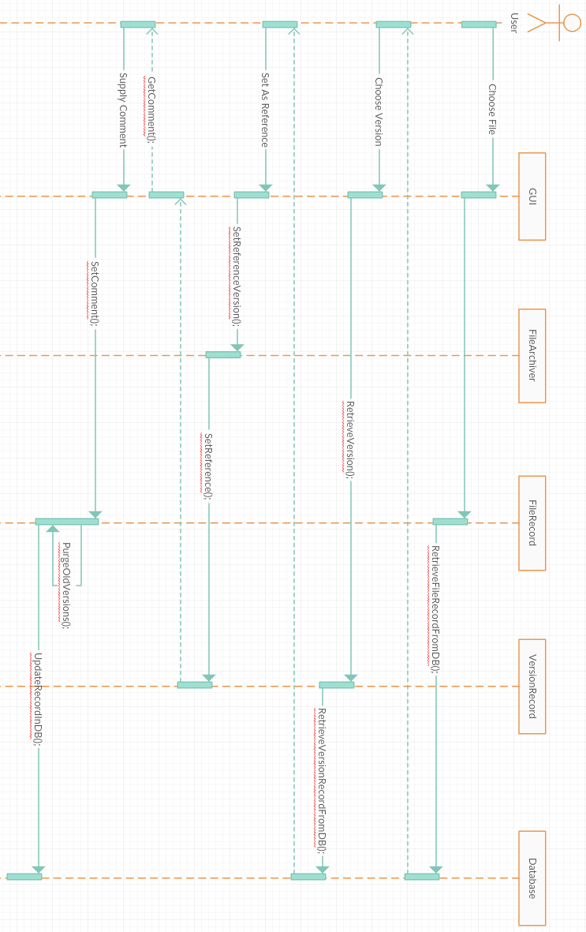

### Attempting To Save Without Having Made Changes

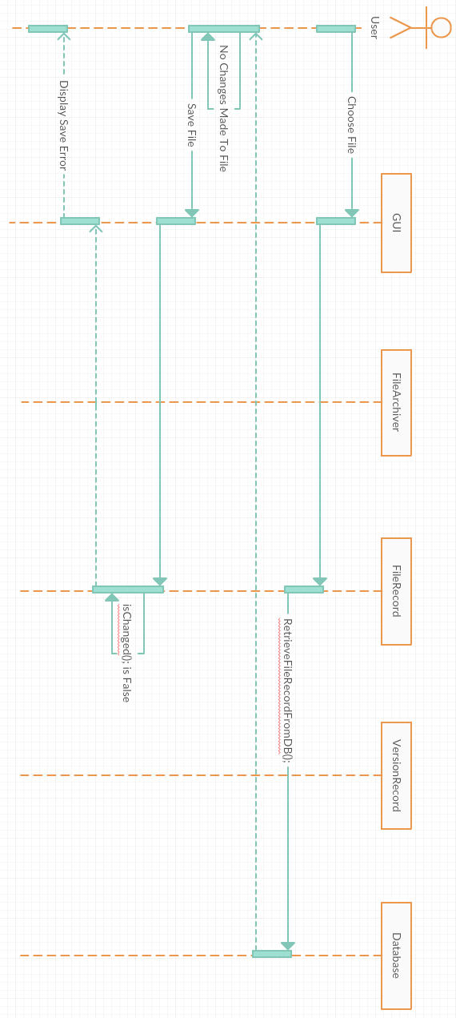

### Viewing The Comment Of A File

