**Program Presentation**

**List of the features**

1. Adding files to persistent storage

- create initial archive

- user supplies a comment with new version

- program compresses given file/data to minimize storage space

2. Save modified version of the file

- detect changes if made in the current file

- get comment from the user and create new version

- program only saves changes that were modified since the previous version that was archived

3. Display summary details of versions in storage for selected file

- version number, date, size

4. Retrieve chosen version of the file

- program retrieves chosen version in the directory and file name specified by the user

5. Discard old

- set reference version to delete versions not needed anymore

6. Show comment associated with version

**Usage**

The initial main window gives user an option to select file with “Select File” button.

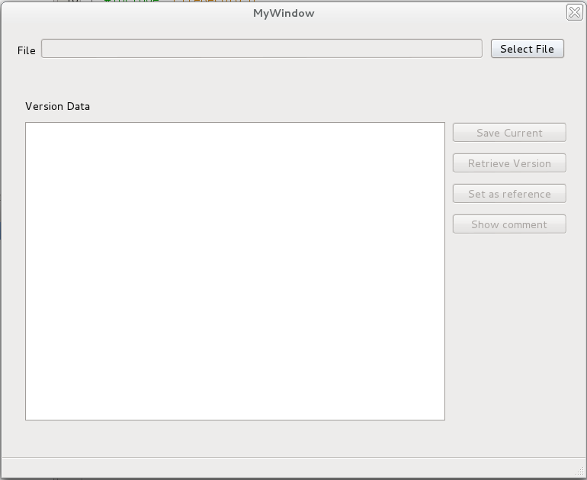

After clicking on “Select File”, the choose file window will appear for user to select file select the file and shows the path chosen.

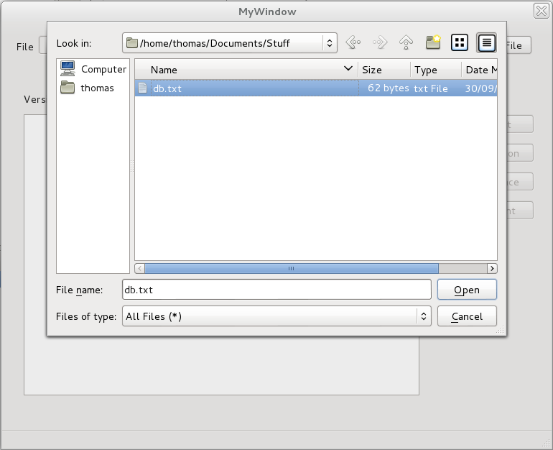

If the file is already saved in the persistent storage, saved versions of this file will be shown in the table.

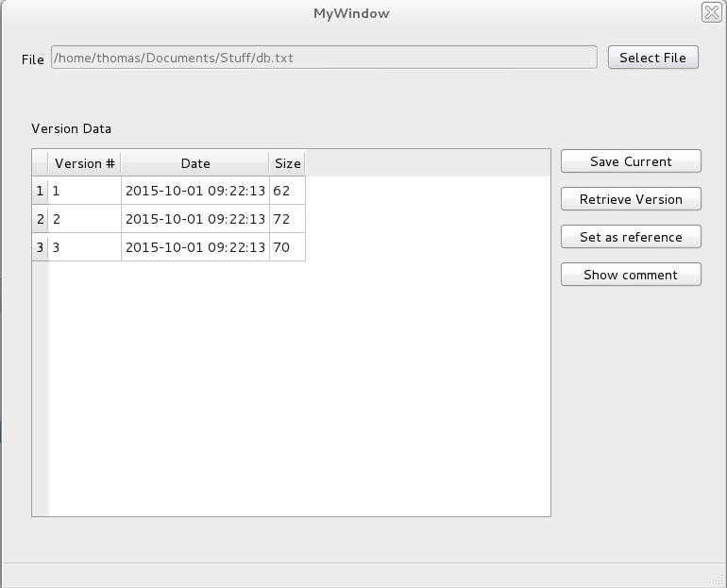

Otherwise, the program will create initial version in the database and ask user for the comment to go with the initial file version.

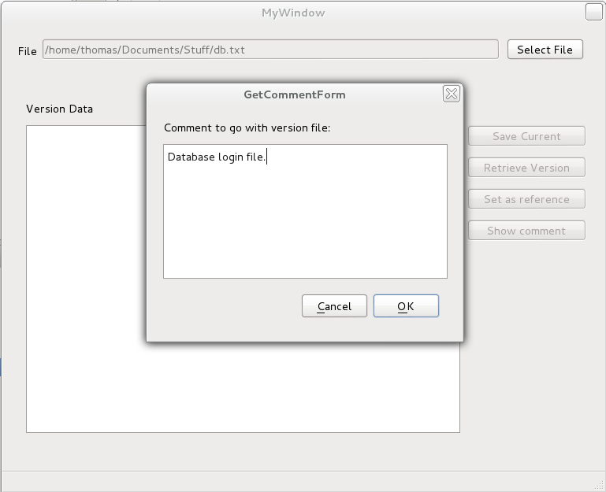

If the user attempts to save the current version of the file that has not been changed since the most recently updated version, the message box will show up to inform the user that there is no need for saving the current version.

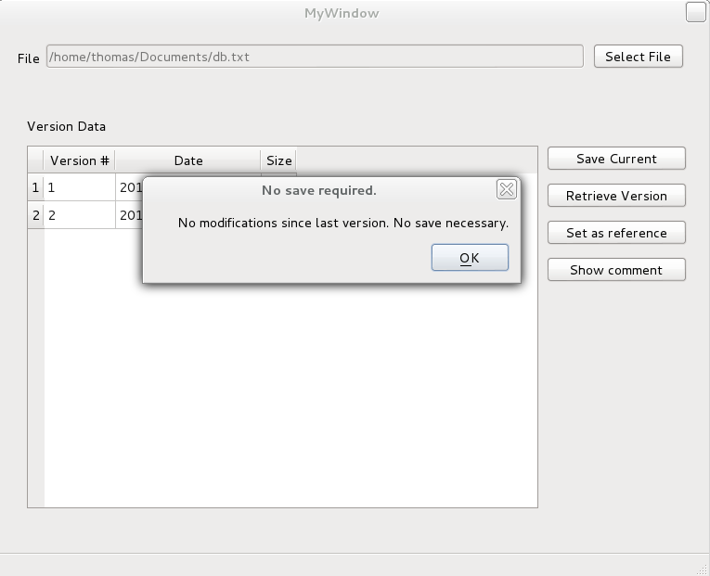

In case the change in the current version was detected, user will be asked to supply the comment for the new version and the new version of the file will be displayed in the table.

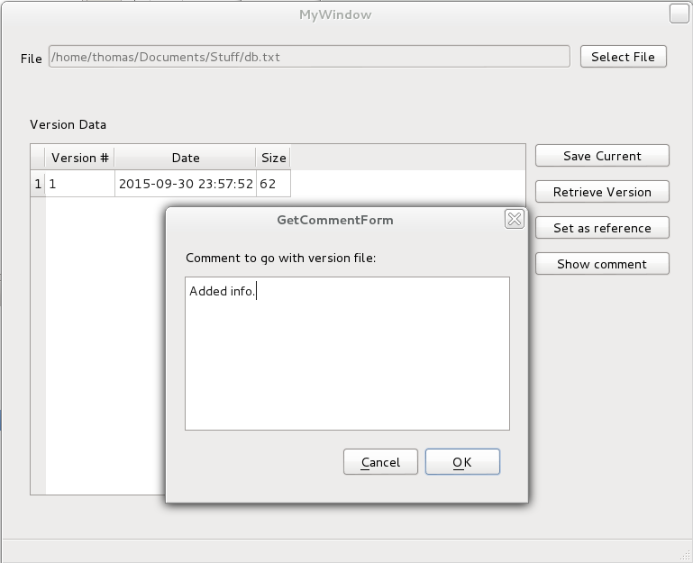

Retrieve version button provides user the option to retrieve the version of the file that is selected in the table view. If the file version to be retrieved was not selected in the table, user will be informed.

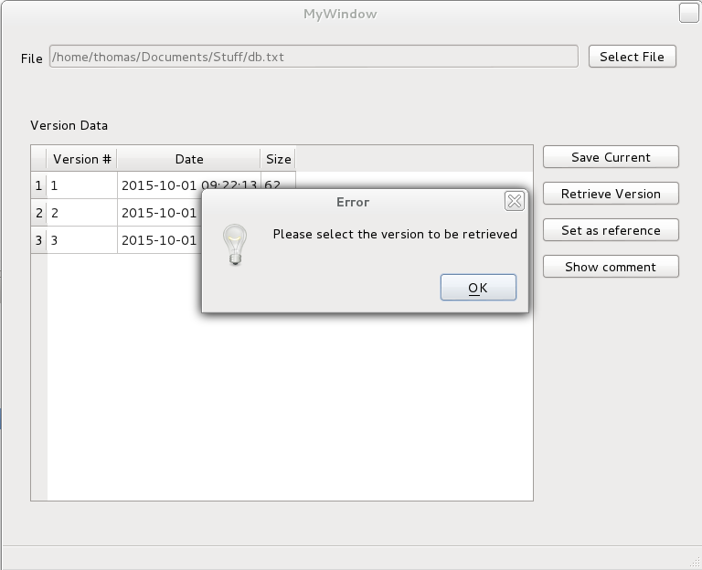

Otherwise, the retrieve form dialog will show up asking user to specify the directory where the retrieved version will be saved, along with the filename.

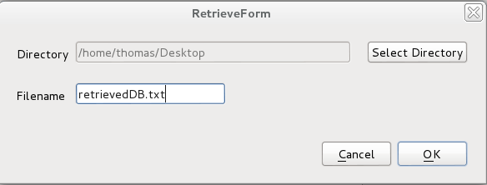

Set as reference option allows user to select version that will be used as a reference to delete all previous versions of the file that are not needed anymore. The program will ask for confirmation to proceed with deletion.

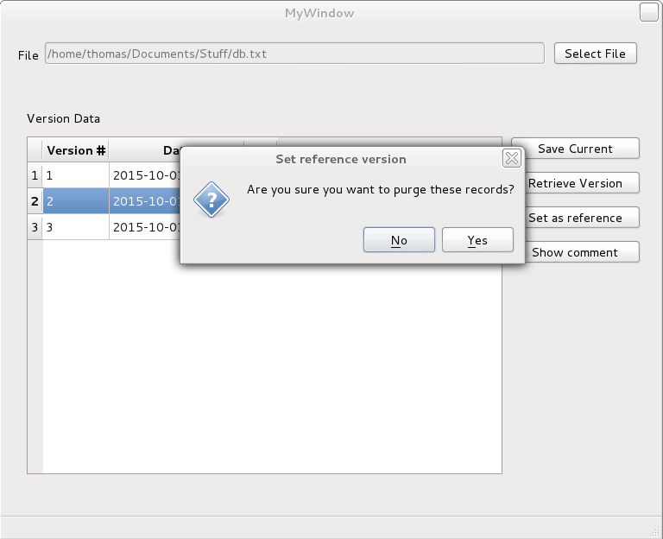

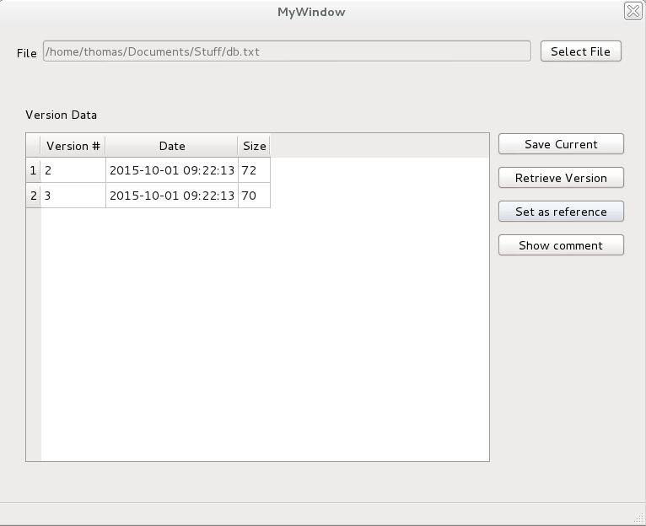

In case the reference version is not selected in the table, the program will notify the user.



If a user wishes to view the comment related to specific version, Show comment button will invoke the information dialog with the comment of the selected version.

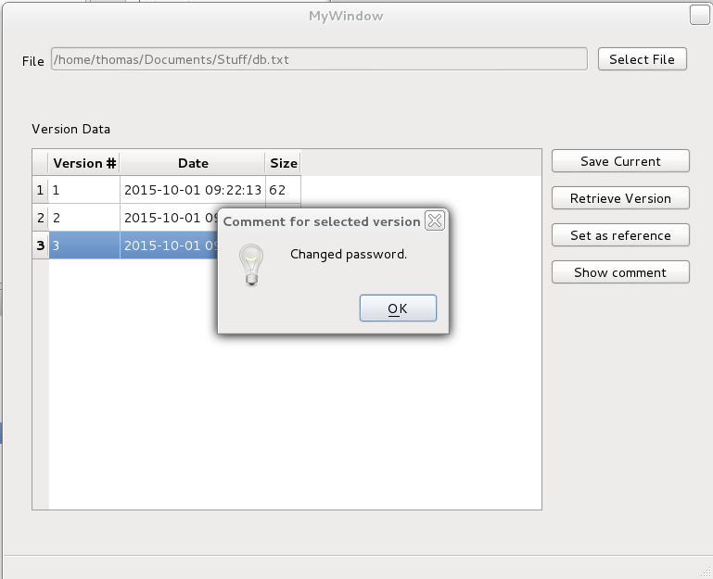

In case the user did not select the version, program will notify the user.

