**PROCEDURE**

1. This lab is different from the labs you have completed previously. In this lab, you will improve your critical thinking skills. One goal of this lab is to learn about experimental error, both how to identify and quantify it, as well as how reducing error affects your data. Understanding these aspects of error will lead to a deeper understanding of your data, which is another goal. Understanding error in data is a skill that applies to all scientific fields of study, and one you will learn or have already learnt about in other classes. You will make measurements and analyse your data; then, you will assess your error, correct for this error, redo the measurement, and then analyse what changed. As you proceed, keep an eye out for possible sources of error. Do not try to obtain perfect data. You will not be told explicitly how to record certain measurements, and so you should use your best judgement.
2. In this lab, we will be interested in the bicep gauge only, and not the other gauge. Remove the forearm bar completely. The biceps tension-compression gauge is now suspended vertically so you can hang masses from it. **To help prevent injury, use the small keeper ring with the thumbscrew on the short right-angle section to prevent the masses from falling off or the apparatus from suddenly dropping and keep your feet away from the area beneath the weights at all times.** Notice that you can zero the scale by rotating the knurled ring at the top of the gauge.

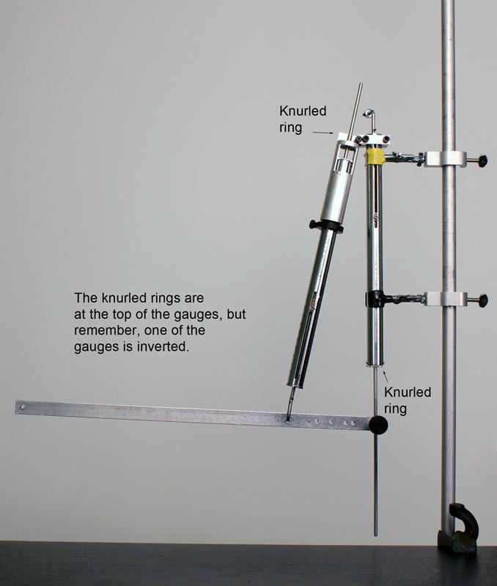

1. Hang one to four 1-kg masses from the gauge in increments of 1 kg. Note that there may be some friction in the gauge. Discuss with your partners whether you think this will be a source of error in using the gauge to measure forces. You may need this knowledge in a future step.
2. You will only be using the bicep attachment hole farthest from the elbow hole in this lab. Measure the distance between the elbow hole and this bicep attachment hole, as well as the distance between the elbow hole and the mass hanger hole at the “hand” end of the forearm bar. Record these values.
3. Measure the mass of the forearm bar without the upper-arm attachment piece, and record this value.
4. Adjust the knurled rings of the gauges so they read zero with no weight attached. Arrange the apparatus as shown in Figure 1, with the biceps gauge attached to the farthest hole from the elbow, which is approximately 12 cm from the hole through which the upper-arm gauge passes. When clamping the forearm gauge, make sure the pointer can move freely through its range and is not obstructed by the clamp jaws. Use the small keeper ring with the thumbscrew on the short right-angle section to retain the biceps gauge in position. Attaching the 50-g mass hanger to the end of the forearm bar, add masses in increments of 100 g up to 550 g, and record the readings of the two gauges. As you change the masses in the “hand,” adjust the position of the upper-arm attachment point at the “elbow” so the bar comes to rest in a horizontal position. You may need compress the upper-arm gauge forcefully when before tightening the attachment in a position that will keep the bar horizontal when using heavy weights.

If you find that there seems to be an unusual amount of friction in your scale readings, check that the scales are not twisted in their clamps. All persons doing experiments in the real world soon realize that nature can be difficult, and not everything works as it is supposed to or according to the simple instructions. This principle has been canonized in variations of Murphy's Law: “If anything can go wrong, it will,” “Nature sides with the hidden flaw,” etc. Throughout this lab series, you will often need to use common sense and resort to your own ingenuity to get through the parts that don't seem to work quite right. Ask your TA for assistance when necessary, but first try to solve the problem yourself. Gradually, you will learn to proceed with confidence that you are doing to make the experiments work and yield good data.

1. With a total mass of 150 g hanging from the end of the forearm bar, take readings from the bicep gauge. Each time you adjust to a new position, make sure the bar is horizontal.
2. Make a neat graph of the biceps force *B* as a function of the hand weight *H* in the “Data” section. Label the axes with units. Construct the straight line predicted by Eq. [(6)](http://demoweb.physics.ucla.edu/content/experiment-6-biceps-muscle-model#mjx-eqn-eqn_3).
3. Pick one of the weights you included in your measurements and hang it on the arm as before. Obtain the angle *α* from tan *α* = *x*/*y* (you already know the value of *x*, but will need to extend the lines of the gauge rods to determine the value of *y*). Find *α* from your graph. Eq. [(6)](http://demoweb.physics.ucla.edu/content/experiment-6-biceps-muscle-model#mjx-eqn-eqn_3) is derived assuming the angle of *α* is the same for each weight. Is this true in the real experiment?

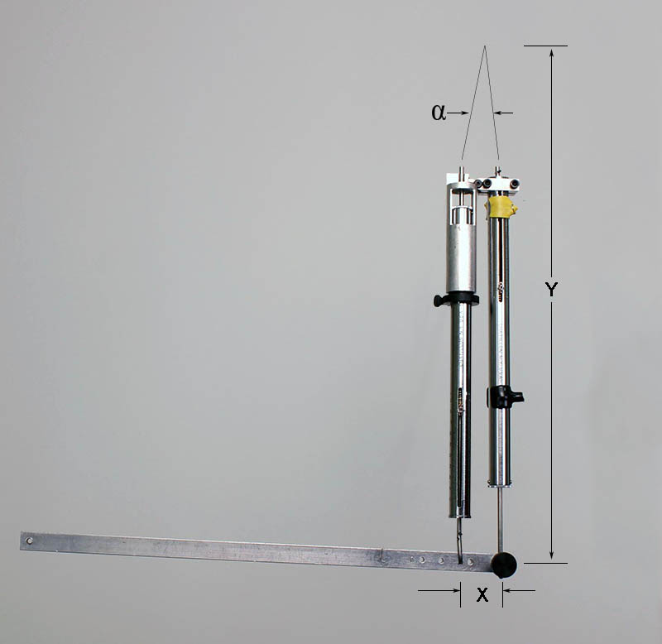

1. You will now be improving the accuracy of your previous force vs. hanging mass relationship. This will involve some creativity on your part. Identify two significant sources of error. One of these sources of error must be something which would affect either the slope or the intercept of the graph. This will involve thinking about each of the measurements you have performed up to this point. You may want to separate the components of the apparatus and play with them.
2. Your data is linear. Sources of error in your data may affect the slope, intercept, or how well a line fits the data. For each of these sources of error, record:
   * 1. Is your measurement of the relevant quantity likely too low, too high, not precise enough, or inaccurate in a way that is difficult to determine?
     2. Why do you think correcting this error will improve the data significantly?
     3. How would this affect the slope, intercept, and goodness of fit? If correcting the error affects the slope or intercept, explain whether it would increase or decrease them.
3. Some errors are inherent in the equipment. Despite this, you can often find a way to minimize this error by performing an additional step with the existing equipment. Devise a method to significantly reduce the error from each source. For each method, record
   * 1. The method
     2. Why this method reduces error
     3. Why this reduction is a significant improvement.
4. Using both methods, record a new data set and plot it against your old data set. Provide the linear fit.
5. Did your predictions of how the error would affect your data hold true? Does your data seem more accurate? Answer this last question in a quantitative way of your choosing.
6. Imagine performing the bicep measurements with the bicep gauge attached at different holes. In such an experiment, what would be the largest value of *P* (the horizontal force exerted by the upper-arm tension-compression gauge) that would have arisen in your measurements be? Refer to the introduction for how to calculate this.
7. People who “work out” regularly with weights can “curl” 25 to 50 or more pounds with one hand (i.e., they can take the weight in one hand held horizontally and raise it to their shoulder). The actual biceps muscle attachment point is approximately 5 cm from the elbow. How large a force would the biceps muscle be exerting when one “curls” 50 pounds?
8. Should the force on the second gauge, which we have omitted until now, depend on how far up the arm the bicep is attached? Specifically, does it increase or decrease with increasing distance?

Lab modified by Allic Sivaramakrishnan