**Print Feature in WinForm**

1. 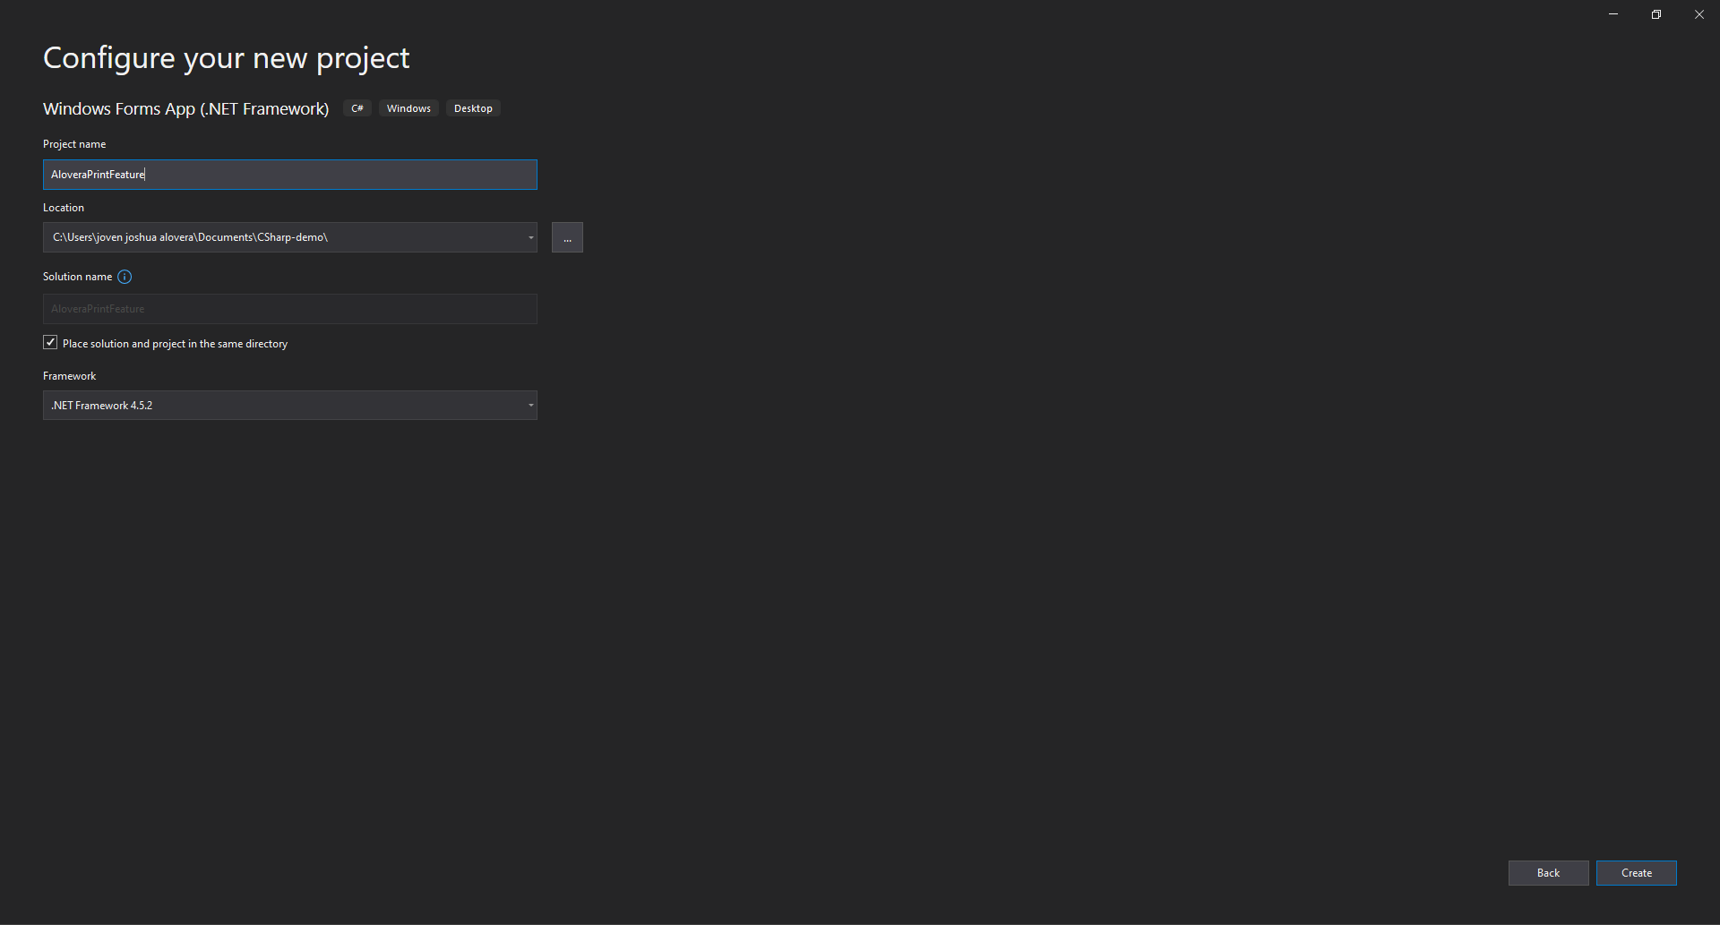 Create a new project and name it with your last name. (e.g., LastnamePrintFeature).
2. 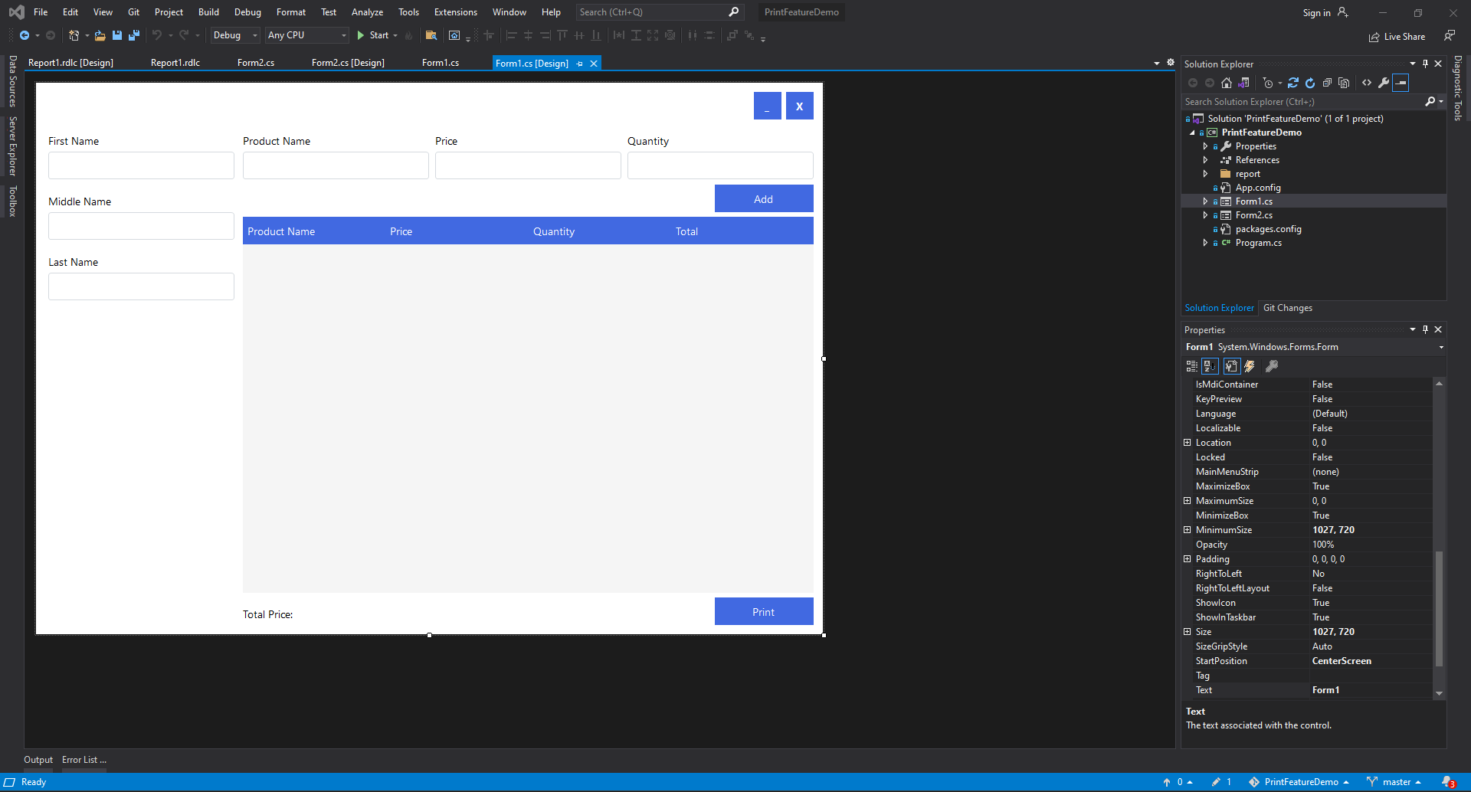 Design your Form1.
3. Find the extension located at the top of the IDE, click it, and select Manage Extensions.



1. In Manage Extensions, search the reporting services. After searching, select the Microsoft RDLC Report Designer and download it. The one with the green check in the picture.

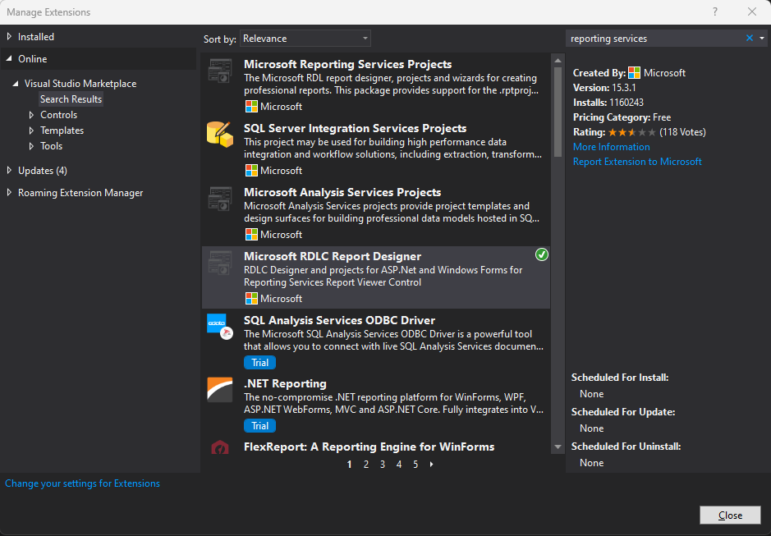

1. After downloading the Microsoft RDLC Report Designer and restarting your VS2019 or VS2022, in Solution Explorer, right-click your project and go to Manage NuGet Packages.

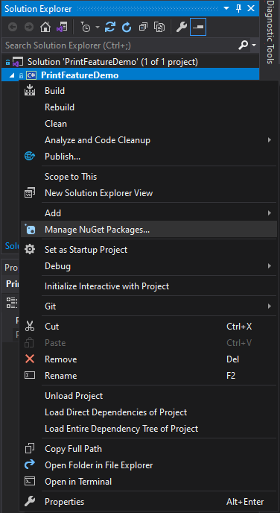

1. In Manage NuGet Packages, download these two packages by Thiago Fialho. After downloading, make sure to rebuild your project. To rebuild the project, see the previous picture. You will see "Rebuild" when you right-click your project; that’s how you rebuild your project.

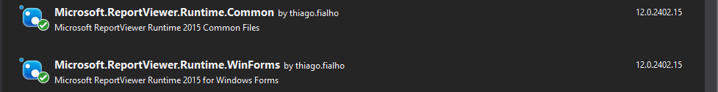

1. After doing this step from 1 to 6, in your toolbox, you will notice there’s a new tab called Microsoft SQL Server with Pointer and ReportViewer.

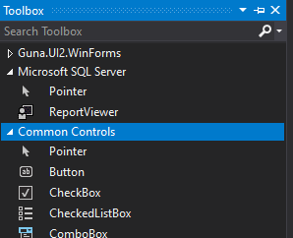

1. Add a new form, which is Form2. In Form2, add the ReportViewer.

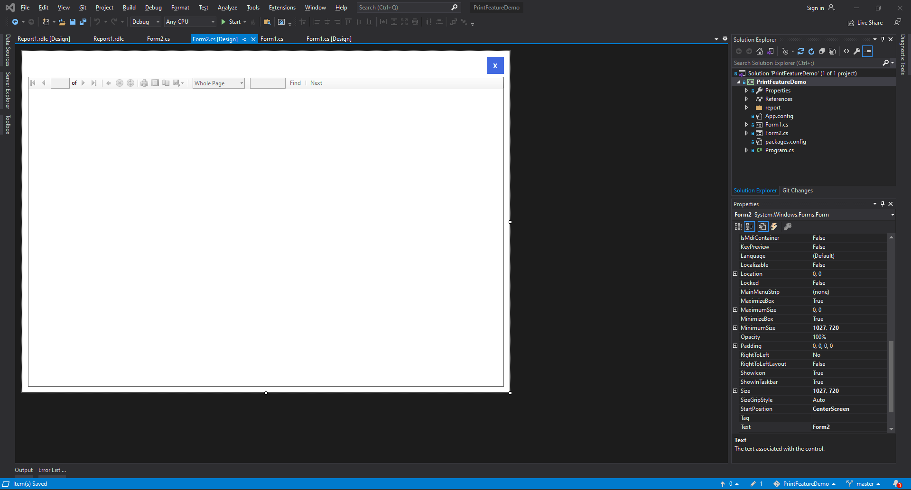

1. After adding ReportViewer to Form2, create a rdlc file to design your report. To create a rdlc file, right-click your project in Solution Explorer, go to Add, and click New Item.

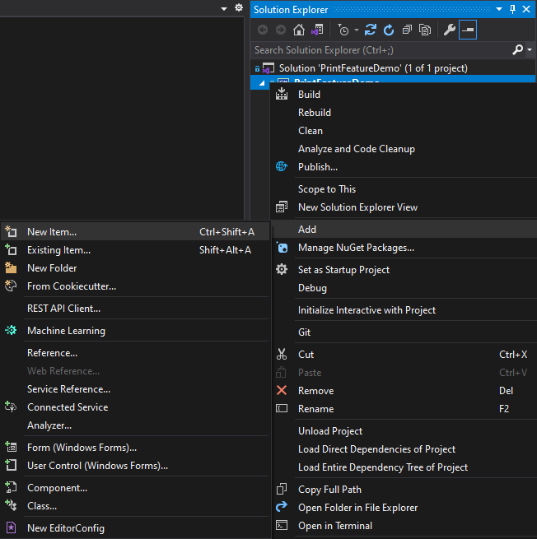

1. In Add New Item, find the "Report" Visual C# Item.

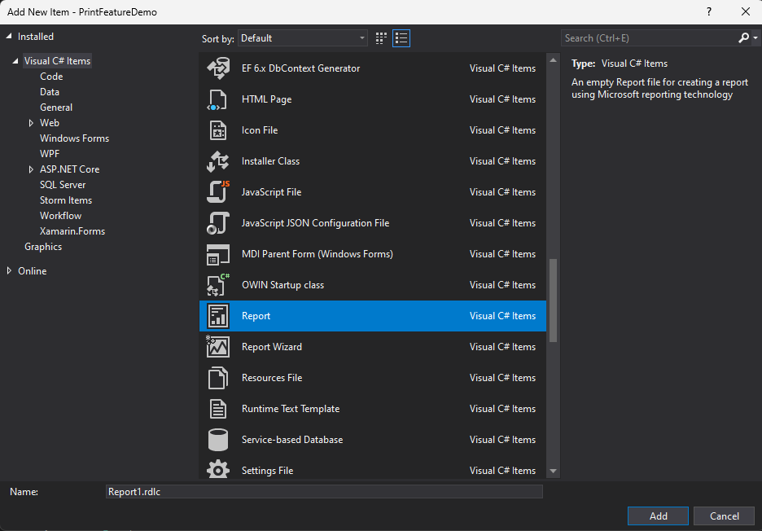

1. After adding the report, you can now design your report. To design your report, click on the toolbox to add a textbox, table, line, etc. same process as designing your UI.

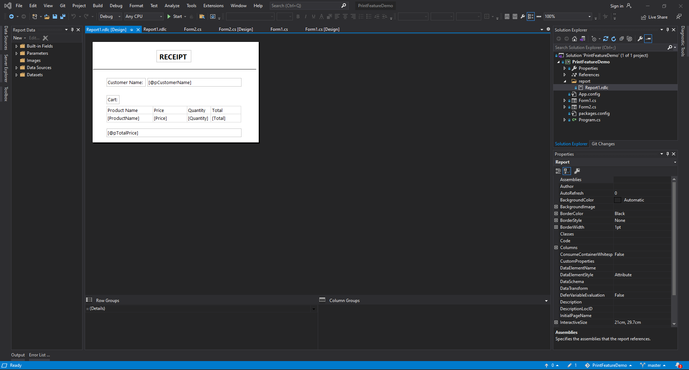

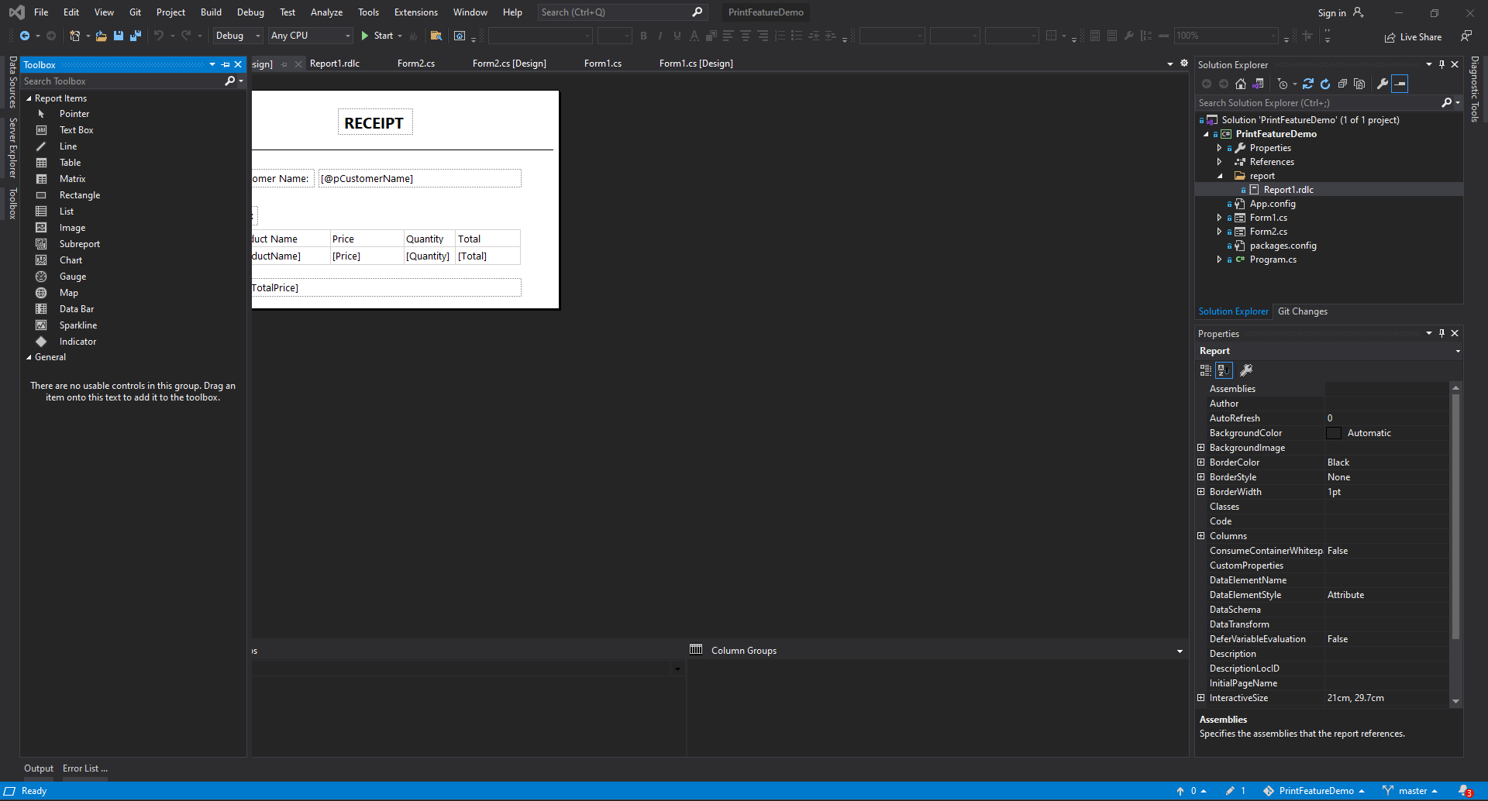

1. By passing a value from a textbox, label, or any item from the form to the RDLC report textbox, like the customer name and total price, add a parameter. To add a parameter, go to Report Data, right-click on the Parameters folder, and select Add Parameter.

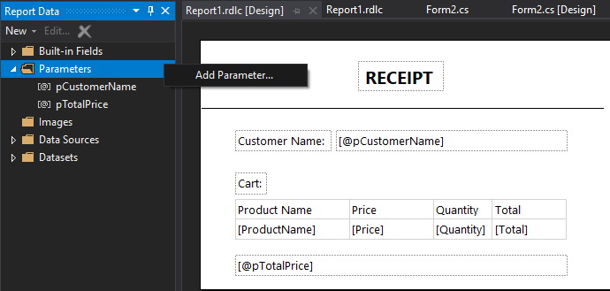

1. While adding a parameter, rename your parameter, and you can change the data type of the parameter if you want. Expect an error if you change the data type. To change the data type, make sure the data type is the same as the data type in the form. After adding a parameter, you can now place it in a textbox in the RDLC report by clicking and dragging.

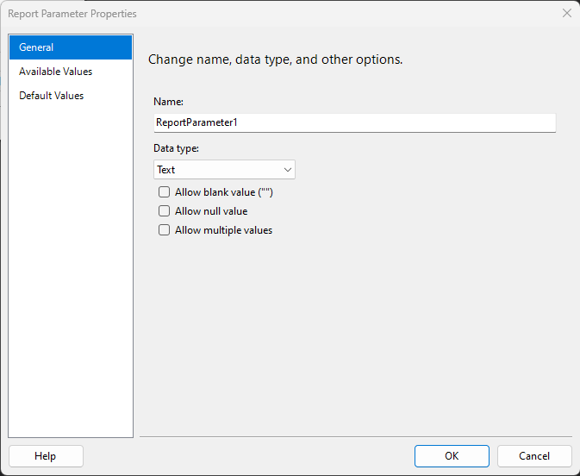

1. By passing a value from the form to the RDLC report table, create a public class in Form1. It’s your choice what the name of your public class is. In the picture, the name of the public class is "Cart". The public class "Cart" contains four columns: product name, price, quantity, and total.

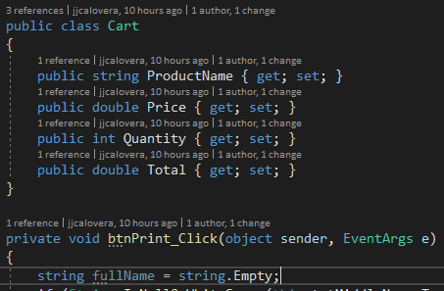

1. The public class Cart is where we're going to store the data from the datagridview pass to the table in the RDLC report. To add a parameter of public class Cart to the RDLC report table, go to Datasets in Report Data in the RDLC report, right-click the Datasets folder, and click Add Dataset.

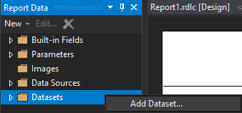

1. After clicking Add Dataset, click the "New" button.

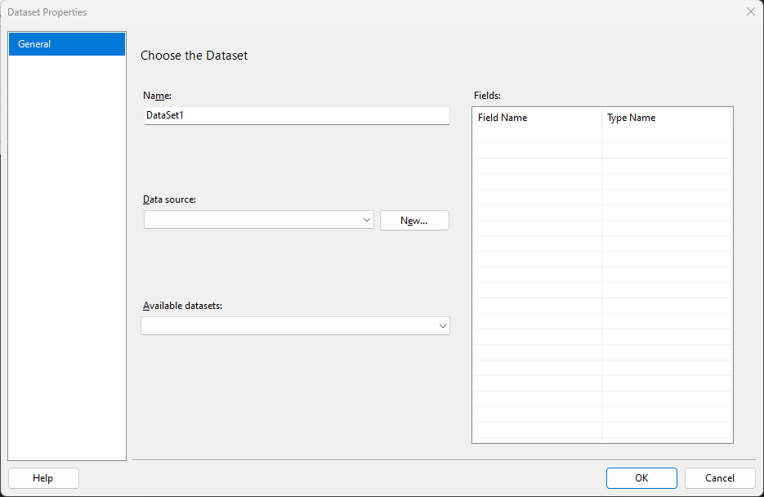

1. After clicking the new button, choose the object for the data source type, or where the application will get data from, and click next.

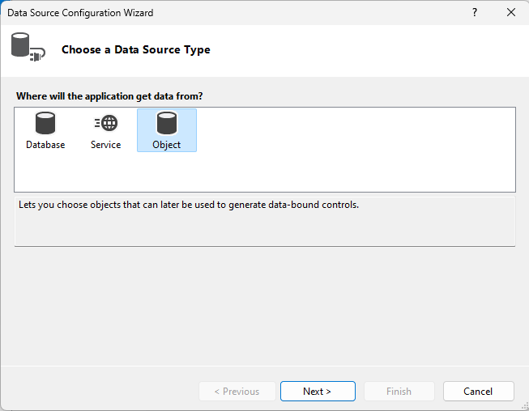

1. Find or locate the cart object to bind to, and click Finish.

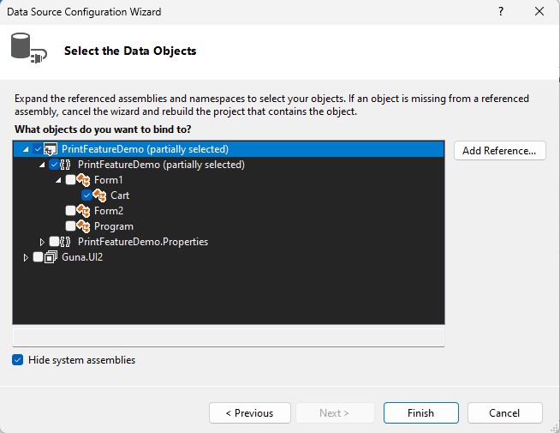

1. After clicking finish, it shows the fields or columns of the object. Before clicking "OK", rename your DataSet1 if you want to.

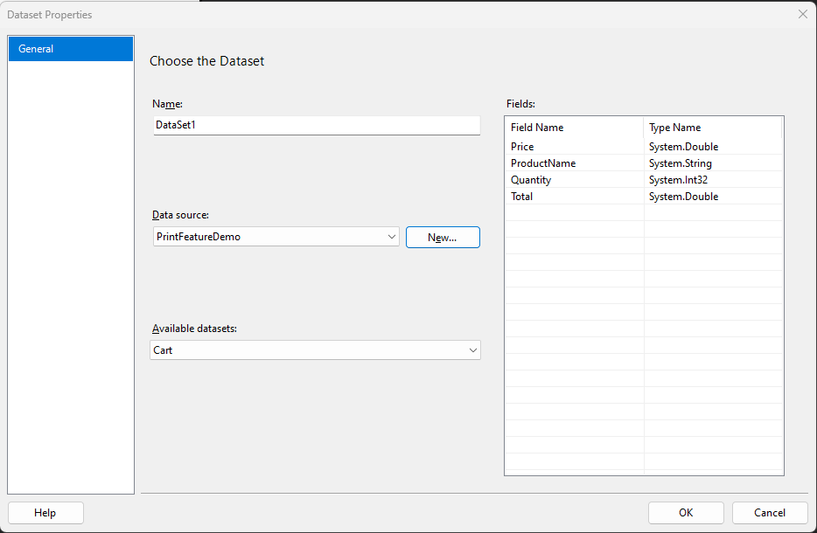

1. You have a dataset with fields or columns inside the datasets folder; all you have to do is place a table in the designer and click and drag every field or column of the datasets into the table.

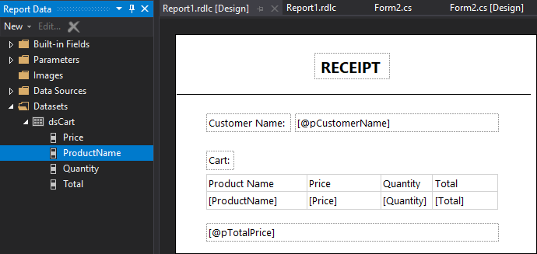

1. After designing the report, including the parameters and data source, right-click the rdlc file in Solution Explorer and open with the XML (Text) Editor. Do this every time if there are changes to the report design.

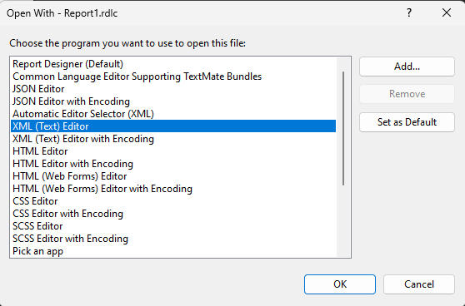

1. Once the XML (Text) Editor is opened, find the report tag with xmlns. We will change the version of the report due to a lack of updates and an incompatible version. We will change the year from 2016 to 2008 in the report tag with xmlns. Do this every time if there are changes to the report design.





1. After changing the year, find the ReportSections and ReportSection tags. Remove them without removing the data inside of these tags. Do this every time if there are changes to the report design.

 

1. After removing ReportSections and ReportSection tags, find the ReportParametersLayout tag and remove it including its data. Do this every time if there are changes to the report design.

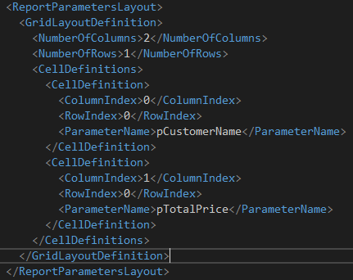

1. After removing the ReportParametersLayout tag, in Form2, in the ReportViewer item, there is a small arrow button; click it and choose report. Choose the RDLC report you designed for this report.

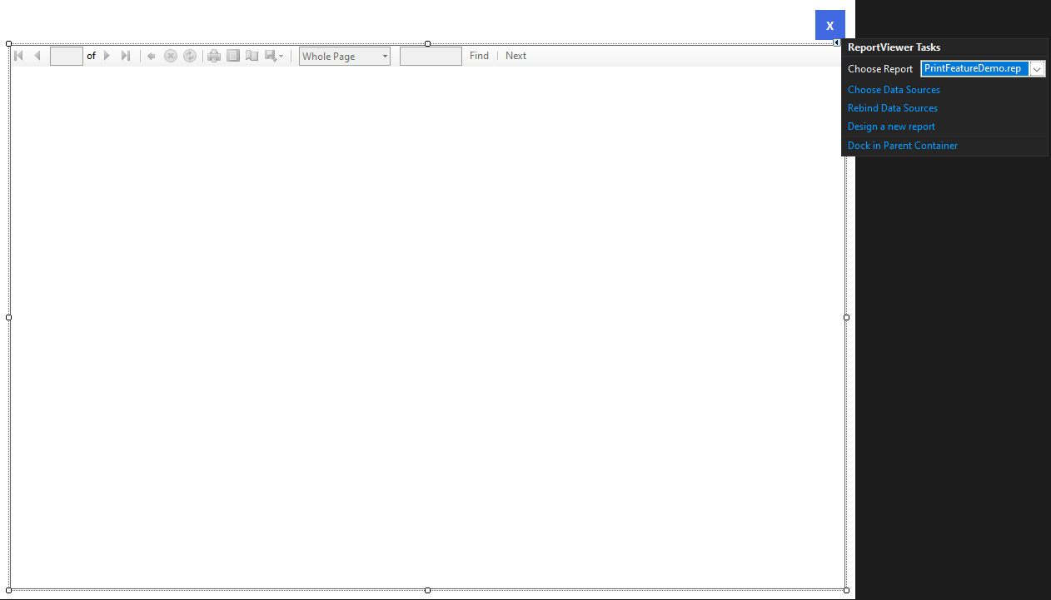

1. To pass the value from Form1 to the RDLC report in Form2, these are the codes. When the Print button is clicked, this is what the application will do. Before doing the coding in the btnPrint_Click event, make sure to add the using Microsoft.Reporting.WinForms at the top.

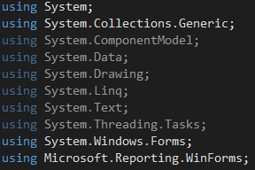

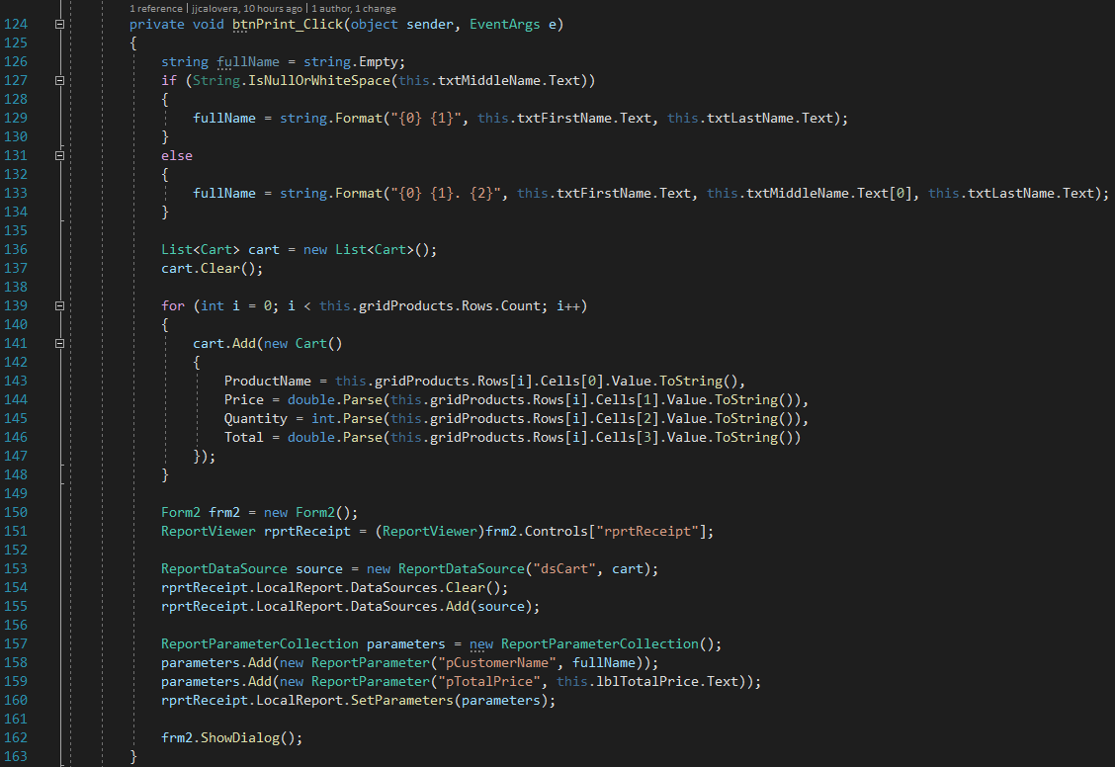

**Assignment**

Redevelop or recreate this print feature project and name it with your last name (e.g., LastnamePrintFeature).

A few changes must be made:

1. Form1 and Form2 should be placed in a folder named "forms."
2. Add a textbox in Form1 for the cash and change, and add a button to calculate or do the payment transaction. Payment transactions will never be made if the datagridview is empty and the cash field is blank. It must show a message box saying that fields are required.
3. In the print preview or report, add the cash and changed values, like the customer's name and total price shown in the example.
4. A product will not be added to the datagridview if the product name, price, and quantity fields are blank. It must show a message box saying that fields are required.
5. Form2 cannot be opened or shown if the customer's first name and/or last name fields are blank.

**Deadline:** Monday, May 22, 2023. Until 11:00 p.m.