**Print Data from Database Feature**

1. Create a new project called Windows Form App (.NET Framework) and name it "PrintFromDatabaseLastname" (e.g., PrintFromDatabaseDelaCruz). Always remember that when you name the project, there is no space.

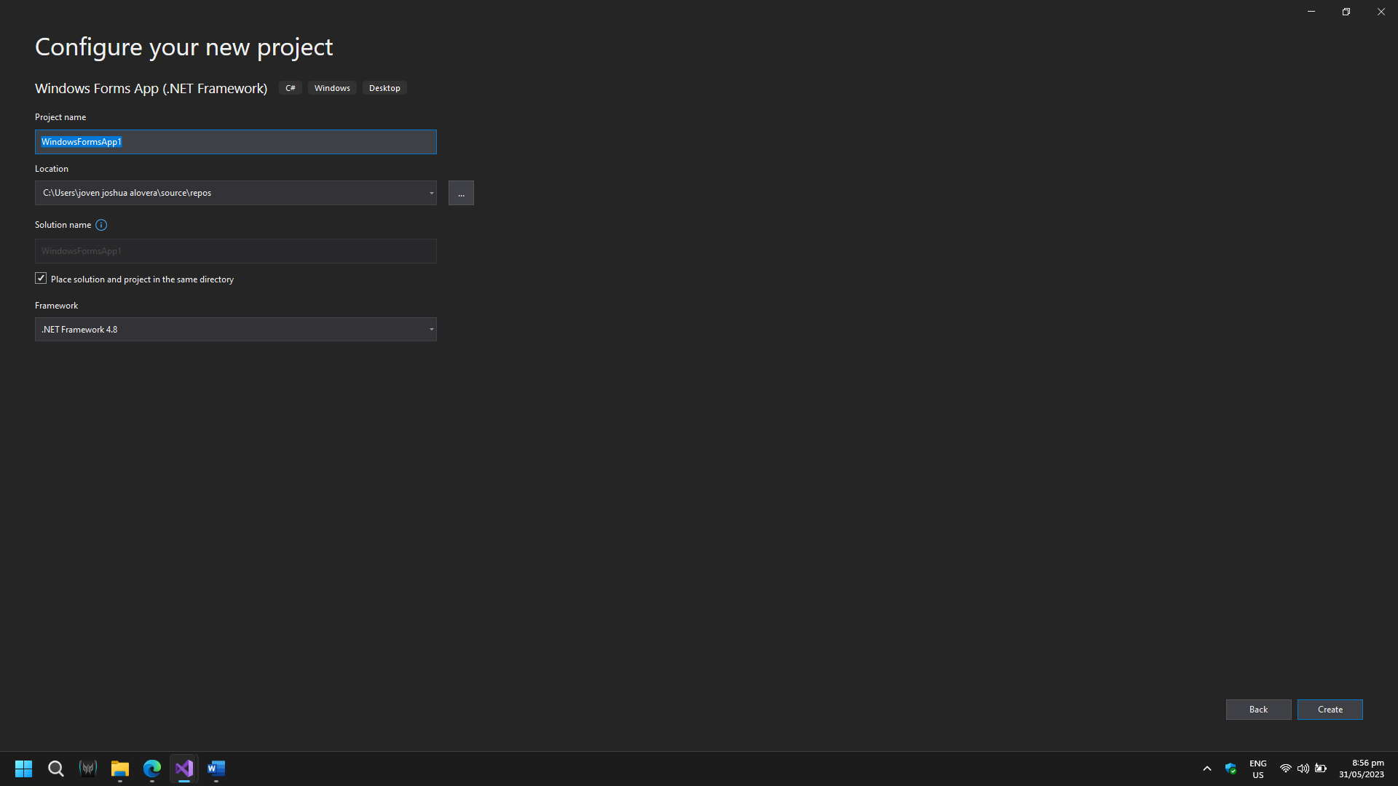

1. In the previous assignment or lesson, you learned how to add or install a report viewer in your project; you will do the same in this new assignment or lesson in your project. After adding or installing the report viewer in your project, create folders for components, forms, functions, reports, and datasets to organize the files in the project. Add a form to the forms folder and design a form with the report viewer only. Make sure your report viewer is renamed to "rprtProducts".

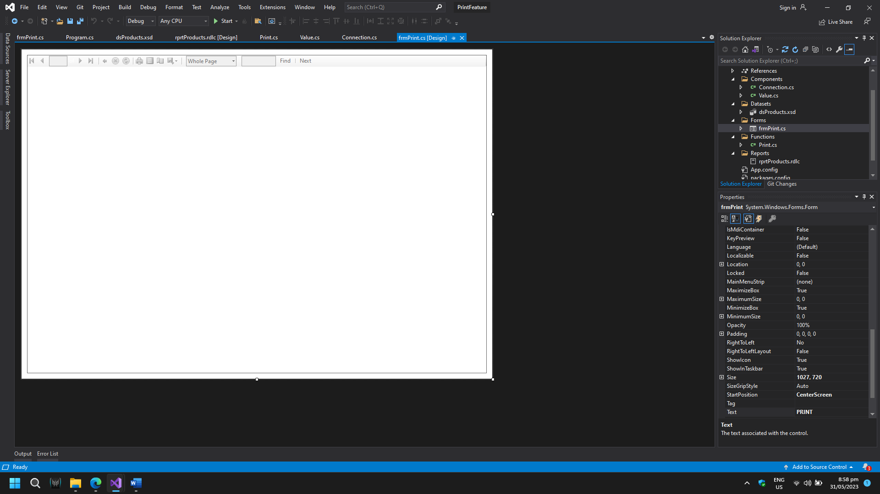

1. In previous lessons, we learned what a foreign key is and how to create and use a foreign key. Create a database named lastnameprint_db (e.g., delacruzprint_db) with two tables named customers and products. Note that the products table has a foreign key that references the customer's ID. After creating the database and its tables, add data for customers and products with foreign keys.

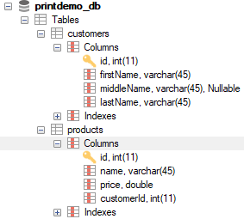

1. In previous lessons, we learned how to connect the WinForm application to a database. After creating the database, connect the WinForm application to the database.
2. In previous lessons, we learned how to create and design an RDLC file. Once your application is connected to the database, create an RDLC file and design your RDLC file with only tables.

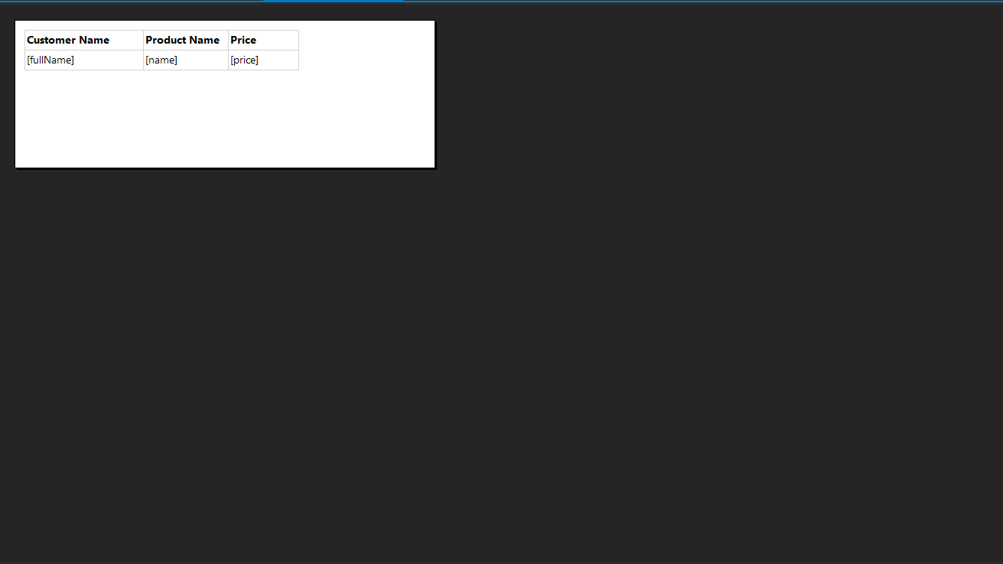

1. After creating and designing your RDLC file, in your project, in your folder named datasets, add a new item called datasets or .xsd file to add a dataset and rename it to "dsProducts".

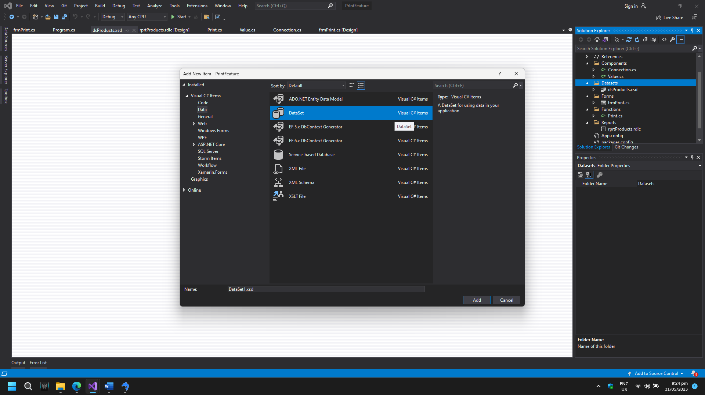

1. In your dataset or .xsd file, add a DataTable and add columns that will be shown in the report, like fullName, name, and price in the example below.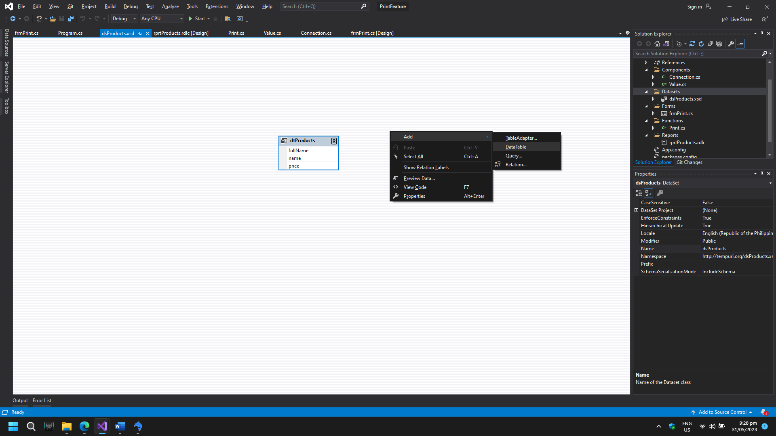
2. After creating a dataset (.xsd file) and adding columns, in your rdlc file, add a new dataset by clicking the Datasets folder located in Report Data, just like in the previous assignment. Click Data Source, and you will find "dsProducts," the name of the .xsd file. Choose that. Before clicking OK, make sure you renamed your DataSet to "dsProducts" as well, and click OK.

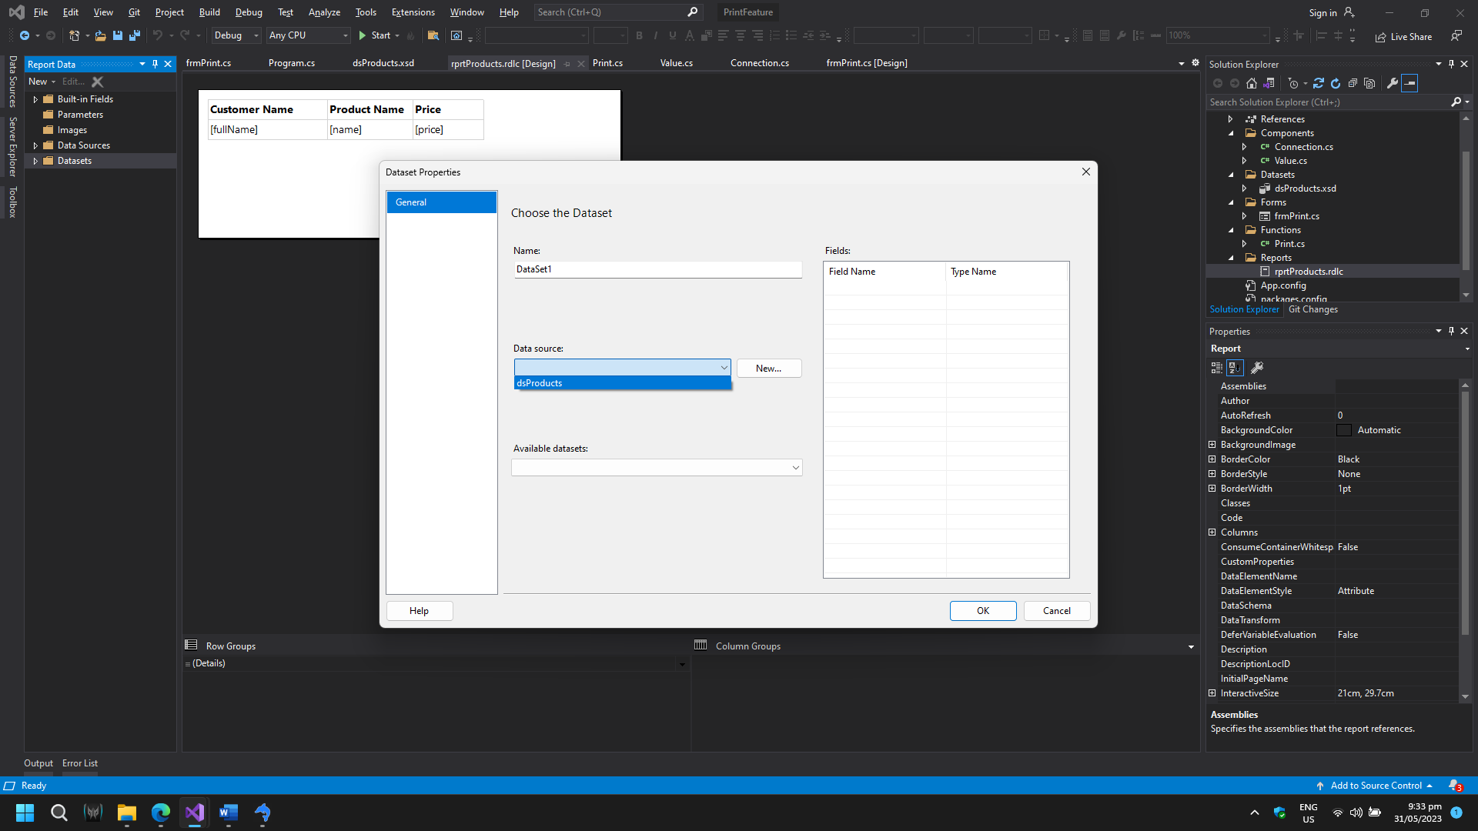

1. After doing this, click and drag the parameters from the datasets into the table in your rdlc file, just like you did in your previous assignment.

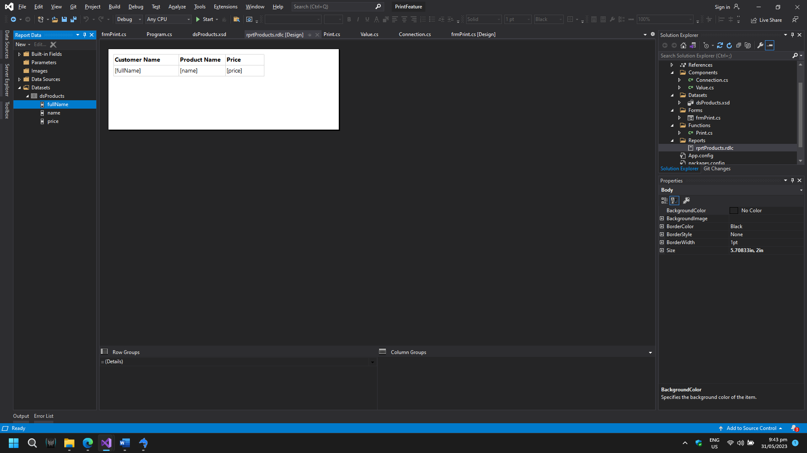

1. In your functions folder, add a class called Print.cs. This is where you will write the code to pass the data from the database to the RDLC, or report viewer. This is the code shown in the example below to pass and show the data from the database to RDLC and the report viewer.

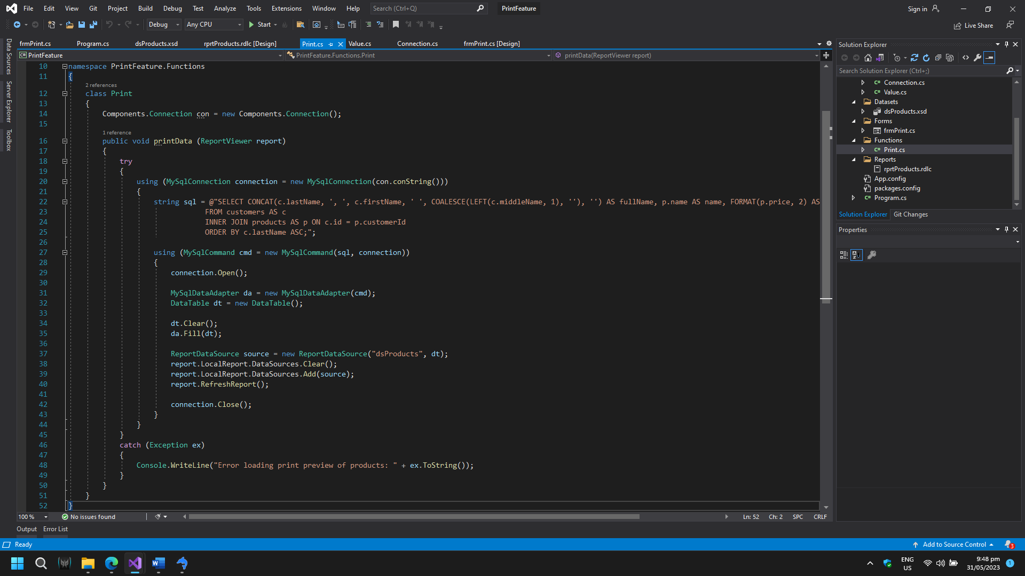

1. This is the query to show or select the data from the database; this is what it will look like when it shows.

 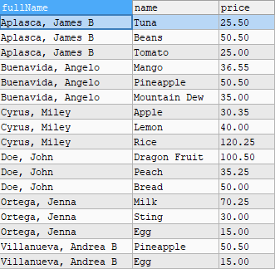

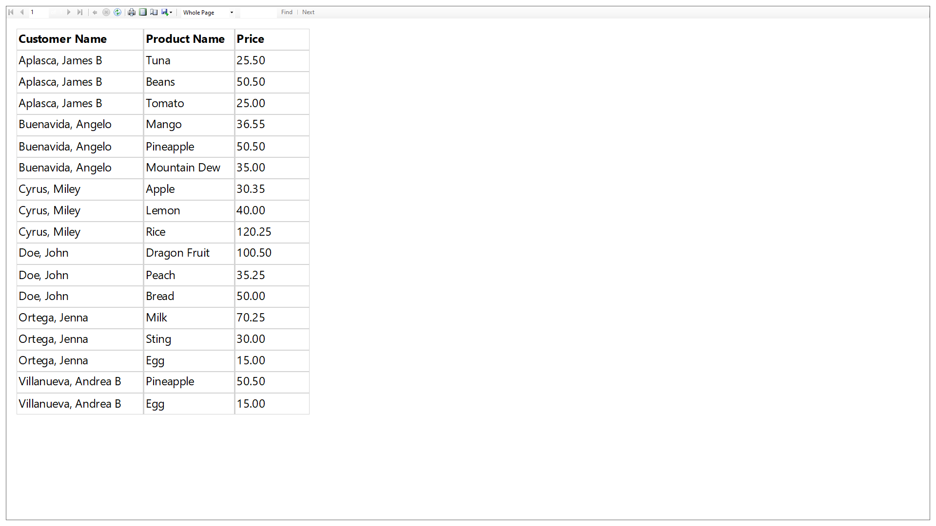

1. Note that the version of your MySQL.Data package should be 8.0.32.1 to avoid other complicated errors, never mind the other packages.

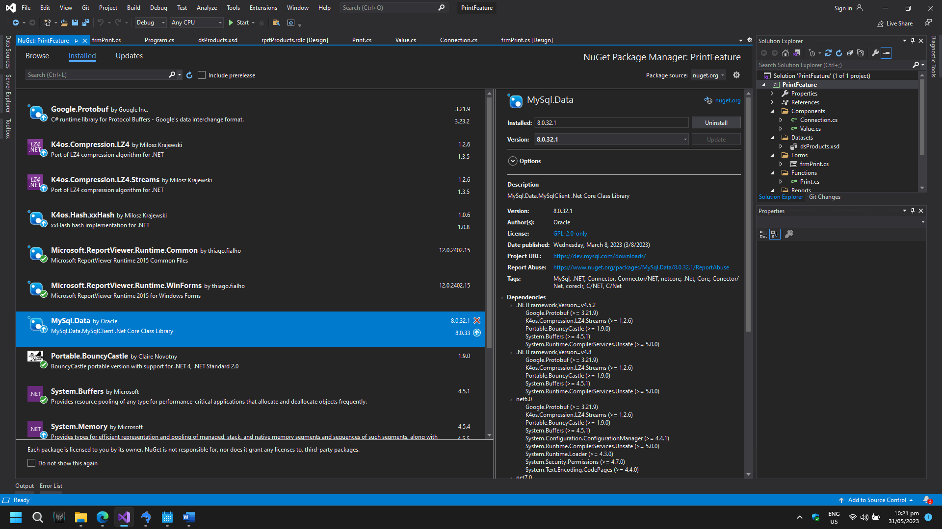

1. Note that the alias name of columns (fullName, name, price) after the "AS" in the query should be the same as the column name in the .xsd file.



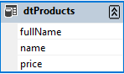

1. Note that "dsProducts" in this code is the name of the datasets in the .rdlc file.



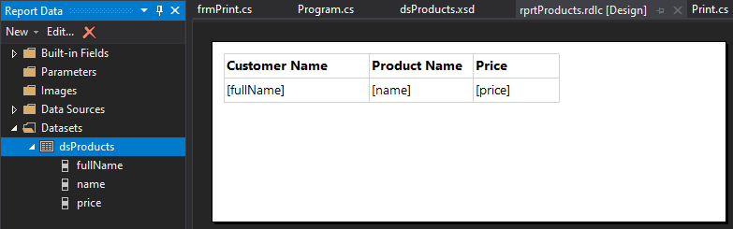

1. Don't forget these three to add at the top of your codes in Print.cs.



1. These are the codes in your form where the report viewer is.

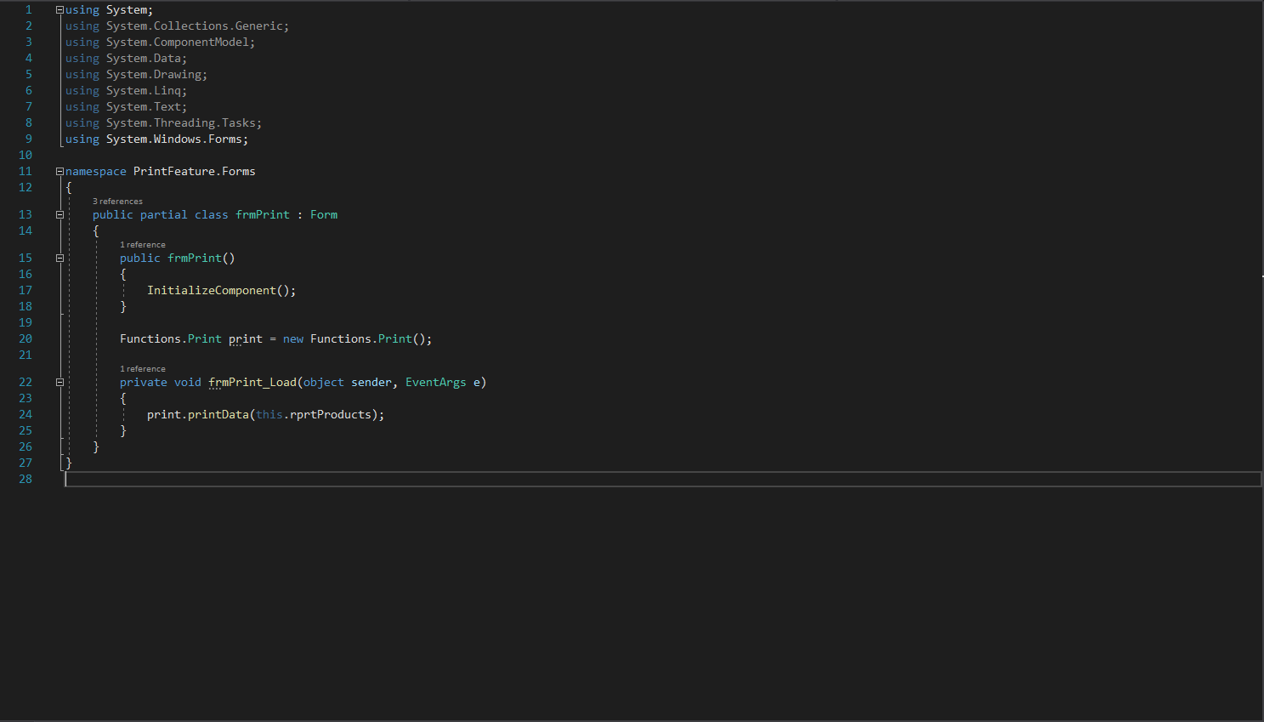

**Assignment**

Recreate or redevelop this print-feature application where you pass or print the data from the database to the report viewer. Create a new project and name it "PrintFromDatabaseLastname" (e.g., PrintFromDatabaseDelaCruz). Always remember that when you name the project, there is no space.

**Deadline:** Tuesday, June 6, 2023