**Unknow Idle Time & Allocation Abuse Project**

The present document aims to propose a series of actions/strategies for possible application at the site in order to minimize Unknown Idle Time (UIT) and allocation abuse. To begin, it is necessary to contextualize the initial situation and how such UIT can be minimized.

Currently, this facility is the second AR Sortable center in Spain with the highest Idle time, below BCN1.

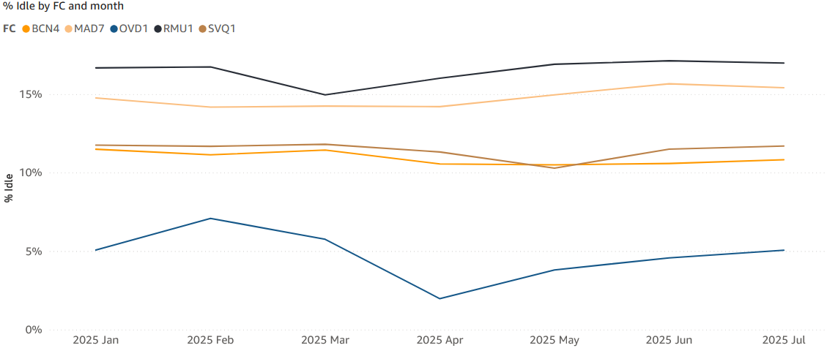

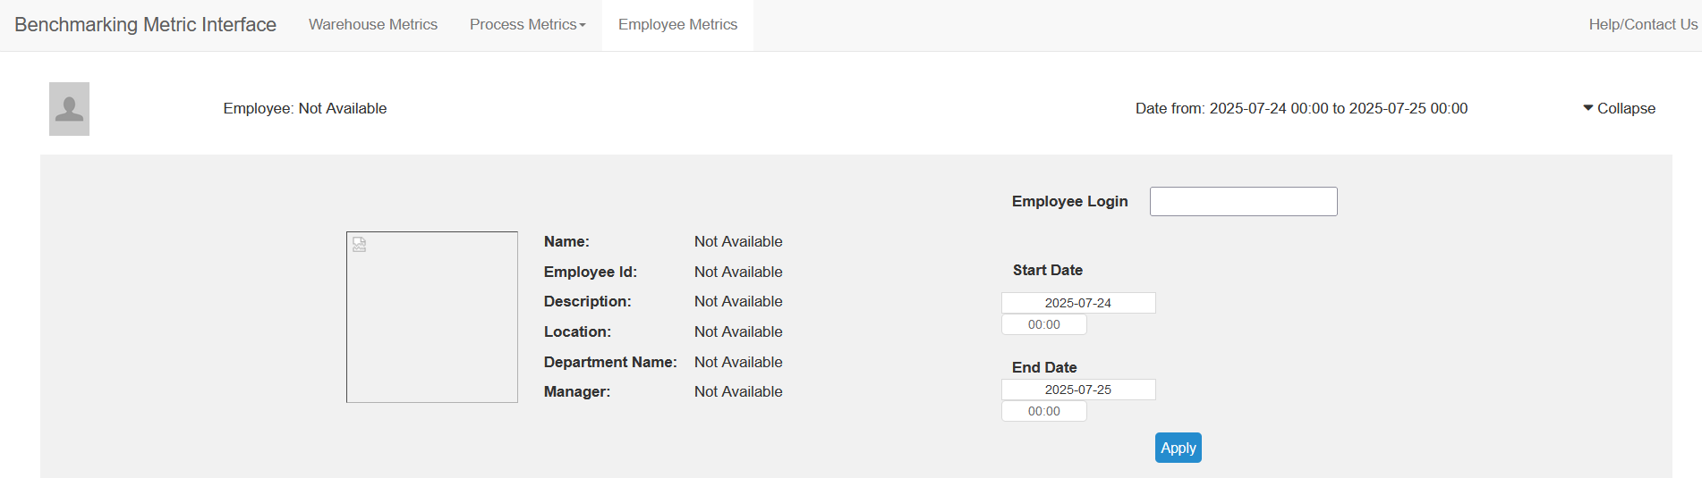

Currently, in order to visualize an AA's Idle time, one had to manually enter each person's login into the "Benchmarking Metric Interface," with the inconvenience that the obtained data presented a minimum delay of 1 day. Furthermore, said tool proved counter-intuitive when measuring UIT. As a result, it was not possible to provide on-site feedback to the AA in which the reasons for their absence could be studied in greater detail that same day. Additionally, the UIT search process was time-consuming because the page filtered the total global Idle (Known Idle Time & Unknown Idle Time), leading in huge struggles in finding the global UIT or sort the shift's top offenders in descending order.

I firmly believe that in order to address a problem from its root cause, the first step is to have correct and organized dataset. In order to minimize UIT, AMs work must be performed on a daily basis, checking UITs tendencies, fluctuations... When studying the UIT behavior throughout the hours over several days, all present certain notable trends.

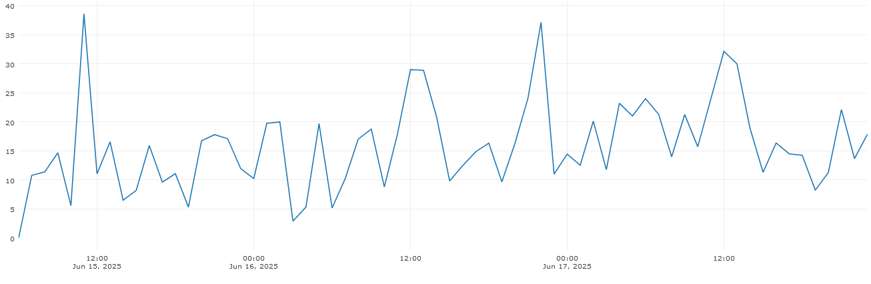

The days of June 15th, 16th, and 17th are chosen as examples. The graph presents purely seasonal behavior without significant trends. Prominent peaks are found during time periods that coincide with the arrival of break times for each shift, particularly 10 minutes before breaks and the following 10 minutes post-break. Once the main focus of the problem has been identified, the following is proposed.

Two scripts have been created so that AMs should integrate them AB with the aim of providing personalized feedback to the AA. In the first one, called "Multi-Employee UIT," each AM will input the logins of individuals who have been assigned to direct tasks during shift. The AM of receive is used as an example. They must access PPR Labor Metrics and select the process they wish to study, selecting the AA group for that specific task.

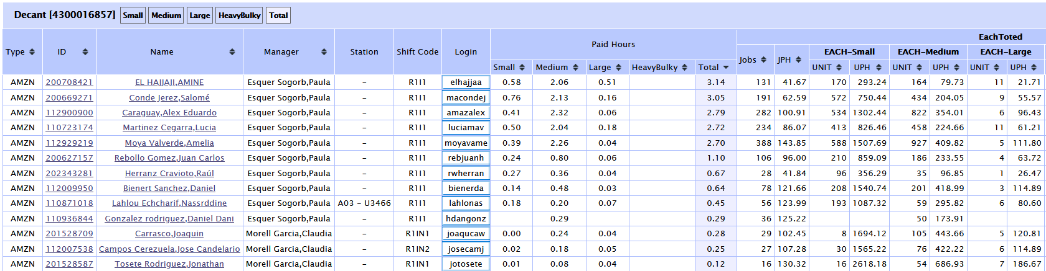

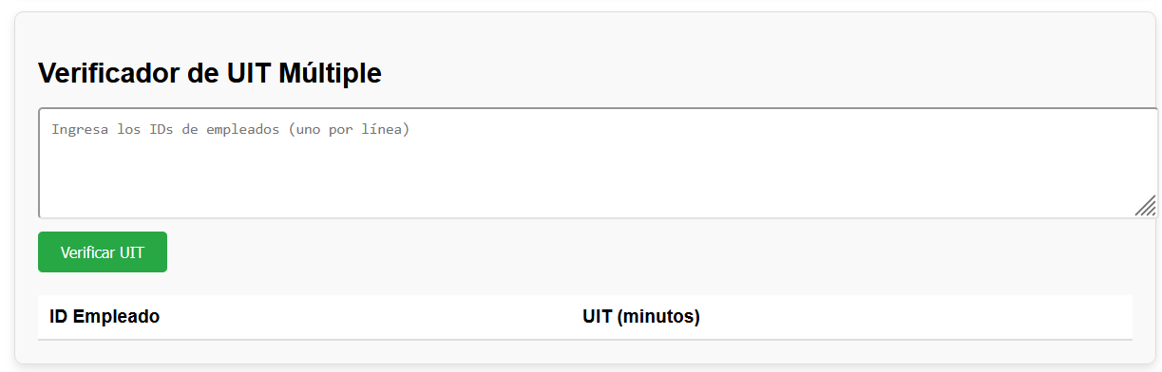 As followed, they will access https://fclm-portal.amazon.com/?warehouseId=RMU1 where a dropdown menu will appear with the following format.

The AM will paste the AA logins and click the "Verify UIT" button. The program will load the UIT in minutes for each AA and, upon completing the calculation, will sort the AAs, with top offenders appearing at the beginning of the table. An example is attached.

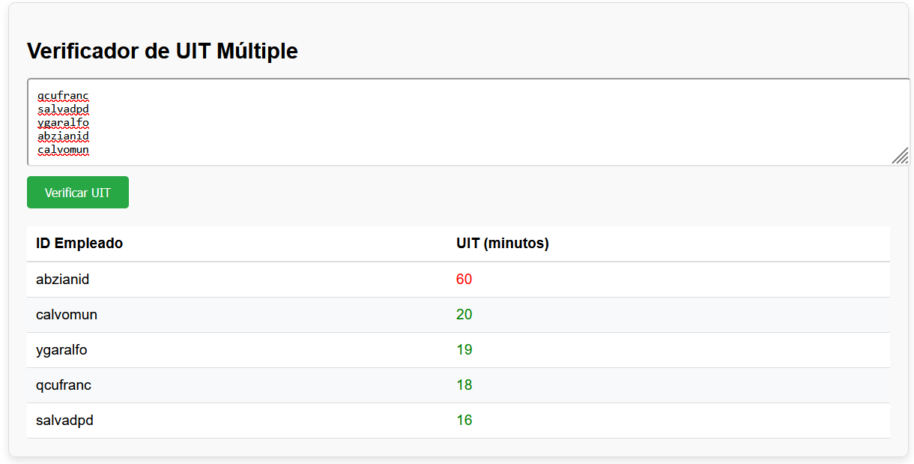

If a deeper analysis of a specific AA is required to review the breakdown of time slots during which they were absent from direct tasks, the duration of such absence, and the process they were previously engaged in before the absence, the script titled “DETAILED AAs UIT” should be accessed. A screenshot is attached for further clarification.

T

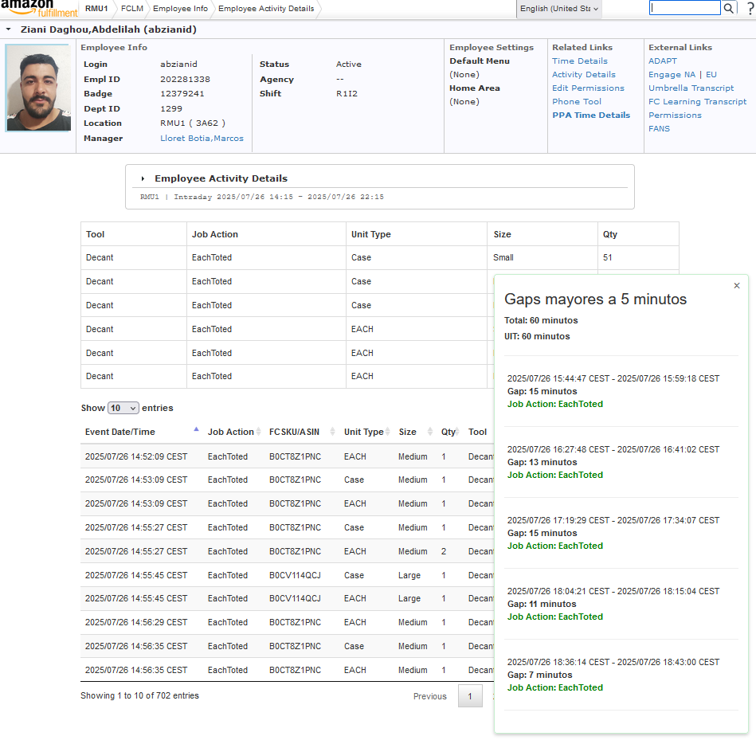

También se podría estudiar si existe relación alguna entre el UIT del AA y el ritmo al que desempeña la tarea directa. En este caso, se tomó como ejemplo el proceso de Stow. Se escogió la data desde el día 15 de junio hasta el día 30 del mismo mes en Roboscout.

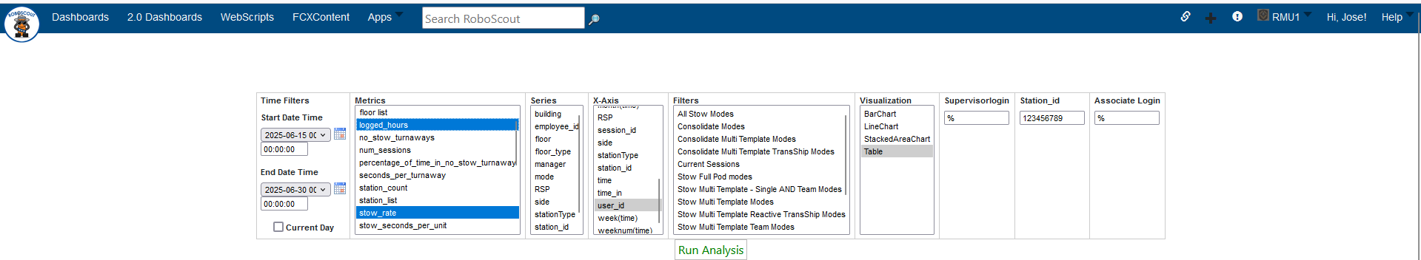

Dado que cada AA había estado logado un x numero de horas, para poder hacer una comparación justo el primer paso fue normalizar los datos. La normalización de datos que se empleó fue la siguiente.