# Conclusion

This max ratio (real geodesic distance/shortest distance) is called the dilation of a graph.

* Nonobtuse meshes are low-dilation triangulations.
* Nonobtuse meshes contributes to make Fast marching more robust, i.e. all ratios >=1.

In the following histograms, all bins for obtuse are from 1 to 3.2, and nonobtuse from 1 to 1.45 and each bin’s size is 0.05.

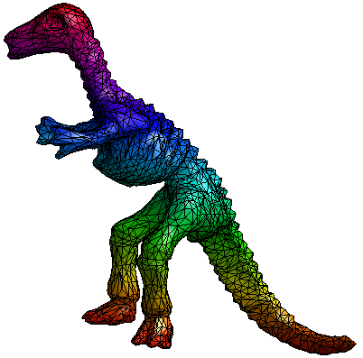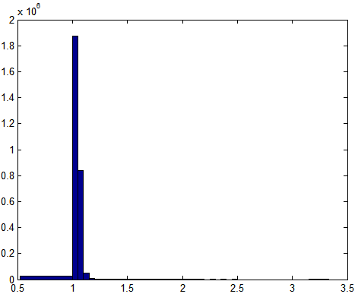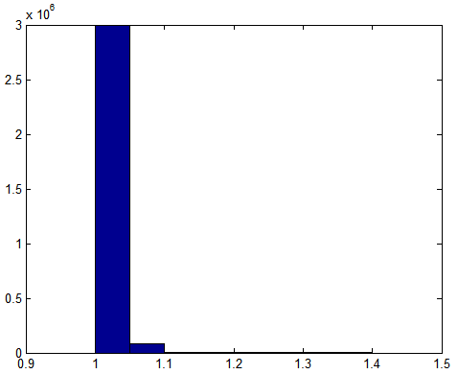

**Histogram of ratio** between geodesic distances by Dijkstra & Fast marching of the **obtuse (left) & the nonobtuse (right)** Dino model.

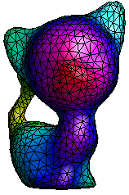 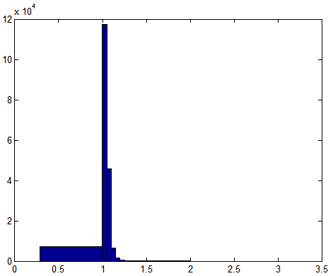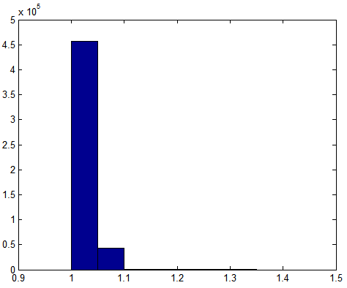

Kitten

 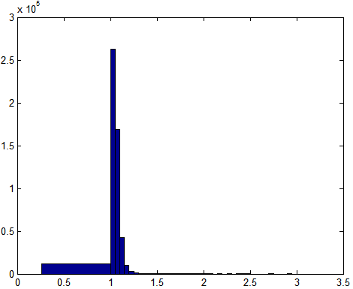 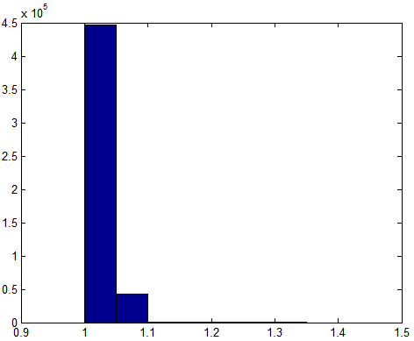

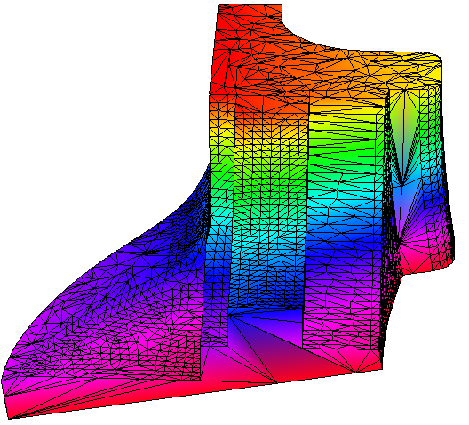 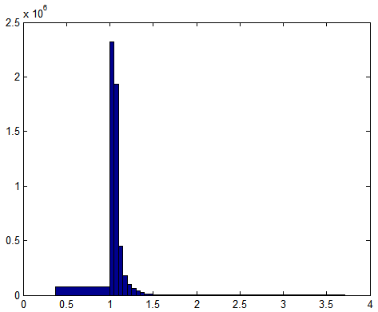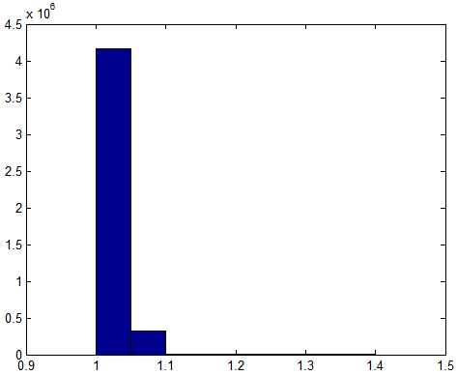

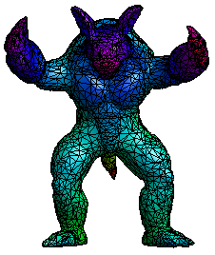 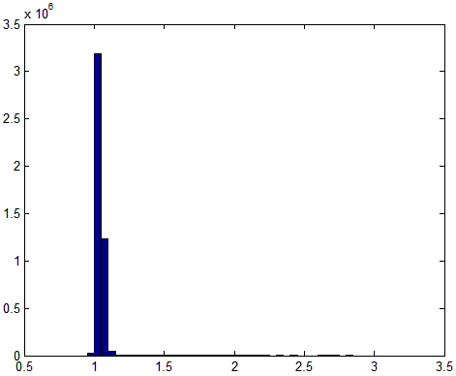 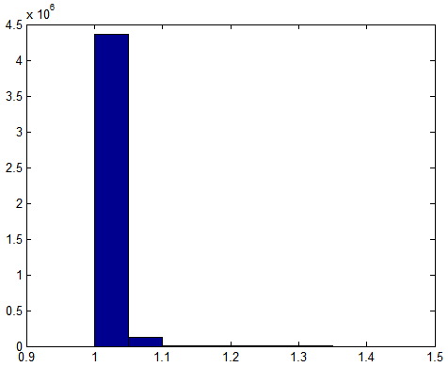

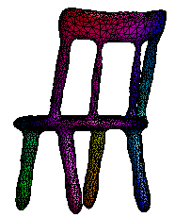 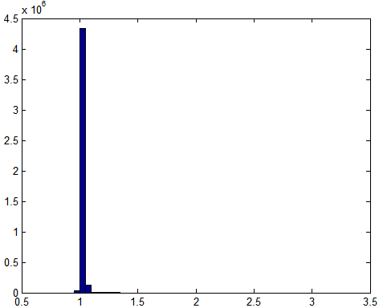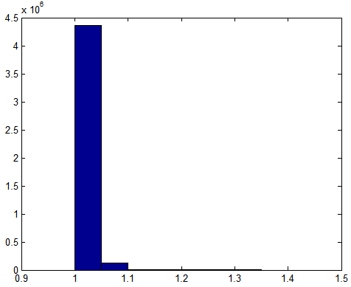

# Dino

## The mesh



Figure 1 obtuse Dino

## nonobtuse

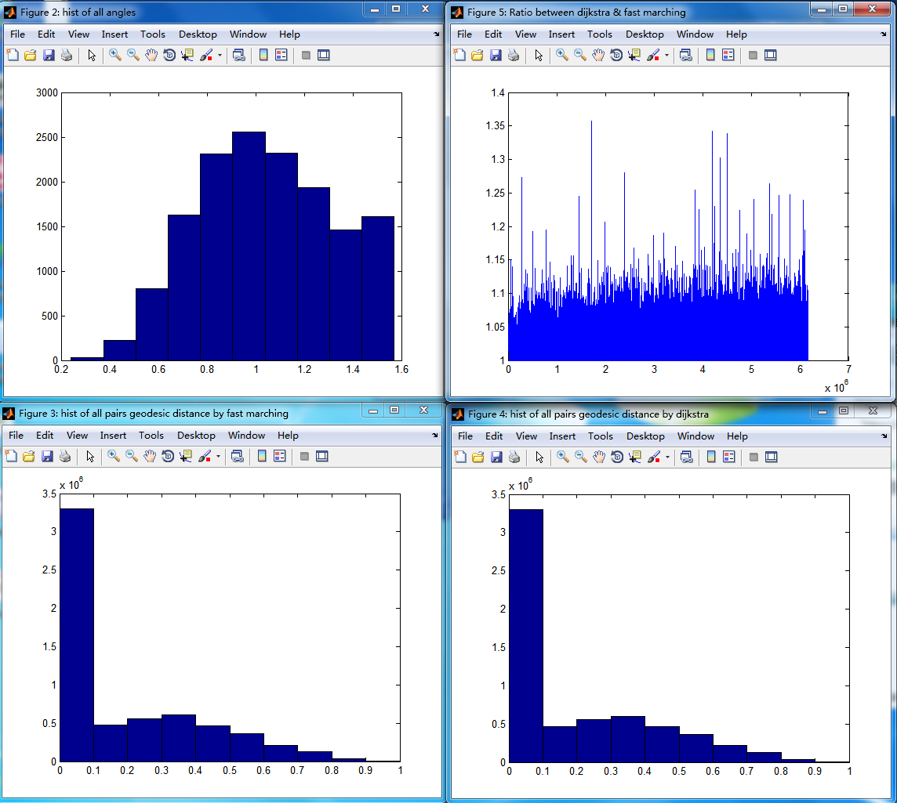

Figure 2 The **dilation of a nonobtuse** triangular mesh. Top left is the histogram of angles. Top right is dilation/ratio between distance by Dijkstra & Fast marching. The dilation is **between 1 & 1.35** approximately. The bottom shows the histogram of distance by fast marching & Dijkstra respectively. They are almost the same.

## Obtuse

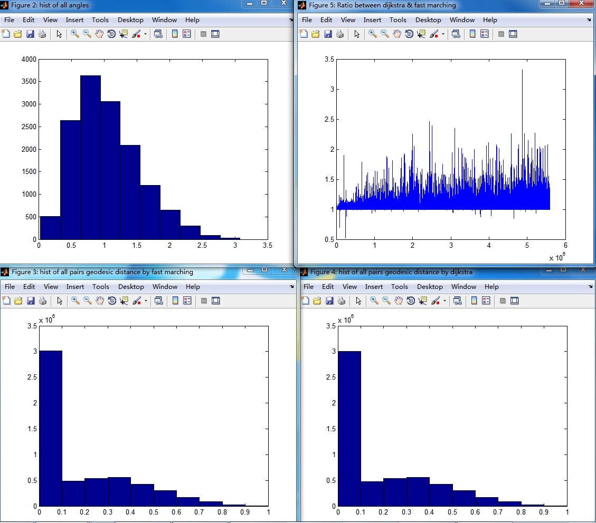

Figure 3 The **dilation of an obtuse** triangular mesh. Top left is the histogram of angles. Top right is dilation/ratio between distance by Dijkstra & Fast marching. The dilation is **between 1 & 3.5** approximately. The bottom shows the histogram of distance by fast marching & Dijkstra respectively. They are almost the same.

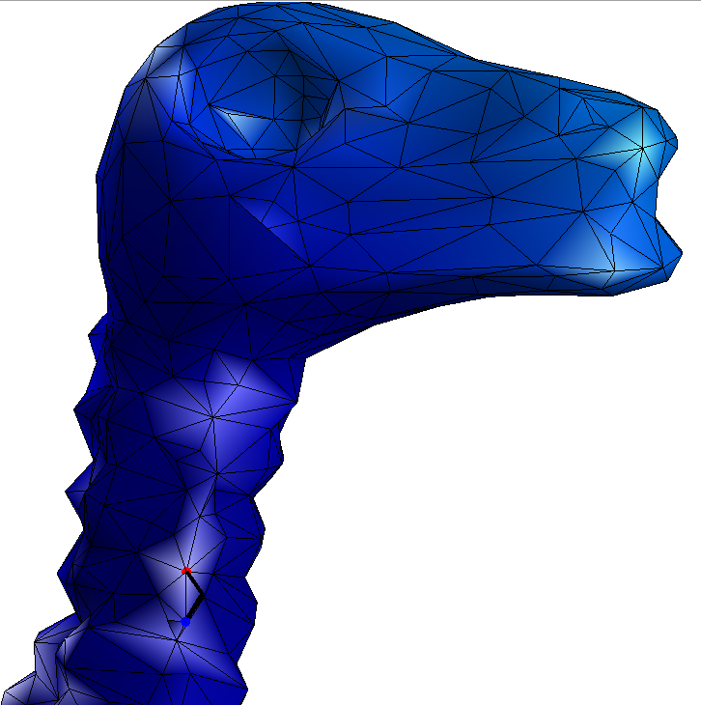

Figure 4 Why there are ratios near 0.5? The fast marching implementation contains errors. The geodesic distance by fast marching between the red and blue points is 0.0395 larger than the Euclidean distance between them 0.0206. The bold black lines represent the corresponding geodesic path. The geodesic distance by Dijkstra between the two points is 0.0206.

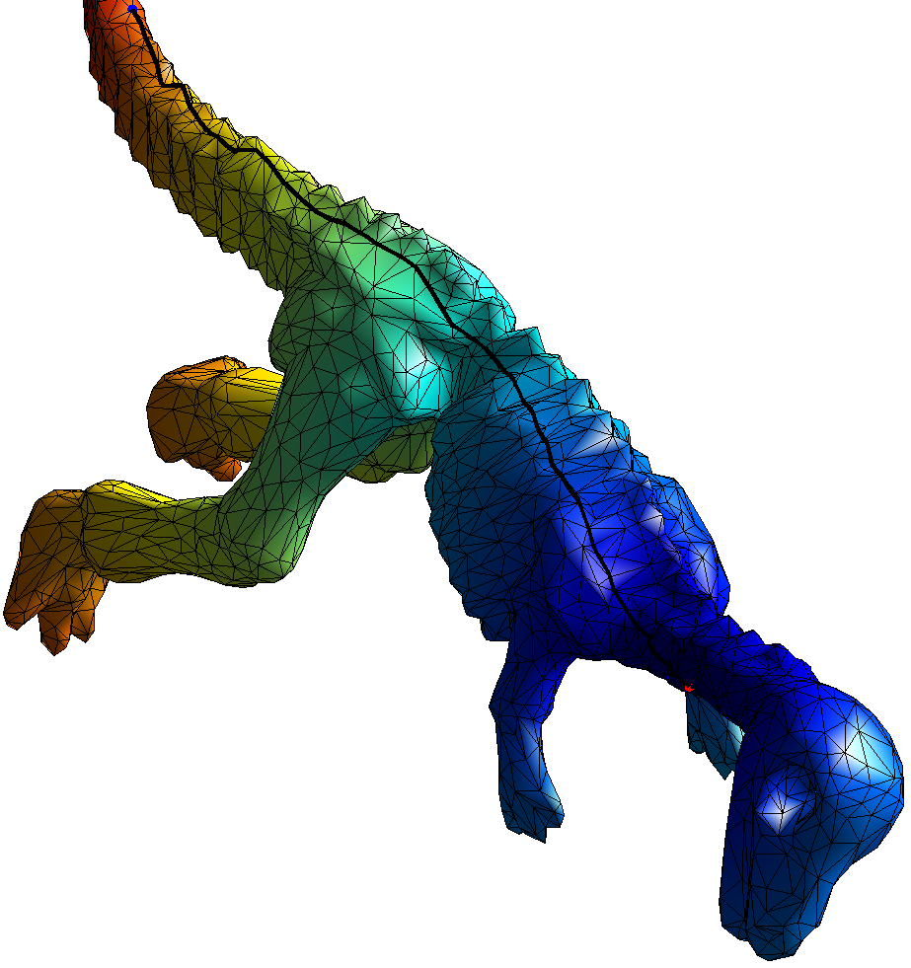 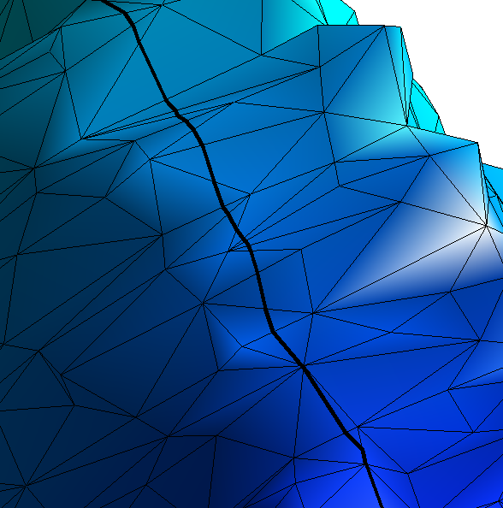

Figure 5 The fast marching implementation is OK in general. Left: geodesic path by fast marching between the red and blue points. Right: a zoom view.