Table of Contents

T1: Shopping Cart 1

T2: Checkout 3

# T1: Shopping Cart

|  |  |  |  |  |
| --- | --- | --- | --- | --- |
| Test Case ID: | | TC-1.1 | | |
| Name: | | Adding Items from Pages Updates Shopping Cart | | |
| Description: | | * Test that adding items to the shopping cart from pages updates the item count and amount appropriately | | |
| Precondition: | | * There is at least one item in the database * The Session storage is functioning appropriately * The Session is empty | | |
| Postcondition: | | * Adding items to the cart updates the count and amount appropriately | | |
| Input | | * Added items (See Appendix A) | | |
| Output | | * Appropriate count and amount | | |
| Last Tested | |  | | |
| No. | Action | | Expected Result | Actual Result |
| 1 | From the Double-sided Aprons page, enter 2 and click Add to Cart | | The shopping cart has “Items: 2 Total: $16.00” | Pass |
| 2 | Click on the Pechera link on the left-hand side menu | | The Pechera Aprons page displays without errors | Pass |
| 3 | Enter 2 in the Qty field of some item and click Add to Cart | | The shopping cart has “Items: 4, Total $30.00” | Pass |
| 4 | In another item, enter 30 and click Add to Cart | | The shopping cart has “Items: 34, Total: $184 | Pass |
| 5 | Click on the Checkout button | | The correct item images and their counts display in the summary table | Pass |

|  |  |  |  |  |
| --- | --- | --- | --- | --- |
| Test Case ID: | | TC-1.2 | | |
| Name: | | Adding Items from Dialogs Updates Shopping Cart | | |
| Description: | | * Test that adding items to the shopping cart from dialogs updates the item count and amount appropriately | | |
| Precondition: | | * There is at least one item in the database * The Session storage is functioning appropriately * The Session is empty | | |
| Postcondition: | | * Adding items to the cart updates the count and amount appropriately | | |
| Input | | * Added items | | |
| Output | | * Appropriate count and amount | | |
| Last Tested | | * 12/27/12 | | |
| No. | Action | | Expected Result | Actual Result |
| 1 | From the Double-sided Aprons page, click on some item | | A pop-up dialog displays with images matching the item clicked | Pass |
| 2 | Enter 2 in the Qty field click Add to Cart | | 1. I) The dialog closes 2. Ii) The shopping cart has “Items: 2 Total: $16.00” | i) Pass  ii) Pass |
| 3 | Click on the Pechera link on the left-hand side menu | | The Pechera Aprons page displays without errors | Pass |
| 4 | Click on some item | | A pop-up dialog displays with images matching the item clicked | Pass |
| 5 | Enter 2 in the Qty field and click Add to Cart | | i) The dialog closes  ii) The shopping cart has “Items: 4, Total $30.00” | i) Pass  ii) Pass |
| 6 | Click on another item. | | A pop-up dialog displays with images matching the item clicked | Pass |
| 7 | Enter 30 in the Qty field and click Add to Cart | | The shopping cart has “Items: 34, Total: $184 | Pass |
| 8 | Click on the Checkout button | | The correct item images and their counts display in the summary table | Pass |

# T2: Checkout

|  |  |  |  |  |
| --- | --- | --- | --- | --- |
| Test Case ID: | | TC-2.1 | | |
| Name: | | Changing Quantity in Summary Table | | |
| Description: | | * Test that updating the quantity in the summary table updates the UI appropriately | | |
| Precondition: | | * Items have been added to the cart | | |
| Postcondition: | | * The cart is updated appropriately * The calculation fields in the summary table, such as Total Amount, Savings, etc., are updated appropriately | | |
| Input | | * An item quantity | | |
| Output | | * Appropriate UI updates | | |
| Dependencies | | * TC-1.2 | | |
| No. | Action | | Expected Result | Actual Result |
| 1 | Click on the Checkout button | | The Checkout table displays without error | Pass |
| 2 | In the double-sided apron entry, enter 30 in the Quantity field and tab out | | 1. I) The Quantity field is changed to 30 2. Ii) The Amount field of that row is changed to 240 3. Iii) The Total Amount is 464 4. Iii) Savings is 101 5. Iv) Subtotal is 363 6. V) Tax is 31.76 7. Vi) Shipping and Handling is 63.96 8. Vii) Total is 458.72 9. Viii) The shopping cart has “Items: 62, Total: $363 | i) Pass  ii) Pass  iii) Pass  iii) Pass  iv) Pass  v) Pass  vi) Pass  vii) Pass  viii) Pass |

|  |  |  |  |  |
| --- | --- | --- | --- | --- |
| Test Case ID: | | TC-2.2 | | |
| Name: | | Deleting an Item from the Summary Table | | |
| Description: | | * Test that an item from the summary table updates the UI appropriately | | |
| Precondition: | | * Items have been added to the cart | | |
| Postcondition: | | * The cart is updated appropriately * The calculation fields in the summary table, such as Total Amount, Savings, etc., are updated appropriately | | |
| Input | | * Deletion of an item | | |
| Output | | * Appropriate UI updates | | |
| Dependencies | | * TC-2.1 | | |
| No. | Action | | Expected Result | Actual Result |
| 1 | Click on the “X” icon of the row containing 30 pechera aprons | | 1. i) The Total Amount is 254 2. ii) Savings is 45 3. Iv) Subtotal is 209 4. V) Tax is 18.29 5. Vi) Shipping and Handling is 31.98 6. Vii) Total is 259.27 7. Viii) The shopping cart has “Items: 32, Total: $209 | i) Pass  ii) Pass  iv) Pass  v) Pass  vi) Pass  vii) Pass  viii) Pass |

|  |  |  |  |  |
| --- | --- | --- | --- | --- |
| Test Case ID: | | TC-2.3 | | |
| Name: | | Continue Shopping | | |
| Description: | | * User can continue shopping from the Checkout page | | |
| Precondition: | | * Items have been added to the cart | | |
| Postcondition: | | * The user is able to continue shopping | | |
| Input | | * Continue Shopping click | | |
| Output | | * The user is redirected to the Double-sided Aprons page | | |
| Dependencies | | * TC-2.2 | | |
| No. | Action | | Expected Result | Actual Result |
| 1 | Click on the Continue Shopping button | | 1. i) The user is redirected to the Double-sided Aprons page 2. ii) The shopping cart has “Items: 32, Total: $209 | i) Pass  ii) Pass |

|  |  |  |  |  |
| --- | --- | --- | --- | --- |
| Test Case ID: | | TC-2.4 | | |
| Name: | | Deleting Last Item from Summary Table | | |
| Description: | | * Test that deleting the last item in the summary table updates the UI appropriately | | |
| Precondition: | | * Items have been added to the cart | | |
| Postcondition: | | * The cart is updated appropriately * The summary table is updated appropriately, including hiding buttons | | |
| Input | | * Deletion of last item | | |
| Output | | * Appropriate UI updates | | |
| Dependencies | | * TC-2.2 | | |
| Last Tested | | * 12/27/12 | | |
| No. | Action | | Expected Result | Actual Result |
| 1 | Click on the “X” icon of the last two remaining rows | | 1. i) The text “No items in the cart. Please continue shopping.” Appears 2. ii) The Payment button is hidden 3. iii) The cart reads “Items: 0 Total: $0.00”. 4. iv) Clicking the Continue Shopping button redirects the user to the Double-sided Aprons page. | i) Pass  ii) Pass  iii) Pass  iv) Pass |

|  |  |  |  |  |
| --- | --- | --- | --- | --- |
| Test Case ID: | | TC-2.5 | | |
| Name: | | Paypal Page Reflects Purchase | | |
| Description: | | * Test that the Paypal page that displaying after clicking the Payment button reflects the purchase correctly | | |
| Precondition: | | * Items have been added to the cart | | |
| Postcondition: | | * The Paypal page matches the purchase | | |
| Input | | * Payment button click | | |
| Output | | * A Paypal page that reflects the purchase | | |
| Dependencies | | * None | | |
| No. | Action | | Expected Result | Actual Result |
| 1 | Add one double-sided and one pechera apron to the cart | | 1. The cart reads “Items: 2 Total: 15” | Pass |
| 2 | Click the Checkout button | | 1. I) The summary table displays the correct images and count for each item 2. Ii) The Total Amount reads 15 3. Iii) Savings is 0 4. Iv) Subtotal is 15 5. V) Tax is 1.31 6. Vi) Shipping and Handling is 5.98 7. Vii) Total is 22.29 | i) Pass  ii) Pass  iii) Pass  iv) Pass  v) Pass  vi) Pass  vii) Pass |
| 3 | Click the Payment button | | 1. A Paypal page displays with the same information as that in step 2 above. | Pass |
| 4 | Click the browser’s back button on the Paypal page | | 1. The Checkout page displays with all the information exactly as in step 2 above | Pass |
| 5 | Change the quantity of the pechera apron to 33 | | 1. I) The Quantity field changes to 33 2. Ii) Amount is 231 3. Iii) Total amount is 239 4. Iv) Savings is 57.75 5. V) Subtotal is 181.25 6. Vi) Tax is 15.86 7. Vii) S&H is 31.98 8. Viii) Total is 229.09 | i) Pass  ii) Pass  iii) Pass  iv) Pass  v) Pass  vi) Pass  vii) Pass  viii) Pass |
| 6 | Click on the Payment button | | 1. A Paypal page displays with the same information as that in step 5 | Pass |

|  |  |  |  |  |
| --- | --- | --- | --- | --- |
| Test Case ID: | | TC-2.6 | | |
| Name: | | Paypal Invoices | | |
| Description: | | * Test that Paypal sends appropriate invoices to both the seller and buyer | | |
| Precondition: | | * A valid order has been entered | | |
| Postcondition: | | * Appropriate invoices are emailed to both the seller and buyer | | |
| Input | | * A valid order | | |
| Output | | * Invoices | | |
| Dependencies | | * TC-2.5 | | |
| No. | Action | | Expected Result | Actual Result |
| 1 | Once on the Paypal Order Summary page, click on “Have a Papal Account” | | 1. The page expands to reveal a Email and PayPay password text box | Pass |
| 2 | Enter [Sender_1352396989_per@gmail.com](mailto:Sender_1352396989_per@gmail.com) in the email text box and swordfish in the password and click Log In | | 1. The page updates do display a consent form. | Pass |
| 3 | Check the “Yes, …” box and click Agree and Continue | | 1. The page updates to display the buyer’s shipping information and the amount to be paid. | Pass |
| 4 | Click the Pay Now button | | 1. A confirmation page entitled “Thanks for your order” is displayed with the following: 2. I) The amount paid 3. Ii) A Print Receipt link 4. Iii) A return to merchant link 5. Iv) A go to Paypal account overview link | i) Pass  ii) Pass  ii) Pass  iv) Pass |
| 5 | Go to the Paypal sandbox and click Test Email | | 1. In the inbox, you should see an email from the sender (buyer) to the receiver (seller) and vice versa. | Pass |

|  |  |  |  |  |
| --- | --- | --- | --- | --- |
| Test Case ID: | | TC-2.7 | | |
| Name: | | Valid IPN | | |
| Description: | | * Test that a valid IPN updates the database | | |
| Precondition: | | * The server has access to an email server * The server has access to the [www.tlaulli.com](http://www.tlaulli.com) server (used in sending IPNs) * A purchase has been successfully made | | |
| Postcondition: | | * The database cur_qty for the corresponding item is decremented by one | | |
| Input | | * Valid IPN | | |
| Output | | * None | | |
| Dependencies | | * TC-2.6 | | |
| No. | Action | | Expected Result | Actual Result |
| 1 | Re-run test case TC-2.6 and check the cur_qty column in the database for the corresponding item | | 1. The cur_qty has been decremented by 1 for the double-sided apron and 33 for the pechera | Pass |

|  |  |  |  |  |
| --- | --- | --- | --- | --- |
| Test Case ID: | | TC-2.8 | | |
| Name: | | Invalid IPN | | |
| Description: | | * Test that an invalid IPN generates an email. | | |
| Precondition: | | * The server has access to an email server * The server has access to the [www.tlaulli.com](http://www.tlaulli.com) server (used in sending IPNs) * A purchase has been successfully made | | |
| Postcondition: | | * An email is sent to the administrator advising of invalid IPN | | |
| Input | | * Invalid IPN | | |
| Output | | * Notification email | | |
| Dependencies | | * TC-2.6 | | |
| No. | Action | | Expected Result | Actual Result |
| 1 | Manually change the code in NotifyChkout.php so that the if in line 23 fails. | | 1. Code is changed successfully |  |
|  | Re-run test case TC-2.6 | | 1. I) Results as described in TC-2.6 2. Ii) An email is sent to the administrator advising of an invalid IPN |  |

|  |  |  |  |  |
| --- | --- | --- | --- | --- |
| Test Case ID: | | TC-2.9 | | |
| Name: | | Unavailable Item and/or Quantity | | |
| Description: | | * Test that an unavailable item and/or quantity in the database generates an email | | |
| Precondition: | | * The server has access to an email server * The server has access to the [www.tlaulli.com](http://www.tlaulli.com) server (used in sending IPNs) * A purchase has been successfully made | | |
| Postcondition: | | * An email is sent to the administrator advising of the unavailable item and/or quantity | | |
| Input | | * Failed condition of item and quantity | | |
| Output | | * Notification email | | |
| Dependencies | | * TC-2.6 | | |
| No. | Action | | Expected Result | Actual Result |
| 1 | Manually change the code in NotifyChkout.php so that the if in line 30 fails. | | 1. Code is changed successfully |  |
|  | Re-run test case TC-2.6 | | 1. I) Results as described in TC-2.6 2. Ii) An email is sent to the administrator advising of a unavailable item and/or quantity |  |

# Appendix A

## TC-1.1

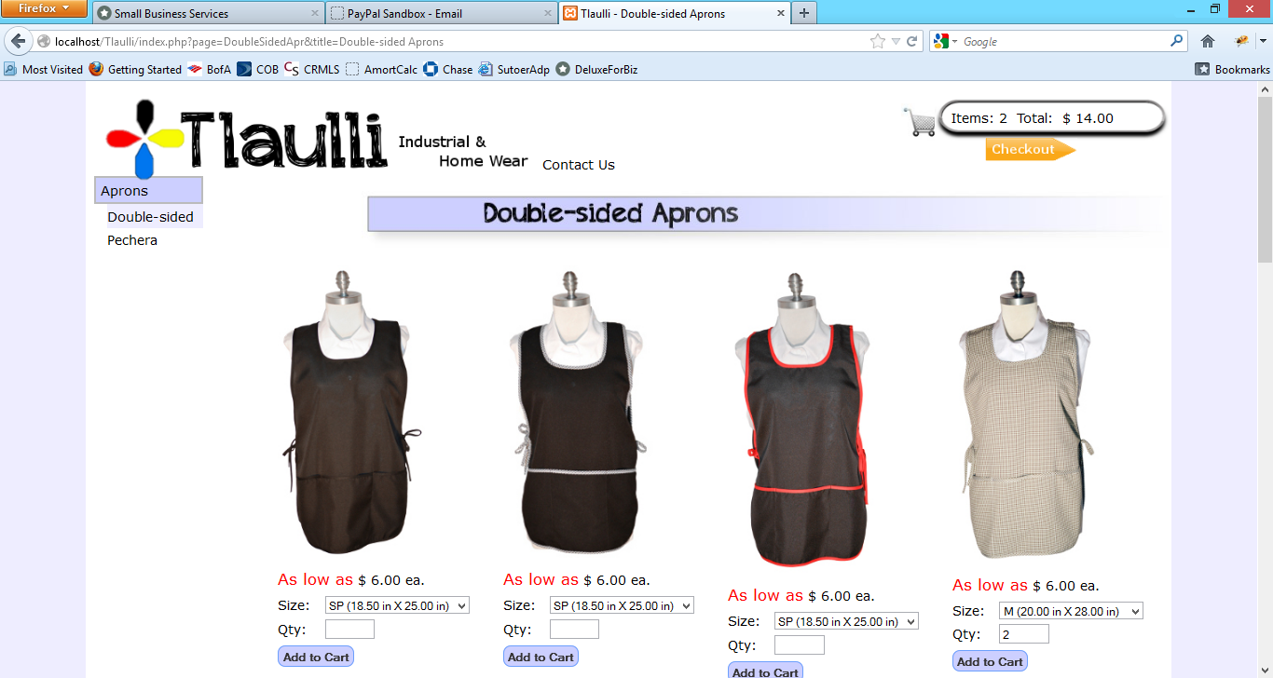

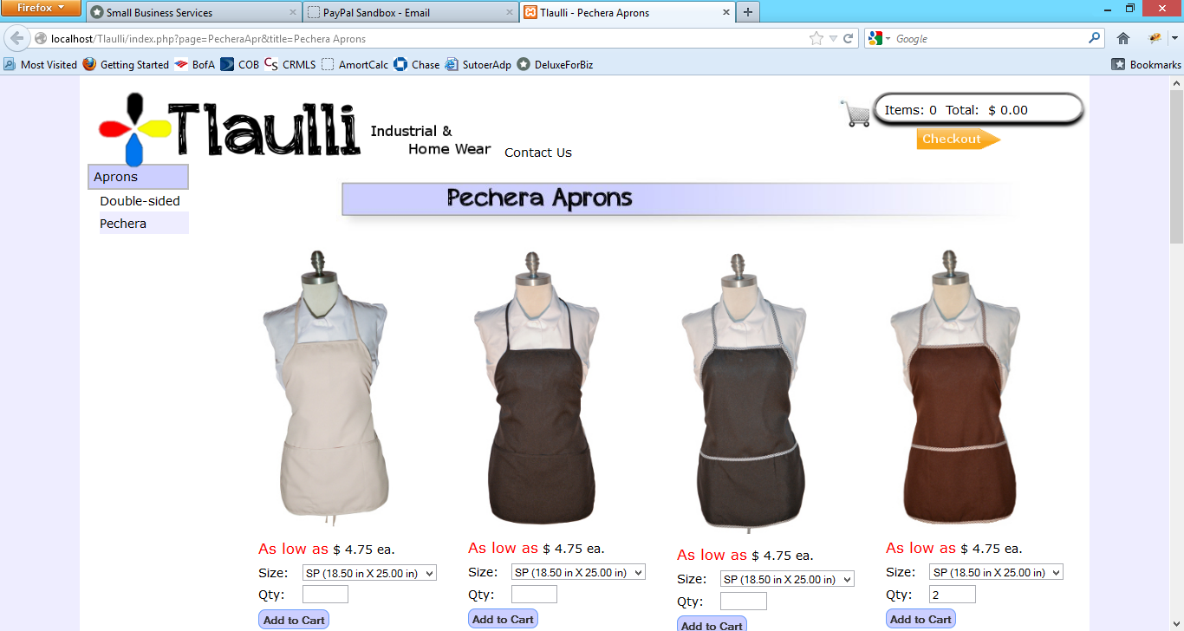

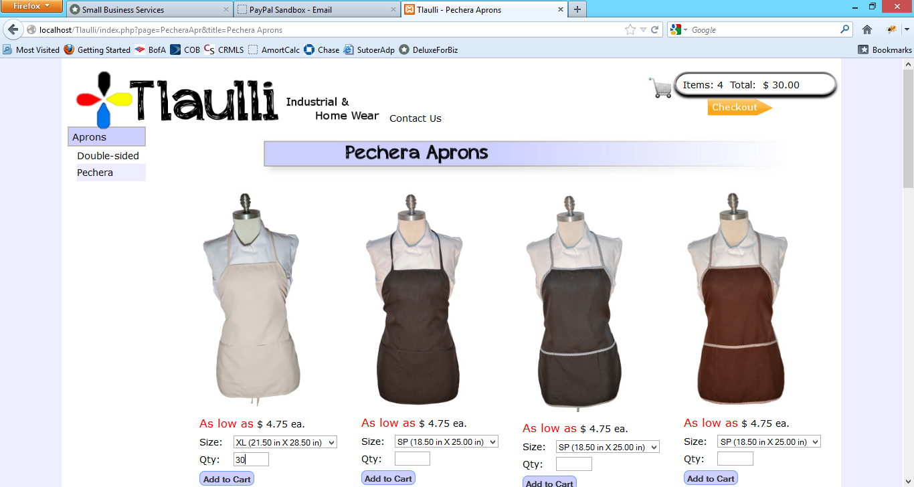

## TC-1.2

