GOLDEN BULL AWARD 2026 · SINGAPORE CHAPTER
Winner Profile & Branding Materials
CE GLOBAL NETWORK INTERNATIONAL PTE LTD
Prestige Package · Outstanding Bull · Digital 50 · Inspirational Entrepreneur Awards

Submitted to | Golden Bull Award Organising Committee — attn. Mr Jason Ooi, Senior Project Manager
Award ceremony | 12 November 2026, Marina Bay Sands, Singapore
Materials due | 31 December 2026 (Winner Profile Write-Up and Company Advertisement)
Contents | 1. Company information  2. Profile write-up (1883 words; limit 2,000)  3. Company photos  4. Company advertisement — capital.asia  5. Rotating banner 728 × 90  6. Rotating banner 340 × 280

1. Company information
CEO / Director's name | DR SHEKINAIH SIEW SIN YAP
Designation | Founder and Managing Director
Chief Advisory & Support Officer | DR J AARON K DAVID — key management, jointly leads the company (co-founder of CE Global Network LLP)
Company name | CE GLOBAL NETWORK INTERNATIONAL PTE LTD (UEN 202605111K)
Company address | 27 Trevose Crescent, Dunearn Estate, Singapore 298042
Company website | https://www.ceglobalnetworkinternational.com
Email | shipping@ceglobalnetworkinternational.com
Chronology | Incorporated April 2026; operations commenced July 2026, carrying forward the freight business of CE Global Network LLP.  The freight business described in the write-up was built as CE Global Network LLP (launched at the start of COVID-19); no financial figures are disclosed in this submission. The Pte. Ltd.'s first financial reporting period ends on 31 December 2026.
Core business, products & services | Freight forwarding and logistics (SSIC 52292 — freight transport arrangement):  • Sea freight (FCL and LCL) and air freight  • Container haulage and transportation  • Warehousing and distribution  • Packing, unpacking and eCommerce logistics  • Customs clearance, handling and cargo insurance  • AI-assisted workflow and SOP advisory for SMEs (planned)

2. Profile write-up
1883 words · British English · names of the award recipients set in full capitals as registered with the organiser.
PROMISE DELIVERED
Freight forwarding is the business. Faith-led leadership is the story. DR SHEKINAIH SIEW SIN YAP prays before she decides, verifies before she signs, and treats the company as something entrusted, not owned. With DR J AARON K DAVID she has led CE GLOBAL NETWORK INTERNATIONAL PTE. LTD. through a pandemic and onto award stages in three countries. Here is the method, and why business owners far outside logistics now bring her their hardest decisions.

The decision behind the business
The problem is still on your desk. You have advice, competing options and responsibility for whatever happens next.
A partner who stopped answering. A contract that turned. A cash gap nobody saw coming.
Several avenues, no clear next step. The moment she calls "when every human solution has failed".
Most leaders push harder at that point. A few ask a different question: who do I listen to before I decide?
For DR SHEKINAIH SIEW SIN YAP, the answer begins with prayer to THE GOD OF THE UNIVERSE. With DR J AARON K DAVID she describes a leadership approach rooted in faith and obedience, carried by verification and practical execution. CE GLOBAL NETWORK INTERNATIONAL PTE. LTD. is where that approach meets commercial responsibility every working day.

Freight is the vehicle. It is not the destination.
The company moves cargo out of Singapore by sea and air: bookings direct with the shipping lines, haulage, warehousing, customs, documents checked line by line before anything is filed. Customers stay because the paperwork is right and a real person answers.
That service is where the leadership is tested.
"THE MISSION CAME FIRST. AND ENTERPRISE BECAME ITS EARTHLY INFRASTRUCTURE."
— DR SHEKINAIH SIEW SIN YAP, Founder and Managing Director
Accepting the Dun & Bradstreet Business Eminence Award in September, she told the room that Crowned Eagles Global carries the heavenly mission, "while CE Global Network International Private Limited serves as a financing arm, supporting that greater mission."
Read that as a business owner. A company that exists to serve a mission behaves differently from a company that exists to serve an owner. Her published rules for it: clear payment terms, strict cargo-release controls, no undercutting, no shortcuts on documents.
"NOT EVERY PROFITABLE OPPORTUNITY IS A PURPOSEFUL OPPORTUNITY."
Freight forwarding is the proof. Leadership is the product.

Two leaders. One order.
DR SHEKINAIH SIEW SIN YAP trained in accounting and finance at Massey University, audited at Deloitte and spent six and a half years in financial control and corporate banking at UOB. She reads the numbers, the law and the cash flow before she says yes. She calls herself a steward, not an owner.
DR J AARON K DAVID, Chief Advisory and Support Officer and co-founder of CE Global Network LLP, was running a real-estate agency and a renovation company at forty when, he says, a voice asked him one question: *are you happy?* He sold the businesses, spent ten years being tested, and then met her.
"SHE IS A SEER. I AM AN INTERPRETER OF VISION AND DREAMS."
— DR J AARON K DAVID
The division of labour is that simple. She hears and writes the blueprint. He interprets, counsels and co-executes. Major commitments are weighed with him before they are signed.
JT Foxx introduced them on his Mega Success stage in Los Angeles as faith leaders who built a global freight enterprise and called them "a blessing to this world". In Singapore, Dun & Bradstreet named the company a Business Eminence Awards 2026 Silver Category winner. In Dubai this October, she received the Global Icon Award for Spiritual Leadership & Divine Strategy and he the Global Icon Award for Leadership & Transformation.

By faith. By obedience. In that order.
Before messages, meetings or money, she gives about an hour each morning to prayer. She asks THE GOD OF THE UNIVERSE what to pursue, what to wait for and what to leave alone. Then she tells her partner and her team what she heard, and they go to work.
Her sequence has five words, and a shipping-line contract goes through it the same way a new company does:
SURRENDER → INSTRUCTION → OBEDIENCE → EXECUTION → MANIFESTATION.
Here is the sequence on one real decision.
The instruction. She says she was instructed to establish Crowned Eagles Global sixteen years ago and CE Global Network thirteen years ago. The freight business as it runs today was built through COVID-19: closing borders, volatile rates, daily rule changes. The worst possible time to be building a logistics company.
The obedience. They built it anyway, without an advertising campaign.
The execution. Bookings direct with the lines. Documents checked against source before filing. Written authority, separation of functions, financial controls, legal review.
The outcome. Customers arrived by referral and stayed. In July 2026 the business was restructured into CE Global Network International Pte. Ltd., the company honoured here. Within three months it had won a Dun & Bradstreet award in Singapore and its leaders had received two Global Icon awards in Dubai.
She credits THE GOD OF THE UNIVERSE with the direction and the protection she experienced along the way.
"WITHOUT HIM, RECEIVING THIS AWARD WOULD BE IMPOSSIBLE."
— DR SHEKINAIH SIEW SIN YAP, Business Eminence Awards 2026
"WE ARE NOT HERE TO COMPETE WITH ANYONE. I BELIEVE HEAVEN IS MORE THAN ENOUGH BLESSINGS FOR EVERYONE."
He puts it more plainly: "We do not despise the things of small beginnings. As long as we obey Him step by step, He has never disappointed us."

Faith that survives due diligence
Here is the part a sceptical judge should read twice.
Her first question on any deal is spiritual: *is Heaven in this agreement?* Her next six are not. Who is the counterparty? What is their legal standing? Who has authority? What is written? What is verifiable? What happens if the promises fail?
"I PRAY, I EXAMINE, I VERIFY, I STRUCTURE AND THEN I DECIDE. CONVICTION SHOULD BE ABLE TO WITHSTAND DUE DILIGENCE."
— DR SHEKINAIH SIEW SIN YAP
Prayer, in her words, does not cancel due diligence; it tells you where due diligence must look more deeply. A banker's discipline wrapped around a believer's calm.
And she learned something from freight that she now teaches leaders in every industry:
"LOGISTICS TAUGHT ME SOMETHING POWERFUL: INTENTION ALONE DOES NOT MOVE ANYTHING. A SHIPMENT REACHES ITS DESTINATION BECAUSE COUNTLESS DETAILS ARE ALIGNED — DOCUMENTS, TIMING, ROUTES, RESPONSIBILITIES, CUSTOMS REQUIREMENTS, SERVICE PROVIDERS AND DECISIONS. LEADERSHIP WORKS THE SAME WAY. VISION MUST TRAVEL THROUGH SYSTEMS."
So the systems were built. Repetitive work was mapped step by step and moved onto AI-assisted workflows the team works with: drafting shipping instructions, bookings and quotations; checking bill of lading drafts; reconciling carrier invoices against agreed charges; tracking vessel schedules. Cloud accounting and a digital document trail underneath, so a shipment can be traced from first enquiry to final receipt. AI drafts, checks and tracks. People decide.
"TECHNOLOGY IS A TOOL. IT IS NOT THE THRONE."

Put one decision on one page
You do not need to run a freight company to use what runs this one. Take one unresolved business decision and put it through her five words. Finish with a decision, an evidence list, an owner and a review date.
- Surrender. Write the problem in one honest sentence: what must be decided, by when, and who carries it. If you cannot write it clearly, you do not understand it yet.
- Instruction. Ask before you act. Pray, if you pray. Then ask someone who has already carried what you are carrying. Separate your conviction from the assumptions that still need checking.
- Obedience. Do the next step you were given, in full. Keep the right to stop if the evidence turns against it; obedience is not the same as refusing to look.
- Execution. Put structure under it: who has authority, what is written, what is verifiable, what happens if it fails. A protocol, not a slogan.
- Manifestation. When the door opens, steward it. Pay what you owe. Keep the records. Review the outcome against the intention, and give some of it away.
Most business plans skip the first three and wonder why the last two never arrive.

Beyond the freight desk
The invitation extends beyond a shipment enquiry.
On a leadership panel in Dubai this month she told of an entrepreneur in her forties, a trained coach who helped other people for a living, whose investments and two new businesses collapsed within a year. She had been to fifteen temples and five churches looking for an answer. After six months of DR SHEKINAIH's training, she says, the woman was standing again, and building again.
That is the kind of problem that now reaches the founder of a freight company: not where is my container, but where is my way out. Business owners bring a leadership question. Shippers bring a shipment. Each is a different conversation, and she treats them that way.
"DO NOT CREATE PERMANENT DEPENDANTS. AWAKEN DESTINY CARRIERS."
— DR SHEKINAIH SIEW SIN YAP
Her stated objective is not to gather followers but to train people who can hear, decide and carry responsibility themselves. That is the business she is really in.

When all else fails, contact DR SHEKINAIH
Every business owner knows the moment. The plan has stopped working and nobody has an answer.
That is the moment these two leaders prepared for. You do not need a polished presentation. Start with the problem.
Bring the decision you cannot move. Email ceg@crownedeaglesglobal.org, subject line BUSINESS QUESTION, with three lines: what is stuck, what you have tried, and the decision needed by when. Address it to DR SHEKINAIH SIEW SIN YAP.
Request a shipment review. Email shipping@ceglobalnetworkinternational.com with your cargo, origin, destination and cargo-ready date. A real person replies, with the carrier named.
See the record first. Visit www.shekinaihsiewsinyap-jaaronkdavid.com for the interviews, the books, the awards and the stages, from Los Angeles to Dubai.

The brand behind the promise
CE GLOBAL NETWORK INTERNATIONAL PTE. LTD. is the freight-forwarding and logistics arm of the Crowned Eagles Global group, led by DR SHEKINAIH SIEW SIN YAP and DR J AARON K DAVID. The group spans seven companies across Singapore and Malaysia, each with its own role.
The Crowned Eagles Global group — seven companies
Singapore
- CE Global Network International Pte. Ltd. — international freight forwarding and logistics (the company honoured here)
- CE Global Network LLP — the original freight business
- Crowned Eagles Global LLP — the founding entity of the group and home of the HEAVEN THRONE ROOM MINISTRY
- Crowned Eagles Global Group Holdings Pte. Ltd. — group holding company
- Crowned Eagles Global IP Holdings Pte. Ltd. — intellectual property, publishing and teaching
Malaysia
- CEG Malaysia Holdings Sdn. Bhd. — Malaysian holding company
- CEG Portfolio Abundant Sdn. Bhd. — portfolio and investments
Two marks carry the group: the CROWNED EAGLES GLOBAL crest and the CE GLOBAL NETWORK INTERNATIONAL PTE LTD shield. Wherever you see them together, the same order applies: pray first, verify always, deliver what was promised.
"WHEN ALL ELSE FAILS, TRY THE GOD OF THE UNIVERSE IN SHEKINAIH. IT WORKS, BECAUSE IT IS FULLY BACKED BY THE POWER OF HEAVEN. BANG! BANG! BANG!"
— DR SHEKINAIH SIEW SIN YAP, Founder and Managing Director, CE Global Network International Pte. Ltd.

3. Company photos
Cover photo — 2000 × 800 px, 72 dpi, .jpg — file: GBA2026_Cover_2000x800.jpg
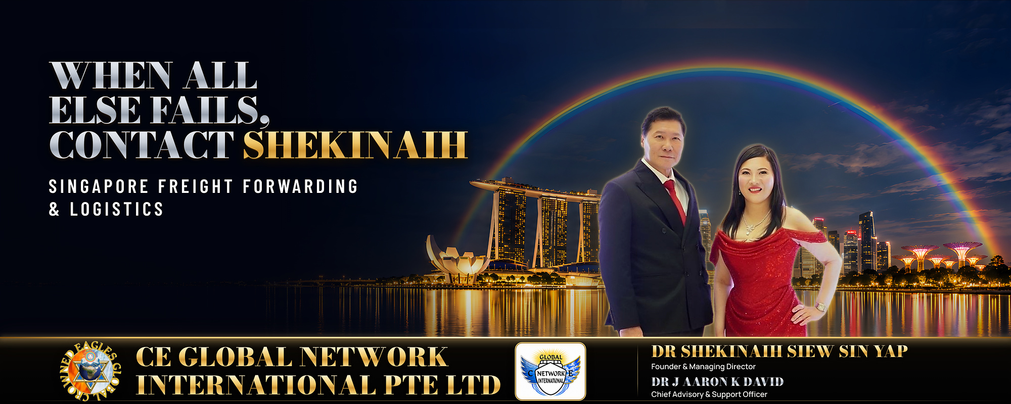
Cover photo. DR J AARON K DAVID, Chief Advisory & Support Officer, and DR SHEKINAIH SIEW SIN YAP, Founder and Managing Director, CE Global Network International — Promise Delivered.
Company photos — 10 to 30 photos, 1000 px wide, 72 dpi, .jpg. Supplied as a separate folder; captions follow the format Subject · Activity · Place.

4. Company advertisement — capital.asia
1000 × 500 px, 72 dpi, .jpg — file: GBA2026_Advertisement_1000x500.jpg
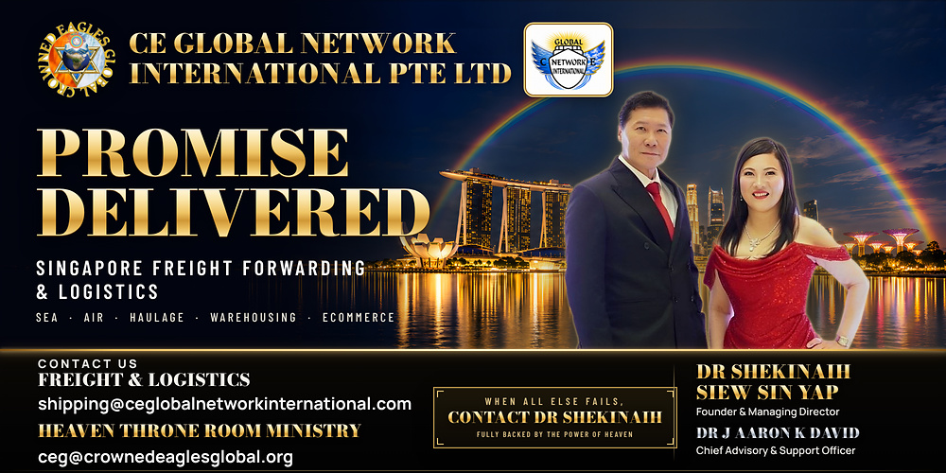

5. Rotating rectangular banner — goldenbullaward.com & capital.asia
728 × 90 px, RGB, 72 dpi — files supplied separately: GBA2026_Banner_728x90_V10_Boss_Sequence.gif (animated, 15 s loop; @2x and 2912×360 MP4 versions also available) and the static final frame. Shown here: the final frame of the V10 sequence.


6. Rotating rectangular banner — capital.asia
340 × 280 px, RGB, 72 dpi — files supplied separately: GBA2026_Banner_340x280_V9_Boss_Sequence.gif (animated, 16 s loop; @2x and 1360×1120 MP4 versions also available) and the static final frame. Shown here: the final frame of the approved V9C sequence.
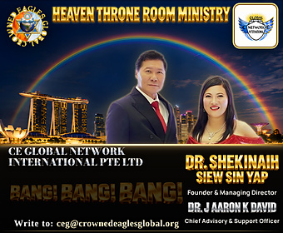

Company boilerplate
CE Global Network International Pte. Ltd. is a Singapore freight forwarder and logistics provider offering sea and air freight, container haulage, warehousing and distribution, and packing, unpacking and eCommerce logistics, with customs clearance and cargo insurance in scope. Incorporated in April 2026 and operating from July 2026, the company carries forward the freight business of CE Global Network LLP and runs an AI-assisted operating model that coordinates the journey of each shipment through one Singapore-based team. It is led by Founder and Managing Director DR SHEKINAIH SIEW SIN YAP and Chief Advisory & Support Officer DR J AARON K DAVID. Web: www.ceglobalnetworkinternational.com

