GOLDEN BULL AWARD 2026 · SINGAPORE CHAPTER
Winner Profile & Branding Materials
CE GLOBAL NETWORK INTERNATIONAL PTE LTD
Prestige Package · Outstanding Bull · Digital 50 · Inspirational Entrepreneur Awards

Submitted to | Golden Bull Award Organising Committee — attn. Mr Jason Ooi, Senior Project Manager
Award ceremony | 12 November 2026, Marina Bay Sands, Singapore
Materials due | 31 December 2026 (Winner Profile Write-Up and Company Advertisement)
Contents | 1. Company information  2. Profile write-up (1287 words; limit 2,000)  3. Company photos  4. Company advertisement — capital.asia  5. Rotating banner 728 × 90  6. Rotating banner 340 × 280

1. Company information
CEO / Director's name | DR SHEKINAIH SIEW SIN YAP
Designation | Founder and Managing Director
Chief Advisory & Support Officer | DR J AARON K DAVID — key management, jointly leads the company (co-founder of CE Global Network LLP)
Company name | CE GLOBAL NETWORK INTERNATIONAL PTE LTD (UEN 202605111K)
Company address | 27 Trevose Crescent, Dunearn Estate, Singapore 298042
Company website | https://www.ceglobalnetworkinternational.com
Email | shipping@ceglobalnetworkinternational.com
Chronology | Incorporated April 2026; operations commenced July 2026, carrying forward the freight business of CE Global Network LLP.  FY2023–FY2025 results cited in the write-up are those of CE Global Network LLP (financial years ending 31 December; management accounts, unaudited). The Pte. Ltd.'s first financial reporting period ends on 31 December 2026.
Core business, products & services | Freight forwarding and logistics (SSIC 52292 — freight transport arrangement):  • Sea freight (FCL and LCL) and air freight  • Container haulage and transportation  • Warehousing and distribution  • Packing, unpacking and eCommerce logistics  • Customs clearance, handling and cargo insurance  • AI-assisted workflow and SOP advisory for SMEs (planned)

2. Profile write-up
1287 words · British English · names of the award recipients set in full capitals as registered with the organiser.
Promise Delivered
A Singapore freight business grew from a team of one into a multimillion-dollar operation without a single advert. Its founder says the customers came because she prayed first. Here is how faith, discipline and a small team deliver, box after box.

An hour on her knees before the first decision
Every morning, before messages, meetings or money, DR SHEKINAIH SIEW SIN YAP gives about one hour to prayer.
She prays to the GOD OF THE UNIVERSE. She asks what to pursue, what to wait for and what to leave alone. Then she tells her partner and her team what she heard, and they go to work. She says this openly, on stage, in Singapore, Los Angeles, Italy and Dubai. It sounds unusual. The numbers are not.
The order matters to her. The calling came first; the company came second, built to carry it. In her words: "THE MISSION CAME FIRST. THE ENTERPRISE FOLLOWED." And: "ENTERPRISE IS NOT THE DESTINATION. IT IS INFRASTRUCTURE."

The business that heaven sent
CE Global Network LLP, the group's freight business, grew its turnover every year for three years running, and stayed profitable in each of them, through a pandemic, rate shocks and port congestion. No advertising campaign. Customers came by referral, stayed, and sent their friends.
In April 2026 that business was carried into CE Global Network International Pte. Ltd., the company honoured here. It began operations in July 2026.
"WITHOUT HIM, RECEIVING THIS AWARD WOULD BE IMPOSSIBLE."
— DR SHEKINAIH SIEW SIN YAP, accepting the Dun & Bradstreet Business Eminence Award 2026

Two leaders. One mission.
DR SHEKINAIH SIEW SIN YAP, Founder and Managing Director, writes the blueprint. She trained in accounting at Massey University, audited at Deloitte, and spent six and a half years in financial control and corporate banking at UOB. She reads the numbers, the law, the contracts and the cash flow before she says yes. She calls herself a steward, not an owner.
DR J AARON K DAVID, Chief Advisory and Support Officer, builds the faith and the leadership around her. He co-founded CE Global Network LLP with her. He is the counsel in the room when a big decision is weighed, the steady hand when the market turns, and the co-author and scriptural contributor to the teaching they publish together.
Together they lead the HEAVEN THRONE ROOM MINISTRY of Crowned Eagles Global. In November 2025, JT Foxx, founder of Mega Success, interviewed them on his main stage in Los Angeles. He introduced them as faith leaders who built a global freight enterprise and called them "a blessing to this world". Entrepreneur Dean Welch, who met them there, put it simply: "They prayed over me, blessed me, and guided me."
In August 2026, at a JT Foxx event at the Lamborghini museum in Italy, she introduced the freight company and the ministry in the same breath: "We are here to serve you and humanity." In October 2026 in Dubai, the Global Icons & Leadership Excellence Awards named her Global Icon for Spiritual Leadership & Divine Strategy and him Global Icon for Leadership & Transformation.
That is the whole model. Pray. Serve. Deliver.

What a promise looks like in a container
Freight is a promise business. A customer hands you a container and trusts four things: the booking will hold, the paperwork will be right, the cargo will be released to the right party at the right port, and nobody will get a surprise bill.
CE Global coordinates all of it through one Singapore team: sea freight (FCL and LCL), air freight, container haulage, warehousing and distribution, packing, unpacking and eCommerce logistics. Customs clearance, handling and cargo insurance can be arranged in the same service.
Its signature is the Singapore export, coordinated from pickup to discharge port:
supplier pickup → warehouse consolidation → container stuffing → customs clearance → sea carriage to the destination port.
Three habits carry it:
- Book direct. CE Global books directly with shipping lines and works with hauliers chosen for their strength on each route.
- Check the paper. Shipping instructions, bill of lading drafts and weight declarations are checked against their source documents before filing, so mistakes are fixed early.
- One contact. One person answers. One set of records. One team that stands behind the shipment.
"TRUST IS A FORM OF CAPITAL. CLIENTS REMEMBER WHO ANSWERS THE TELEPHONE, WHO TELLS THE TRUTH AND WHO REMAINS PRESENT WHEN CONDITIONS ARE DIFFICULT."
— DR SHEKINAIH SIEW SIN YAP

A small team, powered by AI, guided by people
CE Global competes with forwarders many times its size. It does not try to out-hire them. It engineers.
Repetitive work was mapped step by step and moved onto AI-assisted workflows: drafting shipping instructions, bookings and quotations; checking bill of lading drafts line by line; reconciling carrier invoices against agreed charges; flagging vessel schedule changes. Cloud accounting and a digital document trail sit underneath, so any shipment can be traced from first enquiry to final receipt.
AI drafts, checks and tracks. Experienced people decide. The two leaders choose what to automate and what must stay human, because acceleration without wisdom also accelerates mistakes.
"TECHNOLOGY IS A TOOL. IT IS NOT THE THRONE."
— DR SHEKINAIH SIEW SIN YAP

Why faith is good business
Ask DR SHEKINAIH SIEW SIN YAP what sets the company apart and she will not talk about rates. She will talk about purpose.
Her decision sequence has six steps: PRAY DEEPLY · DISCERN CAREFULLY · VERIFY RESPONSIBLY · STRUCTURE PROPERLY · EXECUTE COURAGEOUSLY · STEWARD FAITHFULLY. Prayer first. Verification before signature. Stewardship after the money arrives.
It shows in plain ways. Clear payment and cargo-release controls. No undercutting. No shortcuts on documents. And one line she states without hedging: "NOT EVERY PROFITABLE OPPORTUNITY IS A PURPOSEFUL OPPORTUNITY."
It also shows in what the money is for. She has told of supporting a young man and his family with schooling, housing and food, then using her own savings to help set up a tuition centre so the family could earn a living. "RESTORATION IS WHERE STRATEGY BECOMES LOVE IN ACTION."
Growth never came at the cost of profit: the business doubled in a year and still ended that year in the black, and the year after it was more profitable than before. The record is the evidence.
"PROFIT IS NOT THE THRONE. PURPOSE IS."
— DR SHEKINAIH SIEW SIN YAP

When all else fails, try SHEKINAIH
Every business owner knows the moment. The shipment is stuck. The bill is wrong. The plan has stopped working and nobody has an answer.
That is the moment DR SHEKINAIH SIEW SIN YAP and DR J AARON K DAVID were built for. They carried a freight business through a pandemic, rate shocks and port congestion, and into a new company. They bring two things most advisers cannot: a banker's discipline and a believer's calm.
Small businesses and enterprises come to them for business solutions. Shippers come to them for logistics solutions. The promise is the same: we solve your problem, and we tell you the truth while we do it.
You do not need a polished presentation. Start with the problem. Start the conversation.
How to contact them
- Freight and logistics (cargo out of Singapore by sea or air, paperwork right the first time): shipping@ceglobalnetworkinternational.com
- HEAVEN THRONE ROOM MINISTRY (a breakthrough in your business, your leadership or your life): ceg@crownedeaglesglobal.org
- DR SHEKINAIH SIEW SIN YAP and DR J AARON K DAVID (their story, interviews, books, awards and ministry): www.shekinaihsiewsinyap-jaaronkdavid.com
"WHEN EVERY HUMAN SOLUTION HAS FAILED, CONTACT THE GOD OF THE UNIVERSE … WHEN ALL ELSE FAILS, CONTACT US."
— DR SHEKINAIH SIEW SIN YAP, Founder and Managing Director, CE Global Network International Pte. Ltd.

3. Company photos
Cover photo — 2000 × 800 px, 72 dpi, .jpg — file: GBA2026_Cover_2000x800.jpg
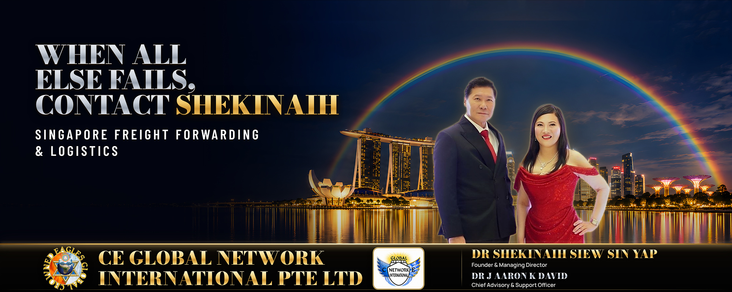
Cover photo. DR J AARON K DAVID, Chief Advisory & Support Officer, and DR SHEKINAIH SIEW SIN YAP, Founder and Managing Director, CE Global Network International — Promise Delivered.
Company photos — 10 to 30 photos, 1000 px wide, 72 dpi, .jpg. Supplied as a separate folder; captions follow the format Subject · Activity · Place.

4. Company advertisement — capital.asia
1000 × 500 px, 72 dpi, .jpg — file: GBA2026_Advertisement_1000x500.jpg
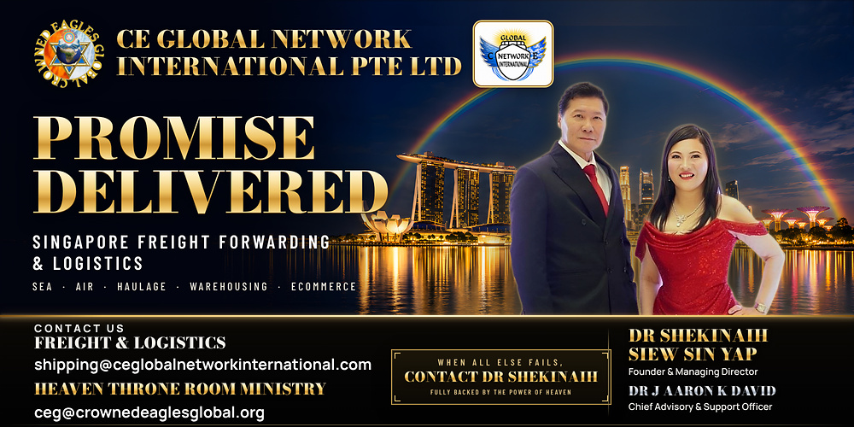

5. Rotating rectangular banner — goldenbullaward.com & capital.asia
728 × 90 px, RGB, 72 dpi — files supplied separately: GBA2026_Banner_728x90.gif (animated, 3 frames, looping) and GBA2026_Banner_728x90.jpg (static). Shown here: the static first frame.


6. Rotating rectangular banner — capital.asia
340 × 280 px, RGB, 72 dpi — files supplied separately: GBA2026_Banner_340x280.gif (animated, 3 frames, looping) and GBA2026_Banner_340x280.jpg (static). Shown here: the static first frame.


Company boilerplate
CE Global Network International Pte. Ltd. is a Singapore freight forwarder and logistics provider offering sea and air freight, container haulage, warehousing and distribution, and packing, unpacking and eCommerce logistics, with customs clearance and cargo insurance in scope. Incorporated in April 2026 and operating from July 2026, the company carries forward the freight business of CE Global Network LLP and runs an AI-assisted operating model that coordinates the journey of each shipment through one Singapore-based team. It is led by Founder and Managing Director DR SHEKINAIH SIEW SIN YAP and Chief Advisory & Support Officer DR J AARON K DAVID. Web: www.ceglobalnetworkinternational.com

