GOLDEN BULL AWARD 2026 · SINGAPORE CHAPTER
Winner Profile & Branding Materials
CE GLOBAL NETWORK INTERNATIONAL PTE LTD
Prestige Package · Outstanding Bull · Digital 50 · Inspirational Entrepreneur Awards

Submitted to | Golden Bull Award Organising Committee — attn. Mr Jason Ooi, Senior Project Manager
Award ceremony | 12 November 2026, Marina Bay Sands, Singapore
Materials due | 31 December 2026 (Winner Profile Write-Up and Company Advertisement)
Contents | 1. Company information  2. Profile write-up (1875 words; limit 2,000)  3. Company photos  4. Company advertisement — capital.asia  5. Rotating banner 728 × 90  6. Rotating banner 340 × 280

1. Company information
CEO / Director's name | DR SHEKINAIH SIEW SIN YAP
Designation | Founder and Managing Director
Chief Advisory & Support Officer | DR J AARON K DAVID — key management, jointly leads the company (co-founder of CE Global Network LLP)
Company name | CE GLOBAL NETWORK INTERNATIONAL PTE LTD (UEN 202605111K)
Company address | 27 Trevose Crescent, Dunearn Estate, Singapore 298042
Company website | https://www.ceglobalnetworkinternational.com
Email | shipping@ceglobalnetworkinternational.com
Chronology | Incorporated April 2026; operations commenced July 2026, carrying forward the freight business of CE Global Network LLP.  The freight business described in the write-up was built as CE Global Network LLP (established 2013; operated through COVID-19); no financial figures are disclosed in this submission. The Pte. Ltd.'s first financial reporting period ends on 31 December 2026.
Core business, products & services | Freight forwarding and logistics (SSIC 52292 — freight transport arrangement):  • Sea freight (FCL and LCL) and air freight  • Container haulage and transportation  • Warehousing and distribution  • Packing, unpacking and eCommerce logistics  • Customs clearance, handling and cargo insurance  • AI-assisted workflow and SOP advisory for SMEs (planned)

2. Profile write-up
1875 words · British English · names of the award recipients set in full capitals as registered with the organiser.
PROMISE DELIVERED
Freight forwarding is the business. Faith-led leadership is the story. DR SHEKINAIH SIEW SIN YAP describes prayer, verification and responsible execution as the foundations of her approach. With DR J AARON K DAVID, she applied that approach at CE GLOBAL NETWORK LLP during the pandemic. It now guides CE GLOBAL NETWORK INTERNATIONAL PTE. LTD., the company honoured here. For a business owner facing a difficult decision, the invitation is simple: start with a clear account of the problem.

The decision behind the business
The problem is still on your desk. You have advice, competing options and responsibility for what happens next.
A partner who stopped answering. A contract that turned. A cash gap nobody saw coming.
Before choosing the next action, there is another question: who do I listen to before I decide?
For DR SHEKINAIH SIEW SIN YAP, the answer begins with prayer to THE GOD OF THE UNIVERSE. With DR J AARON K DAVID she describes a leadership approach rooted in faith and obedience, carried by verification and practical execution. CE GLOBAL NETWORK INTERNATIONAL PTE. LTD. is where that approach meets commercial responsibility.

The operating discipline behind the business
The clearest test of a leader is a decision that costs something. Her published account names four operating commitments for the company: clear payment terms, strict cargo-release controls, no undercutting, and no shortcuts on documents.
Payment terms define obligations. Release controls define authority. Document checks establish what must be verified before approval.
One of those decisions is dated. According to company records, delayed customer payments in the first half of 2026 prompted a policy change in July 2026: no credit terms, and freight charges settled before shipment release. The decision made payment discipline an explicit operating requirement, whatever the length of the relationship.
She dates the establishment of CROWNED EAGLES GLOBAL and CE GLOBAL NETWORK to 2010 and 2013 respectively, and describes operating through COVID-19 as the period that tested the freight business most. CE GLOBAL NETWORK INTERNATIONAL PTE. LTD. began operations in July 2026.
In September 2026 Dun & Bradstreet named CE Global Network (International) a Business Eminence Awards 2026 Silver Category winner. In October 2026 in Dubai, she received the Global Icon Award for Spiritual Leadership & Divine Strategy and he the Global Icon Award for Leadership & Transformation.
She describes prayer as the source of the direction, and credits THE GOD OF THE UNIVERSE with the protection she experienced along the way.
"WITHOUT HIM, RECEIVING THIS AWARD WOULD BE IMPOSSIBLE."
— DR SHEKINAIH SIEW SIN YAP, Business Eminence Awards 2026
"NOT EVERY PROFITABLE OPPORTUNITY IS A PURPOSEFUL OPPORTUNITY."

Freight is the vehicle. It is not the destination.
The company moves cargo out of Singapore by sea and air: bookings direct with the shipping lines, haulage, warehousing, customs, documents checked line by line before filing.
That service is where the leadership is tested.
"THE MISSION CAME FIRST. AND ENTERPRISE BECAME ITS EARTHLY INFRASTRUCTURE."
— DR SHEKINAIH SIEW SIN YAP, Founder and Managing Director
Accepting the Dun & Bradstreet award, she said Crowned Eagles Global carries the heavenly mission, "while CE Global Network International Private Limited serves as a financing arm, supporting that greater mission."
For her, the mission sets the purpose; governance decides how that purpose is carried into business decisions.
Freight forwarding is the proof. Leadership is the product. The invitation to other business owners begins with that experience.

Two leaders. One order.
DR SHEKINAIH SIEW SIN YAP trained in accounting and finance at Massey University, audited at Deloitte and spent six and a half years in financial control and corporate banking at UOB. She reads the numbers, the law and the cash flow before she says yes. She calls herself a steward, not an owner.
DR J AARON K DAVID, Chief Advisory and Support Officer and co-founder of CE Global Network LLP, was running a real-estate agency and a renovation company at forty when, he says, a voice asked him one question: *are you happy?* He sold the businesses, spent ten years being tested, and then met her.
"SHE IS A SEER. I AM AN INTERPRETER OF VISION AND DREAMS."
— DR J AARON K DAVID
She hears and writes the blueprint. He interprets, counsels and co-executes; major commitments are weighed with him before they are signed. JT Foxx, introducing them on his Mega Success stage in Los Angeles, called them "a blessing to this world".

By faith. By obedience. In that order.
Before messages, meetings or money, she gives about an hour each morning to prayer. She asks THE GOD OF THE UNIVERSE what to pursue, what to wait for and what to leave alone. Then she tells her partner and her team what she heard, and they go to work.
Her sequence has five stages, and a shipping-line contract goes through them the same way a new company does:
SURRENDER → INSTRUCTION → OBEDIENCE → EXECUTION → MANIFESTATION.
"WE ARE NOT HERE TO COMPETE WITH ANYONE. I BELIEVE HEAVEN IS MORE THAN ENOUGH BLESSINGS FOR EVERYONE."
He puts it plainly: "We do not despise the things of small beginnings. As long as we obey Him step by step, He has never disappointed us."

Faith that survives due diligence
Her approach also requires verification, and she says so herself.
Her first question on any deal is spiritual: *is Heaven in this agreement?* Her next six are not: Who is the counterparty? What is their legal standing? Who has authority? What is written? What is verifiable? What happens if the promises fail?
"I PRAY, I EXAMINE, I VERIFY, I STRUCTURE AND THEN I DECIDE. CONVICTION SHOULD BE ABLE TO WITHSTAND DUE DILIGENCE."
— DR SHEKINAIH SIEW SIN YAP
Prayer, in her words, does not cancel due diligence; it tells you where due diligence must look more deeply.
"LOGISTICS TAUGHT ME SOMETHING POWERFUL: INTENTION ALONE DOES NOT MOVE ANYTHING. A SHIPMENT REACHES ITS DESTINATION BECAUSE COUNTLESS DETAILS ARE ALIGNED — DOCUMENTS, TIMING, ROUTES, RESPONSIBILITIES, CUSTOMS REQUIREMENTS, SERVICE PROVIDERS AND DECISIONS. LEADERSHIP WORKS THE SAME WAY. VISION MUST TRAVEL THROUGH SYSTEMS."

The systems, as they run today
A small Singapore team competes with forwarders many times its size. During 2026 it mapped its own repetitive work step by step and built AI-assisted tools around it. Four are in use on live shipments:
- Bill of lading checking. Compares the carrier's draft with the shipping instruction — consignee, marks, weights, container numbers — and flags discrepancies for human review before approval. A wrong consignee is meant to be caught on screen, not at the port.
- Invoice checking. Compares carrier invoices with the quoted rates and flags differences for investigation before payment.
- Document filing. Links shipping instructions and booking confirmations to the relevant shipment record for retrieval and review.
- Schedule extraction. Brings several carriers' schedules into one comparison sheet for staff to review.
Company records describe a September 2026 check that flagged a surcharge on invoices covering three bills of lading. The surcharge did not appear in the agreed rates. Staff held the invoices and queried the carrier before payment.
Staff remain responsible for checking source information, resolving exceptions and approving documents. Cloud accounting sits underneath. AI drafts, checks and tracks. People decide, and people sign.
"TECHNOLOGY IS A TOOL. IT IS NOT THE THRONE."

Service beyond the company
Published coverage records the two leaders serving food to the poor in Nagpur, India, in January 2026, and providing blankets and robes to the monastic community there.
In her personal testimony, DR SHEKINAIH SIEW SIN YAP also describes nearly a decade of supporting people facing hardship. One family received help with education, housing and food, followed by a tuition centre, bought with her own savings, intended to support their livelihood.
"DO NOT CREATE PERMANENT DEPENDANTS. AWAKEN DESTINY CARRIERS."
— DR SHEKINAIH SIEW SIN YAP
Her stated aim is not to gather followers but to train people who can hear, decide and carry responsibility themselves.

Put one decision on one page
An exercise inspired by her five stages. Run one unresolved business decision through them; finish with a decision, an evidence list, an owner and a review date.
- Surrender. Write the problem in one honest sentence: what must be decided, by when, and who carries it. If you cannot write it clearly, you do not understand it yet.
- Instruction. Ask before you act. Pray, if you pray. Then ask someone who has already carried what you are carrying. Separate your conviction from the assumptions that still need checking.
- Obedience. Do the next step you were given, in full. Keep the right to stop if the evidence turns against it; obedience is not the same as refusing to look.
- Execution. Put structure under it: who has authority, what is written, what is verifiable, what happens if it fails. A protocol, not a slogan.
- Manifestation. Review what actually happened, whether the outcome was favourable or disappointing. Compare it with your intention, record what you learned and decide what must change.
The test is practical: can another person understand the decision, check its evidence and name who owns the next step?

When all else fails, contact DR SHEKINAIH
You do not need to be shipping cargo to make contact. If you are weighing a partnership, an operational problem or a difficult leadership decision, write down the decision and the facts, and send them to DR SHEKINAIH SIEW SIN YAP.
Bring the decision you cannot move. Email ceg@crownedeaglesglobal.org, subject line BUSINESS QUESTION, with three lines: what is stuck, what you have tried, and the decision needed by when.
Request a shipment quotation. Email shipping@ceglobalnetworkinternational.com with your cargo, origin, destination and cargo-ready date. Ask for the proposed routing, the included charges and the exclusions.
Further reading: interviews, books and event coverage at www.shekinaihsiewsinyap-jaaronkdavid.com.

The brand behind the promise
"WHEN ALL ELSE FAILS, TRY THE GOD OF THE UNIVERSE IN SHEKINAIH. IT WORKS, BECAUSE IT IS FULLY BACKED BY THE POWER OF HEAVEN. BANG! BANG! BANG!"
— DR SHEKINAIH SIEW SIN YAP
CE GLOBAL NETWORK INTERNATIONAL PTE. LTD. is the freight-forwarding and logistics arm of the Crowned Eagles Global group, led by DR SHEKINAIH SIEW SIN YAP and DR J AARON K DAVID. The group spans seven companies across Singapore and Malaysia, each with its own role.
The Crowned Eagles Global group — seven companies
Singapore
- CE Global Network International Pte. Ltd. — international freight forwarding and logistics (the company honoured here)
- CE Global Network LLP — the original freight business
- Crowned Eagles Global LLP — the founding entity of the group and home of the HEAVEN THRONE ROOM MINISTRY
- Crowned Eagles Global Group Holdings Pte. Ltd. — group holding company
- Crowned Eagles Global IP Holdings Pte. Ltd. — intellectual property, publishing and teaching
Malaysia
- CEG Malaysia Holdings Sdn. Bhd. — Malaysian holding company
- CEG Portfolio Abundant Sdn. Bhd. — portfolio and investments
Two marks carry the group: the CROWNED EAGLES GLOBAL crest and the CE GLOBAL NETWORK INTERNATIONAL PTE LTD shield. Wherever you see them together, the same order applies: pray first, verify always, deliver what was promised.
What decision is holding your business back? Send the problem, what you have tried and your deadline to ceg@crownedeaglesglobal.org, addressed to DR SHEKINAIH SIEW SIN YAP.

3. Company photos
Cover photo — 2000 × 800 px, 72 dpi, .jpg — file: GBA2026_Cover_2000x800.jpg

Cover photo. DR J AARON K DAVID, Chief Advisory & Support Officer, and DR SHEKINAIH SIEW SIN YAP, Founder and Managing Director, CE Global Network International — Promise Delivered.
Company photos — 10 to 30 photos, 1000 px wide, 72 dpi, .jpg. Supplied as a separate folder; captions follow the format Subject · Activity · Place.

4. Company advertisement — capital.asia
1000 × 500 px, 72 dpi, .jpg — file: GBA2026_Advertisement_1000x500.jpg
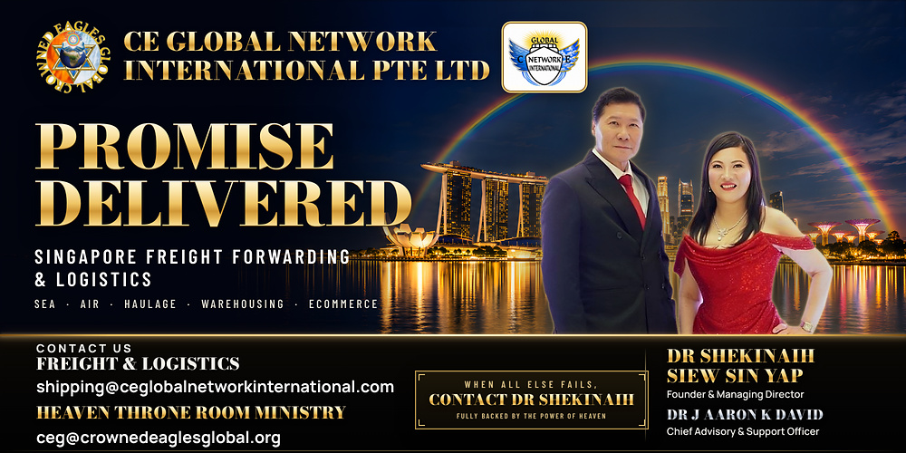

5. Rotating rectangular banner — goldenbullaward.com & capital.asia
728 × 90 px, RGB, 72 dpi — files supplied separately: GBA2026_Banner_728x90_V10_Boss_Sequence.gif (animated, 15 s loop; @2x and 2912×360 MP4 versions also available) and the static final frame. Shown here: the final frame of the V10 sequence.


6. Rotating rectangular banner — capital.asia
340 × 280 px, RGB, 72 dpi — files supplied separately: GBA2026_Banner_340x280_V9_Boss_Sequence.gif (animated, 16 s loop; @2x and 1360×1120 MP4 versions also available) and the static final frame. Shown here: the final frame of the approved V9C sequence.
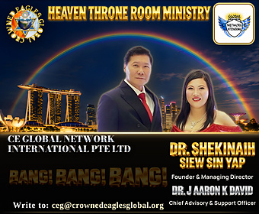

Company boilerplate
CE Global Network International Pte. Ltd. is a Singapore freight forwarder and logistics provider offering sea and air freight, container haulage, warehousing and distribution, and packing, unpacking and eCommerce logistics, with customs clearance and cargo insurance in scope. Incorporated in April 2026 and operating from July 2026, the company carries forward the freight business of CE Global Network LLP and runs an AI-assisted operating model that coordinates the journey of each shipment through one Singapore-based team. It is led by Founder and Managing Director DR SHEKINAIH SIEW SIN YAP and Chief Advisory & Support Officer DR J AARON K DAVID. Web: www.ceglobalnetworkinternational.com

